Fire safety recommendations for
electric vehicles

CFPA-E Guideline No 44:2025 F

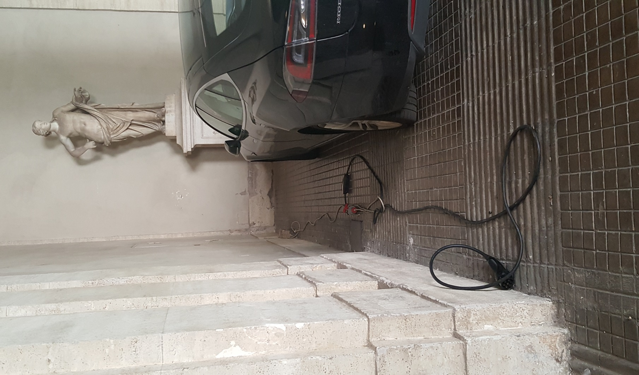




The CFPA Europe develops and publishes common guidelines about fire safety, security, and natural hazards with the aim to achieve similar interpretation and to give examples of acceptable solutions, concepts, and models. The aim is to facilitate and support fire protection, security, and protection against natural hazards across Europe, and the whole world.

Today fire safety, security and protection against natural hazards form an integral part of a modern strategy for survival, sustainability, and competitiveness. Therefore, the market imposes new demands for quality.

These Guidelines are intended for all interested parties and the public. Interested parties includes plant owners, insurers, rescue services, consultants, safety companies and the like so that, in the course of their work, they may be able to help manage risk in society.

The Guidelines reflect best practice developed by the national members of CFPA Europe. Where these Guidelines and national requirements conflict, national requirements shall apply.

This Guideline has been compiled by the Fire Safety Commission and is adopted by the members of CFPA Europe.

More information: www.cfpa-e.eu


Wallisellen, June 2025 Cologne, June 2025
CFPA Europe Fire Safety Commission

Elisabetta Carrea Hardy Rusch
Chairman Chairman



Contents

1 Introduction 4
2 Scope 4
3 Objectives 5
4 Definitions 5
5 Causes and frequency of EV fires 6
6 Minimum fire safety requirements 6
6.1 Electric system 6
6.2 Charging station 7
6.3 External charging stations 8
6.4 Charging station inside enclosed areas 8
6.5 Charging stations with internal Li-ion batteries 9
6.6 Cable 9
6.7 Vehicle 10
6.8 Signage 10
6.9 Extinguishers 10
6.10 Fixed fire systems 11
6.11 Fire safety management system 12
6.12 Crashed or damaged vehicles 13
7 Bibliography 14
European guidelines 15

Introduction
This guideline is concerned with fire safety of electric vehicles.

Early studies suggest that electric vehicles have a fire risk comparable, or possibly even lower, than “traditional” vehicles (i.e. vehicles with an internal combustion engine). Anyway, in an electric vehicle a fire can occur in various moments, also independently from the batteries. In any case, the recharge operations made inside an enclosed space, or dealing with an electric vehicle after a crush or after a previous fire, must be considered as particularly delicate situations.

Electric cars are quickly growing in number and their batteries, normally Lithium-ion batteries, are growing in capability. They can be recharged in open-air recharging stations or also in covered structures, like for example public parking lots or private residential garages.

The thermal runaway of Li-ion batteries can produce the release of gases, which are normally to be considered as toxic and flammable, and the production of heat, sparkles and flames. An explosion hazard develops if the gases continue to accumulate without ignition in enclosed spaces, like for example closed private residential garages, and can lead to an explosion which can blow the garage door meters away, creating a danger to the emergency services.

The recharging operations in open-air structures normally have a lower fire risk when referring to the danger to people, and even in case of fire often the result is the loss of a single car, and sometimes of the recharging station.

If a fire occurs during the recharging operations in enclosed buildings, instead, it can produce a high danger for the people, especially if in the building people can be asleep or cannot make easily a safe egress, like in hospitals and in care homes for the elderly, and can also lead to a propagation of the fire to the surrounding vehicles or even, in worst cases, to the entire building, leading also to a large loss of property.

It must be taken into consideration that burnt, crashed or damaged electric vehicle can re-ignite hours or even days after the first event.

This guideline is primarily intended for those responsible for the charging stations and car park operators, but it’s also addressed to the drivers of these vehicles and to rescue services, first responders (Fire fighters), second responders (for example car dismantlers and car transporters), consultants, fire risk assessors, safety companies, etc., so that, during their work, they may be able to help to increase the levels of fire safety.

Scope
This guideline is intended to provide safety instructions for the design, installation, operation and maintenance of charging structures for electric vehicles.

This guideline only concerns electric vehicles with a licence plate registered for the circulation on public roads which can be charged by means of a conductive recharging system, in public or private spaces.

This guideline does not apply to:
- Inductive recharge;
- Fuel-cell (hydrogen) vehicles;
- Vehicles that only have an internal combustion engine (ICE) and low voltage (normally 12V) batteries;
- Hybrid electric vehicles (HEV) which don’t have a recharging cable, although this guideline can be of interest, at least in part, for these vehicles;
- Battery-powered vehicles which cannot circulate on public roads, like for example forklifts;
- Scooters, bicycles, other electric devices without a license plate;
- The transportation of EVs on ships or trucks.

Extended-range electric vehicles (EREV) are included in this guideline only if they have the possibility to be recharged using a cable connected to the electric grid.

Many European countries already have codes of guidelines about this topic. This guideline can provide the minimum fire safety requirements for those countries which so far do not have codes or can be used as a supplement to national regulations already in force.

In any case, if national or local codes are in contrast with this guideline, national and local codes prevail.

Objectives
The fire safety objectives of this guideline are the following:
- Reducing the risk of fire and explosion during the recharging operations of electric vehicles;
- Reducing the risk of propagation of a fire to the adjacent vehicles and/or properties;
- In case of fire, allowing a safe egress of people from the recharging station and from the adjacent areas;
- Allowing a safe intervention by the emergency services.

Definitions
Electric vehicle: For the purposes of this guideline, an “electric vehicle” is any kind of vehicle which:
- is registered for the circulation on public roads, with a licence plate;
and
- has one or more high voltage batteries, supplying an electric engine;
and
- its batteries can be recharged by means of a physical connection (cable) to a public or private electric grid.

This definition includes for example:
- vehicles without combustion engine (100% battery electric vehicles, or EV, or BEV);
- plug-in electric vehicles with a combustion engine (PHEV);
- in general, all electric vehicles whose battery can be recharged by means of an electric connection to the grid.

Charging system: The entire set composed by the charging station, the cable and the vehicle.

Charging station: The charging point connected to the electric grid.
Charging mode: A charging mode as indicated in the IEC 61851-1.
Mode 1: simple connection to the AC power supply grid.
Mode 2: connection to the AC power supply grid using a mobile cable between the electric vehicle and the charging station which includes an additional protection made of a control box PWM (pulse width modulation) with a 30 mA differential.
Mode 3: connection to the AC power supply grid using a fixed charging station permanently installed on a stable structure (eg. a wall). The minimum safety protections must include the check of the correct insertion of connectors, a check of the electric continuity of the protection conductor, a protection against indirect contacts.
Mode 4: a connection to the DC power supply grid through an external converter. The minimum safety protections are as for Mode 3.

Conductive recharge: The battery charging operation made using a cable which physically connects the battery to the electric grid.

Causes and frequency of EV fires
An electric vehicle can catch fire for various reasons, and many of these reasons have nothing to do with their batteries.

Concerning the fires that are caused by the electric batteries, normally the origin is connected to the thermal runaway of lithium-ion batteries. The thermal runaway of a Li-ion battery mainly happens after a serious mechanical damage, an overheating of the battery caused by an external source of heat, problems of electric overcharge during the recharge operations.

A great concern is growing about the increasing number of fires in electric vehicles. Statistics are still insufficient but according to available data, in the last years EV fires are really increasing in number although they remain lower, and perhaps significantly lower, than fires of ICE vehicles. Probably the reason is that EV vehicles presently are quite new; in the next years they will age, and their defect rate probably will increase.

Although statistics are still insufficient, it appears that the probability of an EV catching fire is lower, and perhaps significantly lower than an ICE vehicle.

Although the heat release rate of an EV is in general comparable to the HRR of an ICE (Internal Combustion Engine) vehicle, the behavior of a fire of a EV can vary significantly from a fire of an ICE vehicle. In EV fires, the duration can be longer, often the propagation happens laterally, the fire can be more difficult to extinguish, there is a danger of re-ignition. EV fires also pose new problems for fire fighters and for second responders.

Minimum fire safety requirements

Electric system
The electric system supplying the charging station(s) must be designed, installed and maintained according to the applicable technical standards and the manufacturer’s instructions. All the installations must be done by qualified personnel.

It’s dangerous, and it’s not recommended, to charge electric vehicles connecting the vehicle directly to an electric system which has not been specifically designed for this purpose. In particular, the electric system must be fit for purpose and suitable for the electric load required to charge the vehicles.
The electric circuit dedicated to the charging stations must not be used other than for charging the batteries of electric vehicles.

Extension cords must never be used.

Any kind of operation on the electric system must be executed by a qualified technician according to national regulations.

The charging station must have an electric switch, to be installed in a position that is clearly visible by the emergency services, with proper signage. In order to guarantee a safe intervention by the emergency services, if the charging station is installed inside an enclosed space, and this enclosed space has its electric switch, then the activation of the electric switch of the enclosed space must automatically switch off also all the charging stations installed inside the enclosed space.
After completing the installation, the installer must sign the Declaration of conformity, with the attachments required by the applicable codes. In the declaration, the technical standards that have been applied must be clearly indicated; the charging Mode according to EN 61851-1 must be indicated.

Charging station
The position of the charging station must be compatible with any other installation in the premises, like for example:
- fuel stations;
- storage of dangerous substances or mixtures;
- storage of flammable liquids;
- storage or pipes of flammable gases;
- storage or pipes of oxidizing substances;
- any source of open flame or heat;
- the presence of green roofs and green walls;
- the proximity of facades with combustible cladding.

An adequate distance between the charging station and any other dangerous installations must be provided according to a specific fire risk assessment.

In any case, the charging station must always be installed out of areas classified for explosive gases or dusts (ATEX) according to 1999/92CE and 2014/34/UE.

The charging station must be reasonably protected from mechanical damage caused by possible incorrect maneuvers of vehicles, for example protecting them by bollards, concrete or metal barriers.

The Mode 1 charging mode is forbidden for electric vehicles.
The Mode 2 is allowed in private spaces; in any case Mode 3 or 4 are always recommended.

In enclosed spaces where the specific fire risk assessment requires it, the charging modes must be only Mode 3 and Mode 4 according to IEC 61851-1.

The charging station should be adequately protected by extreme heat or extreme cold, so that the temperature should always be between -40°C and +60°C.

External charging stations
In general, an area of at least 2,5 m all around the charging station and the vehicle must be kept totally clear from any combustible material. Asphalt floors are allowed but not combustible floors like for example concrete or gravel, are recommended.

In extreme weather, charging stations should be protected from solar radiation with a canopy.
The roof and/or the canopy should have reaction to fire not exceeding B-s2-d0 according to EN 13501.

A charging station protected with a canopy or a roof, where at least one side not less than 15% of the perimeter is permanently open, is to be considered as external.

Charging station inside enclosed areas
When an electric vehicle takes fire, normally the heat release rate does not differ significantly from the HRR of an internal combustion vehicle, so the fire resistance of bearing structures required by the national requirements applicable to traditional (ICE) car parks, in general, can be considered as adequate.

The enclosed spaces where charging stations are installed must be adequately protected from the propagation of the fire, smoke and gases towards other areas. The protection between the area of the charging station(s) and other areas should be as follows:

Other areas | Minimum protection between charging station areas and other areas
Garages only for vehicles (electric, ICE, etc.) | No requirements
Single-apartment residential civil dwellings; short-term rental activities | EI30 - EI30-Sa
Multi-apartments residential civil dwellings; buildings with various different activities (e.g. commercial, residential, short-term rental activities, etc.) | EI60- EI60-Sa
Assembly where people are normally awake, with gross surface less than 5.000 sqm, like for example cinemas, theatres, offices, commercial activities, schools, airports, railway stations, industrial activities, restaurants, etc. | EI30 - EI30-Sa
Assembly where people are normally awake (see before), with gross surface exceeding 5.000 sqm | EI60 - EI60-Sa
Hotels and areas where people can be asleep (excluding private civil dwellings) | EI60 - EI60-Sa
Storage of dangerous substances or mixtures, flammable liquids, gases, etc. | EI90
Rooms containing fire safety systems (fire pumping stations, diesel generators, etc.) | EI90
Hospitals, care homes for the elderly, elderly, activities specifically designed for disabled people | EI90 - EI90-Sa
Charging stations for M3, N2, N3, O3 and/or O4 vehicles | EI90 - EI90-Sa

Note: Where indicated, “Sa” is related to firedoors.
In all the enclosed spaces, where the charging station is installed, all materials should have a reaction to fire in Class A1 according to EN 13501. Concrete or other not combustible floors are recommended; combustible floors like, for example, asphalt floors should be avoided.

As a result of a fire risk assessment, it can be useful to divide the charging stations with barriers among them, or among groups of them (for example, every 5 stalls for cars), in order to avoid a large propagation of the fire in case a single car takes fire. If so, the barrier must have:
- reaction to fire Class A1;
- sufficient mechanical resistance to the emission of sparkles and flames;
- height from floor of at least 1 m.

As an alternative to barriers, each charging station should be installed so that each EV vehicle in recharge has a distance of at least 150 cm to every other vehicle.

In underground or above ground parking lots, in case of fire the emergency services need to remove the burned car safely. If the only system to move cars inside a parking lot is a car lift, then there is the possibility that the car re-ignite during the transport on the car lift. So, it’s forbidden to install a charging station in an underground or above ground floor of a parking lot which only has car lifts; where a charging station is to be installed, at least one ramp is needed for the safe removal of burned cars.

If possible, in large, enclosed spaces like for example large multi-story covered parking lots, the charging stations should be positioned close to the entrances, and possibly at ground floor or in any case at floors as near as possible to the entrance, in positions where the emergency services can easily reach the charging stations.

A safety emergency lighting system must be designed, installed and maintained according to the applicable codes.

Charging stations with internal Li-ion batteries
The fire risk assessment must take into consideration that the charging station can contain Li-ion batteries, used as a buffer during the charging operations, especially when charging Mode 4 has been chosen. If so, the fire risk assessment must consider the continuous presence of a certain number of Li-ion batteries inside the parking lot.

In enclosed spaces, charging stations with internal Li-ion batteries are recommended only:
- With energy of every single charging station not exceeding 200 kWh;
- With automatic fire detection system which, in case of activation, automatically switches off the electric supply to the recharging station(s).

In these cases, an automatic water-based extinguishing system is strongly recommended.

Cable
The cable must be subject to periodic visual inspection in order to guarantee that it is in good conditions, in particular for what concerns the plugs and the insulation.

If the cable has a metal shielding, then it must be earthed.

Vehicle
The proprietor and/or the driver of the vehicle is responsible to guarantee that the vehicle is approved for the circulation on public road according to the national regulations, maintained in good efficiency and successfully subject to the revisions required by national regulations.

The driver must visually inspect the cable before any charging operation. If the cable looks damaged, no charging operation should be performed and the damage must be reported immediately to the responsible of the charging station. Proper signage concerning the need of a visual inspection of the cable must be installed near every charging station.

Signage
Specific proper signage must be installed near the charging station, including the following:

ELECTRIC VEHICLE CHARGING STATION
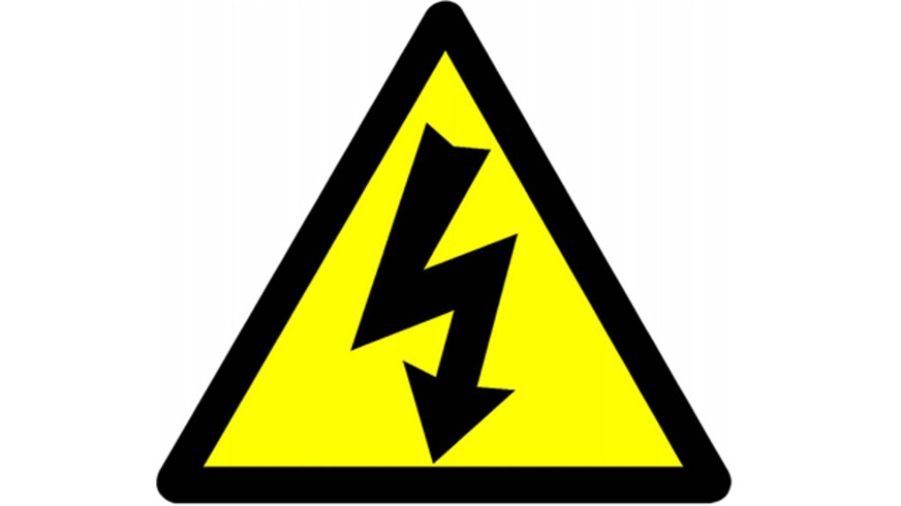

The signage must be written in the national language.

If the charging station is installed inside enclosed space, such as private residential garages, the signage must be clearly visible from outside.

On every charging station, proper signage must be installed in order to inform users about the type or recharge, adapters, connectors, plugs and vehicles (with commercial names) that are compatible with each charging station.

The DC charging station must be clearly differentiated from AC charging station, using proper signage.

In enclosed spaces where there is a charging station, smoking, open flames and hot works are forbidden. Proper signage has to be installed.

Extinguishers
Near the charging station, at least one portable fire extinguisher must be available. If external, the extinguisher(s) must be protected from atmospheric agents.

The extinguisher(s) must be of a type suitable for the use on electrical appliances.

If the charging station are more than one, the number of fire extinguishers must in accordance with the fire risk assessment, with a minimum of one extinguisher every 5 charging stations. If extinguishers have been already installed, for example in garages due to the applicable regulations, there is no need to add other extinguishers, provided that the existing ones are in adequate number and of suitable type.

Fixed fire systems

The following fire systems are recommended or required:
Use | Fire hose | Fire detection and alarm | Water based automatic suppression system | Ventilation system
Open-air charging stations | Recommended | /// | /// | ///
Charging stations in enclosed spaces, including covered and/or underground parking lots not exceeding 300 sqm | Recommended | Recommended | Recommended | Required
Charging stations in enclosed spaces with internal batteries | Recommended | Required | Recommended | Required
Covered and/or underground parking lots exceeding 300 sqm with closed garages | Required | Recommended | Recommended | Required
Covered and/or underground parking lots exceeding 300 sqm with open parking spaces | Required | Recommended | Required | Required
Assembly with gross surface less than 5.000 sqm, like for example cinemas, theatres, offices, commercial activities, schools, airports, railway stations, industrial activities, restaurants, etc. | Required | Required | Recommended | Required
Assembly (see before) with gross surface exceeding 5.000 sqm | Required | Required | Required | Required
Private civil dwellings, short-term rental activities | Recommended | Required | Recommended | Required
Storage of dangerous substances or mixtures, flammable liquids, gases, etc. | Required | Required | Recommended | Required
Hospitals, care homes for the elderly, activities specifically designed for disabled people | Required | Required | Required | Required
Charging stations for M3, N2, N3, O3 and/or O4 vehicles | Required | Required | Required | Required

Notes:
Closed garages: private garages, singularly not exceeding 40 sqm, closed by EI30 walls and metal doors.

Fire hose: at least 1 fire hose, with 120 litres/minute and 2 bars for 30 minutes., installed in a position where fire fighters can safely operate and where it covers all the area of the charging station(s).
Alternatively, a public hydrant reachable in less than 200 m with the same minimum hydraulic performance.
A dry column can substitute a fire hose system, but the fire risk assessment must take into consideration that this system cannot operate until the arrival of Fire fighters.

Fire detection and alarm system: the system must cover at least the area of the charging station(s). The system must be built, installed and maintained according to an applicable technical standard. Single battery-operated detectors are permitted.
Following a fire risk assessment, the fire detection system can be made of smoke, or heat or temperature detectors.
The activation of the fire detection system must automatically switch off the electric system supplying all the charging stations and produce an optical and acoustical alarm. In places where people can be asleep, the alarm must be clearly audible from all places where people may be asleep, with sound pressure not lower than 75 dBA measured at all pillows.

Water based suppression system: the system must cover at least the area of the charging station(s). If a sprinkler system is installed, it must be built, installed and maintained according to an applicable technical standard. If the standard is EN 12845, the sprinkler system must be at least OH2.
The fire detection and alarm function can be considered as carried out by the water based suppression system itself, provided that it’s equipped with a flow switch that activates an acoustic siren; the siren must have emergency electric supply and must be clearly audible from all places where people may be asleep, with sound pressure not lower than 75 dBA measured at all pillows.

Ventilation system: the ventilation system should provide the possibility of extract smoke, heat and gases in order to increase the egress time and ease the Fire fighters’ intervention.
In general, a natural ventilation system should consist in openings, permanently opened and/or with automatic opening in case of fire or, as a less preferable option, with manual opening operated from a position protected from the fire. The total surface of the openings should not less than 1/40 of the floor surface. Possibly the openings should be places in the lower and also in the upper part of the rooms.
A mechanical ventilation system is an alternative, totally or in part, to a natural ventilation system. A mechanical ventilation system should operate automatically in case of fire, combining smoke extraction and fresh air intake, and should be designed, installed and maintained according to the applicable standards.

Factors that may affect the need for a fixed fire extinguishing system are for example the distance to the nearest fire station, the availability of adequate water supply, the fire load in the premises (especially regarding buildings with wooden structures), the dimensions of the premises, the presence of open flame equipment and the possibility of fire spread from the premises to the surrounding area and vice versa.

A thermal camera monitoring system can be useful for an early detection of a fire.

Fire safety management system
In any covered place where an EV charging station is installed, smoking, using open flames, operating hot works, transferring flammable liquids, storage of flammable liquids and/or gases, must be forbidden. Proper signage must be placed in clearly visible positions.

All EV charging stations and all the fire safety systems and devices must be subject to regular and periodical inspection according the national and/or local standards and with the instructions of the manufacturers.

Crashed or damaged vehicles
Crashed or damaged electric vehicles must never be lifted using a forklift.

Crashed or damaged electric vehicles must never be left inside enclosed spaces. They must be left outside, sufficiently far from any other combustible material, for a sufficient period or quarantine before doing any operation (including transportation, disposal, etc.). Proper signage has to be installed on the vehicle, at least on the driver’s side, to indicate:
- That is a damaged electric vehicle;
- The date if beginning of the quarantine;
- The date of the end of the quarantine;
- That it’s forbidden to carry out any kind or operation before the end of the quarantine.

The distance between a crashed or damaged vehicle and any other combustible or flammable material must be at least 10 m. Alternatively, until the correct disposal of the vehicle it must be placed in a container full of water, or in a container specifically made to contain damaged electric vehicles, or covered by a fire blanket.

The quarantine must last at least as indicated by the manufacturer or the authority having jurisdiction. In case of absence of a precise indication, the quarantine period should be as follows:

Damage | Minimum period of quarantine (days)
Crashed with or without airbag deployment | 2
Crashed with damage to high voltage system | 5
Flooded / submerged in fresh water | 5
Flooded / submerged in sea water | 10
Burned / partly burned | 10

During the quarantine, the vehicle must be frequently checked.

The area where the vehicles wait during the quarantine must have at least one fire hose, with at least 120 litres/minute and 2 bars for 30 minutes, for the operations of the emergency services.

If during all the quarantine the vehicle does not show an increase in temperature or production of smoke, then it can be sent to disposal in accordance to national regulations. The documents of transportation must report that it is a damaged electric vehicle that has already been subject to quarantine.

If during the quarantine there is an increase of temperature and/or production of smoke, adequate measures of extinction must be taken immediately. In case of use of water, the water used for suppression must be collected and disposed appropriately, without contaminating the environment. After the suppression, another period of quarantine, not less than 10 days, must be observed before disposal. The documents of transportation must report that it is a damaged electric vehicle that has already been subject to quarantine and that during the quarantine a fire has occurred.

If a battery is removed from the vehicle, then it must be correctly stored in a suitable container.

Bibliography

Consolidated Resolution on the Construction of Vehicles (R.E.3), revision 2, World Forum for Harmonization of Vehicle Regulations (UN 2011).

Circolare 05 novembre 2018 n. 2 prot. 15000, Linee guida per l’installazione di infrastrutture per la ricarica dei veicoli elettrici, Ministero dell’Interno DGPST (Italy 2018).

Ola Willstrand, Roeland Bisschop, Per Blomqvist, Alastair Temple, Johan Anderson, Toxic gases from fire in electric vehicles, RISE report 2020:90 (Sweden 2020).

VdS 3885:2020-12(01), Elektrofahrzeuge in geschlossenen Garagen – Sicherheitshinweise für die Wohnungswirtschaft, (Germany 2020).

VdS 3471:2021-02 (02), Ladenstationen für Elektrostraßenfahrzeuge, (Germany 2021).

Leitfaden für das Bergen, Transportieren, Verwahren und Entsorgen von Fahrzeugen mit Elektroantrieb. Schweizerische Eidgenossenschaft / Auto-Strassenhilfen-Schweiz (Switzerland 2021).

OIB Richtlinie 2.2 Brandschutz bei Garagen, überdachten Stellplätzen und Parkdecks, (Austria 2023).

NIPV, Fire safety of indoor car parks accommodating electrically powered vehicles, (The Nederlands 2023).

Siemens Switzerland Ltd, in cooperation with Danfoss Fire Safety A/S and DBI, White paper - Fire in parking garages with electric vehicles, (Switzerland 2023).

Magnus Arvidson and Őrjan Westlund, Water spray fire suppression tests comparing gasoline-fuelled and battery electric vehicles, RISE (Sweden 2023).

Jonna Hynynen, Maria Quant, Roshni Pramanik, Anna Olofsson, Ying Zhen Li, Magnus Arvidson, Petra Andersson, Electric vehicle fire safety in enclosed spaces, RISE Report 2023:42 (Sweden 2023).

T0194 – Covered car parks – fire safety guidance for electric vehicles, ARUP – UK Government (United Kingdom 2024).

Fire & Risk Alliance, LCC, Electric vehicle fires: an overview and analysis, (USA 2024).

Insurance Europe. Guideline on fire safety for Battery Electric Vehicles parked in underground and above ground covered car parks. GEN-MTR-24-089 (2024).

European guidelines
Fire (https://cfpa-e.eu/category-guidelines/fire-prevention-and-protection/)
Guideline No 1 F - Internal fire protection control
Guideline No 2 F - Panic & emergency exit devices
Guideline No 3 F - Certification of thermographers
Guideline No 4 F - Introduction to qualitative fire risk assessment
Guideline No 5 F - Guidance signs, emergency lighting and general lighting
Guideline No 6 F - Fire safety in care homes
Guideline No 7 F - Safety distance between waste containers and buildings
Guideline No 8 F - withdrawn
Guideline No 9 F - Fire safety in restaurants
Guideline No 10 F - Smoke alarms in the home
Guideline No 11 F - Recommended numbers of fire protection trained staff
Guideline No 12 F - Fire safety basics for hot work operatives
Guideline No 13 F - Fire protection documentation
Guideline No 14 F - Fire protection in information technology facilities
Guideline No 15 F - Fire safety in guest harbours and marinas
Guideline No 16 F - Fire protection in offices
Guideline No 17 F - Fire safety in farm buildings
Guideline No 18 F - Fire protection on chemical manufacturing sites
Guideline No 19 F - Fire safety engineering concerning evacuation from buildings
Guideline No 20 F - Fire safety in camping sites
Guideline No 21 F - Fire prevention on construction sites
Guideline No 22 F - Wind turbines – Fire protection guideline
Guideline No 23 F - Securing the operational readiness of fire control system
Guideline No 24 F - Fire safe homes
Guideline No 25 F - Emergency plan
Guideline No 26 F - withdrawn
Guideline No 27 F - Fire safety in apartment buildings
Guideline No 28 F - Fire safety in laboratories
Guideline No 29 F - Protection of paintings: transports, exhibition and storage
Guideline No 30 F - Managing fire safety in historic buildings
Guideline No 31 F - Protection against self-ignition end explosions in handling and storage
of silage and fodder in farms
Guideline No 32 F - Treatment and storage of waste and combustible secondary raw
materials
Guideline No 33 F - Evacuation of people with disabilities
Guideline No 34 F - Fire safety measures with emergency power supply
Guideline No 35 F - Fire safety in warehouses
Guideline No 36 F - Fire prevention in large tents
Guideline No 37 F - Photovoltaic systems: recommendations on loss prevention
Guideline No 38 F - Fire safety recommendations for short-term rental accommodations
Guideline No 37 F - Fire protection in schools
Guideline No 38 F - Fire safety recommendations for short-term rental accommodations
Guideline No 39 F - Fire protection in schools
Guideline No 40 F - Procedure to certify CFPA-E Fire Safety Specialists in Building Design
Guideline No 41 F - Safety instructions for the use and charging of small and medium size lithium
ion powered devices
Guideline No 42 F – Guidance document for Selection of Fire Protection Systems
Guideline No 43 F – Foam concentrates – The Selection Criteria

Natural hazards (https://cfpa-e.eu/category-guidelines/natural-hazards/)
Guideline No 1 N - Protection against flood
Guideline No 2 N - Business resilience – An introduction to protecting your business
Guideline No 3 N - Protection of buildings against wind damage
Guideline No 4 N - Lighting protection
Guideline No 5 N - Managing heavy snow loads on roofs
Guideline No 6 N - Forest fires
Guideline No 7 N - Demountable / Mobile flood protection systems
Guideline No 8 N - Ensuring supplies of firefighting water in extreme weather conditions
Guideline No 9 N - Protection against hail damage
Guideline No 10 N - Heavy rain and flash floods: Recommendations on flood prevention and protection

Security (https://cfpa-e.eu/category-guidelines/security/)
Guideline No 1 S - Arson document
Guideline No 2 S - Protection of empty buildings
Guideline No 3 S - Security systems for empty buildings
Guideline No 4 S - Guidance on keyholder selections and duties
Guideline No 5 S - Security guidelines for museums and showrooms
Guideline No 6 S - Security guidelines emergency exit doors in non-residential premises
Guideline No 7 S - Developing evacuation and salvage plans for works of art and
heritage buildings
Guideline No 8 S - Security in schools
Guideline No 9 S - Recommendation for the control of metal theft
Guideline No 10 S - Protection of business intelligence
Guideline No 11 S - Cyber security for small and medium-sized enterprises
Guideline No 12 S - Security Guidelines for Businesses
Guideline No 13 S – Cybersecurity basic level – Basic IT security

www.cfpa-e.eu

Classification according to UNECE Resolution R.E.3 (https://unece.org/transport/vehicle-regulations/wp29/resolutions).

