Photovoltaic systems:
Recommendations on loss
prevention

CFPA-E Guideline No 37:2025 F

Please insert the former image again!




The CFPA Europe develops and publishes common guidelines about fire safety, security, and natural hazards with the aim to achieve similar interpretation and to give examples of acceptable solutions, concepts, and models. The aim is to facilitate and support fire protection, security, and protection against natural hazards across Europe, and the whole world.

Today fire safety, security and protection against natural hazards form an integral part of a modern strategy for survival, sustainability, and competitiveness. Therefore, the market imposes new demands for quality.

These Guidelines are intended for all interested parties and the public. Interested parties includes plant owners, insurers, rescue services, consultants, safety companies and the like so that, in the course of their work, they may be able to help manage risk in society.

The Guidelines reflect best practice developed by the national members of CFPA Europe. Where these Guidelines and national requirements conflict, national requirements shall apply.

This Guideline has been compiled by the Fire Safety Commission and is adopted by the members of CFPA Europe.

More information: www.cfpa-e.eu


Wallisellen, June 2025 Cologne, June 2025
CFPA Europe Fire Safety Commission

Elisabetta Carrea Hardy Rusch
Chairman Chairman


Contents

1 Introduction 4
2 Scope 4
3 Definitions 4
4 Hazards and risks 6
5 Prevention measures 8
5.1 Preliminary 9
5.2 Planning and Installation 9
5.2.1 Stability 9
5.2.2 Electrical safety, lightning and surge protection 10
5.2.3 Fire protection 10
5.2.4 Theft protection 14
5.3 Before start of operation 14
5.4 Operation 15
5.5 Special information on fire fighting 16
6 Literature 17
Appendix: Checklists for the planning and acceptance of PV systems 18
European guidelines 23

Key words:

Introduction
Photovoltaic systems are being increasingly installed to meet solar energy demand.

For electrical energy generation, components of photovoltaic systems, especially solar modules, are mounted on buildings in order to optimally capture the sunlight. These components are exposed to the weather, such as wind, snow, hail and temperature fluctuations, but may also benefit from existing structural elements with regards to their protective function e.g. fire protection.

This guideline should give guidance for the proper design, installation, operation and maintenance so that safe operation of photovoltaic systems can be achieved.

Scope
The current guideline covers grid-connected photovoltaic systems installed on buildings. It provides information on loss prevention with respect to fire protection, firefighting, mechanical, electrical and security aspects.

This guideline is primarily directed at
- planners,
- installers and auditors of electrical installations,
- operators of photovoltaic systems and
- building owners.

This publication is based on the current knowledge and previous experience of loss prevention and risk management. It will be reviewed regularly and updated when there are significant improvements or changes in this field.

Legal regulations are not affected.

Definitions
Grid-connected photovoltaic system: as abbreviated to PV system, it converts sunlight into electricity, which used internally or fed in the public grid. In contrast, solar thermal systems convert sunlight into heat. PV systems essentially consist of the following components (numbers in brackets see figure 1):

(1) PV system may consist of one or more interconnected PV modules.

(2) Generator connection box (optional) brings separate strings together and may include protective equipment, for example, surge protection devices, string fuses

(3) Cabling on the DC side

(4) Switch disconnectors, required for maintenance on the inverter and is often integrated in the inverter

(5) Inverter, formed direct current (DC) and DC voltage to grid-compliant alternating current (AC) and AC voltage
(6) Cabling on the AC side

(7) Sub distribution

(8) Feed meter and / or counters for their own consumption

Figure 1 Basic design of a photovoltaic system (source: DGS)

Building integrated PV systems: PV systems with PV modules as part of the building envelope. They are integrated into the roof or the facade and meet in addition to the function of electricity generation at least one constructional function, such as weather protection, thermal protection, electromagnetic shielding.

Figure 2 Examples of building integrated PV systems (source: VdS)

Additive PV systems: PV systems with PV modules in addition to or for the building envelope. They are fixed in parallel or at an angle to the adjacent roof or façade.

Figure 3 Examples of additive PV systems (source: VdS)

Mounting system: The means of securely fixing the PV modules to the building. It essentially consists of a supporting frame, where the loads on the PV modules are introduced into the frame, and fastening elements, so that the PV modules are anchored to the support frame and the support frame is anchored to the adjacent building components.

Hazards and risks
In installing a PV system which is a complex technical system, hazards can be generated, for example, through planning, installation and operational errors. In addition, they are exposed to a number of external threats to both their structure and function, such as
- Wind,
- snow, ice,
- hail,
- lightning and overvoltage,
- fire,
- theft and
- rodents.

Thereby the regular energy production and the use of buildings can be negatively affected.

Figure 4 Example of storm damaged PV modules on the roof (source: VdS 3145)

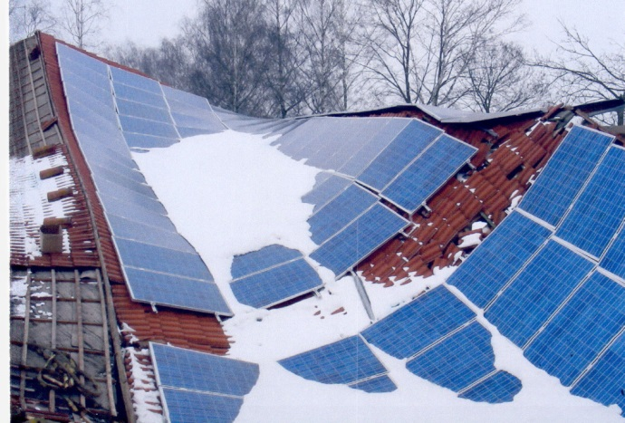

Figure 5 A roof with PV modules collapsed under snow load (source: VdS 3145)

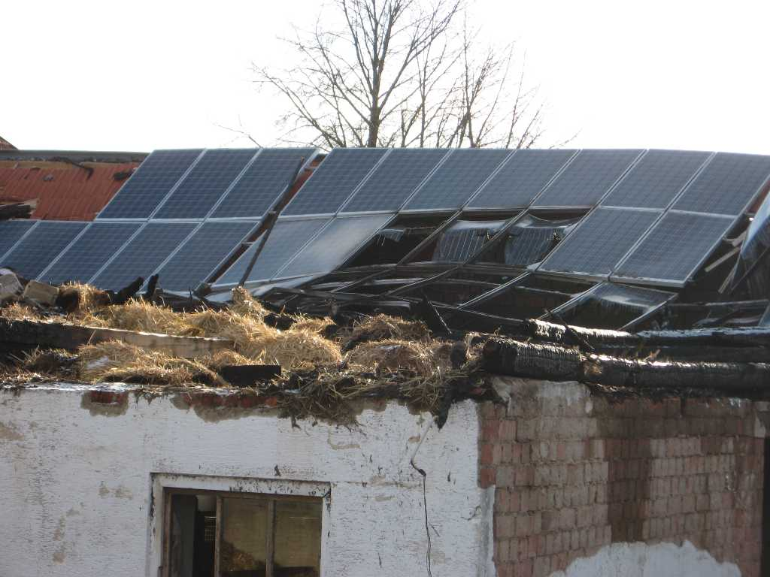

Figure 6 Fire damaged roof with destroyed PV modules (source: VKB)

Figure 7 A roof tile damaged by roof hooks for attachment of PV modules (source: VdS 3145)

In addition, a fire can be caused by inappropriate installation of PV system. The PV module can also damage an adjacent building construction, roof covering and façade.

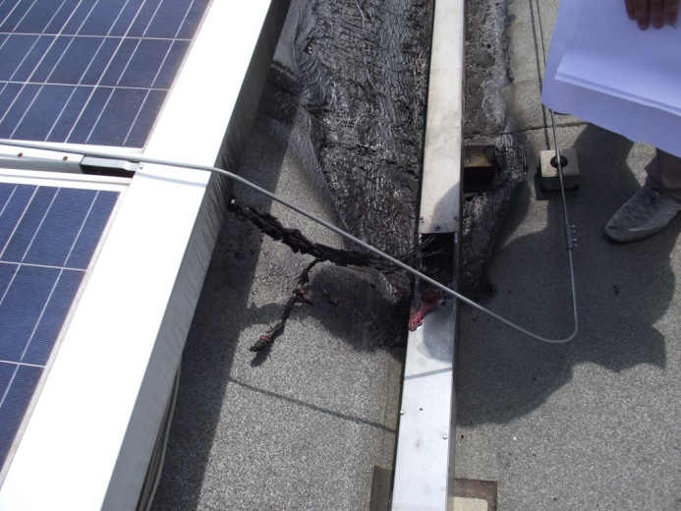

Figure 8 Damage on roof covering caused by fire of PV-installation (source: Guido G. Zaccarelli)

Prevention measures
In the planning, installation and operation of PV systems it is always necessary to take care that the performance of impacted building components, e. g. roofing roof cover or façade, and their use are not affected.

Protective measures that are necessary due to the installation of PV systems, their operation and locally expected external threats (see section 4) should be adapted to the existing protection concept and measures for the building and its use.

All protection measures should conform to generally accepted rules and standards as necessary.

To ensure the optimal planning, installation and operation of PV systems, experience indicates that it is appropriate to consider the protection concepts and measures with all involved parties including the building or facility insurer.
Experience has shown that many fires start in circuit breakers and inverters. To prevent fires, it is important to ensure that circuit breakers (including fireman switches) and inverters are of good quality and protected from the elements as far as possible.

It is important to ensure that the installation should always be assembled in accordance with the manufacturer’s instructions.

Preliminary
For the effective configuration of a PV system following questions should be clarified:
- Location of the site with respect to the
  - optimal capture of sunlight (arrangement of PV modules on the roof or on the facade, parallel or at an angle to the roof or to the façade, avoid of shading) and
  - the loading capacity of the existing structure to bear additional loads,
  - possible spread of fire caused by installation of PV system at roof or on façade,
- which site specific environmental hazards could be expected from the surroundings (e. g. lightning, storm, hail, fire, flood, see section 4);
- what additional loads caused by the installation (e. g. static loads on the roof or façade by the own weight of PV modules, possibly modified arrangement of wind and snow load);
- this comprehensive information underpins all aspects of the installation for planning, installation and maintenance.

Planning and Installation

Stability
When commissioning the planning and installation, the operator should check, whether the planners and contractors have the necessary expertise and experience. Otherwise suitable professionals should be engaged, such as structural engineers, electrical engineers and roofing experts.

All aspects of the planning and installation of PV systems should be fully documented, including any changes or adaptations necessary during installation, in order to ensure safe and trouble-free operation.

For the assessment of the stability and the sizing of relevant construction all expected load cases from its own weight, possible effects from the site specific surroundings and additional loads caused by the installation should be considered.

If the load capacity of the existing structure, such as roof construction, is not sufficient, the effected construction must be suitably upgraded to suit, or the installation must be moved to another more suitable place or structure.

When choosing the appropriate mounting system for installation, the following aspects must be considered:
- Roof shape (flat roof or pitched roof),
- roofing system and materials,
- the load transmission by the installation of the PV modules and other parts of the PV system,
- specific manufacturers requirements for the mounting of PV modules and construction components,
- permissible load of the support frame and fixings according to information provided by the respective manufacturer.

Electrical safety, lightning and surge protection
PV systems and its components, such as modules, cables, inverters including measures for lightning and surge protection and their installation must conform to the generally recognized rules and standards for electrical installations and manufacturer’s instructions. As well as the rules and regulations for the country in which they are being installed. Some of these are listed below:

Some applicable documents:
EN IEC 61215-1-1 Crystalline silicon terrestrial photovoltaic (PV) modules - Design qualification and type approval (IEC 82/684/CD)
EN IEC 61215-1-2 Terrestrial photovoltaic (PV) modules - Design qualification and type approval (IEC 61215-1-2)
EN IEC 62108 Concentrator photovoltaic (CPV) modules and assemblies - Design qualification and type approval (IEC 62108)
EN IEC 61730 Photovoltaic (PV) module safety qualification
- Part 1: Requirements for construction (EN IEC 61730-1)
- Part 2: Requirements for testing (EN IEC 61730-2)
EN 62446-1 Grid connected PV systems - Documentation, commissioning tests and inspection (IEC 62446-1)
EN 50178 Electronic equipment for use in power installations
IEC/TR 61641 Low-voltage switchgear and control gear assemblies
- Part 1: Type-tested and partially type-tested assemblies - Guide for testing under conditions of arcing due to an internal fault
EN IEC 61439 Low-voltage switchgear and control gear assemblies
- Part 1: General rules (EN IEC 61439-1)
- Part 2: Power switchgear and control gear assemblies (EN IEC 61439-2)

PV systems should be protected against lightning, overvoltage and where appropriate, incorporated into the existing lightning protection system. Similarly, the existing lightning protection must not be affected by a PV system. Therefore, the lightning protection system should be suitably interfaced and coordinated with the PV system. It is preferable that the PV modules are located completely within the protection area of the existing lightning protection system. In this case, a sufficient separation distance should be respected.

See additional documents:
EN 62305-3 Protection against lightning
- Part 3: Physical damage to structures and life hazard (IEC 62305-3, modified)
- Supplement 5: Lightning and overvoltage protection for photovoltaic power supply systems
CFPA Europe Guideline No 4 2013 N: Lightning protection

Note: A combination of frequent shading of the panels together with inadequate heat dissipation in the junction box can lead to failure of the module bypass diodes. Failure can also result from lightning overvoltage and reversed polarity of the diodes. As a result care should always be taken to prevent partial shading of the panels.

Fire protection
Components of PV systems often contain flammable materials. In order to effectively limit the spread of fire via components of PV systems, the following measures are required:
- In a PV system, the installation from the solar panels to the inverters will be a DC installation. In such an installation, damage and faults in components can cause the formation of arcs, which can ignite surrounding flammable materials. To minimize the likelihood of ignition, DC installations should only be located outside of buildings.
- The potential damage of a DC arc (both to ignite a fire and to produce electroshocks to a person) is quite bigger than for an AC arc. Therefore, the DC cable route shall be as short as possible and minimize the number of connections.
- The DC installation must be able to be disconnected outside the building, and inverters must be placed outside buildings or in a separate fire compartment on a non-combustible surface.
- In those cases where a BESS is needed (for example, for autonomous installations), it will be located in a separate fire compartment, with direct dedicated access from outdoors. The fire compartment will be provided with good ventilation and temperature control. The length of the cable route between the modules and the BESS will be as short as possible and will run outside.
- Use cables and conduits DC, in accordance with figure 9.

 | Installation location
Type of conduit | On/within flammable parts of a building | In rooms or zones exposed to fire hazards | In horizontal evacuation routes | In vertical evacuation routes | In rooms or zones exposed to explosion Hazards
DC module wiring | without conduit
Main DC conduit, group or string conduit | (1) | (2) | (2) | (3)
Main DC conduit, group or string conduit | Or concentric PE conductor |  |  | (3)

Figure 9 Types of DC Conduits and Installation Locations (source: Fire Protection Guide for "Sensors and Solar Panels" – VKF AEAI, Switzerland - adapted)

Notes to figure 9:
All DC cables should comply with EN 50618: Electric cables for photovoltaic systems. Cable management systems in the DC area should release in case of fire low smoke opacity and low toxicity rating.

Non permitted

(1) Use non-flame propagating cable management systems according to following product standards:
- EN 61386 series for conduits
- EN 61084 series for trunking
- EN 61537 for cable trays and cable ladder
(2) Installations shall be avoided. If it is not possible, they will be installed within a shaft that has the same fire resistance as the fire-resistant compartment corresponding to its designation, but which is, in all cases with at least 30 minutes.
(3) Installation is permitted provided the spaces are separated by a construction element that has the same fire resistance as the fire-resistant compartment corresponding to its designation, but which is, in all cases with at least 30 minutes (e.g., service duct or cable channel).

- Components of PV systems with combustible elements, e. g. cables, are not allowed to be passed over a compartment / fire wall. If this cannot be avoided, they should be installed in fire-resistant cable ducts and shafts.

Figure 10 Conduct of cables in connection with a fire wall (source: VdS 2234)

- Cables must be installed and secured on dedicated conduits that are raised from the roof surface. The conduits will be closed to protect the cables from environmental aggression, birds and rodents. Metal cable management systems are not recommended due to sharp edges and arc fault risk as they are a recognized origin of fire in photovoltaic installations. High heat conduction of metal cable management system can also contribute to the fire spread.
- The use of modules with a good reaction to fire must be considered. There are already specific tests that evaluate reaction to fire of PV modules, such as the UNI9177 or the IEC 61730-2 (UL 790).
- On roofs there should be a minimum distance of 2,5 m between the PV modules on both sides of the compartment / fire walls; a reduced distance is permitted if the potential for a fire to spread across a compartment boundary is considered.

Figure 11 Arrangement of PV modules on the roof and in connection with a fire wall (source: VdS 2234)
- Continuous installation areas and rows of PV modules are to be subdivided by areas of sufficient width in order to provide access for fire-fighting and maintenance of the roof and PV modules.

Figure 12 Required subdivision continuous installation areas and rows of PV modules (source: VdS 2234)

- If smoke and heat exhaust ventilation systems are installed in the roof, the PV modules must be kept a sufficient distance from these. This is to avoid any restriction on equipment operating and ensure the effective discharge of smoke and heat will not be negatively impacted in the event of a fire in the premises (see figure 13).

Figure 13 Example of required distances to openings of smoke and heat vent (source: VdS 3145)

- A sufficient proper distance between PV modules and other openings in the roof, like skylights and penetrations for installations, must also be kept to prevent the fire from spreading into the building.
- For PV systems integrated into building roofs, that have a surface area > 1.200 m² and have a support layer, the latter must be made of incombustible building materials. Large areas of combustible support layer are permitted if the empty space between the solar system and the support layer is divided into fields ≤ 1.200 m² by means of separations at least 0.5 m wide and made of non-combustible building materials.
- PV systems integrated into buildings must be separated from rooms exposed to the fire hazard by a stable support layer that completely covers the surfaces corresponding to these rooms.
- Roof cavities should be sealed to protect them from rodents and other small animals.
- Protect PV installations and their equipment from mechanical damage.
- If PV modules are installed on the façade, they must meet the requirements of the local and appropriate building regulations in terms of limiting the fire spread along the façade. That is to say PV models on the façade have to meet the same requirements as the rest of the façade.

However, as there is no fire monitoring on roofs, there is a serious risk that a fire on the roof will be detected too late if there is no fire detection system installed. Early fire detection could be arranged by for example a thermographic fire detection system or linear heat detectors.

If a risk analysis shows that risk-reducing measures are justified, for example if the roof contains combustible components and the building value is high, an extinguishing system for the solar cell installation can be considered. The protection of the PV system can be an extension of the existing sprinkler system in the building.

Theft protection
PV systems are particularly vulnerable to theft, particularly those on unoccupied or remote buildings, such as agricultural buildings, schools, office buildings, warehouses and where stored system components are outdoors.
PV modules and inverters can be secured mechanically, for example with the use of:
- Metal balls that are hit in Allen screws,
- screws with a two-screw head and the predetermined breaking point
- stick together of screws.

In addition, steps should be taken to minimize the potential for ladders, trash cans, or unguarded interim storage of plant parts in or around the building to be used to prevent any unwanted access to PV panels.

In order to frustrate the sale of stolen PV modules and inverters, they should be provided with non-removable serial numbers. The system owner should keep a list of the serial numbers in the system documentation.

It is also recommended to agree to the anti-theft measures in the planning phase with the insurer.

For PV systems to be installed in open areas further measures might be required, such as:
- To surround with suitable fencing,
- to protect against intrusion with an electronic alarm system with video camera connected to a central monitoring center or permanent transmission to the police (permission required), and/or
- by regular surveillance by a security officer or by employees.

Before start of operation
The PV system once installed is to be approved prior to operation by a competent person. In the course of this approval the following checks shall be performed:
- Complete visual inspection of the system including the mounting of mechanical construction, all electrical connections and cable laying and cable routing.
- Function test, e. g. check the open circuit voltage and polarity before connecting the inverter, and comparing with the device data. Insulation measurement with sufficient test voltage and short circuit current measurement of all strings.
- Check of the complete documentation including the planning, equipment supports, all measurement protocols and necessary information for operation.

In addition, a thermographic camera can be used to identify any flaws in the modules or electrical connections. These checks should be conducted by a certified thermographer. The system documentation should be handed to the operator.

Operation
The operation of the PV system should be undertaken and monitored by a qualified electrician with special training (including "working under voltage") and experience in this field.

A PV system, like any technical equipment, needs to be inspected and maintained at appropriate regular intervals. Competent people should be commissioned to undertake all inspection, maintenance and repair work.

The operator can take the following measures to ensure the system will work safely and satisfactory for many years:
- Regular visual checks,
- event-dependent visual checks (e.g. after a storm),
- regular cleaning, if necessary clearing snow and keeping clean of inverters.

With the regular visual checks, obvious damage, e.g. damage to cable insulation, or damage in distribution and inverter housings, PV systems, etc. can be detected early.

Event-dependent visual checks should be carried out after a storm or thunderstorm. Attention should be paid to whether, for example, items such as tree branches fell on the roof and have caused damage, the supporting systems/framework of the PV systems were damaged by the storm, or any lightning damage is visible.

For inspection of PV systems, thermography is increasingly used as a visual technique for non-contact measurement of temperature on surfaces by imaging, amongst other things for individual components of PV systems, e.g. PV generators, electrical equipment. It is therefore possible during the routine operation of PV systems to examine the temperature distributions of large surfaces and also small individual parts.

To ensure accurate measurements of surface temperatures at a given level of sunlight, the object and material properties of the surfaces to be measured, e.g. emission, reflection and transmission, and the environment must be taken into account. Therefore, thermographers undertaking work on PV systems should be trained separately. See the CFPA-E Guideline No. 3 :F “Certification of Thermographers”.

If damage is found, competent people should be contracted to undertake the repairs. It is also advisable to document damage with pictures and inform the insurer in advance of any repair.

Special information on fire fighting
PV modules continue to generate direct current in daylight as well as when subject to other light sources such as headlights, despite a separation of the system from the grid. Because of this manual fire-fighting may be more difficult.

In the event of a fire in the building, the fire brigade should be able to disconnect the power from the PV modules. A “Fireman’s switch” should be located in a suitable and easily accessible location, in order to allow fire fighters to isolate the power supply from the PV modules. Appropriate signage should be provided to direct fire fighters to the location of the switch. The functionality of this device should be regularly confirmed through testing.

In general, the fire-fighters are trained in fighting fires involving electrical equipment and installations, to which PV systems also belong. Therefore, a fire involving a PV system or of building with PV system can be controlled, when the appropriate construction and technical conditions as well as conditions for effective fire-fighting are met (see also section 5.2).

Any roof with photovoltaic modules should at least be accessible to firefighters from the fire engine ladder (for which they should have sufficient room to maneuver the engine). Additionally, they should also have adequate access to the roof (via exterior and interior ladders, with sufficient clearance at the landings to arrange the means to fight the fire).

Figure 14 Example of labeling for identification (source: VdS 3145)

Buildings with PV systems should be identified by a sign in the house distribution or the house connection (see figure 14).

The signs should be situated at the
- origin of the electrical installation,
- metering position, if remote from the origin,
- consumer unit or distribution board to which the supply from the inverter is connected.

In the fire plans, especially for commercial and industrial buildings, the cable routing of PV systems should be shown which will support the fire and rescue service in their tactical decision making and actions.

Literature
EN ISO 13943 Fire safety – Vocabulary

The Confederation of Fire Protection Association Europe (CFPA-Europe)
CFPA Europe Guideline No 4 2013 N: Lightning protection
https://cfpa-e.eu/category-guidelines/natural-hazards/

Fire Protection Association on behalf of RISC Authority
RC62: Risk Control Recommendations for fire safety with photovoltaic panel installations, 2015

Deutscher Feuerwehrverband
Einsatz an Photovoltaikanlagen; Informationen für Einsatzkräfte von Feuerwehren und technischen Hilfsdiensten

Gesamtverband der Deutschen Versicherungswirtschaft e. V.
- "Brandwände und Komplextrennwände; Merkblatt für die Anordnung und Ausführung (VdS 2234)
- "Photovoltaikanlagen; Technischer Leitfaden" (VdS 3541)
https://shop.vds.de/

Decreto Ministero dell'Interno 30 marzo 2022, "Chiusure d'ambito degli edifici civili"
Circolare Ministero dell'Interno 07 febbraio 2012 n. 1324, "Guida per l'installazione degli impianti fotovoltaici"

Appendix: Checklists for the planning and acceptance of PV systems
With the following sample checklists, initial guidance for the planning and acceptance of PV systems should be provided. The main issues that must be clarified for the planning and inspection are listed; however, the list is not meant to be comprehensive and local conditions and environments should also be considered as necessary.

Customer
Consultant / planner
Location of the proposed installation
(if different from address of customer)
Date and contact of site visit
Preliminary planning
Issues |  |  | Assessment |  |  | Notes
 |  |  | Yes | No | Not  relevant | Notes
Customer requirements - Parameter of system design
- Max. earnings
- Max. ___________ € investment costs
- Max. use of surface area
- Aesthetic point (optics, architecture)
- Other
Location and size of the available area for the installation of PV modules (roof or façade)
- Are all site-related expected impacts were taken into account?
- snow (load zone) and ice
- wind load zone
- Others
- Is the orientation of the adjacent components (roof or façade) suitable?
- Is a sufficient installing area for the required number of modules available?
- Is a possible shading, inter alia through the chimney, antenna, skylights, lightning conductors, dormer or other reason to fear
Conditions of adjacent components (roof or façade) for the installation of PV modules
- Is a permit for the installation required, e.g. for building conservation?
- Of which building material consists the adjacent component and how is its structure?
- Are the building statics and structural analysis of the adjacent component present?
- Is an upgrade of the existing structure for the installation of PV modules required?
- Are all site-and building-related conditions taken into account in the choice of mounting system?
Others?
- Is there a proper grounding?
- Does a lightning protection system exist?
- Can the PV systems be protected with the existing lightning protection system, or additional measures are needed?
- Is the surge protector into account?
- Is the mains supply point already set?
- Is a meter available?
Acceptance of systems
Issues |  |  | Assessment |  |  | Notes
 |  |  | Yes | No | Not  relevant | Notes
Technical system data
- Is a commissioning report or completion report from the network operator filled available?
Generator rated power: __________ kWp
Modules (manufacturer, type, serial and identification number):
See Appendix
Inverter (manufacturer, type, number, inverter rated output AC):
See Appendix
The number of strings per inverter, number of modules per string:
See Appendix
Potential equalization / ground (design, installation, Remarks):
See Appendix
- External lightning protection available?
String fuses, string diodes (if available) (each: manufacturer, type, voltage / current):

Surge DC side and AC side (if available, each manufacturer, type, nominal):

Module connection cable, DC main line (each: manufacturer, type, cross-section):

DC circuit breaker (manufacturer, type, voltage / current):

AC-sided residual current device (RCD switch) (if available) (manufacturer, type):

AC-side backup (manufacturer, type, voltage / current):

- Are functional, earnings, monitoring (remote) data available (Manufacturer, type, measurement and evaluation of sizes)?
Responsible person / company that is involved in the function, earnings, data (remote) monitoring:

- Is the grounding resistance of the earth electrode in order? |  |  |  |  |  | See Appendix
- Is the Insulation resistance of the PV system in order? |  |  |  |  |  | See Appendix
- Is the Insulation resistance of the DC main line in order? |  |  |  |  |  | See Appendix
Other remarks:

Acceptance of systems
Issues |  |  | Assessment |  |  | Notes
 |  |  | Yes | No | Not  relevant | Notes
Visual inspections, match with the planning
- There is no visible damage an installed system, buildings and adjacent components, etc.
- Are the mounting system, roof penetrations and seals in order?
- Is the cabling / wiring in order
- Are the inverter and their respective function in order?
- Is the Functional testing of protective devices in order?
- Is the supply control objected in the counter in order?
- Are the function, earnings, data (remote) monitoring in order
- Does the installation correspond to the extent of planning and offer
Other remarks:

Plausibility check:
- Does the installed system fully work?
- Irradiation __________ W/m2 (+ / - 200 W / m²)
- Outside temperature __________ ° C (+ / - 5 degrees C)
- System output DC __________ W (+ / - 10%, for example display of inverter )
- System performance AC __________ W (+ / - 10%, for example display of inverter)
Other remarks:

Measurement reading
Customer-specific counter or counter of the network operator
Counter number: __________ count reading: __________ kWh
Counter number of PV reference counter: __________ count: __________ kWh
Inverter, type, number | Open circuit voltage U_{L} in V  Generator / String line 1/2/3 ... |  |  |  | Short-circuit current I_{K} in A  String line 1 / 2 / 3 ...
For extended, clearer and full representation __________ additional pages have been attached See Appendix.
For systems with reverse current diodes the voltage drop in each string (in short circuit) is to specify via the diode.
In systems with string fuses the voltage drop in each string is to specify via fuse including contacts (in short circuit).
Acceptance of systems
Issues |  |  | Assessment |  |  | Notes
 |  |  | Yes | No | Not  relevant | Notes
Other remarks:

Defects, rework and other remarks
Shortcomings and possible improvements are marked and listed below as such and provided with execution deadlines
Documentation
- The system documentation is completely available?
The system documentation shall include in particular the following
- Declarations of conformity
- Certificates and warranty certificates
- Technical documentation and data sheets of the essential system components
- Serial numbers of the installed modules with assignment to the interconnection
- Wiring plan with module wiring and inverter assignment
- Measurement protocols (if any)
- Commissioning protocol of the network operator
- Operating instructions especially for inverter and for the function, earnings, data (remote) monitoring (if available)
- Installation instructions of the essential components
- Service or emergency phone numbers
- Conformation of instructions to customers
- Form for independent detection of the yield data by the system operator (e. g, a monthly meter reading).
The documents should be dated and stamped or initialled.
Other remarks:

Instructions to customers
- Has the instruction to the customer been done?
Other remarks:

Signatures
With the signing of this protocol the PV system is, apart from the listed shortcomings, improvements and other remarks accepted without further defects.
Place, Data | Signature Customer |  |  |  | Signature Company / Contact
Appendix

European guidelines
Fire (https://cfpa-e.eu/category-guidelines/fire-prevention-and-protection/)
Guideline No 1 F - Internal fire protection control
Guideline No 2 F - Panic & emergency exit devices
Guideline No 3 F - Certification of thermographers
Guideline No 4 F - Introduction to qualitative fire risk assessment
Guideline No 5 F - Guidance signs, emergency lighting and general lighting
Guideline No 6 F - Fire safety in care homes
Guideline No 7 F - Safety distance between waste containers and buildings
Guideline No 8 F - withdrawn
Guideline No 9 F - Fire safety in restaurants
Guideline No 10 F - Smoke alarms in the home
Guideline No 11 F - Recommended numbers of fire protection trained staff
Guideline No 12 F - Fire safety basics for hot work operatives
Guideline No 13 F - Fire protection documentation
Guideline No 14 F - Fire protection in information technology facilities
Guideline No 15 F - Fire safety in guest harbours and marinas
Guideline No 16 F - Fire protection in offices
Guideline No 17 F - Fire safety in farm buildings
Guideline No 18 F - Fire protection on chemical manufacturing sites
Guideline No 19 F - Fire safety engineering concerning evacuation from buildings
Guideline No 20 F - Fire safety in camping sites
Guideline No 21 F - Fire prevention on construction sites
Guideline No 22 F - Wind turbines – Fire protection guideline
Guideline No 23 F - Securing the operational readiness of fire control system
Guideline No 24 F - Fire safe homes
Guideline No 25 F - Emergency plan
Guideline No 26 F - withdrawn
Guideline No 27 F - Fire safety in apartment buildings
Guideline No 28 F - Fire safety in laboratories
Guideline No 29 F - Protection of paintings: transports, exhibition and storage
Guideline No 30 F - Managing fire safety in historic buildings
Guideline No 31 F - Protection against self-ignition end explosions in handling and storage
of silage and fodder in farms
Guideline No 32 F - Treatment and storage of waste and combustible secondary raw
materials
Guideline No 33 F - Evacuation of people with disabilities
Guideline No 34 F - Fire safety measures with emergency power supply
Guideline No 35 F - Fire safety in warehouses
Guideline No 36 F - Fire prevention in large tents
Guideline No 37 F - Photovoltaic systems: recommendations on loss prevention
Guideline No 38 F - Fire safety recommendations for short-term rental accommodations
Guideline No 37 F - Fire protection in schools
Guideline No 38 F - Fire safety recommendations for short-term rental accommodations
Guideline No 39 F - Fire protection in schools
Guideline No 40 F - Procedure to certify CFPA-E Fire Safety Specialists in Building Design
Guideline No 41 F - Safety instructions for the use and charging of small and medium size lithium
ion powered devices
Guideline No 42 F - Guidance document for Selection of Fire Protection Systems
Guideline No 43 F - Foam Concentrates - The selection criteria
Natural hazards https://cfpa-e.eu/category-guidelines/natural-hazards/)
Guideline No 1 N - Protection against flood
Guideline No 2 N - Business resilience – An introduction to protecting your business
Guideline No 3 N - Protection of buildings against wind damage
Guideline No 4 N - Lighting protection
Guideline No 5 N - Managing heavy snow loads on roofs
Guideline No 6 N - Forest fires
Guideline No 7 N - Demountable / Mobile flood protection systems
Guideline No 8 N - Ensuring supplies of firefighting water in extreme weather conditions
Guideline No 9 N - Protection against hail damage
Guideline No 10 N - Heavy rain and flash flood; Recommendations on flood prevention and protection

Security (https://cfpa-e.eu/category-guidelines/security/)
Guideline No 1 S - Arson document
Guideline No 2 S - Protection of empty buildings
Guideline No 3 S - Security systems for empty buildings
Guideline No 4 S - Guidance on keyholder selections and duties
Guideline No 5 S - Security guidelines for museums and showrooms
Guideline No 6 S - Security guidelines emergency exit doors in non-residential premises
Guideline No 7 S - Developing evacuation and salvage plans for works of art and
heritage buildings
Guideline No 8 S - Security in schools
Guideline No 9 S - Recommendation for the control of metal theft
Guideline No 10 S - Protection of business intelligence
Guideline No 11 S - Cyber security for small and medium-sized enterprises
Guideline No 12 S - Security Guidelines for Businesses
Guideline No 13 S - Cybersecurity Basic level – Basic IT security

Comments and corrective actions:

www.cfpa-e.eu

