Fire safety in farm buildings

CFPA-E Guideline No 17:2025 F

Please insert former image again




The CFPA Europe develops and publishes common guidelines about fire safety, security, and natural hazards with the aim to achieve similar interpretation and to give examples of acceptable solutions, concepts, and models. The aim is to facilitate and support fire protection, security, and protection against natural hazards across Europe, and the whole world.

Today fire safety, security and protection against natural hazards form an integral part of a modern strategy for survival, sustainability, and competitiveness. Therefore, the market imposes new demands for quality.

These Guidelines are intended for all interested parties and the public. Interested parties includes plant owners, insurers, rescue services, consultants, safety companies and the like so that, in the course of their work, they may be able to help manage risk in society.

The Guidelines reflect best practice developed by the national members of CFPA Europe. Where these Guidelines and national requirements conflict, national requirements shall apply.

This Guideline has been compiled by the Fire Safety Commission and is adopted by the members of CFPA Europe.

More information: www.cfpa-e.eu


Wallisellen, September 2025 Cologne, September 2025
CFPA Europe Fire Safety Commission

Elisabetta Carrea Hardy Rusch
Chairman Chairman



Contents

1 Introduction 4
2 Systematic fire protection work 4
2.1 Action plan 5
3 Specific aspects of agricultural buildings 5
4 Electrical installations 6
5 Structural fire protection – compartmentation 6
5.1 Safety zone 9
5.2 Fire ventilation 9
6 Evacuation 10
6.1 Evacuation of people 10
6.2 Evacuation of livestock 10
6.3 Evacuation assembly point 11
6.4 Evacuation routines 11
7 Firefighting equipment 12
8 Water supply for fire fighting 13
9 Fire alarm installations 13
10 Lightning protection 14
11 Fire Prevention and Organizational Fire Protection 14
12 Training 15
European guidelines 16

Introduction
Owing to rationalisation in agriculture, with production buildings and installations of increasing size, there has been an increase in fire risks, and today it is often assets of high value that are at stake.

Fires in the production buildings of agriculture are extensive. Mechanisation that has greatly increased over a few decades, often without any safeguards, combined with extensive electrical and electronic installations, has had a negative effect on fire losses and fire risks.

Assets of high value are lost in connection with fires of increasing size, and one additional serious consequence is that far too many animals die in fires.

In some European countries, for example in the Nordic countries where the climate and fire protection rules impose stringent demands on buildings and installations, fire losses in agriculture make up about 10% of the total fire loss in society and of the costs associated with fire loss.

In many countries, because of the modern rescue services legislation, the responsibility for good fire protection rests on the individual farmer. It is therefore essential that the farmer should become increasingly aware of the importance of fire protection, and that fire protection advice and training should result in good fire safety, with a satisfactory level of protection suited to the circumstances and conditions of the farm.

The endeavour should therefore be good cooperation between agricultural organisations, rescue services and insurance companies, as well as others who are locally engaged in fire protection.

Research and experience – not least full-scale tests – have shown that agricultural fires can be appreciably limited, often by relatively simple measures and means that have a good effect. Good fire protection need not be expensive if it is planned at an early stage.

This guideline – which has been drawn up with the objective of saving livestock and assets in agriculture – highlights a few important action areas and appropriate measures that are of general application and should be aimed for. This Guideline does not cover self-ignition.

Individual countries might have more stringent requirements for fire safety than what is recommended in this guideline.

This guideline is primarily intended for the public. It is also aimed at the rescue services, consultants, safety companies and the like so that, in the course of their work, they may be able to help increase fire protection in society.

Systematic fire protection work
It is the responsibility of the owners of buildings and businesses to ensure that systematic fire protection work is undertaken. This also applies to farmers. Many farms also need to document their systematic fire protection work. The farmer himself/herself must be able to carry out this documentation. An action plan must be drawn up to help the rescue service take the correct priorities in the event of fire and to facilitate firefighting. See also Guideline No 1 – Internal fire protection control.

The objective of systematic fire protection work is to
- serve as part of the operational plan of the rescue service,
- prevent fire,
- detect faults or shortcomings in the fire protection at an early stage,
- make it easier for the correct action to be taken in the event of fire.

Action plan
The action plan must be available on the farm and must be handed to the rescue service when it arrives in the event of fire.

Examples of what information an action plan may contain are as follows:
- Drawings and sketches of buildings on the farm, including any compartmentation
- Where the livestock is kept and how evacuation is to be carried out
- What is most important to protect in a fire
- Where the main isolating switch is located
- Where gas or acetylene cylinders or ammonium nitrate (fertiliser) are kept
- Where water is available and the water capacity – fire pond, river or lake

Specific aspects of agricultural buildings
Agricultural buildings are often close together or made of unprotected timber constructions or other easily ignited material, and they often contain flammable equipment. Dry fodder, livestock bedding, grain or other materials with a high fire load density, which may give rise to very rapid fire spread or flashover, are often stored. They are also often exempted from various requirements in building legislation.

Agricultural buildings are also often situated at a great distance from the rescue service, which makes effective rescue action difficult. Owing to the long attendance time, it is necessary for the farmer to plan and carry out his/her own firefighting action in order to avoid devastation.

It is therefore essential to reduce the extent of loss by good structural fire protection – appropriate safety zones between buildings – correct and sufficient firefighting equipment – appropriate automatic fire protection systems and measures, that facilitate satisfactory evacuation of livestock. It is also important continually to keep an eye on various kinds of objects that may start a fire, and to make these safe, in order to prevent the outbreak of fire. Fire resistant structures in agriculture should withstand fire and smoke for 60 minutes. This requirement may vary owing to differences in national regulations.

In most cases, fire starts in premises adjoining livestock housing, such as fodder stores, barns, haylofts, grain dryers, boiler rooms, machine rooms and farm workshops. It is therefore very important to prevent the spread of fire and also smoke to livestock housing, since it is fire gases that in most cases kill the animals and also make their evacuation difficult.

The most common causes of fire are related to faults in electrical systems, voltage surges due to lightning, mechanical equipment and various forms of heating and drying installations, as well as hot work that poses a fire hazard. Children playing with fire and arson also cause fires on farms.

Electrical installations
Electrical installations and electrical equipment in agriculture are subject to tough working conditions, since the environment is often harsh with e.g. large mechanical stresses, wide temperature variations, moisture and corrosive gases. Regarding various forms of electrical protection, reference should be made to the special regulations and conditions in the country concerned; these may vary considerably from country to country. Such protection may comprise different kinds of protection against overvoltage caused by lightning, earthing, earth leakage circuit breakers, enclosure classes and electronic protection, etc.. Maintenance of all electrical installations in farms should be carried out by a qualified electrician. In some countries, special electrical handbooks have been issued for agriculture.

The fire risk associated with new technology such as battery storage room and solar panels should also evaluated before installation.

Figure 1: Working conditions

Electrical installations and the electrical equipment on farms are often subject to tough working conditions. Many mistakes can be avoided if the electrical contractor consults the farmer as soon as planning begins.

Structural fire protection – compartmentation
A building must be constructed so that the outbreak of fire is prevented, the spread of fire and smoke inside the building is limited, and people and livestock can be evacuated or rescued.

If an evacuation of the animals in case of fire is hardly possible, for example, in the livestock of small animals, it must be ensured, in coordination with the authorities that large-scale fire spread and thus a threat of a large number of animals are prevented, e. g. with structural dividing and separating of livestock.
In order to prevent the spread of fire and smoke between rooms and areas in a building, structural fire protection measures are taken by dividing the building into fire compartments. Activities that present a fire hazard are separated by walls and floors of the appropriate fire resistance.

Compartmentation of buildings on farms which will prevent the spread of fire for 60 minutes may be carried out in many ways. The elements of structure separating compartments may consist of mineral wool insulation and building board on timber framing, or may be solid timber structures, or made of e.g. block work or concrete.
Figure 2: Compartmentation

Buildings are divided into fire compartments, e.g. livestock housing, plant room, workshop, boiler room, garage and store building.

Most fires begin in rooms outside livestock housing. It is therefore important that rooms and spaces where there is a risk of fire should be separated from livestock housing and from other buildings and premises by fire resistant construction.
- Walls and floors in livestock housing which have a fire separating function should withstand fire and smoke for 60 minutes. This requirement may vary owing to differences in national regulations.
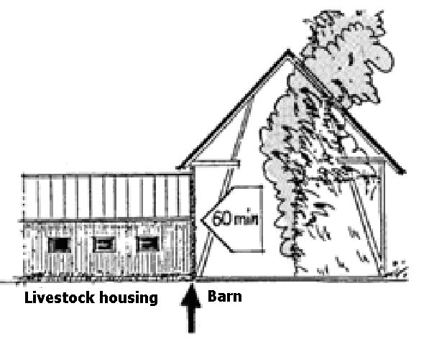
Figure 3: Livestock housing must be protected from fire for 60 minutes
- The residential area (the dwelling) must be separated from the agricultural operation by a fire-resistant compartment; in agricultural buildings with a total volume greater than 3,000 m³, a firewall separating residential area from the agricultural part, should withstand fire and smoke for 90 minutes.
- Walls and floors of fire-resistant construction that separate garages, workshops, boiler rooms, or similar premises where work that presents a fire hazard is carried out, should prevent the spread of fire from the inside for 60 minutes. This requirement may vary owing to differences in national regulations.
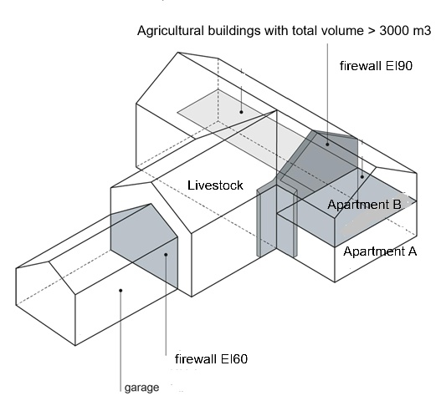
Figure 4: Separations

- Ventilation ducts, doors, feeders, service openings etc. between rooms presenting a fire hazard and livestock housing should resist fire and smoke for the same period as the walls and floors through which they pass.
- Inlet air for ventilation in livestock housing must not be supplied from rooms presenting a fire hazard or from a space outside the fire compartment containing the livestock housing.
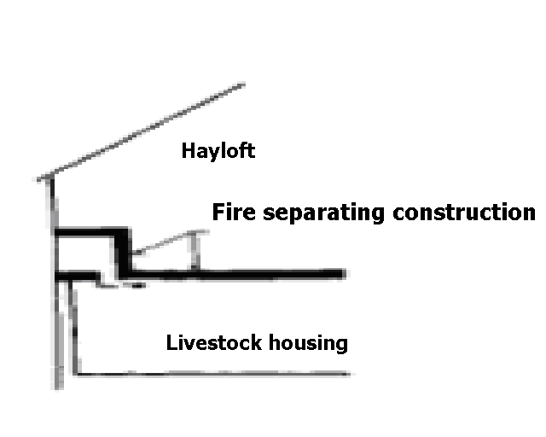
Figure 5: Separations

- Openings for services, e.g. air intakes from a hayloft, must withstand fire and smoke for 60 minutes.

Safety zone
The spread of fire between buildings can be prevented by safety zones or by a combination of a safety zone and walls constructed to fire protection standard. To avoid the spread of fire between two or more buildings the roofs of the buildings should be constructed with non-combustible materials.

Farm buildings closer than 15 m from one another must be designed so that the spread of fire between the buildings is prevented for 60 minutes. Combustible materials should be stored at a distance of at least 15 m from buildings.

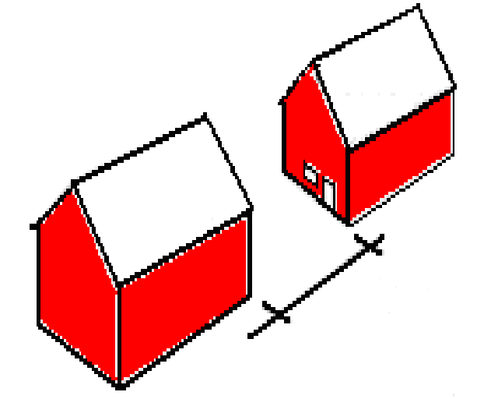
Figure 6: Compartmentation may be replaced by a safety zone

Fire ventilation
During a fire, pressure increases, and temperature rapidly rises, and this increases the risk of the spread of fire and smoke. These risks can be limited by fitting fire vents on the roofs of barns and haylofts. In roofs of aluminium, fibre cement sheeting or plastics of low melting point, openings will form at an early stage and the products of combustion can be vented away. Fire vents should be sited as near ridges as possible.

Fire ventilation prevents the pressure rise caused by a fire and hinders the spread of fire

Figure 7: Fire ventilation

Evacuation
Animals can be saved through well planned evacuation measures and other fire protection solutions that prevent the spread of fire. With increasing numbers of livestock, the possibility of evacuation in a short time reduces. Therefore, it is important to have good fire protection solutions that allow the animals to remain in the stables when there is a fire in adjacent areas.

Escape routes shall be designed so that the animals can be quickly brought to safety. Animals should be in a safe and secure area within 60 minutes from the time the fire started.

Animals rarely burn to death, but they die of smoke inhalation. It is therefore important that the fire area is as small as possible and the overpressure in the fire area can be diverted in a safe way.

Evacuation of people
All premises should have at least two independent means of escape. The longest evacuation distance must not exceed 30 meters. If the premises have more than one floor, the requirement applies to each floor. One of the escape routes for people may be a window or hatch provided that occupants can escape in a satisfactory manner. The requirement for escape routes needs special attention in rooms for overnight use and in drying plants or barns for straw storage.
Small rooms on the ground floor only need one escape route provided that the room is not intended for animals and that evacuation can be made directly to the outdoors.

Evacuation of livestock
Doors for evacuation of animals should preferably be situated in opposite sides of the building. The aim should be to have straight evacuation paths. Fertilizer sites, containers, silos or similar should not be placed closer to a farm building than 3 m if the space next to the building is intended for evacuation.

Steps indoors should be avoided. From an evacuation standpoint, it is better to even out the differences in height indoors with inclined floors than with steps. However, one should consider the risk of slipping.

Exits, especially those in which animals normally use, should be as far as possible from potential
fire risks such as feed rooms, combustible buildings and combustible stockpiles. Evacuation through another premises may be accepted if the other escape route has an opening directly to the outdoors.

The walking distance to emergency exit shall not exceed 30 m
Figure 8: Walking distance, very long buildings
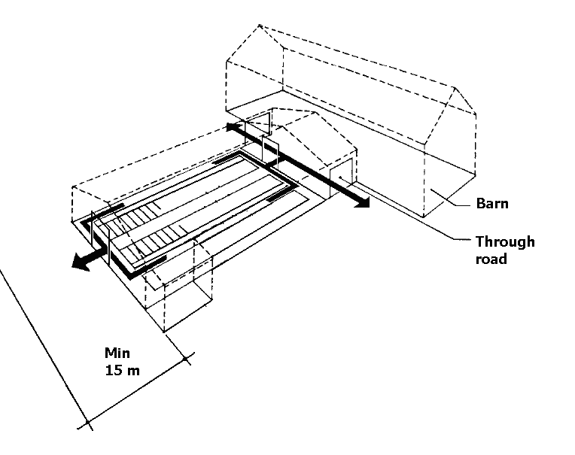
Figure 9: Examples of escape routes

Escape routes, number of doors and door sizes shall be designed so that the animals can be evacuated within 60 minutes from the fire starts. Doors in escape routes should be opened outwards or be sliding sideways. In order to allow the passage of two animals at the same time requires a free space of 1.6 m for cows and horses, and 1.0 m for pigs and sheep.

Emergency exits must not be blocked and should during winter be kept free of snow.
Equipment should be placed so that evacuation paths are created to the emergency exits.

Below are some suggestions of how to facilitate evacuation in farm buildings.
- For cattle and larger juveniles ropes or chains can be used to direct the animals.
- For smaller animals gates or shutters are generally required. The gates should be designed so that livestock don´t stick legs between splints and similar
- Permanent gates or shutters can be used where aisles cross each other and at exit doors.
- Crossings between aisles should be avoided.
- Detachable front gates on boxes and cages can facilitate an evacuation.
- Gates in the interior should be able to open to facilitate evacuation in both directions.
- Gates that can be easily lifted or removed may be an option.

Evacuation assembly point
After the evacuation the animals must be kept separate from the fire site. A simple way is an enclosure where the animals can run. Using ropes a path can be arranged between the door and the fence.

Evacuation routines
To ensure any necessary evacuation in case of fire it must be clarified in advance, which and how much animals should be evacuated. For example, large animals, such as horses, cattle and pigs can be evacuated according to experience, when trained personnel in sufficient numbers are available in case of fire. Small animals, such as chickens can hardly be evacuated because they tend to run to the fire.

During the evacuation especially personnel must make sure that the outgoing animals do not run free and pose a threat to other people.
From a rescue standpoint it is best if the animals are accustomed to the evacuation routines. The decoupling of bound animals can be done centrally or in groups. A knife should be available for cutting straps.

Firefighting equipment
On-site firefighting equipment in suitable places in farm buildings and on some machinery is essential for controlling a fire and saving both livestock and economic assets. On a farm this is particularly important because of the long distance for the rescue service to travel.

Experience shows that many major fires are prevented each year through rapid deployment of the farm’s own firefighting equipment.

The fundamental principle concerning firefighting equipment on a farm is that the farm’s own equipment should be readily available in or near premises that present a fire hazard, flammable equipment, and in conjunction with the handling of flammable materials.

In a livestock building or other premises or equipment that presents a fire hazard, firefighting equipment must be available.

The two most appropriate types of firefighting equipment on a farm are a hose on a central hose reel installed in frost-free livestock buildings and premises, and dry powder extinguishers for other premises and equipment.

The reason that powder is recommended in portable fire extinguishers is that this extinguishing medium is suitable for most materials to be found on a farm, such as hay, straw, cardboard, cloth, plastics, electrical equipment, motors, and for flammable liquids such as petrol, oil and fats.

One good rule is that the distance to firefighting equipment in a building where activity that presents a fire hazard is carried out should not exceed 15 m.

A hose on a central hose reel is most suitable in frost-free livestock buildings and for buildings where fodder is prepared, barns and haylofts etc. which can be easily reached from a hose reel located in the livestock building. The hose must be so long that it can reach every possible seat of fire. In large livestock buildings it may be necessary to have several hose reels.

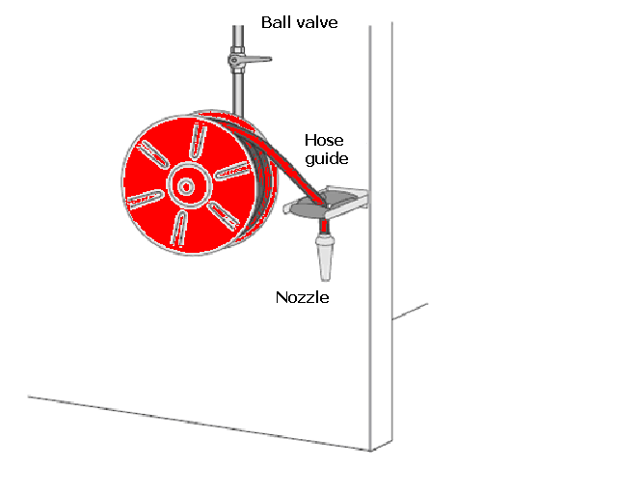
Figure 10: Hose
A hose on a central hose reel in livestock buildings and frost-free premises should be located near doors opening into fodder preparation rooms etc.

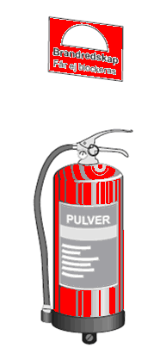
Figure 11: Portable firefighting equipment

For portable firefighting equipment, it is recommended that a powder extinguisher of class 34A 233 BC or higher should be selected

Powder extinguishers are recommended in other premises and for equipment or activity that presents a fire hazard, such as hot work, and for self-propelled machinery. They should be of class 34A 233B C or higher, should contain not less than 6 kg extinguishing agent, and be certified and subject to regular maintenance

To ensure that firefighting equipment has the necessary reliability and effectiveness, the equipment must be maintained according to the national rules and the manufacturer’s instructions.

Water supply for fire fighting
The rescue service and the farmer must be aware of the problems in supplying water for fire fighting since fire on farms normally need a lot of water. It is best to consult the authorities on this subject. Examples of sources of water that may be used are fire ponds, lakes or nearby rivers. The action plan must contain a description of these.

Fire alarm installations
Most buildings on a farm have a high fire load density. Because of this, a fire often develops very rapidly. The time available for fighting the fire, saving livestock and preventing the spread of fire to other buildings is therefore relatively short.

In order that a fire may be detected at an early stage, it may be best to equip rooms in farm buildings with automatic fire alarms which give an alarm rapidly, in the first place to people on the farm itself.

Fire alarms intended for dwellings do not, without special measures, stand up to the aggressive environment in the production buildings on the farm. Therefore, special alarm installations have been developed (in the northern countries) which are designed for the needs and conditions of agriculture.

In some large livestock buildings and in places where there are special requirements or assets of high value, conditions may be imposed regarding alarm installations.

Figure 12: Alarm installation

An alarm installation makes it possible for a fire to be detected rapidly and promotes effective firefighting action at an early stage.

Lightning protection

Large agricultural buildings (over 3,000 m³), including silos and nearby or adjoining residential buildings, require lightning protection.

Fire Prevention and Organizational Fire Protection
The temperature of stored materials such as hay and second-cut hay must be monitored regularly using a probe for at least six weeks after storage.

If their temperature reaches 55 °C, additional measures must be taken, such as extracting gases produced by fermentation, drilling ventilation holes, or creating trenches.

If the temperature exceeds 70 °C, the fire department must be alerted immediately due to the risk of spontaneous combustion.

Straw may only be chopped outdoors at a safe distance from buildings and other structures.

In farm buildings, agricultural vehicles may be parked, provided they are kept outside areas where there is a fire risk.

Training
In many countries, because of the modern rescue services legislation, the responsibility for good fire protection rests on the individual farmer. It is therefore essential that the farmer should become increasingly aware of the importance of fire protection, and that fire protection advice and training should result in good fire safety, with a satisfactory level of protection suited to the circumstances and conditions of the farm. The farmer and his employees must have regular exercises in fire protection and how to act in case of fire.

European guidelines
Fire (https://cfpa-e.eu/category-guidelines/fire-prevention-and-protection/)
Guideline No 1 F - Internal fire protection control
Guideline No 2 F - Panic & emergency exit devices
Guideline No 3 F - Certification of thermographers
Guideline No 4 F - Introduction to qualitative fire risk assessment
Guideline No 5 F - Guidance signs, emergency lighting and general lighting
Guideline No 6 F - Fire safety in care homes
Guideline No 7 F - Safety distance between waste containers and buildings
Guideline No 8 F - withdrawn
Guideline No 9 F - Fire safety in restaurants
Guideline No 10 F - Smoke alarms in the home
Guideline No 11 F - Recommended numbers of fire protection trained staff
Guideline No 12 F - Fire safety basics for hot work operatives
Guideline No 13 F - Fire protection documentation
Guideline No 14 F - Fire protection in information technology facilities
Guideline No 15 F - Fire safety in guest harbours and marinas
Guideline No 16 F - Fire protection in offices
Guideline No 17 F - Fire safety in farm buildings
Guideline No 18 F - Fire protection on chemical manufacturing sites
Guideline No 19 F - Fire safety engineering concerning evacuation from buildings
Guideline No 20 F - Fire safety in camping sites
Guideline No 21 F - Fire prevention on construction sites
Guideline No 22 F - Wind turbines – Fire protection guideline
Guideline No 23 F - Securing the operational readiness of fire control system
Guideline No 24 F - Fire safe homes
Guideline No 25 F - Emergency plan
Guideline No 26 F - withdrawn
Guideline No 27 F - Fire safety in apartment buildings
Guideline No 28 F - Fire safety in laboratories
Guideline No 29 F - Protection of paintings: transports, exhibition and storage
Guideline No 30 F - Managing fire safety in historic buildings
Guideline No 31 F - Protection against self-ignition end explosions in handling and storage
of silage and fodder in farms
Guideline No 32 F - Treatment and storage of waste and combustible secondary raw
materials
Guideline No 33 F - Evacuation of people with disabilities
Guideline No 34 F - Fire safety measures with emergency power supply
Guideline No 35 F - Fire safety in warehouses
Guideline No 36 F - Fire prevention in large tents
Guideline No 37 F - Photovoltaic systems: recommendations on loss prevention
Guideline No 38 F - Fire safety recommendations for short-term rental accommodations
Guideline No 37 F - Fire protection in schools
Guideline No 38 F - Fire safety recommendations for short-term rental accommodations
Guideline No 39 F - Fire protection in schools
Guideline No 40 F - Procedure to certify CFPA-E Fire Safety Specialists in Building Design
Guideline No 41 F - Safety instructions for the use and charging of small and medium size lithium
ion powered devices
Guideline No 42 F – Guidance document for Selection of Fire Protection Systems
Guideline No 43 F – Foam concentrates – The Selection Criteria
Guideline No 44 F – Fire safety recommendations for Electric Vehicles

Natural hazards (https://cfpa-e.eu/category-guidelines/natural-hazards/)
Guideline No 1 N - Protection against flood
Guideline No 2 N - Business resilience – An introduction to protecting your business
Guideline No 3 N - Protection of buildings against wind damage
Guideline No 4 N - Lighting protection
Guideline No 5 N - Managing heavy snow loads on roofs
Guideline No 6 N - Forest fires
Guideline No 7 N - Demountable / Mobile flood protection systems
Guideline No 8 N - Ensuring supplies of firefighting water in extreme weather conditions
Guideline No 9 N - Protection against hail damage
Guideline No 10 N - Heavy rain and flash floods: Recommendations on flood prevention and protection

Security (https://cfpa-e.eu/category-guidelines/security/)
Guideline No 1 S - Arson document
Guideline No 2 S - Protection of empty buildings
Guideline No 3 S - Security systems for empty buildings
Guideline No 4 S - Guidance on keyholder selections and duties
Guideline No 5 S - Security guidelines for museums and showrooms
Guideline No 6 S - Security guidelines emergency exit doors in non-residential premises
Guideline No 7 S - Developing evacuation and salvage plans for works of art and
heritage buildings
Guideline No 8 S - Security in schools
Guideline No 9 S - Recommendation for the control of metal theft
Guideline No 10 S - Protection of business intelligence
Guideline No 11 S - Cyber security for small and medium-sized enterprises
Guideline No 12 S - Security Guidelines for Businesses
Guideline No 13 S – Cybersecurity basic level – Basic IT security

www.cfpa-e.eu

