CFPA-E No 5:2014 N

Managing heavy snow loads on roofs

FOREWORD

The European fire protection associations have decides produce common guidelines in order to achieve similar interpretation in European countries and to give examples how damage from natural hazards can be effectively limited by preventive and defensive measures, normally learnt from experience. CFPA Europe also develops and ratifies guidelines for all aspects of fire prevention, and safety and security related problems.
The objectives of CFPA are to improve safety and security and to prevent the consequent loss of life and destruction of property and business. The market imposes new demands for quality and safety.
The measures of Natural Hazards Guidelines concern not only operators, businesses, specialists and plant officers, but also to population and local administration. This is due to the fact that in contrast to fire, the impact of natural hazards is often very widespread.
The proposal within this guideline has been produced by the members of the Natural Hazards Group.
The Guideline has been compiled by Natural Hazards Group in the Guidelines Commission and adopted by all fire protection associations in the Confederation of Fire Protection Associations Europe.
The guidelines reflect best practice developed by the countries of CFPA Europe. Where the guidelines and national requirement conflict, national requirements must apply.

Copenhagen, March 2014 Helsinki, March 2014
CFPA Europe Guidelines Commission

Jesper Ditlev Matti Orrainen
Chairman Chairman

Contents

- Introduction 4
- Scope 4
- Preparing for the winter 5
- Safe removal of snow 6
- Develop plans 7
- Protection during the winter season 7
- After the snowstorm 9
- Insurance 9
- CFPA E Guidelines 10

Keywords: Snow, snow load, roof, roof collapse, protection measures

Introduction

In some parts of Europe roofs collapse every year because of heavy snowfalls, and heavy snow load. Besides that problem a lot of snow can also produce ice dams on the roof, which can cause a different kind of damage. The problems with snow and ice might increase because of changes in the climate, and in some parts of Europe the weight of snow on roofs is one of the leading causes of quality degradation and roof collapse. So it is important to take steps to protect buildings from the risk of snow. The likelihood of heavy snow is increasing if heavy snow and snow storms are followed by frequent periods of melting giving wet snow. Removal of such wet snow should be the highest priority. Buildings need to be constructed in accordance with the building regulation in each country, but even if that is done the snow load can be too big. Flat roofs and also complex roof geometry give an extra risk that the snow and ice will exceed the loadbearing capacity. Many roofs carry a montage of sun panels, etc. on the roof, something that has been put there long after the construction of the building. The montage gives always a lower possibility for snow load.

Scope

This publication on protection against heavy snow is the one of a series of guideline published by CFPA Europe which address various types of natural hazards. These recommendations are applicable to all types of buildings that are built in those areas where snow falls. The building owner and operators, manufacturers, planners, professional staff for construction work and facility management services all need to be supported in their actions. The Guideline gives recommendations on how to prepare before the winter season, how to remove the snow, and protection work for the snow season. Roof construction design is not the topic of this Guideline, since these requirements are already considered in the Construction Codes of each country.

Preparing for the winter

Snow load is the downward force on a building’s roof by the weight of accumulated snow and ice. It is the weight, not the depth of the snow, which is cause for concern. Light and fluffy snow has a very low weight, packed snow has a higher weight, and moisture laden snow is very heavy. The removal of wet snow should be of highest priority.

The risk for moisture and heavy snow is increasing if snowing follows by frequent periods of melting. Such changes in weather will give heavy snow and ice on the roof. A lot of snow is heavy, but together with ice and water it can be very heavy indeed. Depending on the building age, type of roof and other design parameters, excessive snow, moisture laden

snow, and ice can cause serious property damage, or roof collapse. Ice can quickly accumulate, blocking roof drains. The weight of snow and ice can easily overload a roof above its design parameters and result in collapse. The following best practice will help you to avoid such situations:

- You need to know how much snow your building can safely handle. Building regulations (codes) are different between countries in Europe. Requirements have changed over the years and that can result in different or weaker constructions. Regulations (codes) are normally created to protect human life, and not property damage. If you are not sure you can contact a structural engineer to determining the snow load design.
- New roof additions can change the snow potential. If something has been added to the roof the weight result in a lower tolerance for heavy snow. Montage on roofs such as new roof covering, antenna, sun panels, etc. are also a critical factor.
- When you are determining the maximum permissible snow load, you need to take into account both roof additions and the additional loads of persons and equipment for snow removal.
- Eliminate the conditions that make it possible for dams to be formed. Well insulated attics help to prevent the melting and freezing cycle that cause ice dams to form.
- When replacing a roof you should install a water membrane underneath the shingles. It will act as an extra barrier that helps water from seeping inside.
- The roof can have some damage or corrosion and inspection every year is recommended.
- Gutters and roof drains should be checked every year to ensure that they are not blocked. Repair any damage. Ice accumulation along the eaves is a contributing factor to roof collapse.
- Make sure that gutters are clear before the winter season starts.
- Make sure that insulation is intact before winter sets in, to prevent snow and ice resulting in water leaks in the house.
- Windows and doors should be checked every year, because change in their operation can be a good indicator that the foundation of the building are moving, this can lead to a higher risk for roof collapse.
- Make sure that the roof space can be safely entered, this is best achieved from the stairs but can involve a platform or scaffolding on the façade.

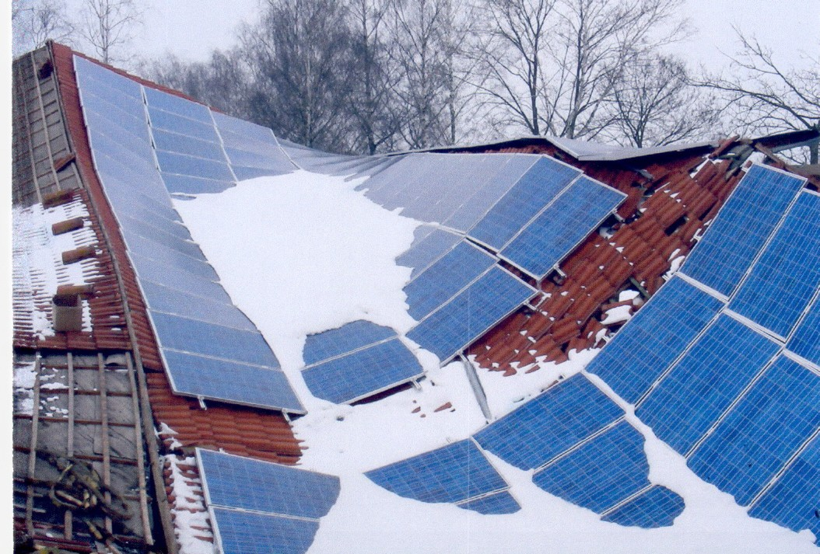

Figure 1. A montage of photovoltaic panels on the roof together with a lot of heavy snow can easily overload a roof above its design parameters and result in collapse. Photo: GVD, Germany

Safe removal of snow

A steep roof will simply force snow to fall off the side of the house as there will be no flat surface to carry it. However a steep roof presents a higher risk of injury to individuals who are working on the roof to clear snow. Before attempting to remove snow from roofs, take note that clearing roofs can be a dangerous task. Don’t put untrained individuals on roofs to clear snow. Arrange the snow removal in time, especially in case of a persistent snowfall, because the necessary staff and appropriate equipment are not always immediately available.

  - A monitoring system helps you to determining when it’s necessary to start snow removal.
  - If there is more than 40 cm of moist, heavy snow on the roof you should remove the snow as soon as possible.
  - Once snow buildup occurs or ice dams form, using a roof rake is the best option. The rake has an extended handle, which enables you to pull snow off the roof from the safety of the ground.
  - Snow shoveling can result in damage to the roof surface and creates other problems.
Use an aluminium scoop shovel to clear the roof.

  - To remove snow and ice, start from the edge and work into the roof using downward strokes.
  - Watch out for ice hanging off the edge of the roof.
  - When clearing snow from a multi-story home it is best to hire professional contractors.
  - Decide if you will remove the snow or if you should hire a contractor to perform the work. Enter into a written contract with a contractor to make sure they can response quickly to your call.
  - If using a contractor you need to make sure they have proper insurance and also check their references

Develop plans

Prepare a plan if the building is located in an area with heavy snowfalls and if there is a risk for roof collapse because of heavy snow.
  - Prepare for the worst case and develop plans to protect your building and equipment.
Also prepare a business continuity plan.
  - Goods and equipment need to be protected. Have a sufficient number of tarpaulins available or have plans to store them in a safe building nearby.
  - Identify shut-off valves for utilities, such electricity and water.
  - Eliminate all sources of ignition if the automatic sprinkler system needs to be turned off.
  - A snow removal plan should be reviewed by a structural engineer and roofing contractor to ensure that it does not increase the danger of collapse or cause damage to the roof covering, and is conducted in a manner that is safe for the workers on the roof.
  - Evaluate yearly the effectiveness of the plans and make necessary changes.

Protection during the winter season

Emergency situations can arise with heavy snowfalls, and it can be necessary to take immediate action. Action is recommended for premises accommodating a lot of people if the roof has a free span structure exceeding 10 meter, and at the same time the snow load exceeds half of the design parameters.

  - Monitor roof conditions and monitor snow and ice accumulation across the entire roof.
  - When it is still safe, implement the plan for snow removal and monitor snow depth on roofs.

  - Clearing the snow yourself you need appropriate equipment specifically designed to remove snow. Remember to put safety first any time you are on the roof, especially one that is covered in snow and ice. Have someone outside with you, in case of an accident. If you have any doubt or when clearing snow from the roof of a multi-story building, you should leave it to the professionals.
  - Remove snow down to the point there is still a couple of cm left on the roof. Scraping the roof clean can reduce the expected lifespan of the roof surface.
  - Decided where snow is placed when removing it from the roof. Do not block building exits. Do not bury equipment such as fire department connections, hydrants, sprinkler, gas and other utility valves. Do not place piles where melting snow can cause seepage or flooding inside the building.
  - Remember that wet snow and ice are far heavier than fresh light snow; the visible depth of snow may be deceiving.
  - Keep eyes open for damps spots or areas of discoloration on walls and ceilings inside the building.
  - Remove an ice dam from the roof by trying to knock the ice dam off with a roof rake or cut a channel through the ice to allow standing water to drain. Another method is to fill a nylon stocking with calcium chloride ice melt and place it vertically across the ice dam so that it melts a channel through the dam. Remember that use of rock salt directly will damage the roof.
  - Large icicles can pose a danger to people when they fall off. Try to safely knock the icicles off
  - Be aware of any warning signs that the building structure may be under significant stress and perhaps in danger of collapse. The obvious sign that the roof is about to give way is sagging. Inspect interior structural members for any sign of deflection or cracking. Inspect walls and ceilings for sign of cracks that have recently developed. Look for cracked or broken windows. Inspect and test doors and windows, to see that they operate as designed. Look for any sprinkler heads that are pushed down. Listen for any unusual creaking or popping sounds. If you hear creaking, cracking or popping sounds, you should get out of the building immediately. The obvious sign that a roof is about to give way is sagging.
  - Signs of deflection or damage to buildings structure should immediately be inspected. Evacuation of the building or temporary shoring may be warranted. Shutdown of sprinkler systems, etc. may be advisable roof collapse is likely.
  - Implement contingency plans if collapse is imminent or has occurred.

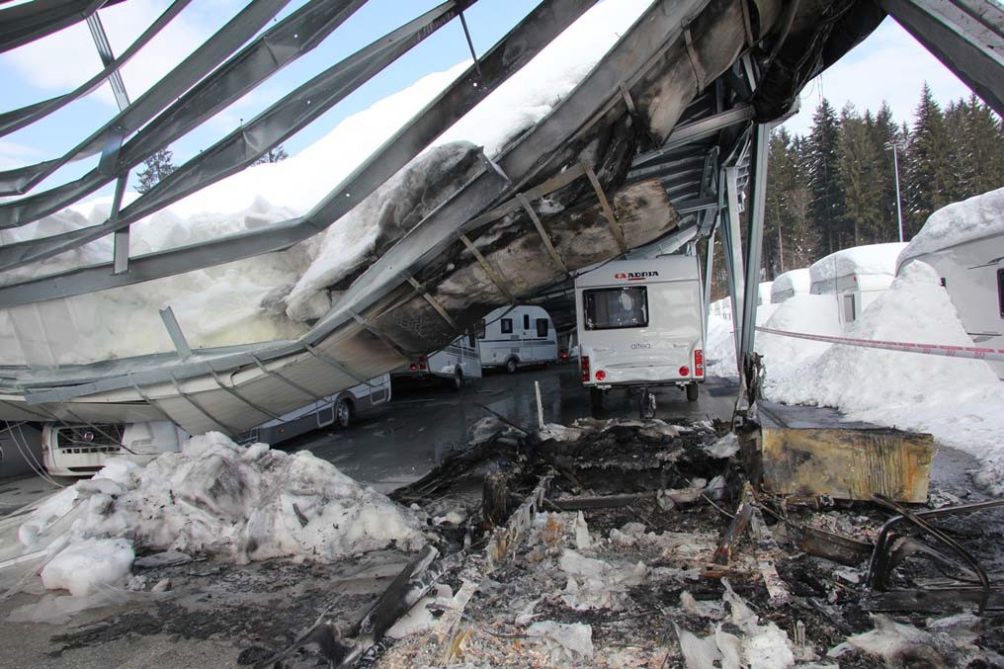

Figure 2. Damage because of heavy snow load can result in very high cost. Photo: Breda Dušič Gornik/Dolenjski list

After the snow storm

Follow up directly after a snow storm.

- Inspect your property for damage.
- Prepare for the next storm and if necessary make changes to the plans.
- Report any damage and claims promptly to your insurance company.

Insurance

Check with the insurance company to:

- Confirm that your property insurance covers roof or building failure due to snow load.
- Make sure the policy pays for actual replacement costs.
- Verify that valuable equipment is covered under a property endorsement.

CFPA-E Guidelines

Fire
Guideline No. | 1:2002 F | Internal fire protection control
Guideline No. | 2:2013 F | Panic & emergency exit devices
Guideline No. | 3:2011 F | Certification of thermographers
Guideline No. | 4:2010 F | Introduction to qualitative fire risk assessment
Guideline No. | 5:2003 F | Guidance signs, emergency lighting and general lighting
Guideline No. | 6:2011 F | Fire safety in care homes for the elderly
Guideline No. | 7:2011 F | Safety distance between waste containers and buildings
Guideline No. | 8:2004 F | Preventing arson – information to young people
Guideline No. | 9:2012 F | Fire safety in restaurants
Guideline No . | 10:2008 F | Smoke alarms in the home
Guideline No . | 11:2005 F | Recommended numbers of fire protection trained staff
Guideline No . | 12:2012 F | Fire safety basics for hot work operatives
Guideline No . | 13:2006 F | Fire protection documentation
Guideline No . | 14:2007 F | Fire protection in information technology facilities
Guideline No . | 15:2012 F | Fire safety in guest harbours and marinas
Guideline No . | 16:2008 F | Fire protection in offices
Guideline No . | 17:2008 F | Fire safety in farm buildings
Guideline No. | 18:2013 F | Fire protection on chemical manufacturing sites
Guideline No. | 19:2009 F | Fire safety engineering concerning evacuation from
 |  | buildings
Guideline No. | 20:2012 F | Fire safety in camping sites
Guideline No . 21:2012 F Fire prevention on construction sites Guideline No . 22:2012 F Wind turbines – Fire protection guideline
Guideline No . 23:2010 F Securing the operational readiness of fire control system Guideline No . 24:2010 F Fire safe homes
Guideline No . 25:2010 F Emergency plan
Guideline No. 26:2010 F Fire protection of temporary buildings on
construction sites

Guideline No . 27:2011 F Fire safety in apartment buildings Guideline No. 28:2012 F Fire safety in laboratories
Guideline No. 29:2013 F Protection of paintings: Transport, exhibition and storage Guideline No. 30:2013 F Managing fire safety in historical buildings
Guideline No. 31:2013 F Protection against self-ignition and explosions in handling and storage of silage and fodder in farms

Natural hazards
Guideline No. 1:2012 N Protection against flood
Guideline No. 2:2013 N Business Resilience – An introduction to protecting your business Guideline No. 3:2013 N Protection of buildings against wind damage
Guideline No. 4:2013 N Lightning protection
Guideline No. 5:2014 N Managing heavy snow loads on roofs

Security
Guideline No. 1:2010 S Arson document
Guideline No. 2:2010 S Protection of empty buildings Guideline No. 3:2010 S Security system for empty buildings
Guideline No. 4:2010 S Guidance on key holder selections and duties Guideline No. 5:2012 S Security guidelines for museums and showrooms

