20.GuideCom.15
CFPA-E No 1:2012 N

Protection against flood

FOREWORD

The European fire protection associations have decides produce common guidelines in order to achieve similar interpretation in European countries and to give examples how damage from natural hazards can be effectively limited by preventive and defensive measures, normally learnt from experience. CFPA Europe also develops and ratifies guidelines for all aspects of fire prevention, and safety and security related problems.

The objectives of CFPA are to improve safety and security and to prevent the consequent loss of life and destruction of property and business. The market imposes new demands for quality and safety.

The measures of Natural Hazards Guidelines concern not only operators, businesses, specialists and plant officers, but also the population and local administration. This is due to the fact that in contrast to fire, the impact of natural hazards as a result of drought, are often very widespread.

The proposals within this guideline have been produced by GDV, Gesamtverband der Deutschen Versicherungswirtschaft e.V., and Dr.-Ing Mingyi Wang has done the final preparation.

The Guideline has been compiled by Naturl Hazards Group in the Guidelines Commission and adopted by all fire protection associations in the Confederation of Fire Protection Associations Europe.

These guidelines reflect best practice developed by the countries of CFPA Europe. Where the guidelines and national requirement conflict, national requirements must apply.

Copenhagen, 22 March 2012 Stockholm, 22 March 2012
CFPA Europe Guidelines Commission

Jesper Ditlev Tommy Arvidsson
Chairman Chairman

Contents
- Introduction 4
- Scope 4
- Definitions 5
- Potential risk and loss experience 5
- Risk assessment and management 6
  - Identification of hazards 6
  - Risk analysis and assessment 8
- Objectives, strategies and protection plan 8
  - Legal requirements and responsibilities 9
  - Strategies 9
  - Priority of safety objectives 10
  - Integrated protection plan 10
- Protection measures 10
  - Local and technical flood protection 10
  - Structural prevention 11
  - Risk prevention 12
  - Be prepared for the flood 12
  - Flood defense and disaster control 13
  - Emergency plan (Who does what, when, where and how?) 13
  - Aftercare 14
- Literature 14
- European guidelines 15
- Appendix: Model emergency plan (who does what, when, where and how?) 16

Key words: flood, hazards, risk management, prevention, protection

Introduction
The flood events of recent years in Europe have shown that by flooding
- Life and health,
- Environment,
- Assets and property and
- The existence of companies (or business)
can be seriously compromised. For the future, climate scientists predict an increase in the number and intensity of extreme weather events that can lead to flooding.
Flood damage can be effectively limited by preventive and defensive measures learnt from experience. For this reason, CFPA Europe wishes to support the efforts of European countries on increased flood protection with practical advice and recommendations which are based on best practice.
Because of the diversity of local situations and threats, it is not possible, to develop a universal protection plan for each individual circumstances. Any objective-specific protection plan should therefore always be coordinated with the local authority and, if necessary, with the relevant insurer.

Scope
This publication on protection against flood is the first publication of a series of Guidelines produced by CFPA Europe. This series will address various types of natural hazards and will be completed over a period of time. In contrast to previous CFPA publications on fire protection, the measures concern not only operators, businesses, specialists and plant fire officers, but also the population and local administration. This is due to the fact that in contrast to fire, the impact of natural hazards, such as floods, heavy rain, storm, hail, tsunamis, earthquakes, landslides and forest fires as a result of drought, are often very widespread. Accordingly, object-specific measures for loss prevention and limitation should be integrated into the local protection plan, for example, in the local flood protection plan with measures for the use of land, building construction, the preparedness of people who may potential be effected and the response of emergency services.
This publication is intended to inform all the above target audiences in terms of flooding hazards and associated risks. It is therefore not addressed to a specific target audience. With instructions and recommendations for practice all the target audiences should, in addition, be supported:
- to identify the existing hazards,
- to identify, analyse, and evaluate the associated risks, particularly to identify and protect people who may be affected,
- to prioritize relevant safety objectives and
- To introduce and implement adequate and effective protection measures.
In parallel, the examples of losses or damage described in this publication, which reflect real life experience, should clearly demonstrate the potential hazards and risks and to demonstrate the importance of enhanced loss prevention measures.

The floods from sea in coastal areas are outside the scope of this guideline.
This publication is based on the current knowledge of loss prevention and risk management. It will be reviewed regularly and updated when there are significant improvements resulted in the specified fields.
Legal regulations are not affected.

Definitions
Flood: temporary covering by water. This includes floods from rivers, mountain torrents and Mediterranean ephemeral water courses and excludes floods from sewerage systems.
Flood risk: the combination of the probability of a flood event and of the potential adverse consequences for human health, the environment, cultural heritage and economic activity associated with the event.

Potential risk and loss experience
Flood damage is influenced by a variety of factors, such as the water level, duration of flooding, the precautionary and preventive measures employed and degree of early warning received. Claims experiences that are systematically collected and analysed can support necessary risk management decisions.

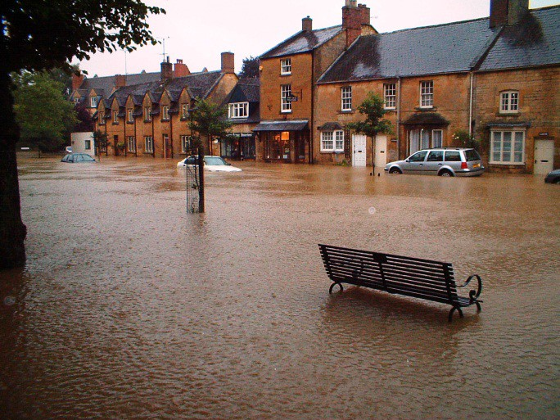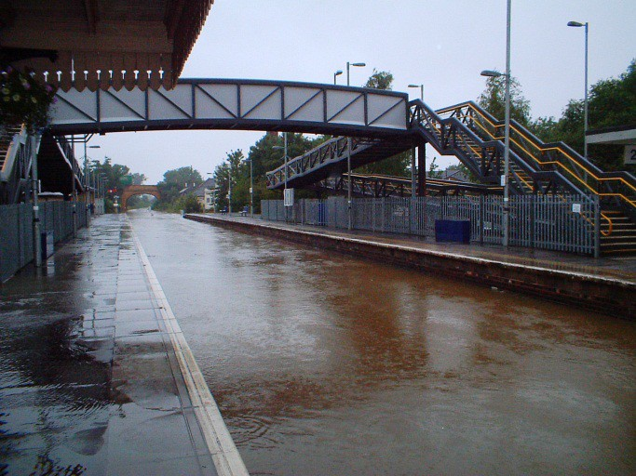
Figure 1 Examples of the vulnerability of infrastructure to flooding: a flooded road and railway station

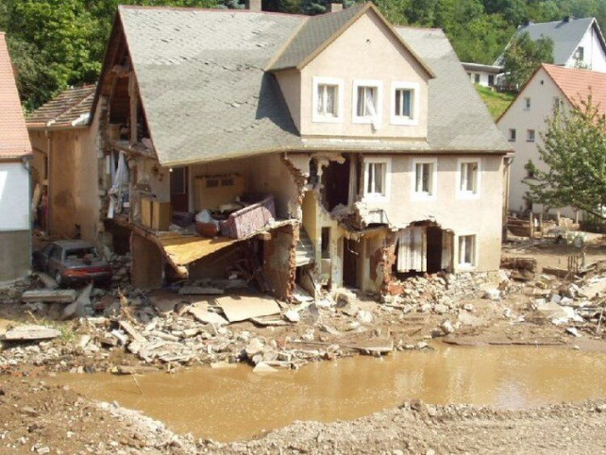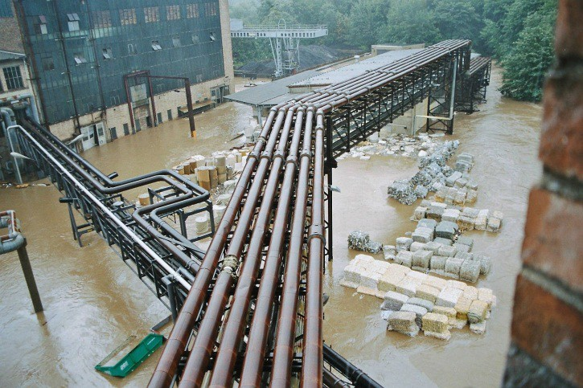
Figure 2 Examples of flood damage to residential buildings and in an industrial plant

The great flood in the catchments of the Elbe and Danube in August 2002 in Germany caused total economic losses of around EUR 11.6 billion. According to the experience of insurers currently in Germany a comparatively small number of major losses caused a significant proportion of the total damage. The largest single loss so far in Germany as a result of flooding occurred in summer 2010 at a manufacturer with a total damage of approximately 100 million €

Risk assessment and management
In order to control the flood risks it is necessary to identify the possible hazards due to the flooding and the estimate and evaluate of the consequences of the events.

Identification of hazards
Floods can have different causes:
- Local heavy rain and flash floods, which, although of short duration and geographically limited, may involve a very great intensity of rainfall.
- Overflowing of larger water bodies such as rivers and lakes, with a relatively slow rise of the water level by several meters, which is often caused by long-ongoing and trans regional rainfall
- Backwater, which occurs to overloading of sewer systems as a result of rainfall and leads in the absence of backwater safeguards and to the influx of water into basements and / or ground floors of buildings
- Rising groundwater, this happens in response to the rising level of nearby water bodies. In these cases the groundwater can penetrate into inadequately sealed basements and flood unprotected construction pits and sealed buildings
To simplify the identification of the hazards, the following information may be helpful:
- Prior flooding history, e. g. historic flood marks, road names, knowledge and experience of long-established employees and residents to past flood events
- Location of the property near to wet meadows and marshes
- Location of the property in a low laying area, which is not always easy to recognize

- Proximity to rivers, streams, other water channels and open bodies of water e.g. lakes, reservoirs etc.
- Proximity to surface water drainage ditches or streams
- Flood hazard maps: Information on flood areas relating to large water bodies is available in many European countries from local municipal and water authorities. Appropriate maps, possibly with indication of the expected height of the flooding, are in many cases available free of charge via the Internet.

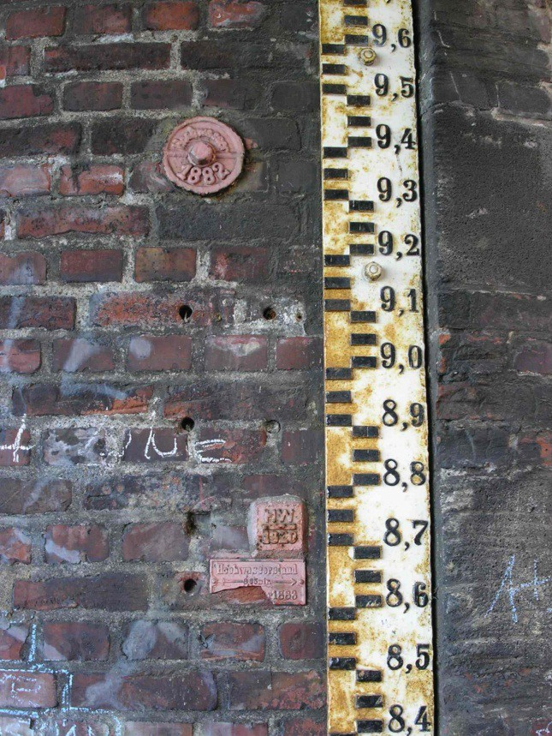
Figure 3 Example of historic flood marks

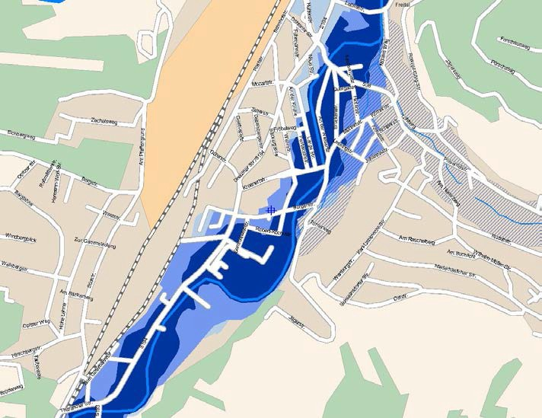
Figure 4 Example of a flood hazard map with the different hazards along a river that are color coded with different shades of blue

An in-depth study of flood hazards is particularly recommended for commercial and industrial operations, in which the recurrence period and the related level of specific floods are determined by a specialist after preparation of site-specific data and a site visit.
For residential buildings, a property-specific check of flood hazards may also be wise, especially if characteristics relating to the property, such as the height of the building site above water level and local protection measures, are not shown on hazard maps.

Risk analysis and assessment
During the risk analysis and assessment the possible consequences in the event of a flood with a related probability of occurrence and intensity should be evaluated. On the basis of this review it can be decided whether the risks may be prevented with the help of preventive and protective measures, or the associated costs are to be addressed by insurance or carried by yourself. For this purpose, event scenarios should be established, if necessary in consultation with the insurer or other risk carrier, in which the hazards and risks as well as the effectiveness and reliability of locally existing preventive and protective measures are considered.

Objectives, strategies and protection plan
Based on the identification of potential hazards and the risk analysis, an assessment of the measures to manage the flood risk should be undertaken. The preventive and protective measures should be established in the context of an integrated protection plan. For this purpose, objectives based on local legislation and regulations and any additional requirements should be defined and specified.

Legal requirements and responsibilities
In 2007 the European Commission published Directive 2007/60/EC of the European Parliament and the Council of 23 October 2007 on the assessment and management of flood risks. This requires the following measures by member states:
- The preliminary flood risk assessment, which shall be completed by 22 December 2011, shall be reviewed, and if necessary, updated by 22 December 2018 and every six years thereafter.
- The flood hazard maps and the flood risk maps, which shall be completed by 22 December 2013, shall be reviewed, and if necessary, updated by 22 December 2019 and every six years thereafter.
- The flood risk management plan(s), which shall be completed and published by 22 December 2015, shall be reviewed, and if necessary, updated by 22 December 2021 and every six years thereafter.
The purpose of this Directive is to establish a framework for the assessment and management of flood risks, aimed at the reduction of adverse consequences for human health, the environment, cultural heritage and economic activity associated with floods in the community.
In parallel, there are national legal provisions for flood protection in individual countries, which should also be observed. For example, according to the Act to Improve Preventive Flood of May 2005 in Germany, any person who may be affected by flooding is obliged to take appropriate preventive measures. In particular, the use of land must be adapted to the potential hazards to life, human health, environment or property. In addition, legislation does not permit new building in areas prone to flooding.

Strategies
To manage flood risks, different strategies can be pursued depending on the prevailing hazards, risks and objectives.
The prevention of flood damage is the preferred strategy, and this can be achieved by avoiding domestic and industrial properties being located in flood hazard areas.
A strategy of defending against a flood by taking appropriate preventive and defensive measures may be adopted. This strategy is also known as "flood resistance" to prevent the ingress of water. Flood resistance is only partially helpful regarding business interruption, because the operation of the business may be limited by the flooding of surrounding areas.
By defending against a flood it must be ensured that the stability of the protected building is not threatened and adversely affected by the buoyancy of the rising water. A structural engineer should be consulted in advance as to the level of flooding that may be manageable. In cases where the stability of a building may be threatened, the buildings should be flooded with clean water to control the level of damage.
Measures against flooding can be only designed for a specific event as scale of a major flood may be both technically and economically challenging. In the case of high impact events, measures for local or object-specific emergencies must be planned, with measures put in place and practiced. This strategy is also known as "flood resilience", and aims to reduce damage caused when flood water gets inside the property.

Priority of safety objectives
For each object (buildings, technical equipment or other item of building contents) an individually appropriate water level associated should be defined as the specification of the objective. Thus, the protection for basements with low values may be sufficient for a 50-year flood, while a 100- year flood may be necessary for production and storage in other areas. For facilities and equipment to be protected, particularly for high value or specific risks, a higher objective is reasonable. For the specification of the objective the duration of the anticipated business interruption should be also included.
For the practical design of protective measures, a safety margin to the design water level according to the specification of the objective should be added, e. g. 50 cm.

Integrated protection plan
In an integrated protection plan the necessary protective measures are established locally or are object specific. These measures, such as dikes and / or emergency evacuation plans, should complement each other both to prevent and manage an event, because they each have different limits and modes of operation.
An object specific protection plan must be embedded in the local protection plan, because object specific measures have limited effect on their own.

Protection measures
The following measures can be taken according to the each hazard, risk, protection strategy and objective:

Local and technical flood protection
As preventive measures for the local area any structural settlement and further building in flooding areas should not be permitted. In addition, the retention area, which is usually the mostly low-lying area next to a river, can be used as a flood runoff area and should be maintained and expanded.
Technical flood protection includes both the construction and maintenance of dams, dikes, walls for flood retention and demountable protection measures to protect the buildings and urban areas.

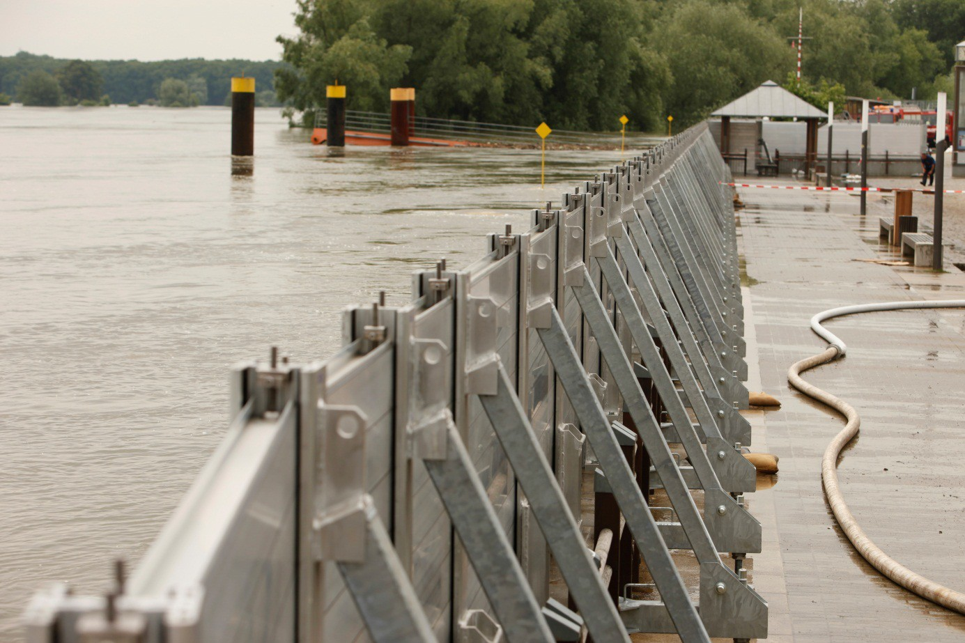
Figure 5 Example of use of a demountable flood protection wall

The responsibility of local and technical protection measures are generally controlled by the public administration, such as local municipalities

Structural prevention
Structural prevention measures aim to make buildings and their use less vulnerable to flooding and therefore able to some extent to "live with floods". These measures include:
- The use of water-resistant building materials (e. g. tiles instead of wood floor)
- The design of structural measures to shield the building from flooding,
- Flood-adapted installation of utilities, e. g. heating systems. Therefore, in areas liable to flooding:
- Building materials selected so as to be less sensitive to water in the assembled state, such as concrete, masonry. In addition, the surface of components should be easy to clean, for example, stones or tiles as flooring and wall covering
- Modes of constructions that may be easily compromised by a flood should be avoided. These may include lightweight- and frame-constructions, and those which are expensive to dry after a flood
- The facilities and equipment to be installed in a building should be of a design, or with parts less sensitive to rising water or which are slightly to repair after a flood. The aim should be for

installations to be returned to service with the minimum of effort, e.g. cable elevator instead of hydraulic lift
- The control centers of building services engineering, such as ventilation control cabinets and electric control cabinets, energy meters, computer servers and telecommunication cabinets should be placed above the expected flood level
- Supply circuits should be able to be shut down storey by storey
- Openings in exterior walls, such as windows, doors and passages for operation-critical supplies such as water, electrical and gas, should be protected against water or be of a watertight design.
- Storage of fuel and other materials should be made according to local regulations, e. g. fuel storage tanks should be suitably anchored so when under flood conditions will not become damaged or float away causing pollution.
Structural protective measures should also be taken, particularly if it is clear that the location of the property cannot be moved. Repairing a property that has been flooded offers an opportunity to minimize the damage and disruption that could be caused by a flood in the future.

Risk prevention
The cost of protection against flood damage can either be addressed through financial reserves or by transfer to the insurance policy. The risk analysis and assessment is an essential basis on which to build these decisions.
Buildings, contents and business interruption can be insured against floods in most cases.

Be prepared for the flood
When the flood comes, and also during the flood, there is, apart from the heavy rain, normally time to control flood damage before critical water levels are reached. Timely and regular updating of flood forecasting and warning of bad weather helps address the hazard-adjusted use of a building and facilities. Extensive preparation, with the help of emergency plans is the key element of preparedness in the times of emergency. In some European countries and areas, flood forecasting is also available on-line.
To promote the awareness of flood risks and necessary measures to be taken in case of a flood, businesses that may be affected should receive appropriate information, including suitable visual materials, from the public administration and if applicable by the insurers.
Experience has shown that basements, garages, outdoor areas and lower floors of buildings, are most at risk. Flood damage can be reduced, for example, by prohibiting:
- The location of high-value facilities and equipment in the basement (business critical machinery, office, party room, sauna, etc.)
- The installation of high-quality equipment, facilities, furniture and electrical hardware, which are difficult to transport, e. g. washing machines, dryers, freezers, built-in cupboards
- The storage of water hazardous substances (heating oil, paints, solvents, etc.)
All measures for flood protection and drainage, e.g. guttering, down pipes and drains, should be regularly serviced and checked for operational readiness

Flood defense and disaster control
The roles of the flood defense and disaster control are:
- To control the flood and to minimize the effects of flooding, e. g. by protection against water ingress
- To help those affected
- To enable and to support early recovery and reconstruction after the event.
To this purpose the following measures should be taken, often with the assistance of the public administration:
- Resourcing of necessary capacity (personnel, equipment, materials, transport etc.)
- Establishment and adjustment of the local emergency organisations
- Development or extension and updating of emergency plans, including civil and military cooperation
- Training of emergency manpower
- Regular exercises.
The required specification of the necessary measures in each case can be made within the possible scenarios, which can be determined depending on the particular risk analysis and assessment.
In order to optimise the flood prevention measures and help develop best practice for the future, local cases of loss should be systematically collected and analyzed. The findings and experiences from this evaluation can be included in future instructions and recommendations for flood prevention. This step closes the circle of flood risk management.

Emergency plan (Who does what, when, where and how?)
In the event of flooding and during a flood the instructions of the disaster control and civil protection authorities must always be followed. In addition to public emergency, adequate preparation of actions in the event of flooding can help to use the warning time, often of several hours, for reduction of losses efficiently. This includes the development of a site-specific emergency plan that will particularly include the following:
- Clear assignment of responsibility
- Sources of information on flood (e. g. The National Environment Agency Flood Alert Scheme and other flood news services etc.)
- Protective measures, such as setting up a demountable barrier, closing flood-control gates, evacuation of vulnerable person and materials
- Identifying the required capacity, such as the manpower and equipment required, e. g. for relocation of storage and machinery. This must be budgeted, resourced and serviced regularly
- Developing instructions for planned measures in case of an event, the implementation of which should be supported by regular exercises with all participants
- Preparing flood kit – including critical key business documents, useful numbers such as customers, suppliers, the local council and emergency services.
The emergency plan for a private household should contain useful telephone numbers and the following actions:

- Alerting and evacuation of vulnerable persons
- Securing of valuables and documents, such as insurance documents,
- Activation of protective measures for the building and outdoor facilities, such as closing the flood protection gates and cleaning of drainage holes
- Driving cars and other vehicles outside of the flood area
- Activation of the safety and evacuation work in the building, such as securing high-quality demountable devices.
In accordance with the advice of the local disaster control and civil protection agencies, the following preparations should be made: wireless communications equipment (battery-powered radio, mobile phone) and rubber gloves, wellington boots, waterproof clothing and a first aid kit and other daily commodities (emergency lighting, drugs, food, camping stove, etc.).

Aftercare
During the pumping out of the flooded building areas it must be ensured that the building is not compromised by buoyancy produced by excessively rapid pumping.
If the flood losses are insured under a buildings or contents insurance, all damage should be documented early and comprehensively, for example, using photos and if possibly even before the water is drained. This eases speedy claims adjustment and allows compensation of insured losses to be supported effectively.
All building facilities, equipment and machinery affected by the flooding, particularly electrical or gas supply, must be checked by qualified persons, before use.
All flood protection devices must be cleaned as soon as possible to avoid potential contamination. They should then be returned to position ready for reuse.

Literature
Directive 2007/60/EC of the European Parliament and of the Council of 23 October 2007 on the assessment and management of flood risks
Association of British Insurers and the National Flood Forum
Repairing your home or business after a flood – how to limit damage and disruption in the future
www.abi.org.uk and www.floodforum.org.uk German insurance association
- GDV-Flyer: "Country under …", www.gdv.de
- Protection against floods; guidelines for protection plans and measures at industrial and commercial companies (VdS 3521), www. vds-industrial.de
Norwich Union Risk Services
Guidance for businesses on managing your flood risk www.nurs.co.uk/riskadvice/index.htm#flood

European guidelines

Guideline No 1:2012 N - Protection against flood

Guideline No 1:2002 F - Internal fire protection control Guideline No 2:2007 F - Panic & emergency exit devices Guideline No 3:2011 F - Certification of thermographers
Guideline No 4:2010 F - Introduction to qualitative fire risk assessment Guideline No 5:2003 F - Guidance signs, emergency lighting and general lighting Guideline No 6:2011 F - Fire safety in care homes for the elderly
Guideline No 7:2011 F - Safety distance between waste containers and buildings Guideline No 8:2004 F - Preventing arson – information to young people Guideline No 9:2012 F - Fire safety in restaurants
Guideline No 10:2008 F - Smoke alarms in the home
Guideline No 11:2005 F - Recommended numbers of fire protection trained staff Guideline No 12:2012 F - Fire safety basics for hot work operatives
Guideline No 13:2006 F - Fire protection documentation
Guideline No 14:2007 F - Fire protection in information technology facilities Guideline No 15:2012 F - Fire safety in guest harbours and marinas Guideline No 16:2008 F - Fire protection in offices
Guideline No 17:2008 F - Fire safety in farm buildings
Guideline No 18:2008 F - Fire protection on chemical manufacturing sites
Guideline No 19:2009 F - Fire safety engineering concerning evacuation from buildings Guideline No 20:2012 F - Fire safety in camping sites
Guideline No 21:2012 F - Fire prevention on construction sites Guideline No 22:2010 F - Wind turbines – Fire protection guideline
Guideline No 23:2010 F - Securing the operational readiness of fire control system Guideline No 24:2010 F - Fire safe homes
Guideline No 25:2010 F - Emergency plan
Guideline No 26:2010 F - Fire protection of temporary buildings on construction sites Guideline No 27:2011 F - Fire safety in apartment buildings

Appendix: Model emergency plan (who does what, when, where and how?)

- Scope
  - information about the affected sites, plants and buildings, if necessary, with position and detail plans

Location:
Building | Equipment and facility
- Hazards
  - A: Effect of water levels on the premises
Examples

Mean return period | Mean water level (reference level) [m] | Impact
1980-2003 | 5.04 | No impact
Every two year | 7.75 | Parking area B flooded
Every ten year | 8,63 | Parking area B and Gate 3 and 4 flooded
Every fifty year | 9,16 | Parking area B and Gate 1, 2, 3, 4 and the outdoor storage flooded

- B: The impact of heavy rain on the premises
Examples:
  - Water accumulation on paved surfaces and penetration of water into the building in the field of roller shutters
  - Backwater of channel
  - Flood of secondary water bodies
  - Dirt accumulation on the premises

- Overview of responsibilities
  - Provision and circulation of information
Mr. Maier, Head of Building Maintenance, informs at the previously established reference sources about the current threat situation. He informs the management, flood protection officer, the shift manager and the security service, depending on the weather conditions and the expected flood situations.

    - Crisis Staff
Example: The crisis unit is composed of
      - Mr. Head, Chief Executive
      - Mr. Maier, Head of building maintenance
      - Mr. Frederick, flood protection officer
      - Mr. Peters, Personnel Manager
      - Mr. Smith, Shift manager and meets in room xxx

- Definition of the tasks of the flood protection officer
Example: Mr. Frederick, warehouse manager is appointed to the flood protection officer. His tasks are:
  - Participate in the creation of protective measures
  - Establish and update an emergency plan
  - Supervision of the protective material
  - Nomination of personnel for the different levels of alarm
  - Training of emergency personnel
  - Carrying out exercises in consultation with the Chief Executive
  - Cooperation with public aides, such as fire brigade

- Information about water levels, flood forecasts and storm warnings
  - Water levels and flood forecasts of the authorities
Example: Information of the flood forecasting center under the web address: http://www.floodcenter.com

  - Reports of the Meteorological Services
In addition to current reports of the broadcasters, other prediction systems if available should be also used

- Measures
  - information about address, phone number etc. of persons and institutions, which are to alarming and informing in case of event
Example
    - Building maintenance, Mr. Maier, Street 12, Tel No. xxxx / yyyyyyyy
    - Chief Executive, Mr. Head, Street 42, Phone No. xxxx / yyyyyyyy
    - Flood Protection officer, Mr. Frederick, Street 24, Tel No. xxxx / yyyyyyyy
    - Personnel Manager, Mr. Peters, 12, Phone No. xxxx / yyyyyyyy
    - Fire station, Mr. Young, street 848, Tel No. xxxx / yyyyyy
    - Electrical service, Mr. Miller, Street 21, Phone No. xxxx / yyyyyyy
    - Security service, Mr. Wachs, Street 124, Tel. Nr. xxxx / yyyyyyyy

- Provision and implementation of necessary protective measures with clear assembly instructions
Example:
  - The material for the required demountable protective walls is stored in Hall 3 and will be checked every six months to complete. In particular, make sure that the marked area in front of the protective material is kept clear. The fuel tanks for the pumps are to refill immediately after each using.
  - The material (sand bags and sufficient amount of sand) for securing the outdoor storage and the roller doors is deposited at the back gate
  - The working tools (broom, wheelbarrow, etc.) for the necessary measures are at the left side of the storage room
  - For the relocation of the products are the existing forklift to use

The organizational activities are regularly to coordinate with the workforce and the names of the responsible persons are regularly to update

- Defining of necessary measures in relation to the expected water level or the weather forecast
Example: Convening of the crisis team to determine the alarm level at

(A) Flood on the river XXX (specify name and location of the measured level clearly)
Alarm level | Water level [m] | Measures
1 | 7,75 m | Remove of vehicles and pallets of parking area B
2 | 8,63 m | Setup of demountable wall at gate 3 and 4
3 | 9,16 m | - Setup of all demountable walls at Gate 1, Gate 2 and sandbag barriers for outdoor storage (0.5 m high))  - Make pumps 1 and 2 ready and remove all vehicles put into the protected area  - Schedule of the production stop at the water level of 9.0 m, inform employees, give schedules of flooding condition known, ensure transfer of employees with boats

(B) Heavy rain
Potential threat situation | Measures before the onset of heavy rainfall
1. Water accumulation on paved surfaces and penetration of water into the building in the field of roller shutters | - Clean of area, drains and gutters of debris (leaves, debris, etc.)  - Put the goods stored directly on the ground and closed to the roll-up doors on pallets und bring it in safety  - Protect roller doors with sandbags
2. Backwater of channel | Close backwater valves, if necessary
3. Flood of secondary water bodies | - Put the goods stored directly on the ground and closed to the roll-up doors on pallets und bring it in safety  - Remove all vehicles and storage goods from the north-western gate  - Protect roller doors with sandbags
4. Dirt accumulation on the premises | Clean the area

- Assignment of responsibility of all involved departments and individuals for the protection sectors or measures

Alarm level | Staff
1 | Management, Flood protecting officer, head of warehouse, driver and forklift driver
2 | Management, Flood protecting officer, head of warehouse and employees of hall 3 and 5
3 | Management, Flood protecting officer, shift manager, employees of production section B

Threat situation | Staff
1 | Management, Flood protecting officer, head of warehouse, driver and forklift driver, employees of hall 1
2 | Management, Flood protecting officer, shift manager, employees of production section B and hall 1
3 | Management, Flood protecting officer, head of warehouse, driver and forklift driver, employees of hall 2
4 | Management, Flood protection officer, all employees of incoming goods department, driver and forklift driver, employees of hall 1

- Documentation
  - Procedures and results of the implemented measures
Example: During the floods on 12.08.xxxx the alarm level 1 + 2 and the threat situation 1 + 3 were declared according to the water level and related measures implemented. Gate 3 was closed. Water penetrated into the hall 2 at Gate 4 by water leakage and stood 10 inches high. Thanks to the measures of threat level 3 there were no goods damaged.

  - Determination of cost and damages
Example: Approx. moisture and dirt on 300 m² á 25 € /m² = 7500 € Coating of basement of hall 1: 40 m² á 20 € /m² = 800 €

  - Lessons learned from the previous event
Example: The setup of the demountable protection walls was sluggish and was ready just before the rush of water. The reason was that the people extended up to 2 staff have never setup the wall.

  - Procedures to update the emergency plan
Example: Occurred deficiencies must be summarized and analyzed. Update the emergency plan what is to be approved by management and to make know for concerned departments and persons. The reason for the leak must be found and eliminated. The crew for setup the demountable wall is instructed regularly and the testing is to perform one times a year

