Securing the operational readiness
of fire control systems

CFPA-E Guideline No 23:2023 F

New image needed!

The CFPA Europe develops and publishes common guidelines about fire safety, security, and natural hazards with the aim to achieve similar interpretation and to give examples of acceptable solutions, concepts, and models. The aim is to facilitate and support fire protection, security, and protection against natural hazards across Europe, and the whole world.

Today fire safety, security and protection against natural hazards form an integral part of a modern strategy for survival, sustainability, and competitiveness. Therefore, the market imposes new demands for quality.

These Guidelines are intended for all interested parties and the public. Interested parties includes plant owners, insurers, rescue services, consultants, safety companies and the like so that, in the course of their work, they may be able to help manage risk in society.

The Guidelines reflect best practice developed by the national members of CFPA Europe. Where these Guidelines and national requirements conflict, national requirements shall apply.

This Guideline has been compiled by the Guidelines Commission and is adopted by the members of CFPA Europe.

More information: www.cfpa-e.eu

Zurich, November 2023 Cologne, November 2023
CFPA Europe Guidelines Commission

Elisabetta Carrea Hardy Rusch
Chairman Chairman

Contents

1 Introduction 4
2 Scope 4
3 Definitions 4
4 Key 5
5 Strategy 5
6 Existing facilities 6
7 Frequency of integral tests 6
8 Demands placed on the operator and resulting obligations 6
8.1 Checks and maintenance work 6
8.2 Changes during operation 6
8.3 Documentation and verification 6
9 Required documentation 6
10 Attachments of the annex 6
Annex 1: Summary of documents 7
Annex 2: Zone plans for fire control systems (collective activation) 8
Annex 3: List of fire control systems (collective activation) 9
Annex 4: Zone plans for fire control systems (selective activation) 10
Annex 5: Matrix of Fire Control Systems (selective activation) 11
Annex 6: Certification (Example for Selective Activation) 12
Annex 7: Periodic check (example for selective control) 17
Annex 8: Key 18
European guidelines 19

Key words:

Introduction
Fire detection systems and fire extinguishing systems must automatically identify any fire that may occur and to signal and alert all endangered persons and operational personnel. They can be used for activating and operating fire protection devices.
Owners and users of buildings and facilities are responsible for ensuring that appliances and equipment used for the structural, technical, and preventive aspects of fire protection systems and facilities are to be maintained and operational at all times in accordance with regulations. A general overview can be found in Guideline No 1 “Internal Fire Protection Control”.

The technical facilities for fire protection should be consistent with state-of-the-art technology and designed and maintained so that they are effective and operational at all times.

Scope
This guideline is primarily intended for those responsible for safety in companies and organisations. It is also addressed to the rescue services, consultants, safety companies etc so that, in the course of their work, they may be able to help companies and organisations to increase the levels of fire safety.

It documents the operational readiness of fire control systems and regulates their design and control.

Additionally, an internal self-checking system must be implemented, that ensures the periodical checks of installations, which are relevant for fire protection. These checks are carried out more frequently than the control of fire control systems. The procedure of this self-checking system is not part of this document.

Definitions
Fire control systems (FCS): Fire control systems are identified as those actuating devices of safety systems and/or safety components such as lift installations, venting systems, doors, fire dampers, etc, that are activated automatically or manually.

Integral test: An integral test is used to check all fire protection components, which are automatically activated and connected directly to the fire control system, and their interrelationship with one another. This includes their proper activation and function. Components that are activated via a follow-up control (e.g., fire dampers as a follow-up control of the ventilation) are not tested. This would have to be tested by means of individual tests as part of commissioning.

Zone- / components plan (see Attachment 2 and 4): The zone plan is a graphical representation of defined areas to show where elements are to be activated as well as to indicate and identify individual components.

Matrix for fire control systems (see Attachments 3 and 5): The matrix for fire control systems is in the form of a table showing all interrelationships between activated zones and those components to be activated.

Action plan of the integral test (see Attachment 6): The action plan is the documentary evidence on the procedure or protocol for testing fire control systems. This is based on specific concepts of established protection objectives.

Periodic checks, function of activation: Periodic checks are those tests on systems and components at specific time intervals. These include:
- Checking the correct functioning of individual components (ad hoc inspections),
- checking zone plans (conceptual),
- carrying out an integrated test (according to the action plan).

Self-control: A periodic internal check consists of a visual inspection and a status and function check of devices throughout the facility (e.g., emergency generator, fire doors, fire extinguishers, fire control system). Results of these checks should be documented.

Documentation: The integral test, internal controls, maintenance and all incidents must be documented (e.g., logbook).

Key
FDS Fire detection system
SPS Sprinkler system
FCS Fire control system
FD Fire damper
SHES Smoke and heat exhaust system
FBCP Fire brigade control and indicator panel

Strategy
Based on the fire protection strategy, a facility-specific, targeted solution for fire control systems is to be drawn up. The following describes the approach to planning and checking fire control systems:
1. Appointing personnel to be responsible for planning.
2. Creating / checking / adapting a fire protection concept.
3. Creating of the evacuation concept (Fire control system must be adapted to the evacuation concept).
4. Creating of an operating concept / utilization concept (Fire control system must be adapted to this concepts).
5. Creating / adapting zone plans and the matrix to reflect the fire protection concept.
6. Installing equipment and updating related documents.
7. Creating / customizing the action plan for integral testing.
8. Carrying out procedures for integral testing.
9. Rectifying faults, if any.
10. Determining periodic checks, function of activation, and time intervals.
11. Carrying out an integral test after any significant changes to the system.
12. Ongoing review of all fire protection related protection concepts and updating documents.

Existing facilities
When extending fire protection measures and/or structural modifications, the documentation must be updated, and an integral test carried out on the area concerned.

An integral test must be carried out after adjustments to the system or after updating hardware or software.

Frequency of integral tests
An integral test is to be carried out periodically, according to the national regulations, but at least every 2 to 6 years, preferably just before a periodic check of the fire protection system by the competent authorities. The periodic integral test should be carried out after maintenance and servicing. This results in fewer defects.

Demands placed on the operator and resulting obligations

Checks and maintenance work
The operator is responsible for ensuring that internal controls and maintenance work on the components is conducted according to a set schedule (according to manufacturer's specifications).

Changes during operation
Documents are to be updated after any functional or structural change or significant modification to the actuating equipment. Depending on the scope of the modifications, the procedure described in Section 5 must be adhered to.

Documentation and verification
All incidents relating to the operation of fire control systems must be documented (e.g., logbook).

Required documentation
- Zone- / components plan of the building.
- Matrix of automatic fire control system with key.
- Action plan of integral test.
- Checklist for internal fire protection control.
- Verification of events and checks (e.g., logbook).

Attachments of the annex
Examples are given in the annex (although not exhaustive, possible solutions), as a guide for full documentation. The extent and definitive illustration or labelling is notional only and can be freely selected.
Annex 1: Survey of documents, necessary planning documents
Annex 2: Zone- / components plans for fire control systems (collective activation)
Annex 3: List of fire control systems (collective activation)
Annex 4: Zone- / components plans of fire control systems (selective activation)
Annex 5: Matrix for fire control systems (selective activation)
Annex 6: Implementation of action plan
Annex 7: Periodic check of fire control systems
Annex 8: Key

Annex 1: Summary of documents

Check-Plan for fire control systems:

Consisting of:

- Zone- components plans for fire control systems

- Matrix for fire control systems

- Control plans
(Action plans for integral test)
for the approval
for periodic check

- Documents of internal fire protection control
Other fire protection documents with potential interfaces
Fire Brigade Intervention Plans and Fire Protection Plans
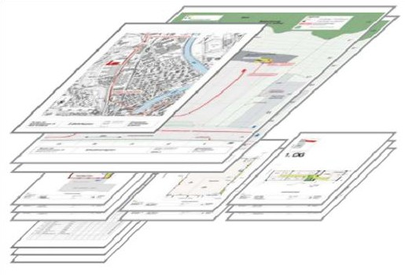
Consisting of:

- Access plan
- Situation plan
- Environment and hazard plans
- Floor plans
- Information sheets etc.
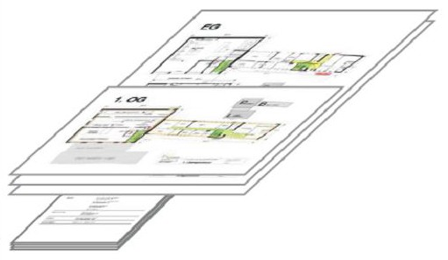
Plans for escape routes, orientation and evacuation

Consisting of:

- Evacuation and orientation plans
- Evacuation concept
- Leaflet "Behavior in case of fire"
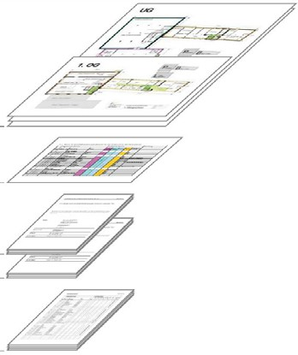

Annex 2: Zone plans for fire control systems (collective activation)

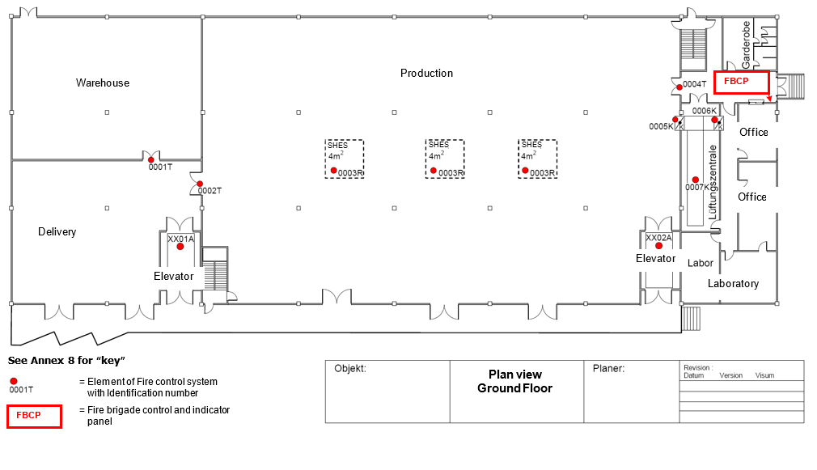

Annex 3: List of fire control systems (collective activation)

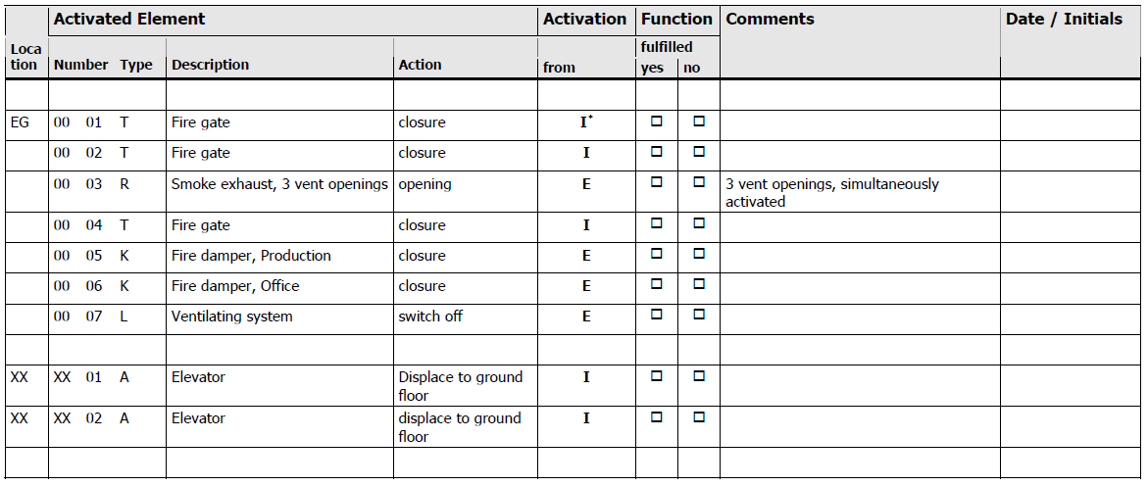

*I: Internal alarm e.g. daytime operation
E: External alarm to the fire brigade or activation by pushbutton

See Annex 8 for key.

Annex 4: Zone plans for fire control systems (selective activation)

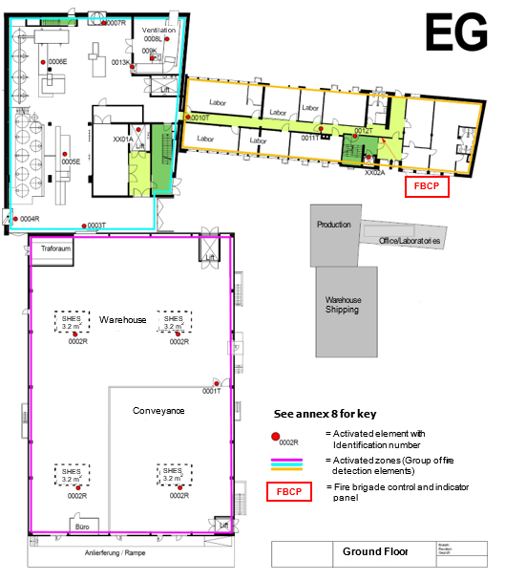

Annex 5: Matrix of Fire Control Systems (selective activation)

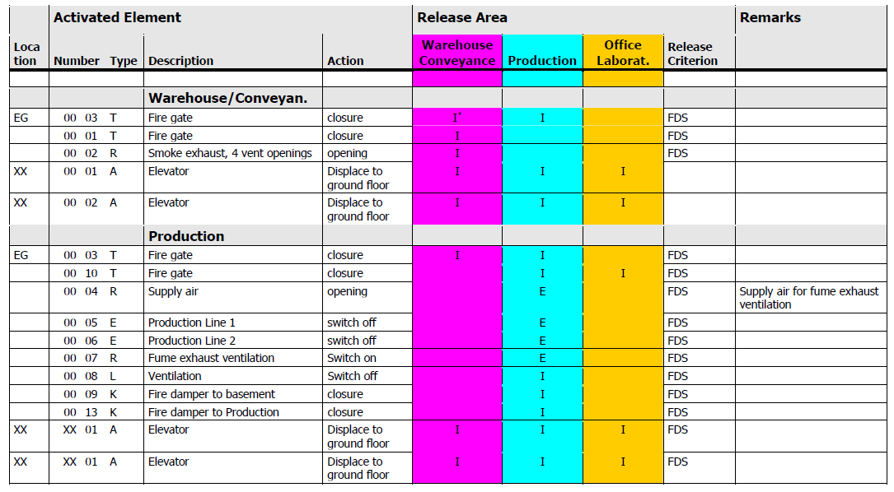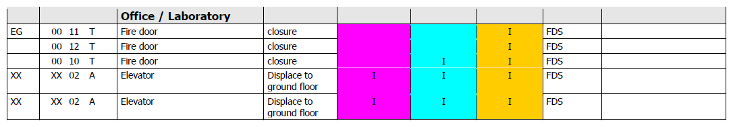

*I: Internal alarm e.g. daytime operation
E: External alarm to the fire brigade or activation by pushbutton

See Annex 8 for key.

Annex 6: Certification (Example for selective activation)

Certification for Automatic Fire Control Systems
Scenario Integrated Test

Contents

1. Basic Principals
1.1 Participants
1.2 Documents
1.3 Procedure for integral tests of fire control systems
2. Integral test of automatic fire control systems
2.1 Scenario 1, Fire in the Ex-Zone Production ground floor
2.1.1 Test Scenario 1
2.1.2 Remarks / Information
2.2 Scenario 2 ff
3. List of deficiencies, action planning
3.1 Deficiencies
3.2 Improvements

- Basic Principals
As part of building renovations, the fire and gas detection systems were modernized, and a personal alarm system was installed. The fire protection systems and all relevant actuating safety equipment and systems are to be checked for functionality and safe operation. An integral test with five scenarios is to be carried out to this end.

1.1 Participants

Company | Function | Name | present
Company X | Owner | Mister A | yes
Company X | Chief technical service | Mister B | yes
Construction Inc. | Construction management | Mister C | yes
... | ... | ... | ...

1.2 Documents
For survey the following documents are given to all participants in advance:
- Fire protection plans and zone plans,
- …

For verification and gap analysis the following documents are essential and must be available at place:

Updated documents | available |  | Comments
 | yes | no
Construction plans, revised | ☑ | ◻
Ventilation plans, revised | ◻ | ☑ | Not actual version, data for test okay
Sanitary plans | ☑ | ◻
... | ◻ | ◻ | ...

1.3 Procedure for integral tests of fire control systems

Time | Action | Responsible
08:00 - 08:15 | Welcome, presence control | Safety representative, company X
08:15 - 08:30 | Document verification | Company XX
08:30 - 09:00 | Meeting, fire scenario verification | All participants
... | ... | ...

2. Integral test of automatic fire control systems
The automatic activation of all security elements such as doors, fire doors, fire dampers, etc. is done periodically within specified time intervals by carrying out an integral test.

The test initially requires all elements to be put into operational readiness. According to the scenarios and action plan, security elements must assume the status for the particular emergency for which they were set. After resetting the alarm systems, the security devices must also be reset to their operating status either automatically or manually.

System functions are to be verified and documented throughout the entire installation. By its signature, the company responsible for the installation and its operation confirms that the safety devices are operating correctly, and that the information given is accurate.

2.1 Scenario 1, fire in the ex-zone production ground floor
Activation of a fire detector in production area; acknowledge of internal alarm within 3 minutes (daytime operation); activation of an external alarm by pressing a manual fire alarm button.

2.1.1 Test scenario 1

Pos. | Action | Responsible company | Function okay |  | Responsible person
 |  |  | yes | no
 | Preparations
1 | Control and indicating equipment: No alarms, failures etc. present | Company of fire detection systems | ☑ | ◻ | I. Isler
2 | Access to all rooms ensured | Company X | ☑ | ◻ | B. Bodmer
3 | Plants switched on | Company X | ☑ | ◻ | B. Bodmer
4 | Closures opened, in operating position | Company X | ☑ | ◻ | B. Bodmer
5 | Building services in operation | Company XX | ☑ | ◻ | E. Ebner
 | Test scenario 1
6 | No activation of any fire control systems of other scenarios | all | ☑ | ◻ | E. Ebner
7 | Activation of a pre-alarm of a smoke detector in delivery office | Company of fire detection systems | ☑ | ◻ | I. Isler
8 | Approval of the transmission to the control and indicating equipment Acknowledge receipt of the alarm within 3 minutes | Company of fire detection systems | ☑ | ◻ | I. Isler

Pos. | Action | Responsible company | Function okay |  | Responsible person
 |  |  | yes | no
9 | Closure of fire gates:  Gate (0003T)  Gate (0010T) | Company XX | ☑ | ◻ | E. Ebner
10 | Elevator (XX01A / XX02A) displaces to ground floor and remains blocked. | Company XX | ☑ | ◻ | E. Ebner
11 | Damper supply air (0004R) opens and fume and smoke exhaust ventilation (0007R) works. | Ventilation Inc. | ◻ | ☑ | Damper (0004R) doesn’t work.  H.Hasler
12 | Production line 1 (0005E) goes to a stable state and switched off. | System Inc. | ☑ | ◻ | M. Manser
13 | Production line 2 (0006E) goes to a stable state and switched off. | System Inc. | ☑ | ◻ | M. Manser
14 | Ventilation (0008L) is switched off | Ventilation Inc. | ☑ | ◻ | H. Hasler
15 | Removal of the fuse for the illumination | Electrical Inc. | ☑ | ◻ | K. Kübler
16 | Control of the emergency lighting | Electrical Inc. | ☑ | ◻ | K. Kübler
 | Reconnection
17 | Reset of the control and indicating equipment, no alarms, failures etc. present. | Company of fire detection systems | ☑ | ◻ | I. Isler
18 | Reset of Illumination Emergency lighting off | Electrical Inc. | ☑ | ◻ | K. Kübler
19 | Reset and run up of all facilities; no alarms, failures etc. present. | All | ☑ | ◻ | E. Ebner
20 | No other faults or effects on installations or facilities. | All | ☑ | ◻ | E. Ebner

2.1.2 Remarks / information
11. Damper (0004R) receives no signal, respectively does not open.
H. Hasler: Clarification with J. Isler about the activation through control and indicating equipment.

2.2 Scenario 2 ff
Tests of further scenarios analogue to scenario 1

3. List of deficiencies, action planning

3.1 Deficiencies

Pos. | Deficiency, error | Responsible / Name | Date | Completed: Date/Visa
1 | Production ground floor:  Ventilation control:  Malfunction of the activation (0004R) from control and indicating equipment.  Clarification and elimination | Company of fire detection systems Mr. Isler | 28.10.07
... | ... | ... | ... | ...

Annex 7: Periodic check (example for selective control)

1. Integral test of fire control systems
The automatic activation of all security elements such as doors, fire doors, fire dampers, etc. is done periodically within specified time intervals by carrying out an integral test.

The test initially requires all elements to be put into operational readiness. According to the scenarios and action plan, security elements must assume the status for the particular emergency for which they were set. After resetting the alarm systems, the security devices must also be reset to their operating status either automatically or manually.

System functions are to be verified and documented throughout the entire installation. By its signature, the company responsible for the installation and its operation confirms that the safety devices are operating correctly, and that the information given is accurate.

1.1 Procedure for integral tests

Time | Function | Responsible Person
1 week earlier | Information of employees | Safety representative
08:00 - 08:15 | Document verification | Safety representative
08:15 - 08:30 | Meeting, fire scenario verification | Safety representative, production manager, chief technical service
... | ...

2. Procedure for integral test
The procedure is based on the basic grid of the integral test for the implementation (see Annex 6).

2.1 Scenario 1ff
- ...
- ...

Annex 8: Key

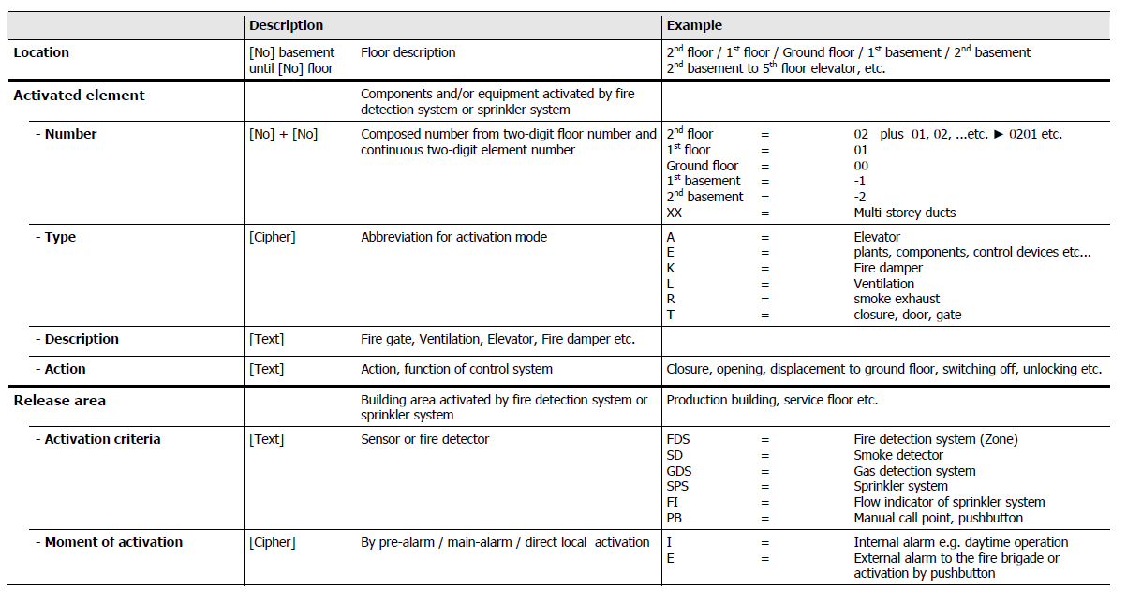

European guidelines
Fire (https://cfpa-e.eu/category-guidelines/fire-prevention-and-protection/)
Guideline No 1 F - Internal fire protection control
Guideline No 2 F - Panic & emergency exit devices
Guideline No 3 F - Certification of thermographers
Guideline No 4 F - Introduction to qualitative fire risk assessment
Guideline No 5 F - Guidance signs, emergency lighting and general lighting
Guideline No 6 F - Fire safety in care homes
Guideline No 7 F - Safety distance between waste containers and buildings
Guideline No 8 F - withdrawn
Guideline No 9 F - Fire safety in restaurants
Guideline No 10 F - Smoke alarms in the home
Guideline No 11 F - Recommended numbers of fire protection trained staff
Guideline No 12 F - Fire safety basics for hot work operatives
Guideline No 13 F - Fire protection documentation
Guideline No 14 F - Fire protection in information technology facilities
Guideline No 15 F - Fire safety in guest harbours and marinas
Guideline No 16 F - Fire protection in offices
Guideline No 17 F - Fire safety in farm buildings
Guideline No 18 F - Fire protection on chemical manufacturing sites
Guideline No 19 F - Fire safety engineering concerning evacuation from buildings
Guideline No 20 F - Fire safety in camping sites
Guideline No 21 F - Fire prevention on construction sites
Guideline No 22 F - Wind turbines – Fire protection guideline
Guideline No 23 F - Securing the operational readiness of fire control system
Guideline No 24 F - Fire safe homes
Guideline No 25 F - Emergency plan
Guideline No 26 F - withdrawn
Guideline No 27 F - Fire safety in apartment buildings
Guideline No 28 F - Fire safety in laboratories
Guideline No 29 F - Protection of paintings: transports, exhibition and storage
Guideline No 30 F - Managing fire safety in historic buildings
Guideline No 31 F - Protection against self-ignition end explosions in handling and storage
of silage and fodder in farms
Guideline No 32 F - Treatment and storage of waste and combustible secondary raw
materials
Guideline No 33 F - Evacuation of people with disabilities
Guideline No 34 F - Fire safety measures with emergency power supply
Guideline No 35 F - Fire safety in warehouses
Guideline No 36 F - Fire prevention in large tents
Guideline No 37 F - Photovoltaic systems: recommendations on loss prevention
Guideline No 38 F - Fire safety recommendations for short-term rental accommodations
Guideline No 37 F - Fire protection in schools
Guideline No 38 F - Fire safety recommendations for short-term rental accommodations
Guideline No 39 F - Fire protection in schools
Guideline No 40 F - Procedure to certify CFPA-E Fire Safety Specialists in Building Design
Guideline No 41 F - Safety instructions for the use and charging of small and medium size lithium
ion powered devices

Natural hazards https://cfpa-e.eu/category-guidelines/natural-hazards/)
Guideline No 1 N - Protection against flood
Guideline No 2 N - Business resilience – An introduction to protecting your business
Guideline No 3 N - Protection of buildings against wind damage
Guideline No 4 N - Lighting protection
Guideline No 5 N - Managing heavy snow loads on roofs
Guideline No 6 N - Forest fires
Guideline No 7 N - Demountable / Mobile flood protection systems
Guideline No 8 N - Ensuring supplies of firefighting water in extreme weather conditions
Guideline No 9 N - Protection against hail damage
Guideline No 10 N - Heavy rain and flash flood; Recommendations on flood prevention and
protection

Security (https://cfpa-e.eu/category-guidelines/security/)
Guideline No 1 S - Arson document
Guideline No 2 S - Protection of empty buildings
Guideline No 3 S - Security systems for empty buildings
Guideline No 4 S - Guidance on keyholder selections and duties
Guideline No 5 S - Security guidelines for museums and showrooms
Guideline No 6 S - Security guidelines emergency exit doors in non-residential premises
Guideline No 7 S - Developing evacuation and salvage plans for works of art and
heritage buildings
Guideline No 8 S - Security in schools
Guideline No 9 S - Recommendation for the control of metal theft
Guideline No 10 S - Protection of business intelligence
Guideline No 11 S - Cyber security for small and medium-sized enterprises
Guideline No 12 S - Security Guidelines for Businesses

Comments and corrective actions:

www.cfpa-e.eu

