Emergency Planning

CFPA-E Guideline No 25:2023 F

New image needed

The CFPA Europe develops and publishes common guidelines about fire safety, security, and natural hazards with the aim to achieve similar interpretation and to give examples of acceptable solutions, concepts, and models. The aim is to facilitate and support fire protection, security, and protection against natural hazards across Europe, and the whole world.

Today fire safety, security and protection against natural hazards form an integral part of a modern strategy for survival, sustainability, and competitiveness. Therefore, the market imposes new demands for quality.

These Guidelines are intended for all interested parties and the public. Interested parties includes plant owners, insurers, rescue services, consultants, safety companies and the like so that, in the course of their work, they may be able to help manage risk in society.

The Guidelines reflect best practice developed by the national members of CFPA Europe. Where these Guidelines and national requirements conflict, national requirements shall apply.

This Guideline has been compiled by the Guidelines Commission and is adopted by the members of CFPA Europe.

More information: www.cfpa-e.eu

Zurich, July 2023 Cologne, July 2023
CFPA Europe Guidelines Commission

Elisabetta Carrea Hardy Rusch
Chairman Chairman

Contents

1 Introduction 4
2 Scope 4
3 Purpose of the emergency plan 4
3.1 What does self-preparedness mean? 6
3.2 The success of the emergency plan depends on the personnel 6
4 Organisation of safety work 7
4.1 Safety manager 8
4.2 Floor, area, or department manager 8
4.3 Every staff membe 9
4.4 Civil defense shelter 9
4.5 Emergency plan or other safety plan? 10
4.6 Who is responsible for emergency planning? 10
4.7 The owner, holder and operator can also be the same entity. 10
4.8 What must the emergency plan at least include? 11
4.9 The emergency plan must contain descriptions of: 12
4.10 Using external consulting in emergency planning 13
5 An example of the phases of emergency planning 14
1. General information 15
2. Preventative measures 15
3. Preparedness and action in case of hazards and emergencies 15
5.1 Starting the process and collecting basic information 16
5.2 Identification of hazards and risks 17
6 Internal risks and external risks in emergency planning 17
6.1 Internal risks 17
6.2 External risks 18
6.3 Identification of risks 20
6.4 Assessment of causes and consequences 21
6.5 Risk management 22
7 Recording conclusions in the emergency plan 25
7.1 Preventive measures 25
7.2 Description of safety arrangements and equipment maintenance 26
7.3 Operating instructions 29
7.4 Preparation for disturbances and state of emergency 32
8 Sheltering indoors 33
8.1 Civil defense shelters 35
9 Communication about the content of the emergency plan 36
10 Comprehensive maintenance of the emergency plan and practical safety 37
10.1 Updating the emergency plan 37
10.2 Training and skills 38
10.3 References and additional information to support emergency planning 40
European guidelines 41

Key words:

Introduction
Taking care of safety is part of the daily routine of every work community. The most important thing is to plan and act before accidents teach you how to do it.

Accidents and damage are often caused by a person's own actions, or the lack of them. Incidents can be reduced and limited by influencing attitudes and practices. It also requires the commitment of workplace management to maintain and improve safety. With good management and organization, employees can also commit to a better safety culture and take responsibility for it.

There are many proactive ways to improve safety in the workplace. The safety work begins with mapping the hazards and risks associated with the operations and the property. Only by identifying hazards can we prevent them from happening. Even a small repair or even a change of attitude can prevent major damage. Each person must also be able to act in dangerous situations and the action must be planned and practiced in advance.

This guideline provides guidance for the workplace on creating an emergency plan and promoting preventive safety work. An emergency plan is a tool that can be used to prevent dangerous situations, but also to minimize damage in the event of accidents. This guideline is designed to support companies, organizations, and communities in emergency planning. However, the size of the company, institution, or other work community, as well as the quality of operations and different safety needs must be considered.

The Finnish National Rescue Association published the original version of this guideline on behalf of the Ministry of the Interior in 2001. The publication was prepared in cooperation with the Rescue Services Department of the Ministry of the Interior, the Espoo Regional Rescue Department and the Confederation of Finnish Industry and Employers. This version of the guideline has been modified together with other CFPA-e members to apply more generally in European countries. Finnish National Rescue Association owns the copyrights to the images in this guideline.

The guideline and its terminology have been updated to reflect organizations’ current safety management and up-to-date legislation several times since then. The original version was updated in 2021 and translated into English and generalized for wider European use in 2023.

Scope
This guideline is primarily intended for those responsible for safety in companies and organisations. It is also addressed to the rescue services, consultants, safety companies etc. so that, in the course of their work, they may be able to help companies and organisations to increase the levels of fire safety.

Purpose of the emergency plan
First and foremost, an emergency plan is drawn up for the users of the property, not for the authorities. The emergency plan shall explain the potential incidents related to the property and the operations taking place there, as well as the preventive measures to counteract risks and preparedness to deal with them.

Preventive measures refer to what needs to be done to prevent the accident from ever happening. Preparedness, on the other hand, prepares for the realization of a potential accident and aims to reduce the damage caused. Preparedness includes, for example, fire alarms and instructions for action in dangerous situations.

It is advisable to draw up different sections of the emergency plan for different target groups: security and safety personnel, all personnel, and all public information. The staff section is recommended to include at least the following items:
- Responsibilities and tasks of staff members in safety issues.
- A brief description of the hazards of the building and operations, as well as their preventive measures.
- How to act in different incidents and property-specific information on technology or other matters affecting operations.
- Information on training available.
- Contact details.

The emergency plan facilitates safety management and continuous improvement. In practice, the emergency plan consists of surveys and measures that have been planned and developed in the building to improve safety. The emergency plan is an excellent tool to ensure that essential safety issues have been investigated and the necessary measures have been taken as planned. However, it is important to ensure that things are recorded as they are, not as they are hoped to be. Creating and updating the plan is a continuous process that is constantly being developed. The plan supports continuity planning, which aims to reduce unexpected outages and damage costs caused by accidents. Furthermore, responsibility issues in different areas of safety will become clearer and the importance of management in accident situations will be emphasized.

The regulations only provide the basis for planning and operations in general, so the work community must identify its own specific characteristics and safety needs. It is also advisable to include things in the emergency plan that are not directly required by the local legislation, but which are nevertheless important for safety.

One of the most important aspects of safety in buildings is evacuation safety. This should be carefully planned and recorded in the plan. The operator is responsible for the safety of its employees and behaviour, also in dangerous situations and accidents. Therefore, the operator must also ensure that the planned evacuation routes for the staff and customers are always in order. Evacuation drills are a good way to ensure this, even if not all exit routes are in the operator's own premises. The property owner is responsible for the building structures, markings and technology related to exits and emergency exits. The property user, on the other hand, is responsible that the technology of the property or the safety of exits is not inoperative by their own actions.

The emergency plan must always be tailored to the specific location, as each location has different risks and safety needs. If the same company has different offices, each office must have its own site-specific emergency plan. Every property and area is different and has diverse risk factors, which means that preventive measures and practices are also different in some way.

What does self-preparedness mean?
Self-preparedness can be described to contain at least the following criteria. The measures also apply to activities outside the building and should be considered also in events and other high-risk scenarios.
- Prevention of fires and other dangerous situations.
- Preparation for the protection of persons, property and the environment in dangerous situations.
- Preparation for extinguishing fires.
- Planning other rescue actions.
- Taking measures to ensure safe exit during fires and in other dangerous situations.
- Facilitating rescue operations.

The success of the emergency plan depends on the personnel
Transitioning safety from plans to practice requires the realization of three parts: the work community has sufficient resources, the personnel have knowledge and skills, and the attitude and culture gives the opportunity to put things into practice.

It is often felt that developing safety is expensive. However, only a small part of safety development involves large financial investments. Developing safety requires a culture in the workplace where people feel it is commonly agreeable and encouraged to do things safely. This means the commitment of both management and employees to take safety into account in all operations. It may sometimes take more time to operate safely but new ways of working become routines, as one gets used to them.

Sometimes it can happen that employees assume the management requires strict cost discipline and work pace, at the expense of safety. Rarely, if ever, does management require this. If only because it would be against the law, but more likely because leaders are human beings too and nobody wants accidents to happen to anyone. Secondly, accidents are expensive and may disturb and pause the operations. Therefore, it is good to ensure there is no opportunity to create and live in the workplace with distorted perceptions of how “in this workplace, things should be done quickly and cheaply” regardless of the damage caused.

Safe practices require that all personnel are aware of the risks related to work, property and the environment, and that they are aware of how to prevent hazards. In addition, staff should be able to identify new risks, report on them and ensure that their concerns are appropriately addressed.

The staff must know how to act in different accidents and dangerous situations. Every employee must know the necessary things about both work and dealing with dangerous situations already during the first shift. Introduction to the most important issues is done immediately, and the induction continues until both parties feel that their knowledge is sufficient. It is good to record the introductions made and sign off on the signatures of the parties. This does not prove that knowledge has transferred into practice, and it does not remove anyone's responsibility if something should happen. However, the document shows that both the employee and the employer agree that the necessary issues have been addressed.

It is recommended to supplement the safety skills of the personnel regularly, for example through education and training. Often these also improve the staff's commitment to safety measures. Training and exercises can be related, for example, what to do in the event of a fire, initial extinguishing, evacuation training, emergency first aid and sheltering indoors.
All members of staff must also know and recognize their own role in different dangerous situations. They must also be given the opportunity to handle security tasks in addition to their own work. It is a good idea to record the tasks of safety work both, for safety development, and operations in dangerous situations separately in the emergency plan. With such safety tasks, there is no additional legal responsibility.

In addition to the exercises, it is good to do regular safety walks and inspections. Observations from these should be written down, so that they can be used in future. In inspections, it is advisable to make use of the different skills and experience within the workplace. A new employee can also have good ideas, not to mention a person with decades of experience. In addition, people from different offices or workplaces can be utilized. Many times, having done the same work in the same workplace, one becomes blind to things and does not notice possible areas for development. An outsider may notice them better. On the other hand, the best expertise is often found in people who does the work and use the facilities in question. Utilizing different experiences certainly brings different points of view.

Even good plans do not help if the management or all employees do not commit to putting safety issues into practice and, for example, practice how to act in dangerous situations. How important safety is really perceived in the workplace can be seen in practical actions. Well-implemented safety is certainly cheaper than accidents.

Organisation of safety work
Local legislation often does not have specific requirements for appointing people to safety tasks, the allocation of roles must be based on the organization's own needs. The persons, their tasks and contact information are recorded in the emergency plan. This chapter presents one example of the organization of safety tasks and the formation of a safety team.

It is recommended to assign overall responsibility for safety tasks in the organization to one person, in which case the coordination of the tasks is clearly up to them. The job title could be, for example, safety manager. Their tasks include monitoring the realization and coordinating safety work. However, additional legal responsibility does not arise from such organizational safety tasks. The employer and supervisors acting as the employer's representatives are legally responsible for the operation of the workplace, including its safety. In addition, it is good to appoint people to cover all workplaces or functions (e.g., floor managers). The safety manager leads a workplace safety team/organization consisting of these persons and they meet regularly, at least 2–4 times a year or more often.

In addition to the safety team, it is good to assign people to the workplace for various safety tasks. These include, for example, those skilled in emergency first aid and fire extinguishing, operators of fire safety equipment and operators of civil defence shelters.

Those appointed to the tasks need sufficient operating conditions to handle the tasks: Know-how, training, use of time, financial resources and the authority to make quick decisions in dangerous situations. The extent of safety tasks affects whether they can be handled alongside one's own work or whether they must be taken care of full-time. The role of communication should also be agreed in advance in case of close calls or accidents.

The safety team should consist of people who are on site as much as possible at the workplace, so that they can guide others in dangerous situations. If it is difficult in the organization to find personnel who are always on site, a wider group of personnel can also be familiarized with the operations of a dangerous situation. For example, in the event of a hazardous situation, the first person to arrive on the site will take the colourful vest intended for the safety team and put it on.
It is recommended for the safety team to put together their own safety kit, which contains the tools needed in dangerous situations and place it in a place familiar to everyone. If a wider group of personnel has been trained in case of dangerous situations, this safety kit should be placed in the agreed place in addition to the colourful vest. The organization itself must consider what supplies the safety team need in dangerous situations. Ready-made evacuation kits etc. are also on the market.

The safety team's safety kit could include, for example:
- Attention vest.
- Whistle.
- Flashlight.
- Post-it notes and reflectors to mark empty rooms.
- Floor plan and areas of responsibility.
- Contact information list: The safety team and other contact information related to the operation of the property.
- A separate kit for the manager, which include, for example, a list of emptied rooms.

Safety manager
It is recommended to appoint one responsible person for each workplace, who ensures that safety issues are planned and implemented appropriately. This does not mean that the person does everything himself, but rather makes sure that those things will be done. There are usually no legal responsibilities with this task, unless defined in the local legislation. The organization can freely decide on a title that suits the culture and activities of the workplace. The safety manager's duties may include, for example, the following:
- Managing a workplace-specific safety team.
- Development and monitoring of building safety and operating procedures.
- Collecting safety-related observations and fixing deficiencies, also organizing safety walks in the workplace.
- Taking care of the preparation of safety-related documents and keeping them up to date.
- Monitoring changes in safety-related regulations and ensuring that the changes are considered in safety documents and practical tasks.
- Ensuring adequate safety training for the staff, familiarizing new employees with safety issues and organizing the necessary exercises.
- Ensuring the availability of safety-related supplies.
- Appropriate inspections of machines, equipment, containers, tools, etc.
- In dangerous situations, acting as a leader of the situation, if present. A substitute person is selected to take the leadership, for when safety manager is absent.
- Making the necessary notifications to the authorities and participation in the inspections carried out.
- Informing the workplace management and staff about safety issues.

Floor, area, or department manager
According to the needs of the workplace, it is recommended to appoint persons responsible for tasks, departments, or parts of the building as assistants to the safety manager. The organization can freely decide on the title that suits the activity best. Tasks can be:
- Development and supervision of a safe property and operating methods together with the safety team.
- Collecting and forwarding safety-related observations.
- Guiding and assisting staff and customers in dangerous situations in accordance with the previously agreed operating model.
- Reporting the situation in the area of their responsibility to the safety manager in case of danger.
- Assisting the safety manager and, if necessary, acting as the safety manager's deputy in a dangerous situation.

Every staff membe
- Maintain safety in the workplace; comply with rules, regulations and instructions given by the employer.
- Is primarily responsible for their own safety and for those close to them.
- Is responsible for what they do and what they choose not to do.
- Is obliged to report immediately any defects they find and report to.
- When possible, is obliged to remove defects or deficiencies that cause obvious danger.

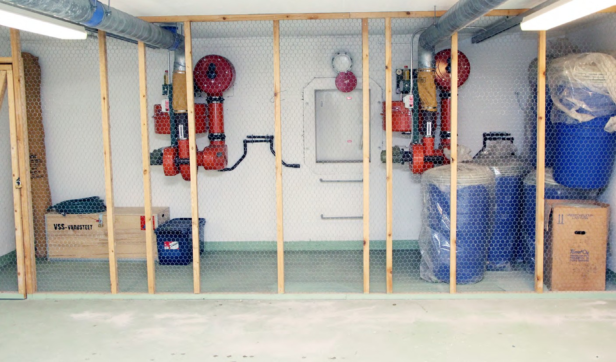

Figure 1: A civil defense shelter. Civil defense shelters are more common in Nordic countries. It is recommended to appoint a shelter manager and their assistant for each civil defense shelter.

Civil defense shelter
Civil defenses are more common in some countries than in others. If there is a civil defense shelter in the building, the responsibilities for the condition and the maintenance of the civil defense shelter depend on the local laws and decisions of the authorities. It is recommended to appoint a shelter manager and their assistant for each civil defense shelter.

It is recommended to hire a property maintenance company to help the shelter manager, because they can help with possible technical issues and minor maintenance. However, they cannot act as shelter managers during the emergency because they cannot be directing people in several shelters at the same time.
There may be courses for the civil defense shelter managers in your country, and they are often organized by the rescue associations.

Civil defense shelter should be in working order (blocking and filtering mode) within the time period ordered by the authorities. It is recommended to prepare a commissioning plan for putting the shelter into use. A written plan helps to execute the various tasks that are necessary when the shelter is needed.

Emergency plan or other safety plan?
The safety requirements of some workplaces are governed by both legislation and regional regulations of several authorities. In this case, it can feel like you have fallen into a jungle of legislations. The work community may be obliged to draw up several different documents in safety, which may partially deal with the same issues. Safety-related documents can include emergency plan, evacuation safety report, safety document, contingency plan, building use and maintenance instructions, as well as documents related to environmental and occupational safety. In addition, for example, hot work plan, documents related to dangerous substances, containers, machines, and equipment. In addition, plans can include a crisis and related communication plan, plans related to a major accident or evacuation, continuity management, etc.

Many of these plans should be combined so that the same things are not presented in several places. If separate plans must be maintained for some reason, it must be ensured that, for example, the instructions related to fire are the same in all instructions. In the best possible scenario, the instructions related to one issue can only be found in one document and the responsibility for updating the document is clear.

Often a separate document called an "emergency plan" is not required if the required information can be found in another document. In this case, it is recommended to include a statement about it in the beginning of the other document, e.g., "the plan contains the information required in the emergency plan”. The emergency plan can also be part of the workplace quality system. The essential thing is not the name of the plan, but the fact that it presents all the necessary issues.

Who is responsible for emergency planning?
There are three parties involved in creating an emergency plan for a building containing workplaces:
- Owner: owns the property (for example, a real estate limited company or a foreign real estate investment company).
- Holder: entity that has general control over the affairs of the entire building (for example, the company's board of directors).
- Operator: uses part of the building for their own operation (for example, a tenant).

The owner, holder and operator can also be the same entity.
Emergency planning is the responsibility of the owner of the building. Their task is to consider the entire building and all the equipment and arrangements that maintain the building's safety. These are, for example, access control of common spaces, crime prevention, fire safety arrangements, agreeing on the internal alarm method, and yard arrangements that ensure the access of emergency vehicles.

When more than one operator in the building is obliged to prepare an emergency plan, the owner of the building shall prepare an emergency plan in cooperation with the operators. Matters affecting the safety of all operators in the building shall be dealt with in a common emergency plan for the entire building. The actions of an individual operator can cause risks to the entire building, for example chemicals, gas cylinders or customers behaving in a threatening manner. The owner of the building is responsible for the joint emergency plan of the building.

In addition, it is recommended for every operator to review the risks affecting their own operations, their prevention methods, and actions in dangerous situations. Based on these, they can prepare a complementary part of the whole building emergency plan.

In particular, the plan must consider operations in different dangerous situations, including evacuation routes and safety technology that are most important to one's own operations. For example, how to operate in a store where a fire alarm goes off or how to make sure there are no one left in the shop in criminal intentions and how to ensure that the money is kept safely in such situation.

By working together and drawing up a joint emergency plan and the supplementary section of the operator, the operation of the entire building is covered uniformly. The implementation of cooperation is especially important when there is a nursing facility or service or apartments intended especially for vulnerable groups of people (eg. elderly) the building.

The building may also have small offices whose operators cannot be obliged to draw up their own emergency plan. However, since accidents and damages do happen and since the self-preparedness shall be considered by these operators, as well, it is also their responsibility to investigate their safety issues. Therefore, in these cases it is worth to consider making an emergency plan in some form. The owner of the building must ensure that all operators of the property know the contents of the building's common emergency plan and especially, how to operate in dangerous situations. In addition, the owner of the building can plan together with smaller operators the necessary measures for them.

What must the emergency plan at least include?
Each emergency plan is individual, and its content is determined by the needs and special features of the workplace. The industry, size, risk factors and the need and ability to prepare for, for example, rescue measures are different in different workplaces. Therefore, it is impossible to build a completely universal model content of the plan, but the basic things in the plan are very similar in content. In addition, you can get good tips for your own plan from people working in the same industry.

When using existing models, it is important that the result is completely target-specific and that its presentation is suitable for one's own operation. When using example model texts of a plan that is drawn up for another site, it is important to ensure that all the information shown in the final plan applies to one’s own site and remember to remove things that do not apply to it.

The table of contents should be modified to suit the activities of the operator. The minimum requirements for the content of the emergency plan are often given in each countries law, regulations, or legislations. The minimum requirements set by these can be, for example, are as follows.

The emergency plan must contain descriptions of:
- Conclusions from risk assessment. Conclusions mean a comprehensive understanding based on risk assessment of where various accidents or disruptions can be caused and what can result from them. The emergency plan therefore not only records a list of risks (e.g. fire, water damage), but also their causes and consequences. The risks should also be specific enough to allow countermeasures, so instead of identifying “fire” as a risk, the likely origins (ie. high probability locations for fire) should be identified.
- The safety arrangements of the building and the premises used in the operation. The safety arrangements mean, for example, structural solutions, technical devices, and equipment used to maintain the safety of the workplace. Safety arrangements include, for example, fire alarms or smoke detectors, fire compartments, smoke extraction and exits. The emergency plan not only includes a list of the various safety arrangements, but also where they are located and what the users of the building should know about them (for example, the locations of the extinguishing equipment and emergency exits). The maintenance of safety arrangements should also be considered in the emergency plan.
- Instructions for residents, personnel and other persons to prevent accidents and how to act in accidents and dangerous situations. Preventive instructions shall refer to concrete instructions, by means of which it is possible to prevent the realization of risks (for example, sanding the yard in slippery weather or instructions on preparing for hot works so that no damage occurs). Operational guidance, on the other hand, refers to guidance that can be followed to minimize the consequences and damage caused by realized risks (for example, extinguishing and evacuation in the event of a fire).
- Possible other measures related to self-preparedness of the workplace. These measures can be, for example, evacuation drills, internal safety walks and the preparation of the civil protection shelter for use and its maintenance.
- How self-preparedness is implemented in exceptional circumstances. This means, for example, a regional or national crisis that requires preparation, instructions, and the skills of personnel, such as prolonged disruptions in the electricity, information network or the use of civil defense shelter. These measures are practically the same as under normal circumstances, but they must be done in particularly challenging circumstances and on their own, possibly without the help of the authorities.
- If unusual use and/or a temporary change in the way of use takes place at the site, the emergency plan must also include a description of special safety arrangements that are prepared for the risks caused by the site's exceptional use. Exceptional use or temporary change of use refers to an activity in which the building or its surroundings are used for a purpose for which it was not originally designed. An example of this is a school that is used for temporary accommodation or office space where the organization's big parties are organized.

In practice, the content requirements mentioned above can therefore mean, depending on the object, describing the following things in the emergency plan:
- Identifying hazards and their prevention.
- Accidents and disruptions.
- The premises' safety arrangements, including the completed floor plan with markings.
- The safety arrangements of the premises, including a floor plan supplemented with markings.
- Civil defense shelter (in the building or nearby.
- Instructions for dealing with danger and disturbances, including the damage limitation
- In-house control of risks.
- Safety walks, internal inspections.
- Close-call records, monitoring of accidents and incidents.
- Training plan and register, including exercises and orientations and related forms (orientation list, forms related to evacuation training).
- Various forms to maintain safety.
- Special instructions for the maintenance and inspection of machines, equipment, tanks, etc., also for managing crises or damage limitation.

Using external consulting in emergency planning
It may be worth hiring an external expert, for example, if the issues under consideration seem too difficult to resolve on your own or if no resources are allocated to it at the workplace. However, it should be remembered that the emergency plan is only a report on how safety issues have been implemented in the building. So, in most cases, the best skills of the workplace and the building can be found in the employees themselves, but they may not have the time to prepare the plan.

Several external consulting companies offer services in which they prepare an emergency plan for the customer based on the information obtained from the site and physical visits. Often, the services also include an online platform through which the subscriber's personnel can familiarize themselves with the emergency plan and update it. If a rescue plan drawn up by an external party does not end up in a format that can be saved on the subscriber's own online platform, it must be ensured that it can otherwise be obtained in an easily updated format (for example, a clear and easily updated Word document).

When utilizing external consulting, it can often be a problem that the emergency plan becomes too general and that updating the plan is not anyone's responsibility. In addition, if the consultant does not make extensive use of the knowledge and expertise of the site's personnel, it is likely that all the essential risks will not be identified. The site's own personnel are often the best experts in identifying the risks and special features of their environment. In addition, it is good to remember that the responsibility for the correctness of the plan always rests with the owner of the building or, in the sections concerning its own operations, with the operator and, ultimately, with its management.

At best, consulting services can be easy-to-use tools for informing and training about the plan and maintaining the plan. However, this requires that the content of the emergency plan is site-specific and that the plan is also taken to a practical level, which requires, for example, the following measures:
- Ensuring the emergency plan drawn up by the consultant corresponds to reality and all risks identified by the organization itself have been taken into account.
- Familiarization with the emergency plan and its practical effects has been planned. It can be implemented, for example, in connection with a safety walk, and participation is confirmed in writing.
- The work community has been informed about how and where to access the emergency plan (online service, intranet, written version, for example in the coffee room).
- There is a person in charge of the emergency plan at the workplace who regularly checks that the plan is up to date and makes any necessary changes to it.
- The organization can make the necessary small changes themselves, and they do not always have to be ordered separately from the supplier.

An example of the phases of emergency planning
This chapter describes an example of the stages in the preparation and implementation of an emergency plan. Every property, workplace, and activity there is different, so the needs related to the emergency plan also vary. However, by following these example steps, the preparation of the emergency plan starts in a controlled and planned manner, and the course of the process is clear before the work starts.

Figure 2: Diagram of the process of preparing the emergency plan.

Each site has individual needs regarding the contents of the emergency plan. All information relevant to the emergency plan does not necessarily have to be recorded in the emergency plan itself, but the emergency plan must contain information about where those documents can be viewed. This is important information for both the site's personnel and the authorities.

EMERGENCY PLAN (example)

General information
  - Information about the area, property and operations
    - Property structures and safety engineering
    - Chemicals used and their hazards
  - Safety organization and its tasks
    - Each employees’ responsibilities
    - Allocation of responsibilities in a hazardous situation
  - Informing
  - Base and layout plans

Preventative measures
  - Risk assessment and preventive action by risk
  - Safety walks
  - Induction
  - Staff safety training
  - Emergency plans and safety documents for public events

Preparedness and action in case of hazards and emergencies
  - How to make an emergency declaration
  - Fires
  - Sheltering indoors
  - Disturbances in energy, water, or waste management
    - Power outages
    - Contaminated water or disruption of the water supply
    - Disturbances in waste management
APPENDICES:
Appendix 1 Floor plans of the property
Appendix 2 Site plan of the area
Appendix 3 Contact details
Appendix 4 Risk assessments
Appendix 5 Safety walk document
Appendix 6 Induction material for staff members
Appendix 7 Public instructions for action in the event of an emergency
Appendix 8 Instructions for staff in gaz hazards
Appendix 9 Instructions for staff in case of fire
Appendix 10 Instructions for staff in first aid situations
Appendix 11 Quick instructions for staff on the safety of chemicals in use

Figure 3: An example of the table of contents of an emergency plan.

Starting the process and collecting basic information
The preparation of the emergency plan begins with the selection of the responsible persons and other persons participating in the preparation of the plan. It is advisable to appoint one or more persons with the main responsibility for the preparation of the emergency plan, who will be responsible for the progress. When selecting other participants in addition to the person in charge, the following questions can help with the selection:
- Who will be responsible for updating the emergency plan after it is completed?
- What kinds of facilities, functions, safety arrangements and technical solutions are there, and who knows them best?
- Who knows best the operational methods and practices of the different functions of the company?
- Does the company already have safety personnel who could participate?
- Does any of the staff have experience in risk management?

Personnel may not need to be involved in the entire emergency planning process, but can only be used, for example, in the evaluation of dangers and risks.

Once the persons participating in the preparation of the emergency plan have been selected, the division of labor and schedules are drawn up. After this, planning begins with mapping and compiling the information. This means collecting information on the current state of the site's safety. Various safety-related documents can be used in the mapping, such as previous emergency plans, fire inspection documents and reports on accidents and close calls that have occurred at the site. In addition, basic information related to the safety of the property is compiled, such as the number of floors, staircases and elevators and the estimated number of people working in the property daily (if there is shift work, how many people are estimated to work in each shift).

It is also recommended to record the contact information of the persons responsible for safety with their areas of responsibility in a separate appendix of the emergency plan. In this way, essential contact information can be easily found in one place and updating them is also easier, and the plan does not have to be approved by the company's management after contact information changes. The names and phone numbers of individuals are likely to be information that changes more often than other information. The site and its size affect who is responsible for safety, but these contact details may include:
- The owner/occupier of the property,
- safety manager and possible deputy,
- floor/area or department managers,
- fire alarm, sprinkler and smoke ventilation systems operator (when any) and backup personnel and any other persons trained to use the equipment,
  - these must always be persons working at the site who have received training in the use of smoke detectors - so this section cannot include the contact details of the property maintenance, if they are not specifically trained for the use of these equipment and responsible for their maintenance,
- house manager or property owner,
- property maintenance, if necessary, their separate emergency number,
- security company,
- people who have received first aid training,
- civil defense shelter operators,
- occupational safety representative and deputy delegates,
- other external information necessary for the management of the property: fire extinguisher, electrical company fault report, insurance company, fire extinguisher service, waste and hazardous waste management, elevator maintenance company and emergency number, etc..

Identification of hazards and risks
The risk assessment serves as the basis of the entire emergency plan. On its basis, decisions are made regarding the site's safety planning and the necessary measures. The emergency plan must include the conclusions of the hazard and risk assessment. This means:
- Identifying hazards and risks and evaluating their causes and consequences.
- Recording the conclusions drawn from the assessment.

Many laws may require hazard assessment at workplaces. Usually it is required that the risks of the property, its operations and the environment should be assessed regarding the safety of employees, customers, residents of the area or the surrounding area, and passers-by. In addition, hazards related to work performance and the work environment shall be assessed. It is recommended to combine risk assessments if it is possible, but it must be solved on an organizational basis. It is essential that the evaluations are consistent if they are done separately.

The most important thing is to investigate what can happen, why, and what can result from it. When doing the evaluation work, unusual use of the site and a temporary change in the way of use must also be considered. For example, use of the hall for multiple purposes (fairs, etc.), use of the school building for accommodation purposes, and hosting events for invited guests. Such cases are characterized by an increase in the number of people compared to the normal use of the building's premises and/or a change in the way of use, in which case the risks can also be substantially greater than usual. Abnormal use of the building can also cause completely new risks, which must be considered in the risk assessment.

If a possible unusual use or a temporary change causes an increase in risks or creates new risks, it is worth creating its own section in the emergency plan for dealing with these and preparing for them. For example, large public events gathering several hundred people, or events that causes unusual risks to the property, bystanders and the environment, e.g. risks involving traffic.

Internal risks and external risks in emergency planning
Workplace risks can be divided into internal and external. Internal risks are often easy to identify, because they are related to the activities taking place in the property and their magnitude, and it is also easy to influence their realization. External risks can be more difficult to identify because their realization can rarely be influenced by oneself. However, by being prepared for external risks, the amount of damage caused can be minimized.

Internal risks

Workplace machines and equipment remain safe for their users when their maintenance is taken care of. Hazards and risks often arise from people's everyday activities and behavior: are safety instructions always followed, or is it customary to take risks due to urgency or other reasons.

Accidents caused by human error, mistakes and misunderstandings or lack of knowledge often originate from hidden problems in working conditions. Deficiencies in organizational and management skills expose employees to mistakes, carelessness and risk-taking. Accident risks are usually caused by insufficient safety instructions, poor working equipment, hard-to-reach safety equipment, disorganization, constant haste, excessive overtime, and insufficient training or information flow.

Typical internal risks of the work community are accidents, vandalism, crimes and risks related to information security. The use of dangerous substances also involves potential environmental damage. It is necessary to find out how a release, leak, explosion or other accident could cause soil, water or air pollution. Errors in technical or information systems may also cause an accident, hazard, or damage. Possible risks outside the office building should also be investigated, such as snow falling from the roof and slippage in the yard or pedestrian area.

The most common type of accident leading to death or hospitalization is stumbling and falling. Falls therefore cause a particularly large number of sickness absences. Most falls occur on flat ground. Typical things that cause falls indoors are wet or snowy footwear, slippery floor material, water or other slipperiness-increasing substance on the floor on walkways. Slippery conditions outdoors and footwear unsuitable for the weather cause a lot of falls. Preventing slippery conditions is one of the most important safety-increasing measures, even if the hazard sounds very ordinary or modest.

Figure 4: One of the most common types of accidents leading to death or hospitalization is stumbling and falling. Therefore, combating slippery conditions is one of the most important safety-increasing measures.

External risks
Workplaces may also be at risk for reasons beyond their control. Is the location of the work community such that danger can arise, or is there dangerous activity nearby? In these matters, it is advisable to cooperate with the rescue authority, which has investigated and evaluated the dangers and risks in the area when defining the service level of the rescue operations in the area.

Typical threat factors are large fires and chemical accidents as well as traffic accidents on busy intersections and at bus and railway stations. An accident, hazard and damage situation can also be the result of criminal activity, vandalism or sabotage. Interruptions in the supply of electricity, water or heat can cause unexpected situations, as can floods, storms or other natural forces.
Exceptional circumstances are external threats that must also be prepared for. These are typically major accidents related to, for example, electricity distribution or information networks, which cannot be controlled with the authorities' normally available resources. Exceptional circumstances also include a state of war or the threat thereof, or when there is a particularly serious threat to economic life or a widespread dangerous infectious disease.

The possibility of arson should be considered. Maintaining order and cleanliness prevents arson, which, according to statistics, accounts for about a third of all building fires. The prevention of dangerous situations and accidents is also significantly affected by the storage of dangerous substances, the storage of goods and waste at a sufficient distance from buildings, security and access control. Adding sufficient lighting is a good and inexpensive way to combat criminal activity in the area.

It is recommended to check the insurance company's protection/safety instructions, at what distance from buildings you can store waste containers and other flammable items. In any case, the terms of the insurance should be read carefully so that there are no surprises with damages. In addition, they often provide good tips. Insurance companies are often happy to assist in developing the safety of the property. They have the same goal as the policyholder; that no damage will occur.

Risks related to repair and modification work can be reduced with proper planning. In this case, special attention must be paid to hot work safety. Hot work is work where sparks are generated or where flame or other heat is used, and which creates a fire hazard. The most common hot wors are gas and arc welding, torch and arc cutting, blade cutting, metal grinding and hot air blasting.

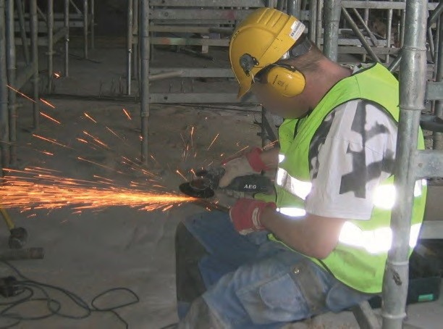

Figure 5: Risks related to repair and modification work can be reduced with sufficient planning. Special attention should be paid to hot work safety.

The work community should draw up permanent instructions for safe hot work - a hot work plan - which will be attached to the emergency plan. When working with fire, the insurance company's instructions for working with fire must be followed. Information on the hot work plan and safety in hot work can be found in CFPA E Guideline No 12 “Fire safety basics for hot work operatives”.

Figure 6: Example of a risk assessment process.

Different systematic methods can be used in risk assessment. With their help, the risk assessment produces considered results, which are also documented so that they can be used in emergency planning. Some examples of such methods are named in the following sections explaining the risk assessment process.

However, it is important to note that the more challenging the method is to implement, the better expertise it requires from the method leader and participants. The emergency plan does not require any special risk assessment method, so the risk assessment can be done at it simplest in a very simple way by identifying the risks and considering the necessary preventive measures.

Identification of risks
In its simplest form, identifying hazards and the risks they cause means compiling a list of probable hazards and situations. Risks can be, for example, fire, falling, gas danger in the immediate area, illness, and electric shock. Each site has different risks, so they must also be identified site-specific. When evaluating the risks of a workplace, the risks observed in other workplaces or listed in various models can be used as help, while remembering to remove the risks that do not apply to one's own workplace, and to add the missing risks.

A risk assessment compiles the identified hazards and their probabilities. The concept of risk in this context includes the information about the unwanted event, its location, causes, consequences and the probability, i.e.. how often the unwanted event identified is likely to happen. By compiling the consequences and the probability, different risks can be quantified and listed based on their seriousness (magnitude).

When identifying risks, it is highly recommended to use the work community's knowledge of risks. In the risk identification phase, it is worth choosing people from the work community as versatile as possible from different functions. For example, in a factory specializing in food production, a versatile selection can mean, for example, machine operators and -custodians, line workers, reception and dispatch workers, forklift drivers as well as line supervisors and trainers. When identifying risks, you can also make use of documents and other material that have been mapped during the start-up phase of emergency planning (see section 3).

Examples of identification methods:
- Safety walk,
- brainstorming or meeting.

Risk identification is never completely ready, because the surrounding world and workplace operations may be constantly changing. There will be new people and new know-how, and some know-how may disappear. Environmental risks are also changing. It is good to evaluate the identification of risks regularly and from different perspectives. In this way, risks will be assessed as comprehensively as possible. Among other things, the following variable factors can be used in risk assessment:
- Members of the risk assessment team, e.g. in kindergartens and schools, children can also participate in the risk assessment - however, the assessment must be guided by a person who coordinates the whole and understands the basics of risk assessment,
- different functions: assessment by department, workplace, etc.,
- Safety aspects of the property, for example regarding the yard and road area,
- different seasons,
- different times of the day.

Assessment of causes and consequences
When the various risks have been comprehensively identified, it's time to consider what things or events may lead to their realization (for example, to a fire). When assessing the causes and consequences of risks, it is also worth making use of the experience of the working community as far as possible. Causes and consequences are assessed for each identified risk.

What can cause it?
What can happen?
What are the consequences?

Figure 7: Assessment of causes and consequences.

There are many reasons for risks to materialize, and they can also materialize because of various chains of events. For example, the causes of a fire can be equipment failure, forgetfulness, carelessness, hot work, arson, and smoking. Once the reasons for the various risks have been identified, it is necessary to consider how these reasons could cause the risk to materialize. For example, can forgetting or carelessness in using the device cause a fire or electric shock? Is there anything on the wall of the building that an arsonist could set on fire? Is the Smoking area too close to an area where flammable substances are stored or used?

Consequences of the realization of risks can be, for example, injury or death, full or partial interruption of operations, material damages and financial losses, as well as environmental damage. The realization of the risk can also cause several consequences at the same time.

Risk management
Once the causes and consequences of the risks have been assessed, decisions can be made for each risk as to whether measures, i.e. preventive measures, are required to control them. Preventive measures mean, for example, processes, practices, devices, equipment, and training that can be used to eliminate or reduce risks. In addition, there are situations where only certain risks are accepted. However, preventive measures aim to minimize the risk to at least a tolerable level. For example, walking outside in slippery weather: we know that there is a risk of falling, but we try to minimize it with appropriate footwear, cleaning, and sanding, and watching where we step.

Risk elimination |  | Risk reduction
 | The hazards that cause the risk to materialize can be removed.  Example: the risk of slipping on the stairs can be eliminated by installing non-slip barriers on the stairs. Eliminating the risk is the primary option, especially if the consequences of the risk are significant or serious. |  | However, even serious risks, such as the risk of fire, are not always possible to completely eliminate.  When it is not possible to eliminate the risk, the probability of its occurrence, the seriousness of the consequences and/or the exposure to the source of the risk can be reduced.  The risk can be reduced, for example, with safety technology, personnel training, instructions, personal protective equipment or by changing the activity that causes danger to a safer one.  Example: the risk of accidents caused by a dangerous chemical can be reduced by replacing the chemical with a less harmful one.

Table 1: Risk elimination or risk reduction.

The magnitude of the risk is affected by its probability, frequency and the magnitude of the damages and their consequences. The assessment of the magnitude of the risks provides the starting point for how management measures are prioritized. However, with the help of systematic identification, there are often so many risks that it is not possible to eliminate or reduce them all. If a risk is assessed as minor or insignificant, it may only require monitoring in case the risk in question develops more seriously. On the other hand, if a small risk can be easily eliminated or reduced, it should be done right away.

In terms of risk management, it is important to identify the problems that require the most urgent measures. These include the most common hazards and the most serious risks.

A risk matrix can be used to assess the magnitude and severity of risks, and it also helps with prioritizing them. However, using the risk matrix and finding a common evaluation method requires a common line within the organization and an understanding of, for example, the magnitude or severity of the risk. Therefore, using a matrix always requires a person to guide the assessment. The person must have a basic understanding of risk assessment and its challenges to obtain the most reliable assessment of risks.

The assessment of the probability and seriousness of risks is always a subjective, and it may not reveal the real or exact magnitude of the risk. For the same reason, there should be one person guiding the risk assessment, so that the assessment remains similar throughout the process and the final magnitudes of the risks are as comparable as possible.

The assessment of the magnitude of the risks is influenced, among other things, by the people making the assessment, their own perceptions, prejudices, and the level of knowledge about the risk being dealt with and its various dimensions.

In addition, for some risks, it is not possible or reasonable to estimate a single correct probability, but their realization depends entirely on the adequacy and functionality of preventive measures. For example, the probability of a fire is affected by how well preventive measures have been implemented. If the property has faulty electrical equipment or poorly made electrical installations, the probability of risk increases significantly. Therefore, the risks of fire should be assessed according to the cause of the danger, each one separately.

Regarding the emergency plan, the risk assessment can also be done without using a risk matrix or other similar tool. In this case, after identifying the risks, the risks that cause serious damage and the most common risks are assessed on a general level. The means of preventing these risks are solved first and then other risks are considered. It would be essential to identify the large and small risks and get them in some sort of order of importance.

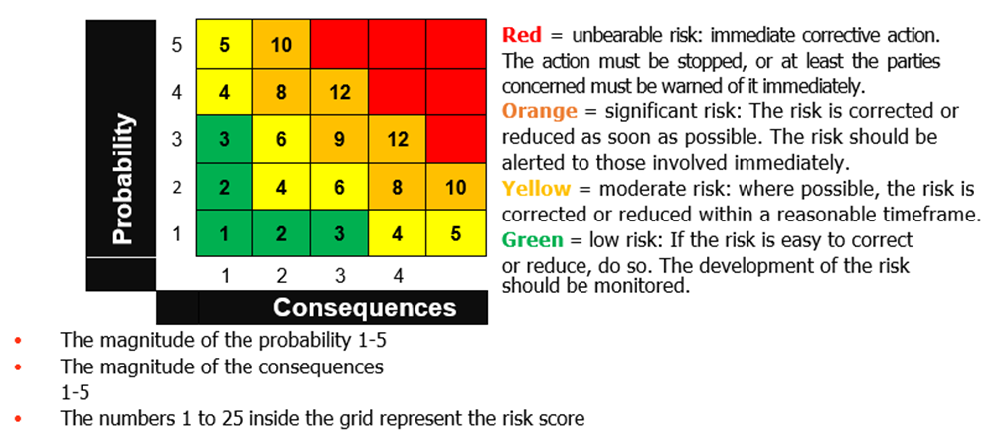

Figure 8: Risk number matrix.
The higher the risk score (1-25) is in the matrix, the higher the risk is. If the consequences of the risk are serious, the risk should always be eliminated, regardless of the probability, if possible. In addition, if the consequences of the risk are very small, but its probability is very high, it is worth removing the risk in question.

Evaluation criteria are needed to define a risk score. The evaluation criteria must be considered suitable for each site's own operations. The evaluation criteria should be thought out in each destination to be suitable for their own activities. An example table of how the criteria could be defined:

Criteria for the probability |  | Criteria for the consequences
5 | Very likely – can happen more than once a year. | 5 | Very serious injury leading to permanent loss of working capacity or death.  Major environmental damage that requires significant resources to be managed and repaired.  Costs: €100,000 - €500,000
4 | Likely – can happen once a year. | 4 | Serious injury resulting in sick leave of more than 30 days and reduced ability to work.  Extensive environmental damage, which requires considerable resources to be managed and repaired.  Costs: €50,000 - €100,000
3 | Possible – can happen once every five years. | 3 | An injury that requires a hospital visit and less than 30 days of sick leave.  Environmental damage that requires moderate resources to get under control and repair.  Costs: €10,000 - €50,000
2 | Unlikely – can happen once every 5–10 years. | 2 | A minor injury that can be treated on the spot.  Slight environmental damage, which can be managed and repaired with small measures.  Cost: 0–10 000€
1 | Very unlikely – not necessarily ever or less than once every 10 years. | 1 | Small damage to a person, environment or property that has no impact on the operation or its continuity.

Table 2: Definition of risk criteria.
An example:
At Anni’s Apple factory, a risk has been identified: "Hot applesauce is leaking from the large stewing pot onto the workers' walkway". The factory wants to find out the magnitude of the risk. CEO Anni and five members of the work community come to the following conclusion:
- Leakage of the boiler is possible due to its condition, so according to the criteria table, it gets a probability of 3, i.e. possible risk.
- The applesauce is fiery hot, so if it drips on the staff's neck, it could cause very serious consequences, in which case the consequences get a score of 5.
- After this, the crossing point of the probability number 3 and the consequence number 5 is looked at in the risk matrix according to the adjacent picture (Figure 9).

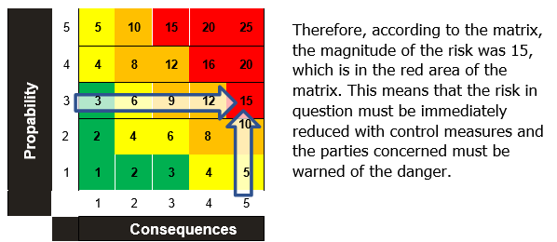

Figure 9: Example of a risk matrix

Recording conclusions in the emergency plan
In practice, the risk assessment conclusions recorded in the emergency plan mean that the plan summarizes the risks found to be the most significant based on the risk assessment, as well as their possible causes and consequences. Measures and instructions are recorded to prevent the occurrence of these most significant risks, either in connection with the conclusions or as a separate section in the emergency plan. The entire staff must be aware of the most typical and serious workplace risks.

Preventive measures

Based on the risk assessment, conclusions are made about which are the risks that can be prevented with written instructions. The instructions may be related to, for example, fire risk, accidents or building technology. The instructions do not necessarily have to be part of the emergency plan, but the emergency plan must contain an explanation of what instructions have been given and a summary of their content. Regarding preventive instructions, note at least the following:
- Preventive guidelines are prepared for all risks that can and need to be addressed by issuing instructions.
- It is possible to follow the instructions in practice.
- The instructions are site-specific as far as necessary.
- The instructions are easy to understand.
- When preparing the instructions, different user groups are considered, for example they are translated into different languages.
- The instructions are put into practice through orientation or other means.
- Photographs taken of the site and site maps should be used in operating instructions, for example a photograph of the meeting place and a site map with the nearest fire-fighting equipment marked on it.

Example of preventive guidance:

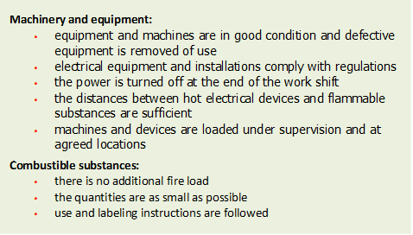
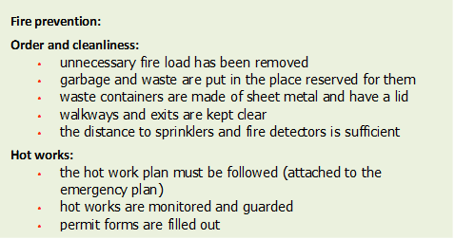

Description of safety arrangements and equipment maintenance
Safety arrangements mean, for example, structural solutions, technical equipment and acquired equipment. Each workplace requires fire extinguishing equipment and first aid equipment. These are usually required by regulations and by the insurance company (see the insurance's protection/safety instructions) and in some cases by the authorities. In addition to this basic equipment, safety equipment required by special hazards related to workplace-specific activities may be needed. These can include, for example, equipment necessary to combat chemical hazards. For civil protection shelters, equipment for putting the shelter in order is needed, as well as equipment for emergencies, such as rescue and clearance equipment and personal protective equipment.

The purpose of safety arrangements is to promote quick and efficient operation and to minimize the amount of damage during and after an accident. Workplace safety arrangements may include, for example:
- Fire compartments,
- fire alarm system or smoke detectors,
- automatic fire extinguishing system,
- fire extinguishing equipment,
- smoke extraction devices,
- ventilation devices and a kill switch button,
- main water shut-off,
- main electric switchboard,
- safety light center,
- evacuation arrangements.

The safety arrangements are described in the emergency plan in the context of risk and its management. Therefore, it is not necessary to prepare a separate list of existing arrangements, but to record the safety arrangements for the risk in question, for example, in the operating instructions. This ensures that the staff knows how to act correctly in dangerous situations and utilize safety equipment and tools.

The following example illustrates what could be written about fire extinguishing equipment in the rescue plan:

It is advisable to attach drawings to the emergency plan, such as diagrams of the smoke detectors and the emergency department's contact information, if such are available. Important safety issues, such as the locations of the fire extinguishing equipment, should also be marked on the station, building and floor plans. The drawings can be used in staff training events and orientation. In the same context, the possible need to update the drawings can also be observed.
All fire-fighting equipment is marked with appropriate signs. All personnel have received fire extinguishing training. The exact locations of the fire extinguishers can be found in the attached floor plan.

Fire extinguishers are inspected and maintained according to the contract:

Extinguisher maintance company, T. +358 401234567.
Location and type of fire-fighting equipment:
- Operation room A: 3 dry powder extinguishers, 43A 183B C
1 liquid extinguisher, 43A 233B
- Operation room B: 2 dry powder extinguishers, 55A 233B C
- Coffee room 1 fire blanket
- Server room 1 CO2 fire extinguisher 89B

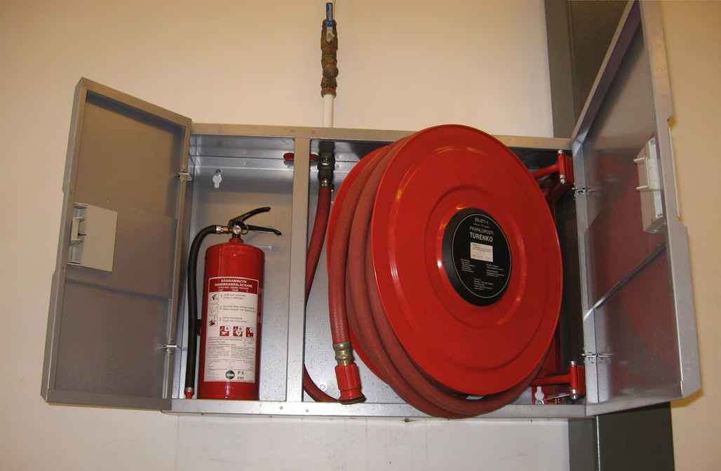

Figure 10: Photographs of the fire extinguishing equipment in your building illustrate the fire extinguishing equipment available.

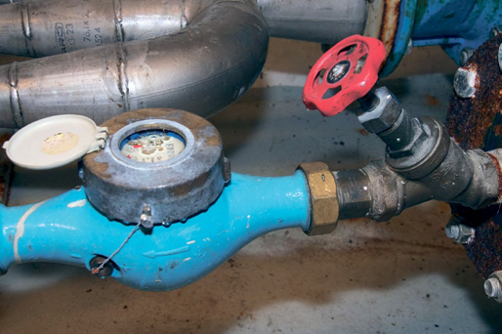

Figure 11: Main water shutoff.

It can also be considered good practice to add photographs taken at the site to the safety arrangements. Pictures can be used to illustrate, for example, what a device or switch looks like. What kind of images can be useful depends on the site in question. They can be, for example, pictures of the fire alarm center, fire extinguishers, fire hydrants, the main water shut-off and the meeting place.

A separate table of the maintenance measures, their frequency, responsible persons, and the person implementing the practice must be made as an annex to the emergency plan. Or alternatively, they can be marked in the electronic system used at the workplace, to which the plan refers. It is recommended to write down the maintenance procedures for each piece of equipment. The plan tells you where to find up-to-date maintenance information. In this way, it is easier to understand the overall maintenance of the safety arrangements related to the emergency plan and to monitor its implementation.

Inspections, tests, maintenance or other measures of devices and equipment that require maintenance are planned and taken responsibility for. In addition, it is important that the implementation of maintenance is actively monitored in practice. The maintenance of these devices and equipment is particularly important:
- Fire alarm equipment,
- automatic fire extinguishing equipment,
- evacuation alarm and safety announcement system,
- exit lighting system and signs,
- smoke extraction equipment,
- fire extinguishing equipment,
- fire protection systems or door closers for fire doors,
- civil defense shelter equipment and devices,
- other equipment in the property that can cause dangerous situations, for example elevators, lifting equipment etc.

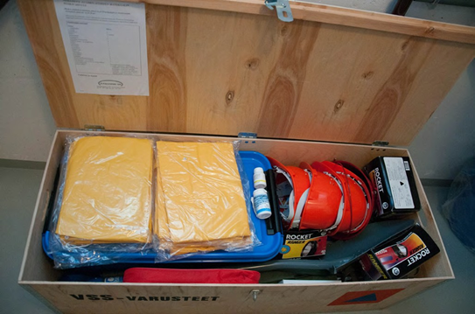

Figure 12: Civil defense shelter supply box.

The above-mentioned devices must be kept in working order and properly maintained and inspected. The owner, holder and operator of the building are together responsible for the arrangements of the building's general facilities and the entire building. The occupier on the other hand, is responsible for the equipment for the premises under their control.

Appropriate maintenance and inspections depend on the device. It is a good practice to follow the device manufacturer's instructions for use and maintenance, unless the legislation specifies the matter in more detail. The service and maintenance instructions for the safety devices should be kept available to everyone who needs them and should also be included as part of the building's operating and maintenance instructions. Separate regulations have also been issued for the maintenance of several devices, such as hand fire extinguishers, smoke detectors, fire detectors and automatic extinguishing equipment.

Operating instructions
In case of dangerous situations, it is recommended to prepare different levels of operating instructions for different users. For example, it is good to prepare public instructions on the wall for fires, as well as separate instructions for the staff and the safety team. With the help of the instructions, everyone knows their own role and can minimize the effects of hazards. Operating instructions are prepared for all dangerous situations for which instructions are necessary based on a risk assessment.

The common instructions for staff can also be attached to the emergency plan, one instruction per page. In this case, the instructions can be easily updated, printed, and collected in one place. The safety team's instructions can also be in attachments or in the actual plan, whichever way suits the plan better. The public instructions contain basic information, such as how to get information about dangerous situations in the property, how to act in situations, how to call for help and where to gather outside.

If external persons use the premises of the property without the staff present, it is assessed what other contact information they need in case of unexpected situations. Unexpected disturbances or dangerous situations, of which the real estate representative must be informed immediately, can be equipment failure, risk of fire, door locks not working, water damage, sewage drains being blocked or flooded, or some device giving an alarm or beeping. External users can be, for example, in gyms, study, hobby or gathering spaces.

Regarding the operating instructions, at least the following points should be considered:
- Operating instructions are drawn up in case of hazards and accidents considered possible based on the risk assessment.
- It is possible to follow the instructions in practice.
- The instructions use terms and images familiar to the organization.
- The instructions are site-specific, they show:
  - How to get information about the danger, for example fire alarms or smoke detectors,
  - how to warn others about the danger,
  - where to go in the event of danger – outside or to the next fire compartment,
  - equipment and other aids in case of danger,
  - evacuation routes, fire compartment boundaries, fire extinguishers, meeting place - the clearest way to present these is to mark them on the floor plan.
- If necessary, the instructions are also translated into different languages.
- The instructions are clear and practical. Note that there are hazards where the action and steps depend on the nature and progression of the hazard, for example fire. Different situations can be considered in the instructions, but the general instructions should be kept very simple.
- If necessary, the instructions will be tailored to the workplace.
- General and public instructions or, if necessary, also staff instructions are posted in a visible place in public spaces or workplaces. Evaluate the public instructions on a workplace-specific basis to ensure that they do not attract outsiders to criminal activity.
- The safety team's own instructions must clearly state the areas of responsibility and how to act in practice, for example the locations of circuit breakers and equipment.

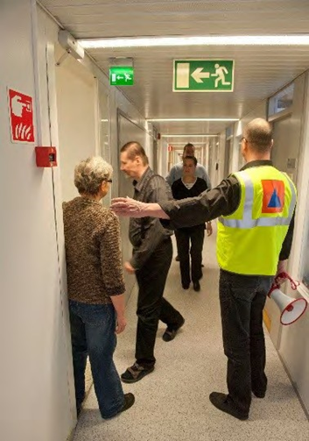

Figure 13: Evacuation through emergency exits.

An example of a fire procedure:

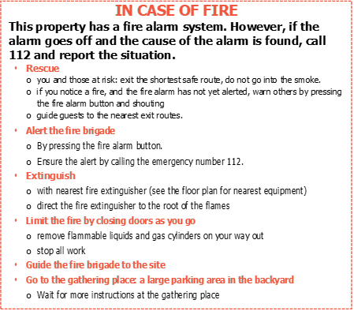

Preparation for disturbances and state of emergency
The emergency plan must include a plan on how the organization is prepared for disruptions and states of emergency.
Disturbances may include:
- Disruptions in electricity distribution,
- network outages,
- disturbances in municipal technology, for example related to heat and water distribution or sewage networks,
- storm,
- floods,
- water epidemics.

States of emergency, on the other hand, are events that seriously threaten the nation. For example:
- An armed attack or an attack comparable in severity to it and its immediate aftermath (the threat of such an attack is also counted a state of emergency),
- a particularly serious event or threat which results in a substantial risk to the functioning of society,
- a particularly serious major accident,
- a very widespread dangerous infectious disease corresponding to a major accident with particularly serious effects.

Preparing for disruptions depends on the industry and operations, as well as location. For example, do disruptions in electricity distribution have a significant impact on safety? Do trees felled by a storm pose a danger to the work community? How about structures damaged by the storm, such as the roof coming off? Is the workplace located in a flood water area and what kind of damage could flood water cause?

In a state of emergency, the rescue services turn take role in civil protection, which includes all systems and formations of the area. In worse scenarios, official assistance is delayed, which emphasizes the importance of self-preparedness and emergency planning.

In a state of emergency, the risks are greater than the risks assessed under normal circumstances. First of all, these are situations that must be often dealt independently and more efficiently than under normal circumstances. Self-preparedness tasks must be handled in more difficult conditions than normal. However, the operations will continue for as long as possible.

The work community can be obliged to plan for emergency situations if it is important in terms of basic maintenance in a state of emergency or military national defense. These organizations must have a contingency plan. Organizations that are not obliged to prepare a contingency plan can also prepare a contingency plan in terms of the threats and operations affecting them, for example in a slightly lighter version. In this case, the plan could consider, for example, the adequacy of material and raw material stocks, ensuring the maintenance and upkeep of equipment, energy supply, and maintaining agreements with partners.

The emergency plan is a very important part of the contingency plan, which is followed in quite exceptional circumstances. Self-preparedness and the readiness of the work community to act independently is emphasized the more serious the threat. The authorities' help is targeted where the need for help is most critical. In large or extensive threat or hazardous situations, the organization may have to act independently, for example when extinguishing small fires or when the roof comes off in a storm.
The goal of the contingency plan is to ensure the continuation of vital functions in disturbances and state of emergency so that people's life chances, society's ability to function and national independence are always safeguarded. The plan is based on identified national, regional and operator threats. Based on the identified threats, operational models are planned for each threat: resources and infrastructure (people, materials, raw materials and alternative suppliers), preventive measures, preparedness, management and areas of responsibility, cooperation and interfaces, maintenance, training and exercises. In addition, the organization must make personal reservations for the defense forces as well as any space and transport equipment reservations.

Many organizations continue to operate in a state of emergency if possible. This is important for national crisis resilience and recovery. In this case, part of the staff may be employed by the army or in civil protection duties. As a result, less staff is available than under normal conditions, and equipment – such as vehicles and spaces in the building – may have been taken over by the government or authorities. Civil defense shelter in the building can be reserved for the use of a general civil defense shelter organization, such as the command center of a protection block, if it has been found to be suitable for the purpose.

Sheltering indoors
It is necessary to shelter inside if there are toxic smoke or chemicals outside. In emergency situations, the authorities warn the population with an emergency warning and a public warning signal, or using other measures like radio broadcasts. Taking shelter in the nearest indoor spaces and acting according to the instructions in a dangerous situation is the first and usually sufficient means of protection. Sheltering inside and taking iodine tablets is a sufficient measure even in a nuclear power plant accident at more than 20–30 km from the power plants. Indoor spaces include a home, school, workplace, or other building.

Examples of situations when you need to take shelter inside:
- A fire in the immediate area, which produces a lot of toxic smoke,
- gas hazard when an accident involving dangerous substances has occurred in the nearby area,
- radiation hazard, for example a nuclear power plant accident.

Since dangerous smoke and gas spreads outside quickly, the staff should know how to close the ventilation on their own. Staff should be aware of the location of the ventilation switch, and it must be accessible to everyone. Installing an emergency stop button in hallways is often a functional solution so that everyone can stop the ventilation when needed.

Not all properties have mechanical ventilation. Then the ventilation openings can be blocked with, for example, tape and/or freezer bags, if toxic gas or smoke enters inside the premises.

Figure 14: Sheltering indoors.

Below are the instructions for sheltering inside, which can also be used in training. It is recommended to practice sheltering inside regularly every few years. This way the staff becomes familiar with the procedures and the ventilation stop is tested.

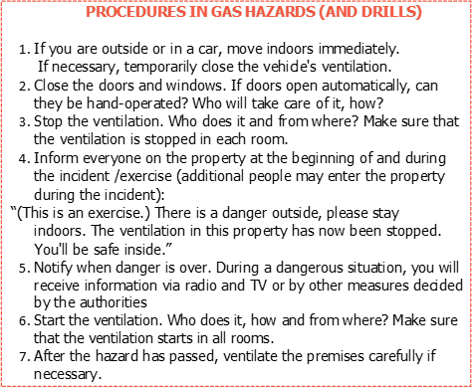

Civil defense shelters
Civil defense shelters are intended to protect the population from a military attack. They provide protection against building collapse (explosions, pressure waves) as well as chemical warfare agents and ionizing radiation (remote fallout of a nuclear weapon). During a sudden gas hazard under normal conditions, during a non-military threat, you should not go to a civil defense shelter, but take shelter in other indoor spaces and close the ventilation.

Most likely, the shelter is used for a short-term protection. Momentarily, as many people as fit in the shelter can be taken there, for example, to protect against the effects of explosions. In long-term use, a maximum number of people to be protected is planned based on the required space, ventilation, and the amount of stored water. In the public shelters, place of refuge has been agreed in advance for different users. People are admitted to the public shelters in the order of entry and the shelters are available to anyone.

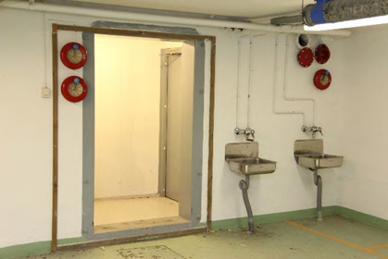

Figure 15: Water points are visible next to the entrance to the civil defense shelter, as well as ribbing around it for the construction of a lock tent. The lock tent serves as a vestibule for the shelter.

The emergency plan must state whether the property has civil defense shelter or if it falls under the scope of a public defense shelter or if the property is completely without the reach of one. In addition, the plan must mention where the documents related to civil defense shelter, performed maintenance and inspection protocols can be found.

If the property has a civil defense shelter, its working condition and preparations are taken care of as commissioned by order of the authorities. The owner of the property is likely to be responsible for the condition of the shelter, annual maintenance, inspections, and other maintenance, unless otherwise agreed. Often, the responsibility for the maintenance and commissioning of the civil defense shelter has been transferred by contract to the main operator of the property.

If sheltering inside is not enough and there is no civil defense shelter in the property, the authorities may share the use of other nearby shelters as needed. Other premises could also be designated as shelters, with guidance on how to make temporary shelters or guide the population to move to a safer place. In a real situation, the authorities communicate to citizens how to act.

If necessary, the authorities can also evacuate in some other local dangerous situations than in a state of emergency. For example, when there is a fire at one's own property or a neighboring property or some other similar accident. In this case, information is given on what equipment and food items to take with you.

Figure 16: Shelter supplies are often stored next to the shelter's ventilation equipment: water storage containers, toilet bowls and waste containers and their inner bags, a lock tent, and other shelter equipment and tools in a separate box.

The role of a civil defense shelter manager is not difficult. A property maintenance company’s help can be utilized, as they can help with possible technical matters and minor maintenance. However, they cannot act as managers of the shelter in a situation when protection is needed because they cannot be in control of the shelter in several locations at the same time. Courses for civil defense shelter managers are organized by regional emergency services associations.

In practice, the task of the shelter manager is to carry out a light maintenance and inspection every year to ensure that all equipment is in place. It is recommended to use the ventilation equipment first by hand and then with electricity, and to test the function of the dam valve and check that the seals and grommets are in order. When the shelter is put into use and in a sheltering situation, the operation is directed and managed by the manager of the civil shelter, unless otherwise agreed in the property.

In addition, civil defense shelters shall be inspected at pre-planned intervals, and a maintenance report should be filled out. It is also recommended to keep records of the annual maintenance by filling out the same form, which ensures that all things are done. It is also recommended to draw up a commissioning plan for the shelter: empty the shelter, check the equipment, fill the water tanks, prepare the shelter to be airtight and put the shelter's own ventilation equipment into operation. If the property of several operators is kept in the shelter, the emptying plan must be processed and approved at the property's general meeting.

Communication about the content of the emergency plan

Communication about the emergency plan means that the emergency plan and the measures and instructions defined in it must be brought to the attention of everyone working in the building. However, the entire plan does not need to be delivered to the entire staff, but only the necessary information for each. Communication is not only limited to the implementation phase of a new emergency plan, but should always be done as necessary, when, for example, the content of the plan is substantially changed or when new personnel arrive at the workplace.

When planning the communication of the emergency plan, it is important to consider:
- What is communicated and to whom?
- What methods and channels are used in communication? For example, electronic platforms, training events, practical exercises, notice boards.
- Have different recipients been considered in the communication? For example, different language needs or the special needs of people with limited ability to function.
- How often is it necessary to communicate the emergency plan? For example, always in orientation and annually.
- How to ensure that the communication reaches all the necessary parties?
- Can the communication be enhanced with, for example, pictures and on maps?

It is necessary to plan separately how customers and the public will receive information about safety instructions. In department stores, theaters, and other places where the public gathers, safety instructions can be given on signs and boards ("No Smoking", etc.). In addition, the visibility and adequacy of safety signs must be ensured. In public spaces, such as hotels, it is good to place instructions clearly visible to customers. The safety of customers depends on the staff's skills and announcements in different languages. In public events, safety instructions can also be announced or distributed to everyone upon entry and confirmed with visible signs. In activities that take place outside the office building, the dangers and safety instructions are explained to the participants in advance. Communication is part of more comprehensive safety training and skill development.

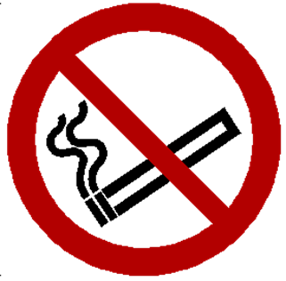

Figure 17: "No smoking" sign.

Comprehensive maintenance of the emergency plan and practical safety
The completion of the first version of the emergency plan does not yet guarantee that the company's safety issues are in order and the safety culture is at a sufficient level. Transitioning the emergency plan into practice also requires actions, such as organizing orientations, placing operating instructions at workstations, and encouraging reporting of observed safety deficiencies.

It is also important that the maintenance of equipment and supplies essential to the emergency plan is handled in a controlled manner and on time.

Updating the emergency plan
Maintaining a sufficient safety level requires continuous evaluation and development of one's own procedures. The emergency plan must state how often it is checked and whose responsibility it is. Checking should be included as part of another regularly recurring task, such as operational and financial planning.
It is recommended to mark the changes made to the plan with a distinctive color and a different font, such as "red italic text", or using other tools like tracking modifications in the document. In this way, changes are detected quickly. In addition, it is worth maintaining the update history of the emergency plan, for example by saving all versions in one place. In addition, it is possible to keep a record of the changes made in an aggregate form, which makes it easy to find out afterwards when and what changes have been made. In this case, it is good to record when the changes were made, who made them and what content was changed, for example the chapter or the content. It is recommended to check the up-to-dateness at least once a year. However, the effect of changes affecting safety at other times must also be considered.

Changes that trigger the need to review and update the emergency plan include, for example:
- When obvious deficiencies or new risks are revealed in connection with a regular risk assessment or by investigating accident and near-miss situations,
- when the safety team or staff discovers a deficiency or previously unrecognized danger in connection with normal work,
- when the operation of the work community is changed in such a way that it has a significant impact on safety, and especially if the risk of personal injury increases. For example, when new methods of operation, equipment, machines, or structural solutions are introduced, or substantial changes are made to them,
- if the currently used emergency or safety plan is old.

When reviewing the timeliness of the emergency plan, it is also worth paying special attention to whether the information and measures recorded in the plan correspond to reality. For example, if the emergency plan states that the exits are to be kept tidy and not blocked by objects, the users of the building must also commit to act accordingly.

Training and skills
The foundation for safety is laid by structural and technical arrangements at the design stage of the building, but the most important part of everyday safety consists of the competence of the personnel and the right action. Even a good plan does not help if it is not followed. Building users should be aware of safety solutions in their daily operations, such as fire compartmentalization and its purpose, as well as exits. These essentially involve closing fire doors, sealing through openings, and making proper use of existing technology.

The authors of the emergency plan and the management of the organization must ensure that the personnel of the work community are trained and familiarized with the plan and its implementation in practice. The personnel must fulfil the obligations given in the plan and follow the instructions.

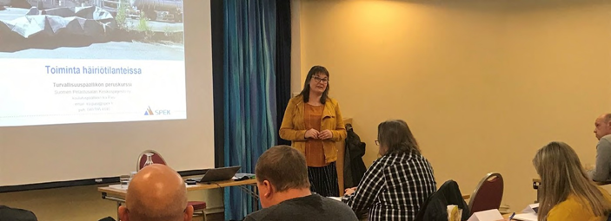

Figure 18: The personnel of the work community must be trained and familiarized with the plan and its implementation in practice.

The emergency plan must indicate how the personnel will be trained and instructed, and where the information on the training is recorded. Many workplaces have existing training registers, which can also be used to record safety trainings and exercises. The records include when, on what subject and for whom the education is carried out.

It is recommended to organize regular trainings for the entire staff on the specific hazards of the workplace, how to act in different kinds of hazardous situations and how to prevent them. It is a good idea to arrange an additional training for the safety team, so that they can learn to identify potential hazards, prevent them and act in accordance with their role in the emergencies.

Every employee must know the hazards associated with their own work and how accidents can be prevented. Also, it is important for everyone to know and understand the technical and structural safety arrangements. In this way, ignorance does not cause dangerous situations if, for example, a fire door is wedged open accidentally or the escape route is blocked. Safety training is given to new and temporary employees in connection with orientation.

In addition, employees shall be familiarized with the operating instructions prepared in case of dangerous situations. Everyone must know how to act safely and limit damage in emergency situations. Training and exercises are the easiest way to achieve this. It is recommended to organize training on at least the following topics:
- Operation in various emergencies, including evacuation, fires, and sheltering inside.
- Use of fire extinguishing equipment.
- Emergency first aid.

It is recommended to have people with fire extinguishing and emergency first aid skills always on site, in every shift and in all departments. Fire extinguishing and emergency first aid skills are generally needed very suddenly, in which case it would be good for everyone to have this basic knowledge. The organization can offer these trainings to the entire staff.

A safe evacuation must be designed so that there are always personnel at the workplace who know how to leave the property safely and can also provide guidance to others if necessary. Sometimes it can mean that every employee must know how to ensure that the premises are emptied, guide others and call for help.

Figure 19: Escape route sign.

The work community can train the staff and the safety team itself or can request training from external operators. The duration and content of the training should be adjusted according to the risks and needs of the operation. The workplace must have adequate first aid preparedness for the conditions and operations.

The operations of many workplaces also extend outside the office building. The obligations of self-preparedness and planning also apply to activities that take place outside the actual premises, for example transport outside the premises or work tasks. It is necessary to gather information for those engaged in such work on possible dangers and how to avoid them, to provide adequate equipment for rescue and first aid, and to ensure that help is available when needed.

References and additional information to support emergency planning
The authorities are likely to help and provide information, advise and guide in self-preparedness arrangements and the preparation of an emergency plan. This experience and knowledge should be used especially in investigating local dangers, defining the safety level, and organizing safety training and exercises.

The response time can be estimated based on the location of the nearest rescue department. The rescue service can also be asked for an estimate of what kind of help, such as personnel and equipment, can be obtained there and how quickly help can be obtained.

European guidelines
Fire (https://cfpa-e.eu/category-guidelines/fire-prevention-and-protection/)
Guideline No 1 F - Internal fire protection control
Guideline No 2 F - Panic & emergency exit devices
Guideline No 3 F - Certification of thermographers
Guideline No 4 F - Introduction to qualitative fire risk assessment
Guideline No 5 F - Guidance signs, emergency lighting and general lighting
Guideline No 6 F - Fire safety in care homes
Guideline No 7 F - Safety distance between waste containers and buildings
Guideline No 8 F - withdrawn
Guideline No 9 F - Fire safety in restaurants
Guideline No 10 F - Smoke alarms in the home
Guideline No 11 F - Recommended numbers of fire protection trained staff
Guideline No 12 F - Fire safety basics for hot work operatives
Guideline No 13 F - Fire protection documentation
Guideline No 14 F - Fire protection in information technology facilities
Guideline No 15 F - Fire safety in guest harbours and marinas
Guideline No 16 F - Fire protection in offices
Guideline No 17 F - Fire safety in farm buildings
Guideline No 18 F - Fire protection on chemical manufacturing sites
Guideline No 19 F - Fire safety engineering concerning evacuation from buildings
Guideline No 20 F - Fire safety in camping sites
Guideline No 21 F - Fire prevention on construction sites
Guideline No 22 F - Wind turbines – Fire protection guideline
Guideline No 23 F - Securing the operational readiness of fire control system
Guideline No 24 F - Fire safe homes
Guideline No 25 F - Emergency plan
Guideline No 26 F - withdrawn
Guideline No 27 F - Fire safety in apartment buildings
Guideline No 28 F - Fire safety in laboratories
Guideline No 29 F - Protection of paintings: transports, exhibition and storage
Guideline No 30 F - Managing fire safety in historic buildings
Guideline No 31 F - Protection against self-ignition end explosions in handling and storage
of silage and fodder in farms
Guideline No 32 F - Treatment and storage of waste and combustible secondary raw
materials
Guideline No 33 F - Evacuation of people with disabilities
Guideline No 34 F - Fire safety measures with emergency power supply
Guideline No 35 F - Fire safety in warehouses
Guideline No 36 F - Fire prevention in large tents
Guideline No 37 F - Photovoltaic systems: recommendations on loss prevention
Guideline No 38 F - Fire safety recommendations for short-term rental accommodations
Guideline No 37 F - Fire protection in schools
Guideline No 38 F - Fire safety recommendations for short-term rental accommodations
Guideline No 39 F - Fire protection in schools
Guideline No 40 F - Procedure to certify CFPA-E Fire Safety Specialists in Building Design
Guideline No 41 F - Safety instructions for the use and charging of small and medium size lithium
ion powered devices

Natural hazards https://cfpa-e.eu/category-guidelines/natural-hazards/)
Guideline No 1 N - Protection against flood
Guideline No 2 N - Business resilience – An introduction to protecting your business
Guideline No 3 N - Protection of buildings against wind damage
Guideline No 4 N - Lighting protection
Guideline No 5 N - Managing heavy snow loads on roofs
Guideline No 6 N - Forest fires
Guideline No 7 N - Demountable / Mobile flood protection systems
Guideline No 8 N - Ensuring supplies of firefighting water in extreme weather conditions
Guideline No 9 N - Protection against hail damage
Guideline No 10 N -Heavy rain and flash flood; Recommendations on flood prevention and
protection

Security (https://cfpa-e.eu/category-guidelines/security/)
Guideline No 1 S - Arson document
Guideline No 2 S - Protection of empty buildings
Guideline No 3 S - Security systems for empty buildings
Guideline No 4 S - Guidance on keyholder selections and duties
Guideline No 5 S - Security guidelines for museums and showrooms
Guideline No 6 S - Security guidelines emergency exit doors in non-residential premises
Guideline No 7 S - Developing evacuation and salvage plans for works of art and
heritage buildings
Guideline No 8 S - Security in schools
Guideline No 9 S - Recommendation for the control of metal theft
Guideline No 10 S - Protection of business intelligence
Guideline No 11 S - Cyber security for small and medium-sized enterprises
Guideline No 12 S - Security Guidelines for Businesses

Comments and corrective actions:

www.cfpa-e.eu

