Safety instructions for the use
and charging of small and medium
size lithium ion powered devices
CFPA-E Guideline No 41:2023 F

New image needed!

The CFPA Europe develops and publishes common guidelines about fire safety, security, and natural hazards with the aim to achieve similar interpretation and to give examples of acceptable solutions, concepts, and models. The aim is to facilitate and support fire protection, security, and protection against natural hazards across Europe, and the whole world.

Today fire safety, security and protection against natural hazards form an integral part of a modern strategy for survival, sustainability, and competitiveness. Therefore, the market imposes new demands for quality.

These Guidelines are intended for all interested parties and the public. Interested parties includes plant owners, insurers, rescue services, consultants, safety companies and the like so that, in the course of their work, they may be able to help manage risk in society.

The Guidelines reflect best practice developed by the national members of CFPA Europe. Where these Guidelines and national requirements conflict, national requirements shall apply.

This Guideline has been compiled by the Guidelines Commission and is adopted by the members of CFPA Europe.

More information: www.cfpa-e.eu

Zurich, June 2023 Cologne, June 2023
CFPA Europe Guidelines Commission

Elisabetta Carrea Hardy Rusch
Chairman Chairman

Contents
1 Introduction 4
2 Scope 4
3 Definitions 4
4 Hazards 5
5 Safety instructions for a safety use of battery powered devices 6
6 Safety instruction for fire protection in the homes 6
7 Damaged batteries 7
8 Disposal of lithium ion batteries 8
European guidelines 9

Key words:

Introduction
The Lithium ion batteries are more and more present in our lives, as a power source to small and medium electronic devices, and also as large scale energy storage systems. Although the batteries are considered as safe elements, no lithium-ion battery is completely risk-free. The utilization of a defective battery can cause a thermal runaway process triggering a fire. Other possible dangers are electric shocks and chemical risks.

The challenge of a battery fire is increased by the fact that the chemical reaction of the battery contains or produces all the elements necessary for fire (heat, oxygen, combustible material). A significant factor in lithium-ion battery fires is thermal runaway, which refers to a highly heat-generating reaction inside the battery cell that can lead to the discharge of gasified electrolyte, ignition and a strong flame. Because of this, it is difficult to extinguish the fire, so it´s very important to identify as soon as possible the signs indicating a potential failure of the battery. In addition, the highly toxic gases formed in a lithium-ion battery fire are very high risks to people who are in the same room when the fire occurs.

This guideline presents recommendations for the users of small and medium electronic devices powered by lithium ion batteries. Other possible dangers are electric shocks and chemical risks.

Scope
Lithium batteries are an energy source of many small electronic devices e.g. cell phones, laptops, cameras, consoles, etc., as well as in medium size items such as electric bicycles, scooters and hover-boards. All these devices and items are regarded as so called “portable items”. These items have to be distinguished by devices or items with removable batteries (for charging), or non-removable batteries (charging fixed with the item).

Although these devices are generally safe devices (must always guarantee a minimum quality standards in design and fabrication), they are susceptible to overheating, a phenomena that can happen especially during the charging process, or when any mechanical damage, that has affected the integrity of the cells.

This guideline is intended to domestic users of small and medium size portable electronic devices, powered by lithium ion batteries, with the purpose of provide recommendations for safe use. The use of such devices under a commercial or industrial use is outside of the scope of this guideline.

This guideline does not include the batteries with a large capacity, such as car batteries, or the batteries used in storage banks for large scale energy production. In addition, the primary (non-rechargeable) lithium metal batteries are outside the scope of this guideline.

Definitions
Lithium ion
It is a type of rechargeable battery, in which lithium ions move from the negative electrode (anode) to positive electrode (cathode) during the discharge, and back when charging.

Primary (non-rechargeable) lithium metal cells
These batteries have anodes of metal lithium that can be match with cathodes of different materials (MnO2, CFx, FeS2, SOCL2, etc.). Depending on the application and the chemistry reaction involved, the product format can be button or cylindrical battery. These batteries are non-rechargeable batteries.

Secondary (rechargeable) lithium metal cells
Its main characteristic is that this type of batteries are rechargeable. Depending of the manufacturing and components, it can endure up to a thousand cycles of charge. The recharge is possible because the lithium is not present in metallic form, but as a part of compounds as the graphite or metallic oxide of lithium, being able to move from anode to cathode during the discharge, and from cathode to anode during the charge, in ionic status. Secondary batteries can be found in cylindrical, button, prismatic and pouch cell format, with varying degrees of robustness.

Thermal runaway
Energy release process in the form of heat, which happens when some battery cells break their physical integrity. When a battery suffers a thermal runaway process, immediate ignition of the emitted gases can occur (especially for batteries with a high level of charge). Alternatively, the gases may spread-out unignited, with the potential for a deflagration (very rapid combustion) or explosion if an external ignition source is encountered.

Hazards
When the batteries are damaged, caused by inadequate manufacturing, improper use, or mechanical damage, among other causes, this can lead to fire or explosion.

The amount of storage energy in a lithium ion cell is very high. Moreover, the failure of a battery gives place to a chain reaction called thermal runaway, which releases the energy contained in the battery in a short space of time. A failure of this type can produce temperatures over 500ºC with emission of flaming particles that can be thrown several meters away. In some cases, the gases can spread-out unignited, forming an explosive mixture with the air with resultant deflagration in case it reaches an external ignition source.
When buying battery devices, it is good to evaluate the safety mechanisms of the product so that the use of the battery is as safe as possible. BMS control systems (Battery Management Systems) are often installed in the devices, which can be used to identify abnormal battery operation and, for example, when the temperature rises, the charging is interrupted and the power is cut off so that the battery can cool down. Battery management systems keep the cells in the desired safe operating range in order to avoid possible e.g. overload.

The following aspects should be considered as potential causes of a critical failure in a battery and should be avoided:
- Charging the battery using devices not recommended by the manufacturer. The battery charger must be able to stop the charging process before the maximum battery charge limit value is reached. Thus, the battery overload that leads to overheating is avoided.
- Mechanical damages to the battery (perforation, deformation, drop, etc.). This could break the physical integrity of the cells.
- Very high ambient temperature. For this reason, some electronic devices have an automatic shutdown system when they reach a certain temperature. In addition, the batteries must be kept far away from direct heat sources, as heaters and open flames.
- Performing the charge process under freezing temperatures. This can lead to the appearance of metallic lithium in the anode, increasing the probability of failure.
- If batteries have to be stored in freezing temperatures, they must be allowed to warm up before charging to minimize damage and risks.
- If the battery and the device are not used for a long time, the battery should not be allowed to run completely empty, because it can damage the battery. The battery must be maintenance charged so that the internal voltage of the battery does not drop too low, or else the battery may be damaged.

Safety instructions for a safety use of battery powered devices
When using and/or recharging lithium ion batteries following safety instructions should be regarded:
- The batteries must have been designed and manufactured following a minimum standard of quality. It is important that the batteries and their chargers have been tested and certified by a third party. Follow the device´s operating instructions and manuals.
- Always use the batteries recommended by the manufacturer of the device to be powered.
- Always use the charge system recommended by the manufacturer of the battery.
- Avoid overloading the batteries. To ensure this the charging devices recommended by the manufacturer usually incorporate a disconnection of the charging system when complete.
- Avoid keeping the battery constantly charging. Do not let the battery charge completely empty.
- Avoid any physical damage of the batteries. Inspect them to ensure there are no signs of deterioration (see section 6).
- Insert the batteries correctly in the device. Ensure a complete contact between the battery and the device terminals. Do not alter the polarity.
- Keep the batteries, or the devices that they power, within the limits of the ambient temperature stated by the manufacturer.
- Do not expose the batteries or the devices that they power, at the direct sun or heat sources (heaters, open flame, etc.).
- Do not make the charge process of the battery outside of the temperature range recommended by the manufacturer.
- If the battery becomes abnormally warm during use or charging, let it cool before the use or charging again.
- If the battery bulges, heats up strongly or starts to smell, do not use it and take the battery to service or to other collection point.
- Do not disassemble the batteries and do not separate the cells that form it.
- Please note that if you are carrying devices equipped with lithium ion batteries on a plane, such devices cannot be checked in and must be carried in the cabin as carry-on baggage.

Safety instruction for fire protection in the homes
This section provides some tips to minimize personal and material damage in the event of a lithium-ion battery fire in the home:
- Do not charge with the devices placed on easily combustible elements like pillows or sofas. Some age groups or persons with cognitive deficiencies when charging their own devices can not be aware at all of the potential hazard that can result from this behavior. If possible, charge the device over a heat-resistant base, in a well-ventilated room.
- Keep the immediate area clear of flammable objects when charging a battery; do not place scooters or e-bikes (pedelecs) near flammable building insulation during charging.
- If possible, do not leave lithium ion battery devices unattended, while charging, and avoid charging overnight. However, it is always advisable to install autonomous smoke detectors, placed in strategic places in the home, to detect smoke from a fire and give an early alarm to the occupants.
- Devices with medium-sized lithium ion batteries, such as scooters or e-bikes (pedelecs), shall not be charged neither on evacuation routes (for example next to the exit door of the house, or at the bottom of the stairwell), nor in places where a quick spread of fire or smoke is probable, as this may prevent safe evacuation in the event of fire
- If a small lithium ion battery has started an overheating process but can still be handled safely, deposit it in a container filled with water that covers it completely. The faster the burning cell gets submerged into water after ignition the less emissions are produced. There are also in the market fire containment bags specifically designed to contain this type of fire. If handling is unsafe, use a metal lid to cover the appliance. If you carry out the process of charging equipment at home, which is equipped with medium-sized batteries, such as scooters or e-bikes (pedelecs), it is advisable to have a fire-extinguishing blanket. In the event that any of these appliances shows signs of the incipient thermal runaway process, and only when it is safe to approach the appliance, cover it with the blanket, keep all combustible materials or furniture away from the equipment (ideally, at least 2 m), close the door of the room behind you, and notify the fire brigade.
- Lithium-ion battery fires are challenging in terms of fire extinguishing because batteries’ casing prevents the cooling and extinguishing effect of the fire extinguisher from getting between the cells. The battery can also ignite again after a long time especially in larger battery packings. Extinguishing visible flames doesn’t stop the reaction inside the battery. The reaction must be stopped by cooling that prevents the heat for transfering from one cell to another inside the battery.
- Anyway, it is advisable to have a dry-chemical or water-based manual fire extinguisher to extinguish any fire, especially secondary fires that may appear from the lithium-ion battery original fire. When trying to fight the fire, it should always be ensured that the minimum safety conditions are met; otherwise it is better to call the fire brigade.

Damaged batteries
Using a defective battery can cause a thermal runaway process and later a fire. Therefore, is important to know how to identify a defective battery, and what to do in this case.

The following items are indicative of a defective battery:
- A size larger than normal, with expanded housing.
- A mechanical damage (puncture or deformation evidence caused by blows or falls).
- An excessive temperature released during the charge process or operating process.
- The battery is releasing smoke or the battery presents leakages.

The way to proceed in these cases are the following:
- Switch off the device that is powered by the battery.
- If possible, remove the battery from the device, using gloves and safety glasses, if they are available. If the battery has an electrolyte leakage, any contact with bare skin must be avoided. Do not try to extract the battery if the thermal runaway process has started and you do not have the adequate equipment to do it.

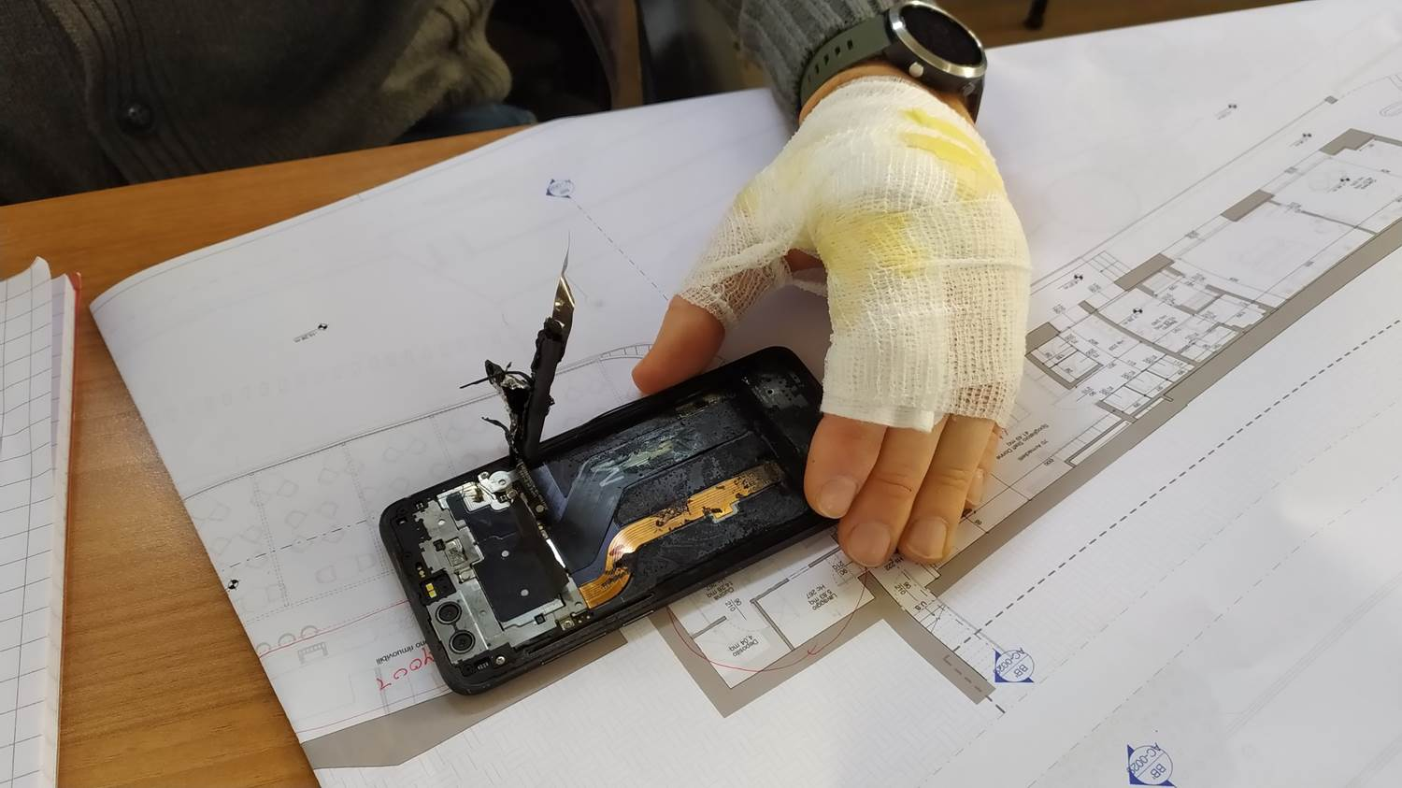

Skin burns after trying to remove from a mobile phone a battery that had started the thermal runaway process

- Deposit the batteries (or the device, if the battery cannot be removed) on top of a non-combustible and non-conductor element (for example, a glass or porcelain tray), and maintain it separate of any combustible element.
- If a fire starts , it´s difficult to extinguish it since the process is liberating oxygen as well as flammable gases, so final extinguishment will probably only be achieved when the burning battery cell burn out. Anyway, the use of water-based fire extinguisher, or the application of dirt or sand can help to reduce or control the energy that is released. If possible, immerse the battery in a container filled with water.

In case that the battery presents electrolyte leak and there´s an accidental contact with it, the following advices must be followed:
- If the contact has been with the bare skin, wash the affected area with water. Remove the contaminated clothing.
- If the contact has been with the eyes, wash with water immediately, and keep washing for around 15 minutes. Ensure the correct washing even under the eyelids.
- If the electrolyte has been inhaled, move the affected person to a place where he/she can breathe fresh air and monitor their breathing. If their breathing stops, use resuscitation.
- In case of any excessive exposure, specialized medical attention should be given.

Disposal of lithium ion batteries
The lithium batteries are considered a dangerous waste, which must be properly collected, stored and recycled.

The used batteries should be deposited intact in specific containers to this type of waste. Normally local authorities facilitate these collection points.

Batteries should never be disposed along with domestic waste.

The lithium batteries should not be mixed with other battery types, such as alkaline, cadmium or other types of rechargeable batteries.

Used batteries should be taken to recycling immediately and shouldn’t be stored at home.

European guidelines
Fire
Guideline No 1 F - Internal fire protection control
Guideline No 2 F - Panic & emergency exit devices
Guideline No 3 F - Certification of thermographers
Guideline No 4 F - Introduction to qualitative fire risk assessment
Guideline No 5 F - Guidance signs, emergency lighting and general lighting
Guideline No 6 F - Fire safety in care homes
Guideline No 7 F - Safety distance between waste containers and buildings
Guideline No 8 F - withdrawn
Guideline No 9 F - Fire safety in restaurants
Guideline No 10 F - Smoke alarms in the home
Guideline No 11 F - Recommended numbers of fire protection trained staff
Guideline No 12 F - Fire safety basics for hot work operatives
Guideline No 13 F - Fire protection documentation
Guideline No 14 F - Fire protection in information technology facilities
Guideline No 15 F - Fire safety in guest harbours and marinas
Guideline No 16 F - Fire protection in offices
Guideline No 17 F - Fire safety in farm buildings
Guideline No 18 F - Fire protection on chemical manufacturing sites
Guideline No 19 F - Fire safety engineering concerning evacuation from buildings
Guideline No 20 F - Fire safety in camping sites
Guideline No 21 F - Fire prevention on construction sites
Guideline No 22 F - Wind turbines – Fire protection guideline
Guideline No 23 F - Securing the operational readiness of fire control system
Guideline No 24 F - Fire safe homes
Guideline No 25 F - Emergency plan
Guideline No 26 F - withdrawn
Guideline No 27 F - Fire safety in apartment buildings
Guideline No 28 F - Fire safety in laboratories
Guideline No 29 F - Protection of paintings: transports, exhibition and storage
Guideline No 30 F - Managing fire safety in historic buildings
Guideline No 31 F - Protection against self-ignition end explosions in handling and storage
of silage and fodder in farms
Guideline No 32 F - Treatment and storage of waste and combustible secondary raw
materials
Guideline No 33 F - Evacuation of people with disabilities
Guideline No 34 F - Fire safety measures with emergency power supply
Guideline No 35 F - Fire safety in warehouses
Guideline No 36 F - Fire prevention in large tents
Guideline No 37 F - Photovoltaic systems: recommendations on loss prevention
Guideline No 38 F - Fire safety recommendations for short-term rental accommodations
Guideline No 37 F - Fire protection in schools
Guideline No 38 F - Fire safety recommendations for short-term rental accommodations
Guideline No 39 F - Fire protection in schools
Guideline No 40 F - Procedure to certify CFPA-E Fire Safety Specialists in Building Design

Natural hazards
Guideline No 1 N - Protection against flood
Guideline No 2 N - Business resilience – An introduction to protecting your business
Guideline No 3 N - Protection of buildings against wind damage
Guideline No 4 N - Lighting protection
Guideline No 5 N - Managing heavy snow loads on roofs
Guideline No 6 N - Forest fires
Guideline No 7 N - Demountable / Mobile flood protection systems

Security
Guideline No 1 S - Arson document
Guideline No 2 S - Protection of empty buildings
Guideline No 3 S - Security systems for empty buildings
Guideline No 4 S - Guidance on keyholder selections and duties
Guideline No 5 S - Security guidelines for museums and showrooms
Guideline No 6 S - Security guidelines emergency exit doors in non-residential premises
Guideline No 7 S - Developing evacuation and salvage plans for works of art and
heritage buildings
Guideline No 8 S - Security in schools
Guideline No 9 S - Recommendation for the control of metal theft
Guideline No 10 S - Protection of business intelligence
Guideline No 11 S - Cyber security for small and medium-sized enterprises

www.cfpa-e.eu

