Panic & emergency exit devices

**CFPA-E Guideline No 2:2022 F**

New image needed!!!



****

**CFPA Europe develops and publishes common guidelines in order to achieve similar interpretation in the European countries and to give examples of acceptable solutions, concepts and models. CFPA Europe has the aim to facilitate and support fire protection, security and protection against natural hazards.**

**The market imposes new demands for quality and safety. Today, fire protection, security and protection against natural hazards form an integral part of a modern strategy for survival, sustainability and competitiveness.**

**These Guidelines are primarily intended for the public. They are also aimed at rescue services, insurers, consultants, safety companies and the like so that, in the course of their work, they may be able to help manage risk in society.**

**These Guidelines reflect best practice developed by the national members of CFPA Europe. Where these Guidelines and national requirements conflict, national requirements shall apply.**

**This Guideline has been compiled by the Guidelines Commission Group and is adopted by all members of CFPA Europe.**

**More information:** [**www.cfpa-e.eu**](http://www.cfpa-e.eu)



Copenhagen, March 2022 Cologne, March 2022  
CFPA Europe Guidelines Commission

Jesper Ditlev Hardy Rusch  
Chairman Chairman



**Contents**

[1 Introduction 5](#_Toc103343143)

[2 Definitions 5](#_Toc103343144)

[3 Panic or emergency? 7](#_Toc103343145)

[3.1 Panic situations 7](#_Toc103343146)

[3.2 Emergency situations 7](#_Toc103343147)

[4 Fields of application 7](#_Toc103343148)

[4.1 Panic exit devices 8](#_Toc103343149)

[4.2 Emergency exit devices 8](#_Toc103343150)

[4.3 Electrically controlled exit systems for use on escape routes 8](#_Toc103343151)

[4.4 Other opening devices 9](#_Toc103343152)

[5 Double doors 9](#_Toc103343153)

[6 Emergency exit button 9](#_Toc103343154)

[7 Safe integration of door access control and fire alarm system 10](#_Toc103343155)

[8 Intruder protection locking device 11](#_Toc103343156)

[9 Installation and maintenance 11](#_Toc103343157)

[10 Choice of exit devices for emergency purposes 12](#_Toc103343158)

[Annex 1: Panic & emergency exit devices 13](#_Toc103343159)

[Annex 1.1 E 1, Single fire door 13](#_Toc103343160)

[Annex 1.2 E 2, Single door with/without fire separating function depending on choice of electric striking plate 14](#_Toc103343161)

[Annex 1.3 E 3, Single fire door 15](#_Toc103343162)

[Annex 1.4 E 4, Single door with/without fire separating function depending on choice of electric striking plate 16](#_Toc103343163)

[Annex 1.5 Ee 1, Single door, not a fire door 17](#_Toc103343164)

[Annex 1.6 Ee 2, Single door with/without fire separating function depending on choice of electric striking plate 18](#_Toc103343165)

[Annex 1.7 Ee 3, Single fire door 19](#_Toc103343166)

[Annex 1.8 P 1, Single fire door 20](#_Toc103343167)

[Annex 1.9 P 2, Single fire door 21](#_Toc103343168)

[Annex 1.10 P 3, Single door with/without fire separating function depending on choice of electric striking plate 22](#_Toc103343169)

[Annex 1.11 P 4, Single fire door 23](#_Toc103343170)

[Annex 1.12 Pe 1, Single fire door 24](#_Toc103343171)

[Annex 1.13 Pe 2, Single fire door 25](#_Toc103343172)

[Annex 1.14 ED 1, Double fire doors 26](#_Toc103343173)

[Annex 1.15 ED 2, Double doors with/without fire separating function depending on choice of electric striking plate 27](#_Toc103343174)

[Annex 1.16 ED 3, Double fire doors 28](#_Toc103343175)

[Annex 1.17 ED 4, Double doors with/without fire separating function depending on choice of electric striking plate 29](#_Toc103343176)

[Annex 1.18 EDe 1, Double doors with no fire separating function 30](#_Toc103343177)

[Annex 1.19 PD 1, Double fire doors 31](#_Toc103343178)

[Annex 1.20 PD 2, Double fire doors 32](#_Toc103343179)

[Annex 1.21 PD 3, Double doors with/without fire separating function depending on choice of electric striking plate 33](#_Toc103343180)

[Annex 1.22 PD 4, Double fire doors 34](#_Toc103343181)

[Annex 1.23 PDe 1, Double fire doors 35](#_Toc103343182)

[Annex 1.24 PDe 2, Double fire doors 36](#_Toc103343183)

[Annex 2 Examples of control routines 37](#_Toc103343184)

[Annex 2.1 Control routines 37](#_Toc103343185)

[European guidelines 39](#_Toc103343186)

Key words:

# Introduction

This proposal for functional solutions is mainly based on European standards for panic and emergency exit devices, EN 1125, EN 179 and EN 13637.

The Guideline applies for doors in escape routes, with or without fire separating function, which normally shall be kept locked from the outside and/or provide the means of controlling the passage of persons from the inside/outside.

For other doors in escape routes, which are not covered by this Guideline, a different opening function can be used accordingly to national regulations.

For information and guidance regarding the selection of suitable means to secure buildings against intrusion via panic and emergency exit doors reference is made to *Security guidelines for safe emergency exit doors in non-residential premises* (CFPA-E Guidelines No 06:S).

Example:

Exit doors which shall normally **not** be kept locked from the outside and/or provide the means of controlling the passage of persons from the inside/outside. For these doors other fittings can also be used.

Exit doors which shall normally be kept locked from the outside and/or provide the means of controlling the passage of persons from the inside/outside. Examples of these doors are given in this Guideline.

Appendix No 1 gives examples of exit devices which can be used on doors to escape routes, where the activity demands that it should normally be possible for these doors to be kept locked from the outside to prevent the passage of unauthorised persons.

The publication does not deal with the fundamental problems of how to identify the doors, which are exit doors.

# Definitions

* **Automatic flush bolt**

Locking device mounted on the meeting stile of the inactive leaf where its bolt is operated by a mechanism that is activated when the active leaf is closed.

An automatic flush bolt must not be used in the inactive leaf when this is part of an escape route because the automatic flush bolt does not have a sequentially activated opening function.

* **Bolt**

Mobile locking component placed in a lock or other locking device which shoots out through the forend, stile plate, etc.

* **CMC**Central management control, centrally controlling panel supervised by authorized personnel to monitor and to operate electrically controlled exit systems including the double time delay function and/or denied exit function
* **Door holder magnet**

Electromechanical locking device which holds the top of the door leaf to the door frame through magnetic force. It locks when connected to the power supply and is always automatically deactivated when disconnected from the supply.

* **Electromechanical door bolt**

Electromechanical locking device which connects the top of the door leaf to the door frame through a mechanical coupling. It locks when connected to the power supply and is always automatically deactivated when disconnected from the power supply.

* **Electromechanical hold-open device**

A hold-open device in the door closer function which is automatically deactivated when disconnected from the power supply. May also be provided in the form of a wall mounted door holder magnet.

* **Fire door**

Door that has a certain period of resistance to fire. The period of fire resistance may vary depending on the position of the door or the fire resistance class of the surrounding elements of construction.

* **Intruder protection locking**

Locking device that complies with the insurer's intruder protection requirement for the premises concerned.

* **Latch bolt**

Bolt with a bevelled end.

* **Lever handle**

Handle to operate the bolt of a lock.

* **Pulse generator**

May be in the form of e.g. push button, key switch, microswitch in exit device, digital code lock, card reader, time switch, pulse from the alarm system or some other electrical function.

* **Standby power/emergency power**

Function that secures the supply of power in the event of mains failure. It is often provided in the form of a battery backup for e.g. electric striking plate, electromechanical door bolt, door holder magnet and entry and exit control system.

* **Striking plate**

Device mounted in the frame to reinforce this where the hole for a bolt is made.

* **Tailpiece**

For double doors in combination with a door coordinator.

If double doors are opened via the inactive leaf, the tailpiece opens the active leaf also, so long as the door coordinator has been activated, which means that the leaves will be closed in the right order

# Panic or emergency?

When designing equipment for exit doors on escape routes, you should always ask the question: is there any chance that a panic situation may arise?

Often, of course, building regulations, fire safety requirements, etc. will give you formal guidance or will even require the use of special hardware. However, the designer should take all possible measures to reduce the consequences of potential risks that may occur in the lifespan of a building. Technical solutions to deal with panic situations and with ‘ordinary’ emergencies are different. It is therefore important to define what type of situation is likely to arise.

## Panic situations

The reactions of a large number of people are always difficult to predict, especially in the event of

a fire in a cinema, a restaurant etc. The chances are that many of them will behave irrationally. The individuals exposed to such a panic situation must be able easily to find the hardware located on the exit door and how to operate it, and must not need any special tool or key, which may not be available.

The exit hardware must be designed to perform correctly in even the most extreme situations, in order to allow panicking people to exit. For example, when two or more people are rushing to an exit door located on an escape route, probably in darkness and/or smoke, it is possible that the first one to reach the door will not necessarily operate the panic exit device, but can push the surface of the door (door under pressure) while other people will be trying to operate the horizontal bar by hand or body pressure.

## Emergency situations

Typically, panic will not arise in hazardous situations involving a smaller number of people. Especially not if these people are familiar with the premises and with the emergency exits and their hardware. This could be the case in offices or other working environments.

Information, training, etc. will allow people to act rationally and to overcome their fears when exposed to a threatening situation. A clear understanding of the means of escape will allow positive and reasonable reactions, thus making a clear choice possible: where to go, what door to use, how to operate the door, etc. Of course, it is necessary here too that the door will operate without using any special tool or key, since this may not be available immediately.

# Fields of application

The fields of application listed below are to be seen as a guide to specifying exit devices. In each individual project, consideration should be given to the layout of the escape routes and premises and their fields of application. Even temporary use of the premises for purposes other than their normal activity may affect the choice of exit devices, e.g. when a sports hall is used for a school dance. Consideration should also be given to the possible future use of the premises, so that provision may be made at an early stage for flexible use. This implies that in certain circumstances the devices should be designed for a greater number of people, with variable knowledge of the premises, than those in the activity that is normally carried on in the premises.

The terms large number, smaller number and few are not defined in numbers of people, but shall be seen as a guide and a basis for assessment of the building as a whole or of the individual premises. The width and number of escape doors, for example should be in accordance with national regulations, in the absence of such mandatory details, this guide can be used as a basis for assessing needs as part of the fire risk analysis.[[1]](#footnote-1)

## Panic exit devices

Appropriate devices in premises and buildings where a large number of people, without good knowledge of the premises, may be present at the same time. Examples are schools, shopping centres, hospitals, theatres, discotheques, sports facilities, and restaurants.

Panic exit devices can also be the appropriate solution for certain hazardous premises, such as laboratories and primary/transformer substations, where conditions can turn very dangerous very quickly. In these types of premises, the panic exit device can be installed vertically to allow quick operation while crawling.

Consideration should be given to the layout of the building and the premises, as well as the number of escape routes and their characteristics.

The publication refers to panic exit devices which comply with the requirements in European standard EN 1125. Panic exit devices defined in EN 1125 are mechanically operated either by a horizontal push-bar or a horizontal touch-bar.

## Emergency exit devices

These devices are intended for escape from buildings where the public are unlikely to be present in large numbers, and where the staff in the building have been trained both in emergency procedures and in the use of the specific emergency exit devices fitted. Examples are offices and medium sized places of assembly.

These are recommended as the lowest level for exit doors where panic exit devices are not required.

The publication refers to emergency exit devices with single action operation, which comply with the requirements in European standard EN 179. Emergency exit devices defined in EN 179 are mechanically operated by either a lever handle or a push pad.

## Electrically controlled exit systems for use on escape routes

The design of an electrically controlled exit system shall be such that any failure of a component included in a single electrical element such as initiating element, controlling element, electrical locking element, CMC (Central management control) shall not affect the immediate release of the door, so the door offers a positive security.

In premises where a larger number of people without good local knowledge are staying at the same time, for example large gathering rooms, is electric controlled emergency exit systems appropriate evacuation solutions. In these cases, the initiating element should be a panic push bar.

For premises where a small number of people can stay and not everyone can be expected to have good local knowledge, the initiating element can consist of an emergency exit button.

This refers to evacuation systems with components that meet the requirements of the European standard EN 13637.

## Other opening devices

These devices are not intended for exit doors and should be used only in premises for a few people who have good knowledge of the premises. Examples are dwellings and similar. The term other opening devices refers only to simple types of devices such as door handles and turn knobs.

Plastic domes over turn knobs are also covered here. These devices are intended to prevent unauthorised use of the turn knob function, e.g. in conjunction with installations for entry and exit control systems. Single action operation of the opening device should always be endeavoured.

# Double doors

Double doors with an inactive leaf smaller than 500 mm, fitted with a door closer, are not recommended for use in escape routes where panic exit devices are required, because the resistance to opening is too great.

Automatic flush bolts shall not be used in inactive leaves where these form part of an escape route, because the automatic flush bolt does not have a sequentially activated opening function.

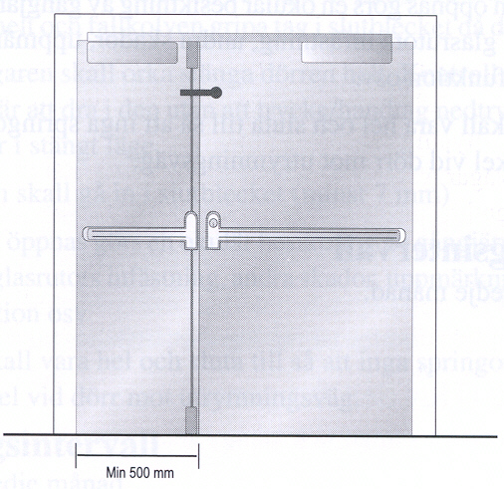

# Emergency exit button

Emergency exit buttons can be accepted where emergency exit devices in accordance with EN 179 are normally recommended according to Table 7.1. The button shall be placed in a prominent position.

For activities where panic exit devices are recommended according to Table 8.1, emergency exit buttons shall not normally be accepted. In this type of activity, the use of an emergency exit button shall be considered only after consultation with, and agreement by, the parties concerned.

Key switches are not accepted.

Properties of an emergency exit button:

- Green encapsulation.

- The emergency exit box is to be marked with a special sign. This sign should be green with white text "Emergency exit". The sign should be large enough to be easily detected.

- The button shall be easy to operate by a single action.

- The button should be visible even in the event of power failure. This can be achieved by providing standby power to illuminate the sign, by making the button luminous or the sign photoluminescence.

- Illuminated emergency exit button. By means of an integral illumination function or some other lighting fitting.

- When the button is depressed, the current shall be interrupted and the lock function released.

- If possible, red light for locked door and green light for unlocked door.

- The emergency exit button can with advantage be equipped with an acoustic exit alarm.

- The use of the button will activate an alarm (on the control panel) or a sound alarm (if use of the normal key for regular activities - no alarm).

Position of emergency exit button:

- It shall be easy to see and placed on or in the immediate vicinity of the door.

- 0.9 – 1.2 m above floor level

- Max 0.5 m from the door laterally, but not on the side of the hinge.

- For single door, the emergency exit button shall be placed on the hinge side.

- For double doors, push buttons should be placed beside the door to achieve the shortest distance between the emergency exit button and the lever handle.

# Safe integration of door access control and fire alarm system

It is increasingly common to integrate door access control system to the fire alarm system of a building. Integrating these two separate systems means that when the fire alarm system detects a fire, the access control system automatically unlocks all emergency exit doors. Doors with fire separating function that are equipped with an electromechanical hold-open device can also be automatically released as soon as fire is detected.

There are different ways of integrating these systems, but it is important to keep in mind at least the following principles when if comes to safety:

* The integration must not interfere with the inherent purpose of the fire alarm system, which is to detect fires, sound an alarm and transmit the alarm information to rescue services.
* If an error occurs in either of the systems, it must be made sure the systems remain in a mode where neither fire safety nor egress are endangered.
* The fire alarm system’s documentation must include detailed information on how and which doors are affected when a fire is detected. The documentation must also include instructions on how to test the operability of the integration on a regular basis. Instructions should also include how to restore normal functionality after a fire alarm or an error.
* Fire alarm system should never be the only initiating element to unlock electromechanical doors without a key, access card or such. An emergency exit button (see section 5) should be secondary initiating element in case the integrated systems suffer a catastrophic failure or the emergency is not related to a fire.

# Intruder protection locking device

If doors are fitted with intruder protection locking devices (night locks), further measures in the form of connecting these via micro switches or similar are required.

Local regulations may allow for “night locking” when not open to the public or for general occupancy, under certain conditions. For example, it may be requested for each person having access to the building (such as cleaning, security or maintenance people) to have their own key allowing them to escape from the building in case of an emergency.

Special conditions, for instance when people are locked in for various reasons, are not dealt with here. In such cases, the solutions must at all times be decided on in consultation with the parties concerned.

For information and guidance on the types of security hardware suitable for use on emergency exits doors and best practise security solutions to reduce the particular vulnerabilities commonly associated with such doors, reference is made to *Security guidelines for safe emergency exit doors in non-residential premises* (CFPA Europe No. 6:S).

# Installation and maintenance

Installation of doors and exit devices must be performed by qualified professionals and according to installation instructions provided by the manufacturer. After installation, correct operability must be tested to make sure the device and components perform flawlessly. When installing exit devices on doors with fire separating function, suitability of the device for this purpose must be confirmed from installation instructions.

The doors and devices, which form part of escape routes, must be properly maintained throughout their lifecycle so that their function in an emergency situation is secured.

Visual and functional inspections and more elaborate maintenance shall be made at regular intervals by a person appointed by the person responsible for the building or firm. Note that some maintenance might require specialist expertise. Inspection and maintenance intervals are to be determined by the responsible person. These intervals usually depend on certain factors, for example frequency of operation and the surrounding environment. Door that is under high traffic and perhaps surrounded by corrosive elements will need maintenance more regularly.

More detailed information regarding maintenance should be available in maintenance instructions provided by the manufacturer of the door or device.

The way inspection is to be performed varies depending on the function, which the door has. See Appendix No 1. All inspection and maintenance procedures should be documented.

# Choice of exit devices for emergency purposes

On the following pages, you can find several examples of door fittings for emergency exit doors, single and double doors, with fire door function and non-fire door function. These door fittings enable controlled passage even when doors must be locked from the outside. Examples in this guideline are intended only as illustrative proposals for you to find functional solutions. The choice of exit devices for emergency purposes in public premises should always be based on a risk analysis. If there is a probability of accumulation of many people at exit doors, panic exit devices should be selected. In this context, it is important to be aware that emergency exit doors and fittings are often regulated by national legislation.

Use the following flow chart to find suitable proposals. Start by choosing a single or double door and then continue according to the diagram referring to the examples described on the following pages.

# Annex 1: Panic & emergency exit devices

These technical solutions apply for exit doors, not sliding doors, both with and without a fire separating function, which shall normally be locked from the outside and/or provide the means of controlling the passage of persons from the inside/outside.

# Annex 1.1 E 1, Single fire door

Fittings on the inside

Emergency exit device

Door closer. Can be fitted with electromechanical hold-open device

Functions on the inside

The exit handle, operated with one hand, secures exit

Option of authorised passage via a key

Fitting on the outside

Lever handle

Functions on the outside

Lever handle secures return

Option of authorised passage via a key

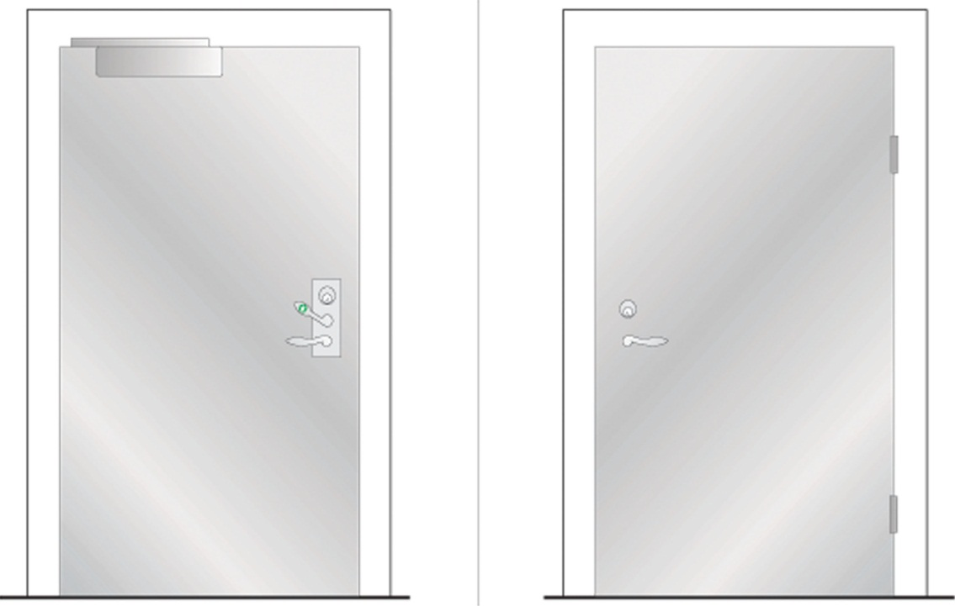

# Annex 1.2 E 2, Single door with/without fire separating function depending on choice of electric striking plate

Fittings on the inside

Emergency exit device

Electric striking plate

Pulse generator, e.g. card reader

Door closer

Functions on the inside

The exit handle, operated with one hand, secures exit

Option of authorised passage via pulse generator/key

Option of automatic unlocking via fire alarm, with fire separating function retained depending on choice of electric striking plate. (Not as the only function)

Fittings on the outside

Lever handle

Pulse generator, e.g. card reader

Functions on the outside

Lever handle secures return

Option of authorised passage via pulse generator/key

Option of automatic unlocking via fire alarm, with fire separating function retained depending on choice of electric striking plate. (Not as the only function)

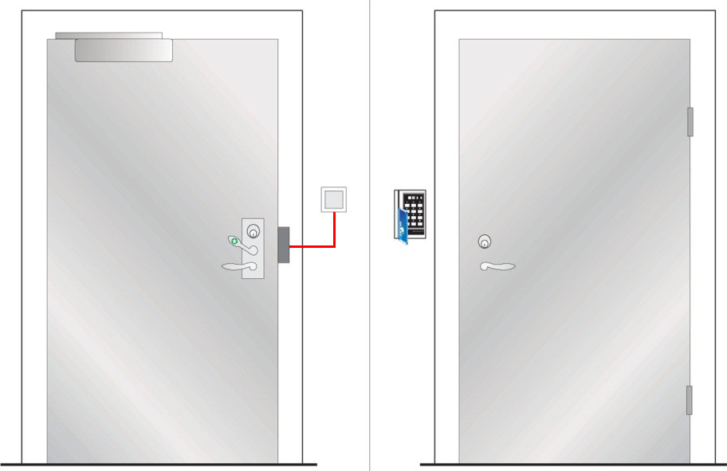

Inside Outside

# Annex 1.3 E 3, Single fire door

Fittings on the inside

Emergency exit device, as push pad

Door closer. Can be fitted with electromechanical hold-open device

Functions on the inside

The push pad, operated with one hand, secures exit

Option of authorised passage via a key

Fitting on the outside

Option 1: See figure. Plain outside face

Option 2: Cylinder + pull handle

Functions on the outside

Option 1: See figure. No return

Option 2: No return but authorised passage via key

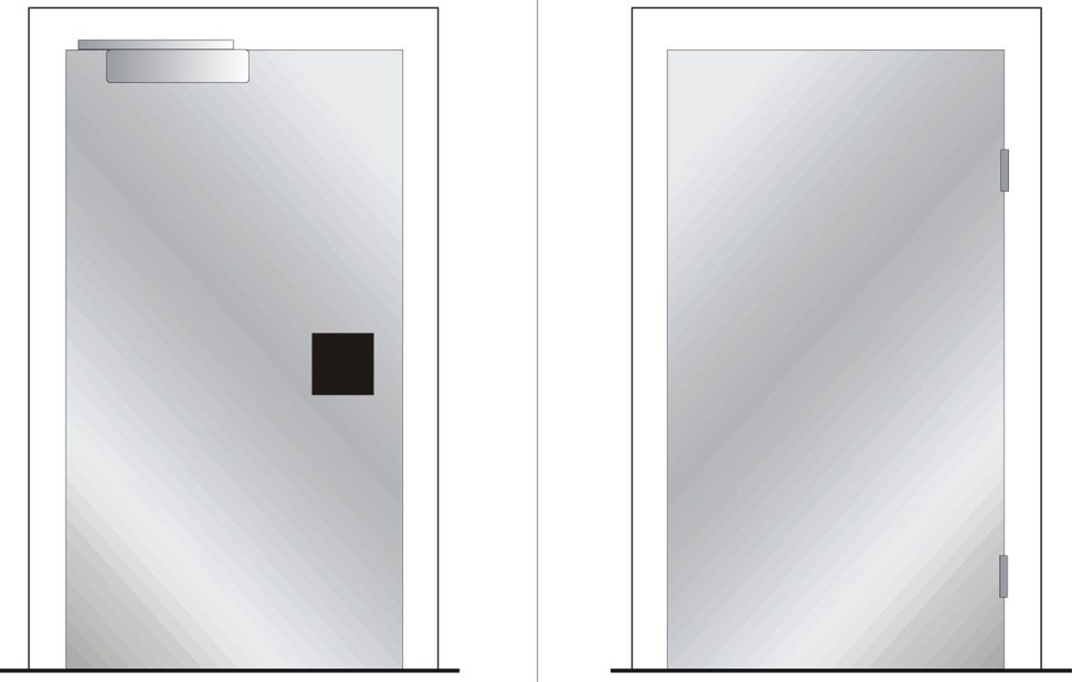

Inside Outside

# Annex 1.4 E 4, Single door with/without fire separating function depending on choice of electric striking plate

Fittings on the inside

Emergency exit device as push pad

Electric striking plate

Pulse generator, e.g. card reader

Door closer

Functions on the inside

The push pad, operated with one hand, secures exit

Option of authorised passage via pulse generator/key

Option of automatic unlocking via fire alarm, with fire separating function retained depending on choice of electric striking plate. (Not as the only function)

Fittings on the outside

Lever handle

Pulse generator, e.g. card reader

Functions on the outside

No return but authorised passage via pulse generator/key

Option of automatic unlocking via fire alarm, with fire separating function retained depending on choice of electric striking plate

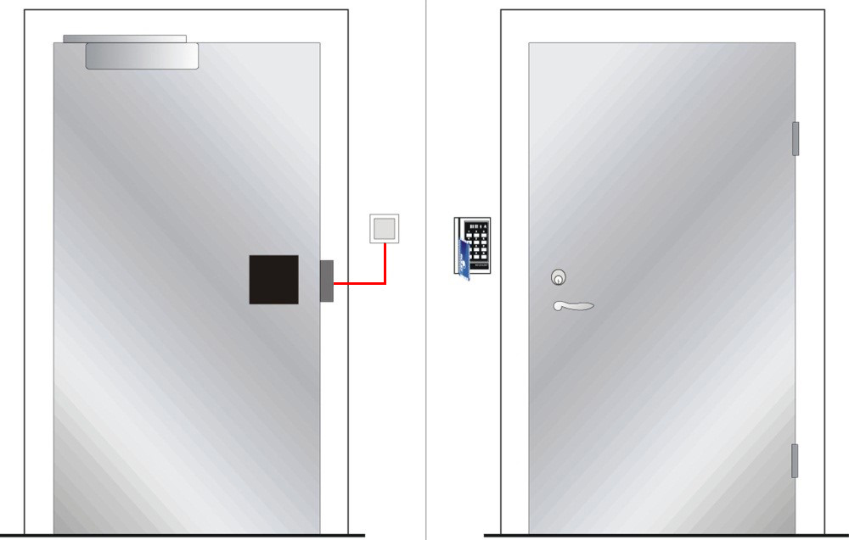

Inside Outside

# Annex 1.5 Ee 1, Single door, not a fire door

Fittings on the inside

Emergency exit button

Door holder magnet/electromechanical door bolt with standby power

Pull handle

Door closer. Can be fitted with electromechanical hold-open device

Functions on the inside

Exit via emergency exit button

Option of authorised passage via key switch or pulse generator

Option of automatic unlocking via fire alarm. (Not as the only function)

Fittings on the outside

Pull handle

Pulse generator, e.g. card reader

Functions on the outside

Return via pull handle after exit or activation of fire alarm

Option of authorised passage via pulse generator

Option of automatic unlocking via fire alarm. (Not as the only function)

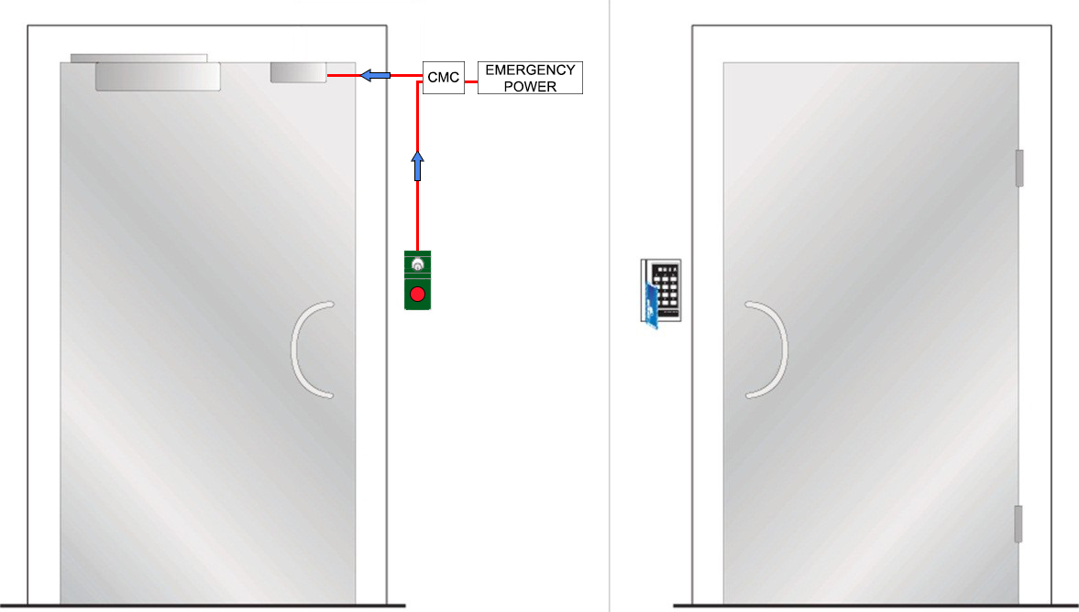

Inside Outside

# Annex 1.6 Ee 2, Single door with/without fire separating function depending on choice of electric striking plate

Fittings on the inside

Emergency exit button

Electric striking plate with folded mechanical lock housing  
Pull handle

Door closer. Can be fitted with electromechanical hold-open device

Functions on the inside

Exit via emergency exit button

Option of authorised passage via key switch or pulse generator

Option of automatic unlocking via fire alarm. (Not as the only function)

Fittings on the outside

Pull handle

Pulse generator, e.g. card reader

Functions on the outside

Return via pull handle after exit or activation of fire alarm

Option of authorised passage via pulse generator

Option of automatic unlocking via fire alarm. (Not as the only function)

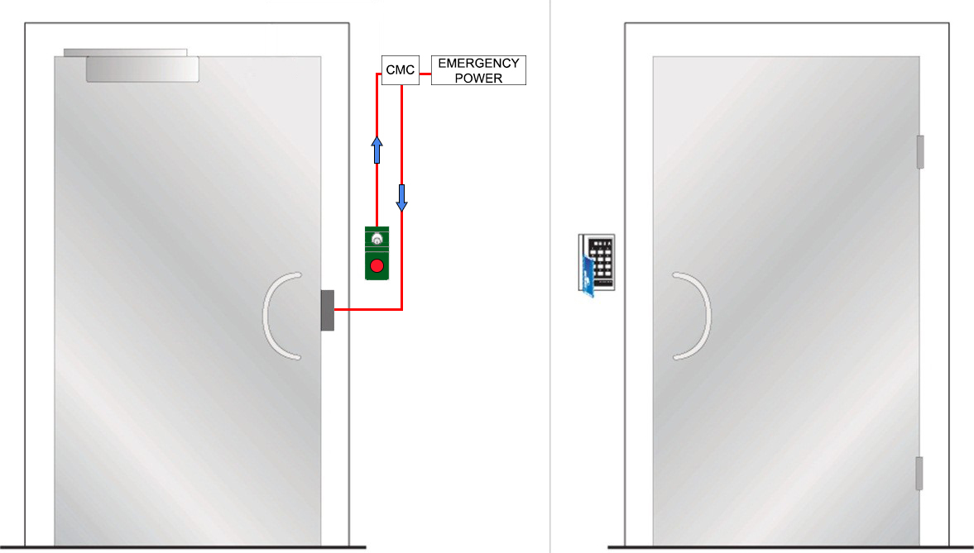

Inside Outside

# Annex 1.7 Ee 3, Single fire door

Fittings on the inside

Emergency exit button

Electric lock/solenoid lock with lever latch

Door closer. Can be fitted with electromechanical hold-open device

Functions on the inside

Exit via emergency exit button

Option of authorised passage via key switch or pulse generator

Option of automatic unlocking via fire alarm. (Not as the only function)

Fittings on the outside

Lever handle

Pulse generator, e.g. card reader

Functions on the outside

Return via lever handle after exit or activation of fire alarm

Option of authorised passage via pulse generator or key

Option of automatic unlocking via fire alarm. (Not as the only function)

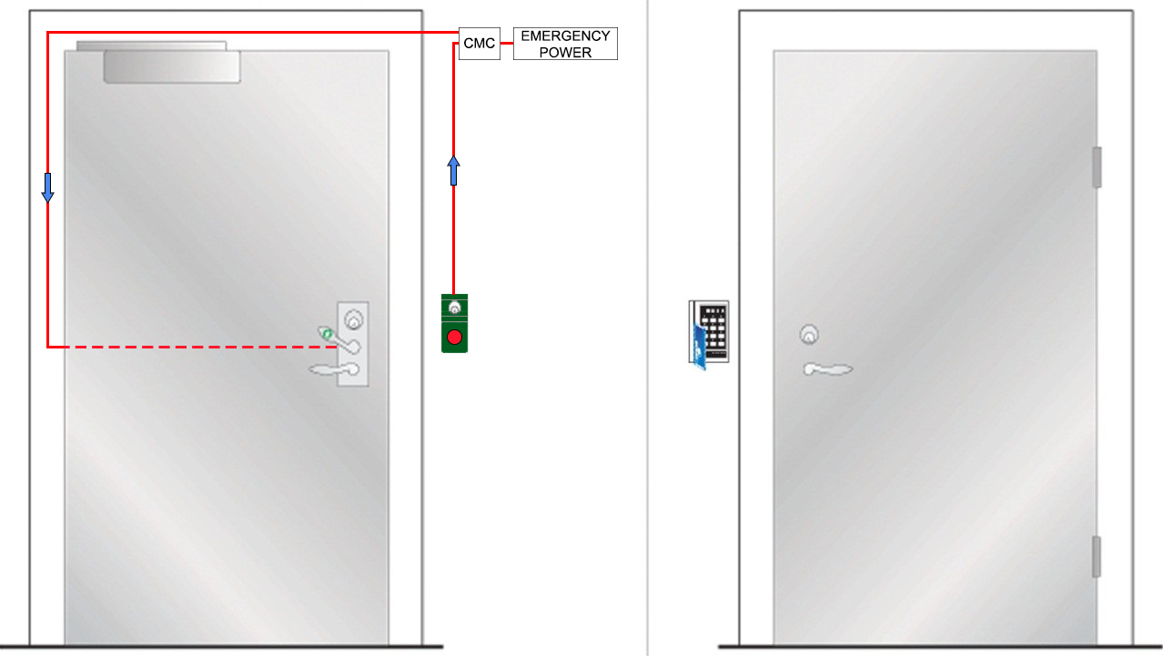

Inside Outside

# Annex 1.8 P 1, Single fire door

Fittings on the inside

Panic bolt push/touch bar

Door closer. Can be fitted with electromechanical hold-open device

Functions on the inside

Panic bolt push/touch bar secures exit.

Option of authorised passage via key

Fitting on the outside

Lever handle

Functions on the outside

Lever handle secures return

Option of authorised passage via key

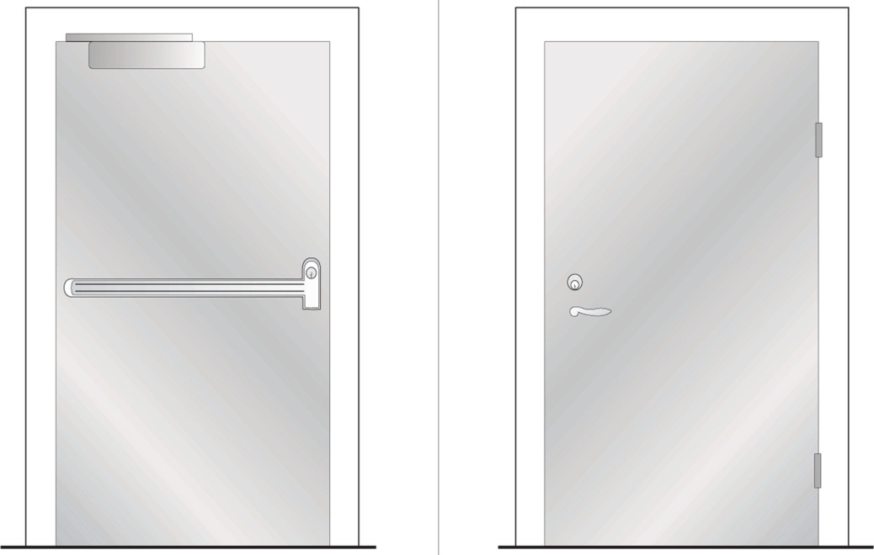

Inside Outside

# Annex 1.9 P 2, Single fire door

Fittings on the inside

Panic bolt push/touch bar

Door closer. Can be fitted with electromechanical hold-open device

Functions on the inside

Panic bolt push/touch bar secures exit

Option of authorised passage via key

Fittings on the outside

Option 1: See figure. Plain outside face

Option 2: Cylinder + pull handle

Functions on the outside

Option 1: See figure. No return

Option 2: No return but authorised passage via key

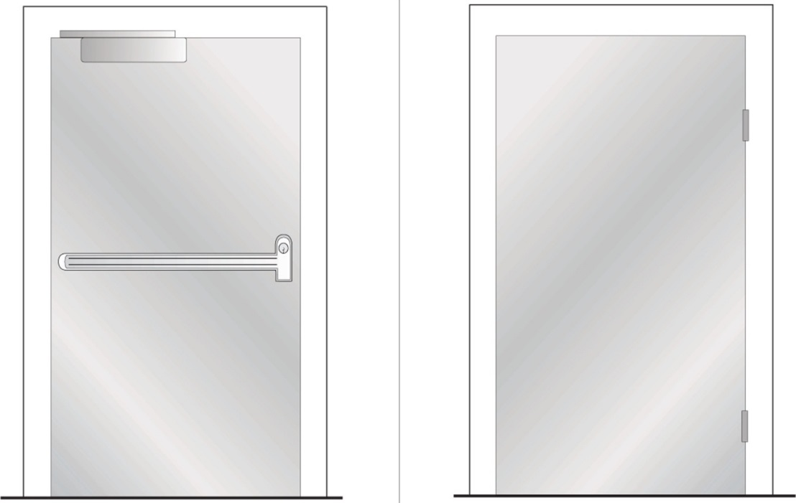

Inside Outside

# Annex 1.10 P 3, Single door with/without fire separating function depending on choice of electric striking plate

Fittings on the inside

Panic bolt push/touch bar

Electric striking plate

Pulse generator, e.g. card reader

Door closer

Functions on the inside

Panic bolt push/touch bar secures exit

Option of authorised passage via pulse generator

Option of automatic unlocking via fire alarm, with fire separating function retained depending on choice of electric striking plate. (Not as the only function)

Fittings on the outside

Lever handle

Pulse generator, e.g. card reader

Functions on the outside

Lever handle secures return

Option of authorised passage via pulse generator

Option of automatic unlocking via fire alarm, with fire separating function retained depending on choice of electric striking plate. (Not as the only function)

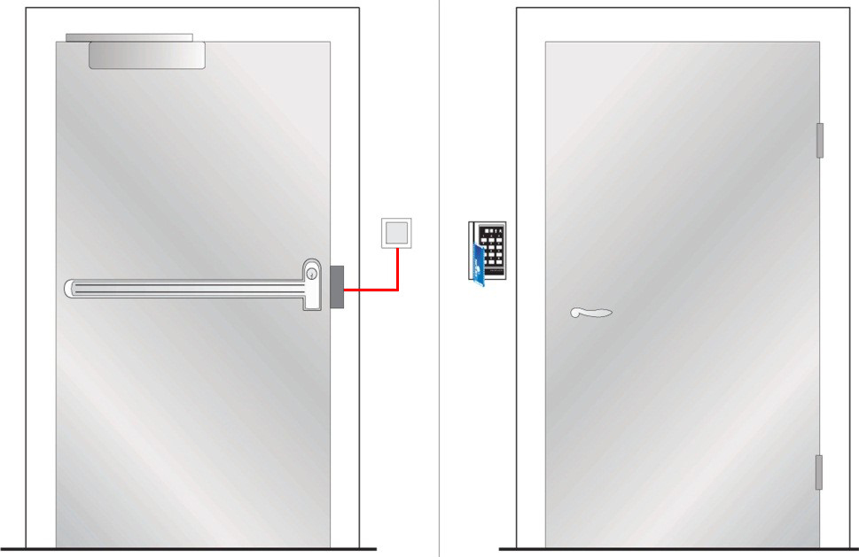

Inside Outside

# Annex 1.11 P 4, Single fire door

Fittings on the inside

Panic bolt push/touch bar with electrical opening

Pulse generator, e.g. card reader

Door closer. Can be fitted with electromechanical hold-open device

Functions on the inside

Panic bolt push/touch bar secures exit

Option of authorised passage via pulse generator

Fittings on the outside

Pull handle

Pulse generator, e.g. card reader

Functions on the outside

No return

Option of authorised passage via pulse generator

Note

The panic bolt push/touch bar shall not be electrically held open. It shall be electrically open only at the time of passage

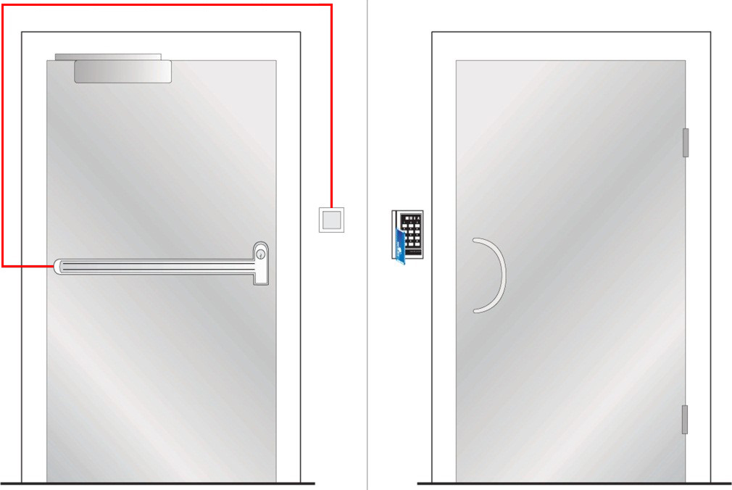

Inside Outside

# Annex 1.12 Pe 1, Single fire door

Fittings on the inside

Panic bolt push/touch bar with micro switch

Door holder magnet/electromechanical door bolt

Door closer. Can be fitted with electromechanical hold-open device

Functions on the inside

Panic bolt push/touch bar secures exit

Micro switch secures opening of door holder magnet/electromechanical door bolt

Option of automatic unlocking via fire alarm, with fire separating function retained. (Not as the only function)

Fittings on the outside

Option 1: Lever handle

Option 2: See figure. Lever handle + pulse generator, e.g. card reader

Functions on the outside

Option 1: Lever handle secures exit

Option 2: See figure. Lever handle secures return

Option of authorised passage via pulse generator/key

Option of automatic unlocking via fire alarm, with fire separating function retained. (Not as the only function)

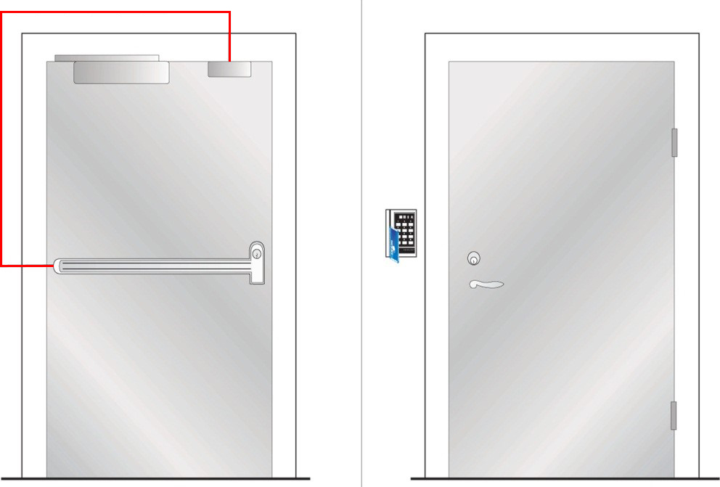

Inside Outside

# Annex 1.13 Pe 2, Single fire door

Fittings on the inside

Panic bolt push/touch bar with electrical opening and micro switch

Door holder magnet/electromechanical door bolt

Pulse generator, e.g. card reader

Door closer. Can be fitted with electromechanical hold-open device

Functions on the inside

Panic bolt push/touch bar secures exit

Micro switch secures opening of door holder magnet/electromechanical door bolt

Option of authorised passage via pulse generator

Option of automatic unlocking via fire alarm, with fire separating function retained. (Not as the only function)

Fittings on the outside

Lever handle

Pulse generator, e.g. card reader

Functions on the outside

Lever handle secures return

Option of authorised passage via pulse generator

Option of automatic unlocking via fire alarm, with fire separating function retained. (Not as the only function)

Note

The panic bolt push/touch bar shall not be electrically held open. It shall be electrically open only at the time of passage

Can be fitted with door automatics

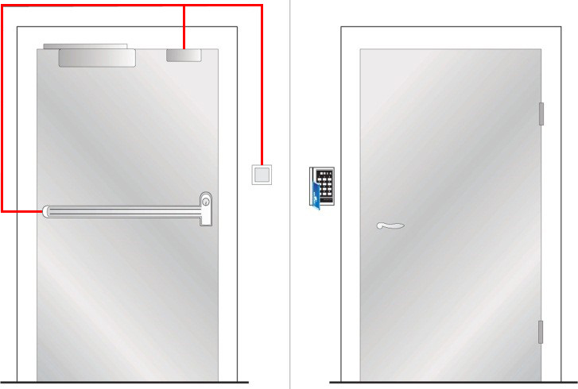

Inside Outside

# Annex 1.14 ED 1, Double fire doors

Fittings on the inside

Emergency exit devices, active leaf

Automatic flush bolts, inactive leaf

Inactive leaf fitted with tailpiece for the door coordinator function

Functions on the inside

Exit handle, operated with one hand, secures exit via active leaf

Option of authorised passage via key

Fittings on the outside

Lever handle

Door closer with coordinator. Can be fitted with electromechanical hold-open device

Functions on the outside

Lever handle secures return

Option of authorised passage via key

Door closer with coordinator closes the leaves in the right order

Note

The inactive leaf shall not form part of the escape route

|  |
| --- |
| NP1_insida NY NP1_utsida NY |

Inside Outside

# Annex 1.15 ED 2, Double doors with/without fire separating function depending on choice of electric striking plate

Fittings on the inside

Emergency exit device

Electric striking plate in inactive leaf

Pulse generator, e.g. card reader

Automatic flush bolts in inactive leaf

Inactive leaf fitted with tailpiece for the door coordinator function

Functions on the inside

Exit handle secures exit via active leaf

Option of authorised passage via pulse generator/key

Option of automatic unlocking via fire alarm, with fire separating function retained, depending on choice of electric striking plate. (Not as the only function)

Fittings on the outside

Lever handle

Pulse generator, e.g. card reader

Door closer with coordinator

Functions on the outside

Lever handle secures return

Option of authorised passage via pulse generator/key

Door closer with coordinator closes the leaves in the right order

Option of automatic unlocking via fire alarm, with fire separating function retained, depending on choice of electric striking plate. (Not as the only function)

Note

Inactive leaf shall not form part of the escape route

|  |
| --- |
| C:\Users\s7416\AppData\Local\Microsoft\Windows\Temporary Internet Files\Content.Word\EP2.png NP3_utsida NY |
| Inside Outside |

# Annex 1.16 ED 3, Double fire doors

Fittings on the inside

Emergency exit devices, as push pad

Automatic flush bolts, inactive leaf

Inactive leaf fitted with tailpiece for the door coordinator function

Functions on the inside

Push pad secures exit via active leaf

Option of authorised passage via key

Fittings on the outside

Option 1: See figure. Plain outside face

Door closer with coordinator. Can be fitted with electromechanical hold-open device

Option 2: Cylinder + pull handle

Door closer with coordinator. Can be fitted with electromechanical hold-open device

Functions on the outside

Option 1: See figure. No return

Door closer with coordinator closes the leaves in the right order

Option 2: No return but authorised passage via key

Door closer with coordinator closes the leaves in the right order

Note

Inactive leaf shall not form part of the escape route

|  |
| --- |
| NP4 insida NY NP4 utsida NY  Inside Outside |

# Annex 1.17 ED 4, Double doors with/without fire separating function depending on choice of electric striking plate

Fittings on the inside

Emergency exit device as push pad

Electric striking plate in inactive leaf

Pulse generator, e.g. card reader

Automatic flush bolts in inactive leaf

Inactive leaf fitted with tailpiece for the door coordinator function

Functions on the inside

The push pad secures exit via active leaf

Option of authorised passage via pulse generator/key

Option of automatic unlocking via fire alarm, with fire separating function retained, depending on choice of electric striking plate. (Not as the only function)

Fittings on the outside

Pull handle

Pulse generator, e.g. card reader

Door closer with coordinator

Functions on the outside

No return but authorised passage via pulse generator/key

Door closer with coordinator closes the leaves in the right order

Option of automatic unlocking via fire alarm, with fire separating function retained depending on choice of electric striking plate. (Not as the only function)

Note

Inactive leaf shall not form part of the escape route

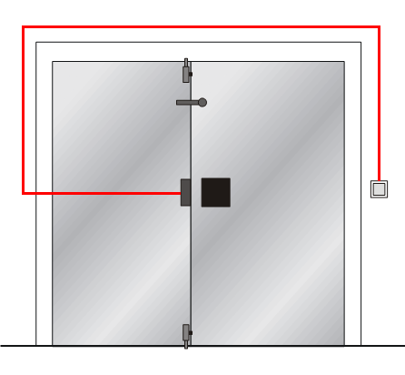NP5_utsida NY

Inside Outside

# Annex 1.18 EDe 1, Double doors with no fire separating function

Fittings on the inside

Emergency exit button

Option 1: See figure. Rebated doors fitted with door holder magnet/electromechanical door bolt with standby power

Inactive leaf fitted with tailpiece for the door coordinator function

Option 2: Not rebated doors fitted with double door holder magnets/ electromechanical door bolts with standby power

Functions on the inside

Exit via emergency exit button

Option of authorised passage via key switch

Option of automatic unlocking via fire alarm. (Not as the only function)

Fittings on the outside

Pull handle

Pulse generator, e.g. card reader

Option 1: See figure. Rebated doors fitted with door closer and coordinator

Can be fitted with electromechanical hold-open device

Option 2: Not rebated doors fitted with door closer. Coordinator not required. Can be fitted with electromechanical hold-open device

Functions on the outside

Return via pull handle after exit or activation of fire alarm

Option of authorised passage via pulse generator

Option of automatic unlocking via fire alarm. (Not as the only function)

Door closer with coordinator closes the leaves in the right order

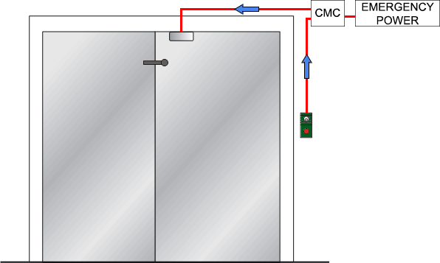NP2_utsida NY

Inside Outside

# Annex 1.19 PD 1, Double fire doors

Fittings on the inside

Panic bolt push/touch bars

Inactive leaf fitted with tailpiece for the door coordinator function

Functions on the inside

Panic bolt push/touch bar secures exit

Option of authorised passage via key

Fittings on the outside

Lever handle

Door closer with coordinator. Can be fitted with electromechanical hold-open device

Functions on the outside

No return

Option of authorised passage via key

Door closer with coordinator closes the leaves in the right order

Note

Where the inactive leaf forms part of the escape route, its width shall not be less than 500 mm.

PP1_insida NY

PP1_utsida NY

Inside Outside

# Annex 1.20 PD 2, Double fire doors

Fittings on the inside

Panic bolt push/touch bars

Inactive leaf fitted with tailpiece for the door coordinator function

Functions on the inside

Panic bolt push/touch bar secures exit

Option of authorised passage via key

Fittings on the outside

Door closer with coordinator. Can be fitted with electromechanical hold-open device

Option 1: See figure. Plain outside face

Option 2: Cylinder + pull handle

Functions on the outside

Door closer with coordinator closes the leaves in the right order

Option 1: See figure. No return

Option 2: No return but authorised passage via key

Note

Where the inactive leaf forms part of the escape route, its width shall not be less than 500 mm.

|  |
| --- |
| PP2_insida NY PP2_utsida NY |

Inside Outside

# Annex 1.21 PD 3, Double doors with/without fire separating function depending on choice of electric striking plate

Fittings on the inside

Panic bolt push/touch bars with micro switches

Electric striking plate in inactive leaf

Pulse generator, e.g. card reader

Inactive leaf fitted with tailpiece for the door coordinator function

Functions on the inside

Panic bolt push/touch bars secure exit

Option of authorised passage via pulse generator

Option of automatic unlocking via fire alarm, with fire separating function retained, depending on choice of electric striking plate. (Not as the only function)

Fittings on the outside

Lever handle

Pulse generator, e.g. card reader

Door closer with coordinator

Functions on the outside

Lever handle secures return. (Depending on choice of electric striking plate)

Option of authorised passage via pulse generator

Option of automatic unlocking via fire alarm, with fire separating function retained, depending on choice of electric striking plate . (Not as the only function)

Door closer with coordinator closes the leaves in the right order

Note

Where the inactive leaf forms part of the escape route, its width shall not be less than 500 mm.

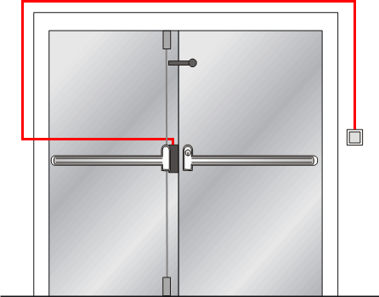PP4_utsida NY

Inside Outside

# Annex 1.22 PD 4, Double fire doors

Fittings on the inside

Panic bolt push/touch bars with electrical opening

Pulse generator, e.g. card reader

Inactive leaf fitted with tailpiece for the door coordinator function

Functions on the inside

Panic bolt push/touch bars secure exit

Option of authorised passage via pulse generator

Fittings on the outside

Pull handle

Pulse generator, e.g. card reader

Door closer with coordinator. Can be fitted with electromechanical hold-open device

Functions on the outside

No return

Option of authorised passage via pulse generator

Door closer with coordinator closes the leaves in the right order

Note

Where the inactive leaf forms part of the escape route, its width shall not be less than 500 mm.

Panic bolt push/touch bar shall not be electrically held open. It shall be electrically open only at the time of passage

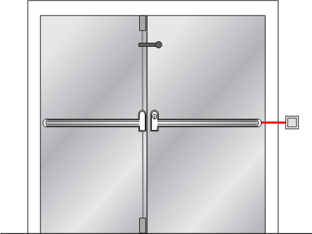PP5_utsida NY

Inside Outside

# Annex 1.23 PDe 1, Double fire doors

Fittings on the inside

Panic bolt push/touch bars with micro switches

Door holder magnet/electromechanical door bolt in active leaf

Inactive leaf fitted with tailpiece for the door coordinator function

Functions on the inside

Panic bolt push/touch bars secure exit

Micro switches secure opening of door holder magnet/electromechanical door bolt

Option of automatic unlocking via fire alarm, with fire separating function retained, depending on choice of electric striking plate. (Not as the only function)

Fittings on the outside

Door closer with coordinator. Can be fitted with electromechanical hold-open device

Option 1: Lever handle

Option 2: See figure. Lever handle + pulse generator, e.g. card reader

Functions on the outside

Door closer with coordinator closes the leaves in the right order

Option 1: Lever handle secures return

Option 2: See figure. Lever handle secures return

Option of authorised passage via pulse generator/key

Option of automatic unlocking via fire alarm, with fire separating function retained. (Not as the only function)

Note

Where the inactive leaf forms part of the escape route, its width shall not be less than 500 mm

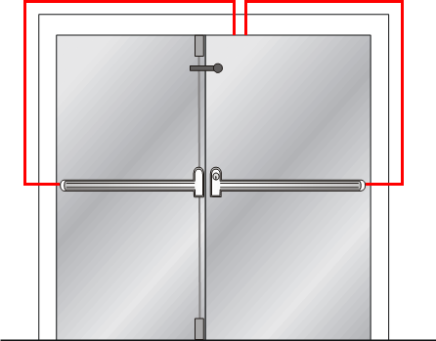PP3_utsida NY

Inside Outside

# Annex 1.24 PDe 2, Double fire doors

Fittings on the inside

Panic bolt push/touch bars with electrical opening and micro switches

Door holder magnet/electromechanical door bolt in active leaf

Pulse generator, e.g. card reader

Inactive leaf fitted with tailpiece for the door coordinator function

Functions on the inside

Panic bolt push/touch bars secure exit

Micro switch secures opening of door holder magnet/electromechanical door bolt

Option of authorised passage via pulse generator

Option of automatic unlocking via fire alarm, with fire separating function retained, depending on choice of electric striking plate. (Not as the only function)

Fittings on the outside

Lever handle

Pulse generator, e.g. card reader

Door closer with coordinator. Can be fitted with electromechanical hold-open device

Functions on the outside

Lever handle secures return

Option of authorised passage via pulse generator

Door closer with coordinator closes the leaves in the right order

Option of automatic unlocking via fire alarm, with fire separating function retained. (Not as the only function)

Note

Where the inactive leaf forms part of the escape route, its width shall not be less than 500 mm.

Panic bolt push/touch bar shall not be electrically held open. It shall be electrically open only at the time of passage.

Can be fitted with door automatics

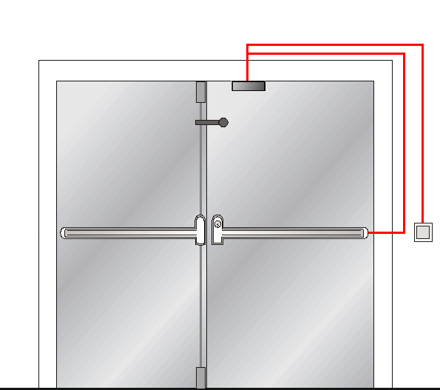PP6_utsida NY

Inside Outside

# Annex 2 Examples of control routines

The user should carry out regular control, but an effort should be made to perform the control together with the property owner as often as possible. The aim of this is to become familiar with the building and to form an overall idea of the total security of escape, and to achieve a good dialogue with the property owner.

In order that control of the technical installation may be carried out in a satisfactory manner, the following checklist should be used in checking doors in, and to, an escape route.

How often controls should be carried out depends on the hazard situation and the general wear and tear in the building and premises. Control of escape facilities should be made every day.

# Annex 2.1 Control routines

**For all doors in and to escape routes, regardless of whether they have, or have not, a fire compartment separating function, the following are to be checked.**

**Function**

* Check that the door can be easily opened without a key, code or card, and that it can be opened at least 90º
* Check that nothing is blocking the escape route
* Check that the force needed to open the door does not exceed 130 N (ca 13 kg)
* Check that return into the premises is possible where so required

**Maintenance**

* When the door is opened, make a visual inspection of hinges, locks, handle, door frame, the attachment of glazed panels if any, any other damage, marking, the function of the door handle, etc.

**For a door with a fire compartment separating function, the following is also to be checked**

**Gas tightness**

* Check that the door is undamaged and closes so that there are no gaps, not even along the doorstep of a door opening into an escape route in a stairway
* Check that any intumescent strips that are fitted along the door are undamaged

**Lock case**

* A lock case with only a cylinder lock must not be fitted with a hold-open device
* Check the engagement of the spring bolt with the striking plate
* Door of fire resistance class E/EI 30 - 7 mm
* Door of fire resistance class E/EI 60 - 10 mm

**For doors that also have the following components fitted, the following shall also be checked:**

**Door closer**

* Open door ca 10 cm and let it go. Check that the door closes completely and that the spring bolt engages with the striking plate
* Check if there are any oil leaks
* Check for damage to the arm system that affects the door holder function
* Check the fixing of the door closer housing and the fixings of the arms

NOTE that split-arm system or hold-open arms are not recommended for doors at fire compartment boundaries

**Electromechanical hold-open device**

Break the current, e.g. with the test button

* Check that the door closes completely and that the spring bolt engages with the striking plate
* Check that it is released in the event of power failure

**Automatic flush bolt for double doors**

* Check that the flush bolt moves easily in the striking plate
* Pull the handle and check that the doors do not open
* Check the fixing of the flush bolt and striking plate

**Coordinator for double doors**

* Check that the “correct” door closes first
* Check the fixing

**Tailpiece for double doors**

* Check fixing and function

**Guidance marking**

* Assess whether the sign is fully visible from appropriate points in the premises
* Check that the sign is in place and that it is functioning, i.e. it is undamaged, illuminated, not concealed
* Check the emergency power supply, if any. This can be done on fluorescent signs with their own backup battery. Press the button on the light fitting or unscrew the fuse that supplies the light fitting, and check the emergency light.

# European guidelines

*Fire*

Guideline No 1 F - Internal fire protection control

Guideline No 2 F - Panic & emergency exit devices

Guideline No 3 F - Certification of thermographers

Guideline No 4 F - Introduction to qualitative fire risk assessment

Guideline No 5 F - Guidance signs, emergency lighting and general lighting

Guideline No 6 F - Fire safety in care homes

Guideline No 7 F - Safety distance between waste containers and buildings

Guideline No 8 F - Preventing arson – information to young people

Guideline No 9 F - Fire safety in restaurants

Guideline No 10 F - Smoke alarms in the home

Guideline No 11 F - Recommended numbers of fire protection trained staff

Guideline No 12 F - Fire safety basics for hot work operatives

Guideline No 13 F - Fire protection documentation

Guideline No 14 F - Fire protection in information technology facilities

Guideline No 15 F - Fire safety in guest harbours and marinas

Guideline No 16 F - Fire protection in offices

Guideline No 17 F - Fire safety in farm buildings

Guideline No 18 F - Fire protection on chemical manufacturing sites

Guideline No 19 F - Fire safety engineering concerning evacuation from buildings

Guideline No 20 F - Fire safety in camping sites

Guideline No 21 F - Fire prevention on construction sites

Guideline No 22 F - Wind turbines – Fire protection guideline

Guideline No 23 F - Securing the operational readiness of fire control system

Guideline No 24 F - Fire safe homes

Guideline No 25 F - Emergency plan

*Guideline No 26 F - withdrawn*

Guideline No 27 F - Fire safety in apartment buildings

Guideline No 28 F - Fire safety in laboratories

Guideline No 29 F - Protection of paintings: transports, exhibition and storage

Guideline No 30 F - Managing fire safety in historic buildings

Guideline No 31 F - Protection against self-ignition end explosions in handling and storage

of silage and fodder in farms

Guideline No 32 F - Treatment and storage of waste and combustible secondary raw

materials

Guideline No 33 F - Evacuation of people with disabilities

Guideline No 34 F - Fire safety measures with emergency power supply

Guideline No 35 F - Fire safety in warehouses

Guideline No 36 F - Fire prevention in large tents

Guideline No 37 F - Photovoltaic systems: recommendations on loss prevention

Guideline No 38 F - Fire safety recommendations for short-term rental accommodations

Guideline No 39 F - Fire protection in schools

Guideline No 40 F - Procedure to certify CFPA-E Fire Safety Specialists in Building Design

*Natural hazards*

Guideline No 1 N - Protection against flood

Guideline No 2 N - Business resilience – An introduction to protecting your business

Guideline No 3 N - Protection of buildings against wind damage

Guideline No 4 N - Lighting protection

Guideline No 5 N - Managing heavy snow loads on roofs

Guideline No 6 N - Forest fires

Guideline No 7 N - Demountable / Mobile flood protection systems

*Security*

Guideline No 1 S - Arson document

Guideline No 2 S - Protection of empty buildings

Guideline No 3 S - Security systems for empty buildings

Guideline No 4 S - Guidance on keyholder selections and duties

Guideline No 5 S - Security guidelines for museums and showrooms

Guideline No 6 S - Security guidelines emergency exit doors in non-residential premises

Guideline No 7 S - Developing evacuation and salvage plans for works of art and

heritage buildings

Guideline No 8 S - Security in schools

Guideline No 9 S - Recommendation for the control of metal theft

Guideline No 10 S - Protection of business intelligence

Guideline No 11 S - Cyber security for small and medium-sized enterprises

Comments and corrective actions:



[**www.cfpa-e.eu**](https://www.cfpa-e.eu)

1. By fitting a panic or emergency device to a CE fire resistant door and/or to any certified fire door, the fire resistance of the door cannot be altered by the fitting of the lock. The door documentation should specify what is authorised or not, and our the way to do it. [↑](#footnote-ref-1)