Fire safety in warehouses

CFPA-E No 35:2017 F

FOREWORD

The European fire protection associations produce common guidelines in order to achieve similar interpretation in European countries and to give examples of acceptable fire prevention and protective measures. CFPA Europe also develops and ratifies guidelines for aspects of natural hazards, safety and security related problems.

The objectives of CFPA Europe are to improve safety and security and to prevent the consequent loss of life, destruction of property and disruption to business activities. CFPA Europe also seeks to meet the increasing demands for quality and safety in the workplace.

This guideline concerns storage premises, both large and small. The measures concern not only owners, tenants and staff who administer and operate warehouses, but also the local population who may be affected by a serious fire in their immediate neighbourhood. It is intended that the contents will help to prevent fires from occurring and minimise the impact of any incident that does take place.

The proposals on which this guideline is based were produced by The UK Fire Protection Association and the author was Adair Lewis.

The Guideline has been compiled by the Guidelines Commission and adopted by all fire protection associations in the Confederation of Fire Protection Associations Europe.

These guidelines reflect best practice developed by the countries of CFPA Europe. Where the guidelines and national requirements conflict, national requirements must take precedence.

Copenhagen, 13 February 2017 Madrid, 13 February 2017
CFPA Europe Guidelines Commission

Jesper Ditlev Miguel Vidueira
Chairman Chairman

Contents

1 SCOPE 4
2 INTRODUCTION 4
3 DEFINITIONS 6
4 COMPLIANCE WITH FIRE SAFETY LEGISLATION 6
5 FIRE RISK MANAGEMENT 7
5.1 Housekeeping 7
5.2 Hot work 9
5.3 Shrink wrapping and heat sealing 10
5.4 Heating 11
5.5 Electricity, gas and other services 11
5.6 Smoking 12
5.7 Lift trucks 12
5.8 Hazardous goods 13
5.9 Arson prevention 13
6 FIRE PROTECTION 14
6.1 Detection and alarm systems 15
6.2 Extinguishing systems 15
6.3 Compartmentation 17
6.4 Escape 17
6.5 Fire fighting 17
7 RULES AND ROUTINES 18
8 BUSINESS CONTINUITY 19
9 TRAINING 19
10 DOCUMENTATION 20
11 CONTROL SYSTEM 20
11.1 Regular fire safety inspections 20
11.2 Closing time inspections 20
12 REFERENCES 20
13 EUROPEAN GUIDELINES 21

Keywords: Warehouse, storage, business continuity, arson, hot works, fire compartment, emergency procedures, fire protection systems

SCOPE

Warehouse accommodation considered in this document includes commercial storage buildings on manufacturing sites and business parks but does not extend to retail warehouses which are routinely visited by members of the public or to premises designed to be let in small areas for the storage of personal effects.

Additional hazards may be associated with specialist warehouses, such as automated high bay warehouses, cold stores, and premises used primarily for the storage of chemicals and other hazardous materials, and these are not specifically addressed in this document. Additional guidance should be sought regarding these premises, in addition to the material set out in this document.

Details of styles and construction of racking are outside the scope of this publication.

INTRODUCTION

Over the past few years the number and size of warehouses has increased dramatically, especially in locations on key transport hubs or adjacent to motorway junctions. The materials stored in these facilities range from small electronic items to books, CDs and engineering products. The number and wide variety of items of stock, activities which may be undertaken (for example heated shrink wrapping and charging of electric vehicles) and the associated numbers of vehicle movements present numerous opportunities for incidents to occur in the absence of a rigorous fire safety management regime.

Whilst the incidence of fires in warehouses is generally low, the size of the buildings and the volumes of combustible material stored results in many of the fires becoming major conflagrations which pose challenges for fire and rescue services and result in significant property losses and disruption to business continuity.

A detailed fire risk assessment to take account of property protection, as well as life safety, in accordance with national fire safety legislation is a key element of an effective fire safety strategy. In some cases an assessment in compliance with the ATEX Directive (ref 1) will also need to be undertaken.

These assessments will identify the fire hazards and the potential for property and business interruption losses and lead to the preparation of an effective risk control programme for the premises. The assessment should consider the structure of the building and the flammability of the products stored both within and outside the premises. Vigilance with regard to deliberate fire setting must also be maintained, with arson prevention also being an important part of the assessment.

It should be recognised that in many warehouses the products stored and the mode of storage, together with the associated fire hazards, may change over remarkably short periods of time and thus the fire risk assessment process will need to be an ongoing activity with frequent reviews. This will ensure that any alterations to the overall fire risk are correctly identified so that the fire safety strategy may be modified as necessary.

Particular attention will need to be given to effectively manage potentially hazardous activities that are carried out in existing warehouses, such as those relating to hot work, shrink wrapping and the charging of electric vehicles.

These recommendations set out in this document are intended to address life and property protection in the event of fire in warehouses and storage premises.

Warehouses referred to in this document include commercial storage buildings on manufacturing sites and business parks but do not extend to retail warehouses which are routinely visited by members of the public or to premises designed to be let in small areas for the storage of personal effects.

Additional hazards associated with specialist warehouses, such as automated high bay warehouses, cold stores, and premises used primarily for the storage of chemicals and other hazardous materials, are not specifically addressed in this Guideline. Additional guidance should be sought regarding these specialist storage premises, in addition to the material set out in this document.

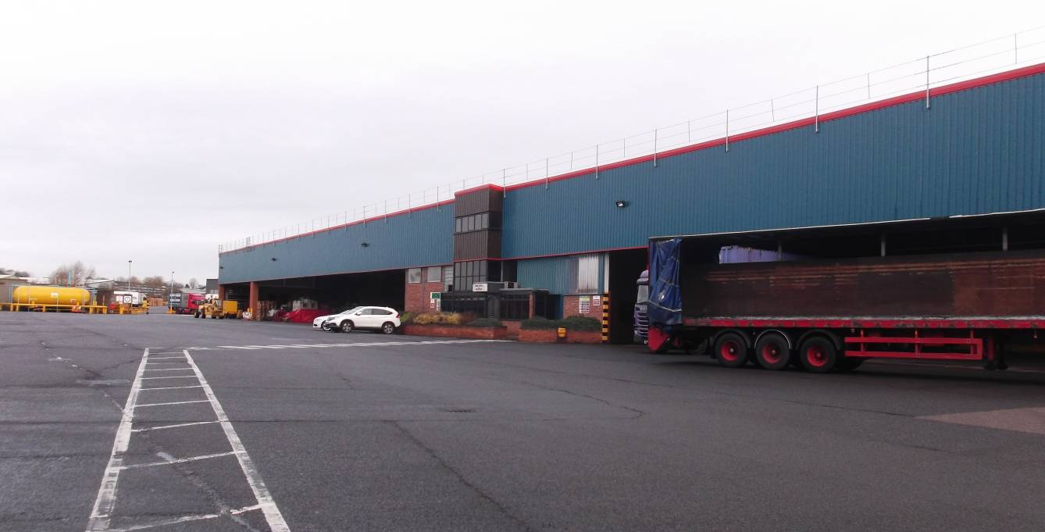

Warehouses tend to very large, undivided buildings

DEFINITIONS

Arson
The deliberate setting of fires by intruders or by people with legitimate access to the premises.
Fire compartment
Part of a building, separated from the rest of the building by construction complying with fire resistance regulations, inside which a fire can develop during a prescribed least period without spreading to other parts of the building.

Composite panel
A panel composed of an insulating core material covered by steel facings. The insulating core may consist of a non-combustible or combustible material. The insulation in various panels may consist of such diverse materials as mineral wool and expanded polystyrene.

COMPLIANCE WITH FIRE SAFETY LEGISLATION

A suitable and sufficient fire risk assessment for the premises should be undertaken in compliance with national legislation and guidelines. The combustibility of the stock and packaging, the nature of the operations, the internal layout and the method of storage have a major influence on the hazards presented. Measures that should be considered include:

- physical segregation of the warehouse from manufacturing areas and other operations being carried out on site
- suitable fire detection and warning systems in case of fire
- the installation of sprinkler installations and other fixed fire suppression systems
- the provision of appropriate portable fire fighting equipment
- development of an emergency action plan to protect life and property and ensure the continuing functioning of the business in the case of fire
- staff training in the actions to take in the event of fire, including the safe shut down of conveyors or similar equipment used in the area and evacuation of the premises.

An assessment in compliance with the ATEX Directive (ref 1) should be undertaken where hazardous materials such as significant quantities of flammable liquids, oils, compressed gases or dusts are being stored. The operation of the warehouse should take into account the findings of this assessment which should identify the hazardous materials that are present and relevant hazard zones where there may be potential for exposable quantities of flammable liquid vapours or dusts to accumulate.

FIRE RISK MANAGEMENT

Close liaison should be established with the fire and rescue service from the initial planning stage of the facility, especially in cases where storage is being planned at high level. The fire service will need to visit the site to familiarise themselves with the layout of the premises and the location and extent of water supplies available in the locality. They will also need to be provided with details of water sprinkler and any other automatic fire suppression systems that have been installed.
The benefits of a comprehensive fire safety management regime coupled with appropriate fire safety procedures and adequate staff training that is observed and embraced by all staff cannot be over-emphasized.

Each goods inwards and despatch area should be clearly defined. Where the risk assessment identifies an increased fire hazard, separation should be provided from the warehouse by compartment walls, floors and ceilings with an appropriate level of fire resistance.

More information about Fire Safety Management can be found in CFPA Guideline No. 1:2015 F “Fire Protection Management System”.

Housekeeping

5.1.1. Indoors

The premises should be kept in a clean and orderly condition at all times and goods or waste materials should not be stored in aisles and other designated escape routes.

Stocks of combustible packaging materials in the open warehouse should be kept to a minimum; bulk supplies should be stored in a separate building or in a separate fire compartment within the main warehouse.

ll loose-fill combustible packaging such as shredded paper, wood-wool and polystyrene beads should be contained in steel bins fitted with steel lids which are kept closed when the container is not in use.

The internal storage of idle pallets should be kept to a minimum, unless external storage is impracticable or there is a significant risk of external items being the target for an arson attack.

All waste materials should be swept up and removed at the end of each working period. Particular attention should be given to goods inwards and despatch areas.

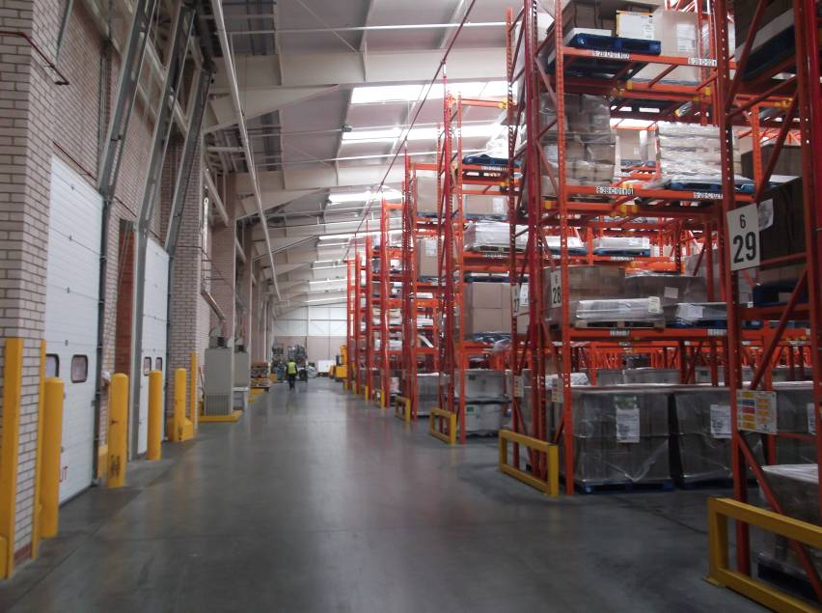

Clear pathways and aisles should be maintained within the warehouse

5.1.2. Outdoors

Combustible materials or items awaiting delivery should not be allowed to remain on loading docks or beneath external canopies when the premises are unoccupied.

All combustible waste removed from the warehouse should be contained in secure, enclosed metal skips or bins with a compactor being used where necessary. If the use of open-topped skips is necessary, they should be located 10m clear of buildings and external storage. More information about safety distances for different types of materials can be found in CFPA E Guideline No 7:2011 F “Safety distances between waste containers and buildings”.

Combustible materials, including idle pallets, stored outside should not be stacked more than 4m high or be stored within 10m of a building. Where these conditions cannot be met, the insurer should be consulted.

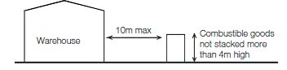
10m min
Figure 1: Ideal external storage arrangements

Where plastic pallets are in use, the storage arrangements should be subject to a specific fire risk assessment.

The area within 10m of the building(s) and external storage should be kept clear of undergrowth. The use of chemical weed control formulations containing chlorates should be avoided.

Combustible materials should be located at least 2m from boundary walls or fences.

External storage should be sited at least 15m from hazardous installations such as transformers, flammable liquid stores and liquefied petroleum gas tanks.

Gas cylinders and liquids stored outside should be kept in secure cages which are prominently labelled in accordance with national standards.

External oil tanks for boilers should be located outside the warehouse, at a distance determined by a risk assessment. Valves controlling the fuel supply from the tanks should cut off the oil supply automatically in the event of a fire, or on actuation of the fire alarm.

The burning of rubbish in the open should be strictly prohibited.

Defined areas should be provided for parking cars. Similar provisions should be available for delivery vehicles and trailers to indicate where they should be parked except when loading or unloading. Parking should be at least 10m away from buildings, hazardous installations and loading areas.

Hot work

Unless unavoidable, hot work such as welding, flame cutting and similar activities should not take place in a warehouse. If for justified reasons this cannot be achieved, all hot work activities should be conducted under an effective Permit to Work system and in accordance with CFPA-E Guideline 12:2012F: Fire safety basics for hot work operatives.

Special care needs to be taken in circumstances where hot work has to be undertaken in the vicinity of composite panels with a combustible core, irrespective of whether they form internal compartmentation or parts of the external fabric of the building.

As well as the hazards directly associated with hot work, other contractors’ operations (such as the laying of flooring with volatile adhesives) may result in an increase in risk to the premises if allowed to proceed without suitable management controls. An additional assessment of the hazards posed by all contractors’ operations should be carried out and any necessary control measures introduced before the operations commence.

Shrink wrapping and heat sealing

All heat sealing and shrink wrapping operations should be carried out in a safe manner in accordance with best practice:

- Methods should be adopted that do not require the use of an open flame.
- Wherever practicable, shrink wrapping and heat sealing operations should be carried out in a separate fire compartment away from warehousing activities. Walls and floors between the warehouse and the heat sealing area should provide at least 60 minutes fire resistance. Where this is not possible, heat sealing should be carried out at least 5m from any stored materials. The intervening space should be clearly marked on the floor, be kept clear of potential sources of ignition and combustible materials and be inspected regularly.
- Relevant staff should be trained in the correct use of the equipment. Mobile equipment should always be used by two trained persons.
- The equipment should be used, inspected and maintained in accordance with the manufacturer’s instructions at all times.
- The heat output of the sealing equipment should be regulated automatically and a high temperature cut out switch should be fitted.
- Where the equipment operates automatically, it should shut down in the event of a malfunction of the feed process.
- Flammable products, such as aerosol cans, should not be packed in heat sealed bags or shrunken foils.
- Combustible waste should be removed from the area on a regular basis.
- Freshly shrunk or heat sealed products should be allowed to cool before being returned to the warehouse. Where large quantities of products are shrink wrapped, a temporary storage area providing at least 60 minutes fire separation from the main warehouse may need to be available for this purpose.
- A check should be made at the end of each work period that the equipment is cool and that there are no smouldering residues in the vicinity before vacating the area.
- A suitable number of appropriate fire extinguishers should be available in the heat sealing area in case of fire.

Heating

Space heating systems should be designed, installed and maintained in accordance with the manufacturer’s instructions.

The use of portable heaters and fans should be avoided.

Central heating boilers should preferably be located in a separate fire compartment providing at least 60 minutes fire separation from the remainder of the premises. Where this is not possible, fixed gas or oil fired heat exchange units should be located near an external wall and be provided with guard rails, allowing a clear space of at least 1m from all surfaces of the appliance.

Flue pipes from heating appliances should take the most direct route from the building and should not penetrate fire compartment walls unless absolutely unavoidable. Where it is necessary for flues to pass through fire compartment walls or floors, proprietary sleeves or penetration seals should be fitted. Where flues pass through combustible material, it should be cut away for a distance of at least 150mm from the duct and the space filled with non-combustible insulation.

Where it is necessary to route flue pipes through or near to storage racking or mezzanine floors, suitable guards should be fitted to provide a clear space of at least 1m from combustible or flammable materials.

Overhead heaters should be sited so as to provide at least 2m clearance from combustible materials. Heaters should not be positioned so as to direct the hot air towards nearby composite panel walls, whether these form internal or external elements of structure. The siting of overhead heaters should be reassessed when alterations to storage arrangements or the type of stock or its packaging are being considered and at times when the fire risk assessment for the warehouse is being reviewed.

Electricity, gas and other services

Electrical installations should be designed, installed and periodically tested by a competent electrician in accordance with national standards. Inspections should be carried out periodically thereafter.

Lighting should be installed so that luminaires are suspended over walkways rather than directly above combustible stock. Wherever practicable, luminaires should be located at least 0.5m from stored goods.

The use of light fittings with integral containment barriers made of tempered or borosilicate glass is recommended. High intensity discharge lamps are commonly encountered in warehouses and should always be fully enclosed even where shatter protected lamps are fitted. This is to prevent pieces of hot glass form dropping onto combustible materials below if a lamp does shatter.

Portable electrical equipment should be inspected and tested periodically in accordance with national standards. The results should be recorded.

Transformers and associated electrical switchgear should be located in fire compartments separated from the warehouse so as to provide at least 120 minutes fire resistance.

Ancillary switchgear and plant rooms should be kept clear of all storage; notices to this effect should be displayed prominently. Plant rooms should be kept locked with access only available to authorised personnel.

Electrical fittings should be mounted on a non-combustible board and not be attached directly to a composite panel.

Control units should be located in cabinets providing at least 60 minutes fire resistance and be surrounded by suitable guard rails to protect them from damage by trolleys and trucks.

Where electrical cables and service pipes are considered to be vulnerable to impact and damage, protection should be provided. This is particularly relevant to oil and gas services and water pipes.

All service pipes should be correctly identified in accordance with national standards and be provided with suitable isolation valves as required.

Where practicable, oil and gas services should be run externally. Suitable Protection should be provided where electrical cables enter buildings through metal clad composite panels.

Water pipes in unheated areas should be lagged or trace heated to prevent frost damage.

Electrical equipment in staff rooms such as microwave ovens, dishwashers, washing machines and dryers should be given as much attention as other electrical equipment in supervisory and maintenance.

Smoking

Smoking in warehouses should be strictly prohibited in accordance with national legislation and notices to this effect should be prominently displayed. A designated safe smoking area should be provided, and where practicable this should be at least 10m from buildings, hazardous installations and externally stored combustible items.

The designated smoking area should be remote from entrances to the building and not be located beneath a canopy or low slung eaves.

Lift trucks

Lift trucks of various styles are commonly used in warehouse operations. Whether powered by petrol, diesel fuel, batteries or liquefied petroleum gas (LPG), significant fire hazards may arise.

All trucks should be designed to be safe for use in any hazard zones identified in the warehouse as a result of the assessment undertaken in compliance with the ATEX Directive (ref 1).

The charging of battery powered vehicles and the management of fork lift trucks and similar mechanisms designed for use within warehouses should be in accordance with national best practice.

Where trucks are powered by LPG, cylinders should be changed in the open air outside the buildings. Similarly, refuelling petrol or diesel fuelled trucks should also be undertaken outside the warehouse.

Hazardous goods

Hazardous materials should be identified and be subject to an assessment in compliance with the ATEX Directive

Where gas cylinders are present on site, they should be stored, used and handled in accordance with national standards. Particular care should be taken where the presence of acetylene cylinders on the site cannot be avoided.

Where significant quantities of hazardous materials such as oxidising chemicals, flammable liquids and aerosol products are stored, information regarding their quantities, locations and mode of storage should be readily available to the emergency services. Before storing such materials the insurers should be consulted, in order that necessary risk control measures can be clearly established and implemented.

Incompatible materials should be stored in compliance with national guidelines and so that they do not come into contact in the event of fire.

Only the minimum volumes of flammable liquids should be held within warehouse premises. Where it is necessary to store flammable liquids within buildings, use should be made of bunded pallets or similar provisions to retain any spillage..

Hazardous goods should be thoroughly inspected on delivery. A safe and secure holding area at least 10m from any building or plant should be available to quarantine any defective or damaged containers pending their safe disposal.

Provisions to deal with spillages and leaks of flammable liquids should be available and staff trained in their use.

Arson prevention

Arson is estimated to account for over a third of all major fires in industrial and commercial premises and should therefore form a key element of a warehouse fire risk assessment.

The possibility of deliberate fire raising from outside the building, by intruders or by staff with legitimate access to the building should not be forgotten.

In many premises work continues during the nights and over weekends when fewer staff may be present to receive deliveries and despatch goods. At these times consideration may need to be given to heightened security measures to detect intruders and potential fire setters outside the premises.

External storage should be kept to a minimum but where it is necessary, the amount of goods, idle pallets, tote boxes, trays and similar items should not be unduly exposed to malicious ignition. Combustible items stored in external areas should be at least 2m from boundary fences.

Fuel dispensing pumps, oil and other flammable liquid tanks should be secured out of working hours.

The security threat to the building(s) and the site as a whole should be one of the focal points of the arson risk assessment. On the basis of this, decisions should be taken on the nature of the protection required, which should be proportionate to the risks identified. This will have a dual effect of reducing the risk of theft and of arson. In most cases, effective security will comprise a combination of measures. Typically, this will involve a combination of physical protection and electronic security systems, such as intruder alarms and security lighting, tailored to the needs of the individual premises or site concerned. For high security warehouses, measures including total perimeter fencing, manned guarding and closed circuit television (CCTV) equipment should be considered.

Personnel access control should be carefully considered as an essential component of the security programme. In the case of high value or high risk warehouses the need for the premises to be secure from the outside during business hours may need to be considered and the measures implemented will need to be compatible with the requirements for effective business operations and means of escape from within in case of fire.

Toilet and refreshment facilities should be provided for delivery drivers and other visitors without the need for them to enter or pass through the warehouse. In some cases provision should also be made for a meeting room in this area.

Shutters on vehicle bays should be closed when vehicles have left.

FIRE PROTECTION

People involved in design, installation and inspection of fire protection systems shall have competence according to national regulations and industry practice.

Detection and alarm systems

Automatic fire detection and alarm systems should be designed to take into account the need for property protection and should be to a recognised category of installation in accordance with national standards, as determined by a risk assessment and in consultation with the insurer.

The automatic fire detection and alarm system should be monitored either on-site or by an off-site accredited alarm receiving centre operating in accordance with national standards.

The installation should be serviced periodically and maintained in accordance with national standards.

Where conveyors, automatic packaging or similar equipment is in use, these should be linked to the automatic fire detection and alarm system so as to halt the movement of goods when the system actuates. The maintenance should include checking of these systems, together with the operation of automatic vents, release of fire doors and other systems linked to the indicator and control panel.

Extinguishing systems

Water supplies should be in the form of one or more of the following:

- Hydrants provided by a water company on street mains.
- Private hydrants designed in accordance with national standards and ideally form part of a ring main system. Hydrant outlets should be positioned not more than 70m from an entry to a building on the site and not more than 150m apart. They should preferably be sited immediately adjacent to roadways or hard standing facilities provided for fire service appliances and not less than 6m from the building so that they remain usable during a fire.
- A static or natural water supply capable of providing a minimum capacity that satisfies the fire and rescue service.

Serious consideration should be given to the installation of a water sprinkler installation when the facility is at the design stage. Sprinkler systems should be designed, installed, commissioned and maintained in accordance with national standards by a company having third party accreditation. The installation of sprinkler systems in warehouses is often a requirement from insurance companies.

In-rack sprinkler heads should be installed where appropriate and where plastic pallets are in use a foam enhanced sprinkler installation should be utilised.

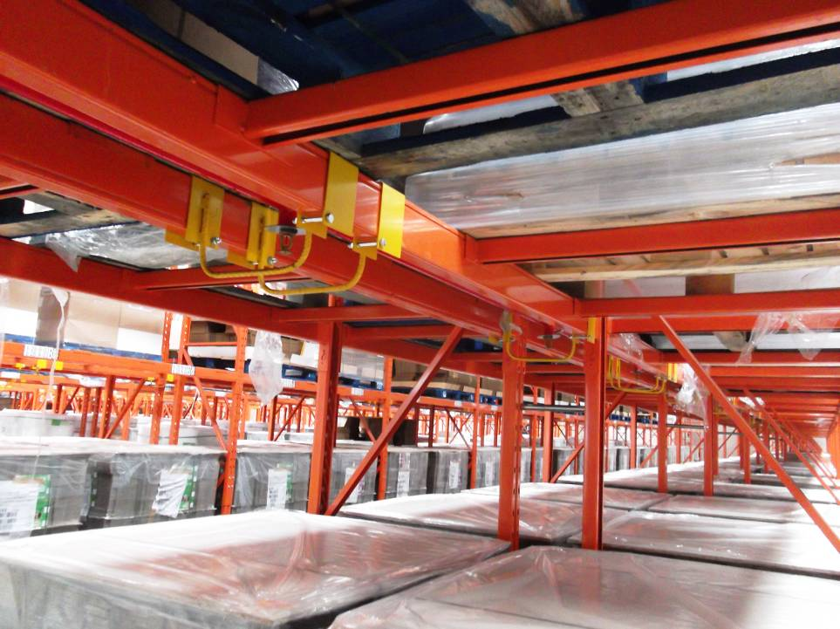

In rack sprinkler heads should be installed where appropriate

Consideration should be given to installing local fire suppression systems where they may be beneficial, such as to protect the electric motors of auto-stacker systems

In addition to an automatic sprinkler installation or other fixed fire suppression system, a suitable number of appropriate portable fire extinguishers should be available and immediately accessible in the case of a fire. Such portable extinguishers should be approved and certified by an independent, third party certification body and be installed, inspected and maintained in compliance with national standards.

Fire extinguishers should be positioned at prominent fire points, usually sited on an exit route. Extinguishers should be clearly signed; in a warehouse high level signs may also be needed to indicate their location to staff. A weekly inspection of all fire points should be carried out to ensure that all extinguishers are in place, undamaged and readily accessible.

Compartmentation

New buildings should be constructed in accordance with national legislation and building codes and comply with best practice.

Care must be taken to ensure that all holes around piped services and cables passing through fire compartment walls, floor and ceilings of a warehouse are suitably fire stopped. Particular attention should be paid to stopping penetrations through composite panels.

Hazardous and business critical areas should be identified in the fire risk assessment. Such areas may include packing operations, plant rooms, boiler rooms, electrical transformer rooms and switchrooms, IT facilities, vehicle maintenance bays and truck charging areas. Consideration should be given to enclosing these areas with elements of structure providing at least 120 minutes fire resistance.

Escape

The occupants must be able to evacuate the premises quickly and safely in case of fire. Number, width and location of escape paths (e.g. internal ways, corridors and stairways) and emergency exits must be appropriate to the risk as well as be free of obstacles hindering the passage to the escape in order to avoid any risk of falls, slips or accidents. Therefore, loadings docks and platforms could not be considered in the evacuation plan.

Inside a large hall, evacuation route should be as short and straight as possible. However, evacuation plan should take into account specific arrangements due to, for example machinery, long shelves or hazardous storage.

It is then strongly recommended to strengthen the mandatory safety signs and make the evacuation route free with an appropriate marking on the floor.

Fire fighting

Arrangements should be made to provide prompt access to the fire and rescue service on their arrival at the site. Fire fighters should be met by security personnel or a designated member of staff who should have the gates or barriers open awaiting their arrival.

Externally, a clear route should be maintained to allow fire and rescue service vehicles and pumping appliances to gain suitable access to the warehouses. Access to the buildings for fire fighters should be in compliance with national building codes and insurers’ requirements.

Within the warehouse, a clear pathway no less than 0.5m wide should be maintained along the external walls and, where achievable, aisles should be at least 2.5m wide. The areas of undivided free standing storage should be limited so as not to restrict access for fire fighting.

Where fire doors are installed for the protection of openings in compartment walls, a clear radius on each side of the opening should be created in which no combustible goods are placed, to prevent the spread of fire by radiated heat when the doors are opened. The safe distances involved should be determined by risk assessment and will vary considerably, depending on the size and type of door or shutter. Goods must not obstruct the free movement of fire doors.

Information should be provided for the fire and rescue service at a prominent location to include:

- the layout of the site, including plans of the building
- the location of emergency shutdown points for conveyors and/or automated operations
- the location of the indicator panel for the automatic fire detection and alarm installation
- details of any automatic fire suppression system(s) and the location of their controls (eg stop valves for the sprinkler system)
- details of ventilation systems
- the nature and location of any hazardous substances on the premises
- contact details for staff who may need to be consulted
- the location of hydrants, rising mains or other sources of water on site or nearby for firefighting purposes.

Smoke venting systems may be installed in warehouses for life safety and property protection purposes, and may be a requirement of the fire and rescue service. Venting helps to prevent smoke logging, thereby assisting the means of escape and the fire brigade in their firefighting efforts.

When smoke venting is installed within a sprinkler-protected building, expert guidance should be sought to ensure that it does not interact adversely with the operation of the sprinklers.

RULES AND ROUTINES

An auditing programme should be established in which all fire protection measures and procedures are monitored. Any deficiencies arising from the audit should be reported and actioned as soon as possible.

Staff should be instructed to report to a named person any impairment in fire protection and safety systems. This is particularly important where dealing with sprinkler installations. Where working practices have resulted in the operation of the system becoming compromised, or likely to be impaired, insurers and the fire brigade should be informed immediately. Any additional fire precautions, as identified by the insurers, should be maintained throughout the period of impairment and a fire risk assessment carried out to identify any further compensatory actions that may be necessary.

BUSINESS CONTINUITY

Even a small fire in a warehouse can have a disproportionate effect on a business. In some cases contamination from such an event can be sufficiently severe to result in severe disruption, with associated loss of orders, jobs, income and profit to neighbouring properties as well as the warehouse in which the fire originated.

All organisations should take steps to ensure the continued smooth running of their business by making a suitable emergency plan. Guidance for this is set out in CFPA-E Guideline 2 N: 2013: Business resilience. The emergency plan should address the implications of a fire, flood or other perceived disaster on all facets of the business model. It should indicate the lines of communication that should be followed and the contact details for specialist assistance, providers of alternative accommodation and suppliers of manufacturing plant.

When complete, the emergency plan should be tested either fully or by means of a table top exercise, with the results being assessed and amendments made to the plan as necessary.

Consideration may be given to applying commercially available computer programmes that are available from the internet free of charge to develop and check the adequacy of the plan.

TRAINING

The correct procedures for raising the alarm and summoning the fire brigade should be established and form part of the staff fire safety training programme.

Induction and periodic refresher training courses should be provided in the use of the fire extinguishing equipment and the procedures to be followed when discovering a fire and responding to a fire alarm.

Where staff have a first language other than that in which the training is presented, it should be established that fire safety training has been properly understood. Where necessary, interpreters may need to be provided at training events and supporting literature and notices be produced in appropriate languages.

Training should be given to selected personnel in the operation of the fire detection and alarm installation and the checking and operation of the sprinkler system and other automatic fire fighting installations.

DOCUMENTATION

Fire safety systems and installations should be documented so that inspections can be carried out in a systematic manner.

CONTROL SYSTEM

Regular fire safety inspections

Control of the fire protection systems shall be carried out regularly and preferably by the fire protection surveyors appointed in the company. The control is to be based on the description of fire protection and the operating and maintenance instructions.

Closing time inspections

Most major fires in industrial premises occur outside normal working hours; closing time inspections should therefore be instituted as a key element of an effective risk control programme.

A detailed inspection of the warehouse should be completed and logged by a responsible person at the end of each period of work to ensure that the premises are left in a safe and secure condition. In particular, this will include checks that:

- conveyors and packing processes have been stopped and made safe
- all accumulated rubbish has been removed
- plant and services have been isolated as required
- fire doors and shutters are closed
- security measures are in place.

REFERENCES

- European Directive 99/92/EC (sometimes known as the ATEX 137 or ATEX Workplace Directive): Minimum requirements for improving the safety and health protection of workers potentially at risk from explosive atmospheres.

EUROPEAN GUIDELINES
Fire
Guideline No. 1:2015 F - Fire protection management system
Guideline No. 2:2013 F - Panic & emergency exit devices
Guideline No. 3:2011 F - Certification of thermographers
Guideline No. 4:2010 F - Introduction to qualitative fire risk assessment
Guideline No. 5:2016 F - Guidance signs, emergency lighting and general lighting
Guideline No. 6:2011 F - Fire safety in care homes for the elderly
Guideline No. 7:2011 F - Safety distance between waste containers and buildings
Guideline No. 8:2004 F - Preventing arson – information to young people
Guideline No. 9:2012 F - Fire safety in restaurants
Guideline No. 10:2008 F - Smoke alarms in the home
Guideline No. 11:2015 F - Recommended numbers of fire protection trained staff
Guideline No. 12:2012 F - Fire safety basics for hot work operatives
Guideline No. 13:2015 F - Fire protection documentation
Guideline No. 14:2007 F - Fire protection in information technology facilities
Guideline No. 15:2012 F - Fire safety in guest harbours and marinas
Guideline No. 16:2016 F - Fire protection in offices
Guideline No. 17:2015 F - Fire safety in farm buildings
Guideline No. 18:2013 F - Fire protection on chemical manufacturing sites
Guideline No. 19:2009 F - Fire safety engineering concerning evacuation from buildings
Guideline No. 20:2012 F - Fire safety in camping sites
Guideline No. 21:2012 F - Fire prevention on construction sites
Guideline No. 22:2012 F - Wind turbines – Fire protection guideline
Guideline No. 23:2010 F - Securing the operational readiness of fire control system
Guideline No. 24:2016 F - Fire safe homes
Guideline No. 25:2010 F - Emergency plan
Guideline No. 26:2010 F - Fire protection of temporary buildings on construction sites
Guideline No. 27:2011 F - Fire safety in apartment buildings
Guideline No. 28:2012 F - Fire safety in laboratories
Guideline No. 29:2013 F - Protection of paintings: Transport, exhibition and storage
Guideline No. 30:2013 F - Managing fire safety in historical buildings
Guideline No. 31:2013 F - Protection against self-ignition and explosions in handling
and storage of silage and fodder in farms
Guideline No. 32:2014 F - Treatment and storage of waste and combustible
secondary raw materials
Guideline No. 33:2015 F - Evacuation of people with disabilities
Guideline No. 34:2015 F - Fire safety measures with emergency power supplies
Guideline No. 35:2017 F - Fire safety in warehouses

Natural hazards
Guideline No. 1:2012 N - Protection against flood
Guideline No. 2:2013 N - Business Resilience – An introduction to protecting your
business
Guideline No. 3:2013 N - Protection of buildings against wind damage
Guideline No. 4:2013 N - Lightning protection
Guideline No. 5:2014 N - Managing heavy snow loads on roofs
Guideline No. 6:2015 N - Forest fires

Security
Guideline No. 1:2010 S - Arson document
Guideline No. 2:2010 S - Protection of empty buildings
Guideline No. 3:2010 S - Security system for empty buildings
Guideline No. 4:2010 S - Guidance on key holder selections and duties
Guideline No. 5:2012 S - Security guidelines for museums and showrooms
Guideline No. 6:2014 S - Emergency exit doors in non-residential premises

