Fire safety measures
with emergency power supplies

CFPA-E No 34:2015 F

FOREWORD

The European fire protection associations have decided to produce common guidelines in order to achieve similar interpretation in European countries and to give examples of acceptable solutions, concepts and models. The Confederation of Fire Protection Associations in Europe (CFPA E) has the aim to facilitate and support fire protection work in European countries.

The market imposes new demands for quality and safety. Today, fire protection forms an integral part of a modern strategy for survival and competitiveness.

This guideline is primarily intended for those responsible for safety in companies and organisations. It is also addressed to fire and rescue services, consultants, safety companies etc. so that, in course of their work, they may be able to help companies and organisations to increase their levels of fire safety.

The proposals within this guideline have been produced by the Fire Protection Association and the author is Adair Lewis from the UK.

This Guideline has been compiled by Guidelines Commission and adopted by all fire protection associations in the Confederation of Fire Protection Associations Europe.

These guidelines reflect best practice developed by the countries of CFPA Europe. Where the guidelines and national requirement conflict, national requirements must apply.

Copenhagen, March 2015 Madrid, March 2015
CFPA Europe Guidelines Commission

Jesper Ditlev Miguel Vidueira
Chairman Chairman

CONTENTS

1 Scope 4
2 Introduction 4
3 Definitions 4
4 General 5
5 Fixed generators 6
6 Portable generators 10
7 Periodic testing and maintenance 11
8 Uninterruptible power supplies 12
9 Batteries 13
10 Alternative sources of power 14
11 Temporary installations 14
12 Action in the event of electrical fires 15
13 References 16
14 European Guidelines 16

Scope

This Guideline outlines practical measures that can be taken to reduce the number of fires associated with emergency power generating equipment. The guidance applies to the use of fixed and portable generators and also to uninterruptable power supplies that are often provided for computer installations and associated equipment.

This document does not make recommendations relating to the provision of emergency escape lighting; the storage of the fuel supplies for generators is also excluded. Provisions for these items should be in accordance with national standards and other Guidelines.

Introduction

With the increasing dependence on electrical power in industry and commerce, many organisations need an immediate back up supply of electricity should the normal power supply fail as a result of a fire, flood or other natural disaster. Power may be needed to run life safety systems, to maintain business continuity or to assist in rescue, salvage and investigation operations. In some cases there may be insurance implications in the event of a complete failure of the electrical supply.

Possible standby sources of power may be:

- storage batteries
- fixed or portable generators capable of independent operation,
- a separate supply feed that is independent of the normal power supply and unlikely to fail at the same time.

The possibility of installing a duplicate provision of power from a three-phase supply should also be considered where this is can be achieved.

Definitions

Uninterruptible power supply (UPS)
A battery powered power supply unit designed to provide power automatically and with the minimum of delay in the event of an interruption in the supply of normal mains electrical power.

General

  - Electrical supply installations, both temporary and permanent, must be installed in accordance with national legislation and appropriate standards.

  - All electrical work should be undertaken by a competent electrician.

  - When considering purchasing a temporary or emergency power generator, a check should be made that the power supply specified is adequate for all intended purposes. For economy, eliminate unnecessary applications.

  - For a safe and reliable service, a source of supply should be selected that will maintain power at the required voltage for an adequate period of time.

  - The standby supply should operate independently of the normal source of power so that it will always be capable of operating in the event of a failure of the normal source.

  - For life safety or business continuity systems to operate in fire conditions, the generator and any control equipment should be provided with fire protection of adequate duration. All elements of construction of enclosures for emergency generators should be of non- combustible material and have a minimum of 1 hour fire resistance.

  - Equipment shall be designed and installed so as to facilitate periodic inspection, testing and maintenance.

  - Stocks of fuel for generators should be kept to the minimum consistent with anticipated running requirements.

  - Fuel should not be kept in portable containers in the immediate vicinity of the generator.

  - Smoking should be prohibited in the vicinity of portable generators.

  - During the period of the emergency, all equipment not powered by the standby power supply should be switched off. When normal power supplies are restored, automatic equipment should be checked and any time clocks and control mechanisms should be reset as necessary.

  - Even if a UPS is present to cope with failure/variation of the normal power supply for computers and other business critical equipment, it will still be necessary for certain systems, such as automatic fire detection and alarm systems, security alarms and similar installations, to have their own back-up power supplies, as specified in relevant installation and operating standards.

  - While it is important to install a generator with sufficient capacity for all foreseeable future needs, the cost of power when a generator is only running at a fraction of its capacity must be considered.

  - In hospitals, nursing homes and similar establishments, the power supplies to critical equipment must be maintained without significant interruption and the level of lighting must also be maintained such that treatment and movement of staff can continue safely. In these instances, specialist advice regarding standby power supplies should be sought.

  - A design where a diesel emergency generator also acts as a fire pump for the sprinkler installation should be avoided.

Fixed generators

  - Fixed generators tend to be fuelled by diesel fuel, natural gas or propane. The choice should be made on availability of the fuel, or for environmental or practical reasons. Diesel-fuelled generators tend to be quieter and need less maintenance (water-cooled diesel units operate for up to 30,000 hours before major service) than comparably sized gas or propane powered units (water-cooled gas units may operate for up to 10,000 hours before major maintenance).

  - The choice will also be determined by the nature of the supply required; single-phase or three-phase generators are available running at either 120V or 240V. Throughout Europe generators should produce power with a frequency of 50Hz.

  - The specification should include the type of air filter, silencer and starter system. The latter consists of a 12V battery and starter motor with a charging alternator and start/stop switch. Diesel units should be fitted with a pre-heat switch and should have a safety shutdown system to protect the engine in case of oil pressure loss, generator overspeed or high water temperature.

  - When specifying new equipment it should be remembered that any electric motors which need to be powered will draw several times more current when starting under load than when running freely. (This will apply, for instance, in the case of air conditioning units, air compressors, pumps, refrigerators and freezers.) This factor may also have a significant bearing on the choice of a single-phase or three-phase generator.

  - Generating equipment must incorporate a feature which prevents it from delivering overcurrent to the system(s) to which it is providing power. The power rating of the integral overcurrent protection shall be co-ordinated with the downstream protective devices to ensure, as far as possible, that the downstream devices operate first.

  - Where electronic protection takes the form of feedback to limit the current output, the internal transfer switches shall operate so as first to eliminate the least critical portion of the connected electrical load.
  - Generator rooms should be kept free of potential sources of ignition except for suitable lighting and illuminated fire exit signs where these are necessary. Similarly, generator rooms should not be used for the storage of combustible materials

  - When the emergency is over, the equipment should be inspected, refuelled and made ready for use in case it is needed shortly afterwards.

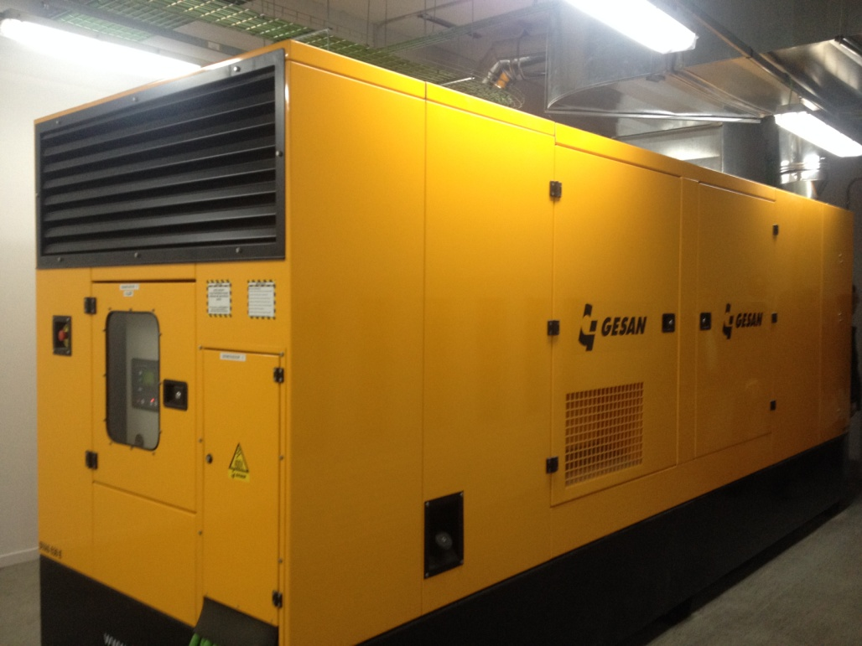

Photo1: Fixed generator installed within a building.

Installation

  - All fixed electrical generating equipment should be installed, operated and maintained in accordance with the manufacturer’s instructions.

  - Fixed generators should be sited in purpose built enclosures of non-combustible construction that are used for no other purpose.

  - Generating equipment should be located remote from the main buildings so as not to be damaged by a fire in the production or other facilities. The location should be clear of stored combustible materials and remote from areas where flammable gas or flammable vapours may be present or released.

  - Generators should not be installed on low lying areas or in other locations where flooding may occur or run-off water from fire fighting operations may accumulate. Positions where they may be subject to mechanical damage, for example from vehicle movements, should also be avoided.
  - When designing a new facility, adequate access should be incorporated to enable the equipment to be unloaded and installed safely.

  - There should be adequate clear space of at least 1m around generating equipment to allow routine maintenance and the replacement of parts as necessary. This area should be marked prominently on the floor and/or by the provision of suitable barriers. No combustible materials should be stored in this defined area.

  - The mounting of the generating equipment should be of sufficient strength and mass to withstand the static and dynamic forces likely to be imposed upon it.

  - The floor of the generator room should have a suitable non-slip and oil resisting surface.

Location

  - The enclosure should be provided with adequate ventilation and an adequate supply of cooling air in accordance with the manufacturer’s instructions.

  - An exhaust pipe should be provided for transporting exhaust gases to a safe place in the open air by the shortest practicable route. Care must be taken to ensure that the smoke and gases vent well away from fresh air inlets and so as not to re-enter the generator room. Care must also be taken to ensure that exhaust gases are not likely to be drawn into nearby premises where they may actuate the automatic fire detection installation or present a health risk to staff.

  - Where the exhaust pipe runs vertically, it should be fitted with suitable means to prevent any condensate from flowing back into the engine.

  - The exhaust pipe should be insulated so that it does not present a fire hazard.

  - Suitable fixed heating should be installed to ensure that the temperature of the enclosure does not fall below 10°C, to ensure easy starting of a diesel engine in cold weather.

  - The engine’s exhaust should be fitted with a suitable silencer.

  - When considering noise attenuation requirements for the generator room, care should be taken to specify materials that are compatible with fire protection requirements.

  - The engine air intake should be fitted with a suitable air filter. A metal mesh filter is preferable to one incorporating a waxed paper cartridge, especially in circumstances where burning brands could be drawn into the engine.

  - Fuel tanks should be of welded steel, with a separate tank for each generator, and each tank should be fitted with a fuel level gauge.
  - Fuel tanks should be positioned above the level of the generator’s fuel pump, but not directly over the engine.

  - The fuel feed pipe should be at least 20mm above the bottom of the fuel tank and a drain valve of at least 20mm diameter should be fitted to the base of the tank.

  - All pipework between the tank and the generator should be of wholly metal construction, with joints being brazed rather than soldered.

  - Any valves in the fuel feed pipe should be positioned adjacent to the tank, have an indicator, and be locked in the open position.

  - Fuel tanks should be fitted with a vent designed to release fuel vapour outside the building.

  - The automatic starting and operation of the generator should not depend on any energy source other than its batteries.

  - The starter motor should be powered by duplicate batteries positioned as close to the generating equipment as possible to minimise voltage drop.

  - Batteries should be selected, charged, used and maintained in accordance with the supplier’s recommendations and relevant national or European standards. Batteries should either be open nickel-cadmium prismatic rechargeable cells or lead acid positive batteries which are selected, used, charged and maintained in accordance with the relevant national or European standard.

  - Each battery should be provided with a continuously connected charger suitable for the battery concerned.

  - A manual start test button and indicator lamp should be provided to permit periodic testing.

Cables

  - All wiring from the generator to the local consumer units should be in accordance with national standards. Cables should be protected against fire and mechanical damage; this may be achieved by running the cables outside the building, or through parts of the building of low fire risk or which are separated from any significant fire risk by an element of structure with a fire resistance of at least 60 minutes. Alternatively the cables may be provided with suitable protection directly or be buried beneath the ground.

  - The colour of the insulation on cables from emergency generators should comply with current national / European standards.

  - Where the colour of the insulation could introduce safety implications, clear and prominent notices should be displayed indicating the colour convention employed. (For example if black insulation may be in use in parts of the premises to denote neutral return cables or phase supplies).

  - Cables from emergency generators to local consumer units should be of single lengths avoiding the need for joints.

Records

  - Up to date documentation, including installation drawings, routes of cables, details of equipment supplied by the generator and safe shut down procedures should be available for fire and rescue service use.

  - The location of emergency generators should be noted on the site plans that are made available for the fire service, as well as listing the equipment that is to receive emergency power when normal power is lost.

Portable generators

  - To facilitate the speedy connection of a portable generator in an emergency, suitable connecting points should be made available at easily accessible locations.

  - Portable generators should be stood on level ground and used unenclosed and uncovered unless provided with a proprietary enclosure designed to reduce noise or vibration.

  - To ensure correct burning of the fuel and the minimisation of noxious exhaust gases, exhausts should not be blocked or restricted.

  - Portable generators should be sited clear of combustible materials, including dry undergrowth. An area of at least 1m around the generator should be kept clear of combustible materials.

  - When it is necessary to place a portable generator on an unpaved surface it should be stood on a fire resistant surface to protect any combustible materials or dry undergrowth beneath.

  - Equipment should not be positioned where it may be overturned or liable to suffer mechanical damage.

  - Portable generators should not be used in areas where a flammable atmosphere may be created by the release of gases, vapours, or dusts.

  - Refuelling should not take place when the generator is operating or still hot from recent use.

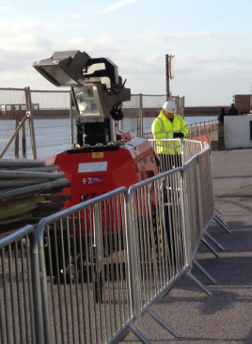

Photo 2: Portable generators should be stood on level ground and clear of combustible materials.

  - Portable generators should not be moved while in operation. (This also applies in the case of generators run from the power take-off shafts of tractors and other agricultural machinery.)

  - When an emergency is over, the equipment should be inspected, refuelled and made ready for use in case it is needed shortly afterwards

Periodic testing and maintenance

  - All testing and maintenance should be carried out by a competent person.

  - At least two instruction manuals should be kept for each generator, one copy being located with the equipment and the other in a secure location elsewhere.

  - The manual should contain:

- a detailed explanation of the operation of the system,
- a schematic wiring diagram,
- a function block diagram,
- the battery specification, installation, maintenance and wiring diagram,
- instructions for routine maintenance,
- list of consumable spare parts with part numbers and sources of supply,
- routine trouble-shooting procedures.

  - Any special tools, test equipment and spare parts should be stored securely in the generator room.

  - All generating equipment should be tested, serviced and maintained in accordance with the manufacturers’ instructions.

  - Generators should be exercised weekly, with load testing being carried out quarterly, with the generator running for at least five minutes on each occasion. Suitable records should be kept.

  - The inspection and servicing of the generating equipment should include:

- checking the fuel levels,
- checking of battery electrolyte levels,
- the conditions of the cells, where the batteries are not sealed,
- checking of the correct function of all indicator lamps, meters and controls,
- checking the load value to ensure that it is within the specification.

  - A written record of the servicing, maintenance, replacement of parts and any unsatisfactory inspection findings should be kept in a log book in the generator room. This log book should also record the corrective actions taken, by whom and when.

  - Following the running of a generator, whether for servicing or maintenance, the fuel level should be replenished to ensure that the equipment is fully operational.

Uninterruptible power supplies

8.1 Computer systems cannot tolerate the variations of power and power cuts normally associated with commercial power systems; a momentary power surge or failure could wipe a computer’s memory or damage its many sensitive circuits. To prevent this, an uninterruptible power supply (UPS) should be installed between the commercial alternating current power lines and the computer system.

8.2 A UPS consists of three major elements, a rectifier/charger, a battery and a direct-current-to-alternating-current inverter. This inverter should be phased to the commercial power frequency so that any fluctuations or interruptions in commercial power do not affect the computer.

8.3 The battery is considered to be the weakest link in the equipment, with UPS systems traditionally having sealed lead acid cells. Care should be taken to maximise the operational life of the batteries by avoiding hostile environments and misuse such as poor balance of the load on three-phase inverters. Batteries should be subject to regular maintenance,

8.4 Note should be taken that UPS equipment may not be sufficient to protect against an excessive power surge or transient overvoltage, such as occurs with a lightning strike, for example, and specialist advice should be sought for this eventuality.

8.5 UPS equipment should be assessed periodically to ensure that it has the capacity and is capable of supplying the service quality within the required time frame for the equipment that is intended to power.

8.6 UPS systems should be maintained, inspected and tested in accordance with manufacturers’ guidance and national standards.

Batteries

  - Where batteries are to be used to power life safety equipment in an emergency they should be suitably protected from the effects of a fire, for example by locating them in a suitable fire resistant compartment.

  - Ideally, the designated battery room should be located on an outer wall of the building so that adequate ventilation can be readily provided for the batteries to be charged in this location. The ventilation should allow for at least two air changes per hour.

  - Battery rooms should not be located at low levels which may be prone to flooding or accumulations of fire fighting water.

  - Battery charging rooms should be ventilated at high level. Chargers should be mounted on noncombustible surfaces and hangers should be provided for storing charging leads when not in use.

  - When specifying battery power, it should be remembered that to maximise battery life, and hence minimise costs, batteries should not be allowed to discharge completely before recharging.

  - There should be no combustible material stored within 2m of the charger(s) or batteries.

  - In areas where wet cells are charged, safe means must be provided for checking electrolyte levels and topping up the cells when necessary.

  - Charging facilities should also include means for mopping up and neutralising any spilled electrolyte.

  - Where necessary, barriers should be provided to protect charging apparatus from damage by vehicle movements.

  - Processes which produce open flames, sparks or electric arcs must be excluded from battery charging areas.

Alternative sources of power

10.1 Although wind, water and solar power units are available, they are yet to have widespread use in industry and commerce or to be accepted as viable and reliable emergency power supplies. Future advances in technology, however, may serve to make these forms of energy available for emergency use in areas where there is not a significant seasonal variation in the climatic conditions which deliver the potential power supply.

Temporary installations

11.1 In all cases where a temporary installation is being considered, the fire risk assessment for the area concerned should be reviewed and the impact of the temporary circuits and equipment should be addressed where necessary. The assessment should include consideration of the risk of deliberate fire raising if elements of the equipment, such as a large portable generator, have to be located outside the premises.

11.2 During periods without mains power, the provision of temporary lighting, other than emergency escape lighting, may be necessary. Where this is the case under no circumstances should naked flames, such as candles, be used for the provision of temporary lighting. Where necessary, battery powered torches should be provided, with the equipment being checked periodically and the batteries being replaced as necessary.

11.3 All temporary installations, including those on construction sites, should be installed in accordance with the requirements of national standards or codes of practice.

11.4 All temporary electrical work, including that on construction sites, should be carried out by a competent electrician.
11.5 All temporary lighting used externally should operate at low voltage in accordance with national standards and, unless specially designed for the purpose, should be sited away from water features and similar hazards.

11.6 All luminaires and catenary installations installed outside buildings should be planned so as to be safe from passing vehicles.

11.7 Similarly, any temporary installations planned within buildings should be well clear of hazards such as travelling cranes and other moving plant.

11.8 Temporary lighting installations should be inspected regularly and be tested at intervals not greater than every three months whether they have been used within this period or not. All other temporary installations should also be inspected and tested at intervals not greater than every three months. The results of the tests should be recorded in a register kept for the purpose.

Action in the event of electrical fires

  - Water should never be used to fight a fire involving electrical wiring or equipment because of the danger of electrocution. In all cases, the power supply should be isolated before taking any action to extinguish the burning materials.

  - In the event of smoke being seen coming from electrical equipment or cables, isolating the circuit by using the switch may serve to remove the source of heat and thus solve the problem.

  - Sustained fires involving electrical equipment are best fought with carbon dioxide or dry powder extinguishers. Where the burning materials are within an enclosed panel or lighting unit, carbon dioxide may be the most effective extinguishing agent since it is able to reach the seat of the fire more easily.

  - Only when the power supply has been isolated should any attempt be made to extinguish burning papers and similar materials to which the fire may have spread. Alternative extinguishers will then be necessary as carbon dioxide and dry powder do not have the required cooling effect. Their use may also serve to blow burning papers around and thus spread the flames.

  - When the power supply has been isolated, spray foam extinguishers may be used as these have been designed to give added operator safety if accidentally used on electrical equipment or circuits that remain live.

  - No attempt should be made to use portable fire extinguishers on high voltage equipment such as electrical transformers.

References
- Guidance Signs, emergency lighting and general lighting, Guideline 5: 2003F, CFPA-E

European Guidelines

Fire
Guideline No. 1:2015 F - Fire protection management system
Guideline No. 2:2013 F - Panic & emergency exit devices
Guideline No. 3:2011 F - Certification of thermographers
Guideline No. 4:2010 F - Introduction to qualitative fire risk assessment
Guideline No. 5:2003 F - Guidance signs, emergency lighting and general lighting
Guideline No. 6:2011 F - Fire safety in care homes for the elderly
Guideline No. 7:2011 F - Safety distance between waste containers and buildings
Guideline No. 8:2004 F - Preventing arson – information to young people
Guideline No. 9:2012 F - Fire safety in restaurants
Guideline No. 10:2008 F - Smoke alarms in the home
Guideline No. 11:2015 F - Recommended numbers of fire protection trained staff
Guideline No. 12:2012 F - Fire safety basics for hot work operatives
Guideline No. 13:2015 F - Fire protection documentation
Guideline No. 14:2007 F - Fire protection in information technology facilities
Guideline No. 15:2012 F - Fire safety in guest harbours and marinas
Guideline No. 16:2008 F - Fire protection in offices
Guideline No. 17:2015 F - Fire safety in farm buildings
Guideline No. 18:2013 F - Fire protection on chemical manufacturing sites
Guideline No. 19:2009 F - Fire safety engineering concerning evacuation from buildings
Guideline No. 20:2012 F - Fire safety in camping sites
Guideline No. 21:2012 F - Fire prevention on construction sites
Guideline No. 22:2012 F - Wind turbines – Fire protection guideline
Guideline No. 23:2010 F - Securing the operational readiness of fire control system
Guideline No. 24:2010 F - Fire safe homes
Guideline No. 25:2010 F - Emergency plan
Guideline No. 26:2010 F - Fire protection of temporary buildings on construction
sites
Guideline No. 27:2011 F - Fire safety in apartment buildings
Guideline No. 28:2012 F - Fire safety in laboratories
Guideline No. 29:2013 F - Protection of paintings: Transport, exhibition and storage
Guideline No. 30:2013 F - Managing fire safety in historical buildings
Guideline No. 31:2013 F - Protection against self-ignition and explosions in handling
and storage of silage and fodder in farms
Guideline No. 32:2014 F - Treatment and storage of waste and combustible
secondary raw materials
Guideline No. 33:2015 F - Evacuation of people with disabilities
Guideline No. 34:2015 F - Fire safety measures with emergency power supplies

Natural hazards
Guideline No. 1:2012 N - Protection against flood
Guideline No. 2:2013 N - Business Resilience – An introduction to protecting your
business
Guideline No. 3:2013 N - Protection of buildings against wind damage
Guideline No. 4:2013 N - Lightning protection
Guideline No. 5:2014 N - Managing heavy snow loads on roofs.

Security
Guideline No. 1:2010 S - Arson document
Guideline No. 2:2010 S - Protection of empty buildings
Guideline No. 3:2010 S - Security system for empty buildings
Guideline No. 4:2010 S - Guidance on key holder selections and duties
Guideline No. 5:2012 S - Security guidelines for museums and showrooms
Guideline No. 6:2014 S - Emergency exit doors in non-residential premises

