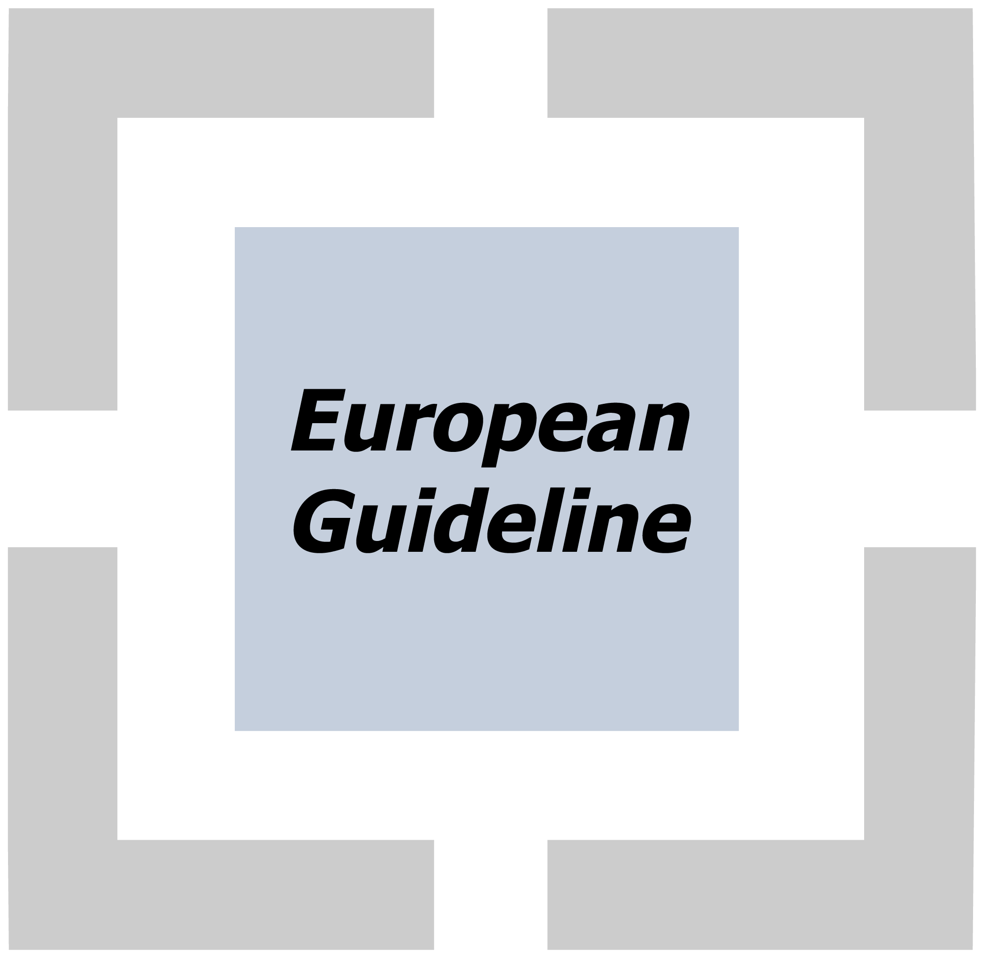Evacuation of people with disabilities

CFPA-E No 33:2015 F

FOREWORD

The European fire protection associations have decided to produce common guidelines in order to achieve similar interpretation in the European countries and to give examples of acceptable solutions, concepts and models. The Confederation of Fire Protection Associations in Europe (CFPA E) has the aim to facilitate and support fire protection work in the European countries.

The objectives of CFPA Europe are to improve safety and security and to prevent the consequent loss of life, destruction of property and disruption to business activities. CFPA Europe also seeks to meet the increasing demands for quality and safety in the workplace.

If a fire would start people with disabilities must be able to get out safely. This guideline describes the measurements that should be considered when designing public premises that are accessible for people with disabilities.

The guideline is based on a Swedish publication. The proposal was developed by Lars Brodin from The Swedish Fire Protection Association.

The Guideline has been compiled by the Guidelines Commission and adopted by all fire protection associations in the Confederation of Fire Protection Associations Europe.

These guidelines reflect best practice developed by the countries of CFPA Europe. Where the guidelines and national requirements conflict, national requirements must take precedence.

Copenhagen, January 2015 Madrid, January 2015
CFPA Europe Guidelines Commission

Jesper Ditlev Miguel Vidueira
Chairman Chairman

Table of contents

1. Introduction 4
2. Different kinds of disabilities 4
3. Obstacles to overcome 6
4. Definitions 6
5. The threat of a fire 8
6. Recommendations 9
7. Accessibility 10
8. Evacuation of people with disabilities 11
9. Design of secure waiting areas 14
10. Requirements in different premises 18
11. Key actors in the design process 19
12. European Guidelines 20

Introduction
All people should have access to the whole of society. It places increasing demands on accessibility in buildings and public facilities. But if a fire were to start people with disabilities must be able to get out safely.

In some cases, it is necessary to set higher goals than national building codes to achieve good fire safety.

The target audience for this book is fire inspectors, accessibility consultants, property developers, architects, project managers, fire engineers and other participators in the building process. This recommendation applies mainly to public premises and workplaces.

The need has become even more evident after the tragic fire in Titisee-Neustadt in Germany where 14 disabled people died in a fire in a workshop at the end of 2012.

Different kinds of disabilities
People in our society are different in many ways. Our ability to observe information and our mobility differs depending on age and disabilities. Older people are in general slower than young people. Persons with limited hearing depend on visual information for example, light signals. We are all different and have different needs. Even if each group itself is small, the impact of all the groups together is considerable.

A greater awareness of people's different needs in recent years has led to an increase in demands for accessibility for persons with disabilities. The result is that more buildings are accessible but they should also be safe in case of fire or other threats.

Reduced mobility
Persons with reduced mobility can have balance disorders, need to rest more often or need to use walking aids such as canes, crutches, walkers or wheelchairs. Mobility is reduced with increasing age. Reduced arm and hand function can for example be caused by muscle weakness, stiffness and pain.

Availability and evacuation safety means being able to move about while avoiding stairs, narrow passages, trip hazards at thresholds, heavy doors and maneuvering some difficult door handles. You should not be forced into long detours. Using hand rails, people with walking difficulties can use ramps and stairs.

Among Sweden’s about nine million inhabitants there are about 100,000 wheelchair users (manual and electric) and approximately 250 000 people using walkers.

In an emergency situation, it is important for people with reduced mobility to announce where he or she is situated. In that situation a cell phone can be life-changing.

The dimensions of an electric wheelchair for limited outdoor use should be used in the design of public buildings, workrooms and facilities in apartment buildings.

Hearing loss and deafness
Almost one million or 14 per cent of the Swedish population age 16 or older, are so hard of hearing that they have difficulty with or without a hearing aid, to hear conversations between several people. Most of them have hearing loss, far fewer are deaf.

People with hearing impairments have difficulty to perceive or distinguish sounds in rooms with poor sound environment (echo effect) and in noisy environments. Many persons with hearing loss also read lips to better perceive speech.

Accessibility and evacuation security means to perceive alerts and information, and being able to communicate (converse) with others. Persons who have reduced hearing or are deaf, rely on signs or textual information and light signals. In addition they need a good acoustic environment (free from echo effects and noise) in order to receive spoken information.

Low vision
A visually impaired person is someone who has difficulty reading or who finds it difficult to orientate with the help of vision. Most can dimly discern colors and objects, or see with strongly limited field of view. Others have difficulties when it is dark or in bright sunshine.
The concept of visually impaired includes severely visually impaired or blind people. Severely visually impaired or blind people lack vision or can only distinguish light and darkness. The white cane is a tool to orient themselves in different environments, by detecting obstacles as curves, stairs or various soil structures.
Accessible environment for people with vision disabilities is for example to be able to orientate with the help of colors, contrasts, sound information and access to a personalized service.

Reduced cognitive ability
People with reduced cognitive ability are a heterogeneous group. Cognition means, among other things, the ability to comprehend language, to orientate themselves in space and time, and to solve problems.
Accessibility and evacuation security means being able to orientate in space and not be exposed to unexpected risks. Information needs to be easily understandable, for example through the use of symbols.

Aging
For older people, it is important to get information in a simple manner, for example by means of symbols. With the help of logical layout it is easier for older persons to understand where they are and to find their way out. Other needs for accessibility and evacuation safety coincide.

More than half of those who are born today will be older than 100 years according to a report from Danish and German researchers. This will increase the demand for both accessibility and evacuation.

More and more older people are visiting cultural events. The elderly account for a large increase in cinema, concert and library visitors. Cultural activities decline with increasing degrees of impairment. One reason that people with disabilities choose not to participate in certain activities can be the lack of accessibility.

Obstacles to overcome
To raise awareness of how people with different disabilities experience difficulties and obstacles in an evacuation, a survey was made in Sweden in 2006. The survey can be summarized in the following table. Later in the guideline there are solutions to these obstacles.

 | Reduced mobility | Low vision | Reduced hearing ability
Difficulties | To be able to move around and get out. | To orientate, find your way out. | To perceive the alarm.
Obstacles | Level differences, especially in the escape route.  High thresholds, obstructions in escape routes.  Spiral stairs, no handrails.  Heavy doors.  Two hands grip. | Small signs, high placed.  Contrast is missing, hard to perceive.  Spiral staircases.  Hard to find opening handle when there are multiple. Difficult to understand how they are used. | Evacuation alarm that lacks low frequency sound and light signals.

Definitions
Accessibility
Generally used accessibility and usability to describe what is required for persons with disabilities to participate equally in society. The individual should be able to make use of and to move and reside freely between and in buildings, streets and traffic systems. Accessibility describes how well an activity, place or locale work for persons with disabilities. It can be flat walking routes and wide passages for persons with mobility impairments, hearing aids for people with hearing loss, clear markings in staircases, doors and glass partitions for persons with Visual impairment, and access to information and good response.

Evacuation Alarm
An evacuation alarm should be installed in public premises in accordance with national legislation or where more than 150 people with poor local knowledge can reside. Evacuation alarms can also be required in other premises where there is a risk for people to be overrun by a fire.

Evacuation of persons with disabilities
Persons with disabilities should have the opportunity to be able to evacuate in case of fire and other emergencies. To evacuate means getting out in the open air or to a safe place in the building. One option is to move to a secure waiting area, and from there get assistance to evacuate.

Evacuation plans
Evacuation plans should be placed in premises where it is not obvious how an evacuation should be performed. The location of secure waiting areas, evacuation chairs and evacuation lifts should be marked on evacuation plans. It is recommended that the bottom of the evacuation plan is about 1.4 meters above the floor to be readable for people in wheelchairs.

Secure waiting area
Secure waiting area means a space in the adjacent fire compartment that is connected to an escape route where persons with reduced mobility or sense of direction can await further evacuation. A secure waiting area may also be a part of the escape route if the secure waiting area is located adjacent to the areas served by the escape route.

The secure waiting area should be able to accommodate people with reduced mobility or sense of direction.

Secure waiting areas should be situated on the same floor as the space it serves. There should be a possibility for two-way communication from the secure waiting area. The communication system function should be supported in the event of a power failure and have protection against power outages as a result of the fire.

Evacuation signs
To be able to quickly find escape routes, they should be marked with special signs. The design of safety and evacuation signs is specified in the standard ISO-EN 7010:2012.

Disability
Disability describes the loss of physical, mental or intellectual functionality. Disability occurs when a person with a disability meets an inaccessible society or inaccessible environment.

Escape routes
The main principle is that there should be access to at least two independent means of escape, direct to outdoors or to isolated, fire protected stairwells and corridors.

The distance to an escape route should not be too long. One of the escape routes can be accessed through the adjacent fire compartment on the same floor. A fire compartment is an area which is protected from the spread of a fire for a period of time.

Operation and maintenance plan
An operation and maintenance plan for fire protection components is required. It should also include components for evacuation of people with disabilities.

Public premises
A simple definition of public premises is a place to where the public has access. Premises intended to be used by the public in a State or municipal body, hospitals, health centers and schools, are virtually always considered premises to where the public has access. Furthermore, the term usually includes sports facilities, libraries, theatres, cinemas, meeting halls, bus and taxi stations, railway stations, airports and ferry terminals, pharmacies, newsstands, restaurants, business premises and other premises intended for and used by the public.

Schools are generally considered as workplaces, because even students are counted as employees. Parts of schools such as lecture halls, reception areas, hallways where the public is invited or premises that could be rented are often also considered as pubic premises. An assessment of what is what, may be made in each case

The threat of a fire
Fires have since early ages been a danger to people. In recent decades, the use of plastics in furniture and furnishings has resulted in faster fire development.

When a fire starts, a layer of hot smoke (fire gases) accumulates below the ceiling. The layer of smoke level drops as more and more smoke is generated by the growing blaze. Finally the smoke level makes it impossible to stay in the room. A room should be evacuated before the smoke reaches approximately 2 meters above the floor level and/or when the temperature is around 170 º C in the smoke layer.

The figure shows how fast burning furniture creates critical impact on evacuating people. The calculations are performed in rooms with 25, 100 or 400 m2 of floor space and 2.5 meters in height. Other burning loose fittings can give different results. A person can remain in the smaller room approximately 0.5 minute and in the larger space approximately 1.5 minutes. In both cases it is the height of the smoke layer that creates critical impact.

Fast burning furniture, no combustible
Fire temperature (ºC)

Smoke level, height from floor (m)

Recommendations
Society establishes the level of fire protection through laws and regulations. Laws are determined by the parliament and government in each nation. The laws are often generally written and government agencies often have the authority to write more detailed regulations and interpretations of the law, related to their area of authority.

Manuals and recommendations from organizations, companies and universities, often describe requirements from different laws and authorities clearer and easier to help end users to get an overall picture of the requirements. Manuals and recommendations also describe how the requirements can be met and sometimes give advice on how to achieve a better fire protection than the law requires.

An EU regulation applies directly as law in EU-countries. An EU directive on the other hand, sets the objectives but doesn´t specify how each country should achieve the objectives.

Globally, there are important guidelines for accessibility in the UN: s Convention on the rights of persons with disabilities, Ds 2008: 23.

Text in a frame describes when CFPA Europe recommends a higher level of fire safety.

If this guideline contradicts with national regulations, national regulations should apply.

Accessibility
Generally the word accessibility is used to describe what is required for persons with disabilities to participate equally in society. Buildings, streets and traffic systems should be adapted so that the individual should be able to make use of them as well as to move freely both within and between them, being able to get out and participate in an activity.

Doors
Accessible doors and gates shall be designed so that they can be easily opened by persons with reduced mobility, allowing the passage of a wheelchair and so that sufficient space is available to open and close the door or gate from the wheelchair.

Other openings in the path to escape routes should be designed to allow passage of wheelchairs. Handles, latches and other necessary devices should be placed and designed so that they can be used by persons with reduced mobility as well as by persons with limited sense of direction.
Doors that are accessible to people with reduced mobility should be equipped with automatic door openers if they have door closers or are heavy.

When using doors with automatic door openers, it is important that the space on the floor is highlighted to show where the door swings open or that doors are supplied with safety sensors or similar.

Doors and doorways should be designed without level differences, unless for example where moisture or the climate makes a threshold necessary. A threshold should however, be as low as possible and be designed so that it is easy to pass and so that the risk of tripping is minimized.

Doors exclusively for evacuation may not be accessible. Doors to secure waiting areas must be accessible.

Door closers
Doors to and within escape routes not expected to be closed, should be equipped with door closers.

For example, the door between the stairwells and apartments should have door closers.
Because motor openers are expensive, it is important that early in the project decide which rooms and doors should be accessible.

It is proposed that doors to meeting rooms, which should be accessible, should be provided with motor openers if they have door closers.

According to the British standard BS 8300: 2009 (amended in 2010), a door which is accessible to people with reduced mobility, can have a maximum of 20 N in door opening force. According to past practice in Sweden was considered an opening force of 25 N acceptable.

CFPA Europe recommends a maximum force of 20 N to open accessible escape doors. Otherwise it is very difficult for people in a wheelchair or walker to open the doors.

Free swing is a type of door closers are available in which the closing function is enabled only when the receiving signal of fire alarm or by built-in detectors. Such fittings need at the beginning of opening a force of approximately 45 N and therefore do not meet the demands. In other cases, 130 N is accepted if there is air pressure that creates such high pressures.

CFPA Europe recommends that the opener should be equipped with emergency power and electrical wiring should be carried out with fire resistant cables. There is otherwise a risk that the power supply is knocked out by a fire.

Evacuation of people with disabilities
Evacuation Alarm
Spaces in public places where people with hearing loss can stay without direct contact with other persons should be provided with complementary optical devices so that even people with limited hearing and deaf people will be reached by warning signals in the event of a fire or other hazard.

For example flashingbeacons are recommended in sanitary facilities. Note that it not only applies to restrooms that are accessible and usable for people with reduced mobility.

CFPA Europe recommends that all toilets where there is an evacuation alarm should be equipped with a flashing beacon, not just those in public premises.

Where a spoken voice alarm is used, it should be carried out with additional information about escape routes and secure waiting areas for people with disabilities in the building. For the alarm to be perceived by people with hearing loss, it should be complemented with optical devices (flashing lights) and sometimes with low-frequency audio and text information.

Additional security for persons who are deaf or have limited hearing is to provide them with a vibrator that reacts to the fire alarm. These devises can be borrowed at some hotels.

Fire alarm push buttons should be placed 0.5 – 1.0 m above the floor to be accessible for people in wheelchairs.

Evacuation strategy
Evacuation for people who cannot use stairs can be met in four different ways:
- Direct access to a safe place on the ground floor.
- Access to a secure waiting area where you can wait for help with evacuation.
- Access to evacuation lifts.
- To split the premises into several fire areas that can be used and equipped as secure waiting areas.

Emergency Lighting
Emergency lighting should be installed in secure waiting areas.

Alarm buttons
It is important that buttons, used to signal presence and need of help, as well as other devices, which can be used by people in wheelchairs, are placed at a height of between 0.8 and 1.0 m above the floor. This applies also to the actuator of the door opener and for voice communication and regular alarm push buttons.

Door fittings
Doors to be used for evacuation should be easy to open and pass through.

For the handles, the vertical force should be less than 70 N. This applies to handles designed according to EN 179. The force to push up the door should be less than 150 N.

Doors with closers can cause great difficulties to pass through for people with reduced mobility. Door closers are also found in other locations, such as on entrance doors. The power allowed for easy pushing of a door, to be used for evacuation, should not exceed 150 N.

Evacuation chairs
Evacuation chairs are used to help people with reduced mobility to descend stairways.

CFPA Europe recommends that evacuation chairs are placed in close proximity to the secure waiting areas.

Evacuation chairs can usually be placed in the stairwells.

Note that the stored evacuation chair should not reduce the required free space.

Evacuation lifts
Standard lifts are typically not constructed in such a manner that they can be used in the event of a fire. An evacuation lift is designed so that it is safe to be used even in the event of a fire.

A secure waiting area should be arranged in front of the evacuation lift. The secure waiting area should be separated from the lift and the surroundings. People with reduced mobility can then use the lift to evacuate if necessary with the help of staff, guards or the emergency services, all the way out into the open. Since using lift for evacuation is not common behavior, signs should be placed at the lift door and information given in the evacuation plan. If there is a spoken evacuation alarm, the message should contain information about the evacuation lifts.

An important issue with evacuation lift design is whether they should be provided with an emergency power supply device or not because there are great costs involved with designing such a lift. If you can show that the availability of power is secured by other means, special backup power is not required.

It is also important that there is an escape-route that leads outside from the landing floor.

Design of secure waiting areas
Public premises accessible and usable for people with reduced mobility or sense of direction should be provided with at least two independent secure waiting areas. If the premises have more than one floor, there should be at least one secure waiting area on each floor. If a room only has access to a single escape route, the room can be designed with a secure waiting area. The secure waiting area should be located in the adjacent fire cell and appear adjacent to or in the escape route. In the secure waiting area must fit at least one wheelchair, occupying 1.30 m x 0,70 m of floor space.
An escape route that is accessible and useable and leading horizontally to a safe place does not need a secure waiting area.

Public premises with automatic extinguishing systems don´t need to be provided with secure waiting areas.

CFPA Europe recommends at least one secure waiting area even in sprinkled public premises, since there can be a lot of smoke even with sprinklers.

If a fire area consists of more than one floor it is sufficient with a secure waiting area per floor.

CFPA Europe recommends at least two secure waiting areas per floor, because people with reduced mobility will have problems to use a secure waiting area on other floors.

In smaller premises, only one secure waiting area is sufficient.

Note that housing and most workplaces do not count as public facilities.

Size
At least one smaller wheel chair for outdoor use should be able to fit in every secure waiting area, without disturbing the evacuation. The area required is 1.3 x 0.7 m2.

Secure waiting areas in public premises, intended for the more than 150 people with poor knowledge of the premises, should put together be large enough so that they can hold 1 % of the maximum number of persons in the premises. The design of the secure waiting areas should be undertaken so that the secure waiting areas together can accommodate the number of persons who require secure waiting areas and taking into account that one of the secure waiting areas can be blocked by fire.

When calculating the area it can be assumed that 1/3 of the persons with reduced mobility are in wheelchairs and need 1.3 x 0.7 m and 2/3 have lesser motion impairments and therefore need 0,3 m2. In addition they need room to maneuver. This assumption is based on the statistics of the distribution of different mobility impairments.

If the dimensions of the secure waiting areas lead to unreasonably large areas where the premises houses many people, a design analysis may show that fewer people need help and the area can be reduced. Influencing factors can be, for example, if sprinklers or smoke ventilation is available.
In premises designed for more people who use wheelchairs, such as certain schools, the secure waiting areas should be big enough to accommodate the actual number of wheelchairs.

CFPA Europe recommends that each secure waiting area should be designed for a capacity of at least two wheelchairs.

Fire areas
Secure waiting areas can either be located in the escape route, such as escape stairwells, or in another fire areas right next to this. The same reasoning applies where a corridor is the escape route, for example in hotels where the secure waiting area can be located in the corridor.
The secure waiting area should be designed with the same fire resistance as other fire areas in the building.

Doors to the secure waiting area should be design with both integrity (E), thermal insulation (I) and be carried out in the Sa class (gas tight), which means that combustion gases are prevented from spreading to the secure waiting area.

Fitting of doors
Doors to the secure waiting area should be usable and accessible for people with disabilities. In addition, they should be fitted with door closers. This means that the doors to the secure waiting area shall be equipped with an automatic door opener. Doors to secure waiting areas should be accessible without a key and be provided with the possibility to return.

Communications
Persons at secure waiting areas use signaling to tell the outside world that they need help. As general advice, this can be done using an alarm button, located 0.8 m from the floor, connected to an alarm system.

CFPA Europe also recommends spoken two-way communication systems at secure waiting areas and not only communication via the alarm button. This compares with lifts which have the possibility of audible two-way communication if the lift gets stuck. Requirements should not be lowered at a place where people with disabilities stay and wait for help in an emergency situation.

It is very important that individuals at a secure waiting area receive confirmation that help is on the way. Possibly even voice communication connected to the alarm center serving the lift.

Organization
Who is responsible to help people with reduced mobility from secure waiting areas? The fire brigade should have a general capacity and readiness for this type of mission, as in the case of a window-evacuation. In some countries the emergency services have the primary responsibility for assisting people from waiting areas but in others the management of the building are required in their emergency plans to make provision for assisting all persons in the premises to escape. The staff in all premises should have routines to help emergency services with information if there are people in the secure waiting areas that need to be evacuated.

Signs
Different types of information signs can be required to give information about secure waiting areas, alarm button and indication of evacuation routes.

In addition, it is good to know that you are at a secure waiting area.

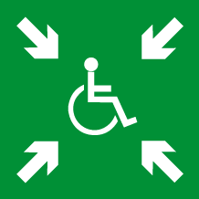

The sign should be designed according to the image above which is an ISO proposal.

The plate should be supplemented with the words "secure waiting area" with white letters on a green background.

The communication equipment should incorporate a sign, for example, with the words "emergency call connected with manned station or alarm center". The sign should be white text on a green background. If communication instead is connected to the control panel of the fire alarm, another text should be used.

Paths to secure waiting areas and accessible escape routes should be supplemented with evacuation signs that contain a symbol for people with reduced mobility.

The sign should include a wheelchair symbol. This applies to signs which lead to the secure waiting areas and evacuating signs showing accessible doors to a safe place. Note that the sign not only needs to have the wheelchair symbol, but also the information that specifies the direction of the escape route for everyone. On the ground floor, all the signs leading to accessible means of escape should have a wheelchair symbol.

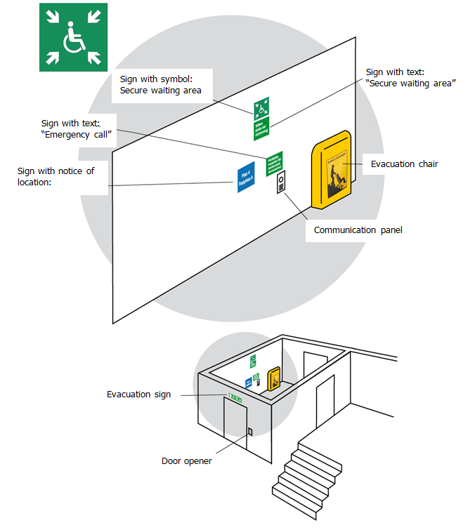

Requirements in different premises

Fire protection requirements vary depending on the activity carried out in different premises and buildings.

Hotels
At hotels there are always two escape routes and a fire-isolated hallway where one can wait for evacuation assistance. There should always be fire and emergency alarms and closers on fire-doors.

To alert people with hearing loss there are vibrating alarms that are activated by means of the alarm. Some hotels lend these to their guests.

Hospitals and other health care facilities
The conditions to evacuate people with disabilities are often good here because there is staff available most of the time, at least in new buildings, sprinklers and emergency alarms are installed. When it comes to people confined to their beds there are obviously huge problems in an evacuation situation.

Churches
Churches are usually easy to evacuate for people without disabilities. It usually takes a long time before smoke from a fire causes problems because of the high ceilings. For people with reduced mobility the main entrance usually works as escape route, because it usually has been made accessible. Other paths often lead to a stairway outside from which one cannot move forward but however, it´s outside where you are relatively safe and can get help.

Shopping malls
In a shopping mall, it can be difficult to orientate. It can be crowded with people and often there are many people with disabilities. On the ground floor there should be evacuation routes leading directly to the open air which can be used by people with disabilities. On the other floors there should be one or several secure waiting areas.

Often there are sprinklers and adequate fire and emergency alarms in the shopping mall, which leads to a good fire safety, even for people with disabilities.

Restaurants, pubs and night clubs
These premises have the biggest risks even for people without disabilities. It is crowded, often low ceilings, loud noise, some people are drunk and therefore less vigilant, and so on.

It can take a long time to evacuate due to queues that occur in escape routes.

Arenas, outside and inside
At outdoors venues there is normally no problem to evacuate people with reduced mobility. At indoor stadiums the amount of people could cause problems to evacuate and create additional problems for persons with reduced mobility. We must especially highlight how persons in wheelchairs should act in order not to disrupt the evacuation of other people.

Museums
In museums there are often wardens, who can help people with disabilities. Voice-communication from secure waiting areas can be arranged through contact with the reception.

Theatres and similar
At theaters, cinemas and similar there are sometimes many people in wheelchairs. These premises often need large secure waiting areas.

Schools
Usually there are two stairwells that can accommodate wheelchairs and could serve as secure waiting areas. Fire compartments prevent too long walking distances to escape routes. Evacuation is exercised every break, which means there is usually no problem to find your way out.

Key actors in the design process

During the design of a new building or change of an old building several technology consultants work together. Fire protection has a central role early in the process by setting the fire protection requirements for the whole project. Evacuation of people with disabilities should thus be treated early in the design process.

To be able to come up with alternative solutions, which makes it possible for everyone to evacuate safely in the event of a fire, both professionalism and high level of ambition is required in order to let the new requirements have an impact on a project. Fire safety for persons with disabilities is such a new requirement with far-reaching implications in many projects. The consultants are forced to new thinking.

Here are important actors in the construction process.

Owner of building under construction
Owner of building under construction has the primary responsibility for the project to comply with regulations and should designate a supervisory officer who is responsible for follow-up and control. It is the developer that sets quality requirements and is able to raise the level of ambition over what is necessary according to the applicable regulations. This is usually done by the developer establishing key program documents, which in turn is the basis for the work of the consultants.

Evacuation is an example of an aspect that can be enhanced by setting quality standards in program documents. The owner of building under construction should know that building codes only are minimum requirements. A satisfactory level of fire safety for those who stay in the buildings may include additional requirements. The end user also should be able to raise the level of ambition for the evacuation issues in a project.

Architect
The architect usually has responsibility for the overall view of the project and has the best knowledge of the builder's intentions. The architect is normally also the first of the consultants to become involved in a project, maybe as a writer to the application documents. The architect often makes the first contacts with various authorities.

Fire protection expert
The fire protection expert is responsible for fire protection engineering solutions, including evacuation strategy, as well as fire protection and fire safety solutions.

The fire protection expert is responsible for design of fire protection solutions which can affect a greater safety for all, including persons with disabilities.

Acoustic consultant
The acoustic consultant can contribute with their knowledge to appropriate solutions to mark evacuation for people with reduced hearing.

Ventilation consultant
The ventilation consultant's responsibility for fire protection means, among other things, to adapt and design the ventilation systems which also apply to secure waiting areas.

Electrical consultant
The electrical consultant’s responsibility is to design fire and evacuation alarms, indicative markings and emergency lighting.

The electrical consultant should understand the consequences of additional requirements for alarm signals, lighting and the appearance of signs and ensure that these requirements are met in the design of the electrical systems.

European Guidelines
Fire
Guideline No. 1:2014 F - Fire protection management system
Guideline No. 2:2013 F - Panic & emergency exit devices
Guideline No. 3:2011 F - Certification of thermographers
Guideline No. 4:2010 F - Introduction to qualitative fire risk assessment
Guideline No. 5:2003 F - Guidance signs, emergency lighting and general lighting
Guideline No. 6:2011 F - Fire safety in care homes for the elderly
Guideline No. 7:2011 F - Safety distance between waste containers and buildings
Guideline No. 8:2004 F - Preventing arson – information to young people
Guideline No. 9:2012 F - Fire safety in restaurants
Guideline No. 10:2008 F - Smoke alarms in the home
Guideline No. 11:2005 F - Recommended numbers of fire protection trained staff
Guideline No. 12:2012 F - Fire safety basics for hot work operatives
Guideline No. 13:2006 F - Fire protection documentation
Guideline No. 14:2007 F - Fire protection in information technology facilities
Guideline No. 15:2012 F - Fire safety in guest harbours and marinas
Guideline No. 16:2008 F - Fire protection in offices
Guideline No. 17:2014 F - Fire safety in farm buildings
Guideline No. 18:2013 F - Fire protection on chemical manufacturing sites
Guideline No. 19:2009 F - Fire safety engineering concerning evacuation from buildings
Guideline No. 20:2012 F - Fire safety in camping sites
Guideline No. 21:2012 F - Fire prevention on construction sites
Guideline No. 22:2012 F - Wind turbines – Fire protection guideline
Guideline No. 23:2010 F - Securing the operational readiness of fire control system
Guideline No. 24:2010 F - Fire safe homes
Guideline No. 25:2010 F - Emergency plan
Guideline No. 26:2010 F - Fire protection of temporary buildings on construction sites
Guideline No. 27:2011 F - Fire safety in apartment buildings
Guideline No. 28:2012 F - Fire safety in laboratories
Guideline No. 29:2013 F - Protection of paintings: Transport, exhibition and storage
Guideline No. 30:2013 F - Managing fire safety in historical buildings
Guideline No. 31:2013 F - Protection against self-ignition and explosions in handling and
storage of silage and fodder in farms
Guideline No. 32:2014 F - Treatment and storage of waste and combustible secondary raw
Materials
Guideline No. 33:2015 F - Evacuation of people with disabilities.

Natural hazards
Guideline No. 1:2012 N - Protection against flood
Guideline No. 2:2013 N - Business Resilience – An introduction to protecting your business
Guideline No. 3:2013 N - Protection of buildings against wind damage
Guideline No. 4:2013 N - Lightning protection
Guideline No. 5:2014 N - Managing heavy snow loads on roofs.
Security
Guideline No. 1:2010 S - Arson document
Guideline No. 2:2010 S - Protection of empty buildings
Guideline No. 3:2010 S - Security system for empty buildings
Guideline No. 4:2010 S - Guidance on key holder selections and duties
Guideline No. 5:2012 S - Security guidelines for museums and showrooms.

