CFPA-E No 26:2010 F

Fire protection of temporary buildings on construction sites

FOREWORD

The European fire protection associations have decided to produce common guidelines in order to achieve similar interpretation in European countries and to give examples of acceptable solutions, concepts and models. The Confederation of Fire Protection Associations in Europe (CFPA E) has the aim to facilitate and support fire protection activities across Europe/work in European/work in the European countries countries.

The market imposes new demands for quality and safety. Today, fire protection forms an integral part of a modern strategy for survival and competitiveness.

This guideline is primarily intended for those responsible for safety in companies and organisations. It is also addressed to the rescue services, consultants, safety companies etc so that, in the course of their work, they may be able to help companies and organisations to increase the levels of fire safety.

The proposals within this guideline have been produced by the Swedish Fire Protection Association and the author is Lars Rang from Sweden.

This guideline has been compiled by Guidelines Commission and adopted by all fire protection associations in the Confederation of Fire Protection Associations Europe.

These guidelines reflect best practice developed by the countries of CFPA Europe. Where the guidelines and national requirement conflict, national requirements must apply.

Zürich, 19 October 2010 Stockholm, 19 October 2010
CFPA Europe Guidelines Commission

Dr. Hubert Rüegg Tommy Arvidsson
Chairman Chairman

Contents

- Introduction 5
- Definitions 6
  - Floor Plan 6
  - Building Area 6
  - Escape route 6
  - Guidance sign 7
  - Fire compartments 7
  - Fire cover protection 7
- Fire risks 8
  - Covering of heating appliances 8
  - Arson 8
  - Electrical equipment 8
  - Hot work 9
  - Smoking 10
  - Waste 10
- Fire protection requirements for escape 10
  - Access to escape routes and finial exit 10
  - Exception from the basic requirement for two escape routes 11
  - Doors in escape routes 12
  - Ladders 12
  - Access balconies 12
  - Escape over a roof 12
  - Escape alarm 13
  - Fittings in escape routes 13
  - Guidance signs 14
  - Plan of escape routes 15
- Protection against the spread of fire inside a fire compartment 15
- Protection against the spread of fire and combustion gases between fire compartments 15
  - Compartmentation 15
- Protection against the spread of fire between buildings 16
  - Siting – safety zone 16
  - Windows in external walls facing one another 17
  - Examples of windows in external walls which face one another 18
  - Facade situated at a higher level 19
  - A window in the higher facade can be protected as follows 19
- Loadbearing capacity in the event of fire 19
  - Building area, regardless of size, for temporary building of one storey 19
  - Building area, smaller than 200 m2, for temporary building of two storeys 20
- Fire fighting equipment and access for the rescue service 21
  - Extinguishing equipment 21
  - Access for the rescue service 21
- Checklists 22
- Handover of temporary building 24
- Checklist for fire protection when a temporary building is handed over 25
- Regular inspections 26
- Examples 28
- European guidelines 30

Introduction
On construction sites, the available space for temporary buildings on construction site is often strictly limited. This means that temporary buildings are placed near the building under construction and sometimes on top of each other. The risk of injuries to both construction workers and surrounding residents, and the rapid spread of fire, is obvious unless certain preventive measures are taken. These recommendations are intended to provide examples of acceptable solutions which satisfy adequate fire protection requirements.

This recommendation deals only with possible arrangements of temporary buildings on construction sites of up to two storeys and a building area of up to 200 m2. The size of temporary buildings varies. This recommendation is based on a size of approximately 2.9 m x 9.0 m. This size is equivalent to a building area of 8 units.

Temporary buildings on construction site in this recommendation are to be considered as office buildings. This will include units for staff accommodation, that is, units for changing.

The recommendation does not include:
  - Accommodation units, other accommodation, schools, preschools or use other than a temporary building
  - Establishment of two storeys with a building area greater than 200 m2
  - Temporary buildings of more than two storeys
  - Mobil caravans (mobile trailers) for staff and offices

When any of the above are to be established, it is advisable to engage a fire protection consultant or other expert to design fire protection.

Definitions

Floor Plan
The first, second and third storeys are defined as shown in the Figure.

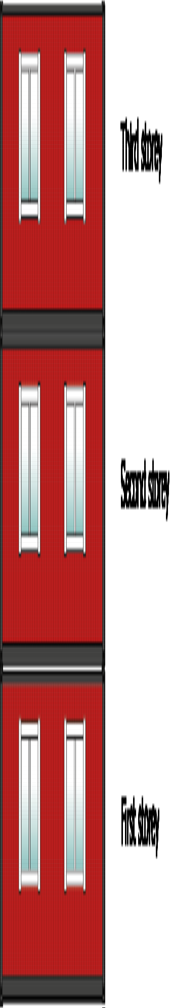

Building Area
The area a building occupies on the ground.

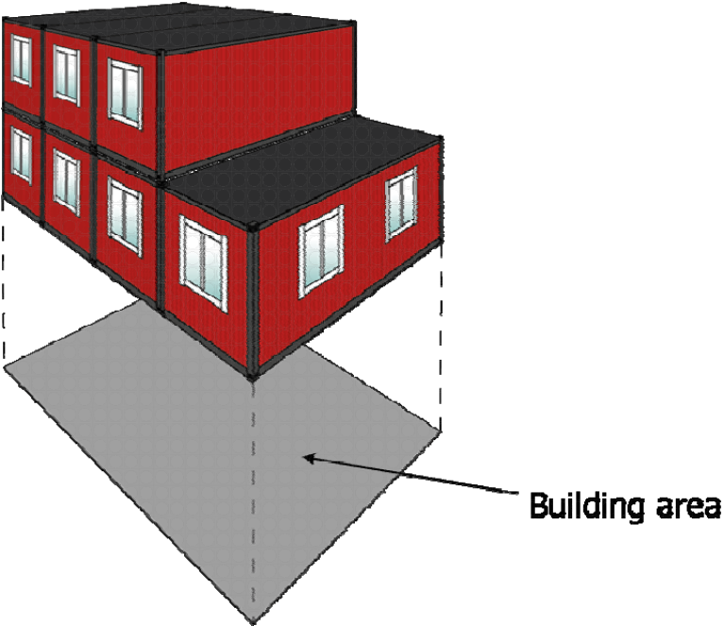

Escape route
An escape route is a path to a safe place, usually outdoors, at the ground level, with an access to a public grounds or. The equivalent is an exit to a terrace, courtyard, etc. that can be easily reached from the street.

Guidance sign
Sign with a green background and clear white symbols in accordance with the EU Directive that shows the way to the escape route.

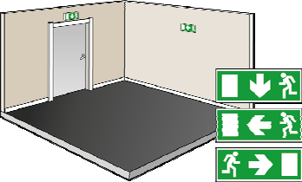

Fire compartments
Distinct part of a building in which a fire during the prescribed minimum period can be developed without spreading to other parts of the building.

Fire cover protection
Fire protection cover is a specially manufactured fabric which is made in a number of E classes of fire resistance. It is suitable for covering containers and piles of timber, etc. In some cases, fire protection cover can be used to separate the temporary building from an adjacent building when the distance between these is not sufficient from the standpoint of fire protection. Such fire protection cover must not be confused with the netting that is suspended on the outside of building scaffolds to provide protection from the weather or to prevent falls. The use of fireproof blanket requires separate assessment and the advice of a fire protecion consultant or other expert.

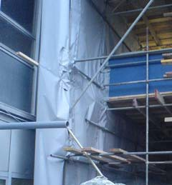

Fire risks
The following are some of the causes of fire/arson which occurin temporary buildings.

Covering of heating appliances
It is common for electric fans or radiators to be used to dry clothes. These heating appliances can easily cause fires if they are covered. This risk can be avoided by providing a special drying cabinet as necessary. Drying cabinets shall be constructed so that the clothes do not come in direct contact with the heating appliance, for example, by placing an inclined protection layer above the radiator or fan.

Arson
Arson is a common cause of fire. It is most usual for fires to be started outdoors. Other common areas where fires are started are basements and stairways. In many cases, arson can be prevented by relatively simple measures. Make sure that unguarded rooms are kept locked and that combustible waste is not piled up along the facades or stored in open containers. Make sure that waste containers are not stored below a window or in front of doors - especially escape routes.

For more information, see CFPA-E Guideline No 8

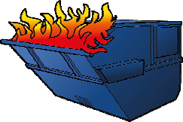

Electrical equipment
Fluorescent tubes often flicker until they go out when a component fails. Condensers and glow starters which are still hot may fall down and ignite combustible material below the light fitting.

Spotlights with directed beams can cause a fire through sustained heating of surrounding combustible material.

The following should be checked:
- that there are no blinking or “glowing” fluorescent tubes. Replace ordinary glow starters by safety glow starters.
- that there are no leaking condensers (discolouration on the cover can be an indication), there is a protective cover and that it is intact.
- that light bulbs, spotlights, uplights and other forms of electric light fittings are positioned in such a manner that they do not encourage people to hang clothing or simular on them.
- that electric light fittings are not equipped with overly powerful bulbs.
- that electric light fittings are stable or are fixed properly.

Switched-on cooker plates and percolators which have been forgotten have caused many fires. Above all, fires often start in kitchenettes in staff rooms or rest rooms. Most fires where kitchenettes are involved start because someone has forgotten to switch off a plate or has by accident turned a knob so that a plate is switched on. Using a kitchenette as a storage space, keeping materials on top of hot plates, may cause them to catch fire. For this reason, such electrical equipment should be fitted with a monitoring system that automatically turns electricity off.

Other types of electrical equipment, such as copiers, can also cause fire, and for this reason they should be fitted with a timer that turns off power after a certain period of time or out of working hours. Computers should also be turned off at the end of the working day.

To avoid fire in electrical equipment, it is also important to check:
- that technical spaces, such as electrical signal boxes and distribution boxes, are not used as storage facilities.
- that cables are intact and not pinched, and that areas surrounding heat radiating equipment are clean and clear.
- that lids and doors to distribution boxes, controller cabinets and switch bays are closed.
- that distribution boxes and other electrical installations are not exposed to humidity.
- that electrical heating equipment such as electric radiators, coffee makers and sauna heating units are not covered or placed in an unsuitable environment.
- that hot plates are cleared of all combustible materials and knobs cannot accidentally be turned on.
- that hot plates not in use are disconnected.

Use electrical products that are CE marked. Through the CE mark, the maker or importer certifies that the product complies with all the fundamental health and safety requirements in directives that are specified in harmonised European standards.

The CE mark applies to products in all countries in the European Union (EU), and without this mark the products must not be sold. The rules that apply for EU countries also apply for countries within EEA, the European Economic Area.

Defective or overloaded electrical installations can cause overheating or a short circuit that may cause a fire or a breakdown in production. Early detection of such defects can be instrumental in saving human lives or property. Modern thermographic equipment is a tool for detecting and eliminating hot areas in electrical equipment and circuits. For more information, see CFPA-E Guideline No 3

Hot work
Hot work is a common cause of fire that has serious consequences. It is in most cases hot work that is involved. Hot work is work that develops heat or causes sparking, such as cutting, welding, soldering or the use of heat guns. Over the years, this type of work has been the cause of many

conflagrations. The fires are caused by heat transmitted by conduction through metals, spray from grinding or spatter from welding. Fire starts when the hot surface comes into contact with combustible material. Fires often start in concealed spaces. Since the fire is not detected immediately, it has time to grow and spread. When it is finally detected, it is often too late.

For more information see CFPA-E Guideline No 12

Smoking
Apart from its pleasurable and working environment aspects, smoking is also a fire protection issue. At the places where smoking is permitted, safety ashtrays should be provided. These prevent cigarettes falling down from the ashtray. In this case also, the management should decide what rules apply to smoking. Smoking in the workplace is prohibited in many countries. The primary reason is to limit threats to health caused by passive smoking. In order to lower the risk of fire caused by lit cigarettes, specially designed (smoke free systems) Smoking Stations with fire proof ash handling systems can be installed.

Waste
Waste inside buildning should be removed daily.

Fire protection requirements for escape

Access to escape routes and finial exit
If the travel distance to the final exit of a temporary building used as an office, changing room, workshop or dining room is more than 15 m, the exit of the unit of temporary building shall lead to the escape route leading to at least two different final exits, independent of one another.

Final exit shall be in the form of doors leading directly to the outside. In some cases windows may be approved as alternative. For temporary buildings with several storeys, the escape route shall be supplemented with stairs. This applies also when a window is an alternative exit from a room.

The travel distance to the final exit should not exceed 45 m. If part of the travel distance to two mutually independent escape routes is shared, the shared distance is to be counted as 1.5 times its actual length. If stairs form part of the travel distance to an escape route, four times the difference in level is to be added to the travel distance.

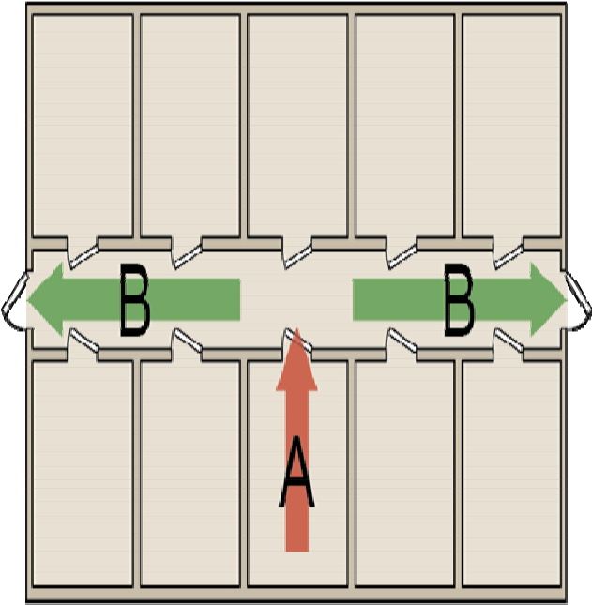
Travel distance: (A x 1.5)+B < 45 m

If temporary buildings are of two storeys and the part on the bottom storey has an elevated fire risk (contains flammable materials and/or is used as a workshop), there shall be at least two mutually independent escape routes on upper storeys and two separate stairs down to ground level.

Exception from the basic requirement for two escape routes
Temporary buildings can in some cases be constructed with only one escape route. When only one escape route is available, there must be no special risk that the exit will be blocked by fire. A special risk may also arise if escape is prevented by a fire in nearby temporary or permanent buildings.

In such cases the following shall be observed:

Storey | Maximum actual travel distance
Storey 1 | 15 m
Storey 2* | 15 m
*It is stipulated that windows and doors situated below the stairs and/or access balcony nearer than 2 m from the stairs shall be have at least 15 min fire resistance. This also applies to windows in temporary buildings on Storey 1 above the stairs.

Calculation of travel distance:

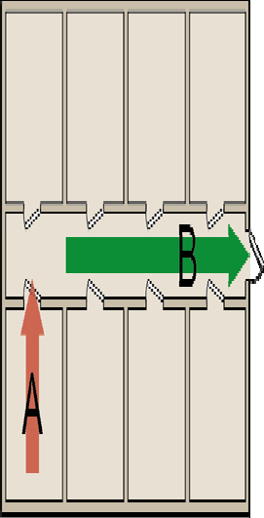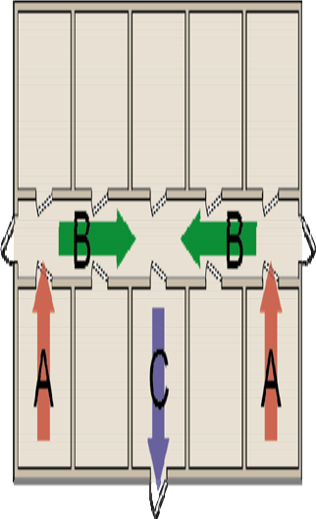
A + B ≤ 15 m A+B+C ≤ 15 m

Doors in escape routes
Doors in or to an escape route shall normally open outwards in the direction of escape.

Ladders
Fixed or freestanding ladders are not longer accepted as a means of connection between ground level and a window that is an escape route, because escape takes a long time. A ladder must be replaced by a stair tower.
Freestanding ladders are not accepted as a means of escape to the ground level from a window, which can be used as an exit from an upper storey of the temporary building. An escape arranged this way can takes a long time. A ladder must be replaced by a stair tower.

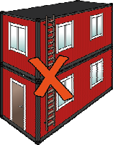

Access balconies
Access balconies may be used as a shared portion of otherwise separate escape routes. The distance between stairs which serve the access balcony should not exceed 30 m. Where only one stair serves the access balcony, the distance from exit door to the stairs should be limited to 15 m. Read more in 4.6 and see the examples in paragraph 14 concerning the protection of the window, etc. during the balcony and adjacent to balcony.

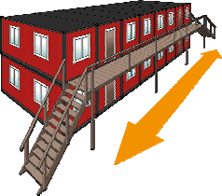

Escape over a roof
Escape over a roof may be regarded as equivalent to escape via an access balcony. When there is only one stairway from the upper storey, windows and doors on storey 1 below or above the stairs/access balcony, nearer than 2 m from the stairs, shall be of construction that resists fire for at least 15 minutes. This fire resistance shall not be understood as a fire resistance of the construction, defined with a fire resistant test for constructions in concealed space.

Alternatively, stairs/access balconies may be protected by metal sheeting or building board of at of construction that resists fire for at least 15 minutes on the underside of the stairs/access balcony.

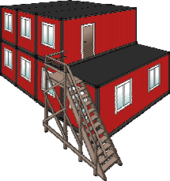

Escape alarm
Rooms in a temporary building where people are present other than occasionally behind closed doors and which are situated in such a way that it is necessary to pass through a corridor or some other space to reach the escape routes, should be fitted with an alarm that is automatically triggered by a smoke fire detector in the corridor.

A rest room should also be fitted with an escape alarm supplemented with a fire alarm function in the room.

Fittings in escape routes
During working hours, people are present in the workplace the escape shall be possible without the help of a key. Note that this also applies to windows if these form part of the escape strategy.

A pull handle or lever handle can be used as the opening device in escape routes in temporary buildings, on condition that the door can be opened by only one operation, i.e. without a knob having to be manoeuvred at the same time. Door opening device should comply with European Standard EN 179.
Ordinary escape lock, regardless of design, can never meet the requirement for an approved locking unit, since the escape lock shall at all times be capable of being opened in the direction of escape without a key or some other implement.

An approved locking unit comprises a lock housing, striking plate and, if necessary, door strengthening accessories. All components must be of a standard not lower than lock class three. A multiple tumbler lock may also be part of an approved lock unit.

When there is a requirement for intruder protection locking, at least one additional approved locking unit must therefore be installed in the door environment.

Many temporary buildings are fitted with external bars and padlocks. It is in most cases impossible to ensure that these are unlocked by various technical arrangements. It is better to set up a strict

locking procedure, for instance that the person who leaves last shall lock all doors and that the person who unlocks the first door must also unlock all the other escape routes.

Guidance signs

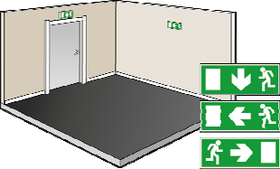

Temporary buildings shall be provided with photoluminescent signs and also with illuminated/luminous signs in those cases where the buildings do not receive daylight. Where illuminated/luminous guidance signs are required, these shall be provided with emergency power that secures the intended illumination for at least 60 minutes.

The signs should be placed in the line of sight, i.e. directly above the door to make it easier for people to find their way to the escape route.

The reading distance and the size of the sign are decisive for the type of guidance sign to be mounted. The table below shows what height the various signs have depending on the reading distance. The height of any of the signs should not be less than 100 mm. The reading distance to the sign is the distance from a place, situated midway between the signs along a notional line, from which two signs can be seen. When only one sign can be seen, the distance from a place situated furthest away from the sign shall be regarded as the reading distance.

Reading distance (m) | Luminous sign Height (mm) | Illuminated sign  Height (mm) | Photoluminescent sign  Height (mm)
5 | 100 | 100 | 100
10 | 100 | 100 | 150
15 | 100 | 200 | 300
30 | 150 | 300 | 450
40 | 200 | 400 | 600

Plan of escape routes
Copies of these plans should be displayed in suitable positions. The plan shall show the escape routes, specify how the alarm to the rescue services and other required assistance is to be communicated and, when appropriate, the siting of manual alarm buttons and alarm telephones, and the place for assembly after escape.

Plans of escape routes are not, however, needed for workplaces whose size, position and layout are such that there is obviously no need for these to ensure the safety of staff. It is thus a matter of judgment in each individual case whether such plans are required for the temporary building.

It is often advisable to display at least one such plan on each storey. It is best to arrange a common place of re-assembly for staff who work together. This makes it easier to check that everybody has been able to come to the place of assembly.

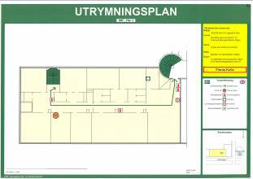

Protection against the spread of fire inside a fire compartment
Materials in building components and fittings and fixtures shall have such properties, or be incorporated in the building components in such a way, that they do not, in the event of fire, cause ignition or rapid spread of fire, nor develop rapidly large amounts of heat or combustion gases. They must not melt and drip outside the immediate vicinity of the seat of fire. The level of requirement for materials depends on the amount of heat and combustion gases that can be allowed to develop in the building. The fire classification of the building is decisive for the choice of materials. Materials in ceilings and walls and in fittings and fixtures must not become deformed when only slightly affected by fire, nor must they fall down or in any other way change so that the risk of injuries increases.

Protection against the spread of fire and combustion gases between fire compartments

Compartmentation

No special compartmentation is required for temporary buildings on one storey unless the travel distance to an escape route, or other conditions, necessitate special compartmentation. Nor is compartmentation required for temporary buildings on two storeys which have a maximum building area of 200 m2.

For temporary buildings that are larger or different from the above, special assessment and the opinion of a fire consultant or some other expert is required.

Protection against the spread of fire between buildings

The spread of fire should be hindered by limiting the level of thermal radiation. This can be achieved, for example, by

- constructing buildings at a sufficient distance from one another,

- limiting the size of unprotected parts of buildings.

Siting – safety zone

When a site is being planned, staff accommodation, offices and other temporary buildings should be sited so that fire cannot spread to or from the building under construction or an existing building.

No special measures for the prevention of the spread of fire between temporary buildings and the building under construction or other buildings are required if a safety zone of not less than 5 m is provided.

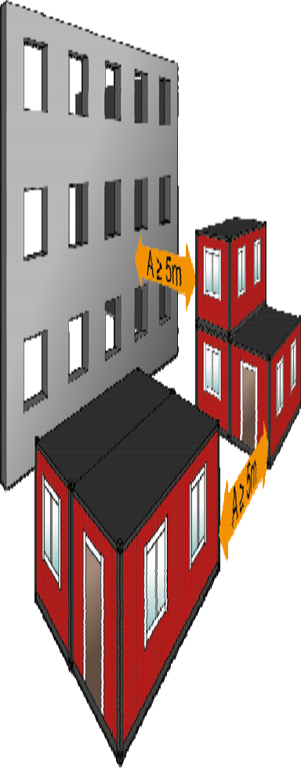When a ≥ 5 m, no special fire protection measures

Special attention should be paid to temporary buildings with activities which pose a special risk of the outbreak of fire, e.g. workshops where hot work is carried out. In such cases further requirements may be specified for e.g. cladding inside the building.

For the prevention of the spread of fire between temporary buildings and nearby buildings, special consideration should be given to the construction of the nearby building, regardless of whether or not it has been evacuated.

If a temporary building must be sited nearer than 5 m from a building, an assessment should be performed regarding the risk of the spread of fire.

The siting of a temporary building nearer than 5 m requires additional measures.

The combustible facade of the temporary building can be protected by fitting a sheet of external grade plasterboard that resists weather and wind. Special plasterboard that can remain outside without extra weather protection for up to one year is available in the market.

In addition to this, the following measures can be taken on the temporary building to hinder the spread of fire to adjacent buildings:

- Windows should have glass of fire resistance, or there should be no windows facing the building concerned. See “Windows in external walls facing one another” in the following.

- Doors should be of fire resistance classification, or there should be no doors facing the building concerned.

Another measure that is increasingly applied is to mount a special fireproof cover either on the building under construction or on the temporary building. The use of such fireproof cover fire protection requires special assessment and the opinion of a fire protection consultant or other expert.

If the adjacent building has a fire wall, no special measures need be taken on the temporary building if it is sited nearer than 5 m.

Windows in external walls facing one another
Windows in temporary buildings which face windows in the building under construction or some other building shall be designed and sited so that the spread of fire between these is impeded. Such windows shall be openable only by the use of tools, keys etc.

This applies to windows (glazed surfaces) which are situated in relation to one another so that direct thermal radiation caused by fire can be transmitted from one window to the other. Thermal radiation is assumed to occur at right angles and at an inclination from the window up to 135o from the plane of the window surface. If the angle of an internal corner is less than 60o, what is specified above for facing (parallel) external walls shall apply.

Examples of windows in external walls which face one another

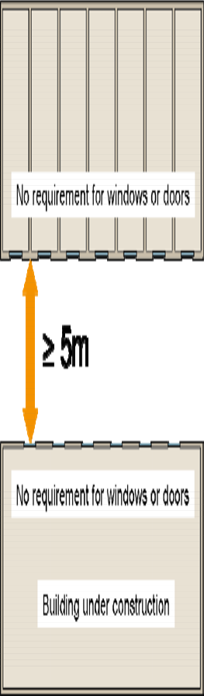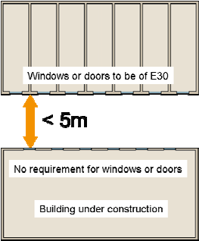

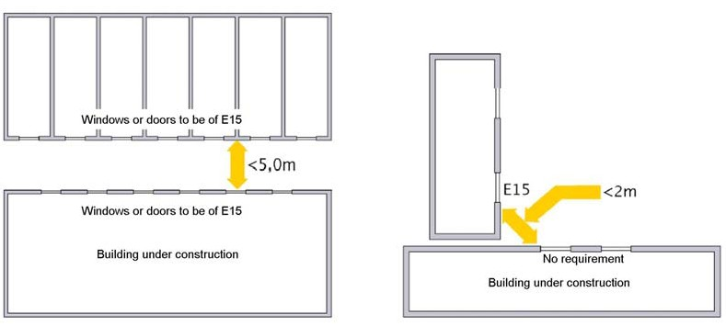

Facade situated at a higher level
When temporary buildings are sited near a building facade which is higher than the temporary buildings, measures must be taken if there are windows in the facade of the building. A distance of 5 m on the higher facade above the roof of the temporary building should normally protected against the spread of fire if the distance between the building and the temporary building is less than 5 m.

A window in the higher facade can be protected as follows
Window openings must be covered by covers of at least 30 minutes’ fire resistance classification. The facade should be covered with a special fireproof blanket. When a fireproof blanket is used, a special assessment is required and the opinion of a fire protection consultant or some other expert must be obtained.

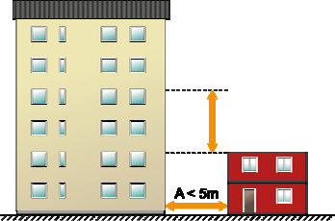If A is less than 5 m, the facade over a distance of 5 m above the roof of the temporary building must be protected to prevent the spread of fire.

Loadbearing capacity in the event of fire
For temporary buildings of one storey or two storeys of 200 m2 maximum building area, the loadbearing structure need not comply with fire protection requirements. For temporary buildings other than these, a special assessment is required and the opinion of a fire protection consultant or some other expert must be obtained.

Building area, regardless of size, for temporary building of one storey

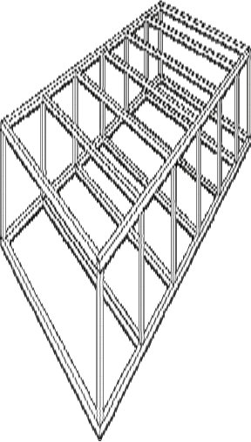
No fire protection requirements for loadbearing structure

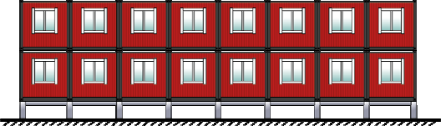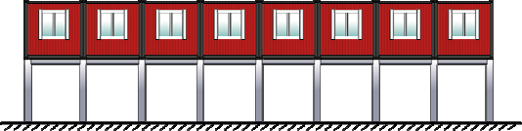

Building area, smaller than 200 m2, for temporary building of two storeys

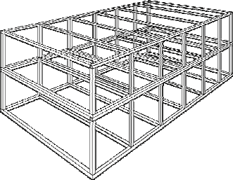

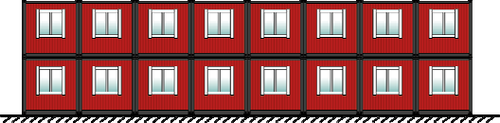No fire protection requirements for loadbearing structure up to a maximum building area of 200 m2.

Single storey building, no limit to area
Two storeys max 200 m2
Two storeys max 200 m2. Loadbearing structure where the columns have a maximum height of 2 m
A loadbearing structure where the columns are higher than 2 m will be regarded as of two storeys. This arrangement is the same as the previous figure, i.e. two storeys of max 200 m2. If another storey is placed on top of this arrangement, other rules must applied.

Fire fighting equipment and access for the rescue service

Extinguishing equipment
It is essential to choose a portable fire extinguisher that has sufficient extinguishing effectiveness for the expected fire. Since it is seldom known in advance what the scope of a fire may be, it is always best to have as large an extinguisher as possible, containing an extinguishing medium that can fight all types of fires.

It is recommended that a certified portable fire extinguisher should be chosen. Recommended fire fighting equipment for temporary buildings:
Extinguishing medium | Powder | Foam | Carbon dioxide
Quantity of extinguishing medium, not less than | 6 kg | 9 liter | 5 kg
Performance class, min | 34A | 21A | 70B
 | 183BC | 183B

Portable fire extinguishers shall be placed in a prominent position and shall be clearly signposted. The travel distance to a portable extinguisher should not exceed 25 m. The exact siting also depends on where people are present and where the exits and normal travel routes are situated. There should be at least one portable fire extinguisher on each storey. An appropriate site is directly inside a door leading outside.

Access for the rescue service
Temporary buildings and containers should be sited so as to ensure that rescue and effective firefighting can take place; this implies, for example, that access for the ladder equipment of the rescue service should be provided, especially when an existing building has not been evacuated. Furthermore, temporary buildings should not be sited so that the fire fighting access routes to the buildings are made unnecessarily long. Fire hydrants and/or gas stop cocks in the carriageway or footway shall not be obstructed. In the same way, temporary buildings shall not obstruct manholes for electricity/telecom, sewers or district heating.

Checklists

To bear in mind when erecting temporary buildings on constrution sites

- Not more than 8 units per storey are to be erected together. If more than 8 units per storey are used, fire engineer shall be consulted.

- With a maximum of 8 units, the travel distance to the nearest escape route will not be too long if it is possible to walk right through the building. Escape shall take place through door/doors; windows should be avoided.

- Between groups of temporary buildings and between temporary buildings and other buildings, there shall be a safety zone of 5 m.

- In cases where there is only one door available as an escape route, not more than 5 units shall be erected together if they are used by a maximum of 15 people at the same time. For more than 15 people, two mutually independent escape facilities shall be available.

- When there is only one stairway from the upper storey, windows and doors on storey 1 below the stairs/access balcony that are situated nearer than 2 m from the stairs, shall have a fire resistance classification of not less than 15 minutes. This also applies to windows in units on storey 1 above the stairway. Alternatively, the underside of the stairway/access balcony can be protected with metal sheeting or building board of not less than 12 mm thickness.

- If temporary buildings are erected on two storeys and the buildings on ground level have an elevated fire risk in the form of combustible materials and/or workshop premises, there shall be at least two mutually independent escape routes on storey 2 and two separate stairs down to ground level.

- Temporary buildings must not be erected so that they obstruct fire hydrants and/or gas stop cocks in the carriageway or footway. Nor must they obstruct manholes for electricity/telecom, water or district heating.

- Temporary buildings must not be erected so that they obstruct rescue roads and/or hard standings for the lift platform or turntable ladder of the rescue service. Consult the rescue service if there is uncertainty concerning the hard standing.

- Temporary buildings shall be equipped with at least one portable fire extinguisher on each storey. An appropriate site is directly inside the external door.

- Temporary buildings without direct daylight shall be provided with an illuminated or luminous guidance sign above the escape door.

- The doors of temporary buildings shall carry notices to the effect that the person who unlocks the door shall also unlock the other escape routes, and the person who is last to leave the group of temporary buildings at the end of the working day shall lock all external doors.

Handover of temporary building
When the temporary building has been erected on site by the hiring company, it should be handed over by completing a checklist. The recipient of this checklist is the site agent. This document shall be regarded as a receipt which confirms that the temporary building has been erected in accordance with the agreement and that what has been ordered has been supplied.

The reason for discrepancies in the checklist may be that a product has not been ordered, or that the tenant has ordered products from another supplier. The reason for other discrepancies may be that the temporary building could not be erected as planned because the area available for it has been altered.

See also “Checklist for fire protection when a temporary building is handed over.”

Checklist for fire protection when a temporary building is handed over

Building area < 200 m2 > 200 m2
Project/No
Client: | Telephone:
Address of site office:
Contact person of hiring company:
Temp. building 1storey | 2 storeys

 | Yes | No with comments | Initials
The building satisfies security of escape regarding:
- Travel distance
- Guidance signs
- Special escape fittings mounted on escape doors
- Only stairs as escape routes
- Windows used as escape routes
- Access balconies used as escape routes
- Escape plans are displayed
- Windows near escape routes (stairs) have fire classification
Are there separate fire compartments
Protection against spread of fire between buildings
- Sufficient safety zone
- Other measures
Equipment for fire fighting
- Portable fire extinguishers
- Fire blankets
- Other measures
Measures taken to provide access for rescue service to existing building (e.g. residential building etc)
Management & maintenance instructions handed over
Temporary building erected in accordance with drawings

Discrepancies/Comments:

Company (Hiring company):
Name Date Signature

Regular inspections
The following checklist may be helpful for inspections. Temporary buildings should be inspected regularly. It is up to the site agent to determine the frequency. It is best to carry out checks regarding arson the day before a weekend or holiday.

Checklist for inspections

Escape | Check that
Escape routes | - escape route is not obstructed  - escape doors are not obstructed. Check also on the outside that they are not obstructed by snow or something else
Signs for escape | - the sign is in place  - sign is easy to see from suitable points in the building  - luminous or illuminated signs are intact and the light is on  - where emergency power supply is installed, that this works
Compartment boundary | Check that:
Wall at compartment boundary | - there are no holes, leaks, gaps etc in the wall  - openings in walls for e.g. pipes, cables, ventilation ducts are sealed
Fire resistant glazing,windows | - the glass is intact  - windows are closed
For all doors in and to escape routes,  regardless of whether or not they have a fire separating function, the following shall be checked | Function  - Check that the door can be easily opened without a key, code or card and that it opens at least 900 mm  - Check that the escape route is not obstructed by some object  - Check that the force needed to open the door does not exceed 130 N (ca 13kg)  Maintenance  - When the door is opened, make a visual inspection of hinges, locks, door handle, frame, fixing of glass (if any), any damage, rating label, function of door handle, etc  Door closer  - Open the door ca 10 cm and release it. Check that the door closes completely, and that  - the spring bolt engages with the striking plate  - Check for oil leaks  - Check for damage to the alarm system that affects door closer function  - Check the fixing of door closer housing and of the arms  - NOTE that split/hold-open arms are not recommended for doors at compartment boundaries  Additional locks  - When burglar proof locks are installed, check that the lock is open during working times
Firefighting equipment | Check that:
Portable extinguishers | - extinguisher is in its intended place  - pressure gauge indicator is in green field  - there is a sign for the extinguisher and that it can be seen  - the extinguisher has had its annual external check (there must be a sticker on the extinguisher which shows date of last inspection)  - the extinguisher is not obstructed and it is readily accessible
Electrical installations | Check that:
Fluorescent tubes | - the tube is not blinking when the light is switched on and it does not blink in normal operation  - the tubes are not burned out and/or their ends are not glowing red
Halogen lights and incandescent  lights | - there is no combustible material such as curtains near, or in contact with, lights  - the fitting is stable and properly fixed  - fittings are not sited so that excessive heating is caused
Electrical installations | - cables are not damaged or pinched  - wall sockets or switches are not damaged  - combustible materials are not kept nearer than 1 m from a fuse board

- electric heaters are not covered
- there are no loose cables
- cables are free from harmful amounts of thermally insulating dust
Other items | Check that
Kitchen and/or staff room | - naked lights are not left unguarded and combustible candle holders are not used. Check also their placing in relation to combustible materials such as curtains, on the TV, etc  - percolators, hotplates etc. have timers  - near cookers there is no combustible material that can fall down or cause a fire in some other way  - the tops of cookers are not used as storage places  - fan filters are clean
Other potential causes of accidents | - skid resistant surfaces on e.g. stairs or in other places where these are needed are in a serviceable state  - there is no smoking other than in authorised places
First aid | - existing contents agree with list of contents
Cleaning/order | - rubbish or empty packaging is not stored in large quantities or in an unsuitable place indoors or too near the facade of the building on the outside
Pallets, containers and storage of combustible materials | - combustible materials, e.g. pallets, waste containers etc are not placed nearer then 5 m from a facade with openings such as windows, doors or air inlets, unless these are of fire resistant construction.
Arson | Around the outside of buildings  - rubbish and empty packaging or other combustible materials are not placed along the facade or under a canopy  - containers for combustible materials are not kept nearer than 5 m from a temporary building  - store rooms are not unlocked  - there are no ladders or some other equipment that can be used to get up on the roof  - windows and doors are locked  - external lighting is not damaged

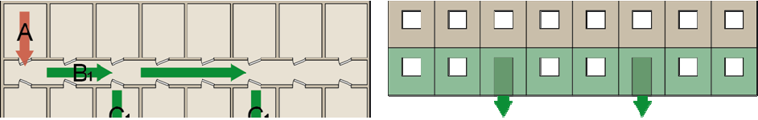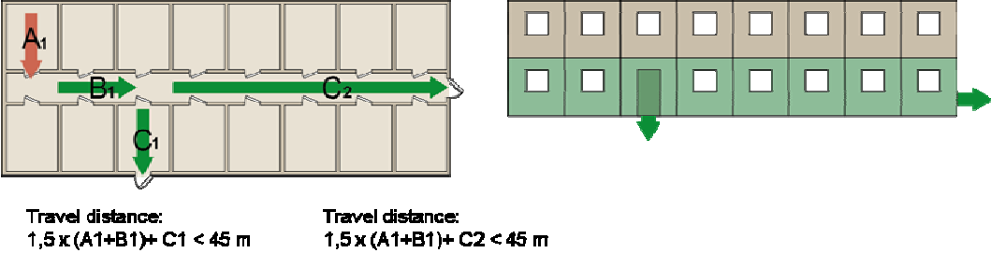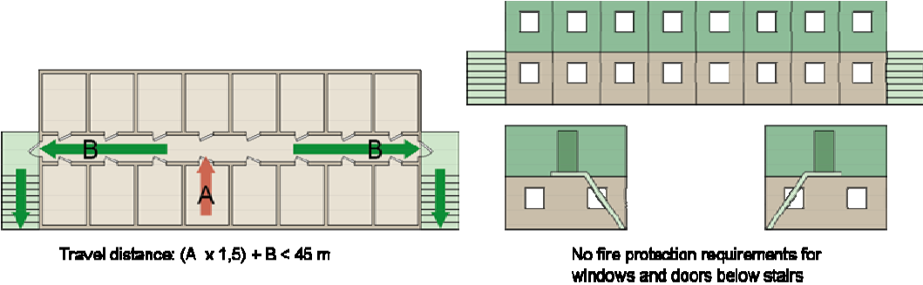

Examples
Temporary buildings of two storeys
Temporary building of 2 storeys of ≤ 200 m2 building area
- No requirement for compartmentation
- No fire protection requirements for loadbearing structure

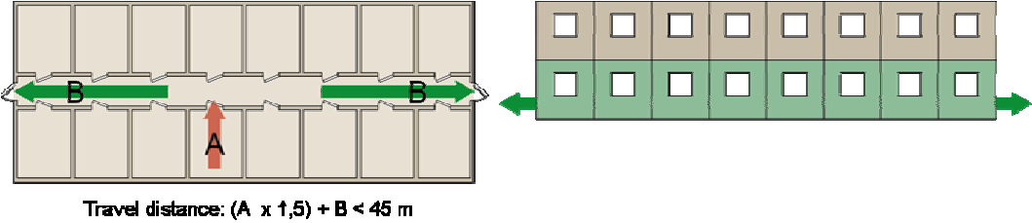
Storey 1
Max. 8 units
2 escape routes via doors

Storey 1
Max 8 units
2 escape routes via doors

Storey 1
Max. 8 units
2 escape routes via doors

Storey 2
Max 8 units Two escape routes
via two stairs

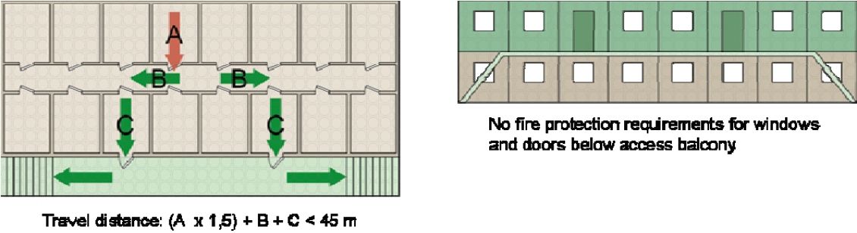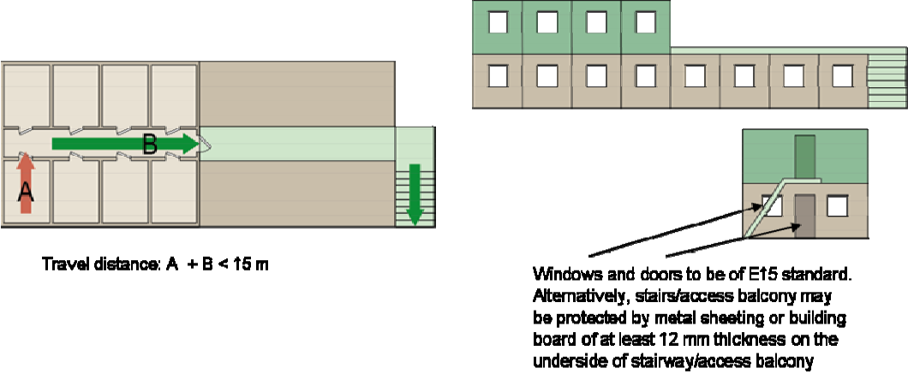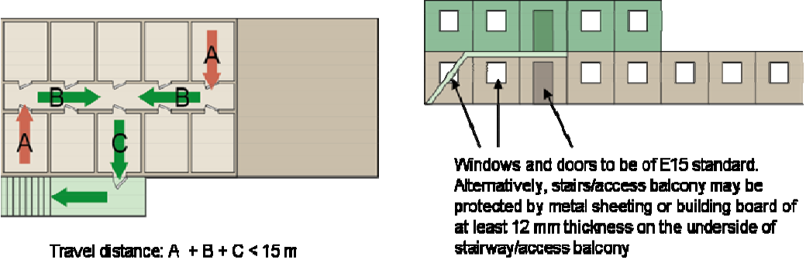
Storey 2
Max. 8 units Two escape routes via access balcony with 2 stairs

Storey 2
Max 4 units One escape route
via roof and stairs
down to ground level

Storey 2
Max. 5 units One escape route
via access balcony and stairs down to
ground level

European guidelines
Guideline No 1:2002 F - Internal fire protection control Guideline No 2:2007 F - Panic & emergency exit devices Guideline No 3:2011 F - Certification of thermographers
Guideline No 4:2010 F - Introduction to qualitative fire risk assessment Guideline No 5:2003 F - Guidance signs, emergency lighting and general lighting Guideline No 6:2004 F - Fire safety in residential homes for the elderly
Guideline No 7:2011 F - Safety distance between waste containers and buildings Guideline No 8:2004 F - Preventing arson – information to young people Guideline No 9:2005 F - Fire safety in restaurants
Guideline No 10:2008 F - Smoke alarms in the home
Guideline No 11:2005 F - Recommended numbers of fire protection trained staff Guideline No 12:2006 F - Fire safety basics for hot work operatives
Guideline No 13:2006 F - Fire protection documentation
Guideline No 14:2007 F - Fire protection in information technology facilities Guideline No 15:2010 F - Fire safety in guest harbours and marinas Guideline No 16:2008 F - Fire protection in offices
Guideline No 17:2008 F - Fire safety in farm buildings
Guideline No 18:2008 F - Fire protection on chemical manufacturing sites
Guideline No 19:2008 F - Fire safety engineering concerning evacuation from buildings Guideline No 20:2009 F - Fire safety in camping sites
Guideline No 21:2009 F - Fire prevention on construction sites Guideline No 22:2010 F - Wind turbines – Fire protection guideline
Guideline No 23:2010 F - Securing the operational readiness of fire control system Guideline No 24:2010 F - Fire safe homes
Guideline No 25:2010 F - Emergency plan Guideline No 25:2010 F - Emergency plan
Guideline No 26:2010 F - Fire protection of temporary buildings on construction sites

