CFPA-E No 23:2010 F

Securing the operational readiness of fire control systems

FOREWORD

The European fire protection associations have decided to produce common guidelines in order to achieve similar interpretation in European countries and to give examples of acceptable solutions, concepts and models. The Confederation of Fire Protection Associations in Europe (CFPA E) has the aim to facilitate and support fire protection work in European countries.

The market imposes new demands for quality and safety. Today, fire protection forms an integral part of a modern strategy for survival and competitiveness.

This guideline is primarily intended for those responsible for safety in companies and organisations. It is also addressed to the rescue services, consultants, safety companies etc so that, in the course of their work, they may be able to help companies and organisations to increase the levels of fire safety.

The proposal for this guideline was produced by the Institute of Safety and Security and the author is Hans-Heinrich Wolfensberger from Switzerland.

This guideline has been compiled by Guidelines Commission and adopted by all fire protection associations in the Confederation of Fire Protection Associations Europe.

These guidelines reflect best practice developed by the countries of CFPA Europe. Where the guidelines and national requirement conflict, national requirements must apply.

Zürich, 5 May 2010 Stockholm, 5 May 2010
CFPA Europe Guidelines Commission

Dr. Hubert Rüegg Tommy Arvidsson
Chairman Chairman

Contents
- Introduction 4
- Scope 4
- Definitions 4
- Key 5
- Strategy 5
- Existing facilities 6
- Frequency of integral tests 6
- Demands placed on the operator and resulting obligations 6
  - Checks and maintenance work 6
  - Changes during operation 6
  - Documentation and verification 6
- Required documentation 6
- Attachments 7
- European guidelines 7
- Basic Principals 16
  - Participants 16
  - Documents 16
  - Procedure for integral tests of fire control systems 16
- Integral test of automatic fire control systems 17
  - Scenario 1, Fire in the Ex-Zone Production ground floor 17
    - Test Scenario 1 17
    - Remarks / Information 18
  - Scenario 2 ff 19
- List of deficiencies, action planning 19
  - Deficiencies 19
  - Improvements 19
- Integral test of fire control systems 20
  - Procedure for integral tests 20
- Procedure for integral test 20
  - Scenario 1ff 20

Introduction
Fire detection systems and fire extinguishing systems must automatically identify any fire that may occur and to signal and alert all endangered persons and operational personnel. They can be used for activating and operating fire protection devices.
Owners and users of buildings and facilities are responsible for ensuring that appliances and equipment used for the structural, technical and preventive aspects of fire protection systems and facilities are to be maintained and operational at all times in accordance with regulations. A general overview can be found in Guideline No 1:2002, Internal Fire Protection Control.
The technical facilities for fire protection should be consistent with state-of-the-art technology and designed and maintained so that they are effective and operational at all times.

Scope
This Guideline documents the operational readiness of fire control systems and regulates their design and control.
Additionally an internal self-checking system must be implemented, that ensures the periodical checks of installations, which are relevant for fire protection. These checks are carried out more frequently then the control of fire control systems. The procedure of this self-checking system is not part of this document.

Definitions

Fire control systems (FCS)
Fire control systems are identified as those actuating devices of safety systems and/or safety components such as lift installations, venting systems, doors, fire dampers, etc, that are activated automatically or manually.

Integral test
An integral test is used to check all fire protection components, which are automatically activated, and their interrelationship with one another. This includes their proper activation and function.

Zone plan (see Attachment 2 and 4)
The zone plan is a graphical representation of defined areas to show where elements are to be activated as well as to indicate and identify individual components.

Matrix for fire control systems (see Attachments 3 and 5)
The matrix for fire control systems is in the form of a table showing all interrelationships between activated zones and those components to be activated.

Action plan of the integral test (see Attachment 6)
The action plan is the documentary evidence on the procedure or protocol for testing fire control systems. This is based on specific concepts of established protection objectives.

Periodic checks, function of activation
Periodic checks are those tests on systems and components at specific time intervals. These include:
- checking the correct functioning of individual components (ad hoc inspections)
- checking zone plans (conceptual)
- carrying out an integrated test (according to the action plan)

Self-checking system
A periodic internal check consists of a visual inspection and a status and function check of devices throughout the facility (e.g. emergency generator, fire doors, fire extinguishers). Results of these checks should be documented.

Documentation
The integral test, internal controls, maintenance and all incidents must be documented (e.g. log book).

Key
FDS Fire detection system
SPS Sprinkler system
FCS Fire control system
FD Fire damper
SHES Smoke and heat exhaust system
FBCP Fire brigade control and indicator panel

Strategy
Based on the fire protection strategy, a facility-specific, targeted solution for fire control systems is to be drawn up. The following describes the approach to planning and checking fire control systems:
1. Appointing personnel to be responsible for planning
- Creating / checking / adapting a fire protection concept
- Creating / adapting zone plans and the matrix to reflect the fire protection concept
- Installing equipment and updating related documents
- Creating / customizing the action plan for integral testing
- Carrying out procedures for integral testing

- Rectifying faults, if any
- Determining periodic checks, function of activation, and time intervals
- Carrying out an integral test after any significant changes to the system
- Ongoing review of the fire protection concept and updating documents

Existing facilities
When extending fire protection measures and/or structural modifications, the documentation must be updated and an integral test carried out on the area concerned.
An integral test must be carried out after adjustments to the system or after updating hardware or software.

Frequency of integral tests
An integral test is to be carried out periodically, according to the national regulations, but at least every 3 years, preferably just before a periodic check of the fire protection system by the competent authorities.

Demands placed on the operator and resulting obligations

Checks and maintenance work
The operator is responsible for ensuring that internal controls and maintenance work on the components is conducted according to a set schedule (according to manufacturer's specifications).

Changes during operation
Documents are to be updated after any functional or structural change or significant modification to the actuating equipment. Depending on the scope of the modifications, the procedure described in Section 5 must be adhered to.

Documentation and verification
All incidents relating to the operation of fire control systems must be documented (e.g. log book).

Required documentation
- Zone plan of the building
- Matrix of automatic fire control system with key
- Action plan of integral test

- Checklist for internal fire protection control
- Verification of events and checks (e.g. log book)

Attachments
Examples are given in the attachment (although not exhaustive, possible solutions), as a guide for full documentation. The extent and definitive illustration or labelling is notional only and can be freely selected.
A1 Survey of documents, necessary planning documents
A2 Zone plans for fire control systems (collective activation) A3 List of fire control systems (collective activation)
A4 Zone plans of fire control systems (selective activation) A5 Matrix for fire control systems (selective activation)
A6 Implementation of action plan
A7 Periodic check of fire control systems A8 Key

European guidelines
Guideline No 1:2002 F - Internal fire protection control Guideline No 2:2007 F - Panic & emergency exit devices Guideline No 3:2011 F - Certification of thermographers
Guideline No 4:2010 F - Introduction to qualitative fire risk assessment Guideline No 5:2003 F - Guidance signs, emergency lighting and general lighting Guideline No 6:2004 F - Fire safety in residential homes for the elderly
Guideline No 7:2011 F - Safety distance between waste containers and buildings Guideline No 8:2004 F - Preventing arson – information to young people Guideline No 9:2005 F - Fire safety in restaurants
Guideline No 10:2008 F - Smoke alarms in the home
Guideline No 11:2005 F - Recommended numbers of fire protection trained staff Guideline No 12:2006 F - Fire safety basics for hot work operatives
Guideline No 13:2006 F - Fire protection documentation
Guideline No 14:2007 F - Fire protection in information technology facilities Guideline No 15:2010 F - Fire safety in guest harbours and marinas Guideline No 16:2008 F - Fire protection in offices
Guideline No 17:2008 F - Fire safety in farm buildings
Guideline No 18:2008 F - Fire protection on chemical manufacturing sites
Guideline No 19:2009 F - Fire safety engineering concerning evacuation from buildings

Guideline No 20:2009 F - Fire safety in camping sites Guideline No 21:2009 F - Fire prevention on construction sites
Guideline No 22:2010 F - Wind turbines – Fire protection guideline
Guideline No 23:2010 F - Securing the operational readiness of fire control system Guideline No 24:2010 F - Fire safe homes
Guideline No 25:2010 F - Emergency plan
Guideline No 26:2010 F - Fire protection of temporary buildings on construction sites

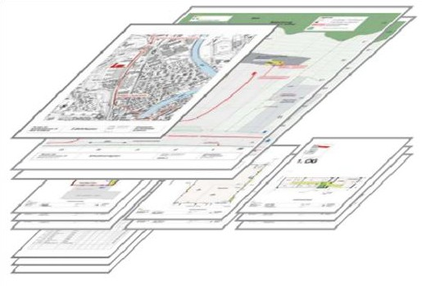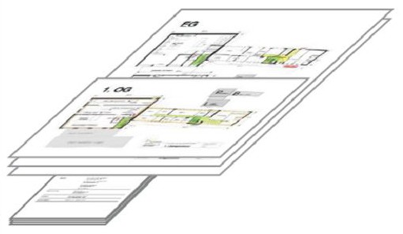

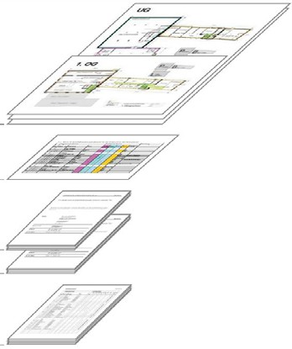Summary of Documents Attachment 1

Check-Plan for fire control systems

Consisting of:

- Zone plans for fire control systems

- Matrix for fire control systems

- Control plans
(Action plans for integral test)
- for the approval
- for periodic check

- Documents of internal fire protection control
Other fire protection documents with potential interfaces
Fire Brigade Intervention Plans and Fire Protection Plans

Consisting of:

- Access plan
- Situation plan
- Environment and hazard plans
- Floor plans
- Information sheets etc.
Plans for Escape routes, Orientation and Evacuation

Consisting of:

- Evacuation and orientation plans
- Evacuation concept
- Leaflet "Behaviour in case of fire"

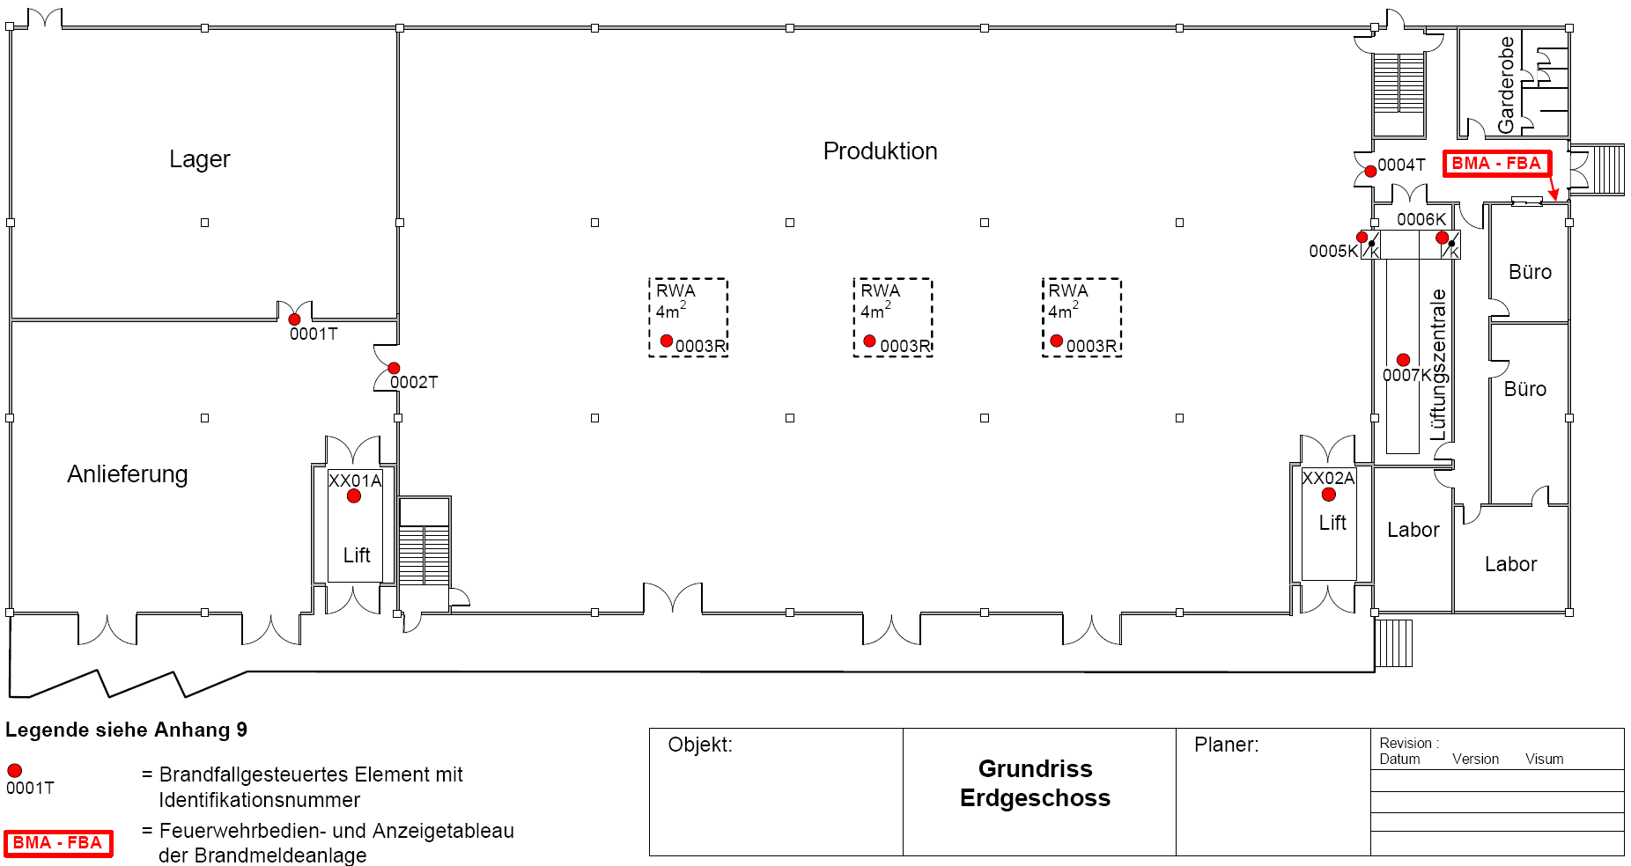
FBCP
FBCP
Production
Warehouse
Office
SHES
SHES
SHES
Office
Delivery
Elevator
Elevator
Laboratory
See Attachment 8 for key

= Element of Fire control system with Identification number
= Fire brigade control and indicator panel
Plan view
Ground Floor

 |  |  | Activated Element |  |  |  | Activation |  | Function |  |  |  | Comments |  | Date / Initials
 | Loca tion |  | Number Type | Description | Action |  |  |  | fulfilled
 |  |  |  |  |  |  | from |  | yes |  | no
EG |  | 00 01 T |  | Fire gate | closure | I∗ |  | ◻ |  | ◻
 |  | 00 02 T |  | Fire gate | closure | I |  | ◻ |  | ◻
 |  | 00 03 R |  | Smoke exhaust, 3 vent openings | opening | E |  | ◻ |  | ◻ |  | 3 vent openings, simultaneously activated
 |  | 00 04 T |  | Fire gate | closure | I |  | ◻ |  | ◻
 |  | 00 05 K |  | Fire damper, Production | closure | E |  | ◻ |  | ◻
 |  | 00 06 K |  | Fire damper, Office | closure | E |  | ◻ |  | ◻
 |  | 00 07 L |  | Ventilating system | switch off | E |  | ◻ |  | ◻
XX |  | XX 01 A |  | Elevator | Displace to ground floor | I |  | ◻ |  | ◻
XX |  | XX 02 A |  | Elevator | displace to ground floor | I |  | ◻ |  | ◻

See Attachment 8 for key

- I: Internal alarm e.g. daytime operation E: External alarm to the fire brigade or activation by pushbutton

12 GUIDELINE No 23:2010 F

Zone plans for fire control systems (Selective Activation) Attachment 4

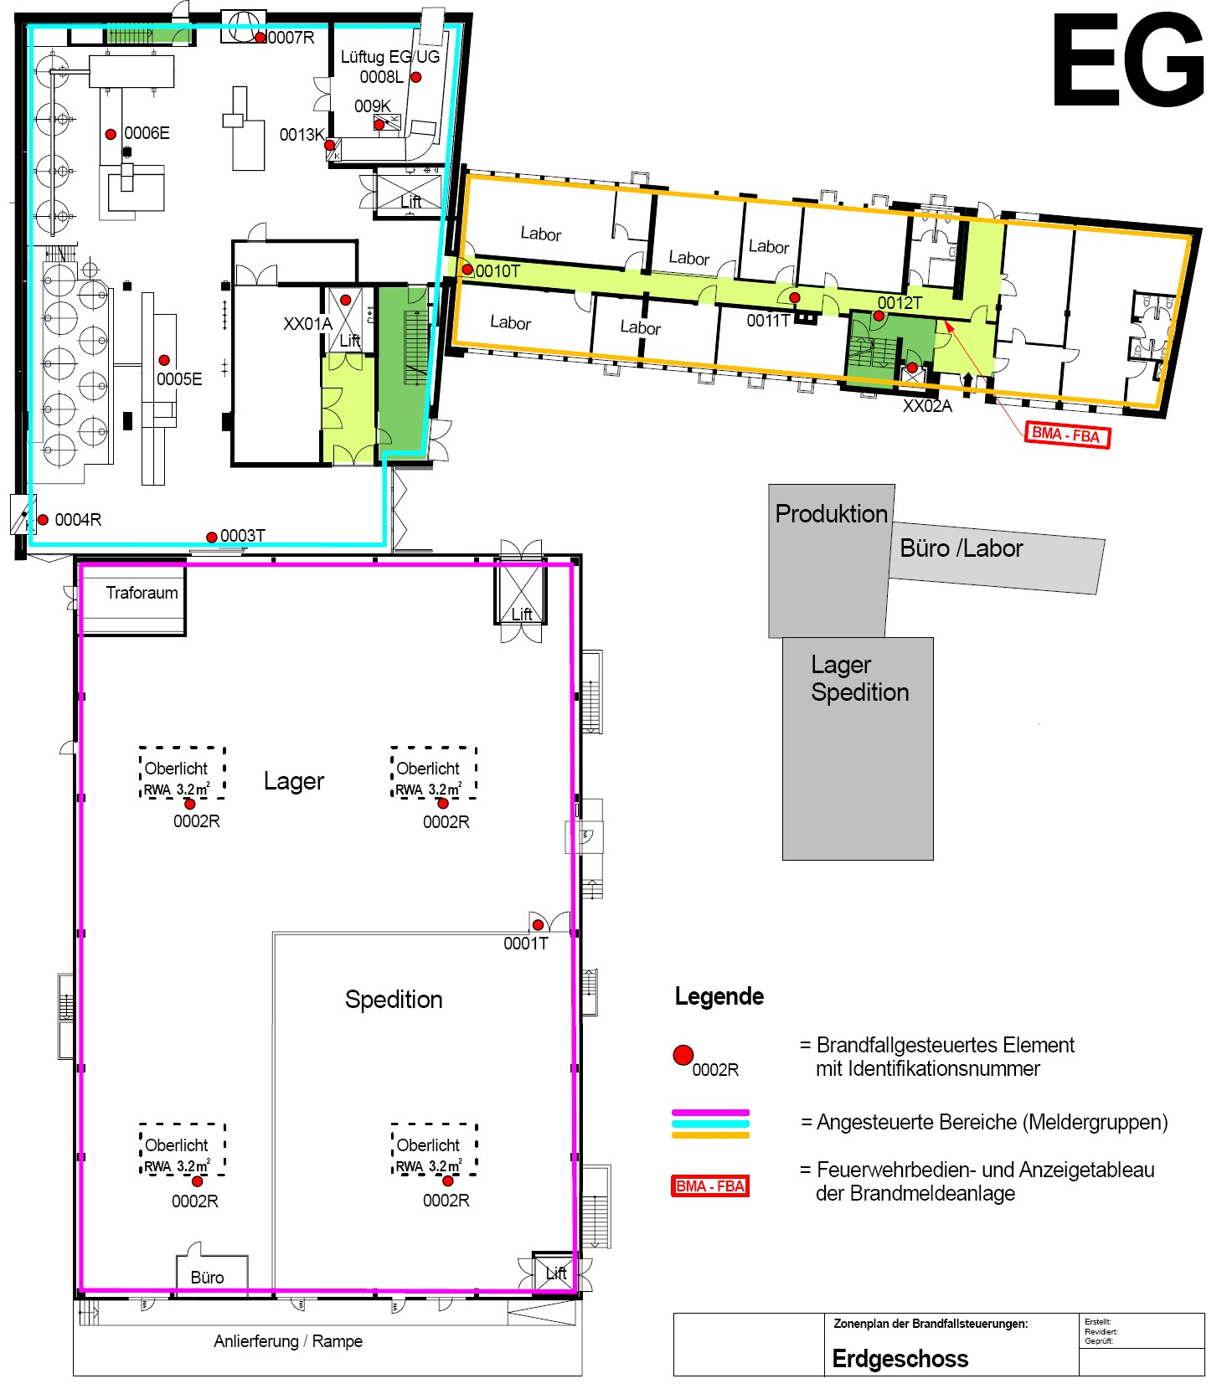
FBCP
FBCP
Ventilation
Production
Office/Laboratories
Warehouse
Shipping
SHES
3.2 m2
Warehouse
SHES
3.2 m2
Conveyance
SHES
3.2 m2
SHES
3.2 m2
See Attachment 8 for key
= Activated element with Identification number
= Activated zones (Group of fire detection elements)
= Fire brigade control and indicator panel
Ground Floor

CFPA-E®-GUIDELINES EFSAC Endorsed

Matrix of Fire Control Systems (Selective Activation) Attachment 5

 |  |  | Activated Element |  |  |  |  |  |  | Release Area |  |  |  |  |  |  | Remarks
 | Loca tion |  | Number |  | Type |  | Description |  | Action | Warehouse Conveyance | Production |  | Office Laborat. |  | Release Criterion
 |  |  |  |  |  |  | Warehouse/Conveyan.
EG |  | 00 03 T |  |  |  | Fire gate |  | closure |  | I∗ | I |  |  | FDS
 |  | 00 01 T |  |  |  | Fire gate |  | closure |  | I |  |  |  | FDS
 |  | 00 02 R |  |  |  | Smoke exhaust, 4 vent openings |  | opening |  | I |  |  |  | FDS
XX |  | 00 01 A |  |  |  | Elevator |  | Displace to ground floor |  | I | I |  | I
XX |  | 00 02 A |  |  |  | Elevator |  | Displace to ground floor |  | I | I | I
 |  |  |  |  |  |  | Production
EG |  | 00 03 T |  |  |  | Fire gate |  | closure |  | I | I |  |  | FDS
 |  | 00 10 T |  |  |  | Fire gate |  | closure |  |  | I |  | I | FDS
 |  | 00 04 R |  |  |  | Supply air |  | opening |  |  | E |  |  | FDS |  | Supply air for fume exhaust ventilation
 |  | 00 05 E |  |  |  | Production Line 1 |  | switch off |  |  | E |  |  | FDS
 |  | 00 06 E |  |  |  | Production Line 2 |  | switch off |  |  | E |  |  | FDS
 |  | 00 07 R |  |  |  | Fume exhaust ventilation |  | Switch on |  |  | E |  |  | FDS
 |  | 00 08 L |  |  |  | Ventilation |  | Switch off |  |  | I |  |  | FDS
 |  | 00 09 K |  |  |  | Fire damper to basement |  | closure |  |  | I |  |  | FDS
 |  | 00 13 K |  |  |  | Fire damper to Production |  | closure |  |  | I |  |  | FDS
XX |  | XX 01 A |  |  |  | Elevator |  | Displace to ground floor |  | I | I | I |  | FDS
XX |  | XX 01 A |  |  |  | Elevator |  | Displace to ground floor |  | I | I | I |  | FDS

- I: Internal alarm e.g. daytime operation E: External alarm to the fire brigade or activation by pushbutton

EG

XX
00 11 T
00 12 T
00 10 T
XX 02 A
Office / Laboratory
Fire door Fire door Fire door Elevator
closure
closure closure
Displace to ground floor
Displace to ground floor
I
I
I
I
I I I
FDS
FDS FDS FDS
XX
XX
02
A
Elevator
I
I
I
FDS

See Attachment 8 for key

Certification for Automatic Fire Control Systems Scenario Integrated Test

Contents

- Basic Principals
  - Participants
  - Documents
  - Procedure for integral tests of fire control systems
- Integral test of automatic fire control systems
  - Scenario 1, Fire in the Ex-Zone Production ground floor
    - Test Scenario 1
    - Remarks / Information
  - Scenario 2 ff
- List of deficiencies, action planning
  - Deficiencies
  - Improvements

Basic Principals
As part of building renovations, the fire and gas detection systems were modernized and a personal alarm system was installed. The fire protection systems and all relevant actuating safety equipment and systems are to be checked for functionality and safe operation. An integral test with five scenarios is to be carried out to this end.

Participants

Company | Function | Name | present
Company X | Owner | Mister A | yes
Company X | Chief technical service | Mister B | yes
Construction Inc. | Construction management | Mister C | yes
... | ... | ... | ...

Documents
For survey the following documents are given to all participants in advance:
- Fire protection plans and zone plans
 ...

For verification and gap analysis the following documents are essential and must be available at place:

Updated documents | available |  | Comments
 | yes | no
Construction plans, revised | ☑ | ◻
Ventilation plans, revised | ◻ | ☑ | Not actual version, data for test okay
Sanitary plans | ☑ | ◻
... | ◻ | ◻ | ...

Procedure for integral tests of fire control systems

Time | Action | Responsible
08:00 - 08:15 | Welcome, Presence control | Safety representative, Company X
08:15 - 08:30 | Document Verification | Company XX
08:30 - 09:00 | Meeting, Fire scenario verification | All participants
... | ... | ...

Integral test of automatic fire control systems
The automatic activation of all security elements such as doors, fire doors, fire dampers, etc. is done periodically within specified time intervals by carrying out an integral test.
The test initially requires all elements to be put into operational readiness. According to the scenarios and action plan, security elements must assume the status for the particular emergency for which they were set. After resetting the alarm systems, the security devices must also be reset to their operating status either automatically or manually.
System functions are to be verified and documented throughout the entire installation. By its signature, the company responsible for the installation and its operation confirms that the safety devices are operating correctly and that the information given is accurate.

Scenario 1, Fire in the Ex-Zone Production ground floor
Activation of a fire detector in production area; acknowledge of internal alarm within 3 minutes (daytime operation); Activation of an external alarm by pressing a manual fire alarm button

    - Test Scenario 1

Pos. | Action | Responsible company | Function okay |  | Responsible person
 |  |  | yes | no
 | Preparations
1 | Control and indicating equipment: No alarms, failures etc. present | Company of fire detection systems | ☑ | ◻ | I. Isler
2 | Access to all rooms ensured | Company X | ☑ | ◻ | B. Bodmer
3 | Plants switched on | Company X | ☑ | ◻ | B. Bodmer
4 | Closures opened, in operating position | Company X | ☑ | ◻ | B. Bodmer
5 | Building services in operation | Company XX | ☑ | ◻ | E. Ebner
 | Test Scenario 1
6 | No activation of any fire control systems of other scenarios | all | ☑ | ◻ | E. Ebner
7 | Activation of a pre-alarm of a smoke detector in delivery office | Company of fire detection systems | ☑ | ◻ | I. Isler
8 | Approval of the transmission to the control and indicating equipment Acknowledge receipt of the alarm within 3 minutes | Company of fire detection systems | ☑ | ◻ | I. Isler

Pos. | Action | Responsible company | Function okay |  | Responsible person
 |  |  | yes | no
9 | Closure of fire gates: Gate (0003T)  Gate (0010T) | Company XX | ☑ | ◻ | E. Ebner
10 | Fire damper to basement (0009K) is closing | Ventilation Inc. | ☑ | ◻ | H. Hasler
11 | Elevator (XX01A / XX02A) displaces to ground floor and remains blocked. | Company XX | ☑ | ◻ | E. Ebner
12 | Damper supply air (0004R) opens and fume and smoke exhaust ventilation (0007R) works. | Ventilation Inc. | ◻ | ☑ | Damper (0004R) don’t works  H.Hasler
13 | Production Line 1 (0005E) goes to a stable state and switched off. | System Inc. | ☑ | ◻ | M. Manser
14 | Production Line 2 (0006E) goes to a stable state and switched off. | System Inc. | ☑ | ◻ | M. Manser
15 | Ventilation (0008L) is switched off | Ventilation Inc. | ☑ | ◻ | H. Hasler
16 | Fire damper (0013K) is closing. | Ventilation Inc. | ☑ | ◻ | H. Hasler
17 | Removal of the fuse for the illumination | Electrical Inc. | ☑ | ◻ | K. Kübler
18 | Control of the emergency lighting | Electrical Inc. | ☑ | ◻ | K. Kübler
 | Reconnection
19 | Reset of the control and indicating equipment, no alarms, failures etc. present | Company of fire detection systems | ☑ | ◻ | I. Isler
20 | Reset of Illumination Emergency lighting off | Electrical Inc. | ☑ | ◻ | K. Kübler
21 | Reset and run up of all facilities; no alarms, failures etc. present | All | ☑ | ◻ | E. Ebner
22 | No other faults or effects on Installations or facilities. | All | ☑ | ◻ | E. Ebner

    - Remarks / Information
12. Damper (0004R) receives no signal respectively don't open. H. Hasler: Clarification with J. Isler about the activation through control and indicating equipment.

Scenario 2 ff
Tests of further Scenarios analogue to scenario 1

List of deficiencies, action planning

Deficiencies

Pos. | Deficiency, error | Responsible / Name | Date | Completed: Date/Visa
1 | Production ground floor:  Ventilation control:  Malfunction of the activation (0004R) from control and indicating equipment.  Clarification and elimination | Company of fire detection systems Herr Isler | 28.10.07
... | ... | ... | ... | ...

Improvements

Pos. | Measure | Offer from | Date | Completed: Date/Visa
1 | Office / Laboratory:  Illumination level in stair cases inadequately, touching up necessary. | Electrical Inc. Herr Kübler | 15.11.07
... | ... | ... | ... | ...

Integral test of fire control systems
The automatic activation of all security elements such as doors, fire doors, fire dampers, etc. is done periodically within specified time intervals by carrying out an integral test.
The test initially requires all elements to be put into operational readiness. According to the scenarios and action plan, security elements must assume the status for the particular emergency for which they were set. After resetting the alarm systems, the security devices must also be reset to their operating status either automatically or manually.
System functions are to be verified and documented throughout the entire installation. By its signature, the company responsible for the installation and its operation confirms that the safety devices are operating correctly and that the information given is accurate.

Procedure for integral tests

Time | Function | Responsible Person
1 week earlier | Information of employees | Safety representative
08:00 - 08:15 | Document Verification | Safety representative
08:15 - 08:30 | Meeting, Fire scenario verification | Safety representative, Production manager, Chief technical service
... | ...

Procedure for integral test
The procedure is based on the basic grid of the integral test for the implementation (see Annex 6).

Scenario 1ff
 ...
 ...

21 GUIDELINE No 23:2010 F

Key Attachment 8

 |  | Description |  |  | Example
Location |  | [No] basement Floor description until [No] floor |  | 2nd floor / 1st floor / Ground floor / 1st basement / 2nd basement 2nd basement to 5th floor elevator, etc.
Activated element |  | Components and/or equipment activated by fire detection system or sprinkler system
 | - Number | [No] + [No] Composed number from two-digit floor number and continuous two-digit element number |  | 2nd floor = 02 plus 01, 02, ...etc. ► 0201 etc.  1st floor = 01  Ground floor = 00  1st basement = -1  2nd basement = -2  XX = Multi-storey ducts
 | - Type | [Cipher] Abbreviation for activation mode |  | A = Elevator  E = plants, components, control devices etc...  K = Fire damper  L = Ventilation  R = smoke exhaust  T = closure, door, gate
 | - Description | [Text] Fire gate, Ventilation, Elevator, Fire damper etc.
 | - Action | [Text] Action, function of control system |  | Closure, opening, displacement to ground floor, switching off, unlocking etc.
Release area |  | Building area activated by fire detection system or sprinkler system |  | Production building, service floor etc.
 | - Activation criteria | [Text] Sensor or fire detector |  | FDS = Fire detection system (Zone)  SD = Smoke detector  GDS = Gas detection system  SPS = Sprinkler system  FI = Flow indicator of sprinkler system  PB = Manual call point, pushbutton
 | - Moment of activation | [Cipher] By pre-alarm / main-alarm / direct local activation |  | I = Internal alarm e.g. daytime operation  E = External alarm to the fire brigade or activation by pushbutton

CFPA-E® - GUIDELINES

