CFPA-E No 22:2010 F

Wind turbines fire protection guideline

FOREWORD

The European fire protection associations have decided to produce common guidelines in order to achieve similar interpretation in European countries and to give examples of acceptable solutions, concepts and models. The Confederation of Fire Protection Associations in Europe (CFPA E) has the aim to facilitate and support fire protection work in European countries.

The market imposes new demands for quality and safety. Today, fire protection forms an integral part of a modern strategy for survival and competitiveness.

This guideline is primarily intended for those responsible for safety in companies and organisations. It is also addressed to the rescue services, consultants, safety companies etc. so that, in course of their work, they may be able to help companies and organisations to increase the levels of fire safety.

The proposals within this guideline have been produced by VdS Schadenverhütung and the author is Hardy Rusch from Germany.

This Guideline has been compiled by Guidelines Commission and adopted by all fire protection associations in the Confederation of Fire Protection Associations Europe.

These guidelines reflect best practice developed by the countries of CFPA Europe. Where the guidelines and national requirement conflict, national requirements must apply.

Zurich, 19 April 2010 | Stockholm, 19 April 2010
CFPA Europe | Guidelines Commission
Dr. Hubert Rüegg | Tommy Arvidsson
Chairman | Chairman

Contents

1 Introduction 4
2 Scope of application 4
3 Risks 5
3.1 Damage to property and follow-up costs 5
3.1.1 Property risk 5
3.1.2 Service interruption exposure 6
3.1.3 Forest fires 6
3.2 Examples of damages 6
3.2.1 Fire damage caused by lightning strike 6
3.2.2 Fire damage caused by machinery breakdown 7
3.2.3 Fire damage caused by failure in electrical installations 8
3.2.4 Fire damage caused by resonant circuits 9
3.3 Causes of loss by fire 9
3.3.1 Increased risk of an outbreak of fire caused by lightning strike 10
3.3.2 Electrical installations 10
3.3.3 Hot surfaces 10
3.3.4 Work involving fire hazards 10
3.3.5 Fire load 11
3.3.6 Strongly limited accessibility for fire fighting 11
3.3.7 Restrictions with respect to maintenance (servicing, inspection and repair) 11
4 Protection targets and protection concept 11
5 Protection measures 14
5.1 Reducing the risks of an outbreak of fire 14
5.1.1 Lightning and surge protection 14
5.1.2 Minimizing the risk of electrical systems 15
5.1.3 Minimizing combustible material 15
5.1.4 Avoidance of possible ignition sources 16
5.1.5 Work involving fire hazards 16
5.1.6 Maintenance (servicing, inspection and repair) of mechanical and electrical systems 16
5.1.7 No smoking 18
5.1.8 Training 18
5.1.9 Prevention of forest fires 18
5.2 Fire detection and fire fighting 18
5.2.1 Fire detection 19
5.2.2 Fire fighting 21
5.2.3 Fault monitoring 24
5.2.4 Deactivation of safety installations 24
5.3 Measures for limiting loss 24
5.4 Quality assurance 25
6 Guidelines 26

Introduction
With the politically declared objective to support renewable energy sources and to increase their share in the overall energy supply significantly, wind turbines have developed rapidly over the last few years. In addition to the expansion of locations, the development is characterized by a constant increase of wind turbines’ dimensions (hub height, rotor diameter). and a constant performance increase to up to 6 MW today

The value increase coming along with the performance increase of wind turbines, and increasing requirements with respect to the availability of wind turbines as well as loss experiences made over the last few years have caused
- the German Insurance Association (GDV) and
- Germanischer Lloyd Industrial Services GmbH, Business Segment Wind Energy (GL Wind) to prepare a VdS-guideline (VdS 3523) on fire protection for wind turbines. This guideline is used as the basis of the following CFPA-Guideline on the same topic.

This guideline will describe typical risks of fire given under the special conditions of the operation of wind turbines. Measures for loss prevention will be suggested as a result of the fire risk analysis. The objective is to minimize the incidence rate and the scope of a potential loss by fire at wind turbines. In addition to special fire protection measures for detecting, fighting and preventing fires, procedural safety measures and comprehensive control technologies/systems for monitoring procedural operations and conditions are required. It must be ensured that the wind turbine is being transferred to a safe state as a result of early detection of malfunctions of the system.

Note: Measures, which are in responsibility of the operator during operation of a wind turbine and
other important facts for the operator, are marked in grey.

Scope of application
The present guideline refers to the planning and operation of wind turbines constructed as lattice mast or tower. The fire protection concept applies to individual wind turbines as well as to wind farms designed as onshore or off-shore installations.

Fire protection requirements on wind turbines refer to the overall system and take into account the system-specific main areas of risk at the rotor blades, in the nacelle (machine house), in the tower, or at the premises. Depending on the kind of risk, different fire protection measures might be required.

Fire protection measures are specifically designed for the operation and for servicing and maintenance activities resulting from the operational process. All fire protection measures should be ready for operation by the time the operation starts at the latest. Fire protection measures mentioned in this guideline do not take into account the assembly period.

This guideline basically applies to turbines that will be newly built. Existing turbines should be adjusted to the fire protection measures mentioned in this guideline as far as is feasible.

Risks
Wind turbines differ from traditional power generation systems in terms of the basically existing risk of total loss of the nacelle as a result of initial fire. Main features of risk include:
- High concentration of values within the nacelle
- Concentration of potential ignition sources within the nacelle, and increased risk of lightning strikes
- Unmanned operation
- No possibility of fighting the fire by fire brigades be-cause it is too high
- Remote, sometimes difficult to reach locations of the wind turbines, which is the case with offshore installations in particular

The expenses for wind turbines and their components as well as the restoration costs after a fire increase with the increase of the installed capacity. In addition, the loss caused by service interruption increases with increasing capacity.

Damage to property and follow-up costs
According to the insurers’ loss experience, fires at wind turbines can cause significant damage to property and very high follow-up costs – as shown in the following examples – amongst others due to the downtime of the wind turbine and liability claims, etc.

Property risk
Loss by fire in wind turbines may occur
- in the nacelle,
- in the tower,
- in the electric power substation of the wind turbine or the wind farm.
Today, in most new wind turbines,
- switchgear, inverter, control cabinets and
- transformer
are placed in the nacelle. Thus, the risk of fire increases significantly there. Due to the high density of technical equipment and combustible material in the nacelle, fire can spread rapidly. Moreover, there is the danger that the upper tower segment will also be damaged addition. In case of a total loss of the nacelle, the restoration costs may well reach the original value of the wind turbine.

With respect to offshore wind turbines, significantly higher costs for required special ships, e.g., floating cranes or cable layers are to be expected. In the case of partial loss, in particular, this can significantly increase the overall loss expenses.

Service interruption exposure
Experience has shown that where wind turbines are damaged, service interruptions usually take some time. Interruptions of several months are not unusual. In the case of total damage to the nacelle, the time of service interruption may well last 9 to 12 months. Components with the longest delivery time include, amongst others, gearbox, generators, and transformers. In case of damages to offshore wind turbines, the dependency on the weather when trying to reach the turbines and the dependency on the availability of a crane/service ship cause additional difficulties.

If the damage is so severe that it would be sensible in economic terms to rebuild the turbine, the operator is subject to official obligations. The notice of approval for erecting a wind turbine usually specifies the type of the wind turbine. The operator does not have any possibility to erect a modified turbine at the site of the damaged wind turbine if
- the notice of approval does not apply any longer or • there is no approval for repowering.
In both cases a new approval procedure is necessary, which might extend the time of service interruption.
If a wind farm’s central electric power substation is damaged by fire, all connected plants are disconnected from the public power supply system at the same time. The loss of profits increases proportionally with the number of disconnected wind turbines. Central electric power substations of offshore wind farms represent a particularly high risk of service interruption since they
- comprise a large number of individual turbines each,
- are particularly efficient, which usually results in longer delivery times in case replacements are required, and
- might be difficult or impossible to reach at some times and depend on the availability of crane/service ships, like offshore wind turbines.

Forest fires
A fire in a wind turbine can lead to the situation, that burning elements, which fall down, can cause a secondary fire on the ground where the tower is located. These circumstances can result in a forest fire, difficult in some cases to be extinguished. Very often long distances between the wind energy plant and the fire station and the strong wind prevailing in these places are both factors that can promote the quickly spreading of forest fires.
In these cases the losses not only concern the direct costs for the burned forest, but more the unrecoverable damage to the environment.

Examples of damages

Fire damage caused by lightning strike
During a heavy summer thunderstorm, the blade of a 2 MW wind turbine was struck by lightning.
The turbine was shut down automatically and the blades were pitched out of the wind.

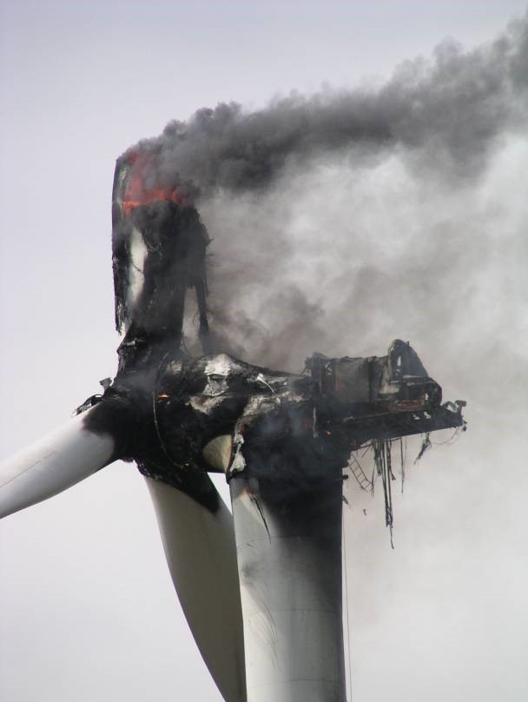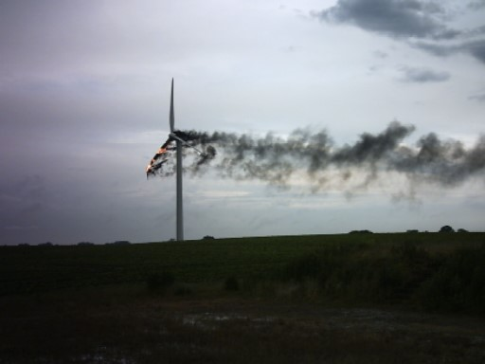

Fig. 1a+b: Fire after lightning struck a 2 MW wind turbine in 2004 (Image source: HDI/Gerling)

The burning blade stopped at an upright position and burned off completely little by little. Burning parts of the blades that fell down caused a secondary fire in the nacelle.

Investigation of the cause of the loss showed that the fire in the blade was caused by a bolted connection of the lightning protection system that was not correctly fixed. The electric arc between the arrester cable and the connection point led to fusion at the cable lug and to the ignition of residues of hydraulic oil in the rotor blades. The nacelle, including the rotor blades, had to be referred to as a total loss. The upper part of the tower had also been destroyed due to the high temperature.

Operations were interrupted for approximately 150 days; the total loss amounted to approximately EUR 2 million. Deficient lightning arrester installations in the rotor blades of wind turbines have already caused several fires.

Fire damage caused by machinery breakdown
The nacelle of a 1.5 MW wind turbine completely burned out after the slip ring fan of the doublefed induction generator had broken. Sparks that were generated by the rotating fan impeller first set the filter pad of the filter cabinet on fire and then the hood insulation. The damage to property amounted to EUR 800,000.

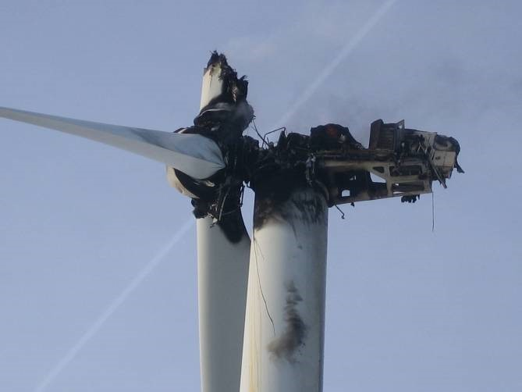

Fig. 2: Burnt down nacelle of a 1.5 MW wind turbine (Image source: Allianz)

Fire damage caused by failure in electrical installations
Low voltage switchgear was installed within the nacelle of a 1 MW wind turbine. The bolted connection at one of the input contacts of the low-voltage power switch was not sufficiently tightened. The high contact resistance resulted in a significant temperature increase at the junction and in the ignition of adjacent combustible material in the switchgear cabinet. The fuses situated in front did not respond until the thermal damage by the fire was very severe. Control, inverter and switchgear cabinets that were arranged next to each other suffered a total loss. The interior of the nacelle was full of soot. Despite the enormous heat in the area of the seat of fire, the fire was unable to spread across the metal nacelle casing. The damage to property amounted to EUR 500,000.

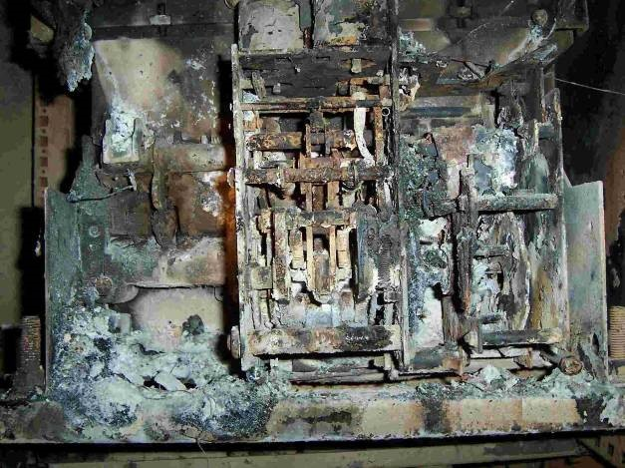

Fig. 3: Power switch of a 1 MW wind turbine – destroyed by fire (Image source: Allianz)

Fire damage caused by resonant circuits
Several areas of damage were caused by parallel resonant circuits existing of capacitors (reactive power compensation or line filters) and inductances (generator, turbine transformer, energy supply companies, power chokes, etc.) which had not been taken into account when designing the turbine. The resonant circuits were activated by harmonics. Resonance phenomena generated high currents which damaged capacitors. Breakdowns in the dielectric of the already damaged capacitors – usually caused by overvoltage events – resulted in an increase of power loss and in some cases in the bursting of the capacitor containers. The resulting fires caused total loss to the reactive power compensation or to the inverter. Protective circuits through discharge resistors and choking were not available in these cases.

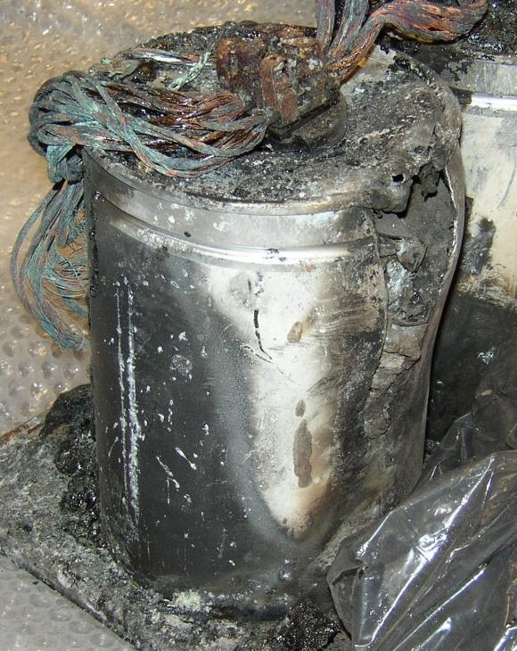

Fig. 4: Burst pressure vessel of a line filter capacitor (Image source: Allianz)

Causes of loss by fire
Based on loss experiences of insurers, the following paragraphs will provide an overview of typical causes of an outbreak and spread of fire.
The causes of loss by fire are basically the same with offshore wind turbines and with onshore wind turbines. However, due to stronger exposure to environmental conditions and currently still quite limited experiences, the probability of technical defects and thus the risk of fire are probably higher with offshore wind turbines than with onshore wind turbines.

Increased risk of an outbreak of fire caused by lightning strike
A large number of cases of loss have shown that lightning strikes are among the most frequent causes of fire at wind turbines. The special risk of lightning strikes arises from the exposed locations (often located at a higher altitude) and the large height of the structure, amongst others.

The risk of fire increases particularly when the lightning protection system is not implemented and maintained properly. If the contact resistance of the lightning conductor path is too high, thermal damage is almost inevitable in case of lightning strike.

Electrical installations
Besides lightning strikes, failures in electrical installations of wind turbines are among the most common causes of fire. Fire is caused by overheating following overloading, earth fault/short circuit as well as arcs. Typical failures include the following:
- Technical defects or components in the power electronics (e.g., switchgear cabinet, inverter cabinet, transformer) that have the wrong dimensions
- Failure of power switches
- Failure of control electronics
- High contact resistance due to insufficient contacts with electrical connections, e.g., with bolted connections at contact bars
- Insufficient electrical protection concept with respect to the identification of insulation defects and selectivity of switch-off units
- No or no all-pole disconnection of the generator in case of failure/switch-off of the turbine
- Missing surge protection at the mean voltage side of the transformer
- Resonances within RC (resistor-capacitor) circuits (line filter, reactive power compensations)

Hot surfaces
If all aerodynamic brakes fail, mechanical brakes, which slow down the rotor, can reach temperatures that result in an ignition of combustible material. In case of such an emergency braking, flying sparks that are caused by mechanical brakes without covers also pose a high risk since flying sparks might also ignite combustible material that is further away. Defects at turbines or parts thereof, e.g., leakage of the oil systems and dirt, increase the risk of fire.

Other risks exist in case of overloading and poor lubrication of generator and gearbox mountings. In these cases the mountings get too hot. Combustible material and lubricants can ignite when they get in contact with hot surfaces. For example, if a failure at the mounting leads to rubbing of rotating components, the flying sparks resulting might cause a fire.

Work involving fire hazards
Work involving fire hazards relating to repair, assembling and disassembling work, e.g., welding, abrasive cutting, soldering and flame cutting, are a frequent cause of fire. Due to the high temperatures that occur during these activities, combustible material that is in the close or further environment of the working site may get on fire. Welding, cutting and grinding sparks are particularly dangerous since they can ignite combustible material that is at a distance of 10 m and more from the working site. Many fires break out several hours after the completion of work involving fire hazards.

Fire load
A wide variety of combustible materials that can cause an outbreak of fire and result in a fast spread of fire are being applied in the nacelles of wind turbines, e.g.,
- internal foam sound insulation of the nacelle, in parts contaminated by oil-containing deposits,
- plastic housing of the nacelle (e.g., GRP),
- oil in the hydraulic systems, e.g., for pitch adjustments, braking systems; if there are any damages or if the temperature is very high, high pressure in the hydraulic pipes can cause the hydraulic oil to escape finely nebulized, and this can cause an explosive spread of the fire,
- gearbox oil and other lubricants, e.g., for the generator bearings, • transformer oil,
- electrical installations, cables, etc.

Hydraulic oils, oil-containing waste that has not been removed, and lubricants, which are stored in the nacelle are additional fire loads and not only increase the general risk of fire unnecessarily, but also increase the risk of a spread of fire.

Strongly limited accessibility for fire fighting
With the currently available means, fire brigades do not have any chance to fight a fire at wind turbines if the nacelles or rotors are affected. The fire brigade’s turntable ladders do not reach the necessary height. Therefore, a nacelle that is on fire cannot be reached from the outside. The way towards the nacelle via ladder or elevator of a burning turbine is also perilous for fire fighters, and therefore, this is also not an option. Fire fighters are exposed to the risk of getting hurt by burning parts falling down even on the ground in the surroundings of the turbine. Due to the fact that there is an increasing trend to integrate transformers into the nacelle, fire fighters also have to pay attention to high-voltage power lines.

With respect to the fires that have occurred so far, the fire fighters’ work has been restricted to the protection of the location of the fire and the prevention of secondary fires on the ground or at adjacent installations.

In case offshore wind turbines are affected by fire, manual fire fighting from the outside is not to be expected.

Restrictions with respect to maintenance (servicing, inspection and repair)
Due to the cramped confines in wind turbines and the limited accessibility of the turbines’ components it is very difficult for the maintenance staff to conduct maintenance work appropriately and professionally. The quality of work might suffer from the difficult conditions.

Protection targets and protection concept
Experience has shown that in order to ensure the required fire safety it is always sensible to prepare a fire protection concept after consulting with all parties involved, the insurer in particular. According to this concept, all structural, turbine-specific and organizational protection measures shall supplement each other in terms of risk and protection targets, and any kind of mutual impairment of protection functions shall be excluded. The risks of an outbreak of fire shall be limited effectively by the following, amongst others:

- Use of non-combustible or difficult to ignite materials
- Early fire detection with automatic fire detection/alarm systems
- Frequent as well as professional maintenance
- Automatic switch-off of the turbines and complete disconnection from the power supply system in the case of fire risks being identified
- Training of employees with respect to handling dangerous situations, and in-house regulations with respect to work involving fire hazards, e.g., welding permit procedure.

In order to limit the risks of fire spread,
- early fire detection with automatic fire detection/alarm systems and
- fire fighting with automatic fire extinguishing systems have proven to be effective in addition to the use of fire resistant components and shall be installed.

Moreover, an emergency plan in order to limit potential damages shall be prepared. The plan must
be kept updated. Implementation of this plan should be ensured by means of staff training that
take place on a regular basis | .

Highly acknowledged rules of technology have been prepared for planning, implementation and operation of these fire precautions as well as for assuring their quality. The present European Guidelines shall be used, harmonised on the special boundary conditions of wind turbines (e.g. climate and temperatures in and outside of the nacelle, etc.).

In addition, changes of the conditions in the power train can be detected early on by means of condition monitoring systems (CMS), and thus the risk of an outbreak of fire due to such changes can be prevented (see also Germanischer Lloyd (GL), guideline for the certification of condition monitoring systems for wind turbines).

In case existing wind turbines shall be revised in terms of fire protection according to this guideline, it should be clarified in advance with authorities, the manufacturer of the turbine, the certifying body of the turbine, and the insurer, amongst others, whether a renewal of the official approval and certification of the turbines might be required due to retrofitting. It is generally sensible to grade the required scope of protection depending on the risk parameters. In doing so, the following have to be taken into account, e.g.,
- loss experiences with different types and components of turbines,
- capacity of the turbine in MW,
- structure of the wind turbine and arrangement of risk components,
- location of the turbine (onshore or offshore),
- amount insured, and
- amount of deductibles.

The required scope of protection for wind turbines may vary depending on the object-specific risk and the risks to be insured, which can also significantly determine the insurability according to the insurers’ experience.
Table 1 shows an example of the grading of protection measures by means of so-called protection levels (independent from e.g. the location or capacity of the wind turbine because of the low influence out of that). It is possible to agree upon a different grading of protection measures after consulting with the insurer. Lightning and surge protection according to paragraph 5.1.1 as well as general electrical protection measures according to paragraph 5.1.2 are generally implied.

Thinking about losses due to business interruption, the protection level of a wind energy plant can vary depending on the fact, if the plant is part of wind energy park or if it is a single plant.

Moreover, in case the automatic early fire detection system which serves to monitor the installation is activated, the wind turbine shall be automatically shut down and disconnected completely from the power supply system.

Table 1: Examples of protection levels
Protection measures as modules | Protection levels
 | 0 | 1 | 2 | 3
Fire detection system – installation and room monitoring | x | x | x | x
Fire extinguishing systems – installation protection
Control, inverter and switchgear cabinets (LV/MV) |  | x | x | x
Transformer |  |  | x | x
Hydraulic system |  |  |  | x
Slip ring housing of the generator |  |  |  | x
Fire extinguishing systems – room protection
Raised floors with oil sump and cable and electrical installation |  |  | x | x
Nacelle with generator, transformer, hydraulic systems, gearbox, brake, azimuth drive |  |  |  | x
Hub with pitch drive and generator, if applicable |  |  |  | x
Tower base/platform with existing installations, if applicable |  |  |  | x

Evidence of the effectiveness and reliability of turbine-specific fire precautions can be provided through use of components and systems approved by an independent third party certification body.

The overall fire protection concept for wind turbines shall be checked by an independent, acknowledged body after consultation with the insurer, if applicable, with respect to whether an adequate protection against risk is ensured for the respective wind turbine.

Protection measures
The following explanations represent an instruction for specifying fire precautions in the framework of a turbine-specific fire protection concept.

Reducing the risks of an outbreak of fire
Potential risks of fire and explosions should be identified and important aspects of fire protection should be taken into account during the planning and construction phase.

Lightning and surge protection
Wind turbines have to be equipped with comprehensive lightning and surge protection that is adjusted to the individual type of turbine. Systems for lightning and surge protection have to be planned, build and operated like other components of the wind turbine according to the acknowledged rules of technology.

In order to plan systems for the purpose of lightning and surge protection it is necessary to do a risk evaluation or to assume the highest possible risk according to IEC 62305 (lightning protection level I = LPL I). When evaluating the risk, the possible lightning paths, e.g., from the rotor blade via hub, nacelle and tower to the foundation, have to be recorded and observed exactly.

Lightning and surge protection have to cover the nacelle and rotor blades, in particular, as well as any kind of electrical installations or equipment, including cable lines that are relevant for the operation and safety.

Fig. 5: Allocation of lightning protection zones (LPZ) at wind turbines with metal nacelle (Source:
Phoenix Contact)
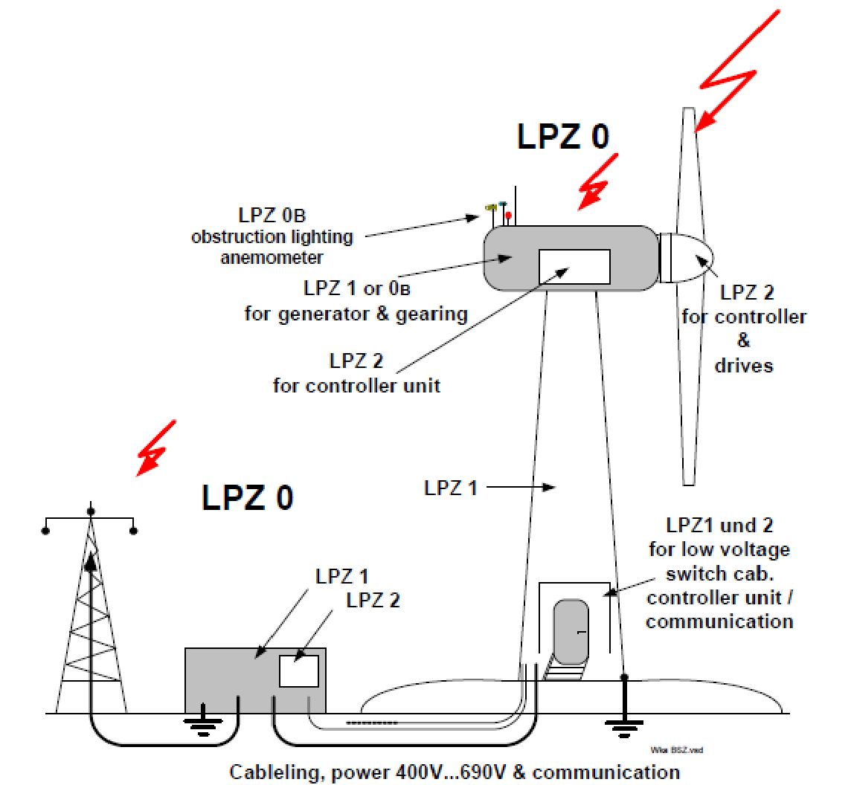

Attention has to be paid to the allocation of the wind turbines’ components to individual lightning protection zones depending on the disturbance variable through partial lightning currents and switching surges that may be expected.
In order to design the turbines’ components for lightning protection, the relevant protection level of the turbines has to be defined. In doing so, at least protection level II should be chosen for a comprehensive lightning protection system for wind turbines.

However, as is the case with high towers, low current lightning also poses a challenge to wind turbines. "Therefore, protection areas at the tower, nacelle, hub and rotors – also rotating – should be identified by means of the so-called rolling sphere method.

Minimizing the risk of electrical systems
The protection technology, which comprises any electrical installations as well as measures for identifying power system faults and other abnormal operating conditions at wind turbines and the associated peripheral systems, shall be state of the art and comply with current national standards. Its main task is to identify flaws selectively and to switch off faulty parts of the power system or individual electrical equipment, e.g., transformer, line, generator, immediately. There is currently no sufficient protection in most of the older wind turbines.

Graded protection concepts which create mutual reserve protection through the integration of the protection systems of adjacent equipment provide the best possible protection against fire. This applies to the overall system planned by the plant’s manufacturer and the wind farm developer and for components which the planner creates on his own according to the plant manufacturer’s requirements. For example, with the respective configuration, the risk of fire arising from an arc in a low-voltage switchgear can be prevented despite failure of the power switch. Appropriate arcing fault protection systems detect the fault and open the medium-voltage switch at the transformer’s high-voltage side. Thus, the faulty component is being selectively disconnected from the power system. The same goes for high-resistance earth faults which emerge between low-voltage power switch and transformer.

The protection systems have to ensure immediate, controlled shutdown of the wind turbine with subsequent all-pole (medium-voltage side) disconnection from the power system. The activating of protection systems shall send a fault message to the remote control.

Minimizing combustible material
Hydraulic and lubricant oils should be chosen according to the following characteristics: in addition to their technical features required, they should preferably be non-combustible or have a high flash point which is significantly above the operating temperatures of the systems.

The application of combustible material, e.g., foamed plastics such as PUR (polyurethane) or PS (polystyrene) as insulating material or GRP (glass-reinforced plastics) for coverings and other components shall be avoided for fire protection reasons.

If the application of non-combustible material is impossible in individual cases, the material used shall at least be of low flammability. Moreover, closed-cell material with washable surface shall be used in order to avoid intrusion of impurities, oil leakage, etc., which otherwise would increase the risk of fire in the course of the operating time.

Cables and lines shall be used that preferably
- produce only slightly poisonous and corrosive decomposition products,
- do not cause much smoke and cause only little pollution of the rooms and content, • do not support fire spread
when they burn.

When working with components that contain flammable liquids or oils, it must be made sure that
leaking fluids are collected safely, e.g., by installing trays or be applying non-combustible oi |  | l
binding agents. Leakages are to be removed immediately | .

After the work has been completed, the collected fluids must be disposed properly, and
contaminated oil binding agents must be removed from the system.

Combustible materials as well as auxiliary materials and operating materials are not allowed to be
stored within the wind turbine | .

Avoidance of possible ignition sources
Possible ignition sources include, e.g.:
- Lightning current
- Flying sparks occurring during the brake application of a mechanical brake
- Short circuit and arc as well as resonant circuits with electrical devices and systems
- Hot surfaces, e.g., bearings, brake disk
- Spontaneous ignition through dirty cleaning cloths (e.g., oil, solvents).

Components and the before mentioned possible ignition sources must be arranged and executed so that combustible material is not set on fire during normal operation or in case of malfunctions. In order to ensure this it is necessary to install coverings, baffle plates or the like that are made of non-combustible material. Electrical equipments shall be secluded.

Dirty cleaning cloths must be disposed when leaving the wind turbine.

Work involving fire hazards
Work involving fire hazards relating to repair, assembling or disassembling work shall be avoided.
If this is impossible it must be checked whether so-called cold procedures (sawing, screwing, cold
bonding, etc.) can be used instead | .

If work involving fire hazards cannot be avoided it is mandatory to take fire precautions prior, during and after the work in order to avoid an outbreak of fire or to detect a fire early on, and to fight it effectively.
For more information on hot works see CFPA Guideline No 12:2006

Maintenance (servicing, inspection and repair) of mechanical and electrical systems
Fires caused by technical defects at electrical and mechanical systems represent the most frequent
causes of loss. Means to reduce such kind of loss include regular maintenance according to the
manufacturer’s instructions (maintenance manual) and inspections of the systems as well as timely
repair of identified deficiencies | .

One tool serving this purpose, which is already available at many wind turbines, is systems that
automatically monitor important operating parameters such as the pressure and temperature of
mechanical and electrical systems such as transformer, generator winding, gearboxes, hydraulic
systems or bearings. If the limiting value is exceeded or is not reached, there must be some kind of alarm and finally an automatic shutdown of the wind turbine. In the course of type testing and certification processes of wind turbines, the monitoring of operating parameters is usually taken into account.

Electrical installations and monitoring systems in wind turbines have to be examined by experts on
site on a regular basis. At least every five years the gas and oil of the transformer insulation liquid
has to be analyzed | .

The analysis allows drawing a conclusion on the quality of the insulating oil and provides insights with respect to possible electrical defects, thermal overloads of the transformer, and the condition of the paper dielectric. If there are any defects in the active component of oil transformers, there is the risk of an explosion due to large electrical currents in connection with the insulating oil as fire load resulting from rapidly increasing internal pressure in the boiler. With respect to drytype transformers, the surface has to be controlled annually, and it has to be cleaned if necessary. Additional safety is provided by installations that serve the optical detection of partial discharge (spark switch).

Recurring inspections of electrical installations shall take place every two years.

In addition to these inspections, thermography at the electrical installations shall be examined on a regular basis, e.g., in the following areas:
- Connection areas and, if possible, contacts of the LV HRC fuse switch disconnectors
- Clamping devices and terminal strips, respectively, in distribution boards as well as switch terminal blocks and control terminal blocks
- Connection areas and, if possible, contacts of bus bars, contactors, capacitors, etc.
- Connection areas and surfaces of transformers, converters, and engines
- Power cable and cable bundles, respectively
- Surfaces of equipment which may pose a risk in case of heating.

Thermography inspections must be conducted by an approved expert (or comparable for countries,
where no certifying system exists) who disposes of the technical qualification and the required |  | o
measuring instruments. For more information on thermography experts see CFPA Guideline N
3:2003.

Mobile devices which are applied in the course of maintenance and repair have to be inspected on
a regular basis according to national requirements. Basically the recommended period is for that is
semi-annually; with an unique annually period in maximum in between | .

Lightning protection systems have to be inspected by an approved expert at regular intervals, the recommended period is in minimum annually. The inspection of the operability and condition of the lightning protection system includes a visual inspection of all air terminals and down conductors as well as measuring the contact resistance of the conduction path from the air terminals in the rotor blades to the ground terminal lug and measuring the ground resistance of the foundation.

The ground resistance of the foundation according to EN 62305-3 has to be measured in addition
in the course of this recurring inspection | .
The result of any maintenance activities must be documented in written form, e.g., in a maintenance specification sheet or a report book. Deficiencies that have been identified during maintenance or testing shall be fixed immediately. The correction of deficiencies has to be documented and reviewed.

No smoking
The entire area of the wind turbine must be declared a non-smoking area.

In order to ensure compliance with the ban on smoking, employees and external companies, if applicable, must be instructed accordingly, and sanctions shall be imposed in case of violation of the ban. “No Smoking” signs have to be put up clearly and permanently right at the entry areas of the wind turbine.

Training
Service staff and authorized external companies, if applicable, are to be instructed on the risks of fire at the wind turbine on a regular basis. Instructions may include, amongst others:
- Preventing risks of fire
- Functionality of fire protection systems and installations installed as well as how to handle them
- Correct behaviour in case of fire, e.g., alerting assisting bodies
- Correct use of fire extinguishers

It is recommended to conduct fire protection training, e.g., fire alarm tests, rehearsals for implementation of the emergency plan and evacuation of the nacelle, at regular intervals, and to involve the local fire brigade (for onshore wind turbines) into this training.

Prevention of forest fires
The possibility of the occurrence of a forest fire due to a fire in a wind turbine can be easily prevented by adopting the measures to clean up the area where the tower is located, so that its surroundings are free of all scrub and low bush that can contribute to the spread of fire in a strip of 25 m.

Fire detection and fire fighting
Operating conditions, first of all environmental and weather conditions, for fire protection systems at wind turbines may vary significantly. The following, in particular, has to be taken into account, e.g.,
- effects of atmospheres containing salt (offshore wind turbines),
- significant fluctuations of temperature due to the change of day and night, e.g., cooling down significantly at night and intensive sun shining at day,
- vibrations,
- oil deposits,
- air change und flow conditions in the nacelle.
•
Moreover, increased humidity, e.g., due to the location, and construction of the wind turbine may have an impact on the functionality of the turbine’s technology.

Therefore, effects that may have an impact on the effectiveness and reliability of the fire protection technology have to be taken into account already in the planning phase of the turbine, and they have to be adjusted to the different techniques and constructions applied at wind turbines.

Fire detection
In order to effectively limit fire and consequential loss, fires at wind turbines shall also be detected early on by automatic fire detection systems, in particular, since wind turbines are usually operated without any on-site staff. Distinction is basically made between room and installation monitoring.

On the one hand, automatic fire detection serves to inform the control unit, and on the other hand, it serves to activate the extinguishing devices automatically plus to shut down the wind turbine automatically, if necessary.

Room monitoring
The nacelle and parts of the tower in which the wind turbine technology is installed as well as external transformer and electric power substations are to be monitored by an automatic fire detection system.

Raised floors and ceiling voids or the like with fire loads, e.g., cables and other lines, have to be included in the monitoring.

Fire detectors have to be qualified for the area to be monitored and for the fire characteristics to be expected. Special environmental conditions, e.g., temperature, humidity, and vibrations, have to be taken into account when selecting and operating fire detectors; detector heating may be applied, if applicable. Fire detectors with the characteristic “smoke” should preferably be applied for the monitoring in wind turbines.

Installation monitoring
Applications which are operated, e.g.,
- encapsulated,
- forced-air-cooled and
- in rooms with high air change rate,
e.g., switchgear and inverter cabinets, monitoring of installations is required in addition to the monitoring of rooms. Also for the monitoring of installations, “smoke” should preferably be used as fire characteristic.

The fire detectors’ qualification is to be reviewed for each individual turbine depending on the respective operating conditions at the wind turbine and after consulting with the system’s owner (manufacturer). Attention is to be paid to optimal fire detection and limitation of false alarms or nuisance alarms, in particular.

Mineral oil transformers shall be protected with so called “Buchholz” relays (pre-alarm and main alarm with shutdown) in addition to room monitoring fire detection and temperature monitoring.

Automatic early fire detection only makes sense if at least the following reactions are triggered in case of activation:
- Fire alarm with alarm signal being forwarded to a continuously manned post
- Shutdown of the wind turbine and complete disconnection from the power supply system
- Activation of the installation and room protection extinguishing system with two-detector dependency (according to EN 54, type B)
Detection systems that allow different alarm thresholds offer the possibility to induce gradual reactions depending on the alarm thresholds, e.g., pre-alarm, main alarm, etc..

When selecting a fire detection system it is important to pay attention to the fact that the maintenance required can be ensured in a feasible way given the location and the little space in the nacelle.

Table 2: Support information on the selection of fire detectors for monitoring rooms and installations
Type of detector  Room/Installation | Smoke detector |  |  | Heat detector  (index “R” according to DIN  EN 54-5) |  | Flame detector |  | Multi-sensor smoke detector
 | Pointshaped | Multipointshaped | Linear | Pointshaped | Linear | IR | UV | Smoke and heat | Smoke and  CO
 | Scattered light | Aspirating | Light beam
Nacelle with transformer, including hub and raised floors | - | + | - | - | - | - | - | - | -
Central electric power substation, switch cabinet rooms | + | + | + | + | + | - | - | + | +
Tower base/platform with available installations, if applicable | - | + | - | + | - | - | - | - | -
Switchgear cabinets | + | + | - | - | - | - | - | + | -
Hydraulic systems | - | + | - | + | - | - | - | - | -
Transformer | - | + | - | Buchholz relay |  | - | - | - | -
+ basically suitable - not likely suitable
The data in this table refers to the basic suitability of several types of detectors with respect to functionality and general application conditions in the respective area of the wind turbine’s system; it serves as orientation guide and does not replace the required proof of suitability as well as the object-specific technical planning by appropriate specialist planners, e.g., certified installers. Type-specific characteristics of wind turbines and fire detection systems have to be taken into account after consulting with the insurer (e.g., Insurer engineering department) as well as the certifying body for wind turbines, if applicable (for more information on detection systems see also CEA-Specifications for the planning and installation of fire detection systems at www.cea.eu).

Fire fighting
Due to the fact that wind turbines are usually operated without any on-site staff and due to the time-consuming accessibility (in case of offshore wind turbines, in particular) and the strongly limited accessibility for fire fighters, effective fire fighting and thus limitation of loss can be ensured by automatic fire extinguishing systems.

Fire extinguishing systems
For the purpose of effective fire protection of wind turbines, automatic, stationary fire extinguishing systems shall be installed. Gas extinguishing systems as well as fine water spray systems are suitable (taking into account the special conditions given and the personal safety for the staff). These fire extinguishing systems can be used as installation- or room protection systems or as a combination of both. Installation protection systems have a selective effect on the device or component to be protected.

Before the fire extinguishing system is activated, the air-conditioning or ventilation system must be switched off automatically.

With respect to the application at wind turbines, extinguishing agents that are as residue-free, non-corrosive and non-electro conductive as possible, and which are suitable with respect to the prevalent environmental conditions at wind turbines (temperature, weather, impermeability of the installations and rooms to be protected) and the fire loads would be desirable. The following systems can be applied at wind turbines, depending on the intended type of application:
- Carbon dioxide (CO₂) fire extinguishing systems
- Inert gas extinguishing systems
- Fine water spray systems (water mist systems)
- Water spray systems (transformer and electric power substation, respectively).

Foam extinguishing systems can be used with every allowed kind of foam expansion.

Powder extinguishing systems as well as aerosol extinguishing systems cannot be recommended for application at wind turbines since they may cause consequential loss.

Suitability of automatic fire extinguishing systems for the purpose of room and installation protection is to be reviewed for each individual turbine by taking into account the respective operating conditions at the wind turbine and by consulting with the manufacturer. The following aspects, in particular, have to be taken into account:
- Effectiveness of extinguishing o Required extinguishing gas concentration and impingement of water, respectively o Application (residence) time for gas extinguishing systems (taking into account possible reignition)
  - Operating time of water extinguishing systems (taking into account an effective extinguishing success)
  - Impermeability of the room/pressure relief
- Storing of extinguishing agents (required quantity, weight, etc.)
- Volume/Required space
- Installation/Approval, implementation
- Maintenance
- Reliability (robustness of the systems with respect to susceptibility to failure in order to limit maintenance and inspection intervals)
- Cost

In order to ensure the effectiveness of gas extinguishing systems it is necessary to pay special attention to the planning requirements in connection with the pressure relief openings that will have to be provided. Moreover, attention should be paid to the required protection regulations with respect to the safety of persons when applying gas extinguishing systems.

Each extinguishing system has certain limits of applicability or advantages and disadvantages, respectively. Therefore, the suitability of the chosen extinguishing system has to be reviewed for each individual application because of the large number of possible parameters and the given conditions that are to be adhered to in order to ensure the effectiveness of extinguishing.

Fire detection, alarm, alarm control, triggering of a fire extinguishing system and its monitoring is usually done by a fire detection system approved for this purpose (see paragraph 5.2.1).

Fire extinguishers
In order to fight initial fires it is necessary to provide a sufficient number of appropriate and operational fire extinguishers in accordance with national standards. They shall be available in all rooms in which a fire may occur, amongst others in the nacelle, in the tower base and in the electric power substation which might be arranged externally.

The extinguishing agent is to be adjusted to the existing fire loads. Due to the negative impacts of
extinguishing powder on electrical and electronic equipment it is recommended to refrain from
using powder extinguishers if possible | .

At least one 6 kg CO₂ fire extinguisher and one 9 l foam fire extinguisher must be installed in the
nacelle (paying attention to the risk of frost). And at least one 6 kg CO2 fire extinguisher must be
installed at the intermediate levels and at the tower base in the area of the electrical installations
each | .

Fire extinguishers have to be inspected by an expert at regular intervals, at least every two years.
In case the extinguisher is subject to high stress, e.g., due to environmental impacts, shorter time
intervals might be required as determined by a risk assessment | .
Table 3: Support information on the selection of fire extinguishing systems for room and installation protection
Extinguishing systems  (extinguishing agents)  Room/Installation wind turbine | Gas extinguishing systems |  | Water extinguishing systems |  |  |  | Other extinguishing systems
 | CO₂ (high pressure) | Inert gases | Sprinkler | Water spray | Fine spray | Foam | Powder | Aerosol¹⁾
Room protection, e.g.,
Nacelle with generator, transformer, hydraulic systems, gearbox, brake, azimuth drive | + | + | + | + | + | - | - | -
Hub with pitch drive and generator, if applicable | + | + | + | + | + | - | - | -
Raised floors with oil sump and cable and  electrical installations | + | - | + | + | + | + | - | -
Central electric power substation, switchgear rooms (without transformer) | + | + | - | - | + | - | - | -
Tower base/platform with available installations, if applicable | + | + | + | + | + | - | - | -
Installation protection, e.g.,
Control, inverter, switchgear cabinets (LV/MV), closed | + | + | - | - | + | - | - | -
Transformer | + | - | - | + | + | - | - | -
Control, inverter, switchgear cabinets (LV/MV), open | + | - | - | - | + | - | - | -
Hydraulic system, open | + | - | + | + | + | + | - | -
+ basically suitable - not likely suitable
The data in this table refers to the basic suitability of several fire extinguishing systems with respect to their functionality and general application conditions in the respective area of the wind turbine’s system; it serves as a first orientation guide and does not replace the required proof of suitability as well as the object-specific technical planning by appropriate specialist planners, e.g., certified installers. Type-specific characteristics of wind turbines and fire extinguishing systems have to be taken into account after consulting with the insurer (e.g., Insurer engineering department) as well as the certifying body for wind turbines, if applicable (for more information on fire fighting systems see also CEA-Specifications for the planning and installation of the respective fire extinguishing systems at www.cea.eu).
¹⁾ There is currently no empirical information available on the reliability and effectiveness concerning the application of aerosol

extinguishing systems

Fault monitoring
Fire detection systems and fire extinguishing systems have to be monitored constantly in order to
ensure their operational reliability | .

Failures with traditional fire protection systems, e.g., failure of individual fire detectors or leakage at the extinguishing agent stock or shrinkage of the extinguishing agent supply will be displayed directly at the fire protection system by means of an error message. Due to the operation without on-site staff and the remote location of wind turbines and the resulting non-identification of possible failures at the fire protection system on site, forwarding of all error messages to a permanently manned post (control post) is required. This control post will then initiate immediate recovery of the unlimited operational readiness of the fire protection system.

Any events have to be documented in the report book.

Deactivation of safety installations
Fire protection systems may only be deactivated for a short period of time after consulting with the
persons in charge in case of compelling requirements | .

When deactivating a fire protection system it must always be checked whether there is any
obligation to inform the insurer because of the increase of risk | .

Sufficient backup measures must be provided for the duration of the deactivation, e.g.,
- ensuring fire alarm/call,
- providing suitable fire fighting equipment (see also paragraph 5.2.2).

After completion of the work all safety and fire protection installations that had been deactivated have to be set in operation again. The operating condition of the systems must be visible at the entrance area of the wind turbine and at the primary control unit.

Measures for limiting loss
Experience has shown that it is sensible to prepare an emergency plan for the case of fire. This plan shall in particular include the following specifications:
- Determination of the personnel that is on standby in the internal work schedule for the existing wind turbines (ensuring “twenty-four-seven” standby of the control post)
- Preparation and introduction of an internal, written schedule in case of fire in which any immediate measures to be taken by the employee in charge are included. The schedule should include the following issues:
  - Provision of local emergency telephone codes o Notification of fire brigade and police o On-site support by fire brigade and police
  - Shutdown of the wind turbine and disconnection from the power supply system, if required o Reporting fire damage immediately to the insurer
- Preparation of an emergency plan for the case of fire after consulting with fire brigades and police offices in charge and with the insurer, if applicable. The following issues should be included in an emergency concept:
  - Leave internal standby schedule and a respective standby telephone number with the police and fire brigade
  - Information and briefing, if applicable, of the competent rescue forces (fire brigade, police) on:
    - Structure of the wind turbine
    - High-voltage components and combustible materials within the wind turbine
    - Route description and access to the wind turbine o Specification of immediate measures that have to be taken in case of a fire alarm/call, e.g., disconnection of the wind turbine from the power supply system
  - Information on the preparation of an emergency concept in case of fire for each wind turbine, e.g., appropriate emergency vehicles and necessary protective clothing as well as protection zone around the wind turbine affected

The following information shall be easily accessible by everyone at the wind turbine:
- Identification number and emergency telephone number
- Code of conduct in case of fire at the wind turbine, e.g., notification of the fire brigade and seeking shelter as well as observing other safety instructions.

With respect to offshore wind farms alternative or supplementary measures might be required for
emergency planning due to special conditions | .

Quality assurance
Experience has shown that the functions of technical installations, of safety-related installations, in particular, can be ensured for their period of operation or service life if appropriate measures for the purpose of quality assurance have been taken with respect to planning, installation and operation. This includes, amongst others:
- Generally accepted standards of technology as fundamentals of planning
- Application of products and systems with proven quality, which might be subject to internal controls and external monitoring, if applicable
- Qualification of specialist planners and installation experts
- Acceptance inspection and recurring inspections by approved experts
- Regular and proper maintenance by specialist companies and trained in-house specialized staff, respectively
- Documentation and monitoring of the maintenance to be performed

These measures shall also be considered and reviewed in the course of type testing or certification
of the wind turbine by independent approval bodies | .

Guidelines
Guideline No 1:2002 F - Internal fire protection control
Guideline No 2:2007 F - Panic & emergency exit devices
Guideline No 3:2011 F - Certification of thermographers
Guideline No 4:2010 F - Introduction to qualitative fire risk assessment
Guideline No 5:2003 F - Guidance signs, emergency lighting and general lighting
Guideline No 6:2004 F - Fire safety in residential homes for the elderly
Guideline No 7:2011 F - Safety distance between waste containers and buildings
Guideline No 8:2004 F - Preventing arson – information to young people
Guideline No 9:2005 F - Fire safety in restaurants
Guideline No 10:2008 F - Smoke alarms in the home
Guideline No 11:2005 F - Recommended numbers of fire protection trained staff
Guideline No 12:2006 F - Fire safety basics for hot work operatives
Guideline No 13:2006 F - Fire protection documentation
Guideline No 14:2007 F - Fire protection in information technology facilities
Guideline No 15:2010 F - Fire safety in guest harbours and marinas
Guideline No 16:2008 F - Fire protection in offices
Guideline No 17:2008 F - Fire safety in farm buildings
Guideline No 18:2008 F - Fire protection on chemical manufacturing sites
Guideline No 19:2009 F - Fire safety engineering concerning evacuation from buildings
Guideline No 20:2009 F - Fire safety in camping sites
Guideline No 21:2009 F - Fire prevention on construction sites
Guideline No 22:2010 F - Wind turbines – Fire protection guideline
Guideline No 23:2010 F - Securing the operational readiness of fire control system
Guideline No 24:2010 F - Fire safe homes
Guideline No 25:2010 F - Emergency plan
Guideline No 26:2010 F - Fire protection of temporary buildings on construction sites

