CFPA-E No 20:2012 F

Fire safety in camping sites

FOREWORD

The European fire protection associations have decided to produce common guidelines in order to achieve similar interpretation in the European countries and to give examples of acceptable solutions, concepts and models. The Confederation of Fire Protection Associations in Europe (CFPA
- has the aim to facilitate and support fire protection activities across Europe.

The market imposes new demands for quality and safety. Today fire protection forms an integral part of a modern strategy for survival and competitiveness.

The guideline is primarily intended for the public. It is also aimed at the rescue services, consultants, safety companies and the like so that, in the course of their work, they may be able to help increase fire safety in society.

The draft of this guideline was produced by The Norwegian Fire Protection Association and the author was Øyvind Engdahl from Norway. This version has been revised by Kjell Schmidt Pedersen from Norway.

This guideline has been compiled by the Guidelines Commission and adopted by all fire protection associations in the Confederation of Fire Protection Associations Europe.

These guidelines reflect best practice developed by the countries of CFPA Europe. Where the guidelines and national requirements conflict, national requirements must apply.

Copenhagen, 22 March 2012 Stockholm, 22 March 2012
CFPA Europe Guidelines Commission

Jesper Ditlev Tommy Arvidsson
Chairman Chairman

  - Introduction 4
  - Scope 4
  - Definitions 4
  - Risks involved and prevention measures to be taken 5
    - General 5
    - Fire precaution guidelines for the camping guests 5
    - Fire precaution rules for the owner of the camping site 5
    - Access for the fire brigade or rescue units and the required water supply 7
    - Caravans and campers 7
  - References 7
  - European guidelines 7

Introduction
Fires and explosions in caravans are feared incidents.
So far the European communities have not experienced devastating fires in camping sites as such, but the risk exists that a large fire might occur. The risk includes danger of fatalities and injuries. There was, however, a large fire with many fatalities in the camping site of Los Alfaques in Spain in 1978 with 210 fatalities. This was due to a truck carrying a liquefied propane tank, which ruptured due to overfilling and exploded beside the camping site. This must be considered as a transport incident with highly inflammable substance.
Fires in camping tents and caravans do occur regularly, but if they were to occur at night-time in an overcrowded camping-site, fatalities and injuries and heavy material damage might be the result.
This guideline is based on a review of the existing different European rules for camping sites. The Finnish rules and guidelines (ref.1) are extensively used as basis. This guideline does not apply to areas used for the permanent siting of mobile homes.

Scope
The aim of this guideline is to prevent injuries, loss of life and loss of property in fires in on camping sites. It recommends fire precaution measures to be taken by the owner of the sites, and measures the guests may take to protect themselves from fires and explosions when they are visiting a camping site.
These precautions rules will also be useful to prevent fires in caravans when they are on the road. Note: This guideline is not applicable to temporary assembly tents like circus tents, and areas temporary used for concerts and festivals.

Definitions

Caravan | A mobile wagon which may be towed by a vehicle and used for dwelling purposes especially on vacations
Camper | A self propelled vehicle used for overnight and dwelling purposes.
Camping site | A ground prepared for caravans, cars and tents. The site imay be guarded and also contain reception, washing-rooms with toilets, kiosks and sometimes leisure equipment.
Camping unit | Caravan or camper including possible tent or similar
Service building | A building intended for the operation of the site with reception, kiosk, shop, restaurant, wash-rooms or similar
Tent area | Part of the camping site where tents are pitched
Caravan area | Part of the camping site where caravans and campers are placed
Distance between tents | Distance between tents measured between the nearest tent wires
Safety area | Area in the camping site fixed to secure sufficient distance to prevent fire spread and secure access for rescue units

Risks involved and prevention measures to be taken

General
In the recent years camping sites have developed from simple grounds with no or few facilities to modern sites with high standards. Most sites have receptions, kiosks where you can buy a selection of the most common articles, toilets- and washing facilities, electric power and leisure equipment.
In recent years the camping sites have grown larger and might hold a large number of guests, tents, caravans and cars. All these together may create a risk of tragic fires with potential loss of lives and property. The probability of a fire to occurring is higher than in normal dwellings. This is due to the fact that:
    - Cooking is performed by use of propane burners in narrow spaces in combustible tents or caravans.
    - Tents, cars and caravans are made of combustible materials, often easily ignitable and the units are often placed with minimum distance to the neighbours.

Fire precaution guidelines for the camping guests
Injuries in connection with fires on camping sites are mostly caused by a fire in ones own camping unit. It is therefore first and foremost the individual camping guest who can influence the risk of a fire.
The risk will be reduced if the following precautions are taken into account:

    - There should be no use of open fires or glowing charcoal inside tents or near tent canvas. A tent will very quickly turn into flash-over. A knife ready accessible inside the tent can easily be used to create a way out.
    - Cooking appliances and field kitchens should not be fuelled unless the burner is put out and cold. If not, the bottle might catch fire and cause heavy injuries.
    - Grills, cooking appliances and similar must not be placed nearer than 1 meter to tent canvas.
    - All flexible tubes and couplings to the gas burner should be checked for leakage and that it is in good order.
    - All inhabitants should be aware of the location of the fire fighting equipments location and how a fire could be detected, and how the alarm should be raised.
    - The area between the tents should be kept clean and orderly and not be subject to storage of any objects.

Fire precaution rules for the owner of the camping site
The following requirements are recommended to be applied by the owners of camping sites:

    - The ground has to be arranged in such a manner that the free distance between each camping unit is a minimum of 3 meter; preferably 4 meter.
    - Portable fire extinguishers and/or fire hoses have to be placed around the site. The traveller distance to a fire extinguisher should not exceed 25 m.

    - Posters with fire precaution rules for the specific site and how to raise the alarm in case of a fire, have to be set up.
    - For every 1000 m2 it is recommended to make an open area of at least 6 meter width to the next section.
    - The owner of the camping site should consult the local building authority regarding camping units with more or less permanent annex constructed of combustible materials.
    - The owner is responsible for the security and should work out a rescue plan for the camping site.
    - Personnel shall preferably restrict the access to the camping site.
    - The camping site should be divided into blocks with 30 places for vehicles, maximum 60 tents, giving each car with trailer a space of minimum 100 m2 and each caravan a space of minimum 80 m2. The distance between the blocks should be minimum 8 meter.
    - Each block in the site should be divided into 3 units, each with space for 10 vehicles and with a minimum distance of 5 meter between each unit.
    - Minimum distance between a caravan and a neighbouring vehicle or awning should be 1.8 meter.

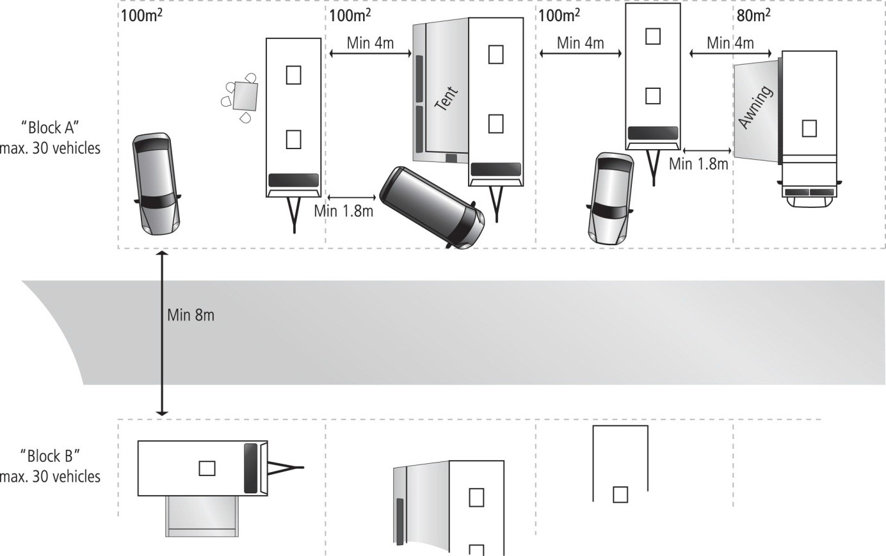

The figure shows the recommended distances between the blocks of a camping site and the recommended minimum distances between the different camping vehicles/units (from Ref.1).

Access for the fire brigade or rescue units and the required water supply
If a fire or accident should occur, it is important that the fire brigade have a good access to every part of the camping site. The fire brigade should be consulted to get the necessary information about the width, height and axle load of their fire engines and the minimum swing radius they can manage. On the site there must be sufficient parking space for the fire brigade vehicles.
The access routes must be free of obstacles and parked cars.

It is important to decide the maximum distance to the water supply (hydrants or cisterns). The water supply must give the necessary quantity of water at adequate pressure.

Caravans and campers
Caravans and campers which are used for staying overnight should be equipped with a smoke alarm and an extinguisher containing at least 2 kg of dry powder.
The vehicles heating and cooking appliances should be regularly inspected by a qualified person.

References
- Fire safety requirements for camping areas in Finland. SF-Caravan.
- Campingplasser og gjestebåthavner (camping sites and guest harbours) issued by Direktoratet for samfunnssikkerhet og beredskap, Norway.
- Brannsikker fritid: Camping (Fire safe leisure: Camping) issued 2004 by Norsk brannvernforening, Norway
- Tekniske forskrifter for forsamlingstelte, selskapshuse, salgsområder og campingområder, der ikke er omfattet av campingreglementet, issued 18th October 2005 by Beredskapstyrelsen, Denmark

European guidelines
Guideline No 1:2002 F - Internal fire protection control Guideline No 2:2007 F - Panic & emergency exit devices Guideline No 3:2011 F - Certification of thermographers
Guideline No 4:2010 F - Introduction to qualitative fire risk assessment Guideline No 5:2003 F - Guidance signs, emergency lighting and general lighting Guideline No 6:2011 F - Fire safety in care homes for the elderly
Guideline No 7:2011 F - Safety distance between waste containers and buildings Guideline No 8:2004 F - Preventing arson – information to young people Guideline No 9:2012 F - Fire safety in restaurants
Guideline No 10:2008 F - Smoke alarms in the home
Guideline No 11:2005 F - Recommended numbers of fire protection trained staff Guideline No 12:2012 F - Fire safety basics for hot work operatives
Guideline No 13:2006 F - Fire protection documentation

Guideline No 14:2007 F - Fire protection in information technology facilities Guideline No 15:2012 F - Fire safety in guest harbours and marinas Guideline No 16:2008 F - Fire protection in offices
Guideline No 17:2008 F - Fire safety in farm buildings
Guideline No 18:2008 F - Fire protection on chemical manufacturing sites
Guideline No 19:2009 F - Fire safety engineering concerning evacuation from buildings Guideline No 20:2012 F - Fire safety in camping sites
Guideline No 21:2012 F - Fire prevention on construction sites Guideline No 22:2010 F - Wind turbines – Fire protection guideline
Guideline No 23:2010 F - Securing the operational readiness of fire control system Guideline No 24:2010 F - Fire safe homes
Guideline No 25:2010 F - Emergency plan
Guideline No 26:2010 F - Fire protection of temporary buildings on construction sites Guideline No 27:2011 F - Fire safety in apartment buildings

Guideline No 1:2012 N - Protection against flood

