CFP
A
-
E No
19:2009

Fire safety engineering concerning evacuation from buildings

FOREWORD

The European fire protection associations have decided to produce common guidelines in order to achieve similar interpretation in European countries and to give examples of acceptable solutions, concepts and models. The Confederation of Fire Protection Associations in Europe (CFPA E) has the aim to facilitate and support fire protection activities across Europe/work in European/work in the European countries.

The market imposes new demands for quality and safety. Today, fire protection forms an integral part of a modern strategy for survival and competitiveness.

This guideline is primarily intended for those responsible for safety in companies and organisations. It is also addressed to the rescue services, consultants, safety companies etc so that, in the course of their work, they may be able to help companies and organisations to increase the levels of fire safety.

The proposals within this guideline have been produced by the AIAS - Associazione professionale Italiana Ambiente e Sicurezza and the author is Tiziano Zuccaro from Italy.

This guideline has been compiled by Guidelines Commission and adopted by all fire protection associations in the Confederation of Fire Protection Associations Europe.

These guidelines reflect best practice developed by the countries of CFPA Europe. Where the guidelines and national requirement conflict, national requirements must apply.

Zürich, , 8 June 2009 | Stockholm, 8 June 2009
CFPA Europe | Guidelines Commission
Dr. Hubert Rüegg | Tommy Arvidsson
Chairman | Chairman

U1 U UIntroductionU ......................................................................................................................4
U2 U UScopeU................................................................................................................................4
U3 U UKey termsU..........................................................................................................................4
U4 U UPrescriptive approach to evacuationU ....................................................................................8
U5 U UEngineering approach: evaluation of evacuation safety conditionsU ........................................8 U5.1U UGeneralU .....................................................................................................................8
U5.2U UASET time quantificationU ............................................................................................9 U5.2.1U UGeneralU..................................................................................................................9
U5.2.2U UFire scenarioU ..........................................................................................................9 U5.2.3U UDesign fire scenarioU ..............................................................................................10
U5.2.4U UCalculation of design fire scenariosU ........................................................................10
U5.3U URSET time quantificationU ..........................................................................................12
U5.3.1U UGeneralU................................................................................................................12
U5.4U UConclusionU ...............................................................................................................13 U6 U _{U}European guidelinesU .........................................................................................................13
UAnnex A: Physiological effects of exposure to fireU ....................................................................14
UAnnex B: Definitions and characteristics of fire scenariosU ..........................................................17
UAnnex C: Considerations regarding the principal fire simulation softwareU ...................................22
UAnnex D: Calculations of RSET timeU ........................................................................................25
UAnnex E: Main characteristics of evacuation modelsU.................................................................42

1 Introduction 0_{B}
Saving human life is the most important objective in fire protection processes. Proper evacuation plans are essential to reach this objective. Two methods can be considered:

- The first is the prescriptive method which deals with the size and number of exits together with the maximum length of the escape routes;
- The second is the performance method which deals with the maximum time limit for evacuation.

The first method is based on three main points:
- density of people;
- flow of people;
- length and width of evacuation routes.

The second method establishes if the required evacuation time is less than available safety egress time.

2 Scope 1_{B}
The main scope of this guideline is to supply valid support for the evacuation strategy to allow occupants, anywhere within the structure, to be able to evacuate to a place of safety.

3 Key terms B₂

Accessibility
The accessibility of an item or a product related to a specific risk concerns the degree of proximity of the user to the item or product, where the risk can occur. Depending on the particular risk, this concept may concern a person or only a part of his/her body (e.g. hand, finger) or even a thing handled by a person, and applies to the possibility of contact (shocks, hot surfaces etc.) or critical distances (electrical shocks, radiation, etc.).

Actions
Actions which may affect the compliance of the works with the essential requirements are brought about by agents acting on the works or parts of the works. Such agents include mechanical, chemical, biological, thermal and electro-magnetic agents.

Active fire protection measures
Systems and equipment installed to reduce danger to persons and property by detecting fire, extinguishing fire, removing smoke and hot gases, or any combination of these functions.

Alarm
Sudden attention or action for protection of persons or property (ISO 8201, 1987)

Critical conditions for occupants
Limit values for temperature increase, oxygen depletion and concentration of toxic combustion gases that seriously endanger life safety in a certain time

Design fire scenario
A design fire scenario is a subsystem of fire scenarios and represents the most probable or onerous of them. They are a specific fire scenario on which an analysis will be conducted.

Emergency
Imminent risk of serious threat to person or property

Escape route
Route forming part of the means of escape from any point in a building to a final exit

Available safe egress time (ASET)
Calculated time available between ignition of a fire and the time at which tenability criteria are exceeded in a specific space in a building

Escape time
Calculated time from the ignition until the time at which all the occupants of a specified part of a building are able to reach place of safety

Evacuation time
In relation to the orderly movement of persons to a place of safety in case of fire or other emergency this is the interval between the time of a warning of fire being transmitted to the occupants and the time at which all of the occupants are able to reach a place of safety.

Exit (fire emergency)
Doorway or other suitable opening giving access towards a place of safety

Exit signs
Signs which clearly indicate an exit

Fire
A process of a combustion characterised by emission of heat accompanied by smoke and / or flame
Rapid combustion spreading uncontrolled in time and escape

Fire alarm installation
Combination of components for giving and audible and / or visible and / or other perceptible alarms of fire. The system may also initiate other ancillary actions.

Fire alarm, alarm of fire

Warning of a fire originated by a person or by an automatic device.

Fire rescue team
Public or private organisation with the aim of safeguarding life and fighting fires.

Fire compartment
An enclosed space in a building that is separated from other parts of the same building by enclosing construction having a specified period of fire resistance, within which a fire can be contained (or from which a fire can be excluded), without spreading to (or from) another part of the building.

Fire detector
Device which give a signal in response to certain physical and /or chemical changes accompanying a fire.

Fire door
A door or shutter, which, together with its frame and furniture as installed in a building, when closed is capable of meeting specified performance criteria.

Fire exposure
Thermal actions affecting the product.

Fire hazard
The potential to lose a life (or injury) and / or damage a property by fire.

Fire resistance
The ability of an element of a building construction to fulfil for a stated period of time the required load bearing function, integrity and / or thermal insulation specified in the standard fire resistance test.

Fire risk level
A function relating to the probability of fire causing a loss of life (or injury) and / or damage the property and the degree of harm caused.

Fire safety installations
Those installations concerned with services, alarm and detection, installations for means of escape, suppression and fire fighting equipment.

Fire scenario
A qualitative description of the course of a fire with time, identifying key events that characterise the fire and differentiate it from other possible fires It typically defines the ignition and fire growth process, the fully developed stage and the decay stage, together with the building environment and systems that will impact on the course of the fire.

Fire separating walls
A wall which separates two adjoining fire compartments.

Hazard analysis
Analysis carried out in order to evaluate the potential for loss of fire or injury and / or damage to the property.

Heat Release Rate
It is the rate at which the combustion reactions produce heat. The term burning rate is also often found. The heat release of a burning item is measured in kilowatts (kW).

Ignition
Initiation of combustion.

Movement time
The interval between the time the occupants make the first move and the time at which all of them are able to reach a place of safety.

Place of safety
A predetermined place in which persons are in no immediate danger from the effect of fire. Note: The place of safety may be inside or outside the building depending upon the evacuation strategy
Pre-movement time (Delay time to start)
Perception of the alarm + alarm interpretation + actions
Time interval between the warning of fire being given (by an alarm or by direct sight of smoke or fire) and the first move being made towards an exit.

Required safety egress time (RSET)
Calculated time required between ignition to detection and the time at which the evacuation is completed.

Smoke
A visible suspension of solid and /or liquid particles in gases resulting from combustion.

Smoke control door
Door set designed to reduce the rate of spread or movement of smoke during the fire.

Tenability criteria
Maximum exposure to hazards from a fire that can be tolerated without causing incapacitation.

Travel distance
Actual distance that needs to be travelled by a person from any point within a building to the nearest exit, having regard to the layout of walls, partitions and fittings.

Travel time
Time needed once movement as begun, for all of the occupants of a specified part of a building to move to a place of safety.

Type of occupancy
Subdivision of occupancies as a function of the age, awareness and mobility of the occupants, the type of fire load, and kind of activity of occupancy.

4 Prescriptive approach to evacuation 3_{B}

The majority of building codes and fire safety standards used today are prescriptive.
Prescriptive codes find their roots in the 19th century when major conflagrations created the need for specific building provision.
These codes have been made without effectively evaluating their adequacy, excessiveness, or conflicts with other requirements. This has created codes based on empiricism and experience, rather than a scientific understanding of fire. Many advances in fire safety have been made, but they have not been incorporated into everyday fire safety practice.

The traditional basis of prescriptive life safety design is concentrated on physical provisions for means of escape. Prescriptive methods on the evaluation of evacuation safety are based on:

- number of exits and maximum width and length of escape routes
- maximum time for evacuation
- managerial strategies to keep escape routes available and safe

The speed of occupants is assumed to be around 0.5 m/s and the time to escape about 3 -5 min. These values can be sufficient for the majority of the situations but in some cases they can be insufficient. In these situations an engineering approach is necessary.

5 Engineering approach: evaluation of evacuation safety conditions 4_{B}

5.1 General B₆
The performance method depends on the definition and comparison between the time available for occupants to reach a safe place, ASET (Available Safe Escape Time (the time at which tenability criteria are exceeded in a specific space) and the time occupants take to reach a safe place RSET (Required Safe Escape Time; it is the escape time).
The engineering approach points to set a margin of safety, given by the difference between ASET and RSET time. This margin of safety may be useful for the uncertainties in the prediction of the two times. Tsafety =TASET −TRSET

Performance method may be used in complex or innovative buildings where a prescriptive approach could not be good. The engineering approach can also evaluate and validate the solutions of prescriptive methods.
5.2 ASET time quantification B₇

5.2.1 General 10_{B}
ASET time quantification involves the ignition of fire and its spreading. It is the calculated time between the ignition of a fire and the time at which “tenability criteria” are exceeding because of smoke, toxic effluents and heat.

The endpoint of an ASET calculation is the time when conditions in each building enclosure are considered untenable.

Untenable conditions occur when it is predicted that an occupant inside or entering an enclosure is likely to be unable to save themselves (is effectively incapacitated) due to the effects of exposure to smoke, heat or toxic effluent.

The prediction of ASET requires estimation of the time-concentrations (or intensity) curves for the major toxic products, smoke and heat in a fire.

Information about physiological effects of exposure to fire is set out in Annex A.

5.2.2 Fire scenario B
Calculating ASET time depends on the nature of the fire, because combustion products make the space uninhabitable.

The concentration and nature of the combustion products and their spread depend on the following factors:
- Chemical elements of substances involved in combustion
- Maximum temperature
- Oxygen concentration

In general, all these factors influence combustion.

To calculate ASET time, it is necessary to make a detailed study of the fire, from the ignition to its development.

“Fire scenario” is what ISO PTDS 16733 - Fire safety engineering – selection of design fire scenarios and design fires reports to define the study of the fire.

In ISO PTDS 16733, “scenario” is a qualitative description of the course of a fire with time identifying key events that characterize the fire and differentiate it from other possible fires. It

typically defines the ignition and fire growth process, the fully developed stage, and decay stage as well as systems that impact on the course of the fire and the nature of the local environment.

5.2.3 Design fire scenario 12_{B}
To characterize fire scenarios, logical process to be followed may be summarized into three points:
- Taking into consideration all possible fire scenarios
- Defining design fire scenarios like the subsystems of the most probable and onerous possible scenarios
- Calculating design scenarios

The number of possible design scenarios is quite high. For this reason, their number is normally reduced using design fire scenarios.
Some information about the definition of fire scenarios and individuation of design fire scenarios are put in Annex B.

5.2.4 Calculation of design fire scenarios 13_{B}
A design fire is characterized from the fire growth of building products and building content; the fire growth could be defined by the actual HRR history of the products or it could be a generalized HRR history of a product category. The definition of HRR represents the “identity card” of the fire and is the necessary factors to both calculate the rate of smoke production and the input parameters for fire simulation software.

Figure 1 Example FDS output

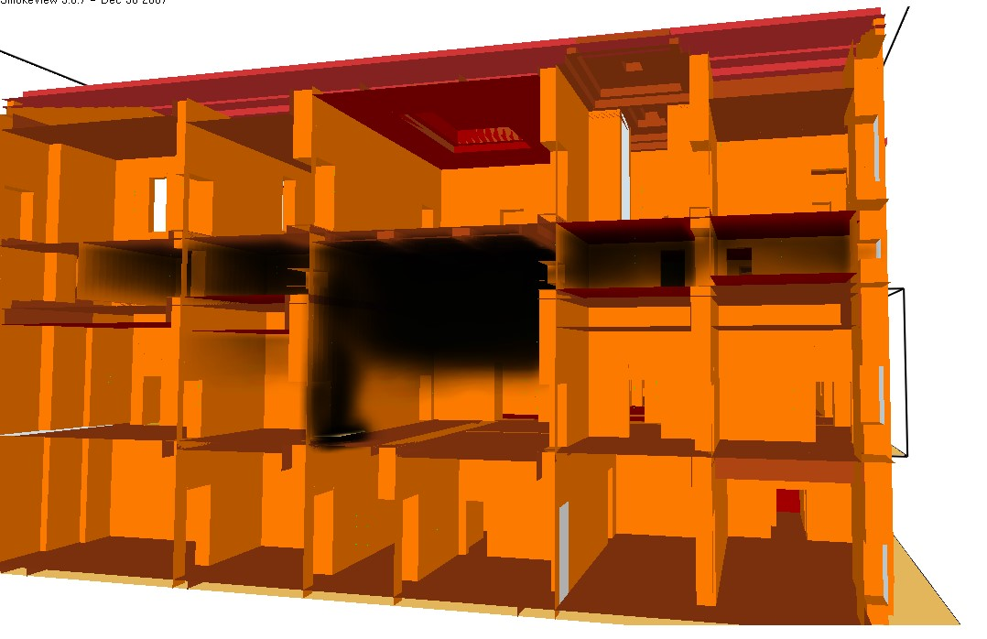

ASE
Smoke La
y
er <

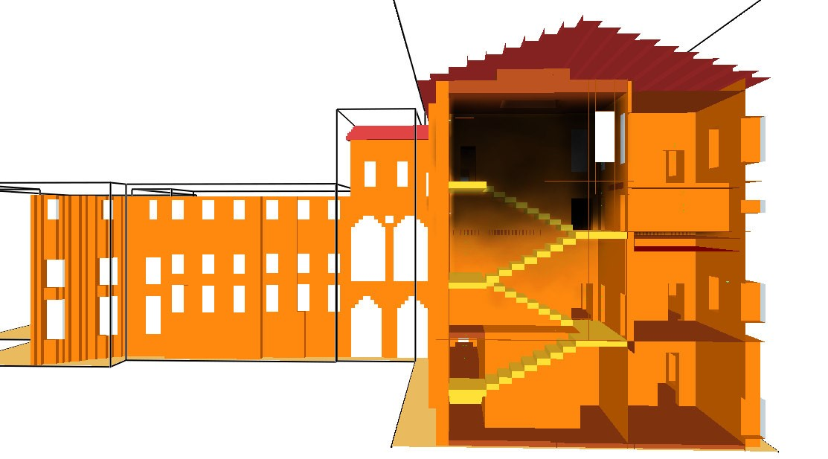

Smoke La
y
er <
ASE

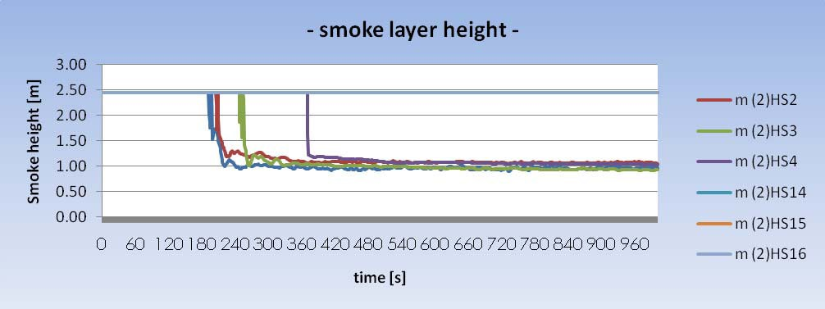

The calculations of design fire scenarios using a fire simulation model have the principal aim to calculate the movement of fire effluent, the concentrations of toxic gas and the temperature of smoke. These parameters are compared with the tenability criteria chosen for the ASET calculation.

Some considerations about the principal software programmes for simulating fire growth are put in Annex C.

5.3 RSET time quantification 8_{B}

5.3.1 General B₁₄
Escape time (RSET) in safe conditions depends on four different “times”, influenced by occupants’ physical and behavioural characteristics. The four times are:

Detection Time: the time from the beginning of ignition to its detection by a manual or automatic system. It may vary according to the fire scenario, the fire detection system (if in place) and the ability occupants have to detect the fire.

Alarm Time: the time from the detection to triggering a general alarm;

Pre-movement time: the time from detection to the moment the first occupant starts moving;

Travel time: the time occupants take to move from where they are to a safer place. It has two sub-components:
- Walking time: the time occupants take to walk to the exit. It may be expressed as a distribution of individual times or as a single time, as to say, the average time required to walk to the exit or the time the last occupant need to walk to the exit. Walking time depends on the walking speed of each occupant, their distance from the exit, physical dimensions of the building and the distribution of the occupants;

- Flow time: the time occupants take to flow through exits and escape routes. Flow time depends on the flow capacity of the exit.

tRSET =Δtdet +Δta +(Δt pre +Δttrav )

Figure 2 RSET
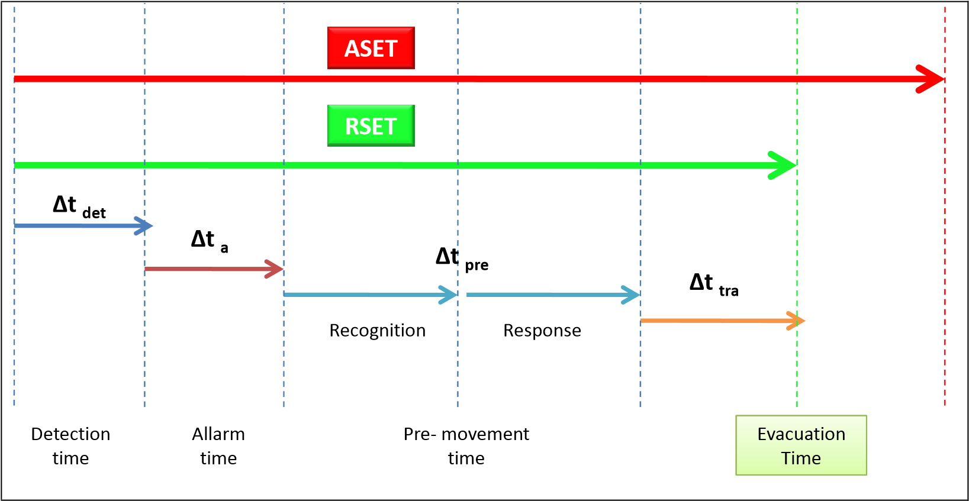
The four times are strongly influenced by human behaviour, for this reason it is not easy to give them an exact value. For the analysis, occupant’s behaviours in real and simulated emergencies have been observed.
Some information about the definition of these times is put in Annex C.

5.4 Conclusion 9_{B}
For a safe evacuation, the precise design of escape routes in relation to the distance to a place of safety and to the evacuation time has a crucial importance, therefore we have to pay attention and consideration to all the opportunities provided by the development of the Fire Safety sciences.

The choice of the most suitable approach and calculation methods for a correct evacuation design belong to the engineer, and can rely on various opportunities, from the most simple manual calculation to the most sophisticated software simulation, depending on the objective and the level of accuracy intended.

6 European guidelines 5_{B}
Guideline No 1:2002 - Internal fire protection control
Guideline No 2:2007 - Panic & emergency exit devices
Guideline No 3:2003 - Certification of thermographers
Guideline No 4:2003 - Introduction to qualitative fire risk assessment
Guideline No 5:2003 - Guidance signs, emergency lighting and general lighting
Guideline No 6:2004 - Fire safety in residential homes for the elderly
Guideline No 7:2005 - Safety distance between waste containers and buildings
Guideline No 8:2004 - Preventing arson – information to young people
Guideline No 9:2005 - Fire safety in restaurants
Guideline No 10:2008 - Smoke alarms in the home
Guideline No 11:2005 - Recommended numbers of fire protection trained staff
Guideline No 12:2006 - Fire safety basics for hot work operatives
Guideline No 13:2006 - Fire protection documentation
Guideline No 14:2007 - Fire protection in information technology facilities
Guideline No 15:2007 - Fire safety in guest harbours and marinas
Guideline No 16:2008 - Fire protection in offices
Guideline No 17:2008 - Fire safety in farm buildings
Guideline No 18:2008 - Fire protection on chemical manufacturing sites

15_{B}Annex A: Physiological effects of exposure to fire

ASET time depends proportionately to the effects of exposure to fire on people. Briefly, the following are most common physiological effectsFF:

Effects due to radiant heatU

- Hyperthermia

- Body surface burns, caused by radiant heat and smoke.

- Respiratory tract burns, caused by hot gases and smoke.

Heat is dangerous for people because it may cause dehydration, breathing difficulties, asphyxia and burns.

The tenable limit of air temperature is about 150 °C. The exposure needs to be very short and the air dry.
The temperature is lower if the air is wet. Unfortunately, in case of a fire, water vapour content is quite high. Air temperature tenable limit for a short time is about 60°C.

Table 1 Tenability limits for a radioactive and convective heat
Mode of heat transfer | Intensity | Tolerance time
Radiation | < 2,5 KW/m²  2,5 KW/m² 10 KW/m² | > 5 min  30 s  4 s
Convention | <60 °C 100% saturated  100 °C < 10% H20  110 °C < 10% H20  120 °C < 10% H20  130 °C < 10% H20  150 °C < 10% H20  180 °C < 10% H20 | > 30 min  8 min  6 min  4 min  3 min  2 min  1 min
Source: PD 7974-6:2004 “Human factors: Life safety strategies –Occupant evacuation, behaviour and condition”

Effects due to the production of fuel gasesU

- Visibility reduction
Cause inability in escaping
- Irritancy to eyes and respiratory tract

Ability to escape through building spaces and ability to locate escape routes and exits depends upon the effects of irritancy and visual obscuration.

“Visibility” distance is a very important element. Decreasing visibility distance, decreases the possibility to find a safe place.

Occupants are likely not to use an exit if the visibility distance is less than approximately 3m. Irritant smoke causes a reduction of visibility and flow speed.

Irritants in fire effluent consist of a range of organic compounds, including acrolein and formaldehyde, which are likely to be present in any fire effluent atmosphere at concentrations depending upon the chemical composition of the fuel and the fire decomposition conditions.

Asphyxia/ToxicityU
Even if fuel gasses get colder and room temperature decreases to 15°C, they continue to be gases. Most common fuel gasses are:

Table 2 Most common fuel gases
Carbon oxide (CO) | Hydrocyanic acid (HCN)
Carbon dioxide (CO₂) | Hydrochloric acid (HCl)
Hydrogen sulphide (H₂S) | Nitrogen peroxide (NO₂)
Sulphurous anhydride (SO₂) | Acrylic aldehyde (CH₂CHCHO)
ammonia (NH₃) | phosgene(COCl₂)

Carbon monoxideU
Carbon oxide develops from fires breaking out in enclosed spaces and in oxygen shortage.
Characteristics
- Colourless
- Odourless
- Not irritating
During fires, it is the most dangerous toxic gas because it is highly toxic and because it is usually produced in high quantity.

Carbon dioxideU
Carbon dioxide is an asphyxiate gas. It is not toxic, but during a fire it takes the place of oxygen When oxygen levels decrease to rates lower than 17% per volume, carbon dioxide causes asphyxia.
It quickens and stimulates breathing. Having just 2% of CO₂, breathing speeding and deepness increases 50% comparing to normal conditions. Having 3% of CO₂, breathing speed and deepness doubles (100%).

Hydrocyanic acidU
Hydrocyanic acid develops in small quantities from ordinary fires, after an incomplete combustion (oxygen shortage) of wool, silk, acrylic, polyamide and urethanic resins. It has the characteristic odour of bitter almonds.
How it acts

Hydrocyanic acid stops the respiratory chain, disabling tissues which need a high level of oxygen (heart, nervous system) to function.

PhosgeneU
Phosgene is a toxic gas developed from combustion of materials with chlorine (plastic materials).
It is very dangerous in enclosed spaces. I

How it acts

Entering in contact with water or humidity, phosgene splits into carbon dioxide and hydrochloric acid. Hydrochloric acid is very dangerous because it is extremely acidic and able to reach respiratory tracts.

Reference value is I.D.H.L: “Immediately Dangerous to Life and Health”: it calculates the concentration of toxic substances in a healthy person after an exposition of 30 minutes without causing serious damages on person health.

Table 1 Most common combustion products I.D.H.L. values
Substance | Formula | I.D.H.L. (ppm)
Carbon monoxide | CO | 1200
Carbon dioxide | CO₂ | 40000
Hydrocyanic acid | HCN | 50
Ammonia | NH₃ | 300
Hydrochloric acid | HCL | 50

I.D.H.L. Values may be found in the substances chart.

Effect due to the reduction of oxygen concentrationU
During combustion, the oxygen level decreases and fuel gases are produced. Oxygen decrease is very dangerous: at rest, people need 10l/min of oxygen in about 20 inspirations of 0,5l each; every inspiration having 16% of oxygen concentration. A person shows serious symptoms if the concentration of oxygen is lower than 14%.

16_{B}Annex B: Definitions and characteristics of fire scenarios

Definitions of fire scenariosU
As far as the definition of the fire scenarios is concerned, it is essential to identify and retrieve all the information that can contribute to the possibility that a fire could start, on the way that it could be caused and spread. Also, information concerning the potential possibility of causing harm to the occupants, building structures and their contents.

For each scenario three characteristics should be defined

1. characteristics of the fire

2. characteristics of the building

3. characteristics of the occupants

Figure 1 Fire scenarios
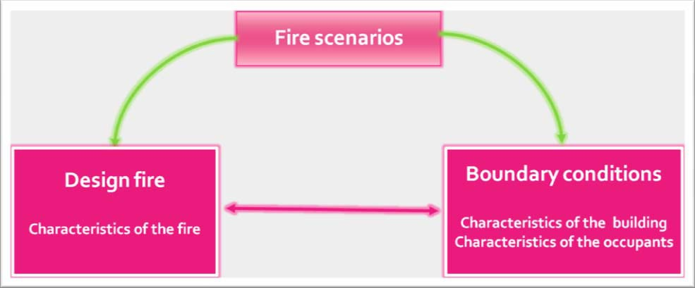

Characteristics of the fireU

- nature of combustibles;
- geometric arrangement of the fuel;
- geometry of the enclosure;
- ignitability of the fuel;
- rate of heat release characteristics;
- ventilation; state of doors (open or closed ). Lapse of time during which fire may develop doors may open or closed
- external heat flux;
- exposed surface area;
- Suppressions system.

The characteristics of the type of fuel (quantity, type, ignition timing and sequence) and the ventilation conditions (geometric enclosure characteristics) are essential to determine the heat release rate during the fire. This definition represents the “identity card” of the fire and is the necessary element in order to both calculate the rate of smoke production and the input parameters for fire simulation software.

A full specification of a design fire through heat release rate includes the following phases:

- incipient phase — characterized by a variety of sources, which may be smouldering, flaming or radiant;
- growth phase — covering the fire propagation period up to flashover or full fuel involvement;
- fully developed phase — characterized by a substantially steady burning rate as may occur in ventilation or fuel-bed-controlled fires;
- decay phase — covering the period of declining fire severity;
- extinction — when there is no more energy being produced.

Table 1 Heat release rate
INCIPIENT
GROWTH
DECAY
FULLY

DEVELOPED
Sprinkler
‐
controlledfire
Heat
Release
Rate
Sprinkler

activation
Flashover

Time
Source: ISO TR 13387-2 “Design fire scenarios and design fires”

Characteristics of the buildingU
When a fire scenario occurs, the characteristics of the building must be detailed with a full description of its physical nature , its contents and the environmental conditions. This will influence the evacuation of the occupants, the growth and development of the fire as well as the movement and diffusion of the fuel.
Generally the following characteristics are taken into consideration:

- architectural characteristics (height, width, enclosures);
- structural characteristics ;
- presence of fire detection systems , active and passive (working or not)
- purpose of the building;
- time of response of internal fire emergency teams;
- environmental factors;
- presence of natural and mechanical ventilation.

Characteristics of the occupantsU
In order to determine the capability of response to evacuation of the occupants during emergency, the characteristics of the occupants must be defined. Generally the following is taken into consideration:

- number of occupants;
- distribution in the building;
- alertness (asleep or wake)
- specific purpose (hospitals, prisons , etc.);
- focal points;
- physical capability, sensorial and mental;
- familiarity with the environment;
- physical and psychological conditions

The factors concerning the characteristics of the occupants, essential aspect for the evaluation of a safe evacuation shall be discussed in more detail in the paragraphs dealing with time calculation RSET.

Characteristics of design fire scenariosU
By means of the information gathered it is possible to assume the most serious scenario which could reasonably or probably occur in the event of fire.
Once all these aspects are determined and are taken into consideration by experts, or by means of analysis of probability a sub-group of the fire scenario project is defined.
The number of possible design scenarios is quite high. For this reason, their number is normally reduced using design fire scenarios, following two different ways:

- Probabilistic way:U is based on the probability that a fire may break out. It studies the U possible consequences. This method is used by industry, where data on probable damages, components and equipment characteristics are more reliable. Methods used are: Hazop, FMEA, Fault tree analysis and Event tree analysis. Probabilistic methods are hardly used by civil engineering, because of the lack of significant statistical data.

- Expert judgments: U according to this method, the most serious fires are assumed to U happen. This is the way mostly used by civil engineering, even if it is quite hard finding a number of fire scenarios which are sufficiently different each others. The expert judgement way doesn't need to know the fire frequency.

The following is an alternative method which refers to NFPA 101 ( live safety code): in this method, the code suggests 8 fire scenarios. A limit of the method is the high number of analytical calculations it needs to cover the different scenarios hypothesis. Another limit is the seriousness of supposed scenarios. For example: estimation of what may happen if exits are blocked by burning materials, or building estimation when a protection system doesn’t work.

It is necessary to mention ISO TR 13387-2 “Design fire scenarios and design fires” because it suggests a method to define design fire scenarios based on the following points:

- Type of fire: The most likely type of fire scenario can be determined from consideration of the items most commonly ignited, the ignition source and location of the fire from relevant fire incident statistics. • Location of fire
- Potential fire hazards
- Systems impacting on fire
- Occupant response
- Event tree
- Consideration of probability
- Consideration of consequences
- Risk ranking
- Final selection

Typically, it is an idealized description of the variation with time of important fire variables such as heat release rate, fire propagation, smoke and toxic species yield and temperature. At the end it is obtained those fundamental elements for the definition of the time of ASET.

When evaluating a safe evacuation all the characteristics of the fire, the building and its occupants likely to cause a critical evacuation, are taken into consideration. For example;

- Detail of fuel ( development speed and toxic/suffocating gasses)
- Fire location in places where it is difficult to control or near emergency exits.
- Sleeping occupants .

Once the project fire scenario has been selected we have got all the information (characteristics of the fire and details of enclosure where it has developed) together with formulas, statistics and fire simulation modules, in order to determine those parameters at the base of time ASET.

The knowledge of these parameters, with regards to time, allows us to establish the exact moment in which the conditions of the environment do not guarantee the possibility to evacuate in safe conditions. (ASET TIME).

The procedure to establish the ASET time is highly specialized and an expert knowledge of the chemical and physical properties of the substances is required, to be able to use these results during the output supplied by software, especially in the case of toxic substances.

The PD 7974-6:2004 “Human factors: Life safety strategies – Occupant evacuation, behaviour and conditions” , because of the difficulties to optimize the necessary information concerning the
calculation of the toxic concentrates, a conservative approach based on the “no exposure” concept is recommended. This concept suggests to refer to, as per ASET time, the time that hot smoke at ceiling height takes to reach 2,5 m from the floor along the exit ways. When the temperature at ceiling height does not reach 200°C heat radiation is still bearable and the occupants are able to evacuate in a space with air which is still clean.

The height and temperature of hot smoke are easily calculated by the fire modelling software at a cost which is less costly than the costs involved in the calculation of the concentrations of toxic gases.

Figure 2 Fire Scenarios and Design fire Scenarios
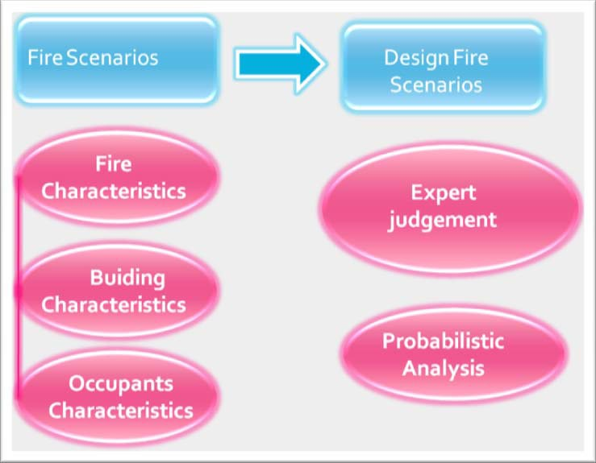

B₁₇Annex C: Considerations regarding the principal fire simulation software

Feature from “An Updated International Survey of Computer Models for Fire and Smoke” -
STEPHEN M. OLENICK* AND DOUGLAS J. - CARPENTER Journal of FIRE PROTECTION
ENGINEERING, Vol. 13—May 2003

The principal aim of this Annex is to show the most common type of fire model giving a short description of two types. The categories chosen for computer fire models include zone models, field models:

Zone ModelsU
A zone model is a computer program that predicts the effects of the development of a fire inside a relatively enclosed volume. In most applications, the volume is not totally enclosed as doors, windows, and vents are usually included in the calculation. Zone models for compartments have been developed for both single-room and multiroom configurations. The ‘zonal’ approach theory to modelling plume and layer development in confined spaces was applied to fires by several groups in the 1970s, e.g. Zukoski . The ‘zonal’ approach divides the area of interest into a number of uniform zones, that when combined, describe the area of interest as a whole. Within each of these zones, the pertinent conservation laws (i.e. mass and energy), in the form of mathematical equations describing the conditions of interest, are solved. The ‘zonal’ approach for an enclosure fire usually divides an enclosure into two distinct zones: the hot upper smoke layer and the lower layer of cooler air. The plume acts as an enthalpy pump between the lower layer and the hot upper smoke layer. In reality, depending on the room size and heat release rate of the fire, there is no perfectly defined ‘interface’ between the hot upper smoke layer and lower layer and the hot upper smoke layer is not an uniform temperature (as higher temperatures are observed closer to the fire and plume); however, the use of two uniform zones allows for reasonable approximations of the development of a fire in an enclosure under many conditions. Table 1 lists the zone models which have been identified :

Table 1 Fire Zone models
Model | Country | Description
ARGOS | DENMARK | Multicompartment zone model
ASET | US | One room zone model with no ventilation
ASET-B | US | ASET in Basic instead of Fortran
BRANZFIRE | NEW ZEALAND | Multiroom zone model, including flame spread, multiple fires, and mechanical ventilation
BRI-2 | JAPAN/US | Two-layer zone model for multistory, multicompartment
 |  | smoke transport
CALTECH |  | Preflashover zone model
CCFM.VENTS | US | Multi-room zone model with ventilation
CFAST/FAST | US | Zone model with a suite of correlation programs-CFAST is the solver, FAST is a front-end
CFIRE-X | GERMANY | Zone model for compartment fires, particularly liquid hydrocarbon pool fires
CiFi | FRANCE | Multiroom zone model
COMPBRN-III | US | Compartment zone model
COMF2 | US | Single room postflashover compartment model
DACFIR-3 | US | Zone model for an aircraft cabin
DSLAYV | SWEDEN | Single compartment zone model
FASTlite | US | Feature limited version of CFAST
FFM | US | Preflashover zone model
FIGARO-II | GERMANY | Zone model for determining untenability
FIRAC | US | Uses FIRIN, includes complex vent systems
FireMD | US | One room, two zone model
FIREWIND | AUSTRALIA | Multiroom zone model with several smaller submodels  (update of FIRECALC)
FIRIN | US | Multiroom zone model with ducts, fans, and filters
FIRM | US | Two zone, single compartment model
FIRST | US | One room zone model, includes ventilation
FMD | US | Zone fire model for atria
HarvardMarkVI | US | Earlier version of FIRST
HEMFAST | US | Furniture fire in a room
HYSLAV | SWEDEN | Preflashover zone model

Field ModelsU
Field models, like zone models, are used to model fire development inside a compartment or a series of compartments. While a zone model divides the compartment into two zones, and solves the conservation equations (i.e., mass, energy, and momentum) within these zones, a field model divides the compartment into a large number (on the order of thousands) of control volumes and solves the conservation equations inside each control volume. This allows for a more detailed solution compared to zone models. Because there are more than two uniform zones, a field model can be appropriate for more complex geometries where two zones do not accurately describe the fire phenomenon. They can also be used for fires outside of compartments such as large outdoor fuel tank fires. While field models provide very detailed solutions, they require detailed input information, and usually require more computing resources in order to model the fire. This can create a costly time delay in obtaining a solution while zone models usually provide a solution more quickly . This trend of increasingly growing numbers of field models stems from improved computer hardware which allows for faster, more complex computational techniques. Table 2 lists the field models which have been identified.

Table 2 Fire field models
Model | Country | Description
ALOFT-FT | US | Smoke movement from large outdoor fires
CFX | UK | General purpose CFD software, applicable to fire and explosions
FDS | US | Low Mach number CFD code  specific to fire-related flows
FIRE | AUSTRALIA | CFD model with water sprays and coupled to solid/liquid phase fuel to predict burning rate and extinguishment
FLUENT | US | General purpose CFD software
JASMINE | UK | Field model for predicting consequences of fire to evaluate  design issues (based on PHOENICS)
KAMELEON  FireEx | NORWAY | CFD model for fire linked to a  finite element code for thermal response of structures
KOBRA-3D | GERMANY | CFD for smoke spread and heat transfer in complex geometries
MEFE | PORTUGAL | CFD model for one or two compartments, includes time-response of thermocouples
PHOENICS | UK | Multipurpose CFD code
RMFIRE | CANADA | Two-dimensional field model for the transient calculation of smoke movement in room fires
SMARTFIRE | UK | Fire field model
SOFIE | UK/SWEDEN | Fire field model
SOLVENT | US | CFD model for smoke and heat transport in a tunnel
SPLASH | UK | Field model describing interaction of sprinkler sprays with fire gases
STAR-CD | UK | General purpose CFD software
UNDSAFE | US/JAPAN | Fire field model for use in open spaces, or in enclosures

18_{B}

Annex D: Calculations of RSET time

Following paragraphs will explain each time, giving information taken from literature.

Detection TimeU
In an automatic system, detection time depends on the sensitivity of the system. Automatic system planners calculate the detection time. Lacking an automatic detection system, detection time is estimated basing on the planned fire scenario. The following are the characteristics of a fire scenario which may cause a delay on fire detection:
- Occupants characteristics: sensory skills and activities they are involved in;
- Building characteristics;
- Fire characteristics: speed of spreading, smoke, etc.

Alarm TimeU
Guidance on estimation of alarm time is provided in PD 7974-6:2004 “ Human factors: Life safety strategies –Occupant evacuation, behaviour and condition”. It reports three different alarm levels:

Level A1
The building is provided with an automatic fire system. Once the fire has been detected, the system activates the alarm throughout the all building. The time from the detection to the general alarm is zero.

Level A2
Even in this case the building is provided with an automatic fire system but the general alarm is not immediate. A pre-alarm is transferred to the safety room (pre-alarm system). In this case, the pre-alarm time depends on the safety management strategy. In any case, pre-alarm time should go from 2 to 5 minutes. Safety management evaluation allows a more exact range definition.

Level A3
A manually activating alarm system is located near the source of the fire. In this case a range time definition is very far from being exact because it depends on fire scenario and occupants characteristics: age, role and responsibility in the building, training in case of fire.

Planning an alarm system, it is important to take into consideration the building structure:
- in a small single storey building, it is necessary to sound an immediate general alarm throughout the building (Level 1);
- in a big multi-storey crowded building, it is advisable to have a staged fire alarm system: first the warning system in the floor affected is activated, then the warning system in the floor upstairs so as not to have a simultaneous evacuation and congestion at the exits.

Pre-movement TimeU
This may be sub-divided into two components:

Recognition
The time from the general alarm to the time occupants begin to respond. It may be divided into two elements:
- Alarm receiving: time used to receive the alarm of cue.
- Alarm processing: time to understand the alarm of cue received and then processed is an evacuation warning.

During the recognition time, occupants continue with the activities they were engaged with before the alarm of cue.

The recognition time ends when occupants decide to take some action in response to the emergency cues received.

For simple evaluations the average or the slowest recognition time may be taken for each group of occupants. For complex evaluations recognition time may be assigned to each individual.

The following are suggestions to minimize recognition time:
- the system should provide precise instructions under varying emergency situations;
- instructions should be capable of varying in the different parts of the buildings so as to provide occupants with the information tailored upon the actions they are desired to take;
- alerting tones should precede voice instructions to capture occupants attention;
- pre-recorded messages may be used in pre-planned situations;
- in health care occupancies, where the staffs are trained to notify and assist occupants with evacuation, it is advisable to alert just those individuals who need to take action, to have a maximum life safety benefit from a fire alarm system. Others can be notified, but not alerted.

Response
The time from the alarm recognition to the time occupants decide to respond, but before beginning the evacuation.

Examples of activities undertaken during the response time:
- investigative behaviour, including action to determine the source, reality or importance of a fire alarm or cue;
- stopping machinery/production processes or securing money and other risks;
- seeking and gathering together children and other family members;
- fighting the fire;
- the time involved in determining the appropriate exit route (i.e. “wayfinding”); and the time involved in other activities not fully contributing to effective evacuation where necessary (for example acting on incorrect or misleading information);
- alerting others

Pre-movement time may vary considerably for different individuals or groups of individuals located within the same enclosure or in different enclosures.
Elements to be taken into consideration to estimate recognition and response time are as follows ( list taken from PD 7974-6:2004 and from ISO/TR 13387-8):
- Building parameters:
  - occupancy type;
  - floor plans, layout and dimensions;
  - contents;
  - warning system;
  - fire safety management emergency procedures;
  - signs;
  - lighting;
  - location of exits and complexity of enclosure layout.

- Occupant status:
  - number and starting location of occupants.U The code occupant load of a U room is the maximum number of persons anticipated to be present for a given configuration or use. Where there is no other information available, the number should be estimated according to use, for example dividing the area of the room or the story by an appropriate occupant load factor. Potential changes in occupancy load data need to be considered. Conservative design requires use of the maximum potential occupant load. Designers should be mindful that the numbers and distribution of occupants in a building will change with the time and the activity.

  - characteristics of the occupants: U gender, age. In general, female are more U likely to alert or warn others to evacuate in response to fire cues than man. In a health care centre, male staff tends to fight the fire, while female staff is more likely to take protective action and rescue patients. Age influences both the capability people have to recognize an alarm and their quickness in acting. Old and young people find more difficult recognizing an alarm , but once young people have decided to move, they are quick and strong to face smoke and heat. Old people and children have difficulties in evacuating without assistance.

  - activities of the occupants before the emergency.U

  - family or group relationships.U Response to alarms or fire cues is affected by U whether people are alone or with others. The presence of other people can have an inhibiting effect on the definition and initiation of action from initial ambiguous cues. They are likely first to attempt to reestablish the group. People who are alone tend to respond more rapidly to ambiguous cues. In addition, the speed of movement will often be dictated by that of the slowest member of the group.

  - occupant condition: physical and mental abilityU .U A proportion of the population may be impaired (cognitively and/or physically) or will present some level of limitation related to injury, illness poor health, or other medical conditions. The initial response of disabled people may involve a considerable preparation time before moving. Their movement is significantly influenced by the nature of their disability and building elements such as doors, ramps and stairs. People with a hearing disability may require special means of notification of a fire, although their evacuation movement may not be different than mobile occupants. People with a visual disability may perceive audible information such as a fire alarm or a voice communication message but might need assistance to find a suitable evacuation route.

  - alertness:U depends on factors such as activities, time of day, sleeping or U awake

  - role and responsibility:U the rules and responsibilities of occupants during the U normal use of the building will, in an emergency, influence their behaviour and the behaviour of the others. Sufficient, well trained, and authoritative staff will shorten the ambiguous, information-gathering phase of premovement time.

- Fire simulation dynamics:
  - building condition and fire location;
  - visibility of smoke or fire;
  - exposure to fire effluent or heat;
  - fire alarm status and type;
  - other warnings or cues (for example from management or other occupants);
  - active protection status.

The analysis of all these elements allows the recognition and response time evaluation for each occupant or for group of occupant per enclosure.

Quantification of Pre-movement time The pre-movement time is given by:
- the time from the spreading, recognition and processing of the alarm to the first occupants moving;
- the time the rest of occupants take to move to a safer place.

Pre-movement time has a normal log distribution: the number of people starting moving increases rapidly and they form a very long queue.

There are two times to take into consideration: the first occupant’s pre-movement time (i.e. 1st percentile) and the last occupant’s pre-movement time (i.e. 99th percentile).

In PD 7974-6:2004 “Human factors: Life safety strategies – Occupant evacuation, behaviour and condition”, a table analyses the two pre-movement times and the so called “behavioural
scenarios”.

Behavioural scenarios summarise the elements used to define recognition and response time. The table is useful to give a value to recognition and response time. In any case, just a close analysis of the elements in a), b), c) allows a total understanding of the table.
The following is a brief scheme of the behavioural scenarios. (Refer to the rule for a detailed explanation of the elements).

PD 7974-6:2004 refers 4 elements to define behavioural scenarios:

- occupancy type;
- alarm system;
- building complexity; 4. safety management system.

The first element gives a sub-division into six categories:

Table 1 Occupant Category
Category | Occupant alertness | Occupant familiarity | Occupant density | Enclosures/complexity | Examples
A | Awake | Familiar | Low | One or many | Office or industrial
B1  B2 | Awake  Awake | Unfamiliar  Unfamiliar | High  High | One or few One with focal point | Shop,restaurant,circulation space Cinema,theatre
Ci Cii | Asleep  Managed occupancy | Familiar | Low | Few | Dwelling  Serviced flats,halls of residence,etc.
Ciii | Asleep | Unfamiliar | Low | Many | Hotel,hostel
D | Medical care | Unfamiliar | Low | Many | Residential
E | Transportation | Unfamiliar | High | Many | Railway station/Airport
Source: PD 7974-6:2004 “Human factors: Life safety strategies –Occupant evacuation behaviour and condition”

The other each element is divided into three categories as follow:

Alarm levels:
Level A1: an automatic detection system which gives a general alarm throughout the building.

Level A2: an automatic detection system which doesn't give an immediate general alarm but transfers a pre-alarm to the security room (pre-alarm system).

Level A3: a manually activated alarm system near the affected area.

Building Level:
BUILDING LEVEL B1: (simple supermarket) represents a simple rectangular single storey building with one or few enclosures and a simple layout with good visual access, prescriptively designed with short travel distance, and a good level of exit provision with exits leading directly to the outside of the building.

BUILDING LEVEL B2: (simple multi-storey office block) represents a simple multi-enclosure building, with most features prescriptively designed and simple internal layouts.

BUILDING LEVEL B3: represents a large complex building. This includes large building complexes with integration of a number of existing buildings on the same site, common with old hotel or department stores, also large modern complexes such as leisure centres, shopping centres and airports. Important features are that internal layout and enclosures involve often large and complex spaces so that occupants may be presented with wayfinding difficulties during an evacuation and the management of an evacuation therefore presents particular challenges.

Management Level:
MANAGEMENT LEVEL M1: the normal occupants (staff or residents) should be trained to a high level of fire safety management with good fire prevention and maintenance practice. For “awake and unfamiliar” there should be a high ratio of trained staff to visitors. The system and procedures are subject to independent certification, including a regular audit with monitored evacuations for which the performance must match the assumed design performance. This level would usually also imply a well designed building with obvious and easy to use escape route (to level B1 or at least B2), with automatic detection and alarm systems to high level of provision (level A1).

MANAGEMENT LEVEL M2: similar to level 1, but have a lover staff ratio and floor wardens may not always be present. There may be no independent audit. Building features may be level B2 or B3 and alarm level A2. The design escape and evacuation times will be more conservative than for a level M1 system.

MANAGEMENT LEVEL M3: representing standard facilities with basic minimum fire safety management. There is not independent audit. The building may be level B3 and alarm system A3

A good guide for fire safety management is BS 5588-12.

Having once found the behavioural scenario close to the occupants’ situation, the following table from BS 7974-6 may be observed to have a rough estimate of pre-movement time. Specifically, the table gives the 1st percentile and 99th percentile pre-movement times.

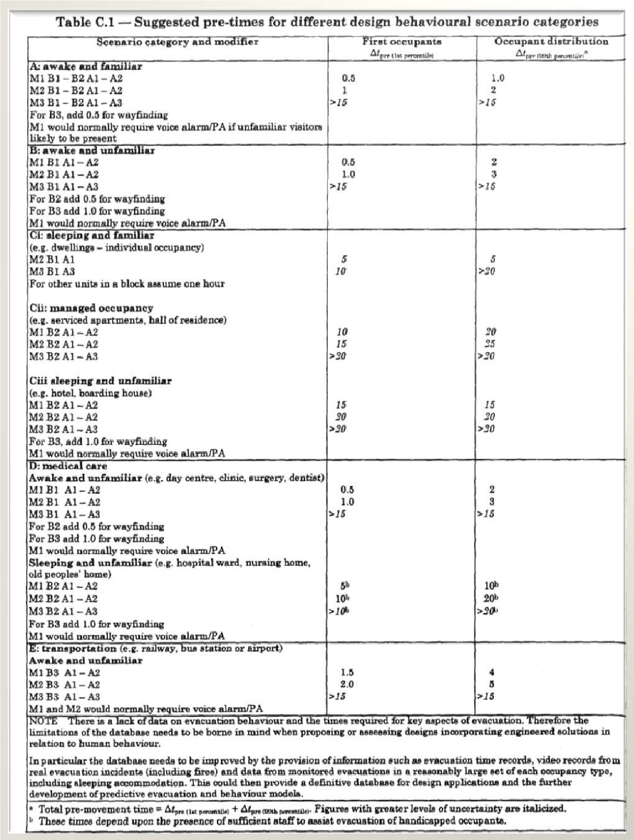
Source: PD 7974-6:2004 “Human factors: Life safety strategies –Occupant evacuation, behaviour and condition”

It is possible to have pre-movement time from others literary sources. The following table gives a rough estimate of pre-movement time, basing on the elements already analysed in the previous table.
Table 2 pre-movement time
Occupancy type | W1  (min) | W2  (min) | W3  (min) | W1: live directives using a voice communication system from a control room, or live directives in conjunction with welltrained, uniformed staff that can be seen and heard by all occupants in the space  W2: nondirective voice messages (prerecordered) and/or informative warning visual display with trained staff  W3: warning system using fire alarm signal and staff with no relevant training  Note:  For occupants in a small room/space of fire origin who can clearly see smoke and flames at a distance, adopt the relevant time given for the W1  For occupants in a large room/space of fire origin who can clearly see smoke and flames at a distance, adopt the relevant time given for the W2, unless W1  For occupants outside room/space of fire origin who cannot clearly see smoke and flames, adopt the relevant time given for the warning system in operation
Office, commercial and industrial buildings, schools, colleges and universities (Occupants awake and familiar with the building, the alarm system, and evacuation | < 1 | 3 | > 4
Shops, museums, leisure-sport centers, and other assembly buildings (Occupants awake but may be unfamiliar with the building, alarm system, and evacuation procedure. | < 2 | 3 | > 6
Dormitories, residential mid-rise and highrise (Occupants may be asleep but are predominantly familiar with the building, alarm system, and evacuation procedure.) | < 2 | 4 | > 5
Hotels and boarding houses (Occupants may be asleep but are predominantly familiar with the building, alarm system, and evacuation procedure.) | < 2 | 4 | > 6
Hospital, nursing home, and other institutional establishment (A significant number of occupants my require assistance) | < 3 | 5 | > 8
Source: Adapted from Fire Safety Engineering In Building, Part 1: “Guide to the application of Fire Safety Engineering
Principles”, Table 21, British Standard Institute, DD240, London, 1997

Once given a value to the pre-movement time using the tables, PD 7974-6:2004 suggests to simplify the complex analysis of evacuation time, considering each occupant position, premovement time, walking time and the effects occupants density have on walking time (subject analysed in the following paragraph), just using two estimations. It may be used for any building enclosure, considering two simple cases:
- a case where the enclosure is sparsely populated with a density population of 1/3 of the design population
- a case where the enclosure contains the maximum design population

For both case, the largest exit should be discounted.

In the first case, evacuation time depends on the pre-movement time of the last group of occupants deciding to leave and on the time they take to travel to the exit and walk through. As long as occupants’ density is low, their walking speed won't be impeded and there won't be queuing at the exits.

tRSET =Δtdet +Δta +(Δt pre(99thpercentile) +Δttrav(walking) )

It has to be done a conservative estimation of the walking time using the maximum direct travel distance to the exit. The walking speed has to be considered to be that of one of the last occupants, not influenced by density.
In the second case, evacuation or RSET time depends on the pre-movement time and walking time of the first group of occupants deciding to evacuate (1st percentile) plus the flow time through the exits where queues are likely to be formed.

tRSET =Δtdet +Δta +(Δt pre(1stpercentile) +Δttrav(walking) +Δttrav( flow) )

The longer case should be used for design purposes and, in most scenarios, the second case will represent the longest required escape times.

In case modelling software cannot be used, the equation makes the calculation easier.

When the evacuation involves simultaneous evacuations from many enclosures into an escape route (corridor or stairs), evacuation time depends on the flow capacity of the escape route where flows from different enclosures merge. In this case hand calculation cannot be carried out simply, for this reason it is advisable to use computer simulation models.

The flow rate of occupants from individual enclosures depends upon the nature of the merging flows at the landings of the escape stairs with occupants from other enclosures and on the flow capacity of the stairs

In the case of a multi-stored building where two floors are evacuated simultaneously and the flow from the upper floor merges with the flow from the floor below, the method described in SFPE Handbook estimates that the flow rate from each floor will be half the maximum flow rate from each storey exit. In some crowded situations, the flow of occupants from in a stairwell from the upper floor may dominate, so that to some extend occupants from the lower floor cannot evacuate until those from the upper floor have gone.

Travel – Time

Travel time depends on three components:
- walking time: the average travel distance to a safe place for the occupants;
- time to queue;
- flow time through the exits

To estimate the three components, three elements have to be considered:

a) walking speed

The movement time is obtained by summing the horizontal and the vertical movement time
Horizontal travel speed

International literature quotes unimpeded walking speed in occupants without physical disabilities as going from 1.2 m/s to 1.25 m/s. Such walking speed may be referred to in case population density is less than 0,54 persons/m². In case population density value gets higher, occupants walking speed gets impeded: walking speed decreases proportionally to density increase. When population density exceeds 3.8 persons/m² speed is considered zero, according to the following equation:

S=K−aKD

S = speed along the line of travel
D= density (persons/m2) K=velocity factor
a=constant 0.266 m2/pers (2.86 ft2/pers)

Table 3 Velocity factor
Egress Component |  | K (m/s) | K (ft/min)
Corridor, aisle, ramp, doorway |  | 1.40 | 275
Stair Riser mm (in.) | Stair Tread mm (in.)
S1: 190 (7.5) | 254 (10) | 1 | 196
S2: 272 (7.0) | 279 (11) | 1.08 | 212
S3: 165 (6.5) | 305 (12) | 1.16 | 229
S4: 165 (6.5) | 330 (13) | 1.23 | 242
Source: PD 7974-6:2004 “ Human factors: Life safety strategies –Occupant evacuation, behaviour and condition”

Other than using the equation, movement speed as a function of density may be taken from
Figure 1:

Figure 1 Movement speed as a function of density
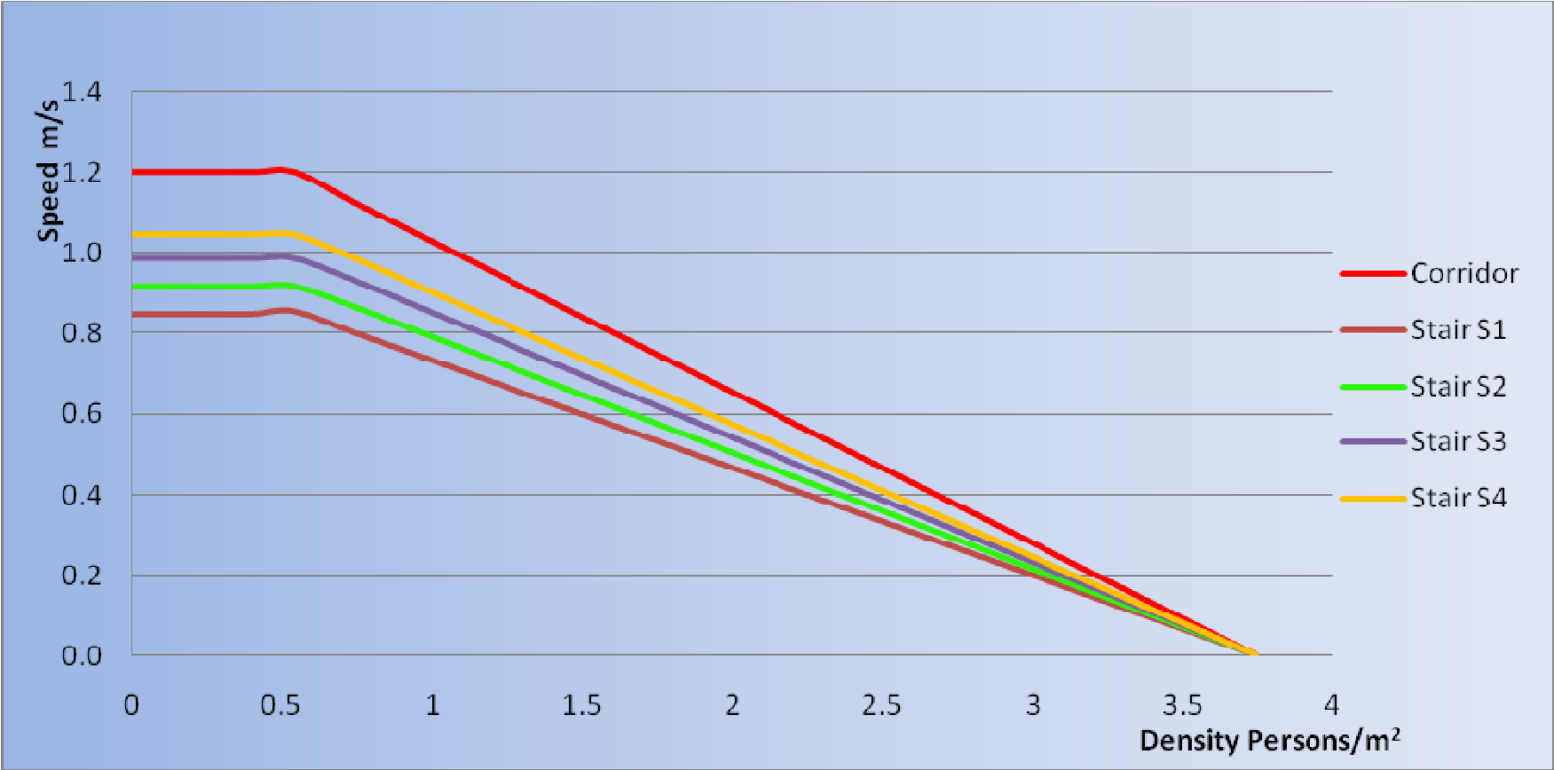
Reports have taken into consideration groups of grown-up people without any physical disabilities (not real situation). For this reason ProulxF2F has estimated a walking speed of about 0.45 m/sec for old people and children younger than 6 years. Walking speed of grown-up people impeded by trolleys, luggage or children taken by hand, varies from 0.22 to 0.79 m/s. Specific estimations have been done considering disabled people. They have confirmed individual walking speed variability. Literature may give experimental examples on walking speed estimations. The following are estimations taken from the Handbook of Fire Protection Engineering:

Speed on horizontal surface
Subject Group | Mean | Standard deviation | Range | Interquartile range
All disabled | 1,00 | 0,42 | 0,10-1,77 | 0,71-1,28
With locomotion disabilities | 0,80 | 0,32 | 0,24-1,68 | 0,57-1,02
No aid | 0,95 | 0,32 | 0,24-  0,1,68 | 0,70-1,02
Crutches | 0,94 | 0,30 | 0,63-1,35 | 0,67-1,24
Walking sticks | 0,81 | 0,38 | 0,26-1,60 | 0,49-1,08
Rollator | 0,57 | 0,29 | 0,10-1,02 | 0,34-0,83
No locomotion disability | 1,25 | 0,32 | 0,82-1,77 | 1.05-1,34
Electric wheelchair | 0,89 | - | 0,85-1,77 | -
Manual wheelchair | 0,69 | 0,35 | 0,13-1,35 | 0,38-0,94
Manual wheelchair | 0,36 | 0,14 | 0,11-0,70 | 0,20-0,47
Assisted manual wheelchair | 1,30 | 0,94 | 0,84-1,98 | 1,02-1,59
Assisted ambulant | 0,78 | 0,34 | 0,21-1,40 | 0,58-0,92
Source: Table 3-13.2 from Section 3, Chapter 13: “Movement Of People: The Evacuation Timing”, The SFPE Handbook of Fire Protection Engineering, 3rd Edition, NFPA Inc., Quincy, Massachusetts, 2002

Vertical travel speed
International literature reports a maximum walking speed variation for physically able people from 1.1 m/s to 0.85 m/s. This estimation refers to a density of people less than 0,54 persons/m. In the case where the density is higher, occupants are impeded and walking speed decreases proportionally to density increase. When density exceeds 3.8 persons/m2 walking speed is zero, according to the following equation:

S=K−aKD

The meaning of each term is the same as that in the previous equation. Factor K refers to table 6.

Other than using the analytical equation, it is possible to refer to the diagram (figure 1).

The following estimations about speed on stairs have been taken from Handbook of Fire Protection Engineering:

 |  | Speed on stairs
Subject Group | Mea n | Standard deviation | Range | Interquartile range
 |  | Ascent
With locomotion disabilities | 0,38 | 0,14 | 0,13-0,62 | 0,26-0,52
No aid | 0,43 | 0,13 | 0,14-0,62 | 0,35-0,55
Crutches | 0,22 | - | 0,19-0,31 | 0,26-0,45
Walking stick | 0,35 | 0,11 | 0,18-0,49 | -
Rollator | 0,14
Without  disabilities | 0,70 | 0,24 | 0,55-0,82 | 0,55-0,78
 |  | Descendent
With locomotion disabilities | 0,33 | 0,16 | 0,11-0,70 | 0,22-0,45
No aid | 0,36 | 0,14 | 0,11-0,70 | 0,20-0,47
Crutches | 0,22 | - | - | -
Walking stick | 0,32 | 0,12 | 0,11-0,49 | 0,24-0,46
Rollator | 0,16 | - | - | -
Without  disabilities | 0,70 | 0,26 | 0,45-1,10 | 0,53-0,90

Source: Table 3-13.3 from Section 3, Chapter 13: “Movement Of People: The Evacuation Timing”, The SFPE Handbook of Fire Protection Engineering, 3rd Edition, NFPA Inc., Quincy, Massachusetts, 2002

b) Specific flow
Specific flow is found by multiplying velocity and density. It states the number of people walking past a point per metre of effective width (door or passageway) per second. Specific flow is similar to the mass flow in a hydraulic system.
FS = S ⋅D

Substituting S with the previous equation:

F_{S} = S ⋅D ⁼ (K −aKD)⋅D ⁼ (1−aD)⋅KD

F_{S}= Specific flow (persons/ms), (persons/fts),
S = speed along the line of travel (m/s), (ft/s),
D= density (persons/m²), (persons/ft²),
K=velocity factor ,
a=constant 0.266 m²/pers (2.86 ft²/pers)

Even specific flow is a function of density, it varies according to the square of density and not proportionally to it as velocity does. The following is a diagram which describes the specific flow progress, referring to vertical and horizontal travels. The progress of the diagram is that of a parabolic curve which has concavity pointing to the bottom. In the first part, the parabolic curve increases because of the increase of density. When density is 1.9 persons/m² (at the top of the curve), the specific flow rate is maximum. In the second part, the parabolic curve decreases: specific flow rate is zero and density 3.8 persons/m².

Figure 2 Specific Flow as a function of density
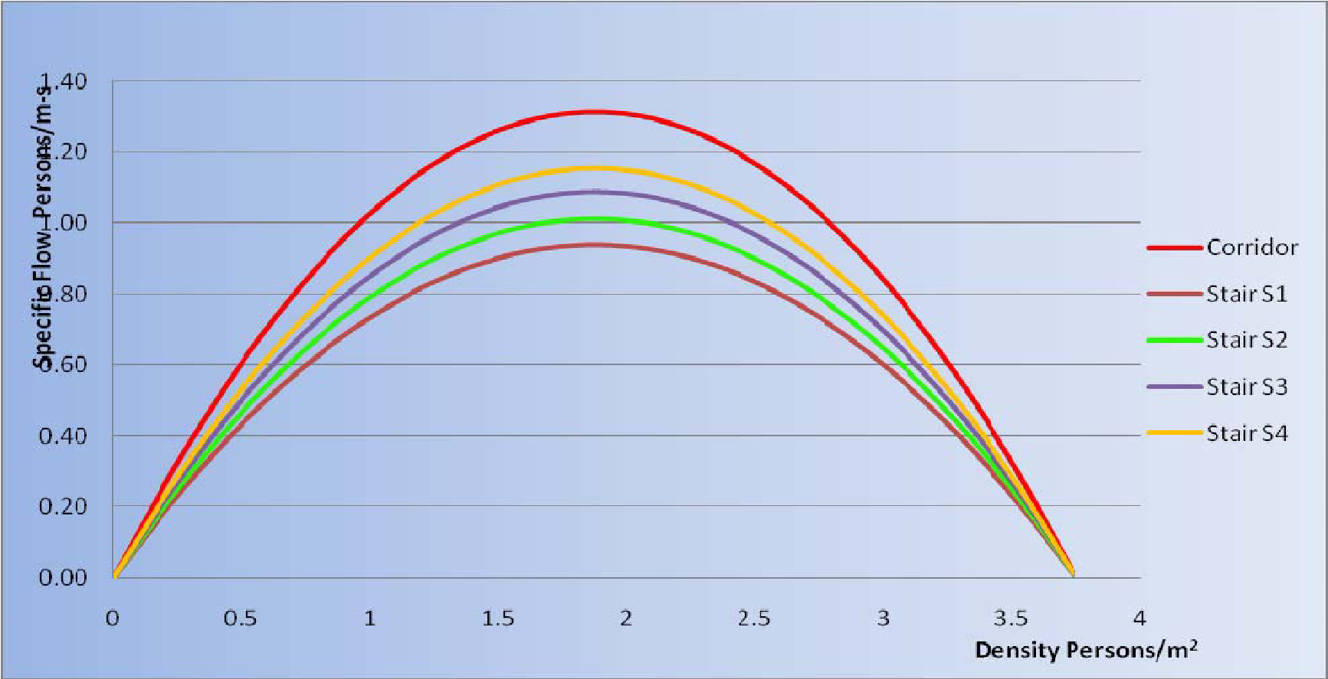

It's important to point out the maximum flow capacity for each egress component (corridors, stairs) to give some remarks on flows fusion and transition in egress components. Table 4 shows maximum specific flow rates.
Table 4 Maximum Specific Flows
Egress Component |  | Fs pers/s m of Effective Width (pers/s ft of Effective Width)
Corridor, aisle, ramp, doorway |  | 1.32 (24.0)
Stair Riser mm (in.) | Stair Tread mm (in.)
190 (7.5) | 254 (10) | 0.94 (17.1)
272 (7.0) | 279 (11) | 1.01 (18.5)
165 (6.5) | 305 (12) | 1.09 (20.5)
165 (6.5) | 330 (13) | 1.16 (21.2)

Where egress components have boundary layers, occupants flow keeping a distance from walls or other obstacles. Doing this, they may have room to move laterally in case of necessity. The result width is given taking away from the all width a variable value given by experimental estimations. Some of the values are reported in table 5.

Table 5 Boundary Layer Width
Component | Boundary Layer mm (inch)
Theater chairs, stadium benches | 0 (0)
Railings, handrails | 89 (3.5)
Obstacles | 100 (4)
Stairways, door, archways | 150 (6)
Corridors and ramp walls | 200 (8)

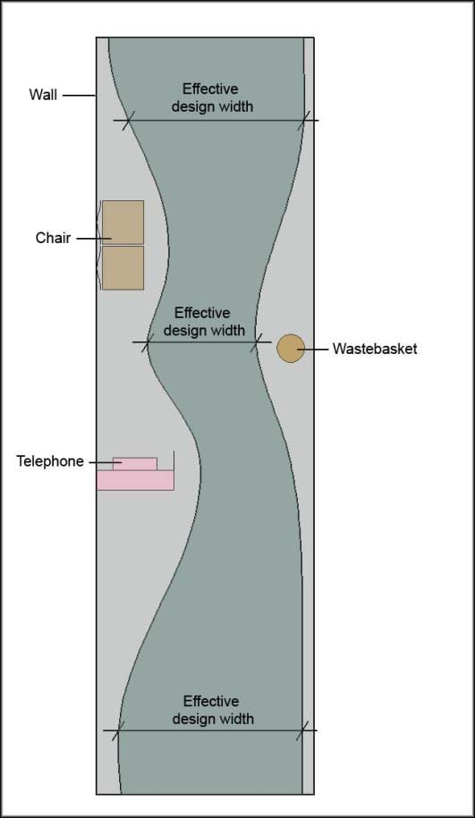
Source: Adapted from fig. 3-14.4 Section 3, Chapter 14: “Emergency Movement”, The SFPE Handbook of Fire Protection
Engineering, 3rd Edition, NFPA Inc., Quincy, Massachusetts, 2002

c) Flow capacity
It is the number of occupants walking through an egress per second. It may be given multiplying the specific flow with the effective width:

F_{C} = F_{S} ⋅L_{e}
Substituting Fs with the previous formula:

FC = FS ⋅Le = (1−aD)KDLe

F_{c} = flow capacity (persons/s), (pers/s)
F_{S}= Specific flow (persons/ms), (persons/fts)

Follow two particular situations:

Merging Egress Flow

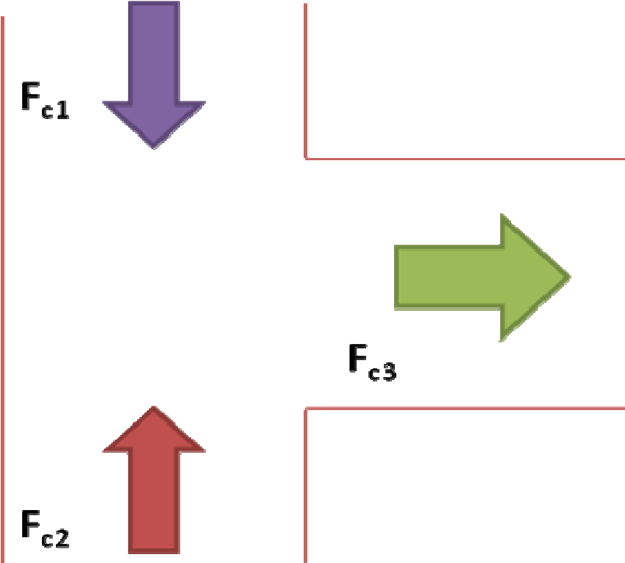
Figure 3 Merging Egress Flow

The combined flow rate of people entering an intersection equals the flow rate of people from intersection:
Fc1 + Fc2 = Fc3
Fs1 ⋅Le1 + Fs2 ⋅Le2 = Fs3 ⋅Le3
Fs3 = Fs1 ⋅Le1 + Fs2 ⋅Le2
Le3

If the combined flow rate of egress components leading to intersections are greater than the specific flow rate for the egress component (see the maximum specific flow rate in table 7 leading from the intersection, a queue is expected to form. If a queue forms, the analysis can continue, considering that the flow rate in component 3 is equal to the maximum capacity of the component.

Transition in Egress Component

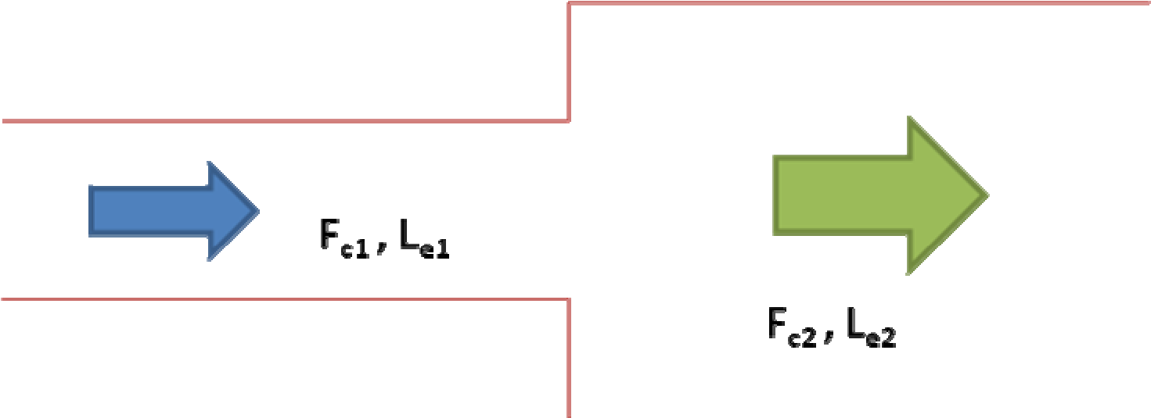 Figure 4 Transitions in Egress Component

When the width of the egress component changes, then the specific flow is also expected to change. The new specific flow is determined by the following relationship:

Fc1 = Fc2 Fs1 ⋅Le1 = Fs2 ⋅Le2
_{F}s2 = Fs1 ⋅Le1
Le2

Again, if the incoming specific flow rate leading to the transition point is greater than the capacity of the flow rate for the egress component leading from the transition (see the maximum specific flow rate in table 7), a queue is expected to form at the transition. Specific flow rate after transition is equal to the maximum flow rate which is likely to be actually found.

Impact of smoke on movement
The emergency movement speeds reported was derived from experiments and observations conducted in smoke-free environments. The remarks in the previous paragraph do not take into consideration the effects of dense smoke. Physiological effects of exposure to smoke have already been discussed previously. Behaviour effects given by seeing the smoke have to be discussed. In a smoke-logged corridor, people tend to turn back rather than continue through the smoke-logged area. In other situations, when people see fires behind them, they tend to move through the smoke.

The presence of smoke will impact movement in two ways:
- It can decrease the probability that occupants will move into an area or continue their evacuationF_{F}.
- It can reduce their walking speed: both the density and optic-irritating properties of the smoke can impact movement speed.

As a supplement on smoke effects, Table 6 taken from PD 7974-6:2004 “ Human factors: Life safety strategies –Occupant evacuation, behaviour and condition”:

Table 6 Smoke effects
Smoke density and irritancy Smoke optical density (Dm-1) | Approximate visibility Diffuse illumination | Reported effects
None Unaffected  0.5 (1.15) non irritant 2 m  0.2 ( 0.5 ) irritant Reduced  0.33 (0.76) mixed 3 m |  | Walking speed 1.2 m/s  Walking speed 0.3 m/s  Walking speed 0.3 m/s  30% people turn back rather than enter
Suggested tenability limits for buildings with:  Small enclosures and travel distances;  Large enclosures and travel distances; |  | D*m-1=0.2 (visibility 5m)  D*m-1=0.08 (visibility 10m)
Source: PD 7974-6:2004 “ Human factors: Life safety strategies – Occupant evacuation, behaviour and condition”

B₁₉

Annex E: Main characteristics of evacuation models

Evacuation modelling Review

During the last 35 years several researchers have written many reports concerning evacuation dynamics. Since from 1969 we have surveys describing:
- the movement of people – including disabled people,
- models for evacuation simulations,
- models which predict the effects of various fire products (heat, toxic and narcotic gases, etc.).

There have been several identifiable generations of evacuation models (which are all still in use):
- 1st generation models involve manual calculations applying mainly prescriptive assumptions;
- 2nd generation models employ computer based flow/hydraulic calculations;
- 3rd generation models use more sophisticated computers than simple flow/hydraulic calculations;
- 4th generations models are the actual state of art and consider several factors (which are discussed below).

Actually the main factors influencing the evacuation performance, and the main factors involved in evacuation modelling, are:
- the spatial configuration of the building (number of exits, exit width, travel distances, etc.),
- the procedures (training, knowledge, signage, etc.),
- the environment (smoke, toxic gases, debris, etc.),
- the human behaviour (response time, travel speeds, route finding, etc.).

All these factors interact and contribute to evacuation performance in a so complex manner, that the latest models have to employ numerical and computational processes involving the use of computers to simulate the evacuation process.

The attempts to simulate evacuation with computer modelling fall in two different categories: 1. the “movement and behaviour” models
2. the “ball bearing” models.

The first model takes in account both the physical characteristics of buildings (spatial configuration), and the characteristics and responses of the individual to the external stimuli produced by fire (reaction times, individual behaviour, etc.).
The second model considers people as “objects” which automatically respond to the external stimuli, treating the population within a building as a mass and not as an “individual”.

Within these categories we have further ways to represent:
- the buildings enclosures,
- the population and their behaviour,
- the simulation type.

The enclosures can be represented as “fine” or “coarse” network. In each method space is divided in sub-regions (or nodes): the size of these regions is the distinguishing parameter

The coarse node method considers the space divided into “segments” representing a whole room or passageway. The occupants movement is evaluated from segment to segment (e.g.: from room to room), without a precise definition of the their real position; so, the representation is less detailed

The fine node method divides the entire floor space in a collection of nodes (often several hundreds) with fixed size and shape (e.g. 0,5 x 0,5 squares). The occupants’ movement is evaluated from node to node; so the representation is more accurate regarding both the enclosures geometry (including obstacles) and the population, which can be treated as individual.

The population, instead, can be represented in an “individual” perspective or in a “global” perspective.

The individual perspective allows several attributes to be assigned to population, which can be used to define the movement and decision making process (if this feature is available). Therefore is possible to represent several population and to trace even a single egress history.

The global perspective does not recognise the individual attributes, defining population as a homogenous whole without differences. Therefore it is possible to establish only average results, representing evacuation details on the basis of the occupants who escape.

Finally, the simulation itself can be approached in three different ways: optimisation, simulation and risk assessment.

The optimisation models assume that people evacuate efficiently, making the best choice in every situation (evacuation paths are optimal), and that flow features of people and exits are optimal. They tend to consider only large population of occupants.

The simulation models try to reproduce the movement and behaviours observed during real evacuations. For these reasons the results tend to vary greatly, as does the accuracy which rely on the sophistication of the model.
The risk assessment model tries to identify the hazards of an evacuation in fire condition, quantifying the associated risks. This model needs many repeated tests with significant statistical variation.

Main characteristics of evacuation models
Evacuation models are hugely available on market. The choice of methods applicable to different design situations is very important.

Figure 1 Commercial simulation models
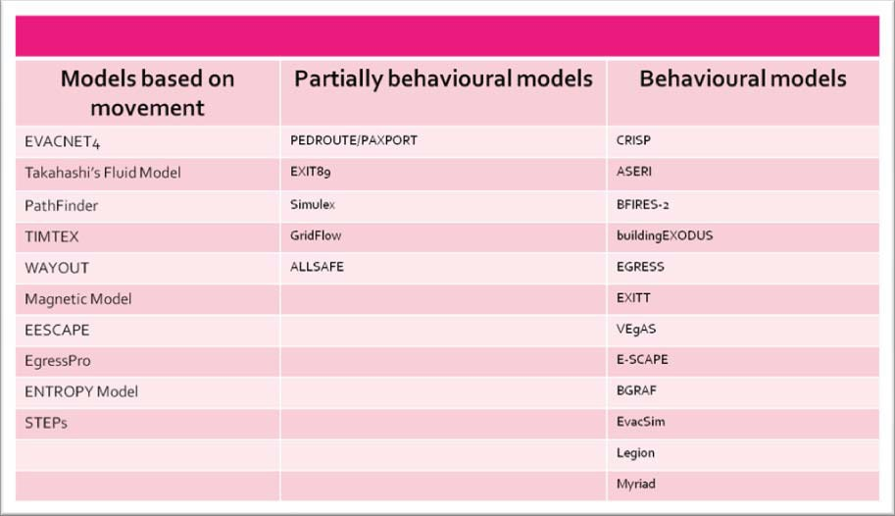

A best evacuation model for each situation does not exist.
The decision to adopt a particular model should agree with computer estimations and limitations.
In general, detailed outputs correspond more complex inputs and longer execution times. Internal parameters have to be distinguished from the external ones. In the model, some internal parameters may be modified (i.e. In fluid dynamics the dimension of the diagram and the time step).
External parameters give input rates. They may be distinguished into three categories:
- geometrical category (environmental dimensions, ventilation system and access between areas);
- set parameters: knowing about thermic release, velocity of mass reduction, fuel distribution;
- thermophysical category: for example, walls properties (conductibility, specific heat, density, etc.)

The following are some characteristics on simulation models which are useful to take into consideration for a better choice:

- documentation added to the model:

  - General information: general information has to report model deficiencies, particularly, model deficiencies about fire hazards. This is a very important point because the correct interpretation of results depends on it.

  - Users' technical and manual documentation: users should be able to know basic scientific references of algorithm. Technical documentation should give users useful information to understand the characteristics of the model:

    - definition of what kind of fire is, or the functions the model carries out;
    - description of theoretical and physical laws which are at the base of the model;
    - equations which rule the process;
    - identification of the most important hypothesis and their limits on application;
    - description of mathematical techniques and processes, and algorithms used;
    - list of auxiliary programs or data files needed;
    - information about data sources, contents and use;

- application on the different buildings: not all models can be applied to every kind of buildings:
    - Model used for the all buildings
    - Model for simulation of residential buildings
    - Model specialized in areas linked to public transport
    - Model to be used in buildings with the maximum height of 20 m
    - Model which allows simulation with just an evacuation exit.

3) Modelling method
- Not behavioural: just movements are considered.

- Implicit behaviour: models which study implicit behaviour, delaying reaction to the alarm (reaction time) or giving occupants characteristics which influence movements during evacuation.

- Conditional behaviour (or based on rules): individual or group of occupants reactions during evacuation, influenced by environmental conditions (“if-then” behaviour: “if” smoke density is higher then “nn”, “then” walking speed is reduced).

- Functional analogy: models using equations to represent occupants.

- Artificial intelligence: models basing on simulation of human intelligence.

- Probabilistic: models which use rules and conditional behaviour basing on probabilistic models. Repeating the same simulation more times, results may be different.

- Data on fire: It states if user can use information on the fire during simulation.
  - Model can have information on fire from other models.

  - Model allow user to insert data about fire, referred to specific times.

  - Model has a fire simulation model in it.

  - Model can not have information about fire; it simply simulates the fire (it is similar to a fire training simulates in a building)

- data visualization: it can visualize overcrowding and critical points in a building. It is a good way to control probable mistakes in the model. 1. 2-D – Bi-dimensional visualization

  - 3-D – Tri-dimensional visualization

  - N – Model with no ability to visualize

- validation: method which validates the software and test result rightness is very important.
  - Validation basing on norm.

  - Validation basing on data from fire prevention training and evacuation experiments.

  - Validation basing on data from literature about evacuation experiments.

  - Validation basing on other models.

  - Models with no validation suggested.

Detailed guidance on estimation of the effects of individual asphyxiates gases and the interactions between them are given in BS 7899‐2.
Proulx G., “Evacuation times and movement times in apartment buildings”, Fire Safety Journal, 24, 1995
PD 7974‐6:2004 “ Human factors: Life safety strategies –Occupant evacuation, behavior and condition”, reports approximately that occupants will not use an escape route if the visibility in that route is less than three meters.

