Dokument
ts betecknin
g
CFP
A
-
E Guideline No
17:2008
Fire safety in farm buildings

Foreword
The European fire protection associations have decided to produce common guidelines in order to achieve similar interpretation in European countries and to give examples of acceptable solutions, concepts and models. The Confederation of Fire Protection Associations in Europe (CFPA E) has the aim to facilitate and support fire protection activities across Europe.

The market imposes new demands for quality and safety. Today, fire protection forms an integral part of a modern strategy for survival and competitiveness.

This guideline is primarily intended for the public. It is also aimed at the rescue services, consultants, safety companies and the like so that, in the course of their work, they may be able to help increase fire protection in society.

This draft guideline has been produced by Arne Kallstenius of The Swedish Fire Protection Association, in cooperation with Björn Björkman, Secretary of The Swedish Fire Protection Committee of Agriculture, FPCA

This Guideline has been compiled by Guidelines Commission and adopted by all fire protection associations in the Confederation of Fire Protection Associations Europe.

Zurich, 26 May 2008 | Stockholm, 26 May 2008
CFPA Europe | Guidelines Commission
Dr Hubert Rüegg | Tommy Arvidsson
Chairman | Chairman

CONTENTS

1 Introduction 4
2 Systematic fire protection work 4
2.1 Action plan 5
3 Specific aspects of agricultural buildings 5
4 Electrical installations 6
5 Structural fire protection – compartmentation 7
5.1 Safety zone 8
5.2 Fire ventilation 9
6 Evacuation of livestock 10
7 Fire fighting equipment 11
8 Water supply for fire fighting 12
9 Fire alarm installations 12
10 Training 13
11 European guidelines 13

Introduction
Owing to rationalisation in agriculture, with production buildings and installations of increasing size, there has been an increase in fire risks, and today it is often assets of high value that are at stake.

Fires in the production buildings of agriculture are extensive. Mechanisation that has greatly increased over a number of decades, often without any safeguards, combined with extensive electrical and electronic installations, has had a negative effect on fire losses and fire risks.

Assets of high value are lost in connection with fires of increasing size, and one additional serious consequence is that far too many animals die in fires.

In some European countries, for example in the Nordic countries where the climate and fire protection rules impose stringent demands on buildings and installations, fire losses in agriculture make up about 10% of the total fire loss in society and of the costs associated with fire loss.

In many countries, because of the modern rescue services legislation, the responsibility for good fire protection rests on the individual farmer. It is therefore essential that the farmer should become increasingly aware of the importance of fire protection, and that fire protection advice and training should result in good fire safety, with a satisfactory level of protection suited to the circumstances and conditions of the farm.

The endeavour should therefore be good cooperation between agricultural organisations, rescue services and insurance companies, as well as others who are locally engaged in fire protection.

Research and experience – not least full scale tests – have shown that agricultural fires can be appreciably limited, often by relatively simple measures and means that have a good effect. Good fire protection need not be expensive if it is planned at an early stage.

This guideline – which has been drawn up with the objective of saving livestock and assets in agriculture – highlights a number of important action areas and appropriate measures that are of general application and should be aimed for. The Guideline does not cover self ignition.

Individual countries might have more stringent requirements for fire safetys than what is recommended in this guideline.

Systematic fire protection work
It is the responsibility of the owners of buildings and businesses to ensure that systematic fire protection work is undertaken. This also applies to farmers. Many farms also need to document their systematic fire protection work. The farmer him/herself must be able to carry out this documentation. An action plan must be drawn up to help the rescue service take the correct priorities in the event of fire and to facilitate fire fighting. See also Guideline No 1 – Internal fire protection control.

The objective of systematic fire protection work is to

- Serve as part of the operational plan of the rescue service
- Prevent fire
- Detect faults or shortcomings in the fire protection at an early stage - Make it easier for the correct action to be taken in the event of fire.

Action plan
The action plan must be available on the farm and must be handed to the rescue service when it arrives in the event of fire.

Examples of what information an action plan may contain are as follows:

− Drawings and sketches of buildings on the farm, including any compartmentation
− Where the livestock is kept and how evacuation is to be carried out
− What is most important to protect in a fire
− Where the main isolating switch is located
− Where gas or acetylene cylinders or ammonium nitrate (fertiliser) are kept − Where water is available and the water capacity – fire pond, river or lake

Specific aspects of agricultural buildings
Agricultural buildings are often close together, or made of unprotected timber constructions or other easily ignited material, and they often contain flammable equipment. Dry fodder, livestock bedding, grain or other materials with a high fire load density, which may give rise to very rapid fire spread or flashover, are often stored. They are also often exempted from various requirements in building legislation.

Agricultural buildings are also often situated at a great distance from the rescue service, which makes effective rescue action difficult. Owing to the long attendance time, it is necessary for the farmer to plan and carry out his/her own fire fighting action in order to avoid devastation.

It is therefore essential to reduce the extent of loss by good structural fire protection – appropriate safety zones between buildings – correct and sufficient fire fighting equipment – appropriate alarm systems and measures that facilitate satisfactory evacuation of livestock. It is also important continually to keep an eye on various kinds of objects that may start a fire, and to make these safe, in order to prevent the outbreak of fire. Fire resistant structures in agriculture should withstand fire and smoke for 60 minutes. This requirement may vary owing to differences in national regulations.
In most cases, fire starts in premises adjoining livestock housing, such as fodder stores, barns, haylofts, grain dryers, boiler rooms, machine rooms and farm workshops. It is therefore very important to prevent the spread of fire and also smoke to livestock housing, since it is fire gases that in most cases kill the animals and also make their evacuation difficult.

The most common causes of fire are related to faults in electrical systems, voltage surges due to lightning, mechanical equipment and various forms of heating and drying installations, as well as hot work that poses a fire hazard. Children playing with fire and arson also cause fires on farms.

Electrical installations
Electrical installations and electrical equipment in agriculture are subject to tough working conditions, since the environment is often harsh with e.g. large mechanical stresses, wide temperature variations, moisture and corrosive gases. With regard to various forms of electrical protection, reference should be made to the special regulations and conditions in the country concerned; these may vary considerably from country to country. Such protection may comprise different kinds of protection against overvoltages caused by lightning, earthing, earth leakage circuit breakers, enclosure classes and electronic protection, etc. Maintenance of all electrical installations in farms should be carried out by a qualified electrician. In some countries, special electrical handbooks have been issued for agriculture.

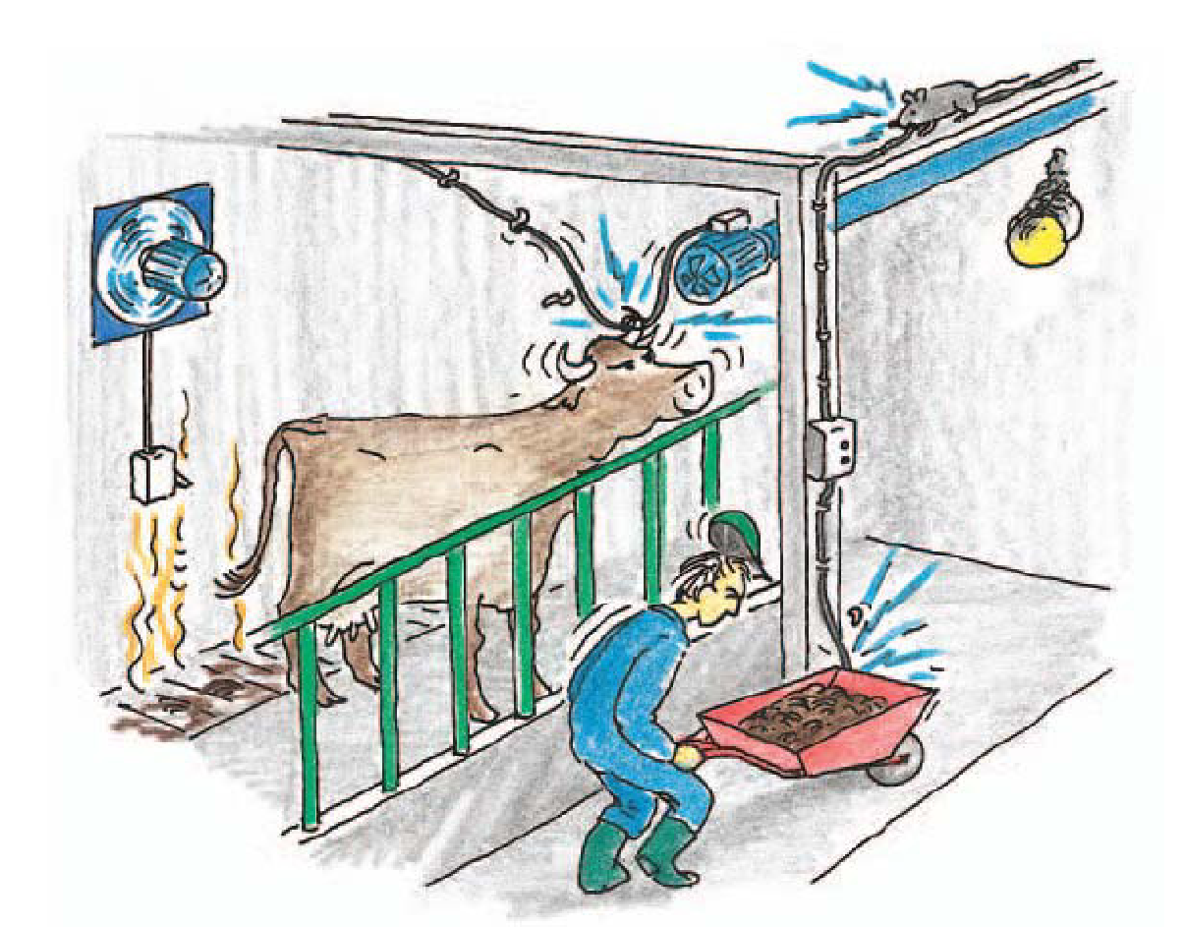 Electrical installations and the electrical equipment on farms are often subject to tough working conditions. Many mistakes can be avoided if the electrical contractor consults the farmer as soon as planning begins.

Structural fire protection – compartmentation
A building must be constructed so that the outbreak of fire is prevented, the spread of fire and smoke inside the building is limited, and people and livestock can be evacuated or rescued.

In order to prevent the spread of fire and smoke between rooms and premises in a building, structural fire protection measures are taken by dividing the building into fire compartments. Activities that present a fire hazard are separated by walls and floors of the appropriate fire resistance.

Compartmentation of buildings on farms which will prevent the spread of fire for 60 minutes may be carried out in many ways. The elements of structure separating compartments may consist of mineral wool insulation and building board on timber framing, or may be solid timber structures, or made of e.g. blockwork or concrete.

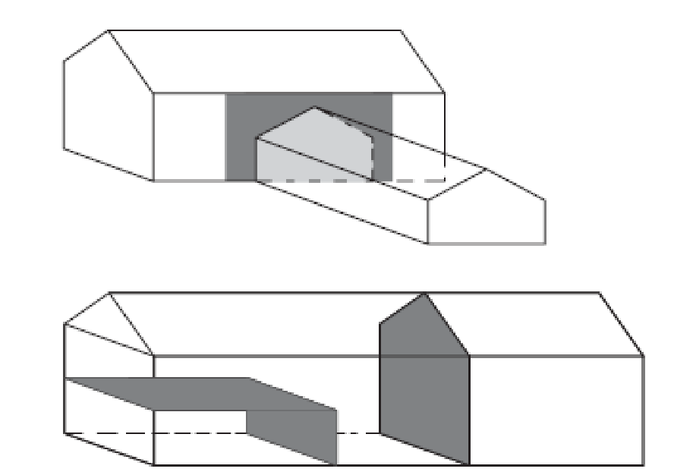
Buildings are divided into fire compartments, e.g. livestock housing, plant room, workshop, boiler room, garage and store building.

Most fires begin in rooms outside livestock housing. It is therefore important that rooms and spaces where there is a risk of fire should be separated from livestock housing and from other buildings and premises by fire resistant construction.

− Walls and floors in livestock housing which have a fire separating function should withstand fire and smoke for 60 minutes. This requirement may vary owing to differences in national regulations.
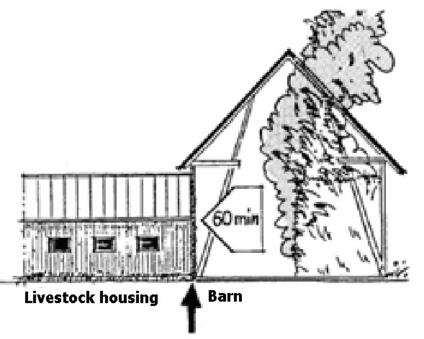
Livestock housing must be protected from fire for 60 minutes

− Walls and floors of fire resistant construction that separate garages, workshops, boiler rooms, or similar premises where work that presents a fire hazard is carried out, should prevent the spread of fire from the inside for 60 minutes. This requirement may vary owing to differences in national regulations.

− Ventilation ducts, doors, feeders, service openings etc between rooms presenting a fire hazard and livestock housing should resist fire and smoke for the same period as the walls and floors though which they pass.
− Inlet air for ventilation in livestock housing must not be supplied from rooms presenting a fire hazard or from a space outside the fire compartment containing the livestock housing.

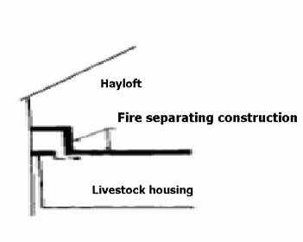
Opening for services, e.g. air intakes from a hayloft, must withstand fire and smoke for 60 minutes.

Safety zone
The spread of fire between buildings can be prevented by safety zones or by a comnbination of a safety zone and walls constructed to fire protection standard. To avoid the spread of fire between two or more buildings the roofs of the buildings should be constructed with non combustible materials.

− Farm buildings closer than 15 m from one another must be designed so that the spread of fire between the buildings is prevented for 60 minutes. Combustible materials should be stored at a distance of at least 15 m from buildings.

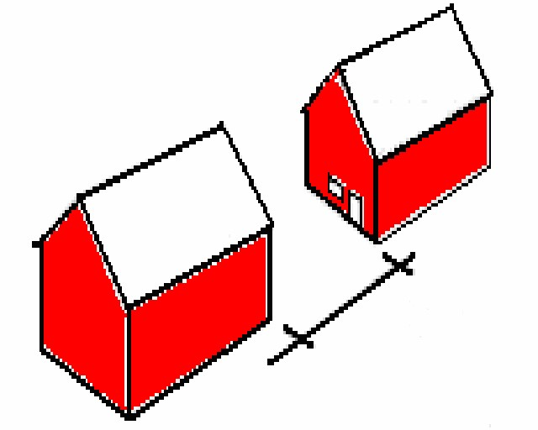
Compartmentation may be replaced by a safety zone

Fire ventilation
During a fire, pressure increases and temperature rapidly rises, and this increases the risk of the spread of fire and smoke. These risks can be limited by fitting fire vents on the roofs of barns and haylofts. In roofs of aluminium, fibre cement sheeting or plastics of low melting point, openings will form at an early stage and the products of combustion can be vented away. Fire vents should be sited as near ridges as possible.

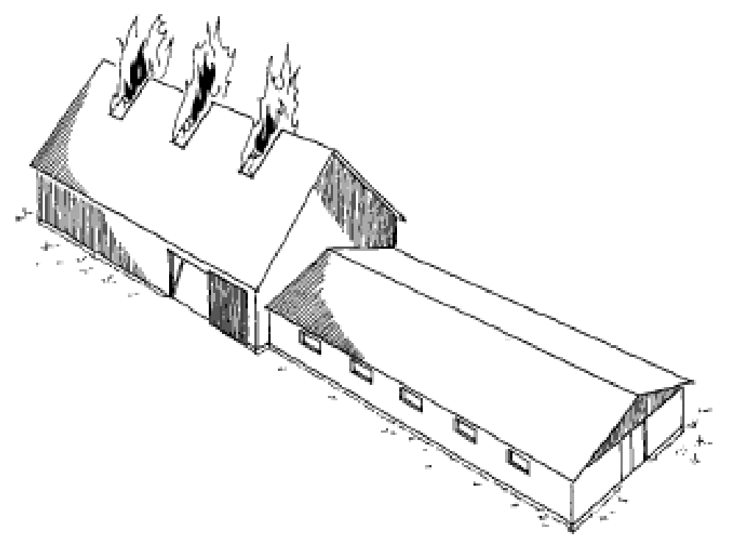
Fire ventilation prevents the pressure rise caused by a fire and hinders the spread of fire

Evacuation of livestock
It must be possible for livestock to be evacuated in the event of fire. If a fire is detected too late, efforts must therefore concentrate on saving the animals. Life is more important than property.

− Livestock housing must have at least two mutually independent exits to the outside, preferably facing in different directions.
− Exits should be located as far as possible from likely seats of fire such as fodder stores, buildings that present a fire hazard and stores of combustible materials.
− Gangways to the nearest exit or door opening into the external air should not be longer than 30 m. It makes evacuation easier if livestock can be driven into an enclosure separated from the building.
− Equipment in livestock housing must be designed so that it facilitates evacuation, e.g. openable front grilles or central release of the livestock, and for animals that are tied up there must be knives or bolt cutters available so that they can be quickly released.

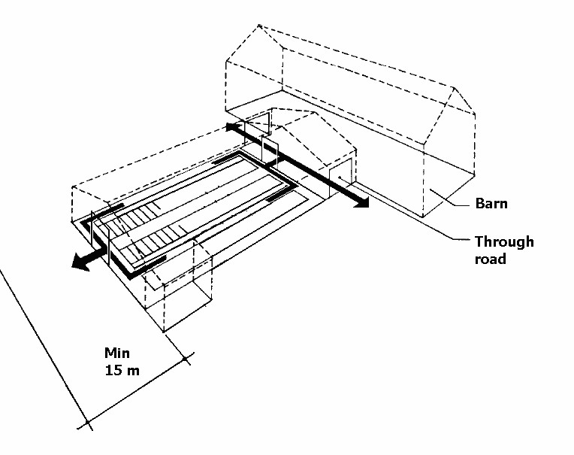
Livestock buildings must have two mutually independent evacuation routes

Fire fighting equipment
On-site fire fighting equipment in suitable places in farm buildings and on some machinery is essential for controlling a fire and saving both livestock and economic assets. On a farm this is particularly important because of the long distance to the rescue service.

Experience shows that a large number of major fires are prevented each year through rapid deployment of the farm’s own fire fighting equipment.

The fundamental principle concerning fire fighting equipment on a farm is that the farm’s own equipment should be readily available in or near premises that present a fire hazard, flammable equipment, and in conjunction with the handling of flammable materials.

− In a livestock building or other premises or equipment that present a fire hazard, fire fighting equipment must be available.

The two most appropriate types of fire fighting equipment on a farm are a hose on a central hosereel installed in frostfree livestock buildings and premises, and dry powder exrtinguishers for other premises and equipment.

The reason that powder is recommended in portable fire extinguishers is that this extinguishing medium is suitable for most materials to be found on a farm, such as hay, straw, cardboard, cloth, plastics, electrical equipment, motors, and for flammable liquids such as petrol, oil and fats.

− One good rule is that the distance to fire fighting equipment in a building where activity that presents a fire hazard is carried out should not exceed 15 m.
− A hose on a central hosereel is most suitable in frostfree livestock buildings and for buildings where fodder is prepared, barns and haylofts etc which can be easily reached from a hosereel located in the livestock building. The hose must be so long that it can reach every possible seat of fire. In large livestock buildings it may be necessary to have several hosereels.

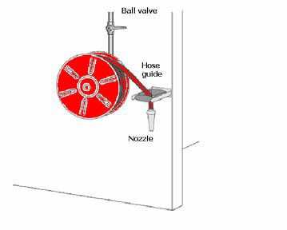
A hose on a central hosereel in livestock buildings and frostfree premises should be located
near doors opening into fodder preparation rooms etc

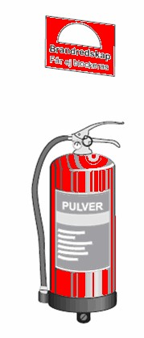
For portable fire fighting equipment, it is recommended that a powder extinguisher of
class 34A 233 BC or higher should be selected
− Powder extinguishers are recommended in other premises and for equipment or activity that presents a fire hazard, such as hot work, and for self propelled machinery. They should be of class 34A 233B C or higher, should contain not less than 6 kg extinguishing agent, and be certified and subject to regular maintenance

To ensure that fire fighting equipment has the necessary reliability and effectiveness, the equipment must be maintained according to the national rules and the manufacturer’s instructions.

Water supply for fire fighting
The rescue service and the farmer must be aware of the problems in supplying water for fire figting since fire on farms normaly needs a lot of water. It is best to consult the authorities on this subject. Examples of sources of water that may be used are fire ponds, lakes or nearby rivers. The action plan must contain a description of these.

Fire alarm installations
Most buildings on a farm have a high fire load density. Because of this, a fire often develops very rapidly. The time available for fighting the fire, saving livestock and preventing the spread of fire to other buildings is relatively short.

In order that a fire may be detected at an early stage, it may be best to equip rooms in farm buildings with automatic fire alarms which give an alarm rapidly, in the first place to people on the farm itself.

Fire alarms intended for dwellings do not, without special measures, stand up to the aggressive environment in the production buildings on the farm. Therefore special alarm installations have been developed (in the northen countries) which are designed for the needs and conditions of agriculture.

In some large livestock buildings and in places where there are special requirements or assets of high value, requirements may be imposed regarding alarm installations.

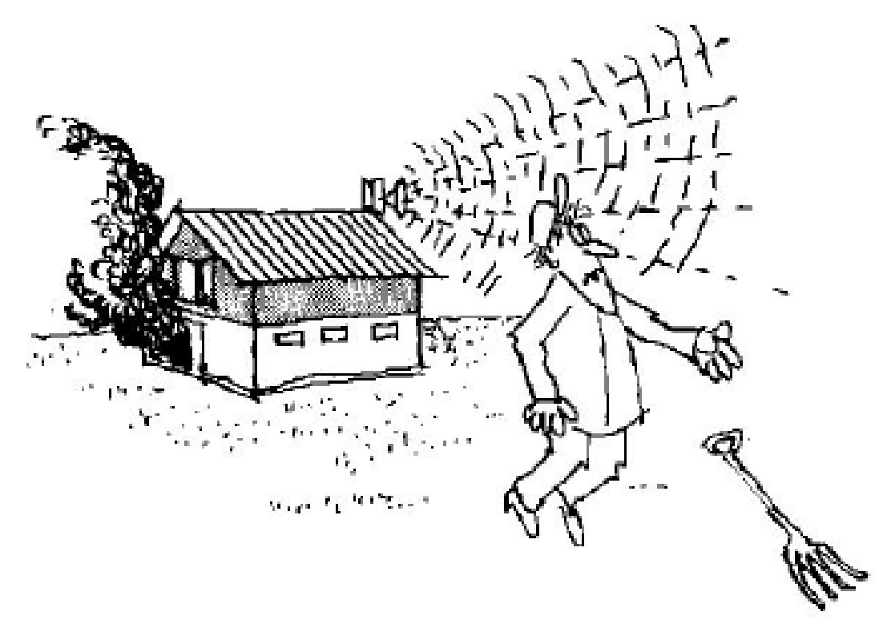
An alarm installation makes it possible for a fire to be detected rapidly and promotes
effective fire fighting action at an early stage

Training
In many countries, because of the modern rescue services legislation, the responsibility for good fire protection rests on the individual farmer. It is therefore essential that the farmer should become increasingly aware of the importance of fire protection, and that fire protection advice and training should result in good fire safety, with a satisfactory level of protection suited to the circumstances and conditions of the farm. The farmer and his employees must have regular exercises in fire protection and how to act in case of fire.

European guidelines
Guideline No 1:2002 - Internal fire protection control
Guideline No 2:2007 - Panic & emergency exit devices
Guideline No 3:2003 - Certification of thermographers
Guideline No 4:2003 - Introduction to qualitative fire risk assessment
Guideline No 5:2003 - Guidance signs, emergency lighting and general lighting Guideline No 6:2004 - Fire safety in residential homes for the elderly
Guideline No 7:2005 - Safety distance between waste containers and buildings
Guideline No 8:2004 - Preventing arson – information to young people
Guideline No 9:2005 - Fire safety in restaurants
Guideline No 10:2007 - Smoke alarms in the home
Guideline No 11:2005 - Recommended numbers of fire protection trained staff
Guideline No 12:2006 - Fire safety basics for hot work operatives
Guideline No 13:2006 - Fire protection documentation
Guideline No 14:2007 - Fire protection in information technology facilities
Guideline No 15:2007 - Fire safety in guest harbours and marinas
Guideline No 16:2008 - Fire protection in offices
Guideline No 17:2008 - Fire safety in farm buildings

