CFP
A
-
E No 15:2010 F

Fire Safety in Guest Harbours and Marinas

FOREWORD

The European fire protection associations have decided to produce common guidelines in order to achieve similar interpretation in the European countries and to give examples of acceptable solutions, concepts and models. The Confederation of Fire Protection Associations in Europe (CFPA E) has the aim to facilitate and support fire protection activities across Europe.

The market imposes new demands for quality and safety. Today fire protection forms an integral part of a modern strategy for survival and competitiveness.

The guideline is primarily intended for the public. It is also aimed at the rescue services, consultants, safety companies and the like so that, in the course of their work, they may be able to help increase fire safety in society.

The proposal of this guideline have been produced and revised by The Norwegian Fire Protection Association and the author is Øyvind Engdahl from Norway. This guideline is revised by Kjell Schmidt Pedersen from Norway.

This guideline has been compiled by Guidelines Commission and adopted by all fire protection associations in the Confederation of Fire Protection Associations Europe.

These guidelines reflect best practice developed by the countries of CFPA Europe. Where the guidelines and national requirement conflict, national requirements must apply.

Zürich, 7 April 2010 | Stockholm, 7 April 2010
CFPA Europe | Guidelines Commission
Dr. Hubert Rüegg | Tommy Arvidsson
Chairman | Chairman

1 Introduction 4
2 Scope 4
3 Definitions and comments 4
4 Description of the subject, -recommendations 5
4.1 Guest harbours 5
4.1.1 Generally 5
4.1.2 Fire Risk Assessment 5
4.1.3 Fire precautions in guest-harbours 5
4.1.4 The placing of boats in the guest harbour 5
4.1.5 Fire extinguishing equipment 6
4.1.6 Routines if a fire occur and if the fire risk is increased 6
4.1.7 Information to the guests 7
4.2 Marinas 7
4.2.1 Generally 7
4.2.2 Regulations 7
4.2.3 Safety precautions 7
4.2.4 Training of the staff. (Common for Marinas and Guest Harbours) 7
4.2.5 Access for the fire brigade and other rescue units, water supply. (Common for Marinas
and Guest Harbours) 8
4.3 Yards for on land storage of pleasure boats 9
5 Reference Publications 9
6 European guidelines 9

Introduction
Fires and explosions in pleasure boats are feared incidents. Especially on board a boat with narrow fitting up, limited place and evacuation possibilities a fire might cause tragic followings. The elements of risk in such premises consist mainly from highly combustible materials, storage and use of flammable gas for cooking and heating and storage of fuel for the machinery. So far the European communities have been spared for devastating fires in guest harbours an marinas, but the risk exist that a large fire might occur. The risk includes also danger of injuries and fatalities.
Fires in pleasure boats do occur regularly, but if it should occur at night-time in a narrow guest harbour, personal injury and heavy material damage might be the result.

Scope
This guideline is meant for guest harbours for yachts and leisure boats of smaller or medium size, up to 35 - 40 feet (about 12 - 13 metres) and yards for on land storage of the boats. On land storage in this context is limited to storage of one by one boat on scaffolds and poles. Storage in “boat hotels” of several storeys is considered to be in buildings and should be treated accordingly.

The aim of this guideline is to prevent injuries, loss of life and loss of property in fires on board pleasure boats or in marinas. It will recommend fire precaution measures taken by the owner of the harbours, and measures the guests may take to protect themselves from fires and explosions when they are visiting a harbour.
These precaution rules will also be useful to prevent fires in boats out on the sea.

Definitions and comments

Marina:
Harbour arranged for fuelling of boats. May also be used as a guest harbour or a place where the public may hire a boat.

Guest harbour:
Harbour where pleasure boats may come at anchor and stay overnight. The harbour is mostly guarded and is equipped with reception, toilets, showers and kiosks. The guests have to pay a fee for the service.

Leisure boat:
A boat or yacht to be used for leisure time, weekends and holidays.

Description of the subject, -recommendations

Guest harbours

Generally
Like camping sites guest harbours also represent the possibility of severe fires with threat to human life and property. Pleasure boats are mostly made of combustible plastic and having an engine fuelled by gasoline and cooking device using propane, you might have an incendiary bomb. The owner of the harbour is responsible to get hold of appropriate and sufficient fire fighting equipment easy to get at the site and announce fire precaution rules on placards.

Fire Risk Assessment
The owner or staffs of the guest harbour have to work out a risk analysis for the harbour dealing with emergencies as fires, drowning and other accidents. The risk assessment should also deal with precautions on how to prevent fires and accidents in the harbour. (See next chapter 4.1.3.)

Fire precautions in guest-harbours
The intention of the fire precaution rules in this chapter are to reduce the risk for spreading fire to neighbouring boats and reduce the consequences if a fire should be breaking out. The greatest risk for fire spreading between boats is at night time when people are sleeping and the time for discovering and fighting the fire is delayed.
Fires in guest-harbours happen mainly in the boats and people are hurt from a fire in their own boat. It is therefore the individual owner who can diminish the risk of a fire in his own boat by having relevant fire-fighting equipment on board.

The responsible staff at the guest harbour might undertake different fire precaution tasks to satisfy a good fire protection in the harbour. The following general advice will deal with the most important effort in this work.

As a part of the systematically work for the guest harbour, it should be found a plan of the establishment where the maximum number of boats is stated and the placing of these.
The systematically fire prevention work might also deal with the removal of boats in case of a fire, where the fire-fighting apparatus are placed and the checking of this, access for the fire brigade and routines if a fire should occur.

The placing of boats in the guest harbour
In the guest harbour the boats must be placed in a way that the spreading of a fire is hindered and the removal of boats is ready in the case of a fire. The boats are to be placed so that they can be reached by the harbours fire extinguishers. In this intention no more than three boats may be made fast alongside outside each other.

It is often difficult to create a sufficient distance between the boats also where they are berthed direct to the quay and therefore the number of boats in one section should be reduced. Where boats are berthed with the bow or the stern against the quay, it is necessary to make a partition at each twenty-five meters or at each 8 – 10 boats. The partition should make a free distance of at least five meters or about two boat-widths.
A safe distance may also be obtained by erecting minor piers with moorings only for about 6 – 8 boats, or for bigger piers make fixed distances between the boats by using so called Y-booms.

Berthing alongside other boats makes it difficult to reduce the number of boats as it in principle is possible to continue to berth boats outside each other as long as there is free water-surface in the harbour. This may complicate the access with fire equipment from the quay, and the moving of boats away from the fire sufficient fast could be hindered.
Another solution might be if only two and two boats are berthed alongside each other.

Fire extinguishing equipment
Fire extinguishers must be available if there is a risk for a spreading of fire between the boats. The extinguishers must be able to be used by the boat-crews.
Fixed extinguishing equipment should be established in harbours containing 80 boats or more. The equipment should be placed with good visibility at each pier and in connection with a reception or a service-establishment. It might if possible be placed together with other equipment for life saving or emergency.
If fixed extinguishing equipment is established, it should be placed in a way that it could be used of every boat in the harbour. If fire extinguishers are used, the distance between the equipment and the boats should not exceed 50 m.
Guest harbours which from time to time are visited by a great number of boats which makes the required berthing complicated should be equipped with additional extinguishers and/or establish night watch.
Boats which are used for overnight accommodation should have smoke alarms and fire extinguisher installed.
Fixed extinguishing equipment with fire hoses should have a capacity of at least 50 l per min. with a pressure of 0,6 Mpa.
Fire extinguishers should be of dry powder type with a content of 6 kg.

The marking of the equipment should meet the national requirements and standards.

Routines if a fire occur and if the fire risk is increased
Written instructions on how the responsible personal have to react if a fire should occur must be accessible. These instructions should contain how to:
- Alert the guests in their boats
- Alert the fire brigade
- Move the boats
- Fire fighting
- Reduce the damage

The personal should also have routines for the cases where the fire risk is increased by too many boats in the harbour. In these cases additional night watches should be established.

Information to the guests
The guests should be informed about fire prevention in the harbour, how to avoid fires, how to fight a fire, placing of fire equipment, alerting other guests, the staff and fire brigade and how to move the boat to a safe place.

Marinas

Generally
A marina may be like a boat harbour where it is possible to tank up the boats fuel tanks with gasoline or diesel. It might also be possible to fill up propane bottles for cooking or heating appliances. In many marinas it is also possible to rent a boat for a trip on the sea.

Regulations
The national authorities make their own demands regarding the planning, construction and operation of plants that deliver engine-fuels.
The authorities are also making clear demands regarding the personnel who shall establish and operate a plant for fuelling. It is mandatory that the responsible personnel knows the regulations very well and realize the commitment which follows the rules.

Safety precautions
The same safety precautions mentioned above in chapter 4.1 are also valid for marinas. In addition the following precautions should be taken into consideration:
- Everybody staying at a plant for fuelling is obligated to act carefully to prevent fires and explosions.
- Everybody is obligated to act in accordance with displayed instructions.
- The responsible personnel should verify that the plant satisfies the respective regulations.

Marinas should be developed in such a way that boats are not able to drift under the quay when fuelling. Boats should be moored in a way so it quickly could be shifted if an emergency situation should occur, and other boats should not be moored at the marina that could cause problems with shifting in such a situation.

A sufficient number of extinguishers suitable for flammable liquids should be placed at easily accessible places on the plant.

Training of the staff. (Common for Marinas and Guest Harbours)
The responsible staff of a guest harbour or a marina should be trained in:
- how to prevent fires, explosions and other accidents,
- how to act if a fire or an explosion should occur and to alert and rescue the guests
- how to alert the fire brigade,
- how to operate the fire hoses and extinguishers.
A risk analysis and an emergency plan should be worked out and exercises and training should be made twice every year. The analysis should contain all the above mentioned spots and point out where the risk for a fire or other accidents is most probable. Measures to reduce the risk should be considered.
Fire safety signs referring to emergency equipment, assembly points, fire alarms, phone number to emergency units, etc. must be placed round about the plant.
A documentation containing all control points and how they are fulfilled should be prepared and kept for the supervision of the authorities.

See also Guideline no 1:2002 – Internal Fire Protection Control.

Access for the fire brigade and other rescue units, water supply. (Common for

Marinas and Guest Harbours)
If a fire or accident should occur, it is important that the fire brigade have a good access to every part of the guest harbour or marina. Consult the fire brigade to get the necessary information about the width, height and axle load of their fire engines and the minimum swing radius they can manage. On the plant there must be arranged for places where the vehicles can be lined up. The access routes must be free of obstacles and parked cars.

It is also important to decide the maximum distance to the water supply (hydrants or cistern). The water supply must give the necessary quantity of water and pressure.

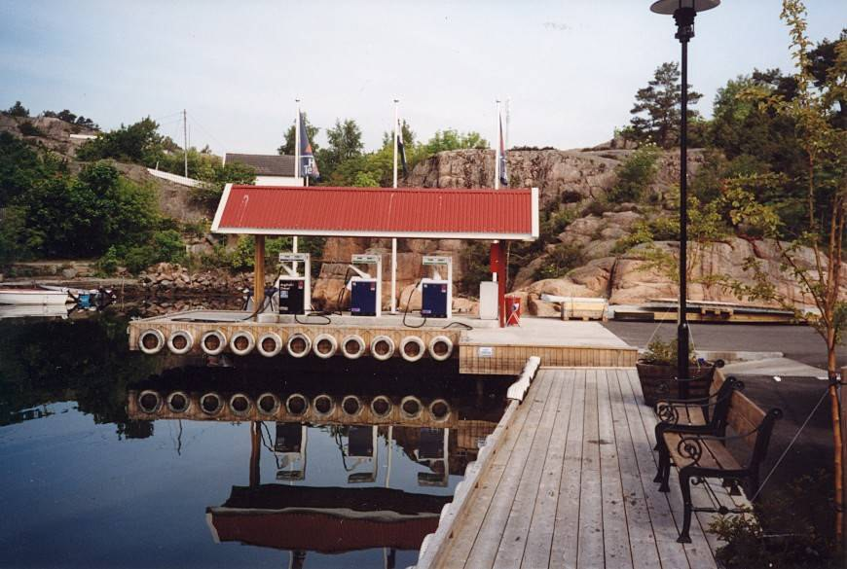

Marina for fuelling of boats, Lyngør Norway

Yards for on land storage of pleasure boats
On land storage in this context is limited to storage of one by one boat on scaffolds and poles. Storage in “boat hotels” of several storeys is considered to be in buildings and should be treated accordingly.

The storage shall be inspected by personnel responsible for the storage prior to approval of the storage of each boat. The inspection shall ensure the removal of any gas canister and portable fuel can, that batteries are disconnected and that fixed fuel containers are either empty and ventilated or at least 95% full.

Hot work shall only be performed by personnel educated for the activity.

Unattended battery charging shall not be permitted.

The distance between the boats should preferably be 4m. The boats should be located in blocks of 30 boats each and with a distance of 8m between the blocks. The distance between any boat and any building should be 8m.

Fire extinguishing equipment should be located in every block of 30 boats in an easy visible and accessible location.

The owners of such yards should consult the official fire brigade to establish the needed access routes of the fire brigade.

Reference Publications

- Statens Räddningsverks allmänna råd om brandskydd i gästhamnar (remiss).
- Direktoratet for samfunnssikkerhet og beredskap (DSB): Campingplasser og gjestebåthavner.(Camping sites, Marinas and Guest Harbours). 3. The Norwegian Building Regulations
- The Norwegian Fire Regulations
- Brannskydd i samband med landförvaring av fritidsbåtar. Rapport 5295. Lunds Tekniska
Högskola, Lunds Universitet. 2009

European guidelines
Guideline No 1:2002 F - Internal fire protection control Guideline No 2:2007 F - Panic & emergency exit devices
Guideline No 3:2003 F - Certification of thermographers
Guideline No 4:2003 F - Introduction to qualitative fire risk assessment
Guideline No 5:2003 F - Guidance signs, emergency lighting and general lighting
Guideline No 6:2004 F - Fire safety in residential homes for the elderly
Guideline No 7:2005 F - Safety distance between waste containers and buildings
Guideline No 8:2004 F - Preventing arson – information to young people
Guideline No 9:2005 F - Fire safety in restaurants
Guideline No 10:2008 F - Smoke alarms in the home
Guideline No 11:2005 F - Recommended numbers of fire protection trained staff
Guideline No 12:2006 F - Fire safety basics for hot work operatives
Guideline No 13:2006 F - Fire protection documentation
Guideline No 14:2007 F - Fire protection in information technology facilities
Guideline No 15:2010 F - Fire safety in guest harbours and marinas
Guideline No 16:2008 F - Fire protection in offices
Guideline No 17:2008 F - Fire safety in farm buildings
Guideline No 18:2008 F - Fire protection on chemical manufacturing sites
Guideline No 19:2008 F - Fire safety engineering concerning evacuation from buildings
Guideline No 20:2009 F - Fire safety in camping sites

