European guideline

Smoke alarms in the home

-Guidelines
Foreword
The European fire protection associations have decided to produce common guidelines in order to achieve similar interpretation in European countries and to give examples of acceptable solutions, concepts and models. The Confederation of Fire Protection Associations in Europe (CFPA E) has the aim to facilitate and support fire protection activities across Europe.

The market imposes new demands for quality and safety. Today, fire protection forms an integral part of a modern strategy for survival and competitiveness.

This guideline is primarily intended for the public. It is also aimed at the rescue services, consultants, safety companies and the like so that, in the course of their work, they may be able to help increase fire safety in society.

The proposal for this guideline has been produced by The Norwegian Fire Protection Association and the author is Øyvind Engdahl from Norway.

This Guideline has been compiled by Guidelines Commission and adopted by all fire protection associations in the Confederation of Fire Protection Associations Europe.

Zürich, 23 September 2005
CFPA Europe

Dr Hubert Rüegg
Chairman

Stockholm, 23 September 2005
Guidelines Commission

Tommy Arvidsson
Chairman

Contents

1 Introduction 4
2 Scope 4
3 Definitions and comments 5
4 Smoke alarms: How they work 7
4.1 Smoke 7
4.2 General 7
4.3 Detection principles 7
4.4 Choice of smoke alarms 8
5 Smoke alarms: how many do I need? 9
6 Detection systems for the elderly and disabled 10
7 The smoke alarm in place 10
7.1 Placement 10
7.2 Testing 11
7.3 Maintenance 11
7.4 Replacing the batteries 12
8 Quality requirements 12
9 Radiation exposure from ionisation smoke alarms 12
10 Reference sources 13
11 Guidelines published by CFPA Europe 13

Introduction
If fire breaks out in your home, early warning is essential if you and your family are to escape its potentially tragic consequences.

A discarded cigarette end, or overheated electrical wires in the walls of your home, can smoulder for hours without your ever knowing it. If you are warned at a very early stage, your chances of escaping or putting out the fire would be very much improved. Once flames break out, your home can be engulfed by fire in a few minutes and the opportunity to save the lives of your family or yourself will be gone. The toxic gases produced by a smouldering fire are also a great threat to life.
Escape is only possible if you are warned of the fire in time.

Statistics indicate that the incidence of fires in dwellings has been increasing steadily in recent years, with the most serious fires occurring between midnight and 6.00am, when most people are asleep and consequently when there is the greatest danger to the occupants.

The best way to get early warning of a fire is to install one or more smoke alarms in your home.

In some European countries installation of smoke alarms has become mandatory. For example, in 1987, as a measure contained in new building regulations in Norway, smoke alarms became compulsory in all new dwellings. And from 1990, under the new fire precautions regulation, smoke alarms had to be installed in all homes, cottages and cabins in Norway. . It is estimated that the presence of smoke alarms in the home have reduced annual fire deaths by between 20 to 30% in Norway.)

Smoke alarms shall comply with the requirements of CEN standard EN 14604: Smoke alarm devices, having been tested to and meeting the requirements of the standard.

Scope
The aim of this guideline is to prevent injuries, loss of life and loss of property in fires in the home.
It proposes the installation of one or more domestic smoke alarms in a dwelling (they are suitable for a wide range of domestic premises, including mobile homes.

There follows a longer list of definitions but essentially a domestic smoke alarm is a batterypowered device which attaches to the ceiling in a dwelling and is designed to detect smoke particles in the air and to signal that detection by emitting a loud, piercing sound. In this Guideline the term ‘smoke alarm’ is used but ‘smoke detector’ is an acceptable alternative.

In some countries the use of such alarms is permitted in smaller kindergartens in the absence of a professional fire detection and alarm system.

For larger blocks of flats and similar buildings with complicated emergency exits, and certainly in industrial and commercial buildings, professional fire detection and alarm installations are recommended.

Definitions and comments
See also EN 14604 for additional terms and definitions.

Single-station smoke alarm: A detector operating with its own electricity source (battery) and giving warning with its own alarm-horn when it detects smoke. This smoke alarm contains all the components necessary for detecting smoke and for giving an audible alarm. The internal power source shall be replaceable by the user unless its operating life is designed to be 10 years or more.

Optical smoke alarm (OSA): A detector which operates by detecting how a beam of light is scattered by smoke particles; it contains no radioactive source.

Ionisation smoke alarm (ISA): A detector which contains a small radioactive source in an integral ionisation chamber designed to effect the detection of smoke particles. (Note: Ionisation
detectors are not permitted in some European countries. National requirements for radiation protection differ from country to country and are not dealt with in this Guideline. Smoke alarms must, nevertheless, be chosen in compliance with national requirements.)

Built-in battery: Some smoke alarms have a built-in battery which cannot be changed. Such a unit can have a lifetime of about 10 years.

Central power supply: Some smoke alarms are connected to a central unit for power supply. Such an arrangement may have additional benefits in terms of operational functions.

CO detector: A detector designed to give an alarm when carbon monoxide (CO) in the atmosphere which is being monitored reaches a certain level in a short time. (Long-term exposure to a low level of carbon monoxide is of concern, especially for the elderly and those with heart and respiratory problems.) A CO detector is no substitute for a smoke detector, being designed for a different purpose.

Combined smoke alarm: A device which comprises both an optical and an ionisation detector in combination.

Connection in series: A smoke alarm can be connected together with other equivalent units so that the alarm signal is given at the same time from all connected alarms. (The alarm manufacturer may give advice about the maximum number that can be connected in this way.)

Emergency (escape) light: Some smoke alarms are equipped with a built-in lamp which lights up at the same time as the alarm signal sounds to aid escape.

Inter-connectable smoke alarm: A smoke alarm which may be connected to other such devices to provide a common alarm system across a wider area. The manufacturer’s installation information shall state the maximum number that may be connected. See also Central power supply.

Light indicator: Some smoke alarms have a flashing light which shows that the detector has adequate battery voltage. Some smoke alarms have a number of light indicators, normally a green light to indicate mains-on, red to indicate an alarm and amber or orange to indicate a fault.

Low-frequency sounder: A smoke alarm which has an alarm-signal with low-frequency sound which is perceived better by people with impaired hearing.

Power source: The power source for a domestic smoke alarm may be internal or external to the alarm housing. An internal power source (battery) shall be capable of powering the alarm for at least one year. The alarm shall give an audible signal to indicate that the battery has lost power and has reached the level where it needs replacing.

Relay: A smoke detector may be equipped with a relay output with a switch function which may activate other equipment on alarm.

Ten-year battery unit: Some smoke alarms have a built-in battery which cannot be changed. The unit has an expected lifetime of about 10 years.

Test facility: All smoke alarms shall be provided with a test facility to simulate the presence of smoke in the sensing chamber. The test feature shall be accessible from outside the smoke alarm and should be operated on a routine schedule.

Traveller’s smoke alarm: A portable smoke detector, made for travel purposes and not recommended for fixed mounting.

Wireless: A smoke alarm which contains a small radio transmitter which can transmit the alarm signal wireless to a central unit or to other equivalent units.

Note: See also new European standard in progress pr EN 14604. The definitions above might not be in accordance with this standard.]

Smoke alarms: How they work

Smoke
Smoke is a suspension of solid (or, sometimes, liquid) particles in a gaseous medium and the particles may vary in size from approximately 1 nanometre (1 x 10-9m) to 10 micrometres (10 x 10-6m). Depending on the particle size and upon its chemical composition, smoke may vary in colour from colourless to black.

Smoke from clean-burning, flaming fires will contain particles of smaller size and will be invisible, while smoke from slow-burning, smouldering fires will be of larger particle size and will be visible because it is capable of both scattering and absorbing light.

General
Most people who die in fires are killed in their own homes by smoke inhalation, and generally at night when they are asleep. It is, therefore, important to install smoke alarms in all homes. These smoke alarms have to be installed in such a way that the alarm signal can be heard in the bedrooms where people are sleeping.

The packaging in which a smoke alarm is sold should indicate that the alarm has been tested and approved to an appropriate national standard and the alarm should come with a set of detailed instructions for the user. The instructions should give information about the detection principle, suitability for use in the home, and advice concerning suitable location in addition to inspection, cleaning and regular testing.

Detection principles
Domestic smoke alarms are small, independent units with a built-in system for detecting smoke and giving alarm about a potential fire. Smoke particles moving through the air will be sensed by the device when they are conveyed into its detection chamber. The detection of these small particles is possible in two different ways, depending on the type of smoke alarm:

4.3.1 Optical smoke alarm (OSA): smoke particles from a burning object enter a dark detection chamber and are there illuminated by a narrow beam of light from a light-emitting diode. The particles scatter the light in all directions and some of the scattered light falls upon a light-sensitive unit (photo diode) which triggers the alarm (see Figure 1).

Light-Emitting Photo Diode Light-Emitting Photo Diode
Diode Diode

Figure 1. The operation of an optical smoke detector.

4.3.2 Ionisation smoke alarm (ISA): air is contained between the references and sensing chambers of an ionisation smoke detector, the surfaces of which are designed to act as oppositely charged electrodes. The device also contains a small quantity of an ion-emitting radioactive source, which ionises air between the two chambers, so causing a small current to flow between them (see Figure 2). Smoke particles from a fire or smouldering site interfere with the movement of the ions, reducing the current, and this reduction is sensed by the detector which triggers an alarm.

Ionisation detectors/alarms should be marked with the international symbol for radiation hazard and can be identified thus.

It is important to follow the national rules for recognition of such devices and readers should be aware that ionisation alarms are not permitted in some European countries. See also section 9.

Sensing ChamberSensing Chamber
-
-
-
+
+
+
+
(Voltage Increasing)
Source
Reference ChamberReference Chamber
(Voltage Decreasing)

Figure 2. The operation of an ionisation smoke detector.

Choice of smoke alarms
Optical smoke alarms (OSA) and ionisation smoke alarms (ISA) have different reactions with certain types of smoke particles and these differing reactions play a part in the choice of detector.

The size of smoke particles is an important factor in detection. The response of an OSA depends on the size and optical scattering properties of smoke particles, while the response of an ISA is influenced by the number of smoke particles in the volume.

Both types of smoke alarms are usually equipped with a battery which provides energy for their electronics and alarm units. Some models offer the facility of connecting a number together, for single-unit detection but multi-unit alarm signalling, while some may be connected to the mains electrical supply for power.

There are no firm rules for the choice of type of domestic smoke alarm.

Optical alarms can be activated by a wide variety of fires but are better at detecting smouldering fires and the kind of dense smoke emitted by foam-filled furnishings.

Ionisation detectors also react to a wide range of fires and in particular to fast flaming fires which do not produce much dark smoke. They respond slightly less quickly to smoke from smouldering fires.

Smouldering fires
With combustible materials in common use as furnishing textiles and in upholstered furniture, often in close proximity to domestic electrical equipment, experience shows that many a fire in the home starts as a smouldering fire. This is a typical smoke-producing fire, starting from a little glow or flame that develops and spreads rather slowly. The smoke development can, however, be strong and the smoke can contain poisonous gases. The smoke circulates slowly in the compartment of origin and beyond and develops large soot particles which often cool to room temperature and do not reach the ceiling.

In spite of the general statement about suitable applications in 4.3, it is the case that in fires like this it has turned out that both OSA and ISA have failed to operate.

If there is only one detector in the house, the smoke might have to move a long distance (and slowly, possibly, if the source is a smouldering fire) before it reaches the smoke detector. This speaks for the installation of more than one smoke alarm.

Other situations
In surroundings where the smoke alarm might be exposed to strong draught, damp air or air from a kitchen stove or bath room, smoke alarms might mistake such circumstances for an alarm situation. It is therefore strongly recommended to keep smoke alarms away from such rooms.

Fires can start easily with readily ignitable, combustible materials like paper, curtain textiles and similar materials found in the home, including flammable liquids. In any such eventuality the result will be a fire with open flame, fast temperature development, and smoke with a relatively high temperature and having small particles which are spreading rapidly. It is not unusual that a flashover will occur in 3 minutes after the start of such a fire. Under such conditions an ionisation detector is efficient since it has increased sensitivity for small smoke particles.

Carbon monoxide (CO) detectors
Strictly speaking, CO detectors are not smoke alarms but they are mentioned here as a matter of completeness.

CO (carbon monoxide) is a colourless and odourless gas. Because it can’t be smelt or seen the gas can affect you before you even know it is there. CO is harmful because it will rapidly accumulate in the blood, depleting the ability of blood to carry oxygen and poisoning the person who inhales it. The installation of a CO detector can save life but it is not a substitute for a domestic smoke alarm and is installed for a different purpose.

Smoke alarms: how many do I need?
The reliability of a fire detection regime will increase with the use of both types of smoke alarms. The mounting and location of a smoke alarm, and which type is appropriate for a particular location, must be thoroughly evaluated. Generally it is recommended to use more alarms than any minimum requirement states. The shorter the distance from a potential fire site to a detector, the quicker will be the alarm.

Dwellings with a great number of rooms and extending over a number of storeys might be equipped with smoke alarms connected together so that if one gives an alarm all will alert at the same time. It is recommended that a connected set of smoke alarms like this should be provided with a central power supply, for example, an accumulator battery that is charged automatically from the main supply. This will reduce the burden of follow-up supervision and the intermittent need to change the battery in each detector, but it does assume that the main supply is continuously and reliably monitored.

If interconnected smoke alarms are used it is important not to exceed the maximum number of alarms specified in the manufacturer’s instructions.

Detection systems for the elderly and disabled
Special measures may be required for domestic accommodation housing vulnerable classes of people. For example, in an apartment building or in sheltered accommodation occupied by people with special nursing or care needs who may require help to evacuate the premises, the alarm might be connected directly to an automatic, central alarm system.. The warning alone will in most cases not give necessary time to evacuate the disabled. Other factors come into play and as well as choices of types and numbers of smoke detectors solutions will include availability of and distance to standby personnel. It is recommended that detector systems for elderly and disabled people are combined with automatic extinguishing systems like sprinklers or water mist.

See also Guideline No.6, Fire safety in residential homes for the elderly.

The smoke alarm in place

Placement
Detectors shall be mounted in accordance with the manufacturer’s instructions. In general the best location for a smoke alarm is as close as possible to the centre of the ceiling, since a central position is best for sensing a fire in any part of the room. Wall placing is not recommended.

In rooms with peaked or sloped ceilings the detector must be mounted away from the highest point of the room. The best placing is about 100 cm from the highest point measured horizontally. (See Figure 3.)

Dwellings which extend over more than one floor ought to have at least one alarm on each floor and the alarms should be connected with each other. The best solution in most cases is to place alarms in every room and connect them with each other.

To reduce false alarms or damage to a detector it should not be installed:
- in unheated basements or garages
- in rooms with high humidity
- in locations where it may be exposed to chemical solvents or cleaners
- near vents, flues or chimneys
- near heating or cooking appliances.

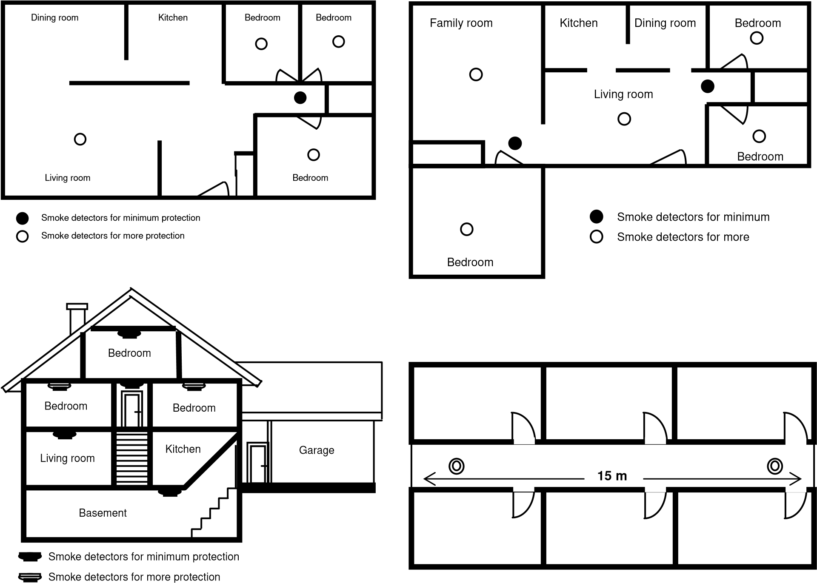

Figure 3. Recommended locations for smoke detectors. (Reproduced by permission of BRE Electronics)

Testing
Smoke alarms ought to be tested weekly or at least monthly to confirm they are working properly. The built–in test switch will simulate smoke and test all a detector’s functions. Never use an open flame to test a detector as this can ignite or cause damage to the detector.

Batteries must be replaced yearly or immediately when the low battery warning sounds.

Maintenance
Maintenance should be carried out in accordance with the instructions provided by the manufacturer of the alarm. It should include cleaning the smoke alarm at least once a year by vacuuming the dust off the cover and the sensing chamber openings. Power to the detector must be disconnected – remove the battery or switch off the AC power supply – before cleaning. After you have disabled power for maintenance purposes, be sure to restore power and test the detector when cleaning is complete.

If repeated false alarms are experienced, clean the detector and move it if it is not properly located. It may be worth checking whether such activations are caused by tiny insects and taking action to eliminate them.

Replace the smoke alarm if it becomes defective and no longer functions. Smoke alarms that do not work offer no protection!

Replacing the batteries
As already mentioned, battery-operated smoke alarms need to have their batteries replaced regularly in accordance with the manufacturer’s instructions, normally once a year or immediately when the low-battery warning sounds.
Warning: Most smoke alarms are mounted on the ceiling and you may need a stepladder or other secure equipment to stand on to reach the detector. Never use an unstable chair or other unsteady furniture when changing batteries. Accidents in the home occur too often!

It is possible to obtain a wall-mounted battery housing with cable connection to the smoke alarm, thus making the replacement of batteries much easier.

Quality requirements.
Every smoke alarm should meet the quality requirements of a nationally accredited approvals and testing organisation to show that it complies with an appropriate national or international functional standard, for example pr EN 14604 and ISO 12239, as well as meeting any relevant local standards and recommendations. It should also come with a user’s guide or instructions in the language of the country in which it is purchased.

Radiation exposure from ionisation smoke alarms
In some European countries the authorities have forbidden ionisation smoke alarms because of the potential radiation hazard from their radioactive source.

Most ionisation smoke alarms contain the radioactive source Americium 241. This element creates an electrical current, a flow of ions, in the sensing chamber. When tiny smoke particles enter the chamber, the flow of electricity is interrupted and the alarm goes off. Americium 241 is harmless outside the body, however, because the radiation it emits is too weak to penetrate the human skin.
The alpha particles emitted by Americium 241 in smoke alarms have a very short range and are so weak that they can be stopped by a single sheet of paper. Studies show that the amount of radiation you would get from standing next to an ionisation smoke alarm constantly for one full year would be less than your exposure from watching television, wearing a luminous wristwatch or cooking on a natural gas range over a year.

Reference sources
CFPA members countries will cite their national reference sources for use at this part of this guideline.

Guidelines published by CFPA Europe

Guideline No 1:2002 - Internal fire protection control
Guideline No 2:2002 - Panic & emergency exit devices
Guideline No 3:2003 - Certification of thermographers
Guideline No 4:2003 - Introduction to qualitative fire risk assessment
Guideline No 5:2003 - Guidance signs, emergency lighting and general lighting
Guideline No 6:2004 - Fire safety in residential homes for the elderly Guideline No 7:2005 - Safety distance between waste containers and buildings
Guideline No 8:2004 - Preventing arson – information to young people
Guideline No 9:2005 - Fire safety in restaurants

