European
Guideline
Safety distances between waste
containers and buildings

FOREWORD
The European fire protection associations have decided to produce common guidelines in order to achieve similar interpretation in the European countries and to give examples of acceptable solutions, concepts and models. The Confederation of Fire Protection Associations in Europe (CFPA E) has the aim to facilitate and support fire protection work in the European countries.
The market imposes new demands for quality and safety. Today fire protection forms an integral part of a modern strategy for survival and competitiveness.
The guideline is primarily intended for those responsible for safety in companies and organisations. It is also addressed to the rescue services, consultants, safety companies etc so that, in the course of their work, they may be able to help companies and organisations to increase the levels of fire safety.
The proposal of this guideline have been produced by SPEK - The Finnish National Rescue Association - and the author is Mr Matti Orrainen.
This guideline was compiled by the Guidelines Commission and has been adopted by all fire protection associations in the Confederation of Fire Protection Associations Europe.
Zurich, 12 Mars 2004 CFPA Europe
Dr. Hubert Rüegg
Chairman
Stockholm, 12 Mars 2004 Guidelines Commission
Tommy Arvidsson
Chairman
This edition of the Guideline has been revised. The changes didn’t influence the content from the original version.
Stockholm, 26 September 2005
Guidelines Commission/ Tommy Arvidsson

1. Introduction 4
2. The safety distance defined 4
3. Example of fire objects 5
4. Rate of heat release 5
4.1 Quick estimation of the safety distance 5
4.2 Horizontal safety distances 5
4.3 Minimum horizontal safety distance 6
4.4 The 4m safety distance group 6
4.5 The 6m safety distance group 6
4.6 The 8m safety distance group 6
5. The alternative to the safety distance 6
6. Conclusion 6
Appendix: Essentials of the calculations 7
The temperature and height of the flame 7
The Acceptance Criteria of Heat Radiation Calculations 13
Horizontal safety distances 13
References 14
European guideline 14

Introduction
Many arson attacks target waste containers and other combustible objects located outside buildings. These relatively innocuous fires too often develop into fires which can cause significant personal injuries or property damage when they spread into buildings. For this reason, it is necessary to give the owners and occupiers of premises some basic advice about ways to prevent these.
This guidance is based upon (1) methods of calculation which have developed from an analysis of fire investigations and (2) empirical knowledge gained in such investigations.
In the prevention of arson, however, particular attention must also be paid to practical measures to thwart the arsonist, i.e. the fencing of the yard, the locking of areas and the removal of all combustible materials from the yard.

The safety distance defined
A fire can spread from its place of ignition:
− by conduction through structures
− through heat radiation from a flame or
− through the hot gases and sparks the fire has created.
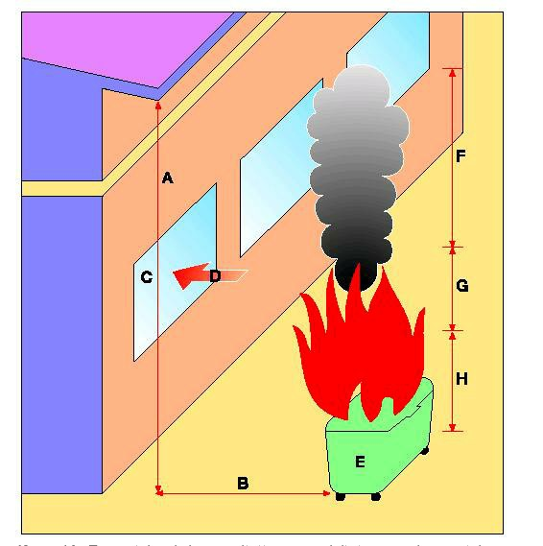
Figure 1. A fire can spread from its place of ignition through heat radiation from a flame (D) or through the hot gases and sparks the fire has created (E).
In outside areas, the heat of a fire is transferred from combustible objects primarily through the last two methods mentioned above. That is why it is vital that the horizontal safety
4

distance between the burning object and (from the technical fire perspective), the building’s weakest point, must be determined.
The potential spread of fire along the eaves caused by the heat energy of a smoke column, has also been addressed by the application of and reference to horizontal safety distances.

Example of fire objects
For the purposes of calculation, three fire objects have been taken as examples:
- a 600 litre waste container made of glass fibre or plastic;
- a group of three such waste containers, burning simultaneously;
- a 2m x 6m demountable platform (open bed), loaded with combustible material.
Using these three examples, it is possible to estimate fire safety distances for other objects or structures in the yard.

Rate of heat release
The material (garbage) stored in waste containers is mostly like household waste, comprising paper, wood, cardboard and plastics. In what follows, heat release rates are based on this kind of fuel. For example the value of heat release of the single waste container (2MW) is comparable the peak value of the heat release of wood pallet stacks, when the pile height is about 1m. The heat release of a burning petrol barrel is about 1MW.
The Rate of Heat Release (RHR) of a fire is needed to determine the height and temperature of the flame. This can be calculated as described in source (3). The test results of source (2) can also be used. On the basis of these results, the following values of RHR of the chosen fire objects were determined:
(a) waste container RHR = 2 MW (b) 3 waste containers RHR = 6 MW
(c) demountable platform RHR = 10 MW

Quick estimation of the safety distance
It is possible to use the results of the fire technical calculations (1) to determine the horizontal safety distances of objects and structures from buildings.
Equation (1) provides a quick approximation of the horizontal safety distance:

Safety distance ≈ width of object to be estimated + 2,5 m (1)
This equation provides a valid result if the height of the fire object is not greater than its width.

Horizontal safety distances
A range of horizontal safety distances can be established for different categories of fire objects and structures outside buildings.
5 CFPA-E® -Guidelines

Minimum horizontal safety distance
According to equation (1) the minimum horizontal safety distance between combustible objects and buildings is 2,5m. This is the horizontal safety distance for, for example, point sources of flames.

The 4m safety distance group
These objects should be located at least 4m away from buildings:
− a single 600 litre waste container made of glass fibre or plastic;
− a waste container made of steel;
− other combustible objects, structures and piles which are less than 1,5m high and wide.

The 6m safety distance group
These objects should be located at least 6m away from buildings:
− a group of waste containers made of glass fibre or plastic;
− a trolley for pasteboard packages;
− other combustible objects, structures and piles which are less than 4m high and wide.

The 8m safety distance group
These objects should be located at least 8m away from buildings:
− an interchangeable platform full of combustible material (dumpsters);
− a rubbish shelter;
− a wooden shed, a small building and similar combustible structures;
− a car shelter;
− a caravan and other mobile homes;
− pallet piles;
− other combustible objects, structures and piles which are less than 6m high and wide

The alternative to the safety distance
If it is not possible to achieve any of the safety distances cited, then it is necessary that the adjacent structure is fire resistant. It must have fire resistance in the EI 30 – EI 120 (2000/367/EC) according to national building regulations. The abbreviation EI 30 refers to a wall which has a resistance to fire of 30 minutes in terms of both integrity (E) and insulation (I).
The class requirements for fireseparating building elements can be copensated by automatic fire extinguishing system, for example according to CEA 4001 (last issue).

Conclusion
In addition to the safety distances included in the guidebook (1),it describes different methods for preventing the spread of fire from structures in a yard into a building.
It is worth repeating that, to thwart the arsonist, it is vital to implement practical measures to secure the perimeter of a yard and to reduce the accumulation of combustible materials in yards.
Guideline No 7:2005

Appendix: Essentials of the calculations

The temperature and height of the flame
The temperature of the persistent flame was presumed, in each fire object, to be 800 ⁰ C ((2) and (3)) (see Figs 2-4). The temperature of the intermittent flame was presumed to be 600 ⁰ C ((2) and (3)). These values have been checked using calculation method (2), which is based on RHR.
The height of the flame and the temperature of the smoke column were calculated using McCaffrey’s smoke column model (2). The flame was assumed to be an orthogonal radiator, radial plate. The largest possible width of the flame was taken to be the width of the flame,
i.e. in the case of the demountable platform, the longest side of the platform faces the building.
The results of the calculations are shown in Figs 2-4.
7 CFPA-E® -Guidelines
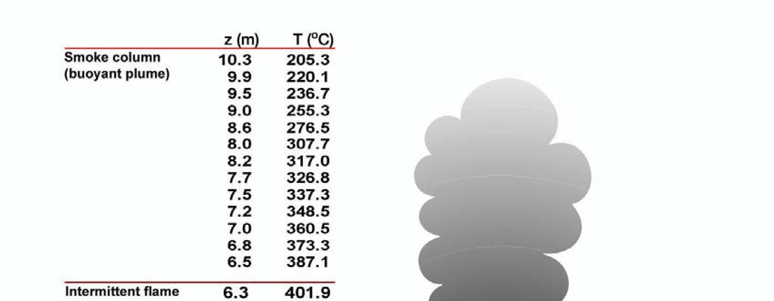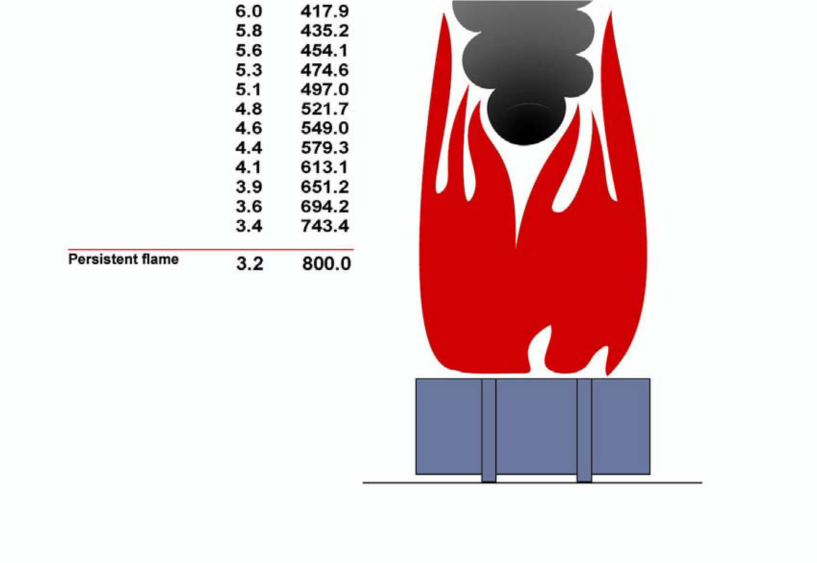
Figure 2. The values of height and temperature of the fire plume on the demountable platform.

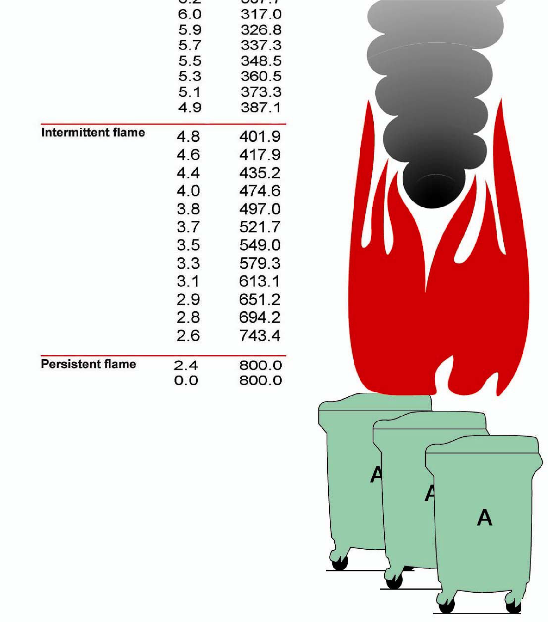
Figure 3. The values of height and temperature of the fire plume when three waste containers are burning.
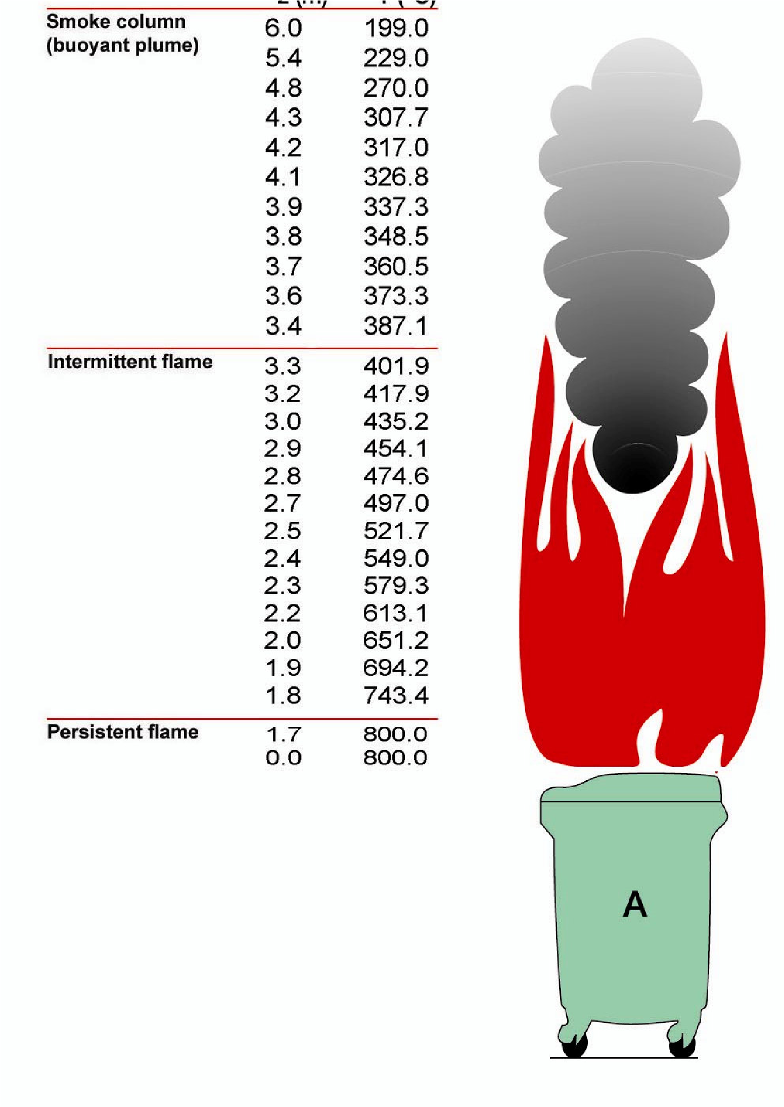
Figure 4. The values of height and temperature of the fire plume when a single waste container is burning.

Heat radiation calculations
The energy of the heat radiation transmitted by the fire plume was calculated from the temperature of the flame, i.e. a persistent flame has an energy of 75kW/m² and a intermittent flame has 33kW/m² . The calculation was carried out according to StefanBoltzmann’s radiation heat estimation theory and was checked using calculation method (2), which is based on fire energy.
The energy of heat radiation, which can impinge on different external elements of a building, can be examined by adding a visibility coefficient to the values of the heat radiation transmitted by the fire plume. See, for example, sourer (2) for information about visibility coefficients. Figure 5 shows the variables which are involved in the heat radiation calculations.
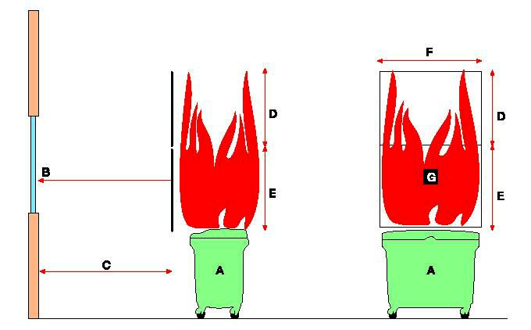
Figure 5. The variables in the heat radiation calculations. B is the heat radiation to the facade of the building and C is the horizontal distance between the fire plume and the facade. Their values are shown in Figs 6-8. (D is the intermittent flame and E is the persistent flame.)
Figures 6-8 are graphs which show the relationship between heat radiation and distance from the building for the three chosen fires.

0
10
20
30
40
50
60
0
2
4
6
8
10
Distance m
Radiation kW/m²
Figure 6. Heat radiation v. distance when the demountable platform is burning.
0
10
20
30
40
50
60
0
2
4
6
8
10
Distance m
Radiation kW/m²
Figure 7. Heat radiation v. distance when the three waste containers are burning.
0
10
20
30
40
50
60
0
2
4
6
8
10
Distance m
Radiation kW/m²
Figure 8. Heat radiation v. distance when the one waste container is burning.

The Acceptance Criteria of Heat Radiation Calculations
The results of the radiation calculations can be used to estimate the safety distances if it is possible to determine the acceptance criteria for the maximum values of the heat radiation onto the facade of the building at risk. It is possible to determine the building elements from the external wall. The heat radiation resistance of the elements is critical when examining the spread of fire into a building from outside. Such elements include the wooden and plastic parts and the windows of the facades. In addition, features inside the windows, such as curtains, must be taken into consideration.
In sources (3) and (4), the experimental and theoretical value of the heat radiation resistance of glass is presented. On the basis of these values it is possible to estimate that the critical long-term radiation flow for normal window glass is about 10 kW/m² .
It can be presumed that when this value is exceeded the glass panes will break one by one and then the heat radiation will strike with full force the movable property which is located inside and the plume gases could flow in through the window openings. The critical heat radiation flow value for wooden materials is about 12.5kW/m² and for plastic materials about 10kW/m² , see source (2) and (3).
When the critical heat radiation flow value onto the external facade is exceeded for a long period the material in question will ignite, at which time the fire will spread into the building itself. The critical heat radiation flow value of wooden material is the same as will ignite thin, cellulose-based curtain material, which in fact will occur at this heat radiation flow level faster than the ignition of a wooden structure.
Thus a value of 10kW/m² is used in the calculations as the largest acceptable heat radiation flow into the external wall surface of the building at risk.

Horizontal safety distances
After a safety examination has been carried out it is possible to use the results of the foregoing calculations to determine the horizontal safety distances of objects and structures which are located outside buildings. The values which have been obtained from the calculations must take into account the inclination of the fire plume towards the building, caused by wind. This is done by carrying out an inclination examination of the fire plume, on the basis of which it is possible to estimate the actual safety distances by adding 1m to the safety distances which have been obtained from the calculations. In respect of the fire objects which have been presented in the calculations, the following values for the safety distance in the horizontal places were obtained:
(a) | waste container | safety distance 4m
(b) | 3 waste containers | safety distance 6m
(c) | demountable platform | safety distance 8m
The spread of fire into and along the eaves, caused by the heat energy of a smoke column, has also been addressed by the application of and reference to horizontal safety distances.

Guideline No 7:2005

References
- Pihan jäteastiat ja tuhopolttojen torjunta Tekniikka opastaa 17 Suomen Palastusalan Keskusjärjestö 2002 (The Finnish National Rescue Association)
- Drysdale, Dougal. An Introduction to Fire Dynamics, John Wiley, 1985.
- Buchanan, A.H. (ed). Fire Engineering Design Guide,: Centre of Advanced Engineering, Christchurch NZ, 1994.
- Keski-Rahkonen Olavi. Ikkunoitten rikkoutuminen tulipalossa Palontorjuntatekniikka-lehti 3/1990.

European guideline
Guideline No 1:2002 - Internal Fire Protection Control
Guideline No 2:2002 - Panic & emergency exit devices
Guideline No 3:2003 - Certification of thermographers
Guideline No 4:2003 - Introduction to Qualitative Fire Risk Assessment
Guideline No 5:2003 - Guidance signs, Emergency lighting and General lighting
Guideline No 6:2004 – Fire safety in Residential Homes for the Elderly
Guideline No 7:2005 – Safety Distance between Waste Containers and Buildings
Guideline No 8:2004 – Prevention Arson – Information to Young People
Guideline No 9:2005 – Fire Safety in Restaurants
Guideline No 10:2005 – Installation of Smoke Alarms in Home
Guideline No 11:2005 – Number of Fire Protection Trained Staff

