CFPA-E No 6:2021 F

Fire safety in care homes

FOREWORD

CFPA Europe develops and publishes common guidelines in order to achieve similar interpretation in the European countries and to give examples of acceptable solutions, concepts and models. CFPA Europe has the aim to facilitate and support fire protection, security and protection against natural hazards across Europe, and the whole world.

The market imposes new demands for quality and safety. Today, fire protection, security and protection against natural hazards form an integral part of a modern strategy for survival, sustainability and competitiveness.

These Guidelines are primarily intended for the public. They are also aimed at rescue services, insurers, consultants, safety companies and the like so that, in the course of their work, they may be able to help manage risk in society.

These Guidelines reflect best practice developed by the national members of CFPA Europe. Where these Guidelines and national requirements conflict, national requirements shall apply.

This Guideline has been compiled by the Guidelines Commission and is adopted by all members of CFPA Europe.

Copenhagen, August 2021 Cologne, August 2021
CFPA Europe Guidelines Commission

Jesper Ditlev Hardy Rusch
Chairman Chairman

Content
1 Introduction 5
1.1 Background 5
1.2 Objectives 5
2 Examples of care home fires with serious consequences 6
2.1 Care home in Norrtälje 6
2.2 Care home in Seoul 6
2.3 Rosepark care home in Glasgow 6
2.4 Care home in Quebec 7
2.5 Past events can develop fire safety 7
3 How does a fire start and develop? 8
3.1 How does a fire start? 8
3.2 Typical fires in care homes 8
4 Assessment of fire-safety in existing facilities 10
5 Fire safety management system 10
5.1 Fire safety policy 11
5.2 Fire protection organization 11
5.2.1 The relationship between owner and business 12
5.3 Fire hazards and risk management 12
5.3.1 Arson 13
5.3.2 Stove / Cooker fires 13
5.3.3 Smoking 13
5.3.4 Candle lights 13
5.3.5 Illumination 14
5.3.6 Charging devices 14
5.3.7 Household appliances 14
5.4 Rules and Routines 14
5.4.1 Rules 14
5.4.2 Routines 14
5.5 Self-monitoring 15
5.6 Training and information 16
5.6.1 Introduction of new staff 16
5.6.2 Basic fire safety training for all employees 16
5.6.3 Recurring training 16
5.6.4 Exercises 16
5.7 What should a training program cover? 16
5.7.1 How fires can be prevented 16
5.7.2 Fire protection systems to limit the consequences of a fire 16
5.7.3 Emergency routines 16
5.7.4 Activities after a fire 17
5.8 Follow-up 17
5.9 Documentation 17
6 Escape/Evacuation 17
6.1 Evacuation strategy 17
6.2 Evacuation versus escape 18
7 Active fire protection systems 18
7.1 Manual fire extinguishing equipment 18
7.2 Fire detection and alarm systems 18
7.3 Sprinkler 19
7.4 Stove / Cooker guard 19
7.5 Portable water mist systems 19
8 Other Measures 20
8.1 Loose interior 20
8.2 Camera surveillance 20
9 Checklists 22
9.1 Checklist - Fire protection management 22
9.2 Checklist self-monitoring 23
10 Appendix – Fire risk assessment 25
10.1 Considerations in the fire risk assessment 25
10.1.1 The effect of limited ability to act 25
10.1.2 Safe means of escape 26
10.1.3 Rescue 26
10.1.4 Rescue by preventing conditions from becoming life-threatening 27
10.2 Preparing a fire risk assessment 27
10.2.1 Can the resident evacuate quickly enough? 27
10.2.2 Can assistance arrive in time? 28
10.2.3 Rescue by preventive measures 28
10.3 Choosing a level of fire safety on basis of fire risk assessment 29
10.4 Schedule for fire risk assessment 30
11 References 33
12 European guidelines 33

Introduction

Background
This guideline has been developed to help those who are responsible for the fire safety in care homes. The aim is not only to describe what needs to be done but also to create an understanding of why these things need to be done. Other stakeholders may be building owners, planners, builders, building control officials and rescue authorities.

In this guideline we use the concept of care homes, but we target all types of similar businesses such as nursing homes and residential homes.

In general people who become residents or patients in care homes and similar are no longer able to take care of their own safety in the event of a fire. For example escaping to safety or the ability to use fire extinguishers. Furthermore, any reduction in the ability to act quickly may also increases the risk of a fire breaking out. The reason why people move to care homes is their fundamental need for assistance and safety.

In an appendix to this guideline we provide a method of performing a fire risk assessment and recommend measures to eliminate or reduce identified hazards.

Firesafe care homes is a term incorporating the combination of technical installations and management aspects that should be provided when conducting this type of business. The aim is that this guideline will provide risk awareness and knowledge so that fires in care homes can be reduced to a minimum.

Several sources of international statistics have shown in recent times that elderly people are more at risk from fire than the average population. The risk of death by fire begins to increase at the age of 65, and, depending on the statistics, those over the age of 80 have a 10 to 20 times greater risk of being injured by fire than younger age groups.

Compared with other forms of accidents the number of annual fatalities caused by fire is not great, but a fire can expose many people to high levels of risk at the same time.

Objectives
Ignorance is a contributory cause of virtually all fires. The aim of this guideline is therefore to contribute to risk awareness and knowledge so that fires in care homes can be reduced to a minimum.

For those responsible for fire safety in care home facilities, this guideline will give you guidance as to what needs to be done. In addition, it explains “how” to take these measures and “why” they need to be done.

This guideline is directly addressed to those premises where the staff are responsible for fire safety.

Examples of care home fires with serious consequences
There have been occasions where a number of people are killed in a care home as a result of fire. Some of these fires are described in this section.

Care home in Norrtälje
On the night of August 27 in 2013, a fire erupted in the main building of Textes Care home in Norrtälje, Sweden. There were seven people in the building. The building consisted of three floors. The building was originally built in 1918. The residents, with mental disabilities of varying degrees, had been medicated for the night and there was no staff present in the building.

The fire started on the second floor of the glazed smoking balcony and then quickly spread into the building. Because smoke detectors were missing on the balcony, the fire was able to grow before the fire alarm was activated. The smoking balcony was adjacent to both the exterior escape staircase and the interior staircase, which quickly reduced the possibilities for escape.

Four of the residents were awake or awakened when the evacuation alarm was activated. One person went up to floor three to wake up the other two people on that floor while another person went to the next building to bring the manager. The manager was simultaneously dialed by the emergency center who had received a call from a neighbour. The people who were now on the third floor could not get out via the interior stairwell that was smoke-filled. One of them succeeded despite the fire on the balcony to get down via the outside spiral staircase. The other two persons on the third floor and one person who stayed in their room, perished in the fire.

The investigation after the fire showed that building permits were lacking for the business carried out in the building and that fire protection in the building, both technical and organizational, had several weaknesses. The lack of building permits and weaknesses in fire protection were not discovered during inspections carried out by the fire service.

Care home in Seoul
At least 21 people died In May 2014 in a fire in a care home for older people outside Seoul in South Korea. The care home had more than 80 beds. Many of the residents were being treated for dementia or were bedridden stroke-patients. Residents were aged 70 – 90 Years.

It was initially unclear how the fire had started, but when examining film from a security camera, it is noted that a 81-year old man who was a dementia patient set fire to a store on the second floor. A number of residents on the building's first floor managed to get out when the fire started, but on the upper floor there were few that escaped. A nurse who worked at the accommodation was among the dead. All perished from the thick black smoke that filled the premises.

Rosepark care home in Glasgow
The fire at Rosepark care home occurred at half past five AM January 31 in 2004. The fire started in a cabinet in a corridor due to an electrical error. The fire grew in the cabinet and exploding aerosol bottles moved the fire into the corridor where some upholstered furniture also caught fire.

The fire alarm panel was newly installed and unfamiliar to the four persons in the staff who had problem with locating the fire and therefore started to evacuate the wrong section.

In a reconstruction of the fire, it was found that the fire self-extinguished due to lack of oxygen after about 7 minutes, which corresponds to the observations made at the site. Many of the door closers of the rooms were out of service and the doors were open. Soon the corridors and rooms were filled with deadly poisonous smoke. If the doors to the rooms had been closed, the residents were most likely to have survived. The fire killed 14 persons.

Care home in Quebec
Shortly after midnight January 23, 2014 a fire started in a kitchen in a care home in a small village outside Quebec, Canada. The wooden building had sprinklers in an annex building, but the main building was only protected with fire alarm. Only one member of staff was present for the 50 residents. At 22.30, the entrance door was locked to prevent dementia patients from walking away. It took about five hours to extinguish the fire. The search for survivors was hampered by a thick ice-cap from extinguishing water that overlaid the fire-site. The temperature was minus 20 degrees Celsius. 32 persons lost their lives. The cause of the fire is unclear.

Past events can develop fire safety
There are also good examples of how the consequences of a fire can be minimized by staff actions. For example, there are some observations made by a fire investigator after a fire in Sweden where a fire was handled in an exemplary manner. "Several so-called fortunate circumstances have minimized the consequences of the fire. However, it should be noticed that many of these fortunate circumstances are not random, but the result of a well performed fire safety management:

- The staff had undergone a recurrent fire safety training.
- Staff have at workplace meetings had continuous reviews regarding fire-safety and routines.
- The building is equipped with both sprinkler and automatic fire alarm, which is diverted to an alarm central.
- The fire alarm is integrated with the resident’s security alarm.
- The building is built with good passive fire protection.

In addition to these circumstances, the following factors contributed to minimize the consequences:

- The four staff on duty were all, experienced health professionals.
- The timing of the fire was such that most residents were in their rooms, the staff could initially concentrate on the rescue operations.

What are the success factors that make a business firesafe? The lack of fires and incidents does not necessarily imply that the business is safe. The potential risk can still be great. It is only when a fire has occurred you know for certain that there is always something to learn to prevent the same thing from happening again.

Experiences from accidents and incidents can be used for continuous improvement.

How does a fire start and develop?

How does a fire start?
Three conditions are required for a fire to occur. Combustible material, oxygen and high enough temperature. The more finely divided the mixture is between oxygen and combustible material, the easier the ignition and the faster combustion. Most material may burn but some materials contain more energy than others. The temperature required for ignition is also different between different materials.

Plastic materials are generally flammable with a high energy content. Plastic materials in many cases emits several toxic gases in a fire.

In theory it is easy to prevent fires. It is only to ensure that these three conditions are not in the same place at the same time. In practice it can be harder. Electrical products for example already contain these three components. There should always be a redundancy through mitigation measures. If some incident still occurs, it should not lead to a disaster.

Typical fires in care homes
A common fire scenario in care homes is that it starts to burn in the clothes of a person or piece of furniture that the person is using. Common injuries are burns or a combination of burns and inhalation of toxic gases.

Another scenario is a smoldering fire that starts in a bed, sofa or similar item. A smoldering fire can last for a long time without something dramatic occuring. The smoldering fire generates some un-combusted fire gases which, due to the heat rise and accumulate in the room's upper roof or ceiling area. As the smoldering fire escalates, more unburnt gases are generated that are mixed up with the air in the room. When finally, gas mixture reaches a certain concentration and becomes in contact with flames, the fire gases ignite in the room's upper part. This phenomenon is called flashover. At this stage the temperature in the room increases very quickly which help to develop pressure changes that can cause windows to implode or explode.

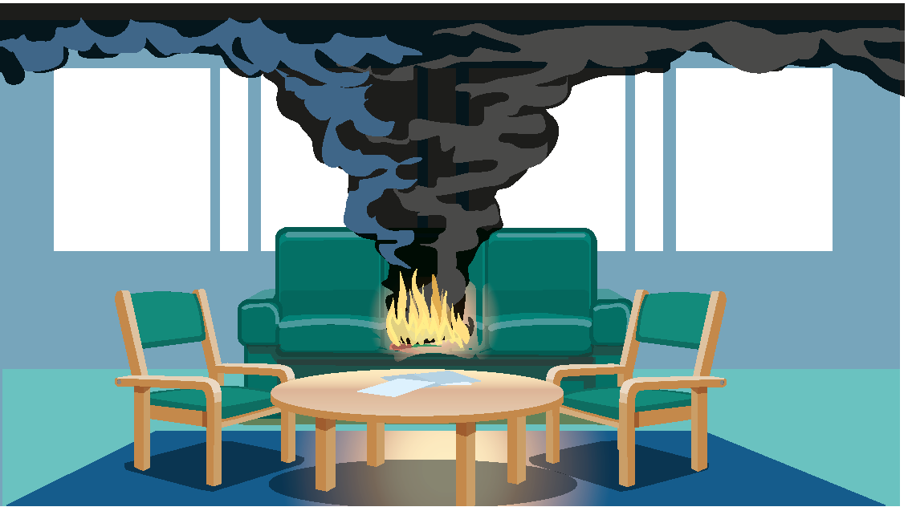

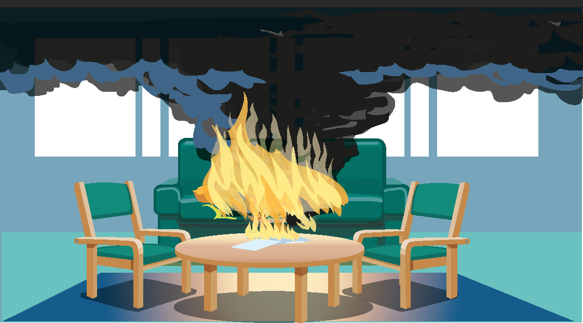

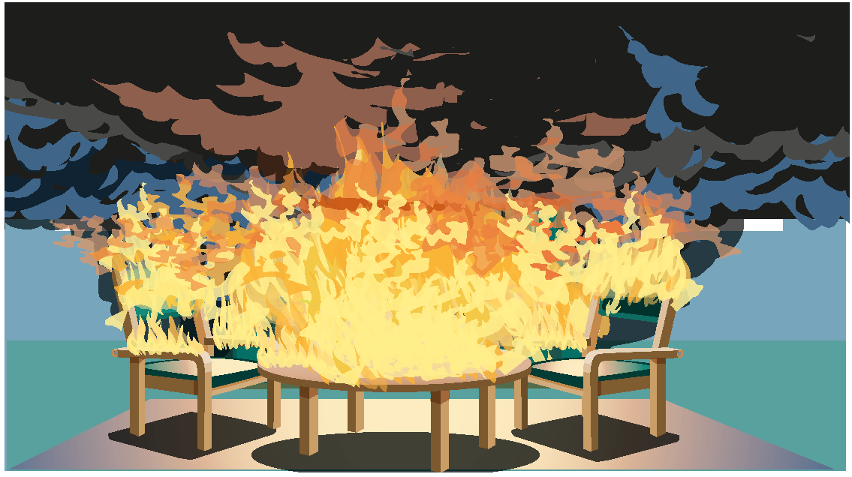

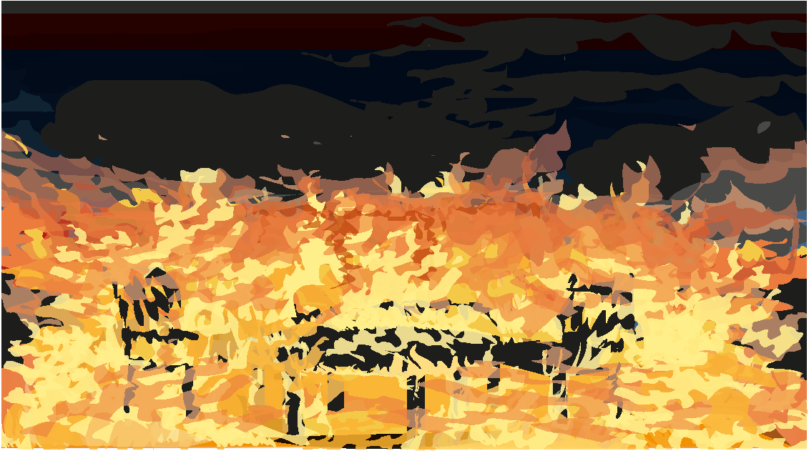
A fire development from ignition to flashover.

Oxygen in room is consumed fast and often the air supply is limited. The fire then becomes ventilation controlled and can even self-extinguish. Temperature is still high, which means that the production of fire gases continues from surfaces with combustible material in the room. It is at this stage of the fire, after the flashover, that the fire gases become extremely toxic:

- All combustion generates carbon dioxide. Carbon dioxides have a suffocating effect at higher concentrations. Another effect that carbon dioxide has is that it affects the respiratory rate. The higher concentration of carbon dioxide the higher respiratory rate, which means inhalation of an even larger amount of toxic fire gases.
- When the oxygen content diminish in the fire gases, carbon monoxide is produced instead of carbon dioxide. Carbon monoxide blocks the blood's ability to transport oxygen in the body. This effect can be delayed on a person saved in a fire.
- Hydrogen cyanide is produced in fires containing some plastic materials such as polyurethane. Hydrogen cyanide has an extremely fast "knock down" effect, allowing a person to become unconscious only after a few breaths.
- The lack of oxygen is another factor that contributes to unconsciousness.
- Substances that burn decomposes in gases and soot particles which can cause acute life-threatening injuries, but also long-term effects like chemical pneumonia and reduced lung-function.

All these substances in fire gases causes a toxic cocktail that never should be underestimated. To enter a smoke-filled room where a flashover has taken place may work in Hollywood movies, in real life it´s associated with extreme danger.

Another scenario that has been identified in many disaster-fires is that the flashover occurs in two steps where the first flashover emerges in a smaller space where the fire can develop unnoticed. When the fire gases in the smaller space are later exposed to the larger room, they are both extremely toxic and combustible and can be ignited again causing an unexpected rapid effect. This scenario occurred in the previous described fires in South Korea (storeroom), Glasgow (cupboards), Norrtälje (glazed balcony) but also in a fire in Gothenburg in Sweden where 63 young people died in a fire that started in a stairwell also used for storage of furniture.

Assessment of fire-safety in existing facilities
It is a complex task assessing fire safety in facilities where the business may have been operating for a long time. The requirements regarding fire safety may have changed over time which means that existing fire protection installations are no longer up to date.

To perform this kind of assessment generally requires expert knowledge.

In the annex to this guideline, we present guidelines for how fire safety can be assessed in a care home.

Fire safety management system
Work on fire safety needs to be carried out systematically in order to perform over time. The extent of the fire prevention work depends on the complexity of the activity. The following is a brief description of what a fire safety management system can involve.

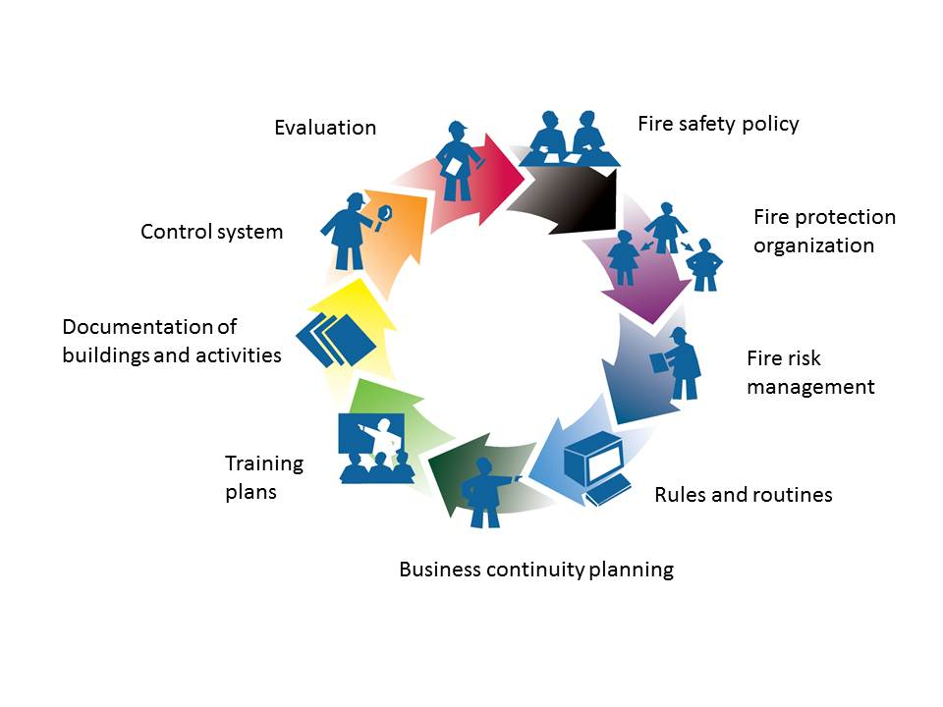

Fire safety policy
An important success factor for good fire safety is that the management of the business lead by example, show interest and are clear about what they want to achieve. One way of clarifying the goal of the work with fire safety is in a fire safety policy.

Fire protection organization
Fire safety issues are not something you deal with in your daily work, especially not in businesses with few employees. For natural reasons, you have a focus on the main mission. What you may not think about is the great responsibility that staff have for the resident’s fire safety. When the unthinkable has happened, there are no acceptable excuses. In a care home, at least one person needs to take responsibility for the fire safety in the premises.

What needs to be done and how many are involved depends on the risks involved, the extent of the business, how the premises are designed and how much technical fire protection installed that needs to be maintained and controlled. A small business, with simple conditions regarding fire safety, leads to less stringent requirements. In a small business, the work can consist of a single person who has all the tasks.

The following tasks always need to be managed:

- Person with responsibility for the fire protection management system
There needs to be a designated person who has the skills to assess the need for fire protection and takes responsibility for systematic fire prevention work. If no person has been appointed, the entire responsibility lies with the manager of the business.

- Person/persons carrying out self-monitoring of fire safety
Appointed persons periodically reviewing the premises to ensure that the fire safety is satisfactory.

- Person responsible for the fire alarm system
To perform over time, a fire alarm system needs to be maintained and tested. Therefore, there should be an appointed person responsible for these tasks.

In addition, for example, if the premises are protected by a sprinkler system there should also be an appointed person responsible for maintenance and testing of this system.
    - The relationship between owner and business
If the premises are rented there should be an agreement as to the various responsibilities and the persons responsible.

A contract can provide answers to the following questions:

- Who carries out control of fire protection installations?
- To whom and how should the deficiencies be reported?
- Who performs continuous care and maintenance?
- Who is addressing deficiencies?
- Who pays for necessary measures?
- Who has the right to ownership of the fire Installations?

For example, the responsibility for the property's overall system, such as sprinklers and controls in public areas such as common stairwells and entrances, can be on the property owner. The system linked to a specific space and business are often checked by the tenant.

Fire hazards and risk management
The starting point for creating a fire safe care home is to be aware of the fire hazards. When the risks are identified, it is necessary to determine whether the risk is acceptable or whether risk mitigation measures need to be made. One opportunity is to reduce the probability of the scenario, for example, by replacing a candlelight with a battery-powered candle. Another measure can be to ensure that the consequences are mitigated if the scenario occurs, for example, by installing a sprinkler system. Other actions can be of organizational nature such as having procedures to check that doors are closed at night when staff numbers are lower.

When the business or building changes, new risks can occur. It is advisable to always have a routine to carry out a risk analysis in case of such changes.

Many common fire causes in care homes have to do with human actions, intentional or unintentional. Here are a few examples of common fire causes.
    - Arson
The risk of arson should be assessed based on the residents and their diagnoses and the likelihood that residents deliberately start a fire. In some types of care homes, it can be an obvious risk while in others it is considered less likely. In some cases, the risk of externally set fires needs to be considered depending on how the view of the business is among those who live in the area.

This type of fires can be large and dangerous as they are often started in hidden spaces and in several places at the same time. The fire development can be extremely fast if the fire has grown strong in a hidden space before it is exposed to other areas. Risk mitigation measures may be to have routines to check that hidden spaces like storerooms and cabinets are kept locked. Other measures may be patrolling or camera surveillance.
    - Stove / Cooker fires

A common fire cause in care homes is that fires start due to a forgotten stove. Risk can be reduced by installation of so-called stove guards. Stove guards come in different designs where the simplest versions cut the power to the stove when fire is detected. More Advanced versions also have an extinguishing function.

A fire on the stove often spreads through the exhaust fan. Therefore, there should be a routine for cleaning hood and filters.

Furthermore, stoves should be designed so that they do not risk being turned on by accident and stoves that are not in use should be disconnected.
    - Smoking
Smoking is still the most common cause of fatalities in fires. The most common fire scenario results from people smoking in bed or dropping ash on a couch or armchair or that ash starts to burn on the person's clothes. Preventive measures can be a smoking apron and to ensure that furniture, mattresses, and bedding used in the premises is non-flammable. Once the fire has started, early detection and rapid action by personnel is required. In special cases when incidents have indicated a high risk, complementary measurements like a quickly activating extinguishing device, can be considered.
Smoking should be avoided in care homes and the occupants may only smoke in specially equipped spaces. The staff should pay special attention to any suspicion of smoking where this is not allowed.

    - Candle lights
Some Fires caused by candlelight still occur even if they are becoming less common. The best way to minimize the risk is to switch all candles to battery powered. If candlelight is accepted, the candle holder needs to be of incombustible material and no curtains or other combustibles should be allowed nearby. Tealight candles must not be put too close together as they can become overheated and form a single large flame that is also difficult to extinguish.

Candle lights should normally be forbidden in care homes.
    - Illumination
Fatalities from fires have occurred when halogen lamps on a foot or stand have been placed next to a bed or on a bedside table. If the light falls onto the bed the heat from the lamp ignites the bedding. Permanently mounted lighting fixtures are preferred for beds and halogen lamps should be replaced with LED lights that have much lower surface temperature.
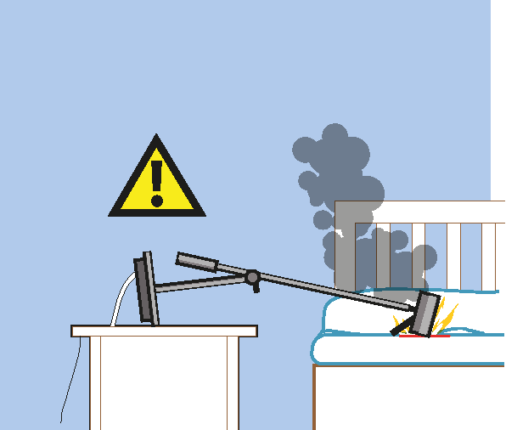
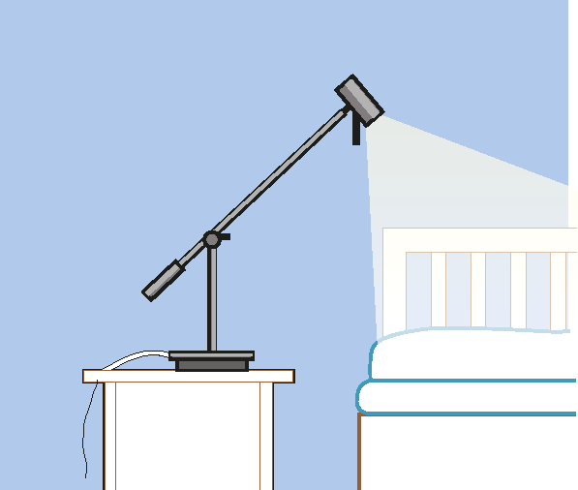

    - Charging devices
Rechargeable devices such as mobile phones, computers and tablets are becoming more and more common. During the time they are charging, it should not be done near combustible material. During charging, it´s important that the charger as well as the device that is charging can be cooled by the air and not is covered, for example in a bed. Invalid carriages charging in rooms or corridors also have a risk of fire from their batteries. The carriage is generally made from significant amounts of plastic, which has a high level of toxicity when burnt. The rooms and corridors in which they are charged are also invariably escape routes and these are then blocked to residents and rescue staff.
    - Household appliances
Electric kettles, coffee makers, dishwashers, microwave ovens, television sets, washing machines and dryers can cause fires and should not be left completely unattended, . Equipment should be replaced before it becomes too old.

Rules and Routines
Creating rules and routines is a way to manage the fire hazards in your business. Rules and routines can prevent fires and reduce the consequences of a fire.
    - Rules
Rules that are not understood tend not to be followed. Rules relating to fire safety must build on actual requirements or needs. Additionally, they need to be adequately communicated so that all concerned are aware of them. The fire safety rules should be available to all staff and residents.
    - Routines
Routines for evacuation must always be set in care homes where the residents need assistance in case of a fire. The staff members have a particularly important role to play, as an evacuation is based on their participation. The routines for evacuation should describe the entire chain of actions/events that may be required to evacuate all the residents in a building or part of a building.

Fast response and firefighting can be crucial and firefighting routines should be a part of every staff member’s introduction and training.

The exact design of a routine depends on the circumstances in each case.

To create enough evacuation capacity, it may be necessary to involve staff from surrounding units in the evacuation routine.

Examples of tasks in a fire alarm routine:

- Identify where fire has indicated.
- Bring a fire extinguisher and head to the place of the fire.
- If a fire is identified, call rescue service.
- If possible, try to extinguish the fire.
- If persons are in danger in the fire room, evacuate if possible.
- Close the door to the fire room.
- Evacuate if necessary other persons who may be in danger.
- Meet the emergency services and give them necessary information.

The exact sequence may vary, and different tasks can if possible, be distributed to several people, for example, to call emergency service and to meet the emergency services. The most important thing is to locate the fire as soon as possible and respond before the fire has become unmanageable.

Note that even if the fire alarm is diverted to the alarm centre, you should call the emergency service. Additional resources can then be called, and the entire rescue operation can be speeded up.

Preventive rules and routines are described in the previous chapter.

Self-monitoring
The fire protection installations and equipment are normally not used in daily business; therefore, routines are required to check the function regularly.

Routines are needed for where, when and how self-monitoring controls shall be carried out and who will perform these checks. It is also important that there are plans for how discovered improvements should be handled. Checks should be formed considering the actual risk of the premises. If previous checks are followed up, recurring deficiencies become known. In such cases, it may be appropriate for management level to act in order fix system errors. If there are no deficiencies, the intervals may be extended. If deficiencies are frequent and if consequences can be severe, checks should be carried out more frequently. To perform self-monitoring increase awareness. The more people who perform these checks, the higher the risk awareness.

In addition to self-monitoring, other third-party checks may be required such as:
- Portable fire extinguishers
- Audit inspection of fire alarm.
- Audit inspection of sprinklers

Training and information
In a care home, the fire safety of the resident’s rests on the staff. Therefore, it is especially important that the staff have enough skills and have been trained on established routines.

A training plan should be provided for the business which might include the following points 5.6.1 to 5.6.4:
    - Introduction of new staff
A theoretical review of fire safety routines and rules, routines in case of a fire/fire alarm and the evacuation strategy. The introduction/induction should also include a check that new staff member has understood the most important information. The introduction/induction should be carried out before the new employee start working.
    - Basic fire safety training for all employees
Theoretical and practical training carried out within a reasonable time the new employee starting work.
    - Recurring training
Recurring training aimed at maintaining the knowledge and skills. Implemented with frequency as needed, but everyone should participate in the recurring training at least every five years.
    - Exercises
All staff need to continuously practice routines for fire and fire alarms. Carrying out evacuation exercises with the residents can be difficult for many reasons. To carry out practical exercises at appropriate times to ensure that the routines works is still highly recommended. Where it is not appropriate for residents to participate, staff or other persons may stand in. A addition to practical exercises is to regularly review the procedures for fire alarms and evacuation theoretically.

What should a training program cover?
The content of the courses can be broadly covered by the following headings, but the scope varies according to the type of education and the target audience:
    - How fires can be prevented
The risks involved and how they can be minimized by, among other things, fire protection rules and routines.
    - Fire protection systems to limit the consequences of a fire
Technical fire protection such as fire compartmentation, evacuation routes, fire alarms and sprinklers, how they are kept in function.
    - Emergency routines
Emergency procedures, evacuation routines, selection and use of fire extinguishers and more.
    - Activities after a fire
Business continuity planning including crisis management, replacement facilities, etc. Persons with special responsibilities may need to ensure their competence through external training.

A good way for managers to ensure that employees are aware of the risks and have enough knowledge in fire safety is to have it as a standing item on the agenda at individual follow-up meetings.

Follow-up
The manager is always responsible for any task and has to monitor the responsibilities of others.

The management of the operation should follow up the fire safety work at least once a year.

One way to systematically follow-up is to have fire safety as a standing item on the agenda for management meetings.

By following up, good experiences can be taken advantage of, and other areas can be improved. The results of the follow-up indicate measures that needs to be considered in the budget.

Documentation
The first step in the documentation is to inventory and evaluate the existing fire protection installations. The documentation normally consists of both drawings and explanatory text. The drawings should contain at least the fire compartmentation and escape routes. The text may describe the design and function and how installations are expected to perform in the event of fire. The documentation forms a basis for the self-monitoring.

Information about the buildings fire protection installations can often be found at the real estate owner.

Escape/Evacuation

Evacuation strategy
Personnel safety is a priority in building’s fire protection. A fire should be detected at an early stage, at best, it can be extinguished by people on site. If not, those threatened by the fire should be able to be placed in safety before any critical conditions arises.

The basic principles of evacuation are that there should normally be two independent escape routes, exits to the open or a fire compartment leading out into the open. Evacuation routes should preferably be in opposite parts of the premises so that if one escape route becomes blocked by a fire, there should be another alternative escape route.

In care homes, evacuation via windows is rarely a good solution. It´s both difficult and time-consuming if the residents have disabilities.

An alternative is so-called horizontal evacuation which is often applied in hospitals. The evacuation strategy in this case is that people threatened by the fire can be evacuated to another section/fire compartmentation on the same floor. In that way, you win time to rescue the residents out into the open at a later stage. This solution requires enough staff on site, around the clock, that can carry out the evacuation.
If the circumstances regarding fire safety and evacuation are unclear, a risk analysis should be carried out as described in the appendix to this guideline.

In care homes, the availability requirements are extensive. This means that both guests and employees should be able to have full access to the premises. In the event of fire, they shall also be able to escape before critical conditions occur, despite any disability.

If evacuation for persons with reduced mobility is not possible, a compartmentation in connection to the stairs, where you can wait for help, can be a solution. You can find more information in CFPA Guideline no.33 Evacuation of people with disabilities.

Evacuation versus escape
Another principle of evacuation is that doors in evacuation routes should be easily openable without a key. This principle can cause problems in care home as the care for patients with dementia may mean that access/escape doors are kept locked.

A push button on the wall adjacent to the door can be an acceptable solution. Other ways of making the staff aware that someone is trying to escape is alarm carpets or camera surveillance in corridors.

Active fire protection systems

Manual fire extinguishing equipment
Portable fire extinguishers and wall fire hydrant or riser will be present at each level, adapted to the hazards, maintained in good state and controlled following to the national regulations.

Equipment’s will be conform to the following standards:
Fire extinguishers : EN 3
Wall fire hydrants : EN 671-1 or EN 671-2.

Fire detection and alarm systems
Fire alarms should be available in all types of care home. Early warning is a vital function for fire safety. The requirement for the staff to have well trained routines in the event of a fire alarm, becomes more important in direct relation to the lack of mobility of the residents/patients.

The design and operation of the fire detection system is directly linked to the emergency procedures in place in the building.

The fire detection system will be of the generalized type, the alarm signal (evacuation order) will be adapted to the occupants and their possible handicaps. A specific analysis may conclude that there should be a brief "pre-alarm" phase between the signaling of an event (activation of a detector) and the order to evacuate, in order to avoid panic among residents.

The alarm signal will be adapted to the occupants (sound siren supplemented by a voice message or flashing lights for example).
The closing of fire doors and the operation of lifts for example will be controlled by the fire detection.

Therefore the design, installation and maintenance of the fire detection system will be carried out by qualified and certified companies. The installation will be checked at commissioning and periodically by a duly accredited inspection body.

The presence of “residential smoke alarms” (stand-alone detectors) alone is not sufficient.

In order to keep the system up to date it´s important to follow national regulations regarding installation, maintenance, testing and audit inspections.

Sprinkler
Sprinkler systems are an effective way to minimize the probability of catastrophic fires like those described earlier in this guideline.

Sprinkler systems will be designed, placed and controlled following the EN 12845, or concerning residential sprinklers EN 16925.

The design, installation and maintenance of the fire detection system will be carried out by qualified and certified companies. The installation will be checked at commissioning and periodically by a duly accredited inspection body.

But in the same way as for fire alarms, it is important that owners and operators agree on how to manage maintenance, testing and audit inspections according to national regulations.

Stove / Cooker guard
Stove related fires are common in care homes. One way to reduce the risk is to install stove guards. There are different types of stove guards and in the standard EN 50615 "Special requirements for devices to prevent or extinguish fire on electric stoves”, the requirements are defined.

Three different variants of the cooker guards are defined in the standard:

Category A Device for extinguishing and simultaneous switching of the appliance.
Category B Unit for preventive shutdown of the unit.
Category AB Unit for preventive shutdown of the unit, followed by extinguishing, if the flame occurs.

Portable water mist systems
Unlike a conventional water sprinkler system that is activated by the heat of the fire, a portable water mist system is a much faster system because it is activated by smoke detectors. When activated, it spreads out a very fine water mist, which extinguishes or limits the fire.
Fast response is crucial because an apartment fire can become fatal in just a few minutes. In addition, many fatal fires are smoking-related where the fire starts in the immediate vicinity of a person. Then it is either a rapid response from staff or a fast-reacting extinguishing system that is required if the person is to be saved.

The disadvantage of portable water mist systems is that their performance depends on multiple components being activated. It is also not covered by standardization, requirements for the competence of installers, testing, audit surveys and so on. The system is thus not as operationally-safe such as conventional sprinkler systems. Mobile sprinklers are a good complement for people who are particularly at risk.

Other Measures

Loose interior
It is usually in the loose interior items that fires are started. At purchase/procurement phase, the fire properties of beds, sofas, armchairs, curtains and other loose fittings should be evaluated.

Attention should be paid to the ignition of upholstered furniture and lose decoration.

In case of arson mattresses have often been used as the initial fuel for an indoor fire. If there are no national requirements for fire properties of loose furnishings interior products, the business should specify their own requirements to achieve reasonable fire safety.

Camera surveillance
The integrity of the residents should always be a priority. National legislation could also limit the options to use camera surveillance in the business. If camera surveillance is to be used the following remarks should be considered.

- The purpose of surveillance is to protect residents from accidents that can have serious consequences.
- The surveillance is limited to the corridors of the accommodation and does not take place inside the resident's own rooms.
- No material from camera monitoring is recorded.
- Monitoring takes place only during the times when the need is greatest and the privacy interest the least.
- The business has examined alternative measures to the monitoring that, however, have been deemed insufficient.

Overall, this criteria’s makes the need and the benefits of surveillance outweigh the interests of residents and other stakeholders in not being monitored.

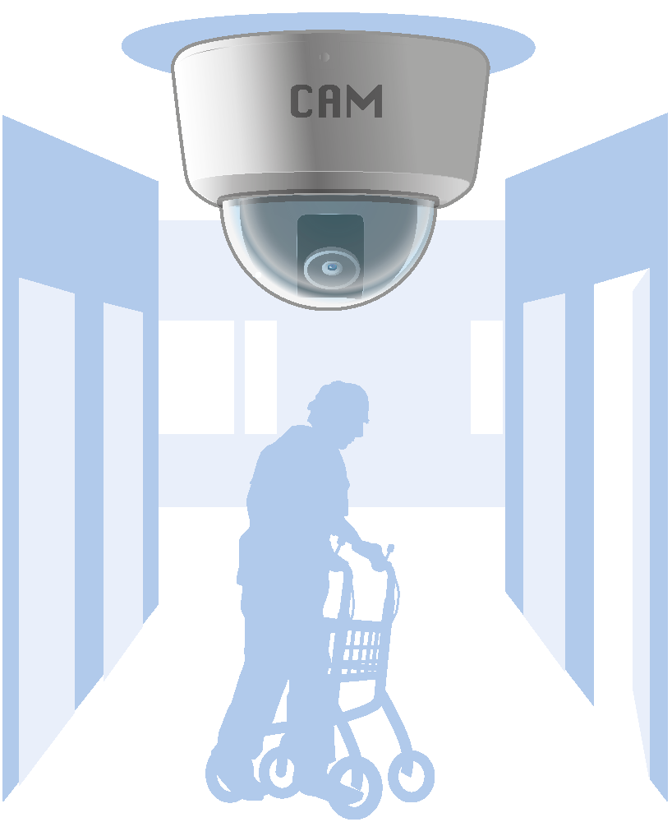

Checklists

Checklist - Fire protection management
Documentation
Building permits have been dealt with for the current business.
The fire prevention work has been documented.
Technical fire protection is documented.

Responsibility
There is one of the management set policies that includes fire safety.
Is a person appointed by the management with special responsibility for fire safety.
The relationship of responsibility between property owners and the business is documented.
The results of the fire prevention work are followed up by the management.

Allocation of tasks
There is a documented distribution of tasks.
The following tasks has been allocated:
- person with responsibility for fires safety
- person/s that performs self-monitoring
- attendants with responsibility for fire alarm and sprinkler system (when relevant)
Duties and powers are documented and signed by the relevant staff.

Risk management
Fire risks have been identified.

Routines
There are routines for staff actions in case of fire and fire alarm.
There are procedures for the personnel's actions in case of evacuation.

Education and information
There are plans for who should be trained and when.
Completed trainings and exercises are documented.

Self-monitoring
A plan is provided with details of when and how checks are to be carried out and who is to perform them.
Checks carried out are documented.
Deficiencies detected are addressed in an action plan.

Follow-up
The fire safety work is followed up at least once per year.

Checklist self-monitoring
Arson
Doors and gates to areas where everyone does not have access, are kept locked.
Fire safe material choices have been made for loose interior, such as mattresses, curtains and furniture.
Lighters, matches and flammable substances are kept locked up.
Exterior lighting, headlamps and motion sensors works, especially on the "back" of the building.
Packaging and waste are stored at specific sites.
Combustible material against façade, on loading platforms or under canopies has been minimized.

Kitchen
A stove guard has been installed if necessary.
Cooker-hoods and filters are cleaned.
Cooking hobs and stoves are free from combustible material, knobs are not likely to be turned on involuntarily.
Cooking hobs and stoves that are not in use, are disconnected.
Electric kettles, microwave ovens, fridge and freezers are of good quality and is replaced when worn.

Luminaries
Flashing fluorescent lamps do not occur.
Check that bulbs, spotlights, up lights are not inappropriately placed and likely to be covered or otherwise likely to come close to combustible material.
Lamps are of type and effect suitable for the lighting fixtures. LED that have a lower surface temperature are selected before halogen.
Luminaires are firmly or securely attached, especially bedside lamps.

Other electrical equipment
Rooms for electrical equipment and similar are not used as store-rooms.
Electric cables are undamaged and not jammed.
Electrical equipment is not put near combustible material.
Electrical equipment being charged is not near easy flammable material.

Other fire hazards
Smoking takes place in designated places with appropriate ashtrays.
Flammable liquids and gases are stored in special rooms or cabinets.
Washing machines, tumble dryers and other laundry equipment are regularly maintained.

Evacuation
Corridors are free from obstacles so that they can allow evacuation from adjacent areas.
Evacuation signs are well visible.
Emergency lighting in illuminated or trans-illuminated signs work when tested.
Evacuation corridors and stairwells are controlled throughout their length so that there are no obstacles in the form of furnishing, waste or similar.
Doors mounted in an evacuation route are easily opened in the evacuation direction without a key, code or card.
Doors normally opened with electrical opening devices, can be opened mechanically during power failure.
Emergency lighting works in case of power failure.
Evacuation plans are updated and show real conditions.

Fire-spread
All fire compartmentation boundaries meet the prescribed fire class according to documentation.
Perforations for cables, ventilation ducts and more, in the fire compartmentation, have been sealed with an approved sealing method.
Fire doors are undamaged and close correctly, no slots between door and frame.
Fire compartmentation above the acoustics and suspended ceilings are correctly made.

Firefighting equipment
Fire-ventilation, if any, have been checked.
Fire extinguishers are of the right type and have enough capacity, and are placed to be visible on intended locations.
Indoor hydrants have a valve that can be opened, the hose is undamaged and equipped with a nozzle that can be opened and closed.

Fire alarm
No damage has been done to detectors or alarm buttons.
System tests have been performed accordingly to national regulations.
Audit inspection has been carried out in accordance with national regulations.

Sprinkler (when relevant)
No sprinklers have been built in or screened.
Audit inspection has been carried out in accordance with national regulations.

Appendix – Fire risk assessment
This fire risk assessment is a document that surveys the fire risk considering premises with people that have weakened ability to escape if a fire breaks out.

It is important to know if the building has been designed for people who have a weakened ability to act if there is a fire. The risk assessment should be prepared regardless of the number of people using the building or of the size of the building. Often these buildings are care institutions, residential homes for the elderly or similar types of accommodation.

Considerations in the fire risk assessment
The fire risk assessment uses the example of an ordinary residential fire as a basis for planning. In considering the case of an individual resident or patient, the most dangerous situation is a fire that ignites in his or her own room. The development of this kind of a fire is well known from research and practical experience. Under normal circumstances a fire in a living room can develop from ignition to an all-embracing fire in less than six minutes. The effects of smoke vapors and heat become life-threatening in three to four minutes from ignition.

If it has not been noticed before, a fire will be detected by smoke detectors. This applies particularly to night time fires. Given the appropriate type of detector, properly installed, it will operate about a minute after the start of the fire. During that minute, any attempt to rescue the resident or patient is unlikely to have started. The conditions in the room where the fire has started becoming life-threatening for the resident or patient typically in 2 to 3 minutes after the fire has been detected.
    - The effect of limited ability to act
For the fire safety of individuals, important features of the ability to act include the ability to perceive, the ability to comprehend and the ability to move. Reduction of any of these abilities lessens the capacity of the residents or patients to save themselves, warn others, attempt to extinguish the fire. These effects should be considered in fire safety planning.

Perception
It is important for fire safety that individuals are quick to notice when a fire starts. Measures to act can only start once the alarm is raised. An individual’s ability to notice is crucial to independent escape. An individual with a normal ability to perceive (and is awake) notices a fire in their own room primarily based on sight, smell and sound. Nowadays, residents’ and patient’s rooms always have a fire alarm, or a smoke detector linked to an automatic fire alarm, to ensure that a fire is detected, and the alarm is raised quickly.

The weakening or absence of an individual’s sight or hearing influence the person’s fire safety by lengthening the time it takes them to notice a fire. Furthermore, deciding and taking to action to escape may take longer than necessary if an adequate assessment of the situation cannot be made immediately. Poor eyesight may cause escape to take longer because movement is obstructed.

Some diseases cause a weakening or complete loss of the ability to communicate. This can have effects comparable to the weakening of the ability to act especially when it comes to notifying others of an emergency and indicating the need for assistance.

The use of tranquillizers or sedatives weakens individuals’ ability to observe. Such medications are most commonly used at night, which is usually the most dangerous time for a fire. Thereby, weakening of a person’s powers of perception which will slows down independent escape. This must be considered in calculating evacuation times. The lack of the ability to notice an outbreak of fire may completely prevent independent escape, in which case the fire safety of such individuals cannot be based on the presumption that they can make their own escape.

Understanding the danger
For independent escape, understanding the danger caused by a fire is important. Deciding to exit and reacting to the situation requires a correct assessment of the situation.

As a result of various illnesses, the most common among the elderly being dementia, an individual’s ability to comprehend can be weakened to the extent that making a quick and correct assessment of the situation is unlikely or impossible. In such a case the individual is incapable of making the decision to exit independently even if the opportunities to do so would be straightforward for an able-bodied person. The evacuation of patients with severe and medium-severe dementia usually requires the assistance of others in a fire situation.

Mobility
The ability to move influences evacuation time. The time taken to evacuate includes getting up from a bed or seat, standing up, beginning to move and passing along the actual exit route.

Mobility may be reduced as a result of rheumatic diseases, disabilities or accidents. The person can move independently but in a limited manner, with or without walking aids. Sooner or later, old age usually leads to such weakening of the ability to move. Mobility can also be lost completely.
    - Safe means of escape
In case of fire, persons must be able to evacuate a building under their own choices or they must be rescued through other means. Evacuation means independent exit to a place of safety in threatening circumstances. Rescue means moving people with the partial or complete assistance of other persons.
    - Rescue
The successful rescue of residents or patients with the assistance of other persons always requires quick response to the alarm on the part of the rescuers. This, in turn, requires an effective automatic fire alarm system (based on smoke detection) that is connected directly to the staff and the emergency center of the rescue service. Because all residents must be rescued within 2 to 3 minutes from the detection of the fire, the rescuers must attend to it immediately. Only the businesses own staff can do this. The fire service cannot get to the scene that quickly. If the fire safety of the residents or patients depends on assistance from others, the staff must be aware of the responsibility for initial rescue measures.

The social and health services for people with a weakened ability to act (supplied by an external provider) are too slow if the person in question cannot get to safety independently or fast enough. Because of delays in using emergency telephones and other alarm systems for the disabled and for elderly persons, help cannot reach the scene within the time limit of 2-3 minutes required to achieve safe rescue from fire. That kind of alarm system is appropriate only when the time in which help arrives is proportional to the seriousness of the emergency.
    - Rescue by preventing conditions from becoming life-threatening
It is not always possible for the staff of fire fighters to rescue all residents or patients quickly enough. It is possible, however, to take steps to prevent conditions from becoming life-threatening as a result of fire. This can be done by equipping the premises with an appropriate, automatic fire-extinguishing system that continuously monitors the premises, quickly detects a fire and operates to extinguish the fire immediately after it has been detected. Furthermore, the system simultaneously sounds the alarm to alert the staff and the fire service. Even if the automatic fire-extinguishing system does not put out a fire completely, it controls the fire and prevents conditions from becoming life-threatening, thus providing extra time for the rescue of the occupants of the premises.

Preparing a fire risk assessment
Those who undertake the preparation of a fire risk assessment need to consider the reduced ability of elderly and disabled people to react in the event of a fire, compared to people with no disabilities.

A fire risk assessment for premises housing elderly or disabled people needs to consider a reduced ability to act and the necessary speed of response.
    - Can the resident evacuate quickly enough?
The fire risk assessment first determines whether the residents or patients can exit to safety on their own in 3 minutes. The manager evaluates all residents or patients so that further planning can consider the number of persons with a weakened ability to act and the extent of their weakening.

If the residents or patient’s ability to act is not weakened and they can exit to safety on their own, this is noted in the conclusion of the fire risk assessment. The information on the residents or patient’s ability to act (used as a basis for planning) is also recorded in the assessment. Fire safety planning is carried out as usual without any further measures required by the fire risk assessment.

If a resident’s or patient’s ability to act is so low that it prevents his independent exit, this is noted in the fire risk assessment and the individual’s chances of being rescued by outside assistance are evaluated.

If the resident’s or patient’s ability to act is weakened to an extent that it slows down the evacuation, it is evaluated more carefully whether the individual can exit the premises in 3 minutes. If the resident’s or patient’s ability to act has weakened to an extent that he or she is not able to exit in 3 minutes, it is noted in the fire risk assessment and the resident’s chances of being rescued with assistance from others are evaluated.

The most hazardous circumstances for the resident or patient should be chosen as the scenario. These circumstances most often occur during the night when people are asleep. The effect of medication on the ability to act must be taken into consideration.

Consideration must be given to the natural but inevitable reductions in the occupant’s ability to act also in the future, linked to possible changes that may be necessary to the building and its facilities. Age-related weakening of the ability to act cannot be ignored in housing and caring for the elderly unless clear and adequate support requirements for the ability to act in an emergency, are available.
    - Can assistance arrive in time?
If the fire risk assessment shows that there are residents or patients who need help in the event of fire, the next phase of assessment determines whether there are often people who can rescue the residents or patients in the fire-affected room in 3 minutes after the smoke detector has activated. If there are several individuals using the same evacuation-routs, they must all be rescued in a specified time frame.

In practice, only the staff in a care home or ward can come to the rescue in time.

If staff can rescue those residents or patients that are threatened, quickly enough when there is a fire in a room, and staff together with fire fighters can rescue the remaining patients or other residents in a ward or building, this is noted in the conclusion of the fire risk assessment. Information about the number of staffs during critical hours, their preparedness to act, the readiness and ability of the fire brigade to get to the site, the fire detection, alarm and notification systems and other necessary information used as a basis for planning, is verified in the fire risk assessment. It must always to be complied within the future and must be kept up to date with changes in circumstances at the premises.
    - Rescue by preventive measures
If the assessment shows that the resident or patient is not able to exit the apartment or treatment room quickly enough and that rescue by others in time is not possible, conditions must be prevented from becoming life-threatening by fitting a system to contain the spread of fire. This is possible with an appropriate automatic fire-extinguishing system. See, for example, Sprinkler systems: planning and installation (CEA 4001). If the staff do not have time to rescue a resident or patient, they will not have time to extinguish the fire with portable extinguishers.

Once fire has broken out, the staff have up to 15 minutes to rescue all occupants of the ward or equivalent unit. In a building that is divided into two sections, the occupants in the neighboring apartments must be rescued in 30 to 60 minutes, depending on the building’s structure. If all occupants cannot be rescued in the relevant time, steps must be taken to effect improvements. This can be done with appropriate automatic fire-extinguishing system, which should be installed in the building if any of its circumstances requires it. This provision needs to be recorded in the conclusion of the fire risk assessment.

A residential sprinkler system aims to prevent general fire in the room which is the site of the fire. It also improves residents or patients’ chances of evacuation or rescue. This kind of sprinkler system is not adequate to protect property, but it will also have some effect on property protection.

Even though the fire safety of individuals is addressed principally by being prepared to extinguish fire in a premise in its early stages with automatic fire-extinguishing apparatus, all other fire safety arrangements must be as effective as possible, considering the circumstances.

Even an efficient system of fire protection (active and passive measures combined) does not decrease the importance of fire prevention. Preventing the outbreak of fire is always the primary goal. The maintenance of passive and active fire protection and concurrent require of fire prevention practice are necessary requirement of good fire safety.

Rescuing individuals as quickly as possible from a burning apartment or room is always important. Because conditions in a room or apartment with a sprinkler system should not become life- threatening, more time is available, and time is therefore not such a critical factor. The conditions in such a room or apartment will nevertheless harmful to human beings because of their combination of smoke, soot and water. For this reason, individuals must still be rescued as quickly as possible. Overall property damage is also smaller the sooner rescue activity is commenced.

Choosing a level of fire safety on basis of fire risk assessment

Smoke alarm
- minimum requirement for an apartment of a small institution
Automatic fire extinguishing system (sprinklers)
- required if at least one patients/residents cannot exit or
be rescued quickly enough
Automatic fire alarm system
- minimum requirement for an institution (25+ beds)
Can the resident/patient exit the room/apartment independently
in 2 to 3 minutes after the fire has ignited?
Can rescuers help in time?
- rescue everybody from a room where fire is burning in 3 minutes
- evacuation from an adjoining room in the same fire compartment in up to 15 minutes
- evacuation from neighbouring compartments in up to 30 or 60 minutes
no
yes
no
yes

Schedule for fire risk assessment

FIRE RISK ASSESSMENT
Starting information
Name of premises
Address of premises
Other contact information
Basic information on the building
Structural information (building's fire class, compartmentation, sectioning structures etc.)
Description of protection level
Number of staff and their level of preparedness
Number of residents/patients and a general description of their ability to act
1. EVALUATION OF THE EFFECT OF OCCUPANTS' ABILITY TO ACT ON INDEPENDENT EXIT
(a) all occupants can independently exit the apartment or patient room in 3 minutes |  |  | move to item 6
(b) weakening of the ability to act slows down the exit of at least one occupant |  |  | move to item 2
(c) weakening of the ability to act prevents the independent exit of at least one occupant |  |  | move to item 3
2. TO WHAT EXTENT DOES THE WEAKENING OF THE ABILITY TO ACT SLOW DOWN EXIT?
(a) all occupants can independently exit the apartment or patient room in 3 minutes |  |  | move to item 6
(b) weakening of the ability to act slows down the exit of at least one occupant |  |  | move to item 3
3. CAN THE STAFF RESCUE THE OCCUPANTS OF A BURNING APARTMENT OR PATIENT ROOM IN TIME?
(a) staff can rescue all occupants in need of assistance from an ignited apartment or patient room in 3 minutes |  |  | move to item 4
(b) staff cannot rescue all occupants in need of assistance from an ignited apartment or patient room in 3 minutes |  |  | move to item 5
FIRE RISK ASSESSMENT
4. CAN THE STAFF AND THE FIRE BRIGADE ACT QUICKLY ENOUGH TO SAVE ALL OCCUPANTS OF THE WARD OR EQUIVALENT OR OF THE BUILDING WHO NEED ASSISTANCE?
(a) the staff and the fire brigade can rescue quickly enough from the building all occupants in need of assistance |  |  | move to item 6
(b) the staff and the fire brigade cannot rescue quickly enough from the building all occupants in need of assistance |  |  | move to item 5
5. CONDITIONS ARE PREVENTED FROM BECOMING LIFE-THREATENING BY INSTALLING AN AUTOMATIC FIRE EXTINGUISHING SYSTEM IN THE PREMISES
Designed and installed in accordance with national regulations. |  |  | move to item 6

6. ON THE BASIS OF FIRE RISK ASSESSMENT, THE BUILDING'S LEVEL OF FIRE SAFETY IS ADEQUATE
It is necessary that the following requirements concerning fire prevention and maintenance of fire safety are followed
- A safety plan has been made and communicated to the staff
- Staff has received building-specific safety training before the commencement of activities. Training will be held for the entire staff later in accordance with the training program of the safety plan.
- Staff is capable of rescue (the entire staff will participate in a rescue drill before the
commencement of operations and after that at least once a year).
- Staff is capable of first response firefighting (the entire staff participates in a first response firefighting drill and after that, at least once a year).
- Before the start of operations, a full-scale fire drill will be carried out to check the functioning of safety arrangements. The drill will be carried out in accordance with the information learned in the fire risk assessment.
- Conditions for a fire have been removed as far as possible.
- A maintenance program has been set up for all fire technical equipment (automatic fire extinguishing equipment, fire detection, fire alarms and fire alarm system, safety and instruction signs, smoke ventilation, automatic fire doors, fire extinguishers etc.), the program is followed, and routines are documented. The maintenance program is added to the instructions for the use and maintenance of the building.
- Self monitoring has been organized.
Date/Signature of main planning representative: | Date/Signature of management representative:

References
Fire safe care home, The Swedish Fire Protection Association, 2017, Author Lars Brodin.
Fire safety in residential homes for the elderly, The Finnish National Rescue Association, Guide 18, 2002, Author Seppo Männikkö.

European guidelines
Fire
Guideline No 1:2015 F -Internal fire protection control
Guideline No 2:2018 F -Panic & emergency exit devices
Guideline No 3:2011 F -Certification of thermographers
Guideline No 4:2010 F -Introduction to qualitative fire risk assessment
Guideline No 5:2016 F -Guidance signs, emergency lighting and general lighting
Guideline No 6:2021 F -Fire safety in care homes
Guideline No 7:2011 F -Safety distance between waste containers and buildings
Guideline No 8:2004 F -Preventing arson – information to young people
Guideline No 9:2012 F -Fire safety in restaurants
Guideline No 10:2008 F -Smoke alarms in the home
Guideline No 11:2015 F -Recommended numbers of fire protection trained staff
Guideline No 12:2012 F -Fire safety basics for hot work operatives
Guideline No 13:2006 F -Fire protection documentation
Guideline No 14:2019 F -Fire protection in information technology facilities
Guideline No 15:2012 F -Fire safety in guest harbours and marinas
Guideline No 16:2016 F -Fire protection in offices
Guideline No 17:2014 F -Fire safety in farm buildings
Guideline No 18:2013 F -Fire protection on chemical manufacturing sites
Guideline No 19:2009 F -Fire safety engineering concerning evacuation from buildings
Guideline No 20:2012 F -Fire safety in camping sites
Guideline No 21:2012 F -Fire prevention on construction sites
Guideline No 22:2012 F -Wind turbines – Fire protection guideline
Guideline No 23:2010 F -Securing the operational readiness of fire control system
Guideline No 24:2016 F -Fire safe homes
Guideline No 25:2010 F -Emergency plan
Guideline No 26:2010 F -Fire protection of temporary buildings on construction sites
Guideline No 27:2011 F -Fire safety in apartment buildings
Guideline No 28:2012 F -Fire safety in laboratories
Guideline No 29:2019 F -Protection of paintings: transports, exhibition and storage
Guideline No 30:2013 F -Managing fire safety in historic buildings
Guideline No 31:2013 F -Protection against self-ignition end explosions in handling and
-storage of silage and fodder in farms
Guideline No 32:2014 F -Treatment and storage of waste and combustible secondary raw
-materials
Guideline No 33:2015 F -Evacuation of people with disabilities
Guideline No 34:2015 F -Fire safety measures with emergency power supply
Guideline No 35:2015 F -Fire safety in warehouses
Guideline No 36:2017 F -Fire prevention in large tents
Guideline No 37:2018 F -Photovoltaic systems: recommendations on loss prevention
Guideline No 38:2021 F -Fire safety recommendations for short-term rental
-accommodations

Natural hazards
Guideline No 1:2012 N -Protection against flood
Guideline No 2:2013 N -Business resilience – An introduction to protecting your business
Guideline No 3:2013 N -Protection of buildings against wind damage
Guideline No 4:2013 N -Lighting protection
Guideline No 5:2014 N -Managing heavy snow loads on roofs
Guideline No 6:2016 N -Forest fires
Guideline No 7:2018 N -Demoutable / Mobile flood protection systems

Security
Guideline No 1:2010 S -Arson document
Guideline No 2:2010 S -Protection of empty buildings
Guideline No 3:2010 S -Security systems for empty buildings
Guideline No 4:2010 S -Guidance on keyholder selections and duties
Guideline No 5:2012 S -Security guidelines for museums and showrooms
Guideline No 6:2014 S -Security guidelines emergency exit doors in non residential premises
Guideline No 7:2016 S -Developing evacuation and salvage plans for works of art and
-heritage buildings
Guideline No 8:2016 S -Security in schools
Guideline No 9:2016 S -Recommendation for the control of metal theft
Guideline No 10:2016 S -Protection of business intelligence
Guideline No 11:2018 S -Cyber security for small and medium-sized enterprises

