Panic & emergency exit devices



**FOREWORD**

The European fire protection associations have decided to produce common guidelines in order to achieve similar interpretation in the European countries and to give examples of acceptable solutions, concepts and models. The Confederation of Fire Protection Associations Europe (CFPA E) has the aim to facilitate and support the fire protection work in the European countries.

This Guideline refers only to exit devices, which comply with the European standards for, panic and emergency exit devices, EN 1125, EN 179 and EN 13637. The guideline applies for exit doors with fire-resistant or non-fire-resistant function, that should be locked from the outside and/or enable controlled passage from inside/from outside. For other means of escape doors, including sliding doors, other opening support system applied. These are not covered by this guideline. The guideline does not deal with in which extent emergency exit doors should exist in different premises.

The guideline is primarily intended for those responsible for safety in companies and organisations. It is also addressed to the installation firms, rescue service, consultants, safety companies, architects etc so that, in the course of their work, they may find it useful to have access to different functional solutions with exit devices complying with European standards.

The proposals within this guideline have been produced by Lars Brodin from the Swedish Fire Protection Association.

This guideline has been compiled by Guidelines Commission and adopted by all fire protection associations in the Confederation of Fire Protection Associations Europe. These guidelines reflect best practice developed by the countries of CFPA Europe. Where the guidelines and national requirement conflict, national requirements must apply.

Copenhagen, October 2018 Madrid, October 2018  
CFPA Europe Guidelines Commission

Jesper Ditlev Miguel Vidueira  
Chairman Chairman



**Contents**

1 Introduction 4

2 Panic or emergency? 5

2.1 Panic situations 5

2.2 Emergency situations 5

3 Fields of application 5

3.1 Panic exit devices 6

3.2 Emergency exit devices 6

3.3 Electrically controlled exit systems for use on escape routes 6

3.4 Other opening devices 7

4 Double doors 7

5 Emergency exit button 7

6 Intruder protection locking device 8

7 Operation and maintenance 9

8 Choice of exit device for locked door as a function of the activity 9

8.1 Table for choosing exit devices 10

9 Definitions 12

10 European guidelines 13

11 Appendix No: 1 15

11.1 E 1, Single fire door 16

11.2 E 2, Single door with/without fire separating function depending on choice of electric striking 17

11.3 E 3, Single fire door 18

11.4 E 4, Single door with/without fire separating function depending on choice of electric striking 19

11.5 Ee 1, Single door, not a fire door 20

11.7 Ee 2, Single door with/without fire separating function depending on choice of electric str 21

11.8 Ee 3, Single fire door 22

11.9 P 1, Single fire door 23

11.10 P 2, Single fire door 24

11.12 P 3, Single door with/without fire separating function depending on choice of electric str 25

11.13 P 4, Single fire door 26

11.14 Pe 1, Single fire door 27

11.15 Pe 2, Single fire door 28

11.16 ED 1, Double fire doors 29

11.18 ED 2, Double doors with/without fire separating function depending on choice of electric str 30

11.19 ED 3, Double fire doors 31

11.20 ED 4, Double doors with/without fire separating function depending on choice of electric str 32

11.21 EDe 1, Double doors with no fire separating function 33

11.22 PD 1, Double fire doors 34

11.23 PD 2, Double fire doors 35

11.24 PD 3, Double doors with/without fire separating function depending on choice of electric str 36

11.25 PD 4, Double fire doors 37

11.26 PDe 1, Double fire doors 38

11.27 PDe 2, Double fire doors 39

12 EXAMPLES OF CONTROL ROUTINES 40

12.1 Control routines 40

Key words: emergency exit, emergency exit device, panics exit device, escape,

# Introduction

This proposal for functional solutions is mainly based on European standards for panic and emergency exit devices, EN 1125, EN 179 and EN 13637.

The Guideline applies for doors in escape routes, with or without fire separating function, which normally shall be kept locked from the outside and/or provide the means of controlling the passage of persons from the inside/outside.

For other doors in escape routes, which are **not** covered by this Guideline, a different opening function can be used accordingly to national regulations.

Example

Exit doors which shall normally be kept locked from the outside and/or provide the means of controlling the passage of persons from the inside/outside. Examples of these doors are given in this Guideline.

Exit doors which shall normally **not** be kept locked from the outside and/or provide the means of controlling the passage of persons from the inside/outside. For these doors other fittings can also be used.

Appendix No 1 gives examples of exit devices which can be used on doors to escape routes, where the activity demands that it should normally be possible for these doors to be kept locked from the outside to prevent the passage of unauthorised persons.

The publication does not deal with the fundamental problems of how to identify the doors, which are exit doors. For the applicable requirements, reference is to be made to the laws, regulations and other publications in the country concerned.

# Panic or emergency?

When designing equipment for exit doors on escape routes, you should always ask the question: is there any chance that a panic situation may arise?

Often, of course, building regulations, fire safety requirements, etc. will give you formal guidance or will even require the use of special hardware. However, the designer should take all possible measures to reduce the consequences of potential risks that may occur in the lifespan of a building. Technical solutions to deal with panic situations and with ‘ordinary’ emergencies are different. It is therefore important to define what type of situation is likely to arise.

## Panic situations

The reactions of a large number of people are always difficult to predict, especially in the event of

a fire in a cinema, a restaurant etc. The chances are that many of them will behave irrationally. The individuals exposed to such a panic situation must be able easily to find the hardware located on the exit door and how to operate it, and must not need any special tool or key, which may not be available.

The exit hardware must be designed to perform correctly in even the most extreme situations, in order to allow panicking people to exit. For example, when two or more people are rushing to an exit door located on an escape route, probably in darkness and/or smoke, it is possible that the first one to reach the door will not necessarily operate the panic exit device, but can push the surface of the door (door under pressure) while other people will be trying to operate the horizontal bar by hand or body pressure.

## Emergency situations

Typically, panic will not arise in hazardous situations involving a smaller number of people. Especially not if these people are familiar with the premises and with the emergency exits and their hardware. This could be the case in offices or other working environments.

Information, training, etc. will allow people to act rationally and to overcome their fears when exposed to a threatening situation. A clear understanding of the means of escape will allow positive and reasonable reactions, thus making a clear choice possible: where to go, what door to use, how to operate the door, etc. Of course, it is necessary here too that the door will operate without using any special tool or key, since this may not be available immediately.

# Fields of application

The fields of application listed below are to be seen as a guide to specifying exit devices. In each individual project, consideration should be given to the layout of the escape routes and premises and their fields of application. Even temporary use of the premises for purposes other than their normal activity may affect the choice of exit devices, e.g. when a sports hall is used for a school dance. Consideration should also be given to the possible future use of the premises, so that provision may be made at an early stage for flexible use. This implies that in certain circumstances the devices should be designed for a greater number of people, with variable knowledge of the premises, than those in the activity that is normally carried on in the premises.

The terms large number, smaller number and few are not defined in numbers of people, but shall be seen as a guide and a basis for assessment of the building as a whole or of the individual premises.

## Panic exit devices

Appropriate devices in premises and buildings where a large number of people, without good knowledge of the premises, may be present at the same time. Examples are schools, shopping centres, hospitals, theatres, discotheques, sports facilities, and restaurants.

Consideration should be given to the layout of the building and the premises, as well as the number of escape routes and their characteristics.

The publication refers to panic exit devices which comply with the requirements in European standard EN 1125.

## Emergency exit devices

These devices are intended for escape from buildings where the public are

unlikely to be present in large numbers, and where the staff in the building have been trained both in emergency procedures and in the use of the specific emergency exit devices fitted. Examples are offices and medium sized places of assembly.

These are recommended as the lowest level for exit doors where panic exit devices are not required.

The publication refers to emergency exit devices with single action operation, which comply with the requirements in European standard EN 179.

## ­Electrically controlled exit systems for use on escape routes

The design of an electrically controlled exit system shall be such that any failure of a component included in a single electrical element such as initiating element, controlling element, electrical locking element, CMC (Central management control) shall not affect the immediate release of the door.

In premises where a larger number of people without good local knowledge are

staying at the same time, for example large gathering rooms, is electric

controlled emergency exit systems appropriate evacuation solutions. In these cases, the initiating element should be a panic push bar.

For premises where a small number of people can stay and not everyone can be expected to have good local knowledge, the initiating element can consist of an emergency exit button.

This refers to evacuation systems with components that meet the requirements of the European standard EN 13637.

## Other opening devices

These devices are not intended for exit doors and should be used only in premises for a few people who have good knowledge of the premises. Examples are dwellings and small offices. The term other opening devices refers only to simple types of devices such as door handles and turn knobs.

Plastic domes over turn knobs are also covered here. These devices are intended to prevent unauthorised use of the turn knob function, e.g. in conjunction with installations for entry and exit control systems. Single action operation of the opening device should always be endeavoured.

# Double doors

Double doors with an inactive leaf smaller than 500 mm, fitted with a door closer, are not recommended for use in escape routes where panic exit devices are required, because the resistance to opening is too great.

Automatic flush bolts shall not be used in inactive leaves where these form part of an escape route, because the automatic flush bolt does not have a sequentially activated opening function.

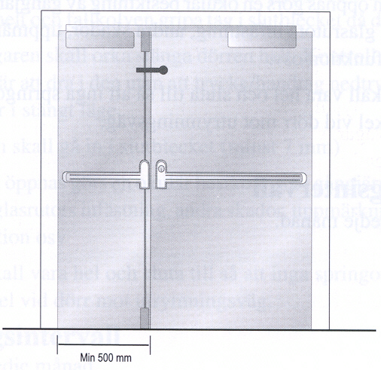

# Emergency exit button

Emergency exit buttons can be accepted where emergency exit devices in accordance with EN 179 are normally recommended according to Table 7.1. The button shall be placed in a prominent position.

For activities where panic exit devices are recommended according to Table 8.1, emergency exit buttons shall not normally be accepted. In this type of activity, the use of an emergency exit button shall be considered only after consultation with, and agreement by, the parties concerned.

Key switches are not accepted.

Properties of an emergency exit button:

* Green encapsulation.
* The emergency exit box is to be marked with a special sign. This sign should be green with white text "Emergency exit". The sign should be large enough to be easily detected.
* The button shall be easy to operate by a single action.
* The button should be visible even in the event of power failure. This can be achieved by providing standby power to illuminate the sign, by making the button luminous or the sign photoluminescence.
* Illuminated emergency exit button. By means of an integral illumination function or some other lighting fitting.
* When the button is depressed, the current shall be interrupted and the lock function released.
* If possible, red light for locked door and green light for unlocked door.
* The emergency exit button can with advantage be equipped with an acoustic exit alarm.

Position of emergency exit button:

* It shall be easy to see and placed on or in the immediate vicinity of the door.
* 0.9 – 1.2 m above floor level
* Max 0.5 m from the door laterally, but not on the side of the hinge.
* For single door the emergency exit button shall be placed on the hinge side.
* For double doors, push buttons should be placed beside the door to achieve the shortest distance between the emergency exit button and the lever handle.

# Intruder protection locking device

If doors are fitted with intruder protection locking devices (night locks), further measures in the form of connecting these via microswitches or similar are required.

They shall be connected to the function essential for the activity in such a way that activity cannot be carried on in the premises until all escape routes have been unlocked. One usual way is to connect the lighting in such a way that it cannot be switched on until all escape routes have been unlocked.

Local regulations may allow for “night locking” when not open to the public or for general occupancy, under certain conditions. For example, it may be requested for each person having access to the building (such as cleaning, security or maintenance people) to have their own key allowing them to escape from the building in case of an emergency.

Special conditions, for instance when people are locked in for various reasons, are not dealt with here. In such cases the solutions must at all times be decided on in consultation with the parties concerned.

# Operation and maintenance

The doors and devices, which form part of escape routes, must be maintained so that their function in an emergency situation is secured.

Inspections shall be made at regular intervals by a person appointed by the person responsible for the building or firm. Inspection intervals are to be determined by the responsible person.

The way inspection is to be performed varies depending on the function, which the door has. See Appendix No 1.

# Choice of exit device for locked door as a function of the activity

Table 8.1 sets out the levels of exit devices in buildings and premises for different types of activities, where doors in escape routes are normally locked from the outside to prevent the entry of unauthorised persons.

In the table, premises which, regarding their size and the number of people present, may be compared to a place of assembly, e.g. a staff dining room or a school dining room, are equated with places of assembly. This means that the devices are designed for a larger number of people, with variable knowledge of the premises, than those engaged in the activity that is daily carried on in the premises.

The reason for the more stringent requirement in large office buildings, hotels and healthcare premises is that in escape situations people from several floors gather in stairways. This means that so many peoples safety are depending on the exits that a more secure exit function is necessary.

**In case of doubt the higher requirement shall at all times be selected, i.e. a panic exit device can always be used.**

## Table for choosing exit devices

The fittings refer only to panic exit devices in accordance with EN 1125 or emergency exit devices in accordance with EN 179.

The numbers in the table heading refer to the corresponding examples of solutions in Appendix No 1.

|  |  |  |  |
| --- | --- | --- | --- |
| **Activity** | **Position of door** | **Panic exit device**  **(EN 1125)**  Examples of solutions**:**  **P = Panic exit device**  **PD = Double doors with P e = Electrically controlled** | **Emergency exit device (EN 179)**  Examples of solutions**:**  **E = Emergency exit device**  **ED = Double doors with E e = Electrically controlled** |
| **School < 200 persons** | To stairway |  | X |
|  | From stairway to external air |  | X |
| **School > 200 persons** | To stairway |  | X |
|  | From stairway to external air | X |  |
| **Office building <2000 m2** | To stairway |  | X |
|  | From stairway to external air |  | X |
| **Office building > 2000 m2** | To stairway |  | X |
|  | From stairway to external air | X |  |
| **Place of assembly** |  |  |  |
| **Large number of people** | To foyer or stairway | X |  |
|  | Out to external air | X |  |
| **Small number of people** | Out or to stairway |  | X |
|  | From stairway to external air | X |  |
| **Department store and retail trade**  **< 300 m2** **net floor space** | To external air or gallery |  | X |
| **Department store or retail trade**  **>300 m2 net floor space** | To external air or gallery | X |  |
|  | From common gallery to external air | X |  |

|  |  |  |  |
| --- | --- | --- | --- |
| **Activity** | **Position of door** | **Panic exit device**  **(EN 1125)**  Examples of solutions**:**  **P = Panic exit device**  **PD = Double doors with P e = Electrically controlled** | **Emergency exit device (EN 179)**  Examples of solutions**:**  **E = Emergency exit device**  **ED = Double doors with E e = Electrically controlled** |
| **Hotel, except restaurant etc**  **< 200 beds** | To stairway |  | X |
|  | From stairway to external air |  | X |
| **Hotel, except restaurant etc**  **> 200 beds** | To stairway |  | X |
|  | From stairway to external air | X |  |
| **Health care premises,**  **< 200 beds** | To stairway |  | X |
|  | From stairway to external air |  | X |
| **Health care premises,**  **> 200 beds** | To stairway |  | X |
|  | From stairway to external air | X |  |
| **Service flats** | To stairway and to external air |  | X |
| **Alternative housing** | To stairway and to external air |  | X |
| **Day care centre** | To external air |  | X |
| **Industry** |  |  | X |
| **Warehouse** |  |  | X |
| **Laboratories etc with activity that presents a fire hazard** |  | X |  |

# Definitions

* **Automatic flush bolt**

Locking device mounted on the meeting stile of the inactive leaf where its bolt is operated by a mechanism that is activated when the active leaf is closed.

An automatic flush bolt must not be used in the inactive leaf when this is part of an escape route because the automatic flush bolt does not have a sequentially activated opening function.

* **Bolt**

Mobile locking component placed in a lock or other locking device which shoots out through the forend, stile plate, etc.

* **CMC**Central management control, centrally controlling panel supervised by authorized personnel to monitor and to operate electrically controlled exit systems including the double time delay function and/or denied exit function
* **Door holder magnet**

Electromechanical locking device which holds the top of the door leaf to the door frame through magnetic force. It locks when connected to the power supply and is always automatically deactivated when disconnected from the supply.

* **Electromechanical door bolt**

Electromechanical locking device which connects the top of the door leaf to the door frame through a mechanical coupling. It locks when connected to the power supply and is always automatically deactivated when disconnected from the power supply.

* **Electromechanical hold-open device**

A hold-open device in the door closer function which is automatically deactivated when disconnected from the power supply. May also be provided in the form of a wall mounted door holder magnet.

* **Fire door**

Door that has a certain period of resistance to fire. The period of fire resistance may vary depending on the position of the door or the fire resistance class of the surrounding elements of construction.

* **Intruder protection locking**

Locking device that complies with the insurer's intruder protection requirement for the premises concerned.

* **Latch bolt**

Bolt with a bevelled end.

* **Lever handle**

Handle to operate the bolt of a lock.

* **Pulse generator**

May be in the form of e.g. push button, key switch, microswitch in exit device, digital code lock, card reader, time switch, pulse from the alarm system or some other electrical function.

* **Standby power/emergency power**

Function that secures the supply of power in the event of mains failure. It is often provided in the form of a battery backup for e.g. electric striking plate, electromechanical door bolt, door holder magnet and entry and exit control system.

* **Striking plate**

Device mounted in the frame to reinforce this where the hole for a bolt is made.

* **Tailpiece**

For double doors in combination with a door coordinator.

If double doors are opened via the inactive leaf, the tailpiece opens the active leaf also, so long as the door coordinator has been activated, which means that the leaves will be closed in the right order

# European guidelines

*Fire*

Guideline No. 1:2015 F - Fire protection management system

Guideline No. 2:2018 F - Panic & emergency exit devices

Guideline No. 3:2011 F - Certification of thermographers

Guideline No. 4:2010 F - Introduction to qualitative fire risk assessment

Guideline No. 5:2016 F - Guidance signs, emergency lighting and general lighting

Guideline No. 6:2011 F - Fire safety in care homes for the elderly

Guideline No. 7:2011 F - Safety distance between waste containers and buildings

Guideline No. 8:2004 F - Preventing arson – information to young people

Guideline No. 9:2012 F - Fire safety in restaurants

Guideline No. 10:2008 F - Smoke alarms in the home

Guideline No. 11:2015 F - Recommended numbers of fire protection trained staff

Guideline No. 12:2012 F - Fire safety basics for hot work operatives

Guideline No. 13:2015 F - Fire protection documentation

Guideline No. 14:2019 F - Protection of information technology facilities

Guideline No. 15:2012 F - Fire safety in guest harbours and marinas

Guideline No. 16:2016 F - Fire protection in offices

Guideline No. 17:2015 F - Fire safety in farm buildings

Guideline No. 18:2013 F - Fire protection on chemical manufacturing sites

Guideline No. 19:2009 F - Fire safety engineering concerning evacuation from buildings

Guideline No. 20:2012 F - Fire safety in camping sites

Guideline No. 21:2012 F - Fire prevention on construction sites

Guideline No. 22:2012 F - Wind turbines – Fire protection guideline

Guideline No. 23:2010 F - Securing the operational readiness of fire control system

Guideline No. 24:2016 F - Fire safe homes

Guideline No. 25:2010 F - Emergency plan

Guideline No. 26:2010 F - Fire protection of temporary buildings on construction sites

Guideline No. 27:2011 F - Fire safety in apartment buildings

Guideline N0. 28:2012 F - Fire Safety in laboratories

Guideline No. 29:2013 F - Protection of paintings: Transport, exhibition and storage

Guideline No. 30:2013 F - Managing fire safety in historical buildings

Guideline No. 31:2013 F - Protection against self-ignition and explosions in handling

and storage of silage and fodder in farms

Guideline No. 32:2014 F - Treatment and storage of waste and combustible

secondary raw materials

Guideline No. 33:2015 F - Evacuation of people with disabilities

Guideline No. 34:2015 F - Fire safety measures with emergency power supplies

Guideline No. 35:2017 F - Fire safety in warehouses

Guideline No. 36:2017 F - Fire prevention in large tents

Guideline No. 37:2018 F - Photovoltaic Systems: Recommendations on loss prevention

*Natural hazards*

Guideline No. 1:2012 N - Protection against flood  
Guideline No. 2:2013 N - Business Resilience – An introduction to protecting your

business

Guideline No. 3:2013 N - Protection of buildings against wind damage

Guideline No. 4:2013 N - Lightning protection

Guideline No. 5:2014 N - Managing heavy snow loads on roofs

Guideline No. 6:2015 N - Forest fires

Guideline No. 7:2018 N - Demountable / Mobile flood protection systems: Recommendations

on planning, selection, providing and using.

*Security*

Guideline No. 1:2010 S - Arson document  
Guideline No. 2:2010 S - Protection of empty buildings  
Guideline No. 3:2010 S - Security system for empty buildings  
Guideline No. 4:2010 S - Guidance on key holder selections and duties

Guideline No. 5:2012 S - Security guidelines for museums and showrooms

Guideline No. 6:2014 S - Emergency exit doors in non-residential premises

Guideline No. 7:2016 S - Developing evacuation and salvage plans for works of art and

Heritage buildings

Guideline No. 8:2016 S - Security in schools

Guideline No. 9:2016 S - Recommendation for the control of metal theft

Guideline No. 10:2016 S - Protection of business intelligence

# Appendix No: 1

Appendix

Panic & emergency exit devices

**FOREWORD**

This Appendix offers technical solutions according to table 8.1 in the European Guide Line "Panic & emergency exit devices"

These technical solutions apply for exit doors, not sliding doors, both with and without a fire separating function, which shall normally be locked from the outside and/or provide the means of controlling the passage of persons from the inside/outside.

This Appendix has been compiled by Guidelines Commission and adopted by all fire protection associations in the Confederation of Fire Protection Associations Europe.

These technical solutions reflect best practice proposed by the members of CFPA Europe. Where the Guidelines and national requirements conflict, national requirements must apply.

## E 1, Single fire door

Fittings on the inside

Emergency exit device

Door closer. Can be fitted with electromechanical hold-open device

Functions on the inside

The exit handle, operated with one hand, secures exit

Option of authorised passage via a key

Fitting on the outside

Lever handle

Functions on the outside

Lever handle secures return

Option of authorised passage via a key

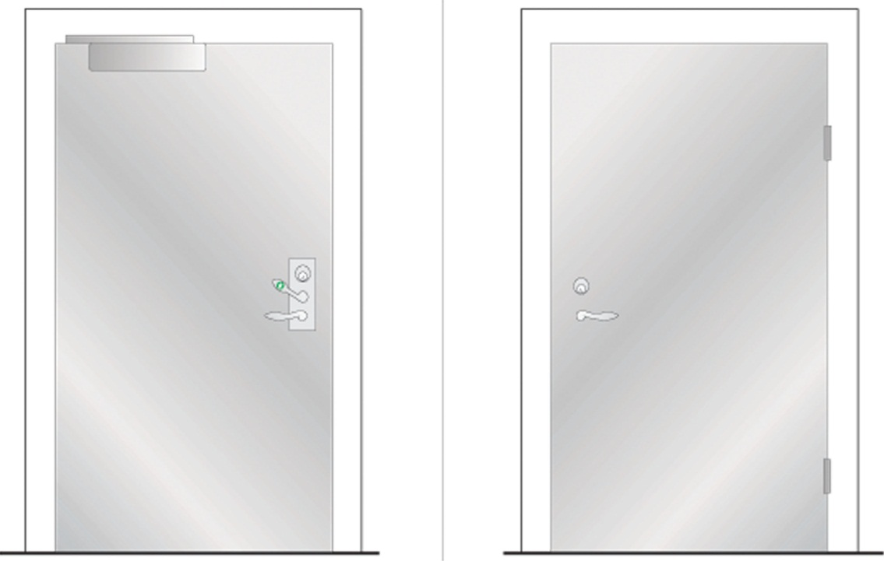

## E 2, Single door with/without fire separating function depending on choice of electric striking plate

Fittings on the inside

Emergency exit device

Electric striking plate

Pulse generator, e.g. card reader

Door closer

Functions on the inside

The exit handle, operated with one hand, secures exit

Option of authorised passage via pulse generator/key

Option of automatic unlocking via fire alarm, with fire separating function retained depending on choice of electric striking plate. (Not as the only function)

Fittings on the outside

Lever handle

Pulse generator, e.g. card reader

Functions on the outside

Lever handle secures return

Option of authorised passage via pulse generator/key

Option of automatic unlocking via fire alarm, with fire separating function retained depending on choice of electric striking plate. (Not as the only function)

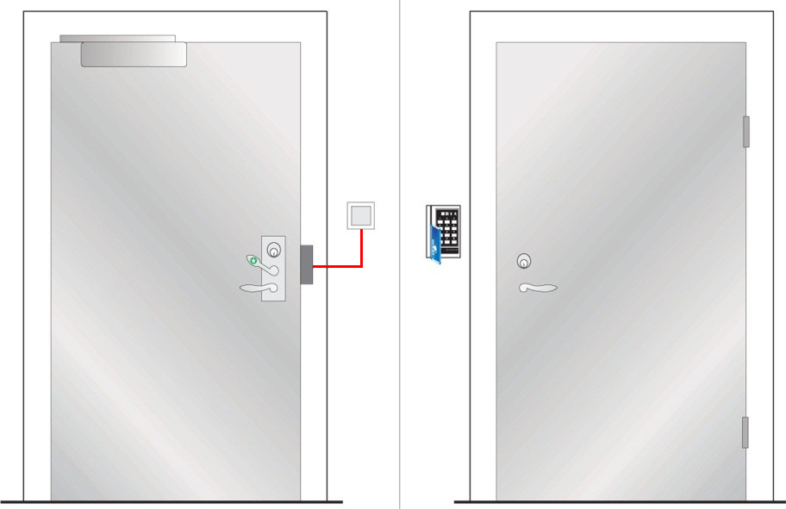

Inside Outside

## E 3, Single fire door

Fittings on the inside

Emergency exit device, as push pad

Door closer. Can be fitted with electromechanical hold-open device

Functions on the inside

The push pad, operated with one hand, secures exit

Option of authorised passage via a key

Fitting on the outside

Option 1: See figure. Plain outside face

Option 2: Cylinder + pull handle

Functions on the outside

Option 1: See figure. No return

Option 2: No return but authorised passage via key

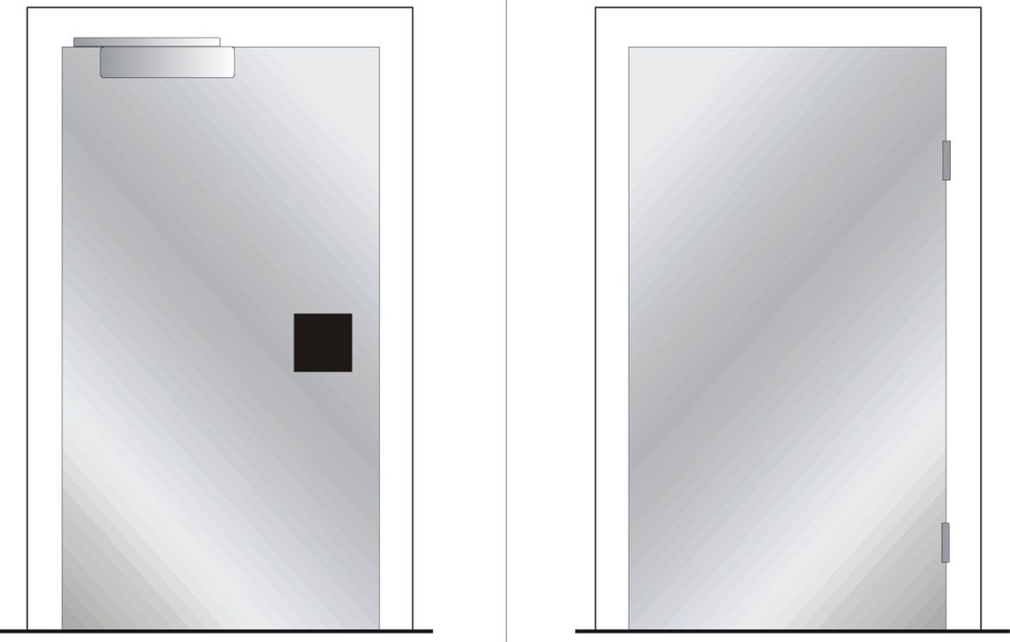

Inside Outside

## E 4, Single door with/without fire separating function depending on choice of electric striking plate

Fittings on the inside

Emergency exit device as push pad

Electric striking plate

Pulse generator, e.g. card reader

Door closer

Functions on the inside

The push pad, operated with one hand, secures exit

Option of authorised passage via pulse generator/key

Option of automatic unlocking via fire alarm, with fire separating function retained depending on choice of electric striking plate. (Not as the only function)

Fittings on the outside

Lever handle

Pulse generator, e.g. card reader

Functions on the outside

No return but authorised passage via pulse generator/key

Option of automatic unlocking via fire alarm, with fire separating function retained depending on choice of electric striking plate

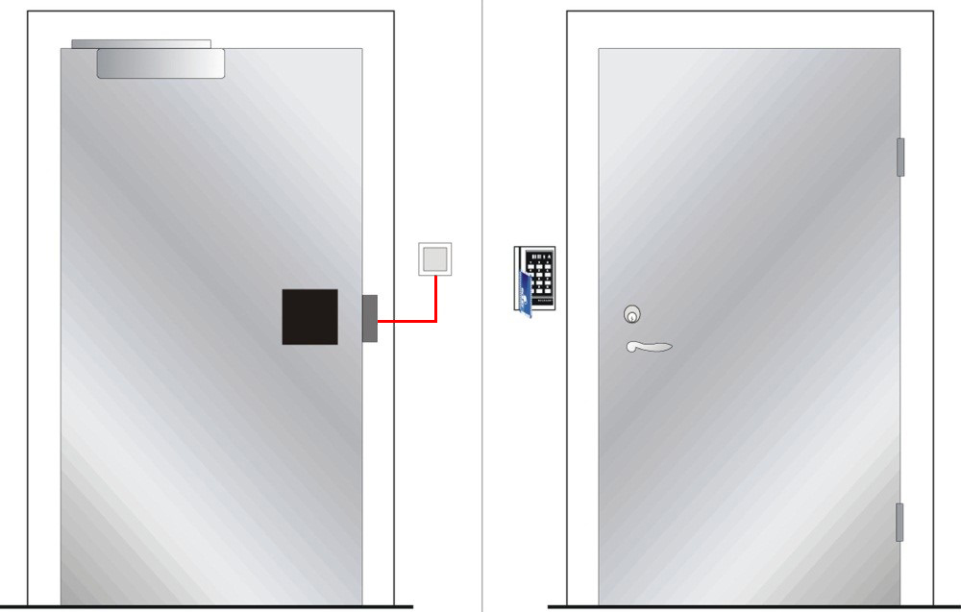

Inside Outside

## Ee 1, Single door, not a fire door

Fittings on the inside

Emergency exit button

Door holder magnet/electromechanical door bolt with standby power

Pull handle

Door closer. Can be fitted with electromechanical hold-open device

Functions on the inside

Exit via emergency exit button

Option of authorised passage via key switch or pulse generator

Option of automatic unlocking via fire alarm. (Not as the only function)

Fittings on the outside

Pull handle

Pulse generator, e.g. card reader

Functions on the outside

Return via pull handle after exit or activation of fire alarm

Option of authorised passage via pulse generator

Option of automatic unlocking via fire alarm. (Not as the only function)

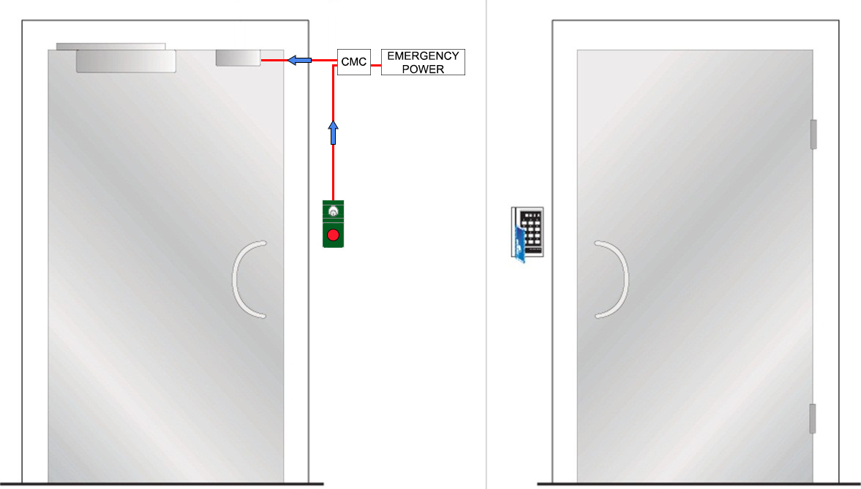

Inside Outside

## Ee 2, Single door with/without fire separating function depending on choice of electric striking plate

Fittings on the inside

Emergency exit button

Electric striking plate with folded mechanical lock housing  
Pull handle

Door closer. Can be fitted with electromechanical hold-open device

Functions on the inside

Exit via emergency exit button

Option of authorised passage via key switch or pulse generator

Option of automatic unlocking via fire alarm. (Not as the only function)

Fittings on the outside

Pull handle

Pulse generator, e.g. card reader

Functions on the outside

Return via pull handle after exit or activation of fire alarm

Option of authorised passage via pulse generator

Option of automatic unlocking via fire alarm. (Not as the only function)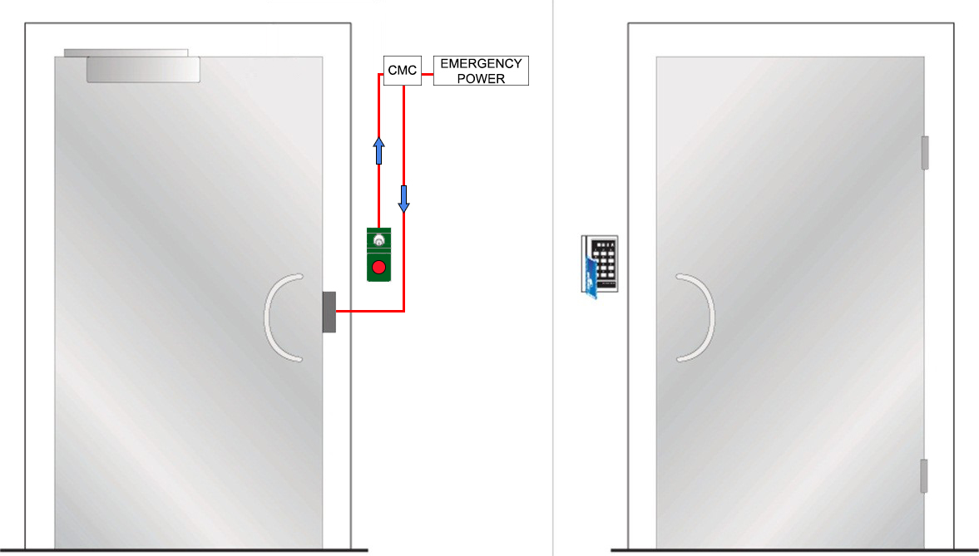

Inside Outside

## Ee 3, Single fire door

Fittings on the inside

Emergency exit button

Electric lock/solenoid lock with lever latch

Door closer. Can be fitted with electromechanical hold-open device

Functions on the inside

Exit via emergency exit button

Option of authorised passage via key switch or pulse generator

Option of automatic unlocking via fire alarm. (Not as the only function)

Fittings on the outside

Lever handle

Pulse generator, e.g. card reader

Functions on the outside

Return via lever handle after exit or activation of fire alarm

Option of authorised passage via pulse generator or key

Option of automatic unlocking via fire alarm. (Not as the only function)

## C:\Users\s7416\AppData\Local\Microsoft\Windows\Temporary Internet Files\Content.Word\Sid 22 EN 3.jpg

Inside Outside

## P 1, Single fire door

Fittings on the inside

Panic bolt push/touch bar

Door closer. Can be fitted with electromechanical hold-open device

Functions on the inside

Panic bolt push/touch bar secures exit.

Option of authorised passage via key

Fitting on the outside

Lever handle

Functions on the outside

Lever handle secures return

Option of authorised passage via key

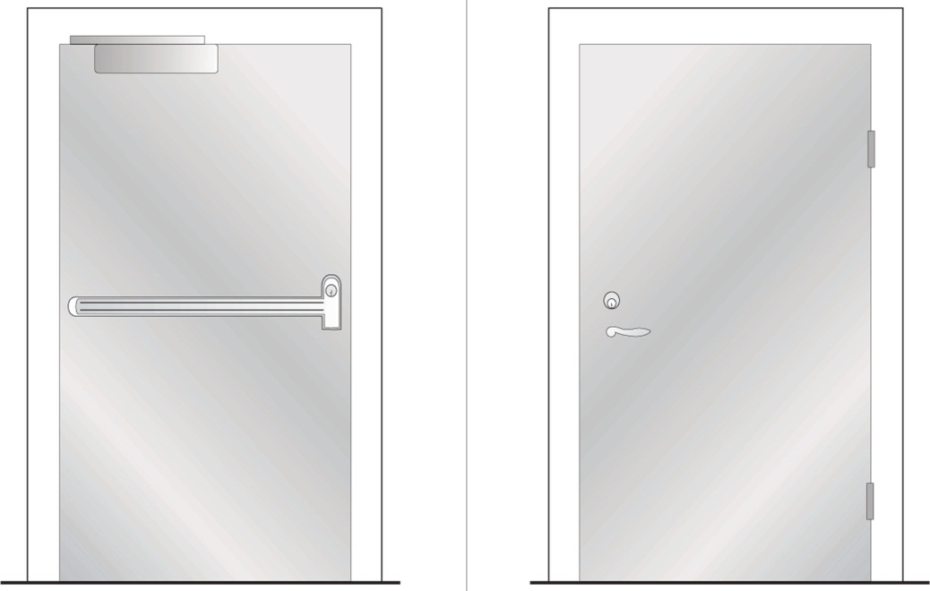

Inside Outside

## P 2, Single fire door

Fittings on the inside

Panic bolt push/touch bar

Door closer. Can be fitted with electromechanical hold-open device

Functions on the inside

Panic bolt push/touch bar secures exit

Option of authorised passage via key

Fittings on the outside

Option 1: See figure. Plain outside face

Option 2: Cylinder + pull handle

Functions on the outside

Option 1: See figure. No return

Option 2: No return but authorised passage via key

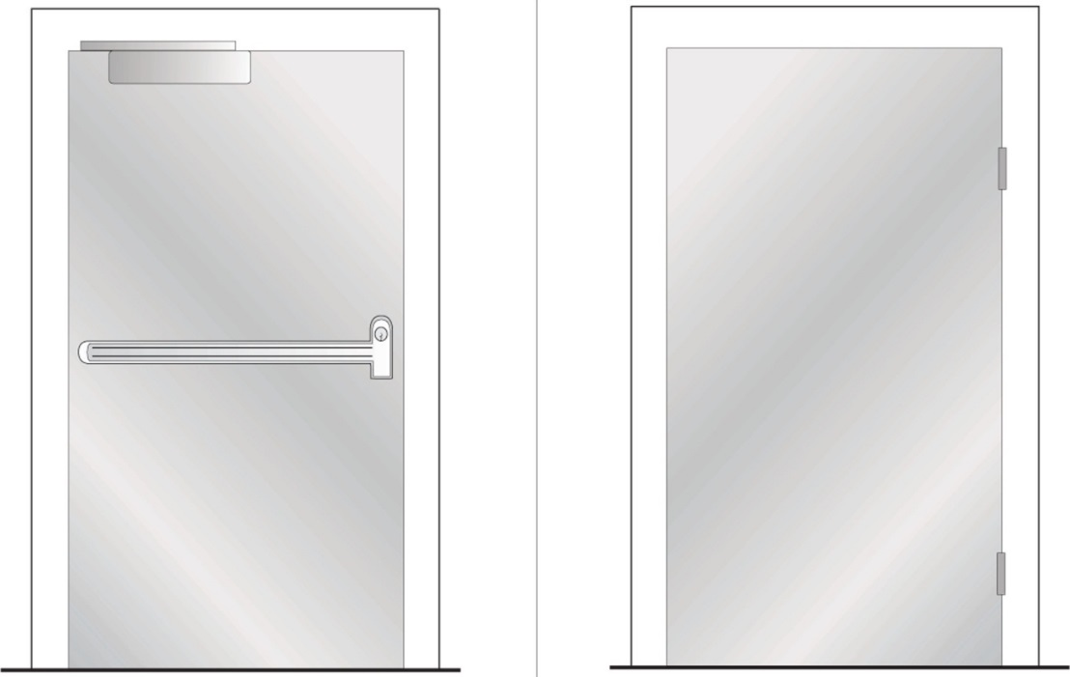

Inside Outside

## P 3, Single door with/without fire separating function depending on choice of electric striking plate

Fittings on the inside

Panic bolt push/touch bar

Electric striking plate

Pulse generator, e.g. card reader

Door closer

Functions on the inside

Panic bolt push/touch bar secures exit

Option of authorised passage via pulse generator

Option of automatic unlocking via fire alarm, with fire separating function retained depending on choice of electric striking plate. (Not as the only function)

Fittings on the outside

Lever handle

Pulse generator, e.g. card reader

Functions on the outside

Lever handle secures return

Option of authorised passage via pulse generator

Option of automatic unlocking via fire alarm, with fire separating function retained depending on choice of electric striking plate. (Not as the only function)

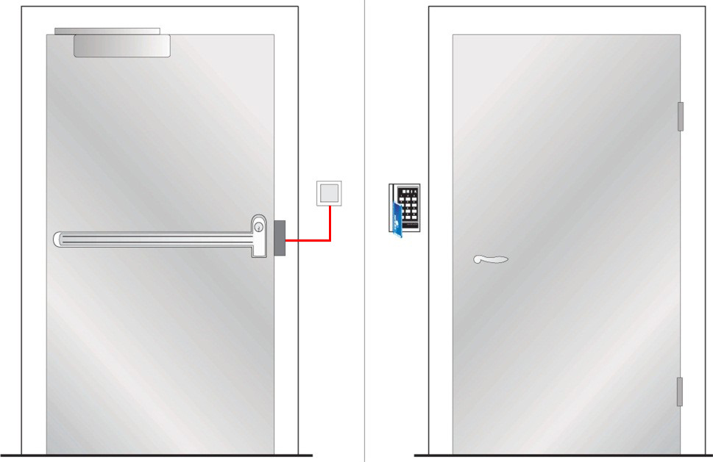

Inside Outside

## P 4, Single fire door

Fittings on the inside

Panic bolt push/touch bar with electrical opening

Pulse generator, e.g. card reader

Door closer. Can be fitted with electromechanical hold-open device

Functions on the inside

Panic bolt push/touch bar secures exit

Option of authorised passage via pulse generator

Fittings on the outside

Pull handle

Pulse generator, e.g. card reader

Functions on the outside

No return

Option of authorised passage via pulse generator

Note

The panic bolt push/touch bar shall not be electrically held open. It shall be electrically open only at the time of passage

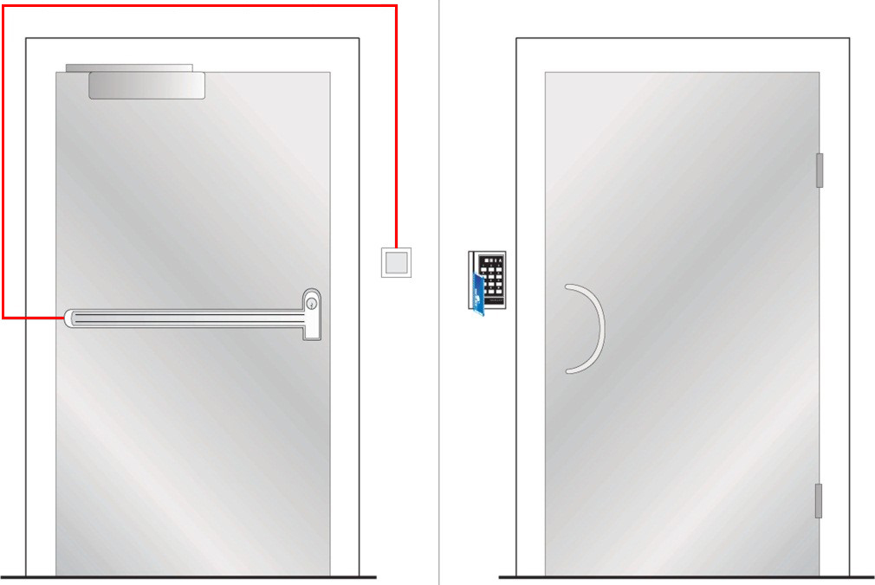

Inside Outside

## Pe 1, Single fire door

Fittings on the inside

Panic bolt push/touch bar with micro switch

Door holder magnet/electromechanical door bolt

Door closer. Can be fitted with electromechanical hold-open device

Functions on the inside

Panic bolt push/touch bar secures exit

Micro switch secures opening of door holder magnet/electromechanical door bolt

Option of automatic unlocking via fire alarm, with fire separating function retained. (Not as the only function)

Fittings on the outside

Option 1: Lever handle

Option 2: See figure. Lever handle + pulse generator, e.g. card reader

Functions on the outside

Option 1: Lever handle secures exit

Option 2: See figure. Lever handle secures return

Option of authorised passage via pulse generator/key

Option of automatic unlocking via fire alarm, with fire separating function retained. (Not as the only function)

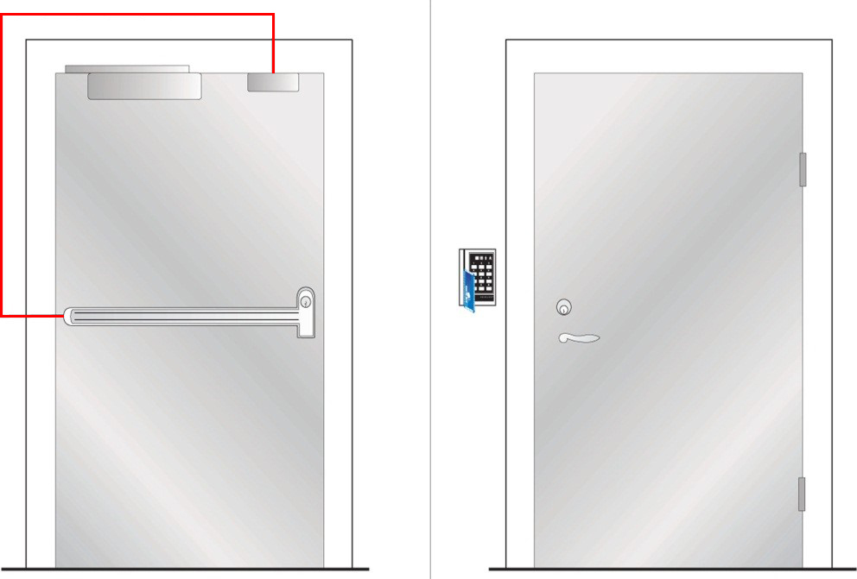

Inside Outside

## Pe 2, Single fire door

Fittings on the inside

Panic bolt push/touch bar with electrical opening and micro switch

Door holder magnet/electromechanical door bolt

Pulse generator, e.g. card reader

Door closer. Can be fitted with electromechanical hold-open device

Functions on the inside

Panic bolt push/touch bar secures exit

Micro switch secures opening of door holder magnet/electromechanical door bolt

Option of authorised passage via pulse generator

Option of automatic unlocking via fire alarm, with fire separating function retained. (Not as the only function)

Fittings on the outside

Lever handle

Pulse generator, e.g. card reader

Functions on the outside

Lever handle secures return

Option of authorised passage via pulse generator

Option of automatic unlocking via fire alarm, with fire separating function retained. (Not as the only function)

Note

The panic bolt push/touch bar shall not be electrically held open. It shall be electrically open only at the time of passage

Can be fitted with door automatics

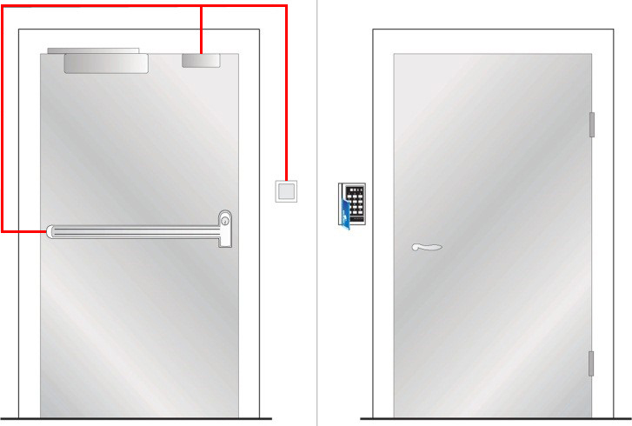

Inside Outside

## ED 1, Double fire doors

Fittings on the inside

Emergency exit devices, active leaf

Automatic flush bolts, inactive leaf

Inactive leaf fitted with tailpiece for the door coordinator function

Functions on the inside

Exit handle, operated with one hand, secures exit via active leaf

Option of authorised passage via key

Fittings on the outside

Lever handle

Door closer with coordinator. Can be fitted with electromechanical hold-open device

Functions on the outside

Lever handle secures return

Option of authorised passage via key

Door closer with coordinator closes the leaves in the right order

Note

The inactive leaf shall not form part of the escape route

|  |
| --- |
| NP1_insida NY NP1_utsida NY |

Inside Outside

## ED 2, Double doors with/without fire separating function depending on choice of electric striking plate

Fittings on the inside

Emergency exit device

Electric striking plate in inactive leaf

Pulse generator, e.g. card reader

Automatic flush bolts in inactive leaf

Inactive leaf fitted with tailpiece for the door coordinator function

Functions on the inside

Exit handle secures exit via active leaf

Option of authorised passage via pulse generator/key

Option of automatic unlocking via fire alarm, with fire separating function retained, depending on choice of electric striking plate. (Not as the only function)

Fittings on the outside

Lever handle

Pulse generator, e.g. card reader

Door closer with coordinator

Functions on the outside

Lever handle secures return

Option of authorised passage via pulse generator/key

Door closer with coordinator closes the leaves in the right order

Option of automatic unlocking via fire alarm, with fire separating function retained, depending on choice of electric striking plate. (Not as the only function)

Note

Inactive leaf shall not form part of the escape route

|  |
| --- |
| C:\Users\s7416\AppData\Local\Microsoft\Windows\Temporary Internet Files\Content.Word\EP2.png NP3_utsida NY |
| Inside Outside |

## ED 3, Double fire doors

Fittings on the inside

Emergency exit devices, as push pad

Automatic flush bolts, inactive leaf

Inactive leaf fitted with tailpiece for the door coordinator function

Functions on the inside

Push pad secures exit via active leaf

Option of authorised passage via key

Fittings on the outside

Option 1: See figure. Plain outside face

Door closer with coordinator. Can be fitted with electromechanical hold-open device

Option 2: Cylinder + pull handle

Door closer with coordinator. Can be fitted with electromechanical hold-open device

Functions on the outside

Option 1: See figure. No return

Door closer with coordinator closes the leaves in the right order

Option 2: No return but authorised passage via key

Door closer with coordinator closes the leaves in the right order

Note

Inactive leaf shall not form part of the escape route

|  |
| --- |
| NP4 insida NY NP4 utsida NY  Inside Outside |

## ED 4, Double doors with/without fire separating function depending on choice of electric striking plate

Fittings on the inside

Emergency exit device. as push pad

Electric striking plate in inactive leaf

Pulse generator, e.g. card reader

Automatic flush bolts in inactive leaf

Inactive leaf fitted with tailpiece for the door coordinator function

Functions on the inside

The push pad secures exit via active leaf

Option of authorised passage via pulse generator/key

Option of automatic unlocking via fire alarm, with fire separating function retained, depending on choice of electric striking plate. (Not as the only function)

Fittings on the outside

Pull handle

Pulse generator, e.g. card reader

Door closer with coordinator

Functions on the outside

No return but authorised passage via pulse generator/key

Door closer with coordinator closes the leaves in the right order

Option of automatic unlocking via fire alarm, with fire separating function retained depending on choice of electric striking plate. (Not as the only function)

Note

Inactive leaf shall not form part of the escape route

|  |
| --- |
| C:\Users\s7416\AppData\Local\Microsoft\Windows\Temporary Internet Files\Content.Word\EP4.png NP5_utsida NY  Inside Outside |
| EDe 1, Double doors with no fire separating function Fittings on the inside  Emergency exit button  Option 1: See figure. Rebated doors fitted with door holder magnet/electromechanical door bolt with standby power  Inactive leaf fitted with tailpiece for the door coordinator function  Option 2: Not rebated doors fitted with double door holder magnets/ electromechanical door bolts with standby power  Functions on the inside  Exit via emergency exit button  Option of authorised passage via key switch  Option of automatic unlocking via fire alarm. (Not as the only function)  Fittings on the outside  Pull handle  Pulse generator, e.g. card reader  Option 1: See figure. Rebated doors fitted with door closer and coordinator  Can be fitted with electromechanical hold-open device  Option 2: Not rebated doors fitted with door closer. Coordinator not required. Can be fitted with electromechanical hold-open device  Functions on the outside  Return via pull handle after exit or activation of fire alarm  Option of authorised passage via pulse generator  Option of automatic unlocking via fire alarm. (Not as the only function)  Door closer with coordinator closes the leaves in the right order   |  | | --- | | NP2_utsida NYC:\Users\s7416\AppData\Local\Microsoft\Windows\Temporary Internet Files\Content.Outlook\UZNNX59S\EDe1 11_21 (002).png |   Inside Outside |

## PD 1, Double fire doors

Fittings on the inside

Panic bolt push/touch bars

Inactive leaf fitted with tailpiece for the door coordinator function

Functions on the inside

Panic bolt push/touch bar secures exit

Option of authorised passage via key

Fittings on the outside

Lever handle

Door closer with coordinator. Can be fitted with electromechanical hold-open device

Functions on the outside

No return

Option of authorised passage via key

Door closer with coordinator closes the leaves in the right order

Note

Where the inactive leaf forms part of the escape route, its width shall not be less than 500 mm.

PP1_insida NY

PP1_utsida NY

Inside Outside

## PD 2, Double fire doors

Fittings on the inside

Panic bolt push/touch bars

Inactive leaf fitted with tailpiece for the door coordinator function

Functions on the inside

Panic bolt push/touch bar secures exit

Option of authorised passage via key

Fittings on the outside

Door closer with coordinator. Can be fitted with electromechanical hold-open device

Option 1: See figure. Plain outside face

Option 2: Cylinder + pull handle

Functions on the outside

Door closer with coordinator closes the leaves in the right order

Option 1: See figure. No return

Option 2: No return but authorised passage via key

Note

Where the inactive leaf forms part of the escape route, its width shall not be less than 500 mm.

|  |
| --- |
| PP2_insida NY PP2_utsida NY |

Inside Outside

## PD 3, Double doors with/without fire separating function depending on choice of electric striking plate

Fittings on the inside

Panic bolt push/touch bars with micro switches

Electric striking plate in inactive leaf

Pulse generator, e.g. card reader

Inactive leaf fitted with tailpiece for the door coordinator function

Functions on the inside

Panic bolt push/touch bars secure exit

Option of authorised passage via pulse generator

Option of automatic unlocking via fire alarm, with fire separating function retained, depending on choice of electric striking plate. (Not as the only function)

Fittings on the outside

Lever handle

Pulse generator, e.g. card reader

Door closer with coordinator

Functions on the outside

Lever handle secures return. (Depending on choice of electric striking plate)

Option of authorised passage via pulse generator

Option of automatic unlocking via fire alarm, with fire separating function retained, depending on choice of electric striking plate . (Not as the only function)

Door closer with coordinator closes the leaves in the right order

Note

Where the inactive leaf forms part of the escape route, its width shall not be less than 500 mm.

|  |
| --- |
| C:\Users\s7416\AppData\Local\Microsoft\Windows\Temporary Internet Files\Content.Word\PP3.png PP4_utsida NY  Inside Outside |

## PD 4, Double fire doors

Fittings on the inside

Panic bolt push/touch bars with electrical opening

Pulse generator, e.g. card reader

Inactive leaf fitted with tailpiece for the door coordinator function

Functions on the inside

Panic bolt push/touch bars secure exit

Option of authorised passage via pulse generator

Fittings on the outside

Pull handle

Pulse generator, e.g. card reader

Door closer with coordinator. Can be fitted with electromechanical hold-open device

Functions on the outside

No return

Option of authorised passage via pulse generator

Door closer with coordinator closes the leaves in the right order

Note

Where the inactive leaf forms part of the escape route, its width shall not be less than 500 mm.

Panic bolt push/touch bar shall not be electrically held open. It shall be electrically open only at the time of passage

|  |
| --- |
| C:\Users\s7416\AppData\Local\Microsoft\Windows\Temporary Internet Files\Content.Word\PP4.png PP5_utsida NY |

Inside Outside

## 

## PDe 1, Double fire doors

Fittings on the inside

Panic bolt push/touch bars with micro switches

Door holder magnet/electromechanical door bolt in active leaf

Inactive leaf fitted with tailpiece for the door coordinator function

Functions on the inside

Panic bolt push/touch bars secure exit

Micro switches secure opening of door holder magnet/electromechanical door bolt

Option of automatic unlocking via fire alarm, with fire separating function retained, depending on choice of electric striking plate. (Not as the only function)

Fittings on the outside

Door closer with coordinator. Can be fitted with electromechanical hold-open device

Option 1: Lever handle

Option 2: See figure. Lever handle + pulse generator, e.g. card reader

Functions on the outside

Door closer with coordinator closes the leaves in the right order

Option 1: Lever handle secures return

Option 2: See figure. Lever handle secures return

Option of authorised passage via pulse generator/key

Option of automatic unlocking via fire alarm, with fire separating function retained. (Not as the only function)

Note

Where the inactive leaf forms part of the escape route, its width shall not be less than 500 mm

|  |
| --- |
| C:\Users\s7416\AppData\Local\Microsoft\Windows\Temporary Internet Files\Content.Word\PPe1.png PP3_utsida NY |

Inside Outside

## PDe 2, Double fire doors

Fittings on the inside

Panic bolt push/touch bars with electrical opening and micro switches

Door holder magnet/electromechanical door bolt in active leaf

Pulse generator, e.g. card reader

Inactive leaf fitted with tailpiece for the door coordinator function

Functions on the inside

Panic bolt push/touch bars secure exit

Micro switch secures opening of door holder magnet/electromechanical door bolt

Option of authorised passage via pulse generator

Option of automatic unlocking via fire alarm, with fire separating function retained, depending on choice of electric striking plate. (Not as the only function)

Fittings on the outside

Lever handle

Pulse generator, e.g. card reader

Door closer with coordinator. Can be fitted with electromechanical hold-open device

Functions on the outside

Lever handle secures return

Option of authorised passage via pulse generator

Door closer with coordinator closes the leaves in the right order

Option of automatic unlocking via fire alarm, with fire separating function retained. (Not as the only function)

Note

Where the inactive leaf forms part of the escape route, its width shall not be less than 500 mm.

Panic bolt push/touch bar shall not be electrically held open. It shall be electrically open only at the time of passage.

Can be fitted with door automatics

|  |
| --- |
| C:\Users\s7416\AppData\Local\Microsoft\Windows\Temporary Internet Files\Content.Word\Sid 40 EPP 2.png PP6_utsida NY |

Inside Outside

# EXAMPLES OF CONTROL ROUTINES

Regular control should be carried out by the usufructuary, but an effort should be made to perform the control together with the property owner as often as possible. The aim of this is to become familiar with the building and to form an overall idea of the total security of escape, and to achieve a good dialogue with the property owner.

In order that control of the technical installation may be carried out in a satisfactory manner, the following checklist should be used in checking doors in, and to, an escape route.

How often controls should be carried out depends on the hazard situation and the general wear and tear in the building and premises. Control of escape facilities should be made every day.

## Control routines

**For all doors in and to escape routes, regardless of whether they have, or have not, a fire compartment separating function, the following are to be checked.**

**Function**

* Check that the door can be easily opened without a key, code or card, and that it can be opened at least 90º
* Check that nothing is blocking the escape route
* Check that the force needed to open the door does not exceed 130 N (ca 13 kg)
* Check that return into the premises is possible where so required

**Maintenance**

* When the door is opened, make a visual inspection of hinges, locks, handle, door frame, the attachment of glazed panels if any, any other damage, marking, the function of the door handle, etc.

**For a door with a fire compartment separating function, the following is also to be checked**

**Gas tightness**

* Check that the door is undamaged and closes so that there are no gaps, not even along the doorstep of a door opening into an escape route in a stairway
* Check that any intumescent strips that are fitted along the door are undamaged

**Lock case**

* A lock case with only a cylinder lock must not be fitted with a hold-open device
* Check the engagement of the spring bolt with the striking plate
* Door of fire resistance class E/EI 30 - 7 mm
* Door of fire resistance class E/EI 60 - 10 mm

**For doors that also have the following components fitted, the following shall also be checked:**

**Door closer**

* Open door ca 10 cm and let it go. Check that the door closes completely and that the spring bolt engages with the striking plate
* Check if there are any oil leaks
* Check for damage to the arm system that affects the door holder function
* Check the fixing of the door closer housing and the fixings of the arms

NOTE that split-arm system or hold-open arms are not recommended for doors at fire compartment boundaries

**Electromechanical hold-open device**

Break the current, e.g. with the test button

* Check that the door closes completely and that the spring bolt engages with the striking plate
* Check that it is released in the event of power failure

**Automatic flush bolt for double doors**

* Check that the flush bolt moves easily in the striking plate
* Pull the handle and check that the doors do not open
* Check the fixing of the flush bolt and striking plate

**Coordinator for double doors**

* Check that the “correct” door closes first
* Check the fixing

**Tailpiece for double doors**

* Check fixing and function

**Guidance marking**

* Assess whether the sign is fully visible from appropriate points in the premises
* Check that the sign is in place and that it is functioning, i.e. it is undamaged, illuminated, not concealed
* Check the emergency power supply, if any. This can be done on fluorescent signs with their own backup battery. Press the button on the light fitting or unscrew the fuse that supplies the light fitting, and check the emergency light