CFPA-E Guideline No 2:2013 F

Panic & emergency exit devices

CFPA-E®-GUIDELINES

FORWORD
The European fire protection associations have decided to produce common guidelines in order to achieve similar interpretation in the European countries and to give examples of acceptable solutions, concepts and models. The Confederation of Fire Protection Associations Europe (CFPA E) has the aim to facilitate and support the fire protection work in the European countries.

This Guideline refers only to exit devices, which comply with the European standards for, panic and emergency exit devices, EN 1125 and EN 179.

The guideline applies where the activity imposes demands on doors, not sliding doors, which shall be normally kept locked from the outside and/or prevent the passage of unauthorised persons, and shall also be capable of use as means of escape.

The guideline is primarily intended for those responsible for safety in companies and organisations. It is also addressed to the installation firms, rescue service, consultants, safety companies, architects etc so that, in the course of their work, they may find it useful to have access to different functional solutions with exit devices complying with European standards.

The proposals within this guideline have been produced by the Swedish Fire Protection Association and the author is Lars Rang from Sweden.

This guideline has been compiled by Guidelines Commission and adopted by all fire protection associations in the Confederation of Fire Protection Associations Europe.

These guidelines reflect best practice developed by the countries of CFPA Europe. Where the guidelines and national requirement conflict, national requirements must apply.

Copenhagen, 7 mars 2013 Helsinki, 7 mars 2013
CFPA Europe Guidelines Commission

Jesper Ditlev Matti Orrainen
Chairman Chairman

Contents
- Introduction 4
- Panic or emergency? 5
  - Panic situations 5
  - Emergency situations 5
- Fields of application 5
  - Panic exit devices 6
  - Emergency exit devices 6
  - Other opening devices 6
- Pairs of doors 7
- Emergency exit knob 7
- Intruder protection locking device 8
- Operation and maintenance 8
- Choice of exit device for locked door as a function of the activity 9
  - Table for choosing exit devices 10
- Definitions 12
- European guidelines 13
- Appendix No: 1 15
  - DOOR N 1, Single fire door 16
  - DOOR N 2, Single door, not a fire door 17
  - DOOR N 3, Single door with/without fire separating function depending on choice of electric striking plate 18
  - DOOR N 4, Single fire door 19
  - DOOR N 5, Single door with/without fire separating function depending on choice of electric striking plate 20
  - DOOR P 1, Single fire door 21
  - DOOR P 2, Single fire door 22
  - DOOR P 3, Single fire door 23
  - DOOR P 4, Single door with/without fire separating function depending on choice of electric striking plate 24
  - DOOR P 5, Single fire door 25
  - DOOR P 6, Single fire door 26
  - DOOR NP 1, Pair of fire doors 27
  - DOOR NP 2, Pair of doors with no fire separating function 28
  - DOOR NP 3, Pair of doors with/without fire separating function depending on choice of electric striking plate . 29 11.15 DOOR NP 4, Pair of fire doors 30
11.16 DOOR NP 5, Pair of doors with/without fire separating function depending on choice of electric striking plate . 31 11.17 DOOR PP 1, Pair of fire doors 32
  - DOOR PP 2, Pair of fire doors 33
  - DOOR PP 3, Pair of fire doors 34
  - DOOR PP 4, Pair of doors with/without fire separating function depending on choice of electric striking plate.. 35 11.21 DOOR PP 5, Pair of fire doors 36
11.22 DOOR PP 6, Pair of fire doors 37
12 EXAMPLES OF CONTROL ROUTINES 38
12.1 Control routines 38
Key words: emergency exit, emergency exit device, panics exit device, escape,

Introduction

This proposal for functional solutions is mainly based on European standards for panic and emergency exit devices, EN 1125 and EN 179.

The Guideline applies for doors in escape routes, with or without fire separating function, which normally shall be kept locked from the outside and/or provide the means of controlling the passage of persons from the inside/outside.

For other doors in escape routes, which are not covered by this Guideline, a different opening function can be used or after other national regulations.

Example

Exit doors which shall normally be kept locked from the outside and/or provide the means of controlling the passage of persons from the inside/outside. Examples of these doors are given in this Guideline.

Exit doors which shall normally not be kept locked from the outside and/or provide the means of controlling the passage of persons from the inside/outside. For these doors other fittings can also be used.

Appendix No 1 gives examples of exit devices which can be used on doors to escape routes, where the activity demands that it should normally be possible for these doors to be kept locked from the outside to prevent the passage of unauthorised persons.

The publication does not deal with the fundamental problems of how to identify the doors, which are exit doors. For the applicable requirements, reference is to be made to the laws, regulations and other publications in the country concerned.

Panic or emergency?

When designing equipment for exit doors on escape routes, you should always ask the question: is there any chance that a panic situation may arise?

Often, of course, building regulations, fire safety requirements, etc. will give you formal guidance or will even require the use of special hardware. However, the designer should take all possible measures to reduce the consequences of potential risks that may occur in the lifespan of a building. Technical solutions to deal with panic situations and with ‘ordinary’ emergencies are different. It is therefore important to define what type of situation is likely to arise.

Panic situations
The reactions of a large number of people are always difficult to predict, especially in the event of a fire in a cinema, a restaurant etc. The chances are that many of them will behave irrationally.
The individuals exposed to such a panic situation must be able easily to find the hardware located on the exit door and how to operate it, and must not need any special tool or key, which may not be available.

The exit hardware must be designed to perform correctly in even the most extreme situations, in order to allow panicking people to exit. For example, when two or more people are rushing to an exit door located on an escape route, probably in darkness and/or smoke, it is possible that the first one to reach the door will not necessarily operate the panic exit device, but can push the surface of the door (door under pressure) while other people will be trying to operate the horizontal bar by hand or body pressure.

Emergency situations
Typically, panic will not arise in hazardous situations involving a smaller number of people. Especially not if these people are familiar with the premises and with the emergency exits and their hardware. This could be the case in offices or other working environments.

Information, training, etc. will allow people to act rationally and to overcome their fears when exposed to a threatening situation. A clear understanding of the means of escape will allow positive and reasonable reactions, thus making a clear choice possible: where to go, what door to use, how to operate the door, etc. Of course, it is necessary here too that the door will operate without using any special tool or key, since this may not be available immediately.

Fields of application
The fields of application listed below are to be seen as a guide to specifying exit devices. In each individual project, consideration should be given to the layout of the escape routes and premises and their fields of application. Even temporary use of the premises for purposes other than their normal activity may affect the choice of exit devices, e.g. when a sports hall is used for a school dance. Consideration should also be given to the possible future use of the premises, so that

provision may be made at an early stage for flexible use. This implies that in certain circumstances the devices should be designed for a greater number of people, with variable knowledge of the premises, than those in the activity that is normally carried on in the premises.

The terms large number, smaller number and few are not defined in numbers of people, but shall be seen as a guide and a basis for assessment of the building as a whole or of the individual premises.

Panic exit devices
Appropriate devices in premises and buildings where a large number of people, without good knowledge of the premises, may be present at the same time. Examples are schools, shopping centres, hospitals, theatres, discotheques, sports facilities, and restaurants.

Consideration should be given to the layout of the building and the premises, as well as the number of escape routes and their characteristics.

The publication refers to panic bolts, which comply with the requirements in European Standard EN 1125.

Emergency exit devices
Appropriate devices in premises and buildings where a smaller number of people are present and where they cannot all be presumed to have good knowledge of the premises. Examples are offices and medium sized places of assembly.

These are recommended as the lowest level for exit doors where panic exit devices are not required.

The publication refers to emergency exit devices with single action operation, which comply with the requirements in European Standard EN 179.

Other opening devices
These devices are not intended for exit doors and should be used only in premises for a few people who have good knowledge of the premises. Examples are dwellings and small offices. The term other opening devices refers only to simple types of devices such as door handles and turn knobs.

Plastic domes over turn knobs are also covered here. These devices are intended to prevent unauthorised use of the turn knob function, e.g. in conjunction with installations for entry and exit control systems. Single action operation of the opening device should always be endeavoured.

Pairs of doors

Pairs of doors with an inactive leaf smaller than 500 mm, fitted with a door closer, are not recommended for use in escape routes where panic exit devices are required, because the resistance to opening is too great.

Automatic flush bolts shall not be used in inactive leaves where these form part of an escape route, because the automatic flush bolt does not have a sequentially activated opening function.

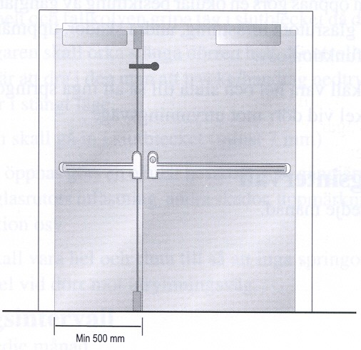

Emergency exit knob
Emergency exit knobs can be accepted where emergency exit devices in accordance with EN 179 are normally recommended according to Table 7.1. The knob shall be placed in a prominent position.

For activities where panic exit devices are recommended according to Table 7.1, emergency exit knobs shall not normally be accepted. In this type of activity, the use of an emergency exit knob shall be considered only after consultation with, and agreement by, the parties concerned.
Key switches are not accepted. Properties of an emergency exit knob:
- Green encapsulation.
- The emergency exit box is to be marked with a special sign. This sign should be green with white text "Emergency exit". The sign should be large enough to be easily detected.
- The knob shall be easy to operate by a single action.
- The knob should be visible even in the event of power failure. This can be achieved by providing standby power to illuminate the sign, by making the knob luminous or the sign photoluminescence.
- Illuminated emergency exit knob. By means of an integral illumination function or some other lighting fitting.

- When the knob is depressed, the current shall be interrupted and the lock function released.
- If possible, red light for locked door and green light for unlocked door.
- The emergency exit knob can with advantage be equipped with an acoustic exit alarm.

Position of emergency exit knob:

- It shall be easy to see and placed on or in the immediate vicinity of the door.
- 0.9 – 1.2 m above floor level
- Max 0.5 m from the door laterally, but not on the side of the hinge.
- For single door the emergency exit knob shall be placed on the hinge side.
- For pairs of doors, push buttons should be placed beside the door to achive the shortest distance between the emergency exit knob and the lever handle.

Intruder protection locking device
If doors are fitted with intruder protection locking devices (night locks), further measures in the form of connecting these via microswitches or similar are required.

They shall be connected to the function essential for the activity in such a way that activity cannot be carried on in the premises until all escape routes have been unlocked. One usual way is to connect the lighting in such a way that it cannot be switched on until all escape routes have been unlocked.

Local regulations may allow for “night locking” when not open to the public or for general occupancy, under certain conditions. For example, it may be requested for each person having access to the building (such as cleaning, security or maintenance people) to have their own key allowing them to escape from the building in case of an emergency.

Special conditions, for instance when people are locked in for various reasons, are not dealt with here. In such cases the solutions must at all times be decided on in consultation with the parties concerned.

Operation and maintenance
The doors and devices, which form part of escape routes, must be maintained so that their function in an emergency situation is secured.

Inspections shall be made at regular intervals by a person appointed by the person responsible for the building or firm. Inspection intervals are to be determined by the responsible person.

The way inspection is to be performed varies depending on the function, which the door has. See Appendix No 1.

Choice of exit device for locked door as a function of the activity
Table 8.1 sets out the levels of exit devices in buildings and premises for different types of activities, where doors in escape routes are normally locked from the outside to prevent the entry of unauthorised persons.

In the table, premises which, regarding their size and the number of people present, may be compared to a place of assembly, e.g. a staff dining room or a school dining room, are equated with places of assembly. This means that the devices are designed for a larger number of people, with variable knowledge of the premises, than those engaged in the activity that is daily carried on in the premises.

The reason for the more stringent requirement in large office buildings, hotels and healthcare premises is that in an escape situation persons congregate in stairways from several floors. This means that so many persons congregate at the exits that a more secure exit function is necessary.

In case of doubt the higher requirement shall at all times be selected, i.e. a panic exit device can always be used.

Table for choosing exit devices
The fittings refer only to panic exit devices in accordance with EN 1125 or emergency exit devices in accordance with EN 179.
The numbers in the table heading refer to the corresponding examples of solutions in Appendix No 1.

Activity | Position of door | Panic exit device (EN 1125)  Examples of solutions: P1-P6  PP1 – PP6* | Emergency exit device (EN 179) Examples of solutions:  N1– N3 NP1–NP3*
School < 200 persons | To stairway |  | X
 | From stairway to external air |  | X
School > 200 persons | To stairway |  | X
 | From stairway to external air | X
Office building <2000 m2 | To stairway |  | X
 | From stairway to external air |  | X
Office building > 2000 m2 | To stairway |  | X
 | From stairway to external air | X
Place of assembly
Large number of people | To foyer or stairway | X
 | Out to external air | X
Small number of people | Out or to stairway |  | X
 | From stairway to external air | X
Department store and retail trade  < 300 m2 net floor space | To external air or gallery |  | X
Department store or retail trade  >300 m2 net floor space | To external air or gallery | X
 | From common gallery to external air | X

Activity | Position of door | Panic exit device (EN 1125)  Examples of solutions: P1-P6  PP1 – PP6* | Emergency exit device (EN 179)  Examples of solutions: N1– N3 NP1–NP3*
Hotel, except restaurant etc  < 200 beds | To stairway |  | X
 | From stairway to external air |  | X
Hotel, except restaurant etc  > 200 beds | To stairway |  | X
 | From stairway to external air | X
Health care premises,  < 200 beds | To stairway |  | X
 | From stairway to external air |  | X
Health care premises,  > 200 beds | To stairway |  | X
 | From stairway to external air | X
Service flats | To stairway and to external air |  | X
Alternative housing | To stairway and to external air |  | X
Day care centre | To external air |  | X
Industry |  |  | X
Warehouse |  |  | X
Laboratories etc with activity that presents a fire hazard |  | X

* NP and PP denote pairs of doors

Definitions

Intruder protection locking
Locking device that complies with the insurer's intruder protection requirement for the premises concerned

Electromechanical door bolt
Electromechanical locking device which connects the top of the door leaf to the door frame through a mechanical coupling. It locks when connected to the power supply and is always automatically deactivated when disconnected from the power supply.

Standby power
Function that secures the supply of power in the event of mains failure. It is often provided in the form of a battery backup for e.g. electric striking plate, electromechanical door bolt, door holder magnet and entry and exit control system.

Electromechanical hold-open device
A hold-open device in the door closer function which is automatically deactivated when disconnected from the power supply. May also be provided in the form of a wall mounted door holder magnet.

Pulse generator
May be in the form of e.g. push button, key switch, microswitch in exit device, digital code lock, card reader, time switch, pulse from the alarm system or some other electrical function.

Door holder magnet
Electromechanical locking device which holds the top of the door leaf to the door frame through magnetic force. It locks when connected to the power supply and is always automatically deactivated when disconnected from the supply.

Automatic flush bolt
Locking device mounted on the meeting stile of the inactive leaf where its bolt is operated by a mechanism that is activated when the active leaf is closed.

An automatic flush bolt must not be used in the inactive leaf when this is part of an escape route because the automatic flush bolt does not have a sequentially activated opening function.

Striking plate
Device mounted in the frame to reinforce this where the hole for a bolt is made.

Bolt
Mobile locking component placed in a lock or other locking device which shoots out through the forend, stile plate, etc.

Latch bolt
Bolt with a bevelled end.

Lever handle
Handle to operate the bolt of a lock.

Fire door
Door that has a certain period of resistance to fire. The period of fire resistance may vary depending on the position of the door or the fire resistance class of the surrounding elements of construction.

Tailpiece
For pairs of doors in combination with a door coordinator.

If a pair of doors is opened via the inactive leaf, the tailpiece opens the active leaf also, so long as the door coordinator has been activated, which means that the leaves will be closed in the right order

European guidelines

Fire
Guideline No 1:2002 F - Internal fire protection control Guideline No 2:2013 F - Panic & emergency exit devices Guideline No 3:2011 F - Certification of thermographers
Guideline No 4:2010 F - Introduction to qualitative fire risk assessment Guideline No 5:2003 F - Guidance signs, emergency lighting and general lighting Guideline No 6:2011 F - Fire safety in care homes for the elderly
Guideline No 7:2011 F - Safety distance between waste containers and buildings Guideline No 8:2004 F - Preventing arson – information to young people Guideline No 9:2012 F - Fire safety in restaurants
Guideline No 10:2008 F - Smoke alarms in the home
Guideline No 11:2005 F - Recommended numbers of fire protection trained staff Guideline No 12:2012 F - Fire safety basics for hot work operatives
Guideline No 13:2006 F - Fire protection documentation
Guideline No 14:2007 F - Fire protection in information technology facilities Guideline No 15:2012 F - Fire safety in guest harbours and marinas Guideline No 16:2008 F - Fire protection in offices
Guideline No 17:2008 F - Fire safety in farm buildings
Guideline No 18:2013 F - Fire protection on chemical manufacturing sites
Guideline No 19:2009 F - Fire safety engineering concerning evacuation from buildings

Guideline No 20:2012 F - Fire safety in camping sites Guideline No 21:2012 F - Fire prevention on construction sites
Guideline No 22:2012 F - Wind turbines – Fire protection guideline
Guideline No 23:2010 F - Securing the operational readiness of fire control system Guideline No 24:2010 F - Fire safe homes
Guideline No 25:2010 F - Emergency plan
Guideline No 26:2010 F - Fire protection of temporary buildings on construction sites Guideline No 27:2011 F - Fire safety in apartment buildings
Guideline No 28:2012 F - Fire safety in laboratories

Natural hazards
Guideline No 1:2012 N - Protection against flood
Guideline No 2:2013 N - Business Resilience – An introduction to protecting your business

Security
Guideline No 1:2010 S - Arson document
Guideline No 2:2010 S - Protection of empty buildings Guideline No 3:2010 S - Security system for empty buildings
Guideline No 4:2010 S - Guidance on key holder selections and duties

Appendix No: 1

Appendix
Panic & emergency exit devices

FOREWORD

This Appendix offers technical solutions according to table 8.1 in the European Guide Line "Panic & emergency exit devices"

These technical solutions apply for exit doors, not sliding doors, both with and without a fire separating function, which shall normally be locked from the outside and/or provide the means of controlling the passage of persons from the inside/outside.

This Appendix has been compiled by Guidelines Commission and adopted by all fire protection associations in the Confederation of Fire Protection Associations Europe.

These technical solutions reflect best practice proposed by the members of CFPA Europe. Where the Guidelines and national requirements conflict, national requirements must apply.

DOOR N 1, Single fire door

Fittings on the inside Emergency exit device
Door closer. Can be fitted with electromechanical hold-open device

Functions on the inside
The exit handle, operated with one hand, secures exit Option of authorised passage via a key

Fitting on the outside Lever handle

Functions on the outside Lever handle secures return
Option of authorised passage via a key

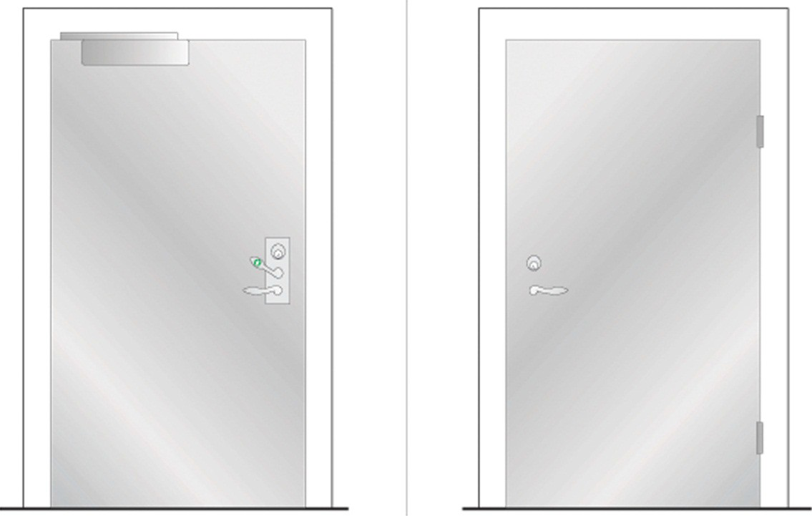

DOOR N 2, Single door, not a fire door

Fittings on the inside Emergency exit button
Door holder magnet/electromechanical door bolt with standby power Door closer. Can be fitted with electromechanical hold-open device

Functions on the inside
Exit via emergency exit button
Option of authorised passage via key switch
Option of automatic unlocking via fire alarm. (Not as the only function)

Fittings on the outside Pull handle
Pulse generator, e.g. card reader

Functions on the outside
Return via pull handle after exit or activation of fire alarm Option of authorised passage via pulse generator
Option of automatic unlocking via fire alarm. (Not as the only function)

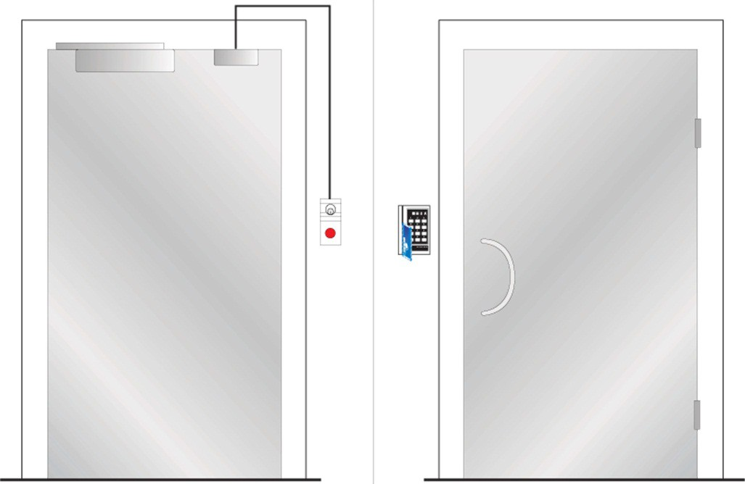
Inside Outside

DOOR N 3, Single door with/without fire separating function depending on choice of electric striking plate
Standard EN

Fittings on the inside Emergency exit device Electric striking plate
Pulse generator, e.g. card reader Door closer

Functions on the inside
The exit handle, operated with one hand, secures exit Option of authorised passage via pulse generator/key
Option of automatic unlocking via fire alarm, with fire separating function retained depending on choice of electric striking plate. (Not as the only function)

Fittings on the outside Lever handle
Pulse generator, e.g. card reader

Functions on the outside Lever handle secures return
Option of authorised passage via pulse generator/key
Option of automatic unlocking via fire alarm, with fire separating function retained depending on choice of electric striking plate. (Not as the only function)

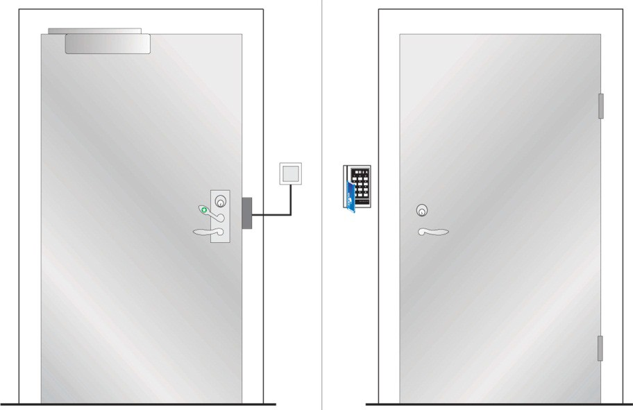
Inside Outside

DOOR N 4, Single fire door

Fittings on the inside
Emergency exit device, as push pad
Door closer. Can be fitted with electromechanical hold-open device

Functions on the inside
The push pad, operated with one hand, secures exit Option of authorised passage via a key

Fitting on the outside
Option 1: See figure. Plain outside face Option 2: Cylinder + pull handle

Functions on the outside Option 1: See figure. No return
Option 2: No return but authorised passage via key

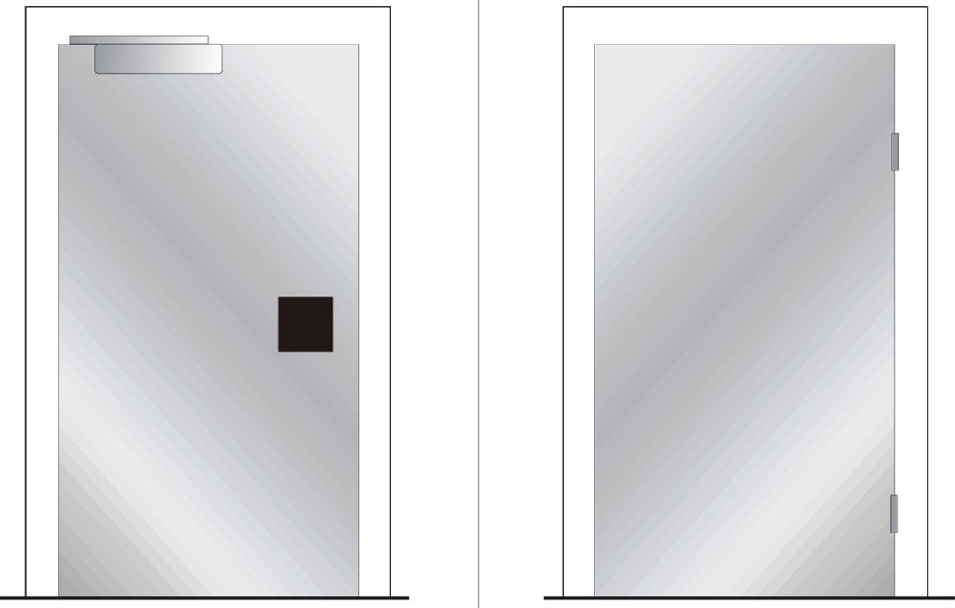
Inside Outside

DOOR N 5, Single door with/without fire separating function depending on choice of electric striking plate

Fittings on the inside
Emergency exit device as push pad Electric striking plate
Pulse generator, e.g. card reader Door closer

Functions on the inside
The push pad, operated with one hand, secures exit Option of authorised passage via pulse generator/key
Option of automatic unlocking via fire alarm, with fire separating function retained depending on choice of electric striking plate. (Not as the only function)

Fittings on the outside Lever handle
Pulse generator, e.g. card reader

Functions on the outside
No return but authorised passage via pulse generator/key
Option of automatic unlocking via fire alarm, with fire separating function retained depending on choice of electric striking plate

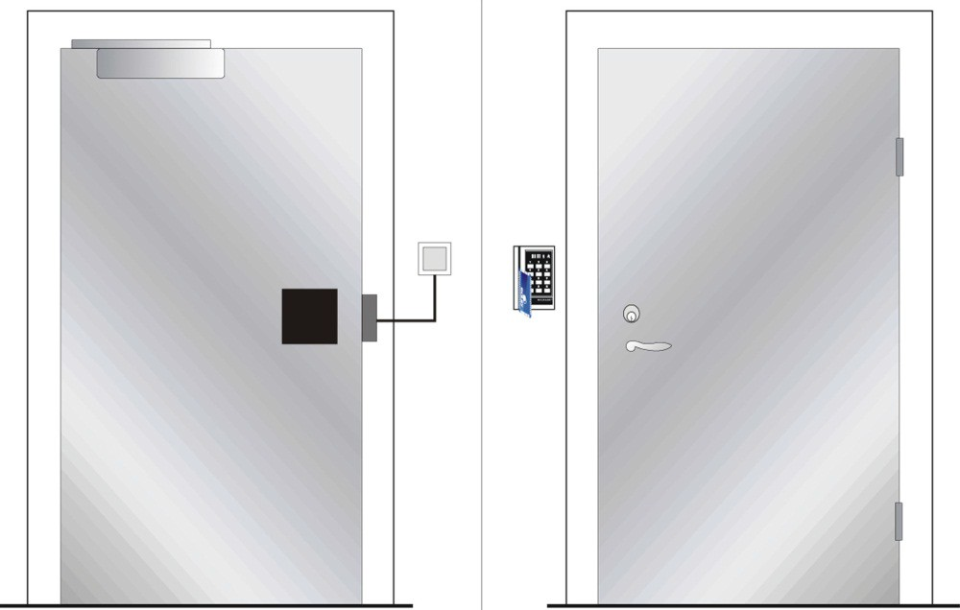
Inside Outside

DOOR P 1, Single fire door

Fittings on the inside Panic bolt
Door closer. Can be fitted with electromechanical hold-open device

Functions on the inside Panic bolt secures exit.
Option of authorised passage via key

Fitting on the outside Lever handle

Functions on the outside Lever handle secures return
Option of authorised passage via key

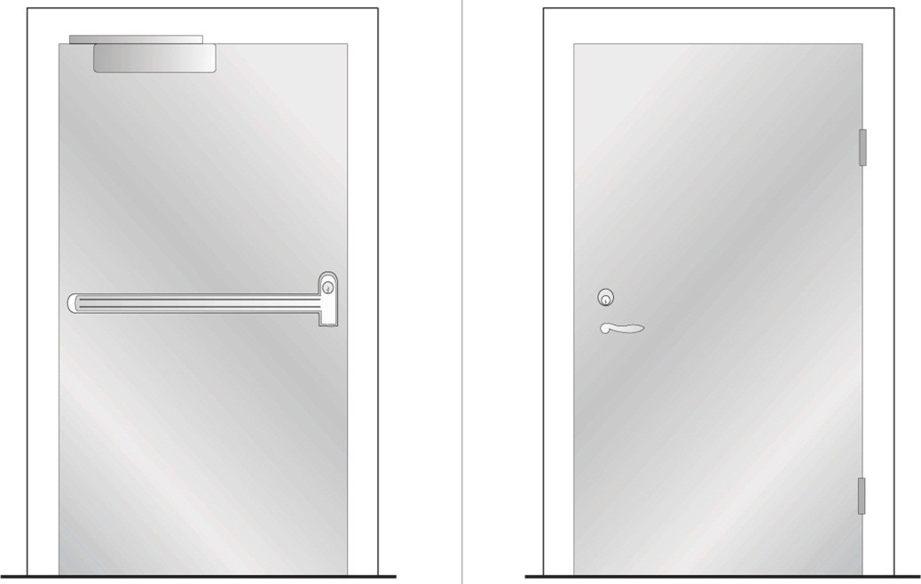
Inside Outside

DOOR P 2, Single fire door

Fittings on the inside Panic bolt
Door closer. Can be fitted with electromechanical hold-open device

Functions on the inside Panic bolt secures exit
Option of authorised passage via key

Fittings on the outside
Option 1: See figure. Plain outside face Option 2: Cylinder + pull handle

Functions on the outside Option 1: See figure. No return
Option 2: No return but authorised passage via key

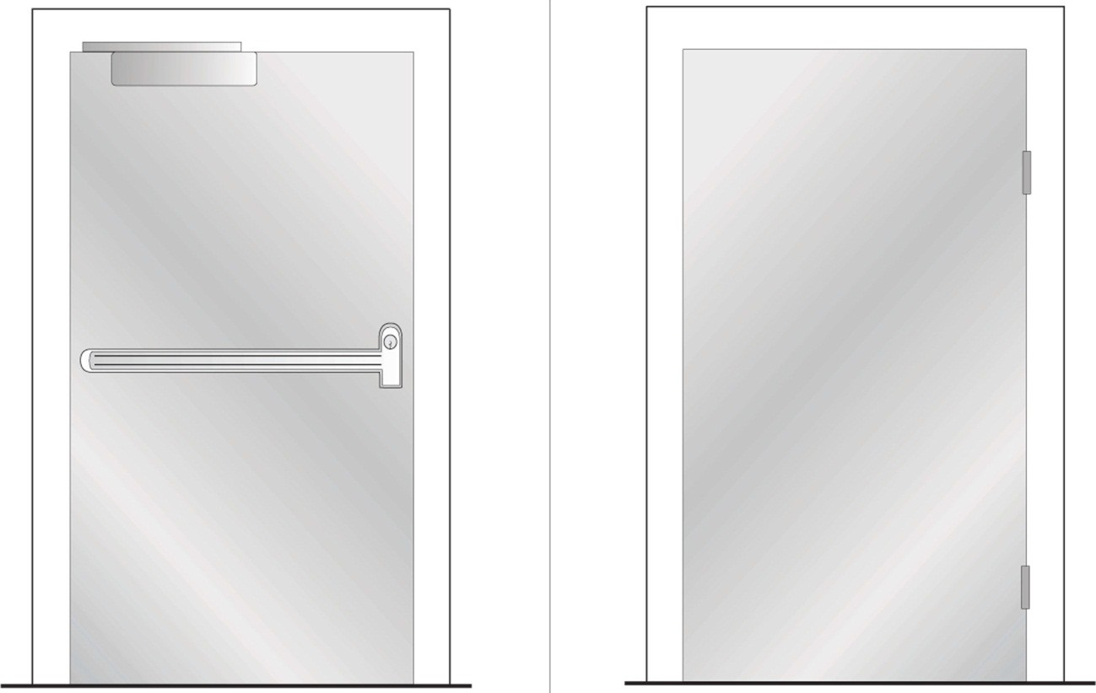
Inside Outside

Option 1 of 2

DOOR P 3, Single fire door

Fittings on the inside
Panic bolt with micro switch
Door holder magnet/electromechanical door bolt
Door closer. Can be fitted with electromechanical hold-open device

Functions on the inside Panic bolt secures exit
Micro switch secures opening of door holder magnet/electromechanical door bolt
Option of automatic unlocking via fire alarm, with fire separating function retained. (Not as the only function)

Fittings on the outside Option 1: Lever handle
Option 2: See figure. Lever handle + pulse generator, e.g. card reader

Functions on the outside
Option 1: Lever handle secures exit
Option 2: See figure. Lever handle secures return Option of authorised passage via pulse generator/key
Option of automatic unlocking via fire alarm, with fire separating function retained. (Not as the only function)

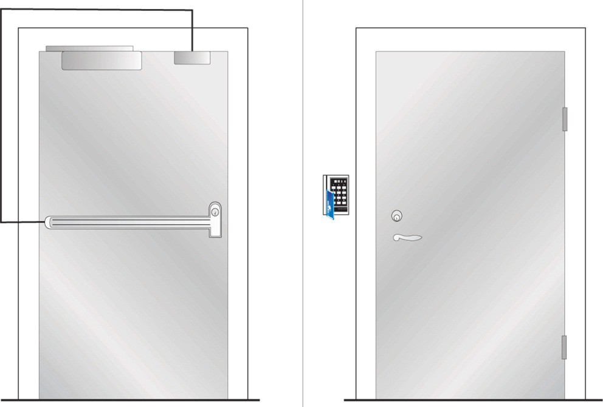
Inside Outside

Option 2 of 2

DOOR P 4, Single door with/without fire separating function depending on choice of electric striking plate

Fittings on the inside Panic bolt
Electric striking plate
Pulse generator, e.g. card reader Door closer

Functions on the inside Panic bolt secures exit
Option of authorised passage via pulse generator
Option of automatic unlocking via fire alarm, with fire separating function retained depending on choice of electric striking plate. (Not as the only function)

Fittings on the outside Lever handle
Pulse generator, e.g. card reader

Functions on the outside Lever handle secures return
Option of authorised passage via pulse generator
Option of automatic unlocking via fire alarm, with fire separating function retained depending on choice of electric striking plate. (Not as the only function)

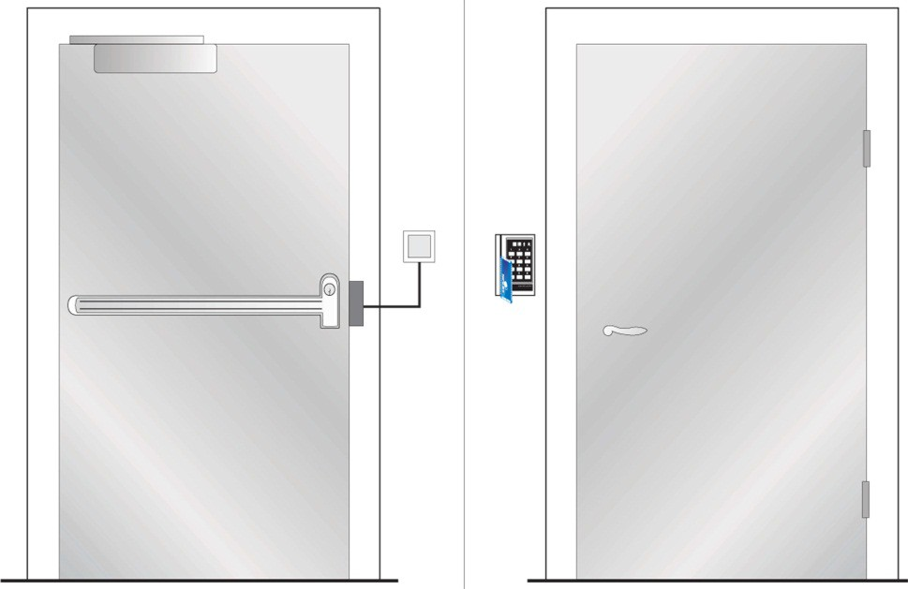
Inside Outside

DOOR P 5, Single fire door

Fittings on the inside
Panic bolt with electrical opening Pulse generator, e.g. card reader
Door closer. Can be fitted with electromechanical hold-open device

Functions on the inside Panic bolt secures exit
Option of authorised passage via pulse generator

Fittings on the outside Pull handle
Pulse generator, e.g. card reader

Functions on the outside No return
Option of authorised passage via pulse generator

Note
The panic bolt shall not be electrically held open. It shall be electrically open only at the time of passage

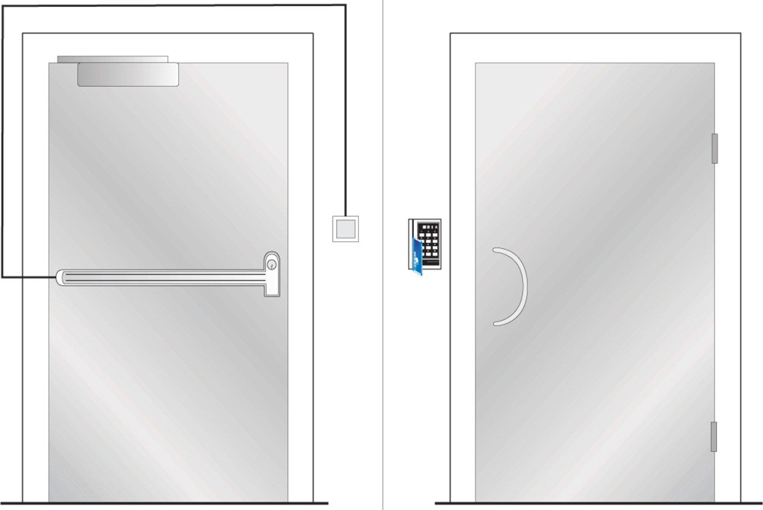
Inside Outside

DOOR P 6, Single fire door

Fittings on the inside
Panic bolt with electrical opening and micro switch Door holder magnet/electromechanical door bolt Pulse generator, e.g. card reader
Door closer. Can be fitted with electromechanical hold-open device

Functions on the inside Panic bolt secures exit
Micro switch secures opening of door holder magnet/electromechanical door bolt Option of authorised passage via pulse generator
Option of automatic unlocking via fire alarm, with fire separating function retained. (Not as the only function)

Fittings on the outside Lever handle
Pulse generator, e.g. card reader

Functions on the outside Lever handle secures return
Option of authorised passage via pulse generator
Option of automatic unlocking via fire alarm, with fire separating function retained. (Not as the only function)

Note
The panic bolt shall not be electrically held open. It shall be electrically open only at the time of passage
Can be fitted with door automatics

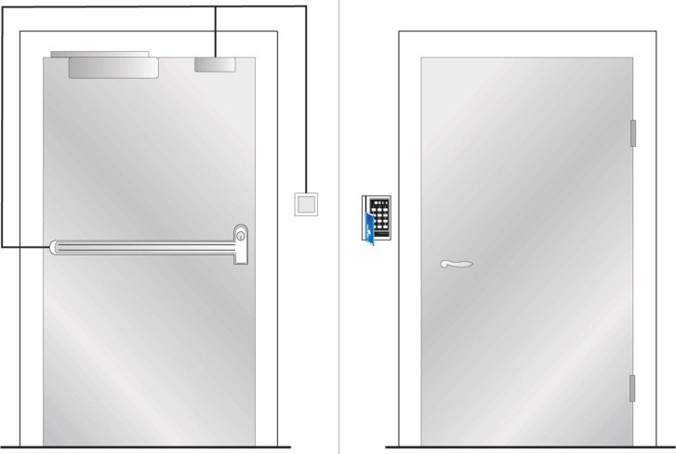
Inside Outside

DOOR NP 1, Pair of fire doors

Fittings on the inside
Emergency exit devices, active leaf Automatic flush bolts, inactive leaf
Inactive leaf fitted with tailpiece for the door coordinator function

Functions on the inside
Exit handle, operated with one hand, secures exit via active leaf Option of authorised passage via key

Fittings on the outside Lever handle
Door closer with coordinator. Can be fitted with electromechanical hold-open device

Functions on the outside Lever handle secures return
Option of authorised passage via key
Door closer with coordinator closes the leaves in the right order

Note
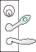The inactive leaf shall not form part of the escape route

Inside Outside

DOOR NP 2, Pair of doors with no fire separating function

Fittings on the inside Emergency exit button
Option 1: See figure. Rebated doors fitted with door holder magnet/electromechanical door bolt with standby power
Inactive leaf fitted with tailpiece for the door coordinator function

Option 2: Not rebated doors fitted with double door holder magnets/ electromechanical door bolts with standby power

Functions on the inside
Exit via emergency exit button
Option of authorised passage via key switch
Option of automatic unlocking via fire alarm. (Not as the only function)

Fittings on the outside Pull handle
Pulse generator, e.g. card reader
Option 1: See figure. Rebated doors fitted with door closer and coordinator Can be fitted with electromechanical hold-open device

Option 2: Not rebated doors fitted with door closer. Coordinator not required. Can be fitted with electromechanical hold-open device

Functions on the outside
Return via pull handle after exit or activation of fire alarm Option of authorised passage via pulse generator
Option of automatic unlocking via fire alarm. (Not as the only function) Door closer with coordinator closes the leaves in the right order

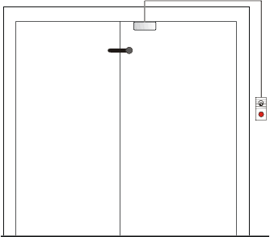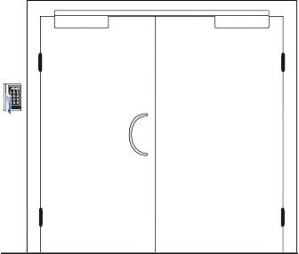
Inside Outside

Option 1 of 2

DOOR NP 3, Pair of doors with/without fire separating function depending on choice of electric striking plate

Fittings on the inside Emergency exit device
Electric striking plate in inactive leaf Pulse generator, e.g. card reader Automatic flush bolts in inactive leaf
Inactive leaf fitted with tailpiece for the door coordinator function

Functions on the inside
Exit handle secures exit via active leaf
Option of authorised passage via pulse generator/key
Option of automatic unlocking via fire alarm, with fire separating function retained, depending on choice of electric striking plate. (Not as the only function)

Fittings on the outside Lever handle
Pulse generator, e.g. card reader Door closer with coordinator

Functions on the outside Lever handle secures return
Option of authorised passage via pulse generator/key
Door closer with coordinator closes the leaves in the right order
Option of automatic unlocking via fire alarm, with fire separating function retained, depending on choice of electric striking plate. (Not as the only function)

Note
Inactive leaf shall not form part of the escape route

Inside Outside

DOOR NP 4, Pair of fire doors

Fittings on the inside
Emergency exit devices, as push pad Automatic flush bolts, inactive leaf
Inactive leaf fitted with tailpiece for the door coordinator function

Functions on the inside
Push pad secures exit via active leaf Option of authorised passage via key

Fittings on the outside
Option 1: See figure. Plain outside face
Door closer with coordinator. Can be fitted with electromechanical hold-open device Option 2: Cylinder + pull handle
Door closer with coordinator. Can be fitted with electromechanical hold-open device

Functions on the outside Option 1: See figure. No return
Door closer with coordinator closes the leaves in the right order Option 2: No return but authorised passage via key
Door closer with coordinator closes the leaves in the right order

Note
Inactive leaf shall not form part of the escape route

Inside Outside

DOOR NP 5, Pair of doors with/without fire separating function depending on choice of electric striking plate

Fittings on the inside
Emergency exit device. as push pad Electric striking plate in inactive leaf Pulse generator, e.g. card reader Automatic flush bolts in inactive leaf
Inactive leaf fitted with tailpiece for the door coordinator function

Functions on the inside
The push pad secures exit via active leaf
Option of authorised passage via pulse generator/key
Option of automatic unlocking via fire alarm, with fire separating function retained, depending on choice of electric striking plate. (Not as the only function)

Fittings on the outside Pull handle
Pulse generator, e.g. card reader Door closer with coordinator

Functions on the outside
No return but authorised passage via pulse generator/key
Door closer with coordinator closes the leaves in the right order
Option of automatic unlocking via fire alarm, with fire separating function retained depending on choice of electric striking plate. (Not as the only function)

Note
Inactive leaf shall not form part of the escape route

Inside Outside

DOOR PP 1, Pair of fire doors

Fittings on the inside Panic bolts
Inactive leaf fitted with tailpiece for the door coordinator function

Functions on the inside Panic bolt secures exit
Option of authorised passage via key

Fittings on the outside Lever handle
Door closer with coordinator. Can be fitted with electromechanical hold-open device

Functions on the outside No return
Option of authorised passage via key
Door closer with coordinator closes the leaves in the right order

Note
Where the inactive leaf forms part of the escape route, its width shall not be less than 500 mm.

Inside Outside

DOOR PP 2, Pair of fire doors

Fittings on the inside Panic bolts
Inactive leaf fitted with tailpiece for the door coordinator function

Functions on the inside Panic bolt secures exit
Option of authorised passage via key

Fittings on the outside
Door closer with coordinator. Can be fitted with electromechanical hold-open device Option 1: See figure. Plain outside face
Option 2: Cylinder + pull handle

Functions on the outside
Door closer with coordinator closes the leaves in the right order Option 1: See figure. No return
Option 2: No return but authorised passage via key

Note
Where the inactive leaf forms part of the escape route, its width shall not be less than 500 mm.

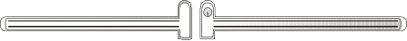
Inside Outside

Option 1 of 2

DOOR PP 3, Pair of fire doors

Fittings on the inside
Panic bolts with micro switches
Door holder magnet/electromechanical door bolt in active leaf Inactive leaf fitted with tailpiece for the door coordinator function

Functions on the inside Panic bolts secure exit
Micro switches secure opening of door holder magnet/electromechanical door bolt
Option of automatic unlocking via fire alarm, with fire separating function retained, depending on choice of electric striking plate. (Not as the only function)

Fittings on the outside
Door closer with coordinator. Can be fitted with electromechanical hold-open device Option 1: Lever handle
Option 2: See figure. Lever handle + pulse generator, e.g. card reader

Functions on the outside
Door closer with coordinator closes the leaves in the right order Option 1: Lever handle secures return
Option 2: See figure. Lever handle secures return Option of authorised passage via pulse generator/key
Option of automatic unlocking via fire alarm, with fire separating function retained. (Not as the only function)

Note
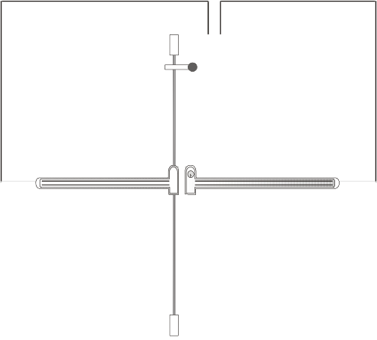Where the inactive leaf forms part of the escape route, its width shall not be less than 500 mm

Inside Outside

Option 2 of 2

DOOR PP 4, Pair of doors with/without fire separating function depending on choice of electric striking plate

Fittings on the inside
Panic bolts with micro switches Electric striking plate in inactive leaf Pulse generator, e.g. card reader
Inactive leaf fitted with tailpiece for the door coordinator function

Functions on the inside Panic bolts secure exit
Option of authorised passage via pulse generator
Option of automatic unlocking via fire alarm, with fire separating function retained, depending on choice of electric striking plate. (Not as the only function)

Fittings on the outside Lever handle
Pulse generator, e.g. card reader Door closer with coordinator

Functions on the outside
Lever handle secures return. (Depending on choice of electric striking plate) Option of authorised passage via pulse generator
Option of automatic unlocking via fire alarm, with fire separating function retained, depending on choice of electric striking plate . (Not as the only function)
Door closer with coordinator closes the leaves in the right order

Note
Where the inactive leaf forms part of the escape route, its width shall not be less than 500 mm.

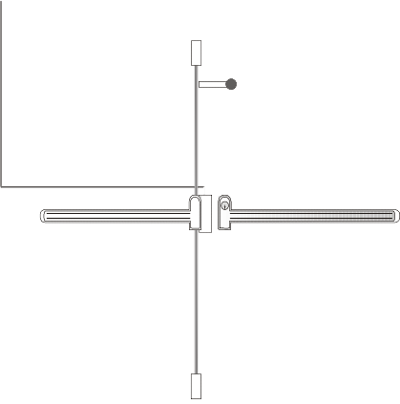
Inside Outside

DOOR PP 5, Pair of fire doors

Fittings on the inside
Panic bolts with electrical opening Pulse generator, e.g. card reader
Inactive leaf fitted with tailpiece for the door coordinator function

Functions on the inside Panic bolts secure exit
Option of authorised passage via pulse generator

Fittings on the outside Pull handle
Pulse generator, e.g. card reader
Door closer with coordinator. Can be fitted with electromechanical hold-open device

Functions on the outside No return
Option of authorised passage via pulse generator
Door closer with coordinator closes the leaves in the right order

Note
Where the inactive leaf forms part of the escape route, its width shall not be less than 500 mm. Panic bolt shall not be electrically held open. It shall be electrically open only at the time of passage

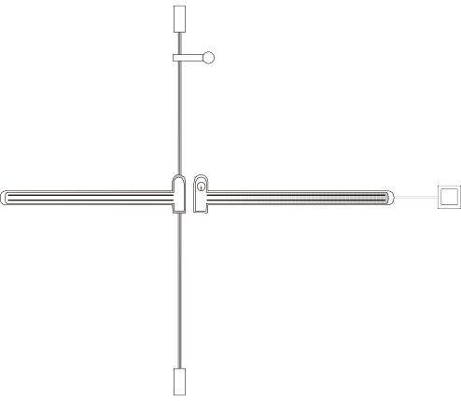
Inside Outside

DOOR PP 6, Pair of fire doors

Fittings on the inside
Panic bolts with electrical opening and micro switches
Door holder magnet/electromechanical door bolt in active leaf Pulse generator, e.g. card reader
Inactive leaf fitted with tailpiece for the door coordinator function

Functions on the inside Panic bolts secure exit
Micro switch secures opening of door holder magnet/electromechanical door bolt Option of authorised passage via pulse generator
Option of automatic unlocking via fire alarm, with fire separating function retained, depending on choice of electric striking plate. (Not as the only function)

Fittings on the outside Lever handle
Pulse generator, e.g. card reader
Door closer with coordinator. Can be fitted with electromechanical hold-open device

Functions on the outside Lever handle secures return
Option of authorised passage via pulse generator
Door closer with coordinator closes the leaves in the right order
Option of automatic unlocking via fire alarm, with fire separating function retained. (Not as the only function)

Note
Where the inactive leaf forms part of the escape route, its width shall not be less than 500 mm. Panic bolt shall not be electrically held open. It shall be electrically open only at the time of passage.
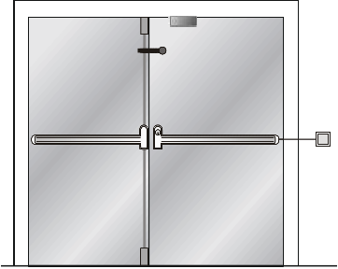Can be fitted with door automatics

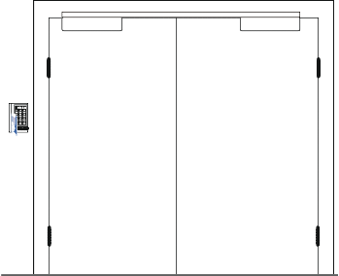
Inside Outside

EXAMPLES OF CONTROL ROUTINES
Regular control should be carried out by the usufructuary, but an effort should be made to perform the control together with the property owner as often as possible. The aim of this is to become familiar with the building and to form an overall idea of the total security of escape, and to achieve a good dialogue with the property owner.

In order that control of the technical installation may be carried out in a satisfactory manner, the following checklist should be used in checking doors in, and to, an escape route.

How often controls should be carried out depends on the hazard situation and the general wear and tear in the building and premises. Control of escape facilities should be made every day.

Control routines
For all doors in and to escape routes, regardless of whether they have, or have not, a fire compartment separating function, the following are to be checked.

Function
- Check that the door can be easily opened without a key, code or card, and that it can be opened at least 90º
- Check that nothing is blocking the escape route
- Check that the force needed to open the door does not exceed 130 N (ca 13 kgf)
- Check that return into the premises is possible where so required

Maintenance
- When the door is opened, make a visual inspection of hinges, locks, handle, door frame, the attachment of glazed panels if any, any other damage, marking, the function of the door handle, etc

For a door with a fire compartment separating function, the following is also to be checked
Gastightness
- Check that the door is undamaged and closes so that there are no gaps, not even along the doorstep of a door opening into an escape route in a stairway
- Check that any intumescent strips that are fitted along the door are undamaged

Lock case
- A lock case with only a cylinder lock must not be fitted with a hold-open device
- Check the engagement of the spring bolt with the striking plate
  - Door of fire resistance class E/EI 30 - 7 mm
  - Door of fire resistance class E/EI 60 - 10 mm

Foor doors that also have the following components fitted, the following shall also be checked:

Door closer
- Open door ca 10 cm and let it go. Check that the door closes completely and that the spring bolt engages with the striking plate
- Check if there are any oil leaks
- Check for damage to the arm system that affects the door holder function
- Check the fixing of the door closer housing and the fixings of the arms
- NOTE that split-arm system or hold-open arms are not recommended for doors at fire compartment boundaries

Electromechanical hold-open device
- Break the current, e.g. with the test button
- Check that the door closes completely and that the spring bolt engages with the striking plate
- Check that it is released in the event of power failure

Automatic flush bolt for double doors
- Check that the flush bolt moves easily in the striking plate
- Pull the handle and check that the doors do not open
- Check the fixing of the flush bolt and striking plate

Coordinator for double doors
- Check that the “correct” door closes first
- Check the fixing

Tailpiece for double doors
- Check fixing and function

Guidance marking
- Assess whether the sign is fully visible from appropriate points in the premises
- Check that the sign is in place and that it is functioning, i.e. it is undamaged, illuminated, not concealed
- Check the emergency power supply, if any. This can be done on fluorescent signs with their own backup battery. Press the button on the light fitting or unscrew the fuse that supplies the light fitting, and check the emergency light

