What are landslides
Landslides are rapid movements of soil or in the bedrock which can cause extensive damage on land and buildings in the affected area, and in the downstream area of land where landslides ends.
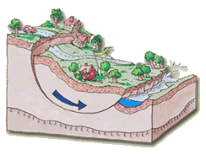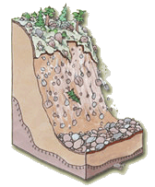
A landslide or race is in many cases a result of a natural process of erosion, but can also be triggered by human intervention in nature. A common denominator is that both landslides and rockfalls can occur without warning.
Landslides
Landslides of mud and mudareas usually occurs below the highest shoreline and adjacent to rivers, lakes and coastlines. Landslides in moraine is most commonly found in mountain terrain but can also occur sparingly in steep slopes in moraine.
Rockfalls
Rockfalls occurs on steep hillsides, bergsslänter with weathered or fractured rock, nipor along the rivers in Northern and central Sweden, steep slopes with blockrik and/or coarse grained moraine and in the steep slopes in the gravel and sand deposits.

Why do landslides occur?
Landslides can occur both by natural reasons and due to man's influence on nature. Often it is a combination of several factors. The greatest risk for landslides are in slopes containing layers of soil with low strength and in hillsides with weaknesses in the bedrock.

Disturbed balance
It is the characteristics and composition of the soil, groundwater conditions and topographic conditions (altitudinal) which determines the slopes stability. The natural erosion process adapts the slopes to a balance. Factors that change the balance can trigger landslides. Such factors might be changing soil water conditions, man's influence on nature, erosion and uplift. Over the years, therefore the stability conditions change.
Landslides occur by rupture occurs along the running surface of the Earth. Soil layers above the surfaces affected and the driving forces and resisting. Before the landslide is these forces in balance. A disruption of the balance can trigger landslides. The balance can be upset by:
• increased burden
• reduced counterweight
• loss of strength in the soil

Increased load
Increased load, for example new buildings, fillings of soil or similar. For example, the weight of 1 m thick compacted gravel weighs about two tons per square meter (corresponding to the load of a two-storey building).
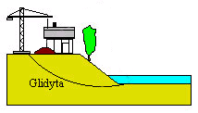

Reduced counterweight
The balance is also affected by what happens in the lower part of the slope. Some of the soil at the bottom of the slope could be eroded away by a river or be removed by excavation works and dredging works.
Along a river or a Lake does the weight of the water work as a resistance (stabilizator) against the slope. The lowering of the water level at a slope leads to reduced counterweight.
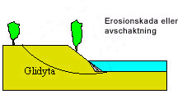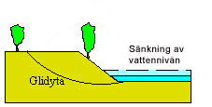

Loss of strength in the soil
The strength of the soil layer can deteriorate for several reasons. An example is the rise in the groundwater level which gives increased water pressure in soils pores (increased pore pressure).
Causes of raised ground water level can be heavy rain, deforested areas and rescheduled or clogged ditches.
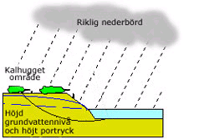

Combination of causes
It is common that a combination of the above described situations can trigger a landslide.

Human intervention in nature
Landslides caused by man have become increasingly common. Intervention of man can make to the natural balance is disturbed and the stability of the slopes are affected.
Man build houseareas, construct roads, railroads, ports, dams, etc. We are changing the soil's natural geometry through excavation and filling of loads, ground with buildings and warehouses.
Cut forrest can also lead to changed stability because the vegetation that sucks up a lot of ground water is removed. This can lead to higher ground water levels and water flows. A higher groundwater level increases the pore pressure in soil layers and the strength of the soil. Water flows can increase erosion of hillsides and valleys.

Landslide in connection with flooding
A flood in progress pushes water into the soil in the flooded area. The groundwater level raises and also the pore pressure in the soil. When pore pressure rises the soil resistance decreases. When the water level is dropping, the ground water level doesn´t drop at the same speed. The ground water level are dropping especially slowly in dense, fine-grained soils such as clay and mud.
If a heavy bank has been laid out to prevent the flood range, the weight of the bank is an affecting factor.

Before the flood
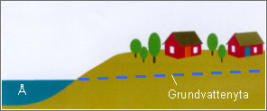
• Buildings in the vicinity of a slope in clay soil against a river.
• The surface of the water is at normal depth.

During the flood
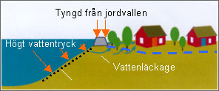
During the flood
• A heavy embankment has been laid out to protect the buildings.
• Water is leaking in through the soil beneath the embankment, which significantly raises the groundwater surface behind the bank.
• The high water pressure on slope due to the high water levels in the river acts as a counterweight.
• The slope eroded by soil materials are taken away by the strong water current in the river.

After the flood
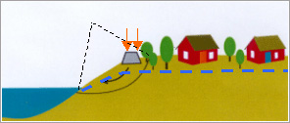
When the water level drops back
• The heavy soil embankment remains.
• The water level in the river drops away and its function as a counterweight is getting worse.
• Even the eroded soil in slope means lost counterweight.
• The elevation of the water table is sinking away slowly and still provides high pore pressure which impairs the soils strength.
• Landslides can be triggered due to the combined effects of increased load, decreased counterweight and the soils lowered strength.
Landslides can be prevented.
The choice of preventive measure is depending on the nature of the problem. The measures must be selected taking into account the conditions of the relevant slope, the available space and economy. In addition, account must be taken to cultural, environmental and nature interests.
You should also look at the consequences of a landslide can get together and weigh this against the cost of action. Sometimes it's the cheapest and most secure socio-economic to vacate and demolish threatened buildings.
It is important that the elections of lever action aimed at addressing the actual cause of the poor stability.
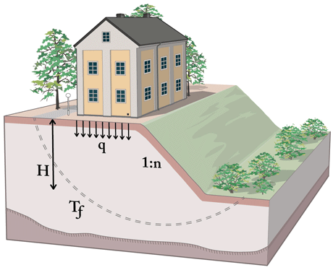
A slope will not have sufficient stability may be too high (H) and steep (n) or charged's too hard (q) in relation to its shear strength (Tf). Reinforcement measure is to change one or more of these parameters.

1. Erosion control
If the lower part of the sloop has been eroded by erosion, the slope can be recovered and future erosion prevented by laying out an erosion protection along the river edge.
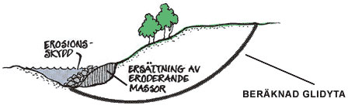
Recovery of slope and construction of erosion protection.

2. Filling and removing of soil
If the slope is steep, one can add lots of fillings that support and even out the slope, so called support filling, it is also advisable to remove the upper part of the slope to reduce some of the load. You can also flatten out the geometry by moving masses of soil.
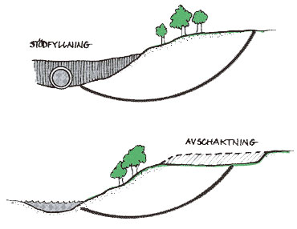
Support filling and removing masses of soil from slope.
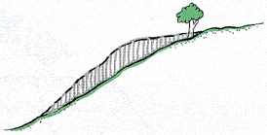
Reduced decline of slope.

3. Reinforcement
The slope can be strengthened through the installation of concrete pillars installed in soil layers to a level well below the feared landslides running surface.
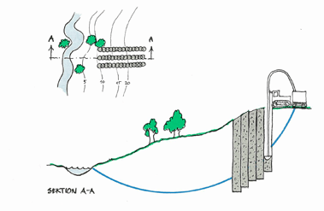
Reinforcement of soil with lime/cement pillars.

4. Reduction or limitation of groundwater pressure
Another way to increase a slopes stability is to reduce or limit the ground water pressure.
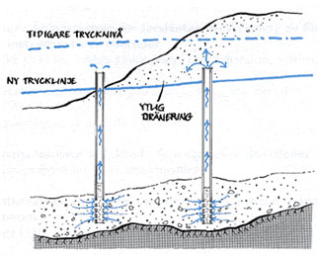
Reduction or limitation of groundwater pressure.

5. Soil tacking
Soil tacking is a method to reinforce the slopes. As is the case for the lime/cement pillars, it is important that the soil tacking reach down below the running surface of the possible landslide or collapse.
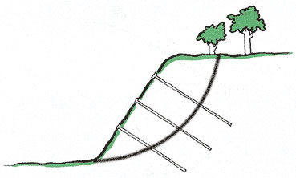
Soil tacking

Prevention measurements in long steep slopes in moraine and other grainy soils
The following enhancement methods are suitable for protecting buildings and facilities located in and below the long and steep slopes in moraine and other coarse grained soils. The methods and measures should be designed taking into account the terrain and the local weather conditions.
- Drainage System
- Establishment of vegetation with continued maintenance (so called Engineering Biology)
- Diversion dams
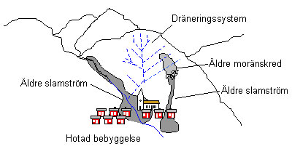
Principle of drainage systems in unstable slopes.

Drainage System
Drainage system is aimed at long-term drain damp slopes from the water produced by snowmelt and prolonged rainfall, so that the water surface and soil moisture is reduced. The ground will then get an increased ability to receive water masses from brief and intense rain.

Establishment of vegetation
Establishment of vegetation (so called engineering biology) in the slope and continued care of this also reduces the risk of landslides and mudslides, landslides will occur.

Diversionary soilponds
Impact of mudslides can be reduced by the construction of ponds that control the mudslides away from buildings.
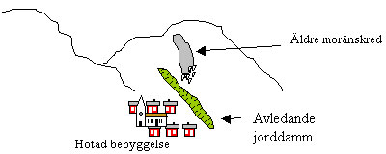
Prevention measures for ravines in moraine and other grainy soils
The most common methods of protecting buildings and establishments along and below the ravines are:
- Erosion stairs (control ponds)
- Diversion dams
- Sedimentationponds
- Channeling
It is also important to ensure the ravines slopes from erosion and to periodically clean out accumulated material along the creek bottoms that can cause impoundments.
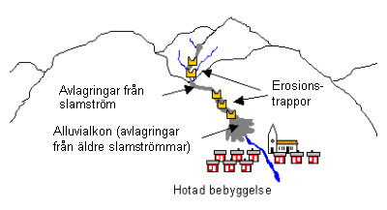

Erosion stairs
Erosion stairs constructed to reduce erosion along a ravine base and reduce mudslides kinetic energy. Erosion of the stairways, locations and size adjusted so that they can slow down any mudslides so that they don´t reach down to the threatened buildings.

Sedimentation-ponds
Sedimentation-ponds are built in order to capture the mudslides and thus limiting them from reaching buildings in the valley downstream. Ponds should be built below the ravine in the upper parts of the remains from repeated earlier mudslides. Most dams are built with a opening with a grid. The grid captures the larger material (logs, gravel, stone and blocks) while the finer material and water can pass. Sedimentation-ponds is not designed to be able to store all of the calculated volume of the mudslide.

Channeling
Channeling of a furrow is performed in order to prevent erosion, prevent the outflow of water and soil outside the mainstream or to re-direct a current along a possible new direction. It is common that channeling occurs downstream of the sedimentation-pond.

