STRATEGY 2018-2020 - What have we achieved?
In this report I will try to summarize what have been done and connect my comments to our Strategy 2018-2020 (Strategy CFPA 2.5). Were we still have some problem or still have not been able to reach the aims the text is marked in red. The first version of this document you got before the GA meeting in Stockholm and it has now been updated.
The sections in my report have the same headlines as in the our “Strategy CFPA 2.5”. When I write “Commissions” below I also include the Natural hazards Group.

Topic A – Customer Centered Service
These two pictures are from existing strategy.
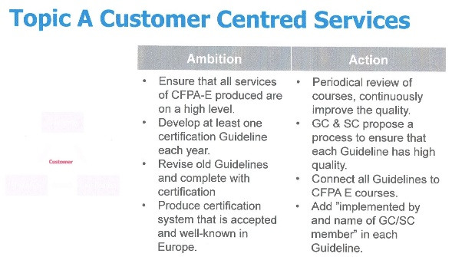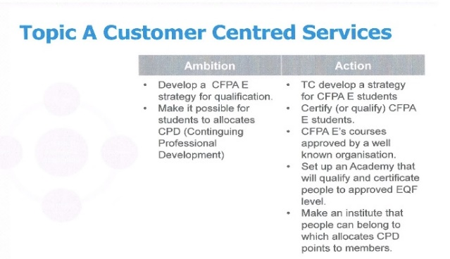

• All commissions are aware of the importance of high quality and the try to improve the quality all the time. Reviews of courses, quality check of members courses, revising of old guidelines, national experts are checking proposals, etc. Beside that is also guidelines connected to our harmonized courses. The Commissions are doing it but it is of course a work that always must be in focus and continue year after year.
• New guidelines are only produced if several members will use the guideline.
• There are some doubts in the Commissions to produce guidelines that can be used for certification. We have here a problem to achieve the ambitions and aims that are mention in the strategy.
• We have problem to connect our training courses to an approved European EQF level. The reason is that there are no activities on the European level. Instead our TC is making our own approval system, and that is great in my opinion.

Topic B – Co-operation & Endorsement
Picture from existing strategy.
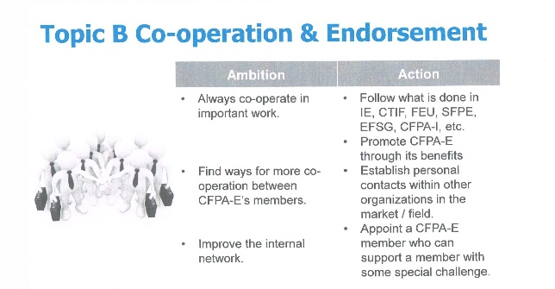
• We have established good connections with a lot of organisations. There are regular contacts with the Insurance Europe, the CTIF, the FEU, the European Fire Safety Alliance, and the CFPA International. We have also established contacts with SFPE, East Central European Fire Protection Corporation and now in the autumn 2019 also with EAPFP (the European Association for Passive Fire Protection). Last meeting with Insurance Europe was in January 2020 in their office in Brussels (meeting with their Policy Advisor Charles Low), and I’m happy that Sara MacArthur could join and inform us at our General Assembly in Stockholm.
• CFPA E’s international network is improving all the time. I my report to the MC meeting you can read that we now have an agreement with the Fire Protection Association in South Africa.
• We try to help members that have some special challenge, and one example is a meeting in Ljubljana between our member SZPV, Slovenia Insurance organization and CFPA E.
• There is also a support to new members. The last years we have helped several of our new members. We have also tried to connect some of our “old” regular members with the new B2 members we got in October.
• Insurance Europe and CTIF are nowadays working with endorsing our Guidelines. It is a work that take a lot of time but nowadays we have some endorsed Guidelines from both. Beside that we also have some other organisations that voluntary have started to endorse some of our Guidelines. One example is SINTEF in Norway.
Topic C – Lobbying
Picture from existing strategy.
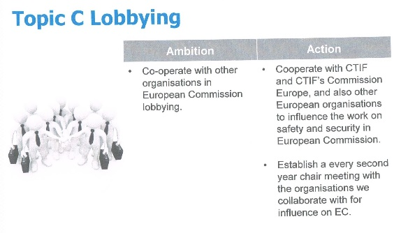
• CFPA Europe has now establish a good relationship to many organisations and we have also established contacts with European Commission. Since we met at GA in Helsinki I have been invited to five meetings in Brussels arranged by European Commission. Three of these meetings have been in different project groups and at all these three they asked me to talk about CFPA E and our opinions. All these meetings are connected to EC’s work with Fire Information Exchange Platform, FIEP. Beside their meetings there is also some lobbying organisations that have arranged, what they call FIEP meetings. I have been invited to some of those to but have never participate. Since the winter 2019/20 it is Policy Officer Heikki Vannanen who is responsible for FIEP and Jesper and I met him in the beginning of 2020 at IE’s office in Brussels.
• We have tried to co-operate with other organisations to see if we have the same opinions about the fire safety and specially on the EC work, and in October 2018 we also met FEU and Insurance Europe. To this meeting I invited also CTIF and SFPE, but both couldn’t join.
Topic D – Promotion
Pictures from existing strategy.
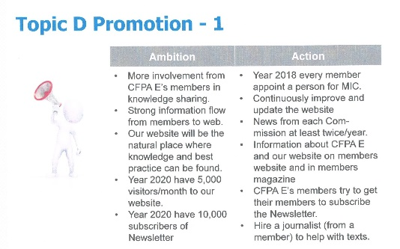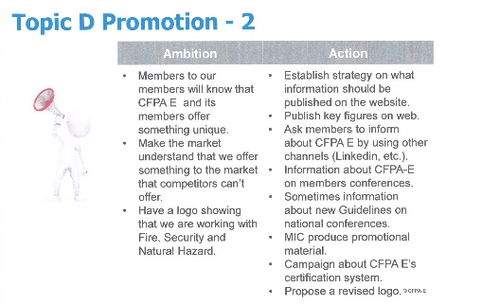

• Most members have now appointed a person for MIC and the website is getting better and better. It is a big work done by Mirna our chair for MIC, but we try to share the work inside MIC in a better way now.
• Commissions use to regularly write new information for our website and newsletter.
• In the last year CFPA E have (together with our national member) been active at exhibitions in Paris (Expoprotection, November 2018), Cologne (VdS International Conference and Exhibition, December 2018), London (FIREX, June 2019) and Manchester (Fire Safety North, October 2019).
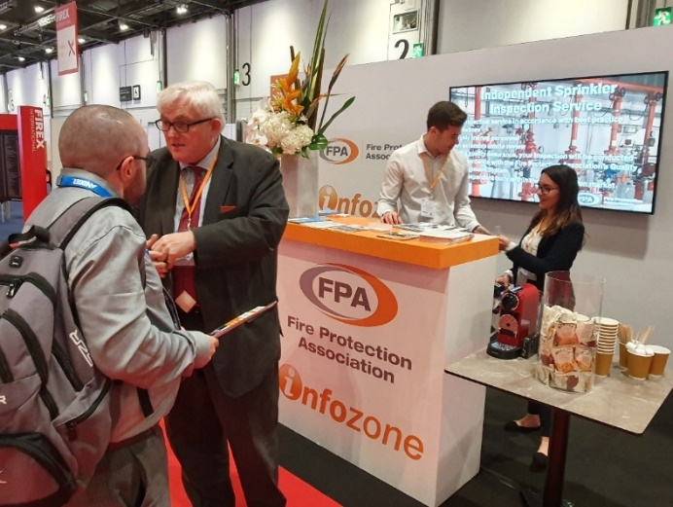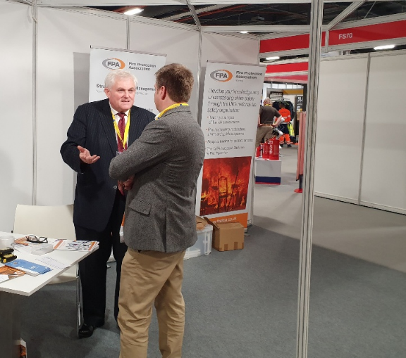
Picture left from “FIREX” June 2019 in London and picture right from “Fire Safety North” October 2019 in Manchester. We got several new contacts and many new subscribers of our Newsletter.

We have also giving presentations at conference in Ankara (February 2019) and Athens (February 2019), and three different presentations at meetings arranged by the European Commission in Brussels. Beside that there have also been presentations when some organization had their meetings, for example one meeting in Ljubljana arranged by East Central European Fire Protection Corporation. In the end of October 2019, I will talk at a conference in Belgrade, arranged by our member DITUR. In November 2019 I’m invited to talk at EAPFP’s annual meeting in Edinburgh.
• We have now two logos, and the new include the words Fire, Security and Natural Hazards.
• There is a big need to get more involvement from CFPA E’s members. We need news, articles, etc. that we can use for the website/newsletter.
• Still there are only some members that active promote CFPA Europe in their countries. A minimum is that all members have information about CFPA Europe on their own website/magazine/newsletter.
• We have not any journalist who help with texts, but we have some more professional marketing and information people as members of MIC. MIC are doing a good work to make texts, etc.
• It will be difficult to reach the aims about number of visitors to our website and number of subscribers of our newsletter.

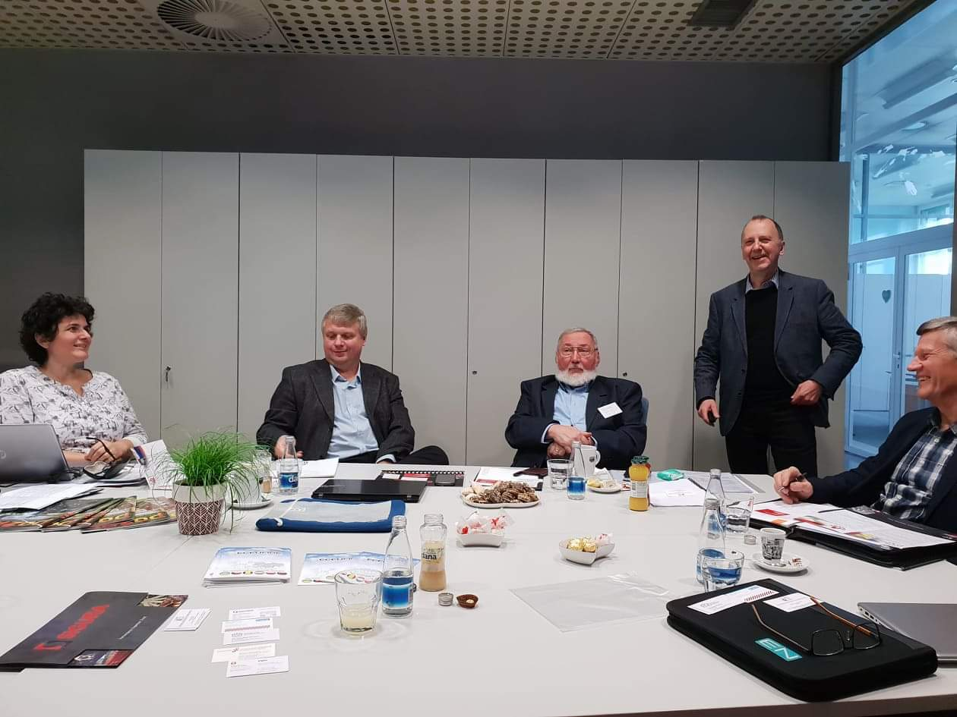
Meeting with the association “East Central European Fire Protection Corporation” (ECEUFIRE) in Ljubljana (November 2018). From left Mateja Gris, SZPV, Gábor Marlovits, Hungary, Horia Mihai Nicolescu, Romania, Tommy Arvidsson, CFPA Europe, and Milan Hajduković, SZPV. Photo: Gašper Golob, SZPV.

Topic E – CFPA International
Picture from existing strategy.
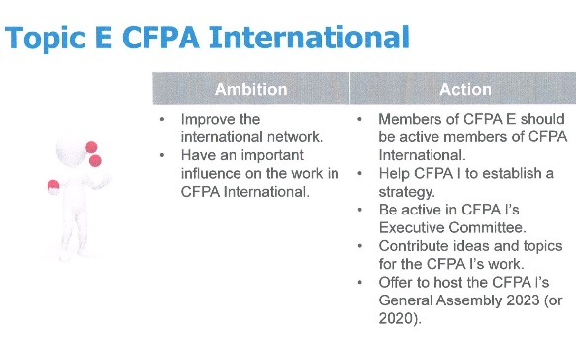
• There is three people from CFPA Europe who are members of the Executive Committee of CFPA International (Jesper Ditlev, Anders Bergqvist and Jonathan O’Neill). Jesper is also the vice chair.
• CFPA I have now a strategy and Jesper has together with Peter Stocker and me made a proposal about CFPA I’s website.
• CFPA E have invited CFPA I to have their GA 2020 in London the same week as we in CFPA E will have our GA in London. These arrangements will be in the same week as the FIREX International in London (FIREX will be held 19-21 May).

Topic F – Membership/Network
Pictures from existing strategy.
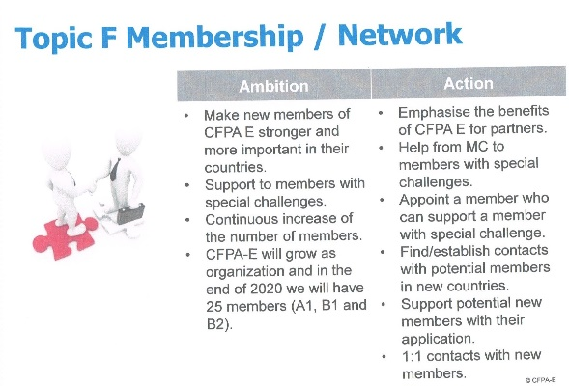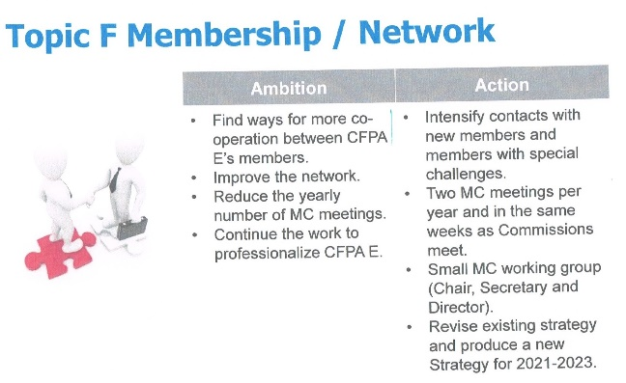
• The number of members is growing and as you remember we got Poland as an A1 member and the Swedish Theft Prevention Association as a B1 member at GA 2018. In the autumn 2018 we got Greece as A1 member and both Albania and Turkey as B2 members. Later in autumn 2019 Turkey became a regular A1 member. We have also got Netherlands as an associated member, B1, and now in the autumn 2020 we got North Macedonia as a B2 member. We have reached the goal, 25 members.
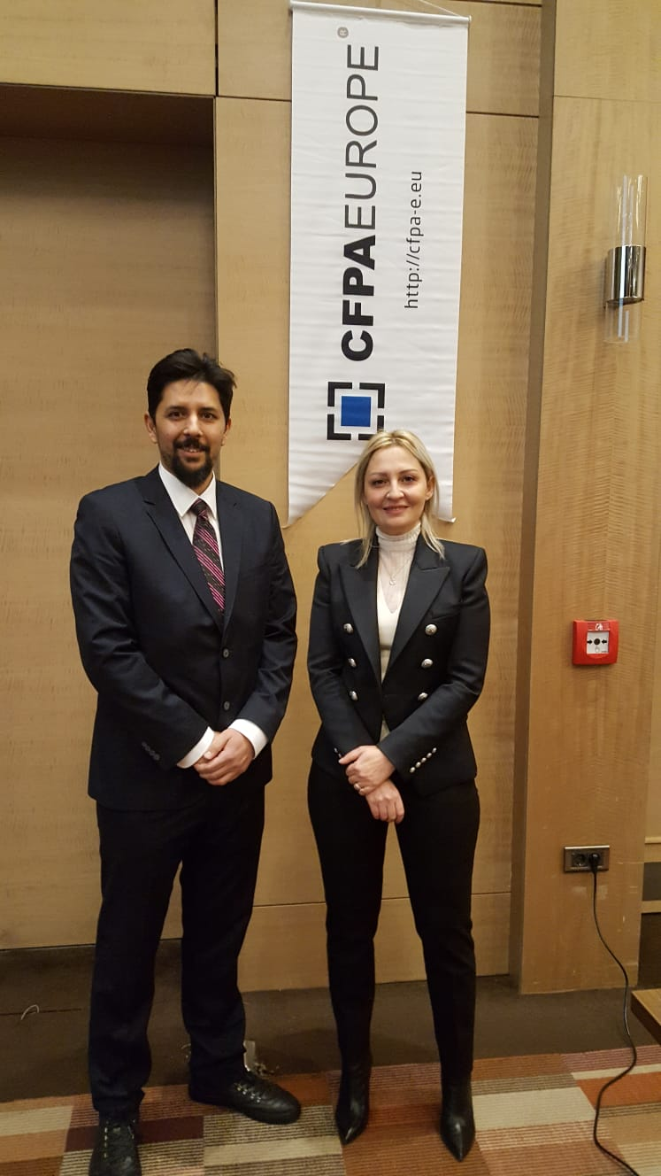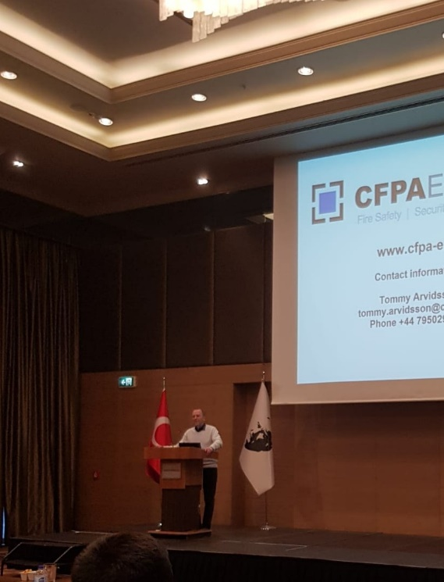
Picture to the left show our B2 member Asuman Erkul (right) together with Şükrü Önder Sağbaş, who is a member of FPPA’s Board. FPPA is the organization that our B2 member wish to become a regular member of CFPA Europe. Picture to the right is from my presentation at the meeting in Ankara (February 2019).

• We have also been working to see if it’s possible to get members in Hungary, Luxembourg, Malta, Montenegro, Romania, Slovakia and Ukraine. Some of these contacts might give some new member in the future but it takes time to discuss and find some organisation (or to see if it is possible to start an organisation) in these countries. We had good progress with Slovakia but in spring 2020 they decided to not apply. When we were in Bologna in October 2019 (the Commission week) I could arrange a meeting with a person from Malta.
• CFPA E use to help members with special challenge, but of course that is done if the member asked for help. We also connect members to each other when we think one member can help another member.
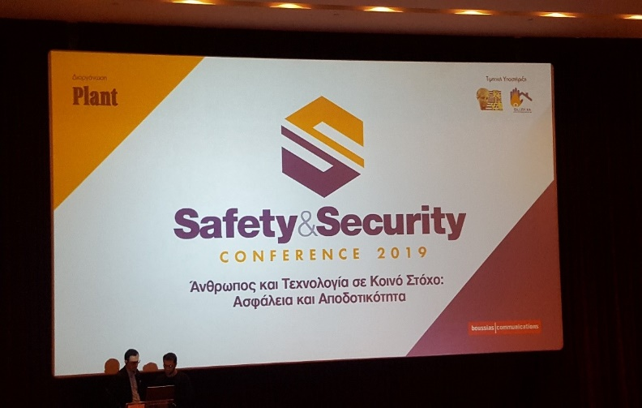
Picture from conference in Athens, that was supported by our member ELIPYKA in Greece (February 2019). I was speaking at the conference and so also Dr. Yiannis Kontoulis and Dr. Dionysis Kolaitis from ELIPYKA. Big conference and a good opportunity for ELIPYKA and CFPA E to promote our activities.

• The arrangement with a week in the spring and another week in the autumn where all Commissions and MC can meet have been successful. We have already booked these weeks until the end of 2024.
• MC has prepared a proposal for Strategy 2021-2023, a proposal that member can decided at GA 2020 in October. The work started with an enquiry to all members and we got eleven answers. All members of MC have been involved in the evaluation, and in the work to prepare the proposal for strategy 2021-2023

Topic G – Security & Natural Hazards
Picture from existing strategy.
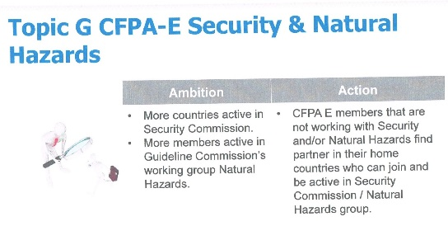
• The numbers of members active in Security Commission and Natural Hazards Group have increased. Insurance Europe has also decided that they wish some new natural hazard guidelines and this work is done in our Natural Hazards Group by inviting also some insurance people. Mingyi Wang is the chair and he is doing this work excellent.
• We have tried to find security associations/organisations that can become B1 members in countries where our regular member (A1) is not working with security or need help with their security work. Until now we have only been successful with Sweden (The Swedish Theft Prevention Association became member in May 2018). The B1 member from Sweden is now very active in Security Commission. Most of our regular members are working with both fire safety and security.

September 2020 (latest update)
Tommy Arvidsson

Abbreviations
CTIF: International association of fire and rescue services
EAPFP: European Association for Passive Fire Protection
FEU: Federation of the European Union fire officer associations
GA: General Assembly
GC: Guidelines Commission
MC: CFPA Europe’s Management Committee
MIC: Marketing & Information Committee
NH: Natural Hazards Group
SC: Security Commission
SFPE: Society of fire protection engineers
TC: Training Commission

