Comments from Lars Brodin – November 26 2019
Document: 19019 Guidelines Arson Document(SPEK) - Comments from Lars B

Factors behind Arson

Motivation of the Arsonist
The people who are guilty of arson are not trying to find remote areas in which they could light something on fire when no-one is looking. Identifying potential arsonists need to be done, who may be intruders, visitors, contractors or staff. Research (for example, Canter & Fritzon 1998; Dickens & Sugarman 2012) indicates about the charactereristic of offenders that people convicted of arson are suffering from various neurological, mental, social and substance abuse problems

The Different Kinds of Arson
Areas where fire occurs

Fires are intentionally lit in places where people typically spend time: in homes, yards, parks and on streets. Wildfires are lit near populated areas or roads. The people who are guilty of arson are not trying to find remote areas in which they could light something on fire when no-one is looking.

Schools and similar premises
There is not a simple answer to why schools are exposed to fires, but there is a clear connection between conflict situations, vandalism and fires....

Children and Adolescents Playing with Fire
CFPA E European Guidelines No. 8 : 2004 F emphasises the need to engage with and educate young people in ways which will help to dter them from coming arson. See Guidelines no. 8 : 2004 F.

Fire Protection Equimpment for Control of Arson

Fire Prevention Systems

Line-type heat detectors (heat detection cables) can be used as a complement to the conventional fire detection system for the protection of for example schools and cultural buildings where there are high probability of fires being started on the outside of the building...

Prevention arson Information to young people CFPA-E Guideline No 8:2004 F
These next parts will be checked / added to the contents of the arson document:

FOREWORD
- In most developed, industrial countries arson has become the major fire problem of our time. While fire statistics in general and arson statistics in particular are inadequate to a lesser or greater degree in most countries, it has been clearly established that world-wide the cost of arson as a proportion of all fire costs is at least 15 per cent and may be as high as 50 per cent depending on the country. Insurers throughout the world are devoting between a quarter and a third of their total loss expenditure to pay for losses resulting from arson.
>> EDIT: Already in chapter: Background on Arson
- There are many different motives for arson although it is felt in most European countries that arson for gain (i.e. to defraud insurers), while a significant factor, accounts for only a small part of the cost. Where evidence has been collected it is seen that arson is principally linked to vandalism and other crimes such as burglary. A substantial number of offenders are young males aged 14- 18; even younger children are often the culprits.
>> EDIT: Already in chapter: Motivation of the Arsonist
1 INTRODUCTION
- Arson causes society extensive material damage and economic losses, and it creates insecurity and suffering for many people.
EDIT: Same information already in chapter: Effects of arson

- Experience at local level shows that the number of cases of arson can be reduced by effectively and systematically utilising and co-ordinating the limited resources that are available. Preventive work of a more targeted nature must, however, be carried out to bring about a permanent reversal of this trend at national level.
EDIT: Text added to: Development areas concerning arson prevention

- Experience shows that preventive action against arson – directed towards young people – has the effect of reducing vandalism of other types in the community. Action against arson can therefore be co-ordinated with other action to prevent vandalism so that juvenile delinquency in society may be reduced.
EDIT: Text added to: Co-operation and producing information about Arson for young people

2 ARSON EXPERIENCE AND REACTION
- fire protection associations and individual rescue services have formed a number of local "arson prevention groups" with representatives from the rescue service, police, insurance companies, social services, schools etc. Who have produced information material and have been active at local level.
- Experience indicates that nothing is done unless the fire sector assumes the principal responsibility for highlighting the issue and promoting arson prevention work. (The work has also in many cases been depended on individual voluntary activists). It is in the fire sector that the insight, knowledge, resources and engagement are to be found – leading to arson prevention initiatives which will bring considerable economic benefits to society as a whole.
- This is a consequence of systematic and targeted information for school children not yet in their teens. In most cases it has been the staff of the rescue service who have done this work – work which has often been carried out by activists on a voluntary basis and taken the form of projects.
- in most cases, they are committed by young people; those young people do not understand the consequences of their actions, for themselves or for their surroundings.
The provision of appropriate information for our children and young people must begin at an early stage and should be carried on continuously if we are serious in our efforts to reduce arson. Society can make large economic and social gains by disseminating information about arson at school, but so far efforts have been too localised, fragmented and short-term in nature.
EDIT: Texts added to: Co-operation and producing information about Arson for young people
Combined and added text:

5 Prevention of Arson

Co-operation and producing information about Arson for young people
Experience shows that preventive action against arson – directed towards young people – has the effect of reducing vandalism of other types in the community. Action against arson can therefore be co-ordinated with other action to prevent vandalism so that juvenile delinquency in society may be reduced. In the cases where Arson is committed by young people; those young people do not understand the consequences of their actions, for themselves or for their surroundings.

Fire protection associations and individual rescue services with police, insurance companies, social services, schools etc. Who have produced information material and have been active at local level should highlight the issue and promote arson prevention work at society.

3 ARSON – SOME BASIC FACTS
- The most common motives among children and young people are curiosity, extreme boredom and vandalism. Other motives among both young people and adults are concealment of crime, revenge, hate, conflicts and insurance swindles.
- Most fires that are started by children are probably not deliberate but begin as play. But there are also many young arsonists that are known to the police or to social workers from earlier incidents. Many of these youngsters have difficulties at school or at home, feel a failure, or have other difficult relationships.
EDIT: Texts added to: Arson comimted by children and young people

- Cause-of-fire analyses and fire investigations are often time consuming detective work. In most cases, the vital signs vanish in the first few minutes. Co-operation between the police, the fire and rescue service, insurance companies etc has improved in recent years but further improvement is desirable.
EDIT: Text added to: Co-operation and role of police and fire department

- The most important part of local activities is the provision of information to young people in school.
EDIT: Text added to: Co-operation and producing information about Arson for young people

4.1 Local involvement is vital

The local fire and rescue authority must take responsibility for ensuring that measures against arson are included and dealt with in the agenda, for example, the rescue services plan. The emergency services and the parties who deal with safety and crime prevention activity and insurance issues should be the obvious players in this local effort. The key concepts are enduring engagement and close networking. A model should be drawn up to replicate the local plan to combat arson and to identify the roles of the parties.
EDIT: Text added to: Co-operation and role of police and fire department

4.2 Information for schoolchildren will reduce the risk

Continuous information for children and young people concerning arson and its consequences is the most important part of an action programme.
All experience shows that young arsonists do not appreciate the consequences of their actions, either for
themselves or for their surroundings. Information for these groups is therefore the major challenge and also provides the opportunity for enduring improvements of a more long-term nature.
EDIT: Same information already in chapter: Co-operation and producing information about Arson for young people
4.3 Fire investigation is an essential deterrent
Investigation of fires that results in young people and others who commit arson being called to account for their action is essential from the standpoint of general deterrence. A higher percentage of crimes must be solved. Co-operation between the fire and rescue service, police, the courts, insurance companies, social services etc is of the greatest importance.
EDIT: Text added to: 2 Arson Investigation

EDIT: Other new updates to Arson document
----

Factors behind Arson (2)

Motivation of the Arsonist
There are many different motives for arson (see chapter 3) although it is felt in most European countries that arson for gain (i.e. to defraud insurers), while a significant factor, accounts for only a small part of the cost. Where evidence has been collected it is seen that much arson is associated with vandalism and other crimes such as burglary. A substantial number of offenders are young males aged 14-18; even younger children are often the culprits. See also Guidelines No. 8 : 2004 F.
Reference deleted
----
There is no reference list to be found in the end of the document:

Do we keep that in the document and do we keep the refernce to: Prevention arson Information to young people CFPA-E Guideline No 8:2004 F (Now included to Arson Document)

----

Fire Protection Equimpment for Control of Arson (6.4)
In all types of buildings, management planning against fire has to include the provision of the most appropriate and cost-effective fire protection equipment. Such equipment is required to deal with accidental fires as well as deliberate fires, but to ensure control against the latter, additional factors need to be taken into account. Also, since much arson originates from outside the building, it is necessary for management to consider the provision of security as well as fire equipment. This particular aspect is dealt with in Chapter 7 of the document.
Reference deleted

----
Fire Protection Equimpment for Control of Arson – Updated

- some small text updates
- Update: fire detection as mentioned earlier in this document
- Word updates: as mentioned earlier in this document: Fire Protection Equimpment – Fire Protection systems (some parts included word: prevention systems)

To Note:

EDIT: there would still be a need for simplified diagrams of procedures for textual content.

Example 1
For example from the guideline: Prevention arson Information to young people CFPA-E Guideline No 8:2004
From chapter: prioritised measures
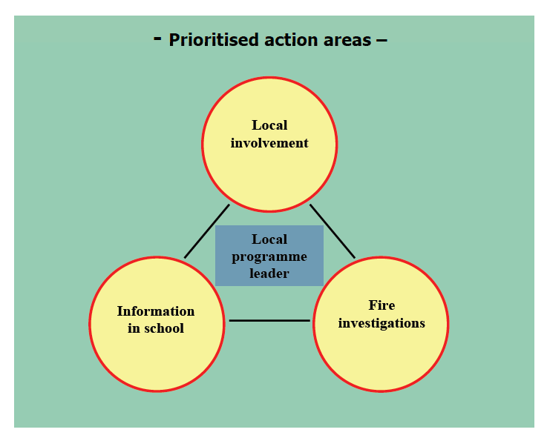
The areas in the diagram are the case areas on which efforts should be concentrated unceasingly.
Only then will it be possible to break the trend and to bring about a more lasting reduction in the
incidence of arson in society. This will have the great additional benefit of helping to prevent our
young people embarking on a criminal career. The most important part of local activities is the
provision of information to young people in school.

>> edit: this could be in the chapter Co-operation and role of police and fire department

Example 2

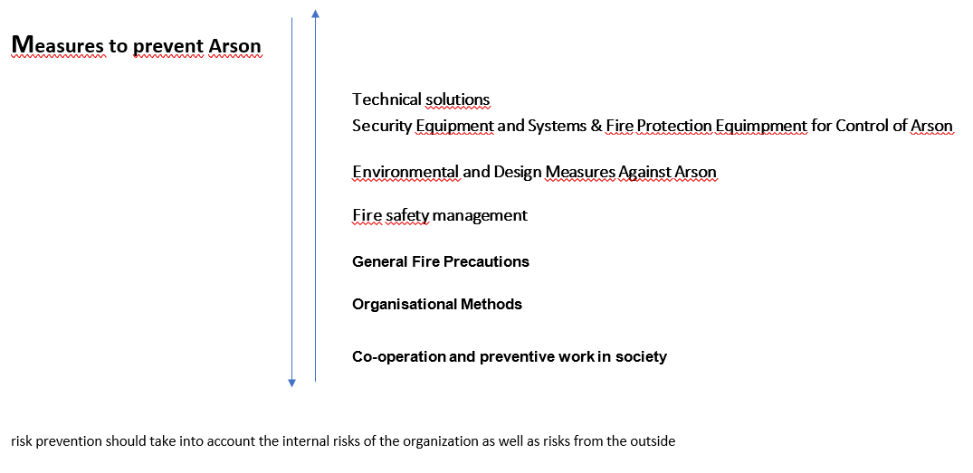

Example 3

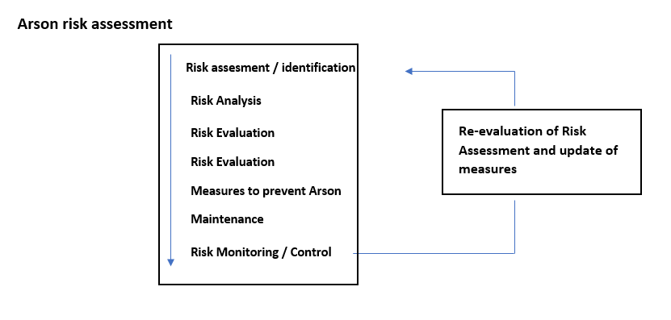
Edit: this could be in the chapter 4 Risk Management

