Guidelines

Developing
Evacuation and Salvage Plans for
Works of Art and Heritage Buildings

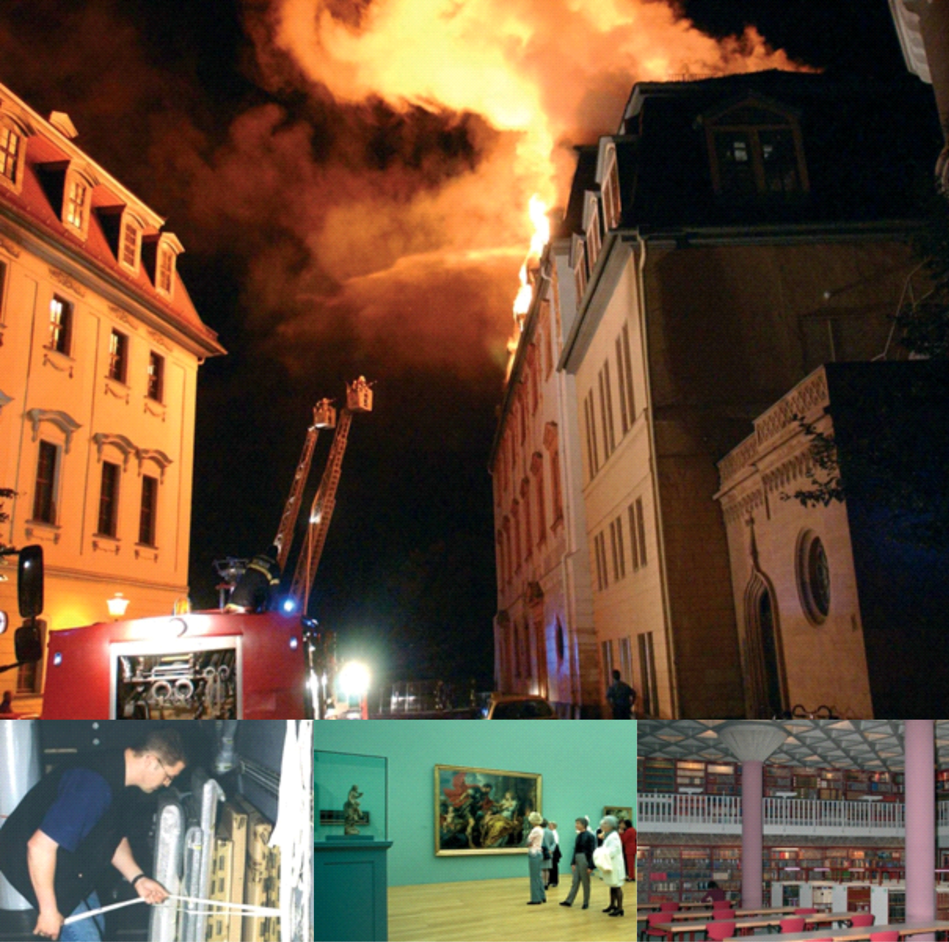

Foreword
The Security Commission of the Confederation of Fire Protection Association Europe (CFPA-E) has developed common guidelines in order to achieve similar interpretation in the European countries and to give examples of acceptable solutions, concepts and models. The CFPA-E has the aim to facilitate and support fire protection and security aspects across Europe.
The market imposes new demands for quality and safety. Today fire protection and security aspects form an integral part of a modern strategy for survival and competitiveness.
The guidelines are primarily intended for the public. They are also aimed at the rescue services, consultants, safety companies and the like so that, in the course of their work, they may be able to help increase fire safety and security in society.
These guidelines have been compiled by the Guidelines Commission and are adopted by all fire associations in the CFPA-E.
These guidelines reflect best practice developed by the countries of CFPA-E. Where the guidelines and national requirements conflict, national requirements must apply.

Content
1 Introduction 4
2 Scope 4
2.1 Validity 4
3 Risk Characteristics 4
4 Preventive Measures 5
5 Contingency Planning 5
5.1 How to Compose a Planning Team 5
5.2 Roles and Responsibilities of the Planning Team 6
5.2.1 Risk Assessment 6
5.2.2 Inventory Lists 6
5.2.3 Works of Art and Exhibits – Properties 7
5.3 Emergency Plan 7
5.3.1 Before the Emergency 8
5.3.2 During the Emergency 9
5.3.3 After the Emergency 10
Annex A Alarm Control Panel (Example) 11
Annex B Training of Personnel 12
Annex C Literature List 13
Annex D List of all CFPA Guidelines 14

Introduction
It is only human to assume that not having suffered any losses in the past would automatically lead to a future of the same nature. On that point, a court once expressed the following opinion:
Experience tells us that we have to expect a fire developing at any time. The fact that certain buildings have not suffered any fire loss for decades does not constitute evidence of there being no hazard but rather of good fortune for the parties affected who have to expect that this could change any time. (Gelsenkirchen administrative court, 5 K 1012/85 of 14 Nov. 1985).
Considering that the possibility of a loss cannot be ruled out with 100 % certainty, every museum, art collection or library should have a plan that stipulates what should be done before, during and after such a loss scenario in order to avoid panic, helplessness and chaos.
The individual circumstances of every building housing works of art and cultural assets in terms of its location, construction, occupancy, frequency of visitors and type of exhibits inventorymake it
necessary to adapt evacuation and salvage plans for works of art and heritage buildings to these givens. In this context, special precautions for exhibits on loan may be necessary.
Contingency plans should cover a period of 48 hours immediately following the loss. During this period, the course for successful salvage measures is set. The plans also provide a good basis for emergency measures in case of hazards that are imminent but have not occurred yet (e.g. floods, storms and the like).
The general recommendation for burglaries is not to attempt to salvage stolen works of art or heritage assets without the agreement of the authorities (e.g. police) and any insurer in order to avoid inadvertently encouraging art-extortion (“art-napping”).
In general, timely implementation of evacuation and salvage measures immediately following the loss is critical for loss minimisation

Scope
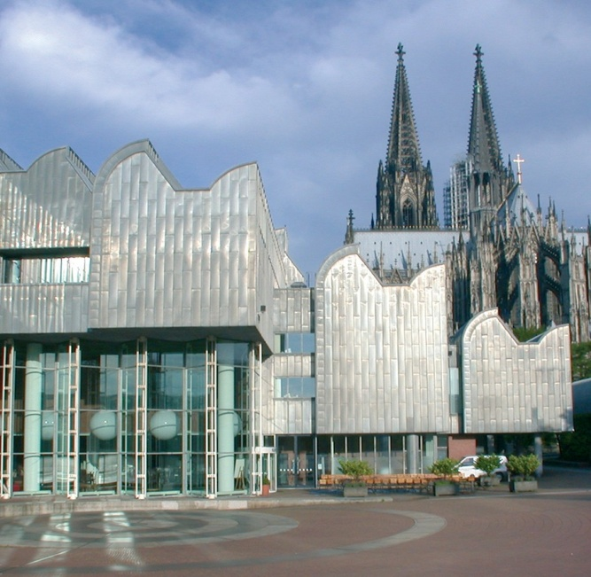
Figure 1 Museum Ludwig, Cologne
These Guidelines have been designed for museums, libraries, archives, churches and other buildings housing works of art and heritage assets such as warehouses of forwarding companies, galleries and trade exhibition centres.

Validity
This document Developing Evacuation and Salvage Plans for Works of Art and Heritage Buildings, CFPA-E 07 : 2010/S are valid from September 1st, 2014

Risk Characteristics
In general, museums, libraries, archives and other buildings housing works of art and heritage assets have the following risk characteristics in common:
- High concentration of valuable assets
- Irreplaceble collections and individual exhibits
- High sensitivity of the exhibits to external influence
- Unpredictable crowd behaviour (visitors).

Preventive Measures
The prerequisite for a safe operation is the formulation/development of a comprehensive protection and safety concept and its full implementation for the respective building. All safeguards against fire, burglary, theft, hold-ups, vandalism, water leaks and natural disasters (flood, storm etc.) must fit seamlessly. They contribute to avoiding and/or minimizing any negative impacts on works of art and heritage buildings. Regular inspections, maintenance and repair measures ensure the continued reliability of installed technical safeguards.
National regulations may overrule these recommendations
Important factors include the following:
- change as proposed Fire safety doors shall be kept closed at all times and it is imperative to make sure that they are not wedged open. In case operational reasons make it necessary to leave them open for a longer time, only hold-open systems approved by building supervision agencies shall be used (cf. CFPA No 2/F as well as CFPA No 6/S).
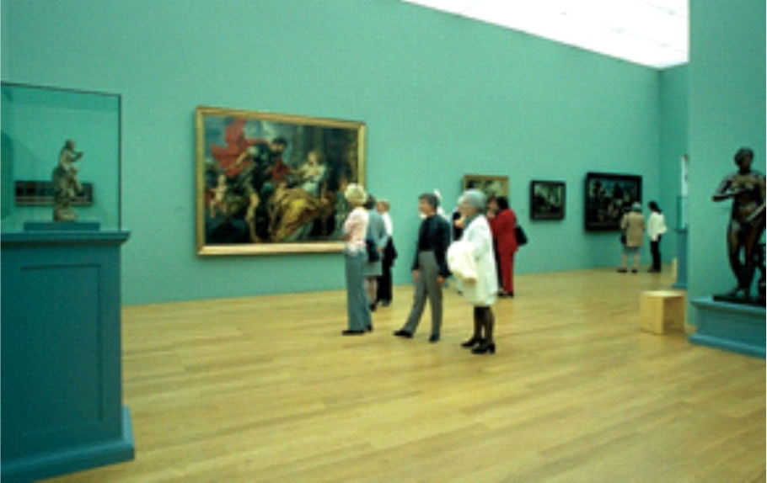
Figure 2 Courtesy of Vaduz PR
and information service
- Fire safety, intruder and burglary alarm systems shall be regularly inspected (if possible, annually), maintained and, if necessary, repaired (cf. European and national regulations).
- Openings in walls with fire safety functions (firewalls) introduced be sealed with flame-retardant material.
- Flood protection structures have to be inspected and serviced (cf. CFPA No 1/N).
- The required width of escape routes and exits leading outside must be usable and cleared of any objects.
- Appropriate safeguards must be installed to minimise the risk of burglary and theft. They shall be developed in close cooperation with the police and the insurer (cf. CFPA No 29/F, CFPA 30/F as well as CFPA 5/S).
Personnel shall be trained (cf. Annex A) and instructed in the implementation and realisation and ensure the operational readiness of protection measures.
The possibility of a loss cannot be ruled out despite all preventive actions. This is where a contingency plan is useful.

Contingency Planning

How to Compose a Planning Team
It makes sense to bring together decision-makers and experts from different disciplines and select a coordinator to develop contingency plans. The planning team should include the following:
- Representatives of the museum’s management/director (incl. person responsible for communication)
- Fire protection manager
- Safety manager
- Head of IT
- Conservator
- Head of facilities management
- Fire brigade
- Police
- Security company
- Insurer

Roles and Responsibilities of the Planning Team

Risk Assessment
A risk assessment should be carried out with a view to the control of fire (cf. CFPA No 4/F), natural disasters, burglary, theft, vandalism, hold-up and the repercussions thereof.
For this purpose, the structural, operational and organizational conditions shall be assessed:
- Risks resulting from the location (if necessary, consult specialists)
- Structural and organisational circumstances / conditions such as e.
  - Sensitivity of the structural shell
  - Possible access for emergency services
  - Clear and accurate identification of the location on the part of the response forces (fire brigade, police, etc.)
- Accessibility of authorised personnel
- Storage of packaging material
- Risks resulting from the type of the facilities / equipment, e.g.
  - high proportion of plastic materials, in case of fire risk of smoke, aggressive particulates and gases
  - high content of wood in heritage buildings, rapid spread of fire, sensitive to humidity (vapour).
- What kind of technical facilities (e.g. facilities such as heating, air condition and ventilation system, lift, fire suppression system) are available which in case of an emergency pose a risk potential themselves?
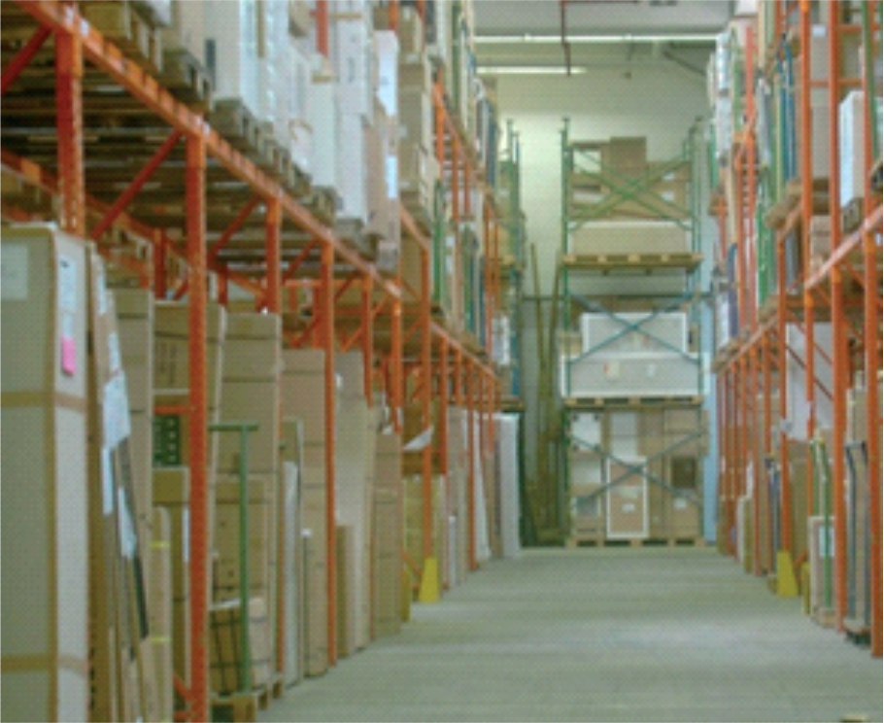
Figure 3 Museum's depot
- Special occupancies (meetings, events and the like).
- Are there any secondary installations (e.g. workshops, catering areas etc.) or any secondary occupants or neighbours?
- Risks posed by repair work (e.g. roofing, welding and soldering; consider permit procedure). For information on Hot works cf. CFPA 12/F
- Risks posed by sub-standard maintenance (mildew as a result of humidity, poorly serviced air condition systems, defects in electrical systems, damage of water pipes caused by frost etc.).
- Risks posed by biological agents e.g. mold, rodents, insects.
- Transportation (cf. CFPA No 29/F)
Preventive measures (e.g. procurement of suitable extinguishing agents) derived from the risk assessment must be taken.

Inventory Lists
Inventory lists must include the following additional details based on the object’s ID:
- Condition (tested)
- Size and weight
- Material
- Photo documents
- Evidence of ownership
- Storage location (verify location)
- Storage conditions
- Transport options
Note:
Inventory lists must be continuously updated!

Works of Art and Exhibits – Properties
Account should be taken of risks especially resulting from the particular features (material, design) of the works of art and heritage buildings and the individual protective systems.

Note:
Consult expertise of specialist conservators.
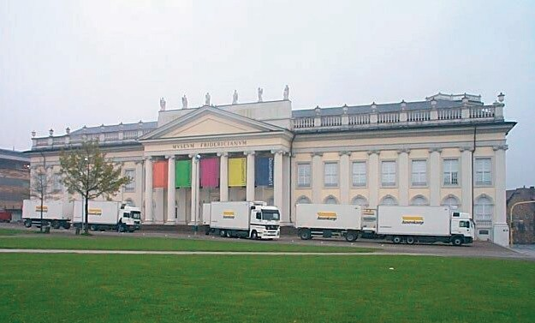
Figure 4 Courtesy of hasenkamp Internationale Transporte GmbH

Emergency Plan
In order to develop evacuation and salvage plans on the basis of the above risk assessment, the following considerations should be made and measures defined:
- Predict the possible scenario
  - What could happen?
  - Which areas could be affected?
  - Who is going to initiate evacuation measures?
- With the specialist conservators
  - Talk about the possible hazards for the objects, exhibits, collections.
  - Define necessary emergency measures
- Emergency process organisation:
  - Appointment of emergency coordinators
  - Designation of decision-makers and authoities
  - Prioritisation by value (what has to be saved first) – if not addressed elsewhere
  - Internal and external communication (cf. CFPA No 2/N)
- Plans, prepared measures etc. shall be reviewed on an annual basis or whenever circumstances change (special exhibitions, exhibits on loan etc.) .
The staff of the relevant establishment should be briefed regularly on the status of progress during the development of the contingency plan in order to ensure feedback. Emergency plans can only be fully effective if they are supported and committed to by the staff. It is advisable to regularly validate that data on designated persons (names, telephone numbers) are up to date.
See also CFPA No 29/F.

Before the Emergency
Contents of plan  (what?) | Who does what?  (roles) | When? | Where?
Alarm control panel
(see Annex A)
Provision of emergency aids
(covers, drying equipment, blankets, gloves, pallets, packaging material, industrial aspirators, templates for documentation, cameras, necessary tools/keys to disengage mechanical security locks, emergency kit for conservators etc.)
Storage capacities
(external/internal) contingency warehouse, cold store
Transport capacities  Forwarding agent for art | Note: If possible, coordinate with conservator
Lyophilisation (vacuum),
freeze drying
Compile address list of specialist companies
Recovery and return
in case of loss
Define possible priorities
for recovering the works of art
Senior manager on duty
Calendar
HR resources available
Compose rescue teams
Site inspection/introduction:
Staff, fire brigade, police, security service provider (annually)
Monitoring of safeguards
Plan update
Fire brigade inspection/exercise, fire drill, regular site visits, management, availability of emergency aids
Coordinate contingency plan
with insurer

During the Emergency
Contents of plan  (what?) | Who does what?  (roles) | When? | Where?
Calling emergency services
Alert visitors, staff, contractors and neighbours
Evacuation of visitors and staff and immediate corrective action
Convene emergency team (coordination of operations, advisory support to external forces and relief teams, public relations)
Specify priorities for the recovery of works of art
Initiation and implementation of
evacuation measures
Sampling by specialised conservators and initiation of
harmful substance analysis to
determine the next steps
Documentation of evacuated works of art in writing and with photos
Contact insurer

After the Emergency
Contents of plan  (what?) | Who does what?  (roles) | When? | Where?
Security structural measures, surveillance, intermediate storage
- Involvement of insurer
- Continuation of rescue, recovery and restoration measures
Measures to ensure
business continuity
Structural partition

Alarm Control Panel (Example)
Emergency phone numbers (please alert in this order)
 | business | private | mobile
Fire brigade
Police
Emergency coordinator
Emergency coordinator notifies:
- Management/Director of museum
- Head of facilities management
- Conservator
- Fire protection manager
- Security company
- Manager on duty
- Insurer
General code of conduct
Individual emergency measures

Training of Personnel
Overview of courses : see www.cfpa-e.eu
Special courses:
Fire and Security for museums (specialists course)

Literature List
- CFPA-EUROPE Guideline No 2/N Business Resilience, An Introduction to Protecting Your Business
- Bruno Klotz-Berendes
Notfallvorsorge in Bibliotheken Deutsches Bibliotheksinstitut Berlin, 2000 http://hdl.handle.net/2003/5596
- Lecture manuscripts of IFS workshop
„Sicherheit in Museen“ Kassel, 10 Mai 2000 www.ifs-kiel.de
- Wilhelm Kallenbach, Cäsar Rohlfs, Rudolf Princ, Klaus Kempe, Hermann-Josef Dornhoff, Günter Wagner, Werner Boeck
Brandschutz in Baudenkmälern und Museen AG öffentlich-rechtliche Versicherung im VdS e. V., Karl Thiemig, Graphische Kunstanstalt und Buchdruckerei AG, Pilgersheimerstr. 38, 81543 München
- Verband der Restauratoren e.V. (VDR)
Weberstr. 61, 53113 Bonn www.restauratoren.de/bonn.html
- Prof. Dr. Friederike Waentig
Fachhochschule Köln Institut für Restaurierungs- und Konservierungswissenschaft Ubierring 40, 50678 Köln www.re.fh-koeln.de
- Emergency Response and Salvage Wheel
National Task Force on Emergency Response 1730 K Street, NW Suite 566, Washington, DC 20006 www.heritagepreservation.org
- Handhabung und Lagerung von mobilem Kulturgut
Joachim Huber, Karin von Lerber Landschaftsverband Rheinland transcript Verlag, Bielefeld, 2003 ISBN 3-89942-140X
- Günter S. Hilbert Sammlungsgut in Sicherheit Gebr. Mann Verlag, Berlin, 2002
- DRIESSENS J.
Dans les bibliothèques : Sauvegarder le trésor documentaire scientifique et culturel in Revue Belge du Feu (B) - 1987 - n° 86, juin - pp 33-37
- CENTRAAL LAB. ONDERZOEK VOORWERPEN VAN KUNST
Calamiteiten - Amsterdam (Nl) : CL onderzoek voorwerpen, sd - pm
- CENTRAAL LAB. ONDERZOEK VOORWERPEN VAN KUNST
Museale calamiteiten en calamiteitenplanning - Amsterdam (Nl): CL onderzoek voorwerpen, 1992 - 81 p
- CENTRAAL. LAB.ONDERZOEK VOORWERPEN VAN KUNST MOSK L.
Voor het kalf verdronken is : Handleiding voor het maken van een museaal calamiteitenplan - Amsterdam (Nl): CL onderzoek voorwerpen, 1992 - 102 p (CL informatie, 10)
- FPA
Heritage under fire : A guide to the protection of historic buildings - 2 ed, London (UK): FPA – 1995 - 112 p
- FEMA NATIONAL TASK FORCE ON EMERGENCY RESPONSE
Emergency response and salvage wheel - Washington (US) : National Institue for the Conservation of Cultural Property; FEMA, 1997 - - 1 disque carton EMERY Steve, Counter culture in Fire prevention (UK) n° 413, February, 2007 - pp 18-21 (4 p)
- CFPA-EUROPE
Guideline 29 F : Protection of paintings : Transport, exhibition and storage; sl : CFPA Europe, 2013 - 40 p

List of all CFPA Guidelines
Security
Guideline No. 2010 1 S Arson document
Guideline No. 2010 S Protection of empty buildings
Guideline No. 3:2010 S Security system for empty buildings
Guideline No. 4:2010 S Guidance on key holder selections and duties
Guideline No. 5:2012 S Security guidelines for museums and showrooms
Guideline No. 6:2014 S Security Guidelines for safe emergency exit doors
in non-residential premises
Guideline No. 7:2015 S Developing Evacuation and Salvage Plans for Works
of Art and Heritage Buildings

Fire
Guideline No. 1:2002 F Internal fire protection control
Guideline No. 2:2013 F Panic & emergency exit devices
Guideline No. 3:2011 F Certification of thermographers
Guideline No. 4:2010 F Introduction to qualitative fire risk assessment
Guideline No. 5:2003 F Guidance signs, emergency lighting and general lighting
Guideline No. 6:2011 F Fire safety in care homes for the elderly
Guideline No. 7:2011 F Safety distance between waste containers and buildings
Guideline No. 8:2004 F Preventing arson – information to young people
Guideline No. 9:2012 F Fire safety in restaurants
Guideline No. 10:2008 F Smoke alarms in the home
Guideline No. 11:2005 F Recommended numbers of fire protection trained staff
Guideline No. 12:2012 F Fire safety basics for hot work operatives
Guideline No. 13:2006 F Fire protection documentation
Guideline No. 14:2007 F Fire protection in information technology facilities
Guideline No. 15:2012 F Fire safety in guest harbours and marinas
Guideline No. 16:2008 F Fire protection in offices
Guideline No. 17:2008 F Fire safety in farm buildings
Guideline No. 18:2013 F Fire protection on chemical manufacturing sites
Guideline No. 19:2009 F Fire safety engineering concerning evacuation from buildings
Guideline No. 20:2012 F Fire safety in camping sites
Guideline No. 21:2012 F Fire prevention on construction sites
Guideline No. 22:2012 F Wind turbines – Fire protection guideline
Guideline No. 23:2010 F Securing the operational readiness of fire control system
Guideline No. 24:2010 F Fire safe homes
Guideline No. 25:2010 F Emergency plan
Guideline No. 26:2010 F Fire protection of temporary buildings on construction sites
Guideline No . 27:2011 F Fire safety in apartment buildings
Guideline No. 28:2012 F Fire safety in laboratories
Guideline No. 29:2013 F Protection of paintings: Transport, exhibition and storage
Guideline No. 30:2013 F Managing fire safety in historical buildings
Guideline No. 31:2013 F Protection against self-ignition and explosions in handling and storage of silage and fodder in farms

Natural hazards
Guideline No. 1:2012 N Protection against flood
Guideline No. 2:2013 N Business Resilience – An introduction to protecting your business
Guideline No. 3:2013 N Protection of buildings against wind damage
Guideline No. 4:2013 N Lightning protection
Guideline No. 5:2014 N Managing heavy snow loads on roofs

