®
guidelines
Protection of Business intelligence
The sustainability and development of business requires the management and protection of critical information
CFPA-E®-Guidelines xxx : 2016/S

Foreword
The Security Commission of the Confederation of Fire Protection Association Europe (CFPA-E) develops common guidelines in order to achieve similar interpretation in the European countries and to give examples of acceptable solutions, concepts and models. The CFPA-E aims to facilitate and support fire protection and security aspects across Europe.
The market imposes new demands for quality and safety. Today fire protection and security aspects form an integral part of a modern strategy for survival and competitiveness.
The guidelines are intended for all interested parties as well as the general public. Interested parties include rescue services, consultants, safety companies and the like so that, in the course of their work, they may be able to help increase fire safety and security in society.
These guidelines have been compiled by the Guidelines Commission and are adopted by all fire associations in the CFPA-E.
These guidelines reflect best practice developed by the countries of CFPA-E. Where the guidelines and national requirements conflict, national requirements must apply.
This document is based on xxx xxx xxx xxx xxx xxx x xxx xxx xxx xx xxx and was kindly supported by xxx xxx xxx xxx xxx xxx xxx xxx xxx.
Chief Executives and Managers,
Entrepreneurs
IIn a world where competition is heightened, competitiveness determines the survival of a company. The protection of know-how and information then becomes a vital issue for its sustainability.
From company head to employee everyone is affected by what is commonly called "business intelligence".
This means shedding fresh light on the company, its critical information, and its environment, to anticipate challenges and adapt its behaviour accordingly.
1
More than a public policy, business intelligence is an approach to help you identify opportunities and
critical factors for success, anticipate threats, prevent risks, secure information, and act on and influence the outside world to preserve the competitiveness of your business. We propose you implement this method with the help of this guide.
In it, you will find help in diagnosing the vulnerabilities of your business, as well as the critical actions to take to protect and defend its interests and ensure its future development.
Don't forget that

THE BUSINESS SECURITY
of your business is YOUR FUTURE!
Business interference is frequently carried out by people authorised to enter research structures or businesses. It is common to see motivated trainees going back to the workplace outside normal hours. These types of behaviour can be a warning sign which should attract the attention of offi cials in the establishment. They must be reported to the service.
>>> What to do in case of an incident?
If the trainee's behaviour conflicts with national
law, particularly in the case of a compu-
ter intrusion attempt or a theft of samples, a complaint should be made to the relevant services.
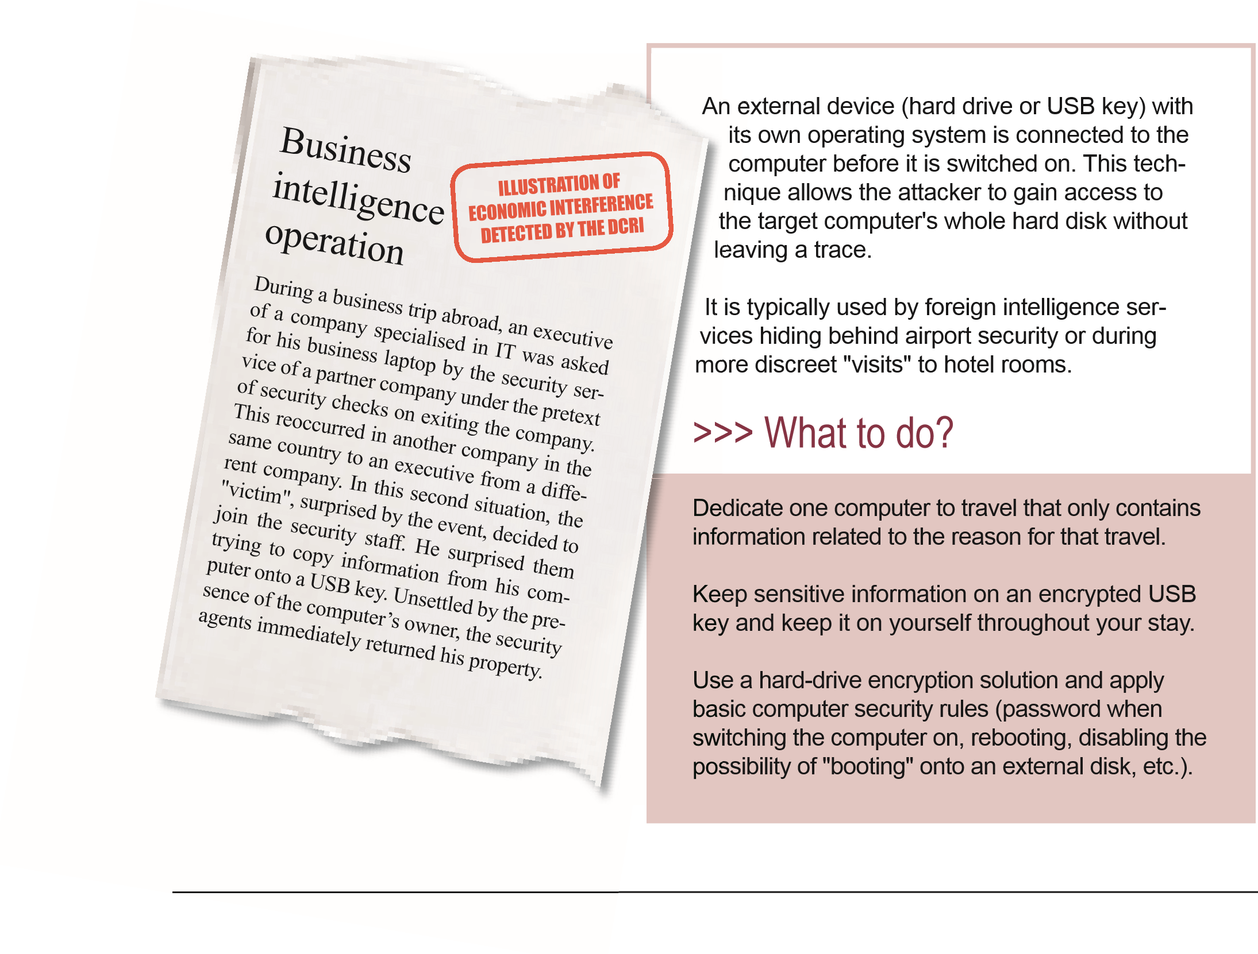
2 It could happen to you!
Dishonest trainee
A foreign national working
toward a PhD in a laboratory
specialising in nanomaterials
sent data relating to the re-
search work carried out by the
host organisation to his home
university over the Internet.
This transfer of information
was done informally outside of
any cooperative work and wit-
hout his superiors’ knowledge.
Once informed of this situati-
on, the laboratory decided not
to make a complaint, but asked
the person concerned to leave
the facility.
Document monitoring is being
performed to claim authorship
of any work that is published
by the university with which
he interacted.
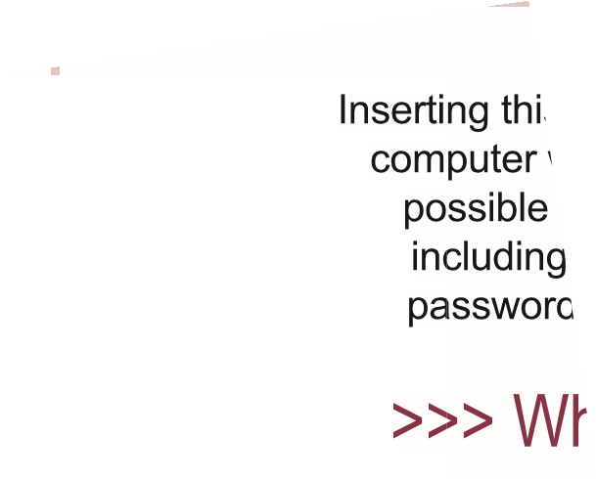
Inserting this key into a company computer would have made it possible to hack into the data, including administrator and user
passwords.
>>> What to do?
Strictly control all company
computer access by outside staff.
Only use storage methods (CD, USB keys) that have been checked by the IT department, especially if they were supplied to the company by visitors.
A seemingly "ordinary" crime might have an economic objective.
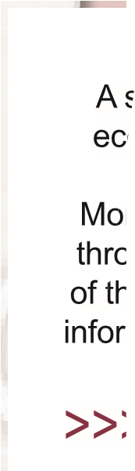
More than half of economic interference cases through attacks on computer systems consist
of thefts of computers containing very sensitive
information.
>>> What to do?
Do not leave your equipment unattended in an uncontrolled environment.
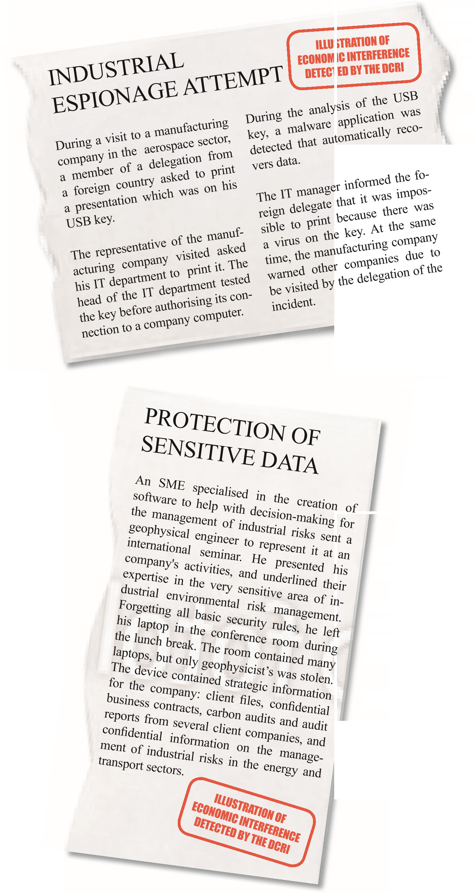
2 It could happen to you!
→Gh, bitte den roten Stempel in den Ausschnitten überall entfernen.

3 Get organised
Protection of your sensitive and strategic
information:
GET ORGANISED
Define the company’s business security policy.
Appoint a security officer, whose tasks include:
☺ report to a member of the management or executive committee so that his/her activities are effective.
☺ define and ensure the proper implementation of the company's security policies.
☺ play a role that is: < →Gh, von “preventive” bis “instructive” bitte einrücken>
☺ preventive - they must therefore be consulted ahead of major projects,
☺ advisory - they contribute to business development by helping in management decision-making and securing operations,
☺ informational,
☺ instructive,
☺ be the contact person for authorities.
Identify and classify items to be protected to avoid intentional or unintentional leaks:
Intentional or unintentional leaks of sensitive information often lead to market losses or damage to the company image. THIS AFFECTS THE SUSTAINABILITY OF THE COMPANY.
☺ Sensitive data,
☺ Strategic information,
☺ Sensitive equipment and facilities.
Regularly educate staff:
☺ Through the security officer,
☺ Through national authorities
☺ Through internal/external experts (e.g. insurance companies) <→Gh Leerzeichen hinter “Access:” Bild tauschen → Bedien-Paneel>
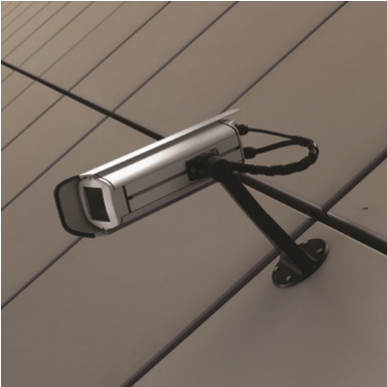
Access:
SECURE IT
The site, sensitive facilities:
☺ Secure the site passively (walls, fences) and actively (access codes, deterrent lighting),
☺ Install surveillance products and services (e.g. alarms, remote surveillance, security guards), adaptedto your company.
☺ Always report any intrusion, theft or attempted break-in to the police.
Controlling access:
☺ Implement a policy for the management of visitors (e.g. should they be accompanied)
☺ Ensure that sensitive information and similar material is available only to authorised personal.
☺ Put in place a controlled access system to offices and premises containing sensitive information and materials,
☺ Differentiate employees from external visitors with badges (trainees, temporary workers, contractors, visitors, etc.)

4 Secure your IT system

RISK: Theft, loss of sensitive information, contamination by computer viruses, unavailability of the IT system
Designate a network administrator responsible for computer security.
IT organisation:
DETAIL IT

☺
☺ Establish an IT policy to which all staff are committed. Annually reinforce with users the computer security rules (security policy compliance, always locking the computer when it is not in use, etc.).
☺ Define a software update policy.
☺ Establish procedures for change of users (staff, trainees...), e.g. joining or leaving the company.
Internal network:

PROTECT IT FROM INTERNET RISKS

☺
Use a continuously updated anti-virus software and a firewall.
☺ Wherever possible, exclude from the shared network computers capable of accessing the Internet.
☺ Avoid the use of wireless technologies (Wifi). If its use is essential, separate Wifi network access from the rest of the IT system and use Wifi security measures as encryption, strong passwords, virtual private networks (VPN), etc.
☺ Prohibit the use of the same password for professional and personal applications.
☺ Vary passwords between applications.

4 Secure your IT system
Risks related to IT:
MANAGE IT

☺
Protect user accounts with an individual password (minimum 10 characters

of different types) that is secret and changed regularly. Delete default authentication data.
☺ Use a phonic method or first letters for the passwords.
(e.g. "I bought eight CDs for one hundred euro this afternoon" will become "ibawt8CDdisan"; The quote "a bird in the hand is worth two in the bush" will produce "1bithiw2itb").
☺ Only use storage methods (CD, USB key) previously checked by the IT service, especially if these storage methods have been provided by visitors to the company.
☺ Beware of suspicious emails or those from unknown senders. Do not open them. <→gh: nächsten Punkt „Delete…“ hier anhängen>
☺ Delete them permanently.
☺ Limit the number of backups to the necessary and store them securely.
☺ Do not install any software without making a preliminary analysis of its characteristics.
☺ Pay attention to the connection of personal equipment (smartphones, tablets, etc.) to the company IT system. If remote working is necessary, provide the necessary professional means to do this.
☺ Extract and store the hard drive of the printer or photocopier in the event of repairs outside the company or in the case of maintaining or scrapping the machine.
☺ Take care of an effective destruction of every hard drive of any device no longer in use.
☺ Arrange monitors, IT screens, etc. with caution to ensure confidentiality when entry is permitted (visits, traineeships, deliveries, cleaning, etc.).

5 Manage the human factor
RISK:
Dissemination of information, leakage, corruption,
Include a confidentiality clause in all employment contracts.
Sensitive information:
ACT

☺
☺ List the premises containing strategic information; provide access on a need-to-know basis only.
☺ Pay particular attention to external service providers (cleaning, maintenance, partner companies, suppliers, etc.).
☺ Educate your employees as to how to protect strategic information.
☺ Instal good practices: storage of sensitive documents under lock and key (lunch break, evening, during office cleaning), use of the shredder, etc.
☺ Educate your employees as to the proper use of social networks
(Facebook, Twitter, Dailymotion, YouTube, etc.)

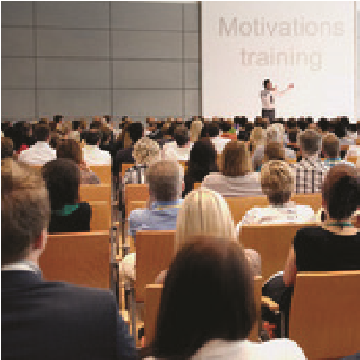
5 Manage the human factor
Trainees and temporary workers:

MONITOR THEM<change Picture ; 2 Personen am Tisch>
Before the traineeship or temporary work period
☺ Study individuals’ CV. Check with the educational institute or the last employer.
☺ Define the contents of the training course or temporary assignment by identifying the critical aspects of the planned work as regards your strategic information, documents, facilities or materials.
☺ Designate a staff member responsible for overseeing the trainee or temporary worker.
☺ Draw up a specific contract between the company, the trainee/temporary worker and his/her organisation. This shall specify the IT restrictions, security measures, confidentiality clause, and limits of dissemination of reports written by trainees outside of the company.
☺ Inform management and relevant staff beforehand of which areas of information and premises are accessible to trainees/temporary workers.

☺ Inform the trainee/temporary worker beforehand of which areas of information and premises are accessible, and what the conditions are for use any device for making copies as well as using IT tools, and any personal equipment (smartphones, USB keys, etc.)

During the traineeship or temporary work period
☺ Do not allow trainees or temporary workers to access sensitive equipment or materials alone, nor any documents or information of a strategic nature, particularly via uncontrolled access to computer systems.
☺ Be aware of bonds that may develop between the trainee or the temporary workers and staff members.
After the traineeship or temporary work period
☺ Retrieve badges at the end of the work period. Change the access codes.
☺ Study the trainee's work. Check that no data deemed to be sensitive have been disclosed.
☺ Give the traineeship report to the security officer.
☺ Establish the identity and position of the visitors.
☺ Ensure the reason for the visit matches the position of the visitors. During the visit
☺ Keep a record of visits. Provide a specific badge.
☺ Make visitors of sensitive areas leave all electronic devices (e.g. mobile phones and photographic equipment) at a designated place (e.g. reception).
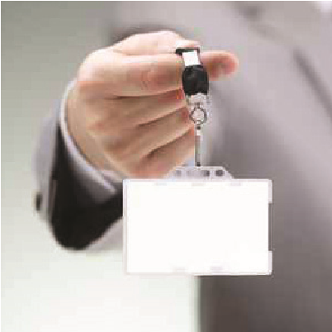
☺ Accompany visitors at all times in the company, even into the most incongruous places.
Before the visit
Visitors:
ACCOMPANY THEM
☺ Establish a visit program clarifying content of presentations and identifying information that should not be disclosed.<hochstufen>Define the visit route, avoiding sensitive areas in the company.
☺ Prevent contact with employees not previously approached to be their contacts.
☺ Prevent the same questions from being asked to different employees.
☺ Do not answer any relevant questions outside the originally planned subject of the visit.
☺ Do not allow any photos, sound recordings or sampling to be taken/made except if authorised.

5 Manage the human factor
Many developments of new processes, products, services, etc. are the product of collaboration among several complementary companies (co-design) or
Collaboration with partners:
BE CAREFUL
between companies and research institutions or technical centres.
The most innovative developments often require the skills of suppliers, complementary businesses, clients, public and private laboratories, technical centres, or business development centres, national or international.
When this type of organisation is necessary for the creation of new solutions, it is particularly difficult to ensure satisfactory protection of the interests of each partner.
Before the project:
☺ Carefully analyse the objectives, issues and risks related to the collaborative project for the company.
☺ Clearly identify and define the position of each of the partners in the project:
☺ Who does what?
☺ Who accesses what type of information? Who is responsible for what?
☺ What are the objectives and the expected return of each partner?
☺ Are there any potential competitors?
☺ Are there any partners who already have close links with some competitors?
☺ Identify by name the people who will be involved in various parts of the project. Find out their backgrounds, their work and their past or present links with potential competitors.
☺ Build a partnership agreement or consortium clearly stating the role and operating limits of each of the structures involved in the project and how the intellectual property of the results will be distributed (patents, licenses, scientific publications, etc.).
☺ Require confidentiality agreements (from the people involved) and exclusivity agreements (from the structures) on the technologies developed. The use of a specialised lawyer is highly recommended.
During the project:
☺ Use a secure collaborative platform, providing access only for each previously identified person to the information that they are authorised to see.
☺ Hold regular meetings with the partners involved. Examine the tools and means to ensure the security of the knowledge or information that they hold.
☺ Thoroughly monitor the information published by the partners on the project in question and/or on related projects (communication campaigns, press articles, scientific publications, etc.).
☺ Organise, re-evaluate, and secure the distribution of intellectual and industrial property rights for each innovation.
☺ Equip yourself with tools for the traceability of work carried out (such as laboratory specifications kept individually by each partner). Each person can thus prove their authorship or that they are the inventor of the new elements they have provided to the project.

6 Protect information outside of the company
RISK:

Dissemination of information through negligence
Public places:
ESTABLISH GUIDELINES

☺
Avoid bringing up professional topics verbally or at the telephone (train, plane,
restaurant, etc.)
☺ Monitor your work equipment (briefcase, documents, computer, telephone).
☺ Avoid using the communication equipment (computers, telephone, etc.) available in hotels.
☺ Be aware of the risks of using internet access available in hotels and other public places without proper security means.<Zeilensprung>
- Do not leave any media containing sensitive data in hotel rooms (even in the hotel safe).
☺ If you must work in public places, disable the Wifi and install a filter on your computer screen.
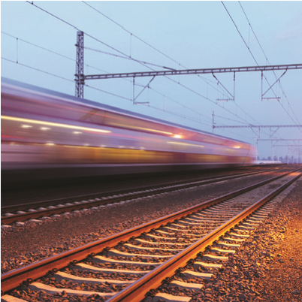
Trips abroad:
FOLLOW CERTAIN BEHAVIOURAL RULES
Daily life
☺ Avoid travelling alone to high risk locations.
☺ Refuse any valuable gifts.
☺ Be careful in terms of relations outside work.
Professional life
☺ Select the information to be transported.
☺ Report your presence to your official national authorities, if adviced.
☺ Be aware of the risk of giving away confidential information while reading or working on public transport.
☺ Never leave a computer, mobile phone or confidential material in a room.
☺ Do not talk about sensitive matters over the telephone.
☺ Be careful about photocopying on site.
☺ Be discreet about your comings and goings.
☺ On your return inform management on any suspicious incidents.

6 Protect information outside of the company
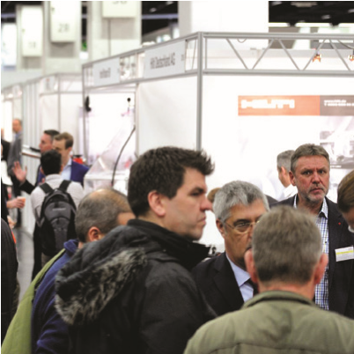
TRADE SHOW
Before the show:
anticipate
☺ Define the objectives of your participation (prospecting, finding partners, launching a product, etc.)
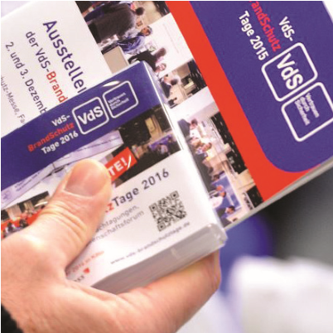
☺ Target stands. Prepare a visit plan.
<”VdS-Bild” mit CFPA-Topic neu erstellen>
☺ List the information that you want to gather, including the level of detail and the way of obtaining it (brochure, sample, etc.)
☺ Define the information that can and cannot be given out at the show.
☺ Prepare answers to sensitive subjects (know-how, innovation, etc.)

During the show: collect
☺ Do research. Collect information (customer expectations, discontent regarding a product, etc.).
☺ Get professionals, not “hostesses”, to present your technical products.
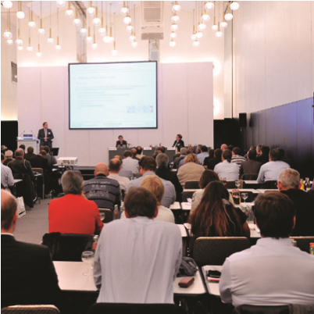
☺ Listen and have a conversation before launching into your demos.
☺ Stay aware during your conversations.
☺ Be careful of visitors who may seek for confidential information of your company.
☺ Monitor at risk materials. Keep the number of sensitive documents or materials to a minimum.

After the show: evaluate
☺ At closing time, empty the stand and check all materials and documents.
☺ Study reactions in the press and on the Internet.
☺ Analyse the documentation collected.
☺ Organise a debriefing session.
☺ Draw up a summary document with new contacts, surprising facts and action to be taken.

7 Protect your assets and your know-how
RISK:

Copying, counterfeit
Protect your technical or aesthetic creations with industrial property titles (patents, trademarks, designs, models, etc.). They allow you to maintain your legitimate rights to these creations.
Industrial property:
ORGANISE IT

☺
☺ For partnerships, draw up confidentiality agreements. Establish ways to prove the date on which the innovations were implemented.
☺ Keep absolute secrecy before filing the patent application. Any disclosure is likely to destroy the condition of novelty and thus be an obstacle to filing a patent or a reason for its cancellation.
☺ Make sure there is maximum awareness within the company of the necessity of protecting your intellectual property rigths (IPR) and of the importance of confidentiality.
☺ Be sure to address invention and creation activities in the employment contracts of the employees who will participate in the development of your innovations. If this is not done, the employee could claim ownership of the invention.
Patent, trademark, logo:

MONITOR YOURS AND YOUR COMPETITORS'
☺ Monitor your patents and trademarks and those of your competitors to ensure that no one uses your invention without authorisation.
☺ In particular, use patent information sources freely accessible on the Internet (www.epo.org) so as, for example, see what your competitors have filed: have they filed patents on technologies that you have already protected?
☺ Try to identify signs of counterfeiting as early as possible (reduced activity due to loss of markets, unexplained deterioration of reputation, etc.).

7 Protect your assets and your know-how
Have you identified a counterfeiter?
You should immediately challenge the counterfeiter. Start by negotiating amicably. Presentation of your property title may put an end to any hint of counterfeiting or lead to an agreement between the parties (a license agreement, for example). If the counterfeiter persists, request the intervention of specialised services (customs, industrial property consultants, specialised lawyers, etc.) that will help you enforce your rights.
For any questions, please contact your national patent office or institution in charge of dealing with counterfeiters.<Anstrich streichen>
Links on organisations:
INPI: https://www.inpi.fr
OHIM: https://oami.europa.eu
European Consumer Center: http://www.eu-verbraucher.de/en/home/
European Union Intellectual Property Office: https://www.euipo.europa.eu
Specific know-how linked to an employee:

ANTICIPATE
☺ Organise the departure of any staff member assigned to a strategic post in the company (retirement, resignation, headhunting, illness, etc.) while preserving their know-how (training of another member of staff) and through precautionary measures, so as to prevent disclosure (prior signature of a non-competition clause).

8 Monitor your environment
RISK:

Denigration, defamation, trademark infringement, loss of markets
E-REPUTATION:

Do you know what the Internet says about you?

☺
Monitor your image on the Internet. Study the information on your company
and your products, and any information found by your customers (site, forum, blog, social networks, etc.)
☺ Answer reviews (positive and negative). Show your interest in questions and comments made by customers. Manage the information provided on your products.
☺ Protect your online reputation. Establish crisis communication and continuity plans in case of damage to the company image.
STRATEGIC MONITORING:
Do you know your
competitors as well as they know you?
☺ Define the strategic issues for your company. Focus on those who are truly important for your business.
☺ Is it better to know your customers, your partners, your competitors, or your suppliers?
☺ Is it more relevant to detect new technologies or market trends?
☺ Analyse your strengths and weaknesses.
☺ Discover development opportunities or threats to your business.
☺ Develop a culture of information gathering among your employees (experience feedback, discovery reports, ability for self criticism, etc.).
☺ Do not hesitate to contact the consular network (chamber of commerce Enterprise Europe Network, etc.), professional structures (e.g. branch organisations), or technical centres.
☺ They organise technology, materials, markets, regulatory monitoring, etc.
☺ They will support you in developing your innovation and competitiveness.

THE BUSINESS SECURITY
of your business is YOUR FUTURE!
®

