Guidelines

Security Guidelines for Safe Emergency Exit Doors in Non-Residential Premises

Foreword
The Security Commission of the Confederation of Fire Protection Association Europe (CFPA-E) has developed common guidelines in order to achieve similar interpretation in the European countries and to give examples of acceptable solutions, concepts and models. The CFPA-E has the aim to facilitate and support fire protection and security aspects across Europe.
The market imposes new demands for quality and safety. Today fire protection and security aspects form an integral part of a modern strategy for survival and competitiveness.
The guidelines are primarily intended for the public. They are also aimed at the rescue services, consultants, safety companies and the like so that, in the course of their work, they may be able to help increase fire safety and security in society.
These guidelines have been compiled by the Guidelines Commission and are adopted by all fire associations in the CFPA-E.
These guidelines reflect best practice developed by the countries of CFPA-E. Where the guidelines and national requirements conflict, national requirements must apply.
Content
1 Introduction 4
2 Scope 4
3 Principles 4
3.1 General 4
3.2 Risk assessment 5
3.3 Ease of escape 5
3.4 Management Systems 6
4 Security Considerations 6
4.1 Construction of emergency exit doors 6
4.2 Security hardware for emergency exit doors 7
4.2.1 General requirements 7
4.2.2 Small business, stable workforce, no public areas 7
4.2.3 Larger businesses and/or public access: 8
4.3 Door bolts for emergency exit doors 9
5 Additional security vulnerabilities 10
5.1 Glazing in, or adjacent to, doors 10
5.2 Letter plate openings 10
5.3 Hinge bolts 10
6 Enhanced security 10
6.1 General 10
6.2 "Drop-in" bars 11
6.3 Padlocks 11
6.4 Grilles, gates and shutters 11
6.5 Intruder alarm systems 11
6.6 CCTV 12
6.7 Access control/building management systems 12
Annex A Guidelines 13

Introduction
It is true that allowing unhindered escape from a building in the event of an emergency, whilst preventing unwanted intrusion by criminals, are difficult to reconcile. Naturally, life safety interests are paramount but security against intrusion is all too often jeopardised unnecessarily.
A balance between safety and security is possible. Recognising that livelihoods, as well as property and profits, are often at risk in the event of serious crimes such as arson and theft, it is vital that proper consideration be given to securing premises against intrusion, and that all potential weak spots in the building perimeter are protected to as high a standard as necessary, without hindrance to life safety.
Whilst insurers may impose minimum physical security requirements on normal premises entry/exit doors, they usually exempt any door designated as an emergency exit. Nonetheless, with the benefit of thorough risk assessments and careful planning, specifications can be devised to optimize the security of emergency exit doors through the use of specialised products and good quality materials. This document offers guidance on the types of security hardware suitable for use on emergency exit doors and best practice security solutions to reduce the particular vulnerabilities commonly associated with such doors.
Any national guidelines will overrule this document.

Scope
These guidelines have been produced to assist specialists and end users in selecting suitable means to secure buildings against intrusion via emergency exit doors. For further details regarding the doors refer to Panic and Emergency Exit Devices, CFPA-E No2/F : 2013.
They relate to commercial and public premises only, but not to dwellings (where different considerations apply), nor prisons, detention centers or secure hospitals (for which special provisions have to be made).
This guidance relates specifically to emergency exit doors. Windows and other openings, such as hatches, that may also be intended to offer emergency exit from a building, are outside the technical scope of this document; although the general principles outlined may, on occasion, be successfully applied to such openings.
Emergency escape is usually considered in the context of fire. The provisions made for adequate escape in the event of fire are also likely to be adequate in other circumstances. However there may be special issues to consider when it comes to evacuation for other reasons, for example, bomb scares, crowd surges and flood.
This guidance does not set out to detail every possible arrangement that may be recognised as acceptable practice. However, comprehensive configurations for emergency escape solutions for fire doors, both with and without and fire separating function, are to be found in the CFPA document Panic and Emergency Exit Devices, Appendix No 1, CFPA-E No2/F : 2013.
The reader is recommended to reference that document as a template on which to base designs which take into account the issues discussed in this document.

Principles

General
When considering how to achieve the right level of security for the premises whilst providing adequate means of escape from it in the event of fire or other emergency, it is important to adhere to certain basic general principles, namely:
- All risks (and potential consequences) should be properly assessed in a structured and thorough manner.
- Emergency exit doors must be capable of being readily and easily opened from the inside when premises are occupied.
- Doors whose sole intended purpose is to provide a means of emergency exit, should not normally be used for other day-to-day purposes.
- Rigorous management systems must be in place to ensure that:
  - Emergency exits are not prevented or impeded during hours of occupancy.
  - Security is not undermined by misuse, neglect or lack of maintenance.

Risk assessment
The number and location of emergency exit routes from a building, together with decisions concerning the suitability of different types of security device and release mechanism, will normally be considered as part of building regulation approval and/or the fire risk assessment.
In commercial and public premises the doorways in everyday use such as those used as main access routes for staff and customers may not be enough to allow for safe evacuation of all occupants in the event of a fire or other emergency. Additional emergency exit doors in the building perimeter may have to be provided.
The risk assessment should recognise that different categories of occupants or users may have differing requirements to enable them to make an effective escape and this should be reflected in the types of emergency device chosen.
- In buildings used by the general public, it is important that emergency exit doors can be easily opened by people who have had no training in emergency procedures or in the use of the particular exit device, and no familiarity with the layout of the premises. Such people may panic in the rush to escape.
- Other buildings may normally be occupied only by authorised personnel who are familiar with the layout of the premises and who will have been trained specifically in the procedures for escape. They are therefore less likely to panic in an emergency.
- It is also important when considering siting and hardware of emergency exit doors that the needs of the disabled are met.
It may be advisable, in cases of doubt as to the adequacy of emergency exit arrangements or suitability of door hardware, to consult architectural hardware supplier, specialist access control providers and/or the local fire authority.
To ensure that a properly balanced solution is arrived at, a thorough assessment should also be made of the crime risks to which the premises and its occupants and contents are exposed. This should take account of:
- the potential for theft, arson and vandalism whilst the premises are unoccupied
- the personal safety of staff, customers and visitors whilst the premises are occupied
- the possibility of pilferage of stocks or other contents via unlocked/unsupervised doors when the premises are occupied.

Ease of escape
When considering the suitability of existing or proposed emergency exit doors, it should be ensured that they:
- open in the direction of travel wherever possible (unless it is impracticable or unsafe to do so), and lead to the open air away from the workplace or to some other place of safety
- are fitted with security devices that can be readily and easily released, without the use of a key, whilst the premises are occupied
- are fitted with a safety vision panel if necessary.
If the escape route is, beside the escapers, intended to be used by rescuers a provision to open the door from the outside may also need to be made.

Management Systems
In common with almost all safety and security measures, the provision of suitable emergency exit doors and door hardware is not a simple matter of "fit and forget". Safety and security will each only be properly maintained if rigorous management systems are put in place to ensure that neither objective is undermined over time through, for example, misuse of facilities or lack of maintenance.
Often a national law exists dealing with the maintenance and inspection of safety routes and in addition to this the security measures shall be checked regularly.
In all cases, the management of the premises must operate an effective system to guarantee that emergency exit doors are always
- available for emergency use when the premises are occupied
- adequately secured against intruders.
In particular, it must be ensured that
- any additional locking device used to secure an emergency exit door is
  - immediately disengaged (or removed) at the beginning of each period of occupation and
  - engaged (or replaced ) as part of the final locking-up procedure at the end of each period of occupation.
- emergency exit doors (and approaches to them) are never obstructed or blocked, either internally or externally (signage and floor-markings may be helpful in maintaining compliance)
- hardware on emergency exit doors is properly maintained in good working order. All such hardware (especially any that is not in routine use) should be regularly checked for correct action and the results should be recorded. The regular checks should, for example, ensure that bolt-work continues to operate smoothly and that the floor socket for a panic bolt has not become clogged with dirt, sawdust or other waste material. They should also make certain that all electromagnetic and electro-mechanical locks and latches that are used to secure emergency exit doors will "fail-safe" (i.e. the lock will be disengaged) when the power supply fails or is withdrawn. Alternatively, such devices may "fail-secure" provided that other provisions exist for the door to be easily opened manually in such circumstances. Any defects or signs of deterioration should be addressed immediately and the inspection record should be annotated accordingly.
- unauthorised or inappropriate use of emergency exit doors, for example for smokers’ breaks or casual ventilation purposes, is discouraged.
- the end-of-day security (locking-up) procedure includes a careful physical inspection of all emergency exit doors to ensure that the security hardware remains properly engaged.

Security Considerations

Construction of emergency exit doors
There are a variety of doors that could be used as emergency exit doors, for example steel or timber sandwich construction in both single or double leaf configurations. It is the combination of their construction, frame, fittings and locking arrangements that will determine their overall level of security. Ideally, all external doors should comply with a recognised security performance standard.
Frequently in operation is a national grading framework and there also exist European standards in this area (e.g. EN 1627 ff., Pedestrian doorsets, windows, curtain walling, grilles and shutters - Burglar resistance - Requirements and classification).
Timber doors, particularly those of lighter construction, for example panelled or semi-solid construction and/or filled with lightweight material, can be vulnerable to attack by intruders even when fitted with good quality locks and bolts. Door panels can be kicked-in or hand tools can be used to cut holes in the doors or around locks and for doors secured by a panic release handle or bar. A small hole is often all that is needed to allow intruders to insert a hook and operate the mechanism to gain entry.
Consideration should therefore be given to reinforcing vulnerable timber doors with sheet steel cladding fitted externally with edges wrapped around the edge of the door. The sheet steel should
- be not less than 1.5 mm thick
- use fixed dome-headed bolts of a minimum diameter of 6 mm passing through the full thickness of the door and spaced at intervals not exceeding 150 mm around the perimeter of the door and through other solid timber elements
- have all securing nuts and washers on the inside of the door, with the nuts welded to the bolts, or alternatively, the ends of the bolts disfigured, to hinder removal.
For added security, reinforcing plates, lock guards or door frame reinforcers may also be applied.
Doors with glazing that, if broken, may give access to the securing mechanism should be improved by the means mentioned later in this document (cf. chapter 5.1).
Where a door is constructed of lightweight materials, and its construction does not lend itself to reinforcement with supplementary skins or panels (for example aluminium or plastic framed doors), consideration should be given to replacing it with a door that complies with an appropriate grade of a recognised security performance standard.

Security hardware for emergency exit doors

General requirements
As stated earlier, emergency exit doors must be able to be opened from inside the premises without the use of a key when the premises are occupied. It is not safe practice to allow key-locked emergency exit doors with keys kept in glass-fronted boxes adjacent to the door because:
- the key may be missing when it is required
- the wrong key may be present
- smoke may be present, obscuring the box and/or making the keyhole difficult to locate
- the key may be copied and so allow the security measures to be breached.
The fire and crime risk assessments at the premises should indicate what types of security and emergency release devices are appropriate for the emergency exit doors according to the categories of occupants using the building.

Small business, stable workforce, no public areas
Devices that may be considered suitable for use on emergency exit doors intended to be used by a limited number of staff, familiar with the layout of the premises, and use of the devices in question, include the following:
Door locks
Locks such as mortice deadlocks, latch/mortice deadlocks and rim deadlocks may be used provided that the locks selected allow for key-less exit during periods of occupation (for example locks that can be operated by handle or knob from the inside).
Note. Where primary entry doors are not kept locked during working hours (for example retailers’ customer-entrance doors) it is acceptable to fit conventional key-lockable security devices.
Emergency exit devices
These are intended for emergency exit-only doors (not for doors in day-to-day use). They are available in different forms, for example a
- panic and emergency exit devices described below (cf. chapter 4.2.3) as being suitable for use in larger businesses
- glass panel or plastic dome which, when broken, gives access to a lever handle or turn-knob which can be operated to unfasten a door bolt
- device consisting of a glass tube holding a spring-loaded bolt which secures the door in the closed position. When the glass is broken (usually with a small hammer on a chain supplied for the purpose) the bolt may be withdrawn, releasing the door. Normally, a small padlock retains the glass tube in position. If the tube is broken to open the door, a new tube must be installed.
Electro-magnetic locks
These must be designed and configured to permit direct and immediate over-ride by persons seeking emergency exit from the premises.
Note: This is normally achieved by interruption of the current locally, for example by pressing an internal door release button sited adjacent to or on the door.
They may, in addition, be released by
- interruption of the current from a remote point
- activation as a result of an alarm of a fire detection system.

Larger businesses and/or public access:
In all other cases, the choice of suitable emergency exit door hardware will normally be restricted to panic or emergency bolts and latches as outlined in
- EN 1125 Building hardware - Panic exit devices operated by a horizontal bar, for use on escape routes - Requirements and test methods
- EN 179 - Building hardware - Emergency exit devices operated by a lever handle or push pad, for use on escape routes - Requirements and test methods
In general terms, where the public are freely admitted into premises, emergency exit doors should be fitted with devices that comply with EN 1125.
Furthermore, in respect of all commercial premises and places of assembly (whether or not the public are freely admitted) doors on escape routes from rooms with an occupant capacity of more than 60 should, if they need any security fastenings, only be fastened with EN 1125 devices.
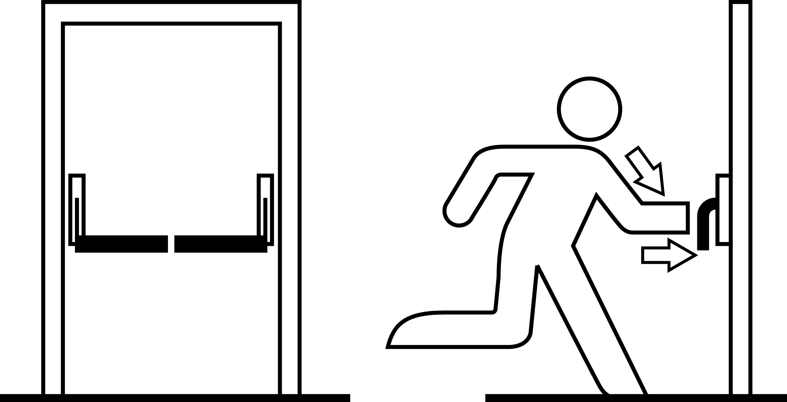
Figure 1 EN 1125 device
with push-bar operation
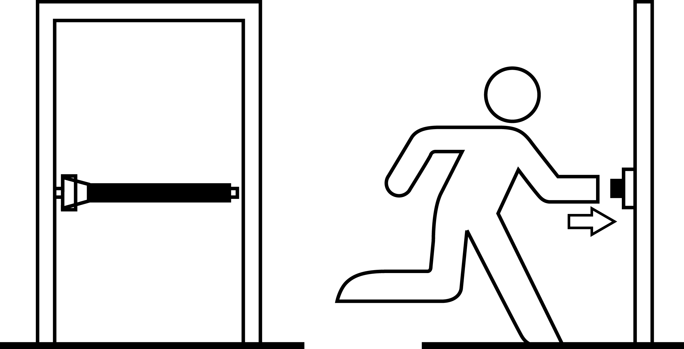
Figure 2 EN 1125 device
with touch-bar operation

Where premises are normally occupied only by staff or other persons who are familiar with the premises layout and have been trained in emergency escape procedures, emergency exit doors may alternatively be fitted with devices that comply with EN 179 (subject to the 60 occupants capacity rule outlined in the previous paragraph).
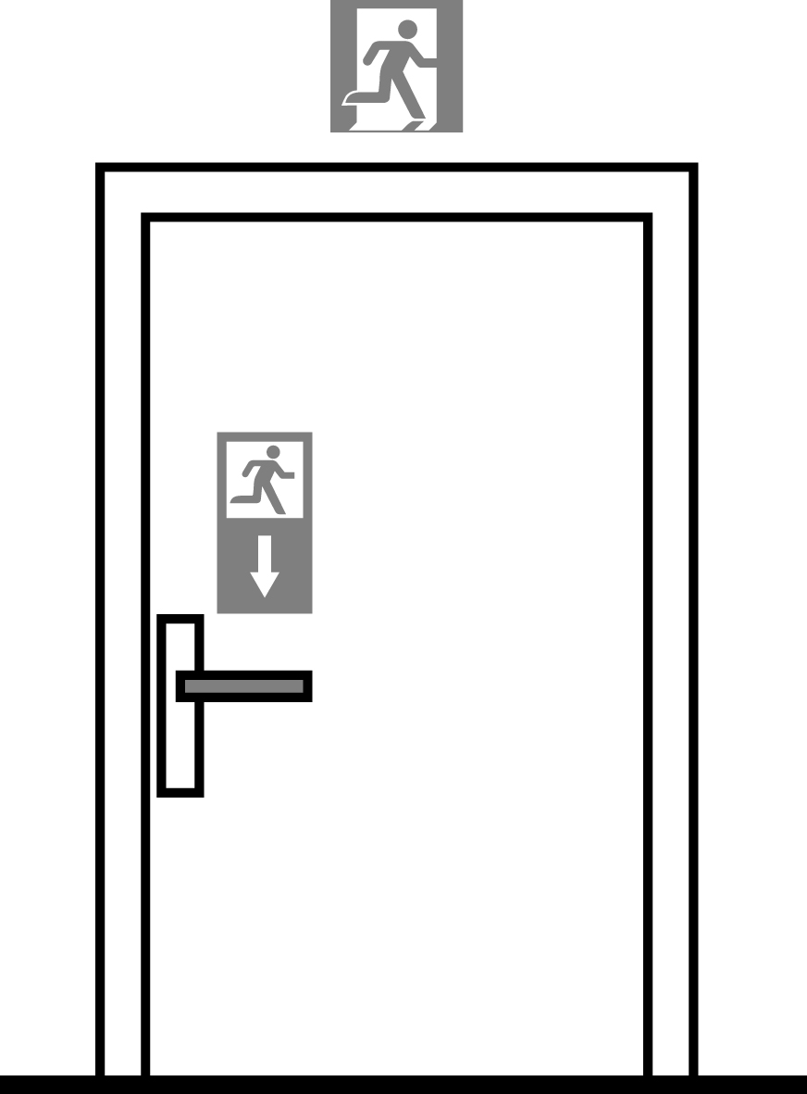
Figure 3 EN 179 device
with lever handle operation
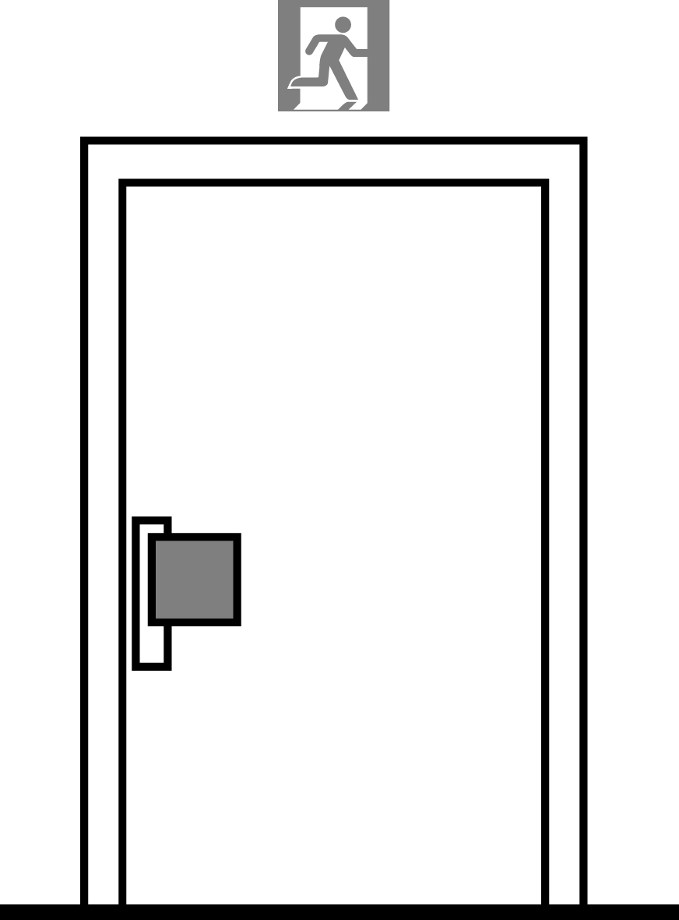
Figure 4 EN 179 device
with push-pad operation

Both EN 1125 and EN 179 are concerned primarily with the quick and effective escape from a building. Such panic and emergency exit devices will, however, normally only provide a basic level of protection against intrusion. They are particularly susceptible to
- surreptitious operation by anyone legitimately on site during business hours (either for immediate criminal purpose or for later intrusion having left the door unfastened but still in a closed and, apparently secured, state)
- manipulation from outside the premises with simply contrived tools (for example bent wire) via a small breach created in the door or immediate surrounding building perimeter
- accidental misoperation by staff following legitimate use, resulting in misalignment of the door and/or boltwork. Such risks are made worse by lack of maintenance
- failure to fully secure the door on closing (often caused by warping).

Door bolts for emergency exit doors
Only in exceptional circumstances will it be appropriate to fit bolts to emergency exit doors because
- bolts may be difficult to locate or operate in an emergency
- misalignment or wear may make them difficult to operate
- distortion of the door by warping or the pressure of those trying to escape may impede easy operation
- some types such as mortise bolts, require more than one operation to release them and it may not be possible to easily see whether they are engaged or retracted.
In particular, bolts that require the use of a key are not acceptable on emergency exit doors (cf. chapter 4.2.1).
Building hardware - Door and window bolts - Requirements and test methods, Grade 4 or Grade 5 and be
- surface mounted and
- easy to use from within the premises and
- sufficiently robust to resist forced entry.

Additional security vulnerabilities

Glazing in, or adjacent to, doors
Where emergency exit doors contain glass panels, or there is glazing adjacent to such doors, it may be very easy to break the glass and so gain external access to the door release hardware. In situations requiring a reasonable level of security, any glazing should offer a high degree of resistance to physical attack. At the very least, it should be of laminated glass to a thickness of 6.8 mm but, ideally, it should comply with EN 356, Glass in building - Security glazing - Testing and classification of resistance against manual attack.
Where glazing is not of an attack-resistant quality, and it is not practicable to replace it, then consideration should be given to the fitting of internal grilles or panels over the glazed areas with a mesh size sufficient to prevent access to internal electric lock release buttons and/or bolt release mechanisms.

Letter plate openings
Letter plate apertures should never be located in, or adjacent to, emergency exit doors as they might readily permit manipulation of the door release hardware, or access to internal electric lock release buttons, by persons outside the premises. If they have to remain they should be internally fitted with a robust enclosure, for example a mail holder, security hood or deflector plate, to hinder access.

Hinge bolts
Emergency exit doors normally open outwards. Consequently the knuckles of the hinges are exposed on the outside which makes them vulnerable to attack as a means of gaining entry to the premises. It is therefore advisable to fit “hinge bolts” to such doors. These engage with the outer frame when the door is closed. In no circumstances should “lift-off” hinges, or hinges with removable pins, be used.

Enhanced security

General
In view of their inherent vulnerability to a range of attack methods, panic bolts and latches may not be suitable for use on some doors in high crime-risk buildings such as banks, jewellers, warehouses containing consumer goods, etc. In these cases a balanced risk assessment may conclude that more secure means of
- fastening the doors during business hours and/or
- locking the doors out of business hours
is warranted.
It is important that all staff are familiar with the alternative method employed and can operate it quickly in an emergency.
As suggested earlier, fire risk assessments for smaller businesses with few staff and no general public access indicate that entry/exit doors secured by conventional locking devices such as key or handle-operated mortise deadlocks are acceptable and that panic bolts and latches are not warranted in the circumstances. Enhanced locking security may be safely introduced if the end-of-day procedures are thorough and reliable. This principle may also be applied to larger businesses (even those with general public access) and, if the circumstances are such that
- the crime risk assessment indicates that enhanced (locking) security is needed on emergency exit doors and
- management quality is of a high standard and the clearly visible safe removal of all enhanced security will be assured at the outset of every period of occupation and
- any fire or other risk assessment indicates that such enhanced measures acceptable.
It may then be acceptable to apply enhanced locking and physical security, for example, "drop-in" bars, padlocks or grilles and shutters.

"Drop-in" bars
The security of emergency exit doors may be enhanced when the premises are unattended by the use of "drop-in" bars.
These should be of sturdy timber or metal construction, normally rectangular in cross-section and of sufficient length to extend beyond each vertical door-frame post. The bars are held in position horizontally by a series of open-topped metal brackets (normally two brackets on the inner face of the door and one bracket on either side of the door frame) set at a height of around 1,000 mm to 1,300 mm. Management procedures should be rigorously applied to ensure that the bars are always placed into position when the premises are locked up at the end of business hours and are always removed as part of the daily unlocking procedure.

Padlocks
Good quality padlocks, in conjunction with matching locking bars or sturdy steel chains, will considerably improve the security of emergency exit doors against intrusion during periods of unoccupancy. Any such padlock should be deployed on the internal face of the door so that its removal at the beginning of each period of occupancy can be readily checked as part of the daily management audit – for example by being placed on a numbered padlock board in a manager’s or supervisor’s office.
In order to provide a good degree of resistance to criminal attack, padlocks should conform to EN 12320 - Building hardware - Padlocks and padlock fittings - Requirements and test methods, minimum grade 4.

Grilles, gates and shutters
Where physical security is required to be to the highest of standards, consideration may be given to additionally protecting external doors out of business hours by means of either internal or external security grilles, gates or roller shutters. As with padlocks and locking bars (or chains), it is vitally important that there are rigorously applied management procedures to ensure that the shutters or grilles are fully withdrawn or removed at all times that the premises are occupied. Internal and external security grilles or shutters should conform to a recognised security performance standard. Other security grilles and shutters should be secured by means of a close shackle padlock that conforms to EN 12320, minimum grade 4, or by integral locking devices that offer a similar level of security.
Important note: If the highest standards of management control cannot be relied upon to ensure that the aforementioned enhanced security devices will always be safely removed or withdrawn when the premises are occupied, then these forms of additional protection should not be employed. In addition, apart from use on normal entry and exit doors which are also used as emergency exists, such devices should never be fitted on the outer face of an emergency exit door.

Intruder alarm systems
Local door alarm devices
Depending upon the circumstances, some emergency exit doors may benefit from provision of a local alarm in order to deter their misuse (for example abuse in connection with smokers’ breaks, or for the pilferage of stock).
Some makes of panic bolts and latches are available with an integral stand-alone alarm sounding locally and/or communicating to a control panel located at a reception desk or security control room. In using these, care should be taken to avoid introducing multiple alarm tones which may confuse staff.
Premises intruder alarms
As emergency exit doors are usually perimeter doors, they will often benefit from being provided with general alarm protection in the form of door contacts, and/or vibration sensors and/or adjacent movement sensors linked to any premises intruder alarm system. The value of such protection is enhanced if an internal secondary gate or shutter is fitted to emergency doors, as forced opening of the external door will trip the alarm system before intruders are able to attack the inner barrier.
Door alarm contacts forming part of any premises alarm system may be programmed to operate on a “24-hour circuit”, i.e. be active whilst the main alarm system is unset. Any alarms created by the opening of the door during periods that the premises are legitimately occupied may be monitored in an on-premises security control room or simply produce a local audible alert. It may be undesirable to signal alarms to a remote monitoring centre when the premises are occupied to avoid false alarms.

CCTV
In heavier risk situations, closed circuit television cameras may be used in conjunction with alarm detection to provide additional supervision of emergency exit routes – preferably through "real-time" monitoring (offering the possibility of immediate security response) or through the recording of images (to support detection, arrest and conviction in criminal cases, or disciplinary procedures in cases of staff misuse).
"Detector-activated" CCTV systems are often designed to transmit images to a remote monitoring centre. Such systems should be designed, installed, monitored and maintained in accordance with the recognised national standard if one exists.

Access control/building management systems
It is increasingly common for commercial premises to install and use access control systems, either as "stand alone" systems, or as part of a building management control system.
A well designed and correctly managed electronic access control system can be a valuable component of an effective security plan for many businesses, offering enhanced and cost-effective protection during working hours.
The security of access controlled doors is normally achieved by the use of electromagnetic or electro-mechanical locks. As previously stated, fire and other risk assessments will normally determine that these should “fail safe” in the event of removal or failure of the power supply.
It will frequently also be the case that, where the premises are fitted with a fire alarm system, any activation (whether initiated via a call-point or by an automatic detection device) will, through the interfacing of relevant systems, ensure that power is withdrawn from access control locking devices, thus releasing them and allowing exit.
The requirement to “fail safe” thus introduces additional opportunities to deliberately compromise locking arrangements (or to take advantage of genuinely “failed safe” insecure openings), and for this reason access-controlled locking devices should not be relied upon as the only means of securing emergency exit doors (or any other external doors) outside working hours. However, it can be ensured that the access from the outside still needs the use of a key or card even in case of a fire alarm.
As with other means of securing emergency escape doors, the type and functionality of any access control system to be employed on such doors should only be determined as part of a detailed risk assessment programme.
Additional guides may prove helpful in informing the correct decision, e.g. as published by
- Fire authorities
- insurers
- national regulations
- standardisation bodies.

Annex A Guidelines
Security
Guideline No. 1:2010 S Arson Document
Guideline No. 2:2010 S Protection of Empty Buildings
Guideline No. 3:2010 S Electronic Security Systems for Empty Buildings
Guideline No. 4:2010 S Guidance on Keyholder Selection and Duties
Guideline No. 5:2012 S Security Guidelines for Museums and Showrooms
Guideline No. 6:2014 S Security Guidelines for Safe Emergency Exit Doors in Non-residential Premisis

Fire
Guideline No. 1:2002 F Internal fire protection control
Guideline No. 2:2013 F Panic & emergency exit devices
Guideline No. 3:2011 F Certification of thermographers
Guideline No. 4:2010 F Introduction to qualitative fire risk assessment
Guideline No. 5:2003 F Guidance signs, emergency lighting and general lighting
Guideline No. 6:2011 F Fire safety in care homes for the elderly
Guideline No. 7:2011 F Safety distance between waste containers and buildings
Guideline No. 8:2004 F Preventing arson – information to young people
Guideline No. 9:2012 F Fire safety in restaurants
Guideline No. 10:2008 F Smoke alarms in the home
Guideline No. 11:2005 F Recommended numbers of fire protection trained staff
Guideline No. 12:2012 F Fire safety basics for hot work operatives
Guideline No. 13:2006 F Fire protection documentation
Guideline No. 14:2007 F Fire protection in information technology facilities
Guideline No. 15:2012 F Fire safety in guest harbours and marinas
Guideline No. 16:2008 F Fire protection in offices
Guideline No. 17:2008 F Fire safety in farm buildings
Guideline No. 18:2013 F Fire protection on chemical manufacturing sites
Guideline No. 19:2009 F Fire safety engineering concerning evacuation from buildings
Guideline No. 20:2012 F Fire safety in camping sites
Guideline No. 21:2012 F Fire prevention on construction sites
Guideline No. 22:2012 F Wind turbines – Fire protection guideline
Guideline No. 23:2010 F Securing the operational readiness of fire control system
Guideline No. 24:2010 F Fire safe homes
Guideline No. 25:2010 F Emergency plan
Guideline No. 26:2010 F Fire protection of temporary buildings on construction sites
Guideline No. 27:2011 F Fire safety in apartment buildings
Guideline No. 28:2012 F Fire safety in laboratories
Guideline No. 29:2013 F Protection of pain tings: Transport, exhibition and storage
Guideline No. 30:2013 F Managing fire safety in historical buildings
Guideline No. 31:2013 F Protection against self-ignition and explosions in handling and storage of silage and fodder in farms

Natural hazards
Guideline No. 1:2012 N Protection against flood
Guideline No. 2:2013 N Business Resilience – An introduction to protecting your business
Guideline No. 3:2013 N Protection of buildings against wind damage
Guideline No. 4:2013 N Lightning protection
Guideline No. 5:2014 N Managing heavy snow loads on roofs Security
Guideline No. 1:2010 S Arson document
Guideline No. 2:2010 S Protection of empty buildings
Guideline No. 3:2010 S Security system for empty buildings
Guideline No. 4:2010 S Guidance on key holder selections and duties
Guideline No. 5:2012 S Security guidelines for museums and showrooms

